State University of New York at New Paltz

Zachary Smith
Project Type: On-campus, Student’s “Class Key”: i_s24_16

“Archaea: The Forgotten Kingdom”

FINAL PROJECT REPORT

Computer Science Projects
Spring 2024
(Prof. Hanh Pham)

(VERSION A)

TABLE OF CONTENTS
1. Problem Description
1.1 Business Context and Goals ….……………………………………….…………….……. page 03
1.2 Technical Requirements ….……………………………………………….……….………. page 05
1.3 Your Responsibilities ……...……………………………………………….……….………. page 05
2. Technologies
2.1 Related Technologies ….……………………………………….……………………..…….. page 06
2.2 Newly Learned Skills/Technologies …………………………………..………………. page 06
3. Design
3.1 System Architecture ………………….……………………………………….………………. page 07
3.2 Components ………………………….…………………………………………..………………. page 08
4. Software/System Description ………………………………………….……………..……..…………. page 09
4.1 Map of Files ………………………….…………………………………………..………………. page 09
4.2 DATA Format & Description ………………………………………………………………. page 10
4.3 Developer’s Guide …..…………….…………………………………………..………………. page 10
4.4 User’s Guide …..…………….…………….……………………………………..………………. page 10
5. Test Results (Functionality/Performance)
5.1 Test Function 1/Transaction # 1 …………………………..….…….…..………..……. page 11
5.2 Test Function 2/Transaction # 2 …………………………..….…….……..……..……. page 12
5.2 Test Function 2/Transaction # 2 …………………………..….…….……..……..……. page 13
6. Professional and Career Benefits ……………………………….……..….…….……..……………. page 14
6.1 Challenges and Solutions ……….…….……..……………………………………….……. page 14
6.2 Other Learned Lessons …….…….…….……..……………………………………….……. page 15
7. Conclusions ………………………….……………………………………………...…………..………………. page 15
8. References ………………………….…………………..………………………………………..………………. page 15
9. Appendixes …………………….………………….……………………………………………..………………. page 15

1. Problem Description

1.1 Business Context and Goals

General Description:
I am working on a project called “Archaea: The Forgotten Kingdom”. This is on-campus at SUNY New Paltz, under the supervision of Dr. Hanh Pham and Prof. Michael Curry. I will be using The Nature of Code by Daniel Shiffman, in building the world. I am the sole contributor to the project, aside from Dr. Pham’s and Prof. Curry’s advisement. This educational simulation promotes awareness of major theories in the fields of Population Biology, Microbiology and Evolutionary Studies and demonstrates the applicability of Computer Science to the natural world.

Project Description:
I am working with Prof. Curry on creating a 2D virtual microbiological ecosystem simulator called “Archaea: The Forgotten Kingdom”, using Java Processing. The Nature of Code by Daniel Shiffman will be used to build the world. It will contain a genetic algorithm and simulate the natural variation between species and between individuals of the same species. This is a large project with various tasks and sub-projects.

Archaea will simulate, track, and display aspects of life on a microbiological scale. The cells, or LUCAs (“Last Universal Common Ancestor”) will start off extremely simple in terms of the traits and behaviors, and progressively complexify as they adapt, mutate new traits, and are acted upon by environmental pressures. Simulating an environment with finite resources will drive competition to procure those resources, survive in the environment, and reproduce, causing the LUCAs to adapt and change over time. Archaea will be at the intersection of two foundational sciences: Computer Science and Biology—technology and life. Archaea bridges the gap.

It is for anyone interested in seeing how environmental factors, when paired with a genetic algorithm, can have a profound impact on a population of inhabitants; or in how the natural world can be simulated with computers, by simply programming an environment, agents, and the rules and functions of both. This educational software can be used by teachers and students alike, to illustrate concepts from class. Evolution explains much about the natural world, and Archaea aims to illustrate those explanations. Users will be able to pause the simulation, change its speed, and save a species for use in other simulations.

To occur, evolution by natural selection requires three conditions to exist in a closed system: phenotypic variation¹, heredity², and differential survivability³. Archaea aims to simulate an environment with these conditions built in. The genetic algorithm will provide the variation of traits and behaviors¹ as well as the inheritance of those traits and behaviors². It will aim to allow for as many types of variation as possible between generations. These variations along with the rules of the simulation, will naturally result in some individuals surviving longer than others³, giving them a better chance of living long enough to replicate. This, in turn, determines which of these variations will thrive in the environment, and ultimately, the fate of the species.

In building this world with these conditions in place, we can illustrate how natural selection occurs ‘naturally’ under these circumstances, as well as how other mechanisms of evolution act on a system—speciation, mutation, gene flow, genetic drift, altruism, and selective pressures such as predation, resource availability, and intra- and inter-specific competition. By laying out the rules for life in the ecosystem, founded on the three key principles, we can simulate evolution, a process that can take millions of years to take place, in a short amount of time. In this way, this revolutionary, evolutionary, educational software aims to help people visualize a process that no human could ever before observe with their own eyes. By setting the stage for evolutionary processes, Archaea demonstrates and visualizes how such a system can result in remarkably interesting patterns among and between species, while also demonstrating “the nature of code.”

USERS: the users of the program would be science teachers, students, professors, enthusiasts, and anyone interested in observing evolutionary processes act upon a closed system over time and the resulting variation; as well as anyone interested in how computer programs can be modeled after the natural world.

When & Where can the users use this ?
The program can be accessed online. The simulation is free-to-use. If the user wishes to save their species for later use and/or access other possible member-only features, they can sign up for the premium membership.

Functionalities: What can the software do ?
The program will start by asking the user to set the initial conditions. The simulation will begin, using these input parameters to initialize the world. The cells will be programmed with needs, and priorities in terms of which needs need to be met at any given time. Their traits and behaviors will start out very basic, and they will gradually change as time goes on and they mutate and adapt to the environment. As two simulations will never play out exactly the same, users will basically be culturing their own petri dish, with a front row seat to observe from. Users can save a species for use in future simulations. This educational software can be used by teachers, students, and anyone interested in seeing concepts of population biology in action and learning something in the process. Evolution explains much about the natural world, and Archaea aims to illustrate those explanations. Users will be able to pause the simulation, speed it up to skip generations, or slow it down so they don’t miss a thing.

+ “BUSINESS” PROBLEM/GOALS (in the context of the given business situations):

Components/hardware: display and mouse.

List of transactions, operations, interactions:

- Restart
Input = mouse. Button in panel on top of screen
Output = void: Clears screen and reinitializes simulation

- Pause
Input = mouse. Button in panel on top of screen
Output = void: Pauses the simulation

- Play
Input = mouse. Button in panel on top of screen
Output = void. Plays / resumes at normal speed (11fps)

- Fast Forward
Input = mouse. Button in panel on top of screen
Output = void: increases speed (factors of two, capped at 165)

- Step
Input = mouse. Button in panel on top of screen
Output = void: advances simulation one frame at a time

- About Page
Input = mouse. Button in panel on top of screen
Output = void: displays ‘About’ page

1.2 Technical Requirements

-ENVIRONMENT: Any computer
-PLATFORM: PC
-CONNECTIONS: N/A
-MEAN OF INTERACTION with user: keyboard, mouse => input | screen => display
-SYSTEM COMPONENTS:
- User Interface:
- Graphical (mouse and keyboard): restart, pause, play, step, forward, about
- Processing:
  - N/A – Registration, Log-in, Saving, Loading not yet implemented
- Data:
- N/A
- Hardware
- No additional drivers or support needed

1.3 Your Responsibilities

I am responsible for the whole project.

2. Technologies

2.1 Related Technologies

- Java Processing

2.2 Newly Learned Skills / Technology

- Java Processing
- Fisica
- Box2D
- Godot
- GDscript
- Working with and building physics engines
- Working with systems of particle systems
- Programming autonomous agents
- Integrating a genetic algorithm

3. Design

3.1 System Architecture

See the Archaea class diagram and UI diagram below.

3.2 Components

See the Archaea State Diagrams below.

4. Software / System Description

4.1 Map of Files

Archaea.pde | It contains the setup and draw methods.
Biome.pde | A system of Species objects and the tools to manage them (includes speciation, extinction, etc.)
Environment.pde | A system of Food objects and the tools to manage them
Food.pde | An object that spawns around the screen that, when eaten, disappears and reduces the consumer’s hunger attribute—and the tools to manage them.
Luca.pde | A class to create the agents of the simulation—microorganisms—and methods that provide all their possible behavioral and physical attributes. Variation is key and will be inevitable due to the random mutations they will undergo, which will also be handled by this class.
Species.pde | A system of Luca objects, along with the tools to manage their behavior. Each Species object will contain attributes that hold an average of the corresponding attributes of all the cells that belong to the Species, as well as the standard deviation. When a standard deviation grows too large, it means one Species has diverged into two; A new Species object will be created, and hence, speciation will occur.
Predator.pde | This class extends Luca. It’s a class to create the agents of the simulation—microorganisms—and methods that provide all their possible behavioral and physical attributes. These agents are able to consume Lucas that are not also Predators
DNA.pde | A class to simulate genetics. It holds the lucas’ genes (prey and predator) which are passed from ancestor to descendant upon replication. Each gene acts as a base, which is ‘mutated’ by adding a random offset within a specified range. This simulates heredity and variability.

4.2 Data Format & Description

I have not yet utilized MySQL.

4.3 Developer’s Guide

Set-up/installation process have not yet been decided. The software is still in development.

4.4 User’s Guide

All you must do is start the program. From there, you can adjust the simulation speed, pause it, resume at normal speed, restart the simulation, step through it frame by frame, or see the ‘About’ page. The rest is up to “nature”.

5. Test Results (Functionality / Performance)

Restart – clears the screen and reinitializes the simulation
Pause – pauses the simulation
Play – resumes the simulation at (or reset frame rate to) normal speed
Step – Advance the simulation by one frame
Forward – increase speed by 2x (up to 165)
About – Display the ‘About” page

5.1 Simulation & GUI

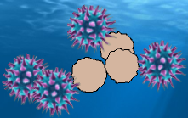

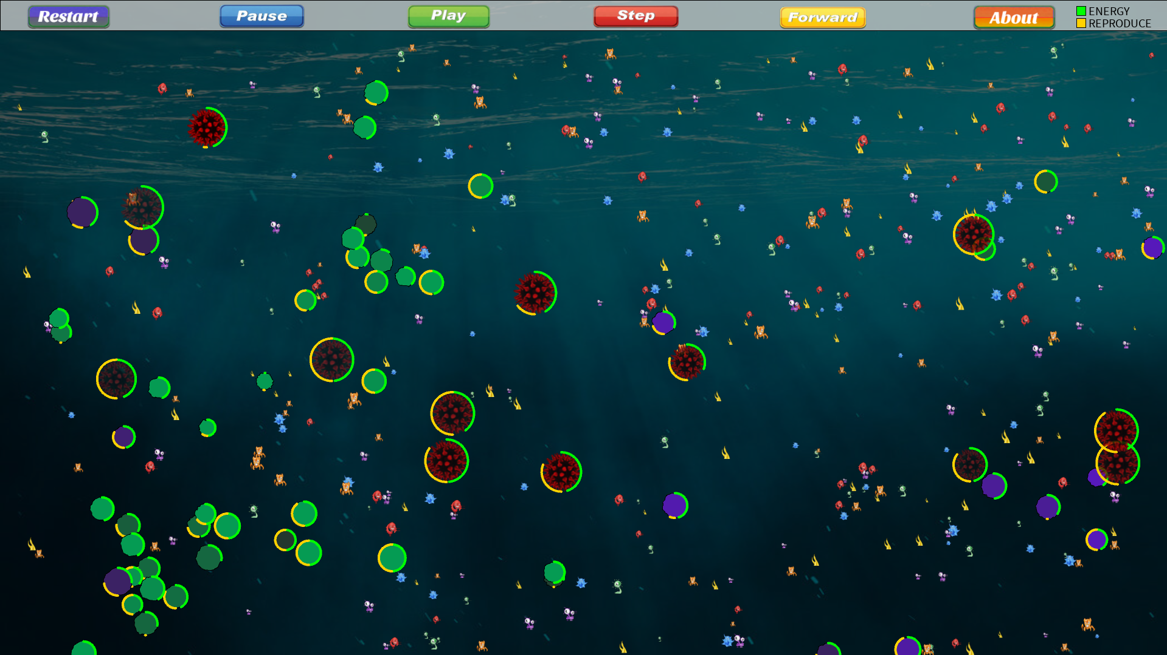
Click the buttons to control the simulation or see the ‘About’ page.

5.2 Random Backgrounds

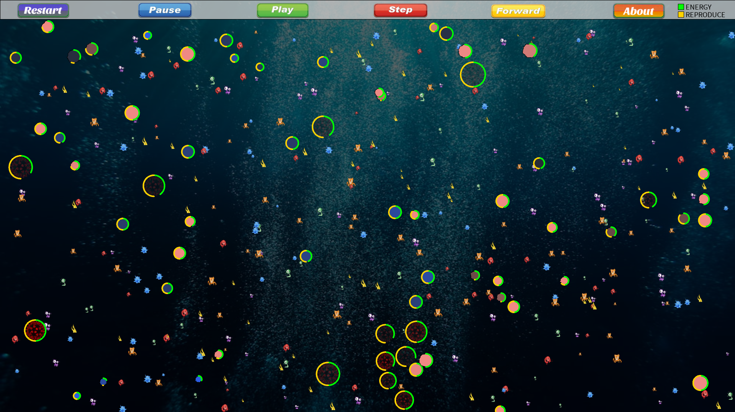

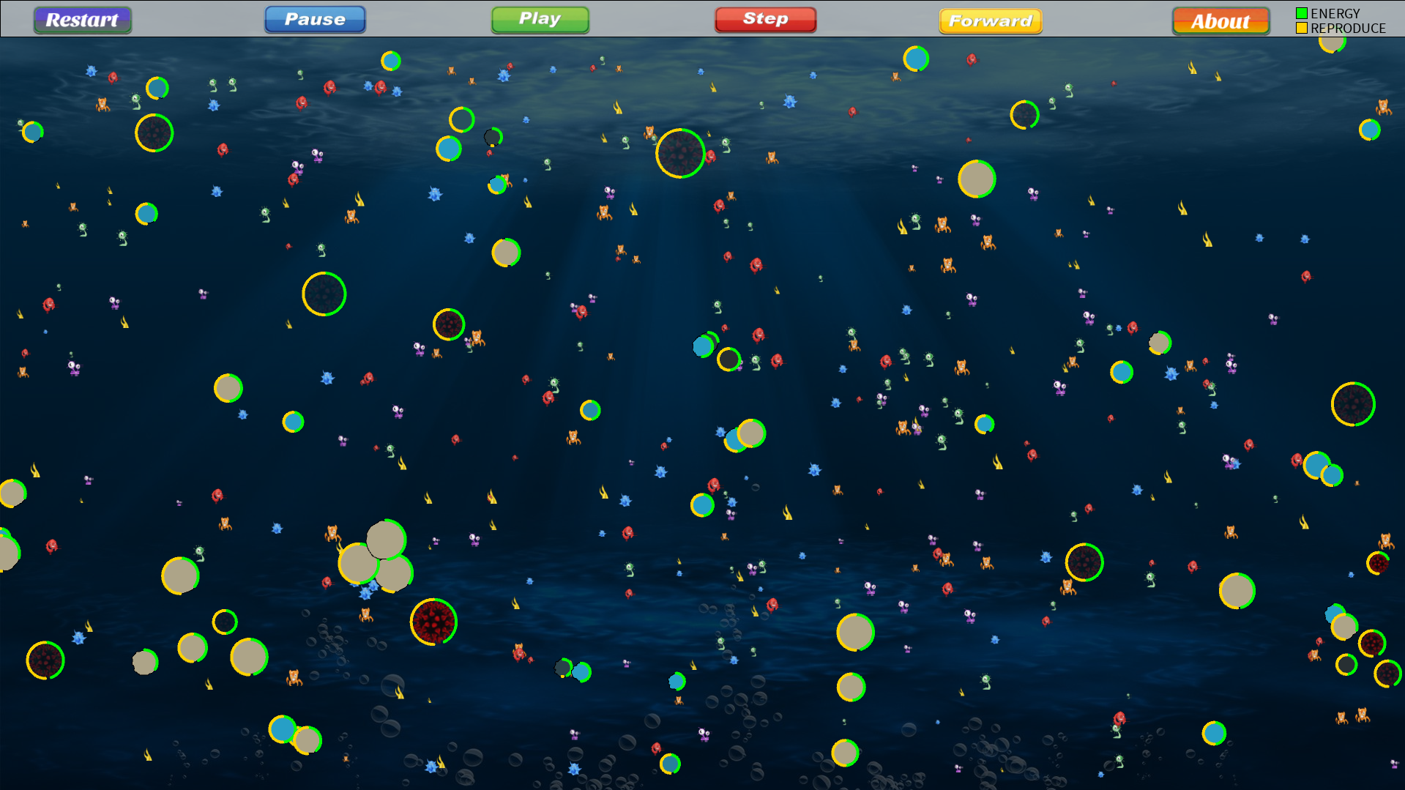

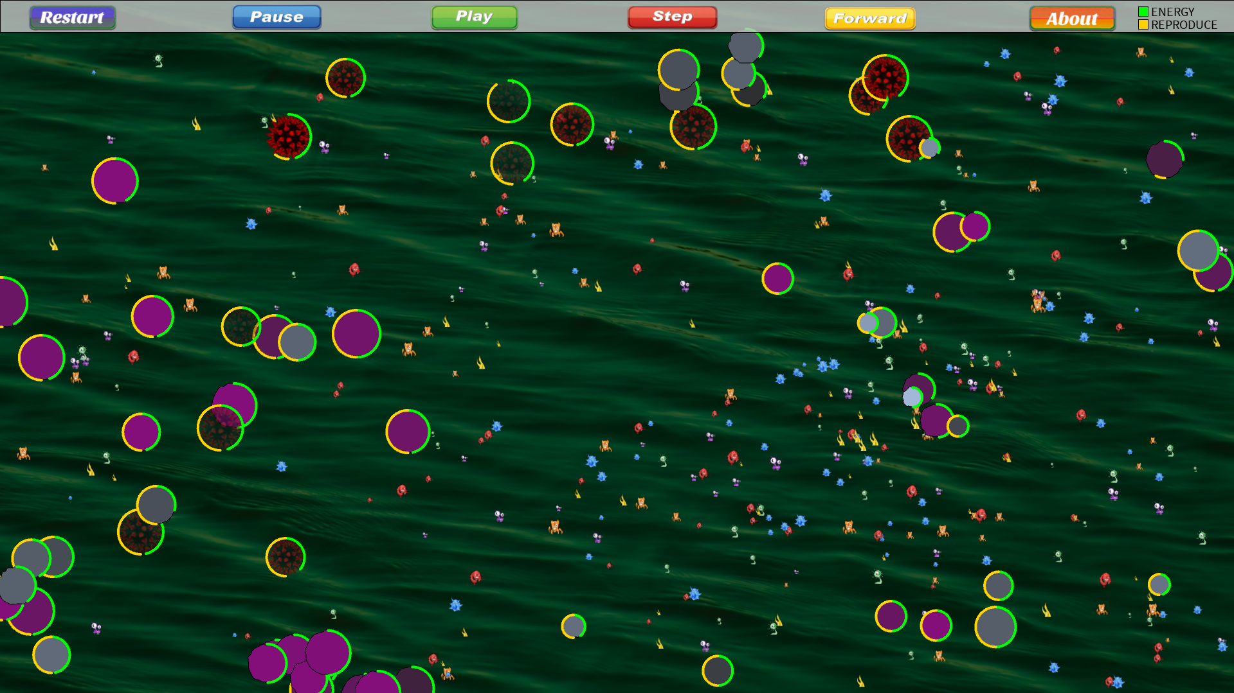
When you click ‘Restart’ it randomly chooses a background again.

5.3 About Page
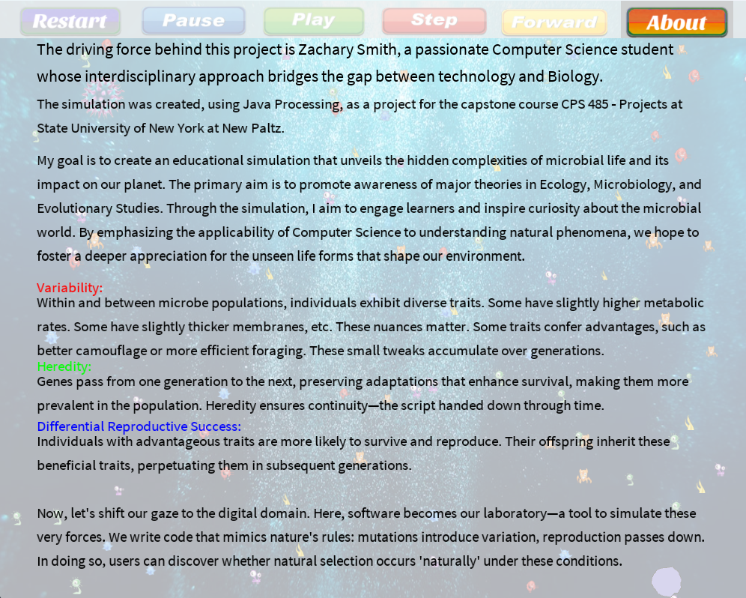
Click ‘About’ again to resume the simulation.

6. Professional and Career Benefits

I now feel even more proficient in teaching myself to use new software/languages which is a necessary skill in the field of Computer Science. A career in Game Design would be fantastic, and I believe that creating my own physics engine and programming autonomous agents may help me to achieve that. I very much enjoyed working with vectors on a graphical application, and now feel more certain that a Game Design career is my ultimate goal. I hope that having Archaea on my resume will help me to stand out to the right people.

6.1 Challenges and Solutions

A challenge I faced was finding the right software for the job. Fisica was too restrictive. It could not provide soft-body functionality and collision detection simultaneously. Box2D did not offer the functionality I was looking for—soft bodies. I ultimately decided to use Java Processing because Michael Curry is proficient in it, and I simulated soft-body motion using sine and cosine functions. I realized that while it is not good for everything, it does offer more control. Moving forward, I might try translating it into GDscript in Godot.

I did not have time to properly adjust the starting attributes to ensure that all the predators and prey don't die right away, or the prey in the long run. The limit on the number of predators got it to a point where it was presentable.

Presenting is also very challenging for me, but with Dr. Pham’s help and encouragement, I got through it, and now it is behind me. I am thankful. She obviously wants her students to succeed.

6.2 Other Lessons Learned

Other lessons include how to debug different issues in Java Processing, how to work with physics engines and systems of particle systems, and how to implement a genetic algorithm.

7. Conclusions

Even just having a vision and seeing it all begin to come together was a highly beneficial experience. I say ‘begin’ because there is so much more I would like to have done with Archaea before presenting it, that if I had even one more week, would have made the program feel much more complete and visually aesthetic. It pains me to submit this, as unpolished as it is. I will continue to implement these changes in my free time moving forward.

8. References

Shiffman, D. (2024b). The nature of code. No Starch Press.

Bacteria transparent PNG, Free Bacteria clipart images - Free transparent PNG logos. (n.d.). https://www.freepnglogos.com/pics/bacteria

Get4net. (n.d.). Set of buttons vector image. VectorStock. https://www.vectorstock.com/royalty-free-vector/set-of-buttons-vector-346773

https://www.narodnatribuna.info/lists/u/unicellular-organisms-examples-bacteria/

9. Appendixes

All related images, tables, and diagrams reside in their respective sections.

