Babu Banarasi Das University

University Logo

Case Study
on
Customer Segmentation using K-Means Clustering BCA-DS-AI

SECTION-35

SUBMITTED TO: SUBMITTED BY:
Mr. Vikas Kumar Rifa Jalees
Rajnandini Gupta,
Saloni Ojha

FINAL OUTPUT-
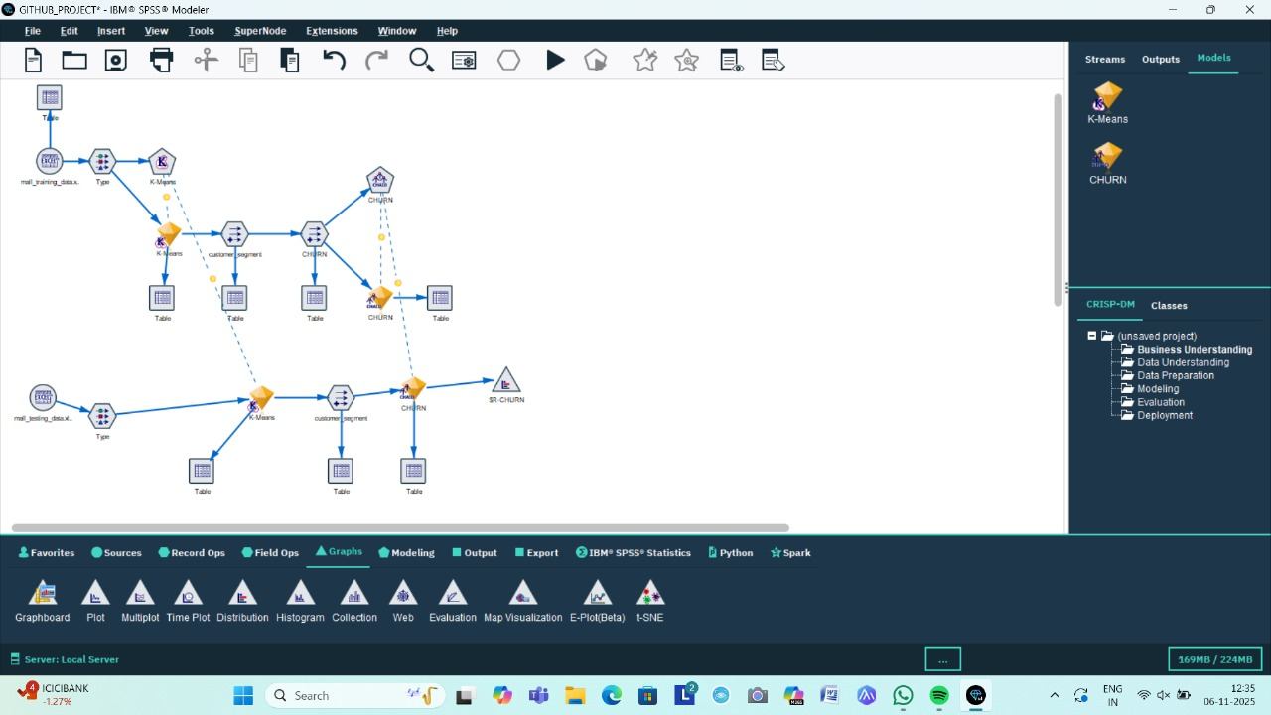

Agenda / Definition:
The project 'Customer Segmentation using K-Means Clustering' aims to classify customers into different groups based on their purchasing behavior, demographics, or interests. By using clustering techniques, companies can target specific customer segments more effectively.

Outcomes / Learning:
Through this project, we learned how to use IBM SPSS Modeler for data preprocessing, clustering, and analysis. We also understood the importance of customer segmentation for improving marketing strategies and decision-making.

Required Tools:
IBM SPSS Modeler version 18.6

Working:
We used a dataset named 'Mail_Customers.csv' to perform segmentation of male customers using the K-Means algorithm. The steps performed in SPSS Modeler are as follows:

Step 1: Import Dataset
Imported the dataset 'Mail_Customers.csv' into IBM SPSS Modeler using the Source node. This dataset contains customer details such as age, income, spending score, etc.

Step 2: Apply Type Node
Added a Type node to assign proper measurement levels to each variable (for example, numeric or categorical). This ensures that SPSS correctly interprets the data types.

Step 3: Filter Male Customers
Used a Select or Filter node to create a subset table named 'Male_Customers_Table' containing only male customer data for analysis.

Step 4: Apply K-Means Clustering
Added the K-Means node to perform clustering on the male customers. We selected relevant variables such as age, income, and spending score for the clustering process. The algorithm grouped customers into clusters based on similarities.

Step 5: Visualize and Analyze Clusters
Connected the output of the K-Means node to a Graph node to visualize the clusters. The resulting chart showed how customers are segmented into different groups.

Step 6: Interpretation
From the output, each cluster represented a unique type of customer segment. For example, high-income frequent buyers, medium-income average spenders, and low-income occasional buyers. This helps the company target each group with specific marketing strategies.

Benefits to the Company:
1. Enables targeted marketing and personalized offers.
2. Helps identify valuable customers and improve retention.
3. Supports better decision-making through data-driven insights.
4. Enhances customer satisfaction and loyalty by addressing their specific needs.

Final Output Screenshot:
Below is the final view of the SPSS Modeler stream used in this project:
