Endnote file prep for export into HAWC

Table of Contents

Export your search results from databases 2

Import Process steps 3

Import PubMed references: 3

Import WOS references: 3

Import Scopus references: 4

Import Embase references: 4

Remove Duplicates 5

Export appropriate references and upload to HAWC 6

Other skills you may need to use this process 7

Adding a new filter (Output or Import) to your Endnote 7

Changing the displayed fields in your Endnote window 8

**Modified Endnote filters are available:**   
<https://hawcproject.org/lit/ris-export-instructions/>

* HAWC_PubMed import filter
* HAWC_WOS import filter
* HAWC_Scopus_RIS import filter
* HAWC_Embase_TEXT import filter
* HAWC_Export_RIS style
* HAWC_EndNote_Export style
* HAWC_EndNote_Import filter

**Suggested Endnote columns displayed for Library preparation and de-duplication:**

* Author
* Year
* Title
* Volume
* Pages
* Journal
* Name of DB
* Custom 8 (PMID)
* DOI
* Accession #

# Export your search results from databases

* For PubMed, Use the Medline format and save the text file
* For Web of Science, Search the Core Collection, Save to “Endnote Desktop” and select “Full Record” for the record content

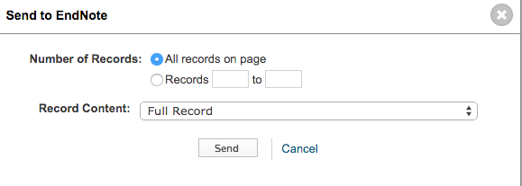

* For Scopus use the RIS format and be sure to “Specify fields to be exported” including the Citation information, DOI, PMID, Abstract etc. 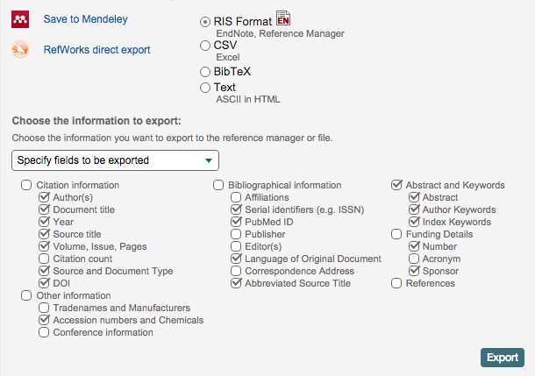
* For Embase, Use Export format “Plain Text” and choose “Full Record” Output
* 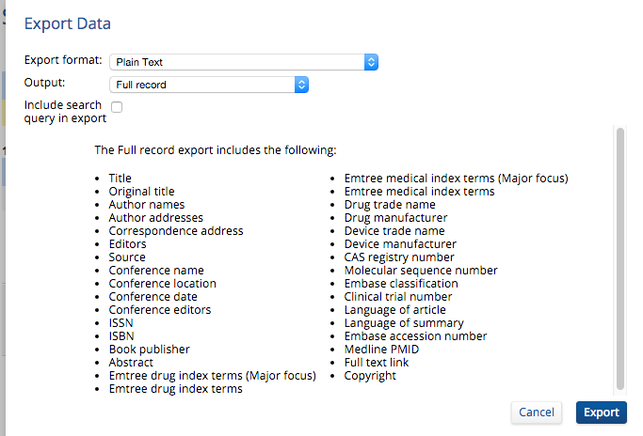

# Import Process steps

## Import PubMed references:

*Instructions include copying the PMID into the Custom 8 field*

Import using PubMed filter customized for HAWC imports (HAWC_PubMed)

NLM will appear in Database Name field

When all PubMed citations are imported copy the PMID into the Custom field as follows:

Select the PubMed references (“ctl A” selects all showing references)

Select “Change Move and Copy Fields” from the “Tools" dropdown on the top menu

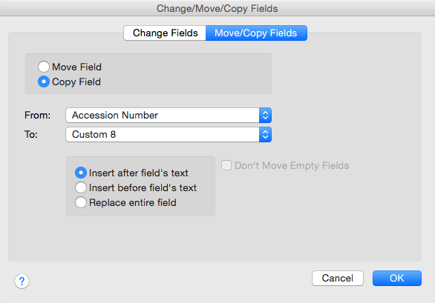

1

2

3

4

5

6

A pop-up window will appear

1. Select: Move or Copy tab

2. Select: Copy

3. From field: Accession Number

4. To Field: Custom 8 *

*\*Note if your Custom 8 is already assigned you will need to identify a new custom field to use.*

5. “Insert after field’s text” is fine (field should be empty)

6. Click OK

The PMID will now appear in both the Accession Number field and in the Custom Field identified as PMID

## Import WOS references:

*Instructions include manually adding the “Database name” not included in the export.*

*NOTE: When searching Web of Science, Be sure to search the “Core Collection”.*

Import records using ICI filter customized for HAWC imports (HAWC_WOS)

All the other references in the library should be from PubMed and have “NLM” in the Database Name field.

Select the imported references

*\*If you have multiple sets of WOS references you may either do the following steps for each import of WOS references, or import them all then segregate the WOS references for processing by selecting all those with nothing in the Database Name field and choosing “Show Selected References” from the “References” drop-down on the top menu.*

Add the text “WOS” to the Name of Database Field as follows:

Select “Change Move and Copy Fields” from the “Tools" dropdown on the top menu.

In the pop-up window

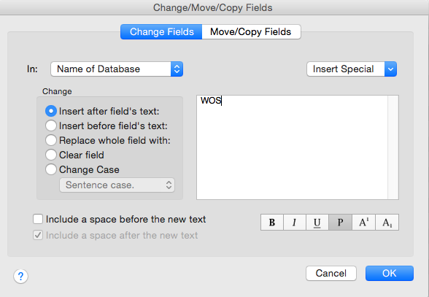

1

2

4

3

6

5

1. Select: Change Fields tab

2. In field: Select “Name of Database”

3. Leave “Insert after field’s text” selected

4. In the box type “WOS”

5. Uncheck the box to “Include a space before new text”

6. Click OK

## Import Scopus references:

*Scopus should appear in Database Name and The PMID should appear in Custom 8*

Import using Scopus filter customized for HAWC imports (HAWC_Scopus_RIS)

No need to modify results

## Import Embase references:

*Instructions include manually adding the Database Name not included in the export, and re-formatting the DOI from the link in the URL field.*

Import using Embase filter customized for HAWC imports (HAWC_Embase_TEXT)

Add the database name (EMB), using the same process above in WOS instructions.

Copy URL field to DOI field using the same process as PMID in PubMed instructions.

Do a “find and replace” on DOI field to remove the text <http://dx.doi.org/> as follows:

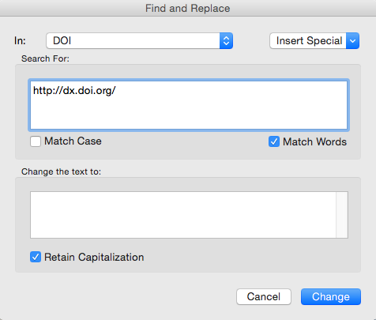

1

2

3

4

Select “Find and Replace” from the “EDIT " dropdown on the top menu

A pop-up window will appear

1. Select “In” field: DOI

2. In “Search For” box paste: <http://dx.doi.org/>

3. Leave “Change the text to” box blank

4. Click: Change

# Remove Duplicates

Use your preferred method of ensuring there are no duplicates within your list.

Also remove duplicates of items already in your HAWC project.

If you have an Endnote file of your previous HAWC entries you may merge the new and old libraries for de-duplication as follows:

Use the customized HAWC_EndNote_Export style to export your new references from their library.

In your Library of the references already held in your HAWC project, (or a copy of that library), create a group folder for the “old” set, and move all the references into the group folder. Label it to differentiate it from the new import.

Use the customized HAWC_EndNote_Import filter to import your new references into your library of existing HAWC references. (Remember to set your duplicate recognition preferences as you see fit before the import.)

Use your preferred method of ensuring there are no duplicates within your list.

Your new set of references should be in the “Unfiled” grouping in your left hand “Library” pane. You may make a new group folder for them or leave them unfiled.

# Export appropriate references and upload to HAWC

Select references to be exported. *\*Your new export should contain only unique citations not yet included in your HAWC project.*

* Export using customized HAWC_Export_RIS filter. *Your file may have a .txt extension, but it can still be processed.
* Go to the target HAWC assessment
* Click on Literature review in the left hand menu (1)   
  Then click the “Actions” button on the right top area of the screen (2).
* Select “New Import from File” from the drop-down list.

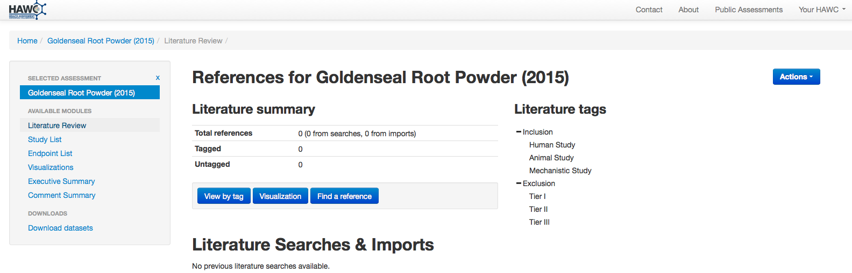

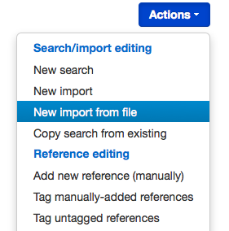

In the form:

* leave RIS selected (even if your file has a txt extension)
* provide a meaningful title to help differentiate it from other uploads
* Include a description to further clarify the content of the individual upload
* Click “Browse” and select your exported file

Click Save and the upload will process.

# Other skills you may need to use this process

## Adding a new filter (Output or Import) to your Endnote

Copy or drag the required filters from the source location (whether attached to an email or stored in a shared folder) to the correct folder on your computer.

Locate you Endnote folder (probably under My Documents). Inside it you will see a Styles folder and a Filters folder.

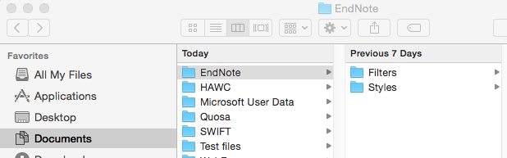

For IMPORT Filters: Place the new files in your “Filters” folder

For OUTPUT Styles: Place the new files in your “Styles” folder

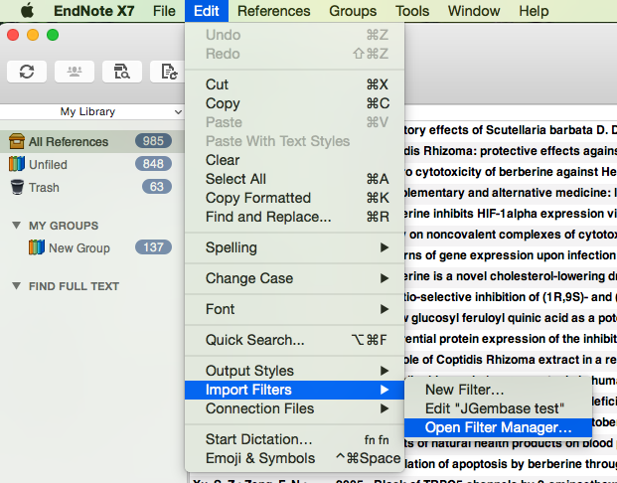Next, go to your library and select “Import Filters” from your Edit menu

Chose “Open Filter Manager”

A new window will pop up.

Scroll through the list of choices in the new menu to select the filter you saved.

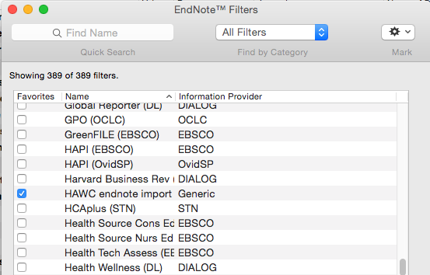

Click the box to the left of the filter you would like to make available in your library. Anything with a blue check in the box will be available in your choices for the import process.

Close the box when you finish, and return to your library to use the filter.

For new output styles, use the same process but choose “Output Styles” from the Edit menu instead.

## Changing the displayed fields in your Endnote window

You may display 10 fields at a time in your library view window. You may change them in the library screen (one at a time) or go to the Preferences window to make multiple changes at one time.

To change which fields are showing within the library window, right-click in the header bar where you would like to add a column

A list of fields will open showing the fields in use in black text with a check, and fields not displayed grayed out.

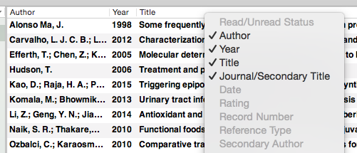

If you don’t have 10 fields showing already, you may simply check an additional field and it will be added. (You will have to add them one at a time, as the choice list closes after each selection)

If you already have 10 displayed, you will need to click one of the checked fields to remove it, then re-open the choice list to add the new field.

If you have several fields to add or remove it may be easier to open the utility and assign the fields there.

Go to “Endnote” in the top menu and select “Preferences”

In the window that pops up, chose “Display Fields”

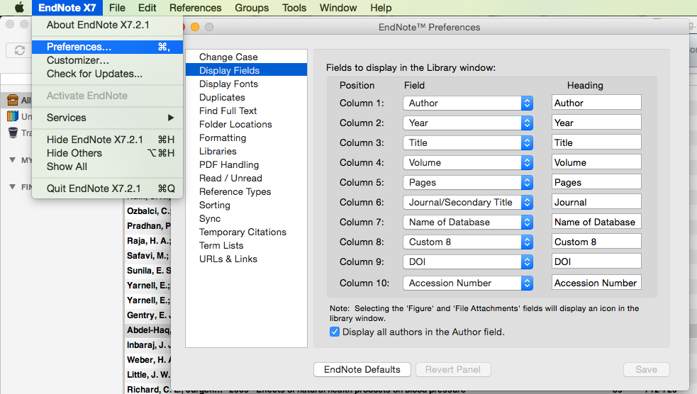

Select the fields by their systematic fields name in the left column \**Here you will need to know the number for any custom field you wish to display.*

In the right column you have the option to edit the way the field is displayed in your library. You may chose to change the heading for Custom 8 to “PMID”.

You may set the order here with the top (Column 1) representing the first column on the left, proceeding to the right as you go down. You may also drag and drop the headings in your library window to change the order.