1. SELECT \* FROM Production.ProductModel;
2. SELECT IllustrationID, Diagram FROM Production.Illustration;
3. SELECT ProductID, LocationID, Shelf, Quantity FROM Production.ProductInventory WHERE Quantity > 400;

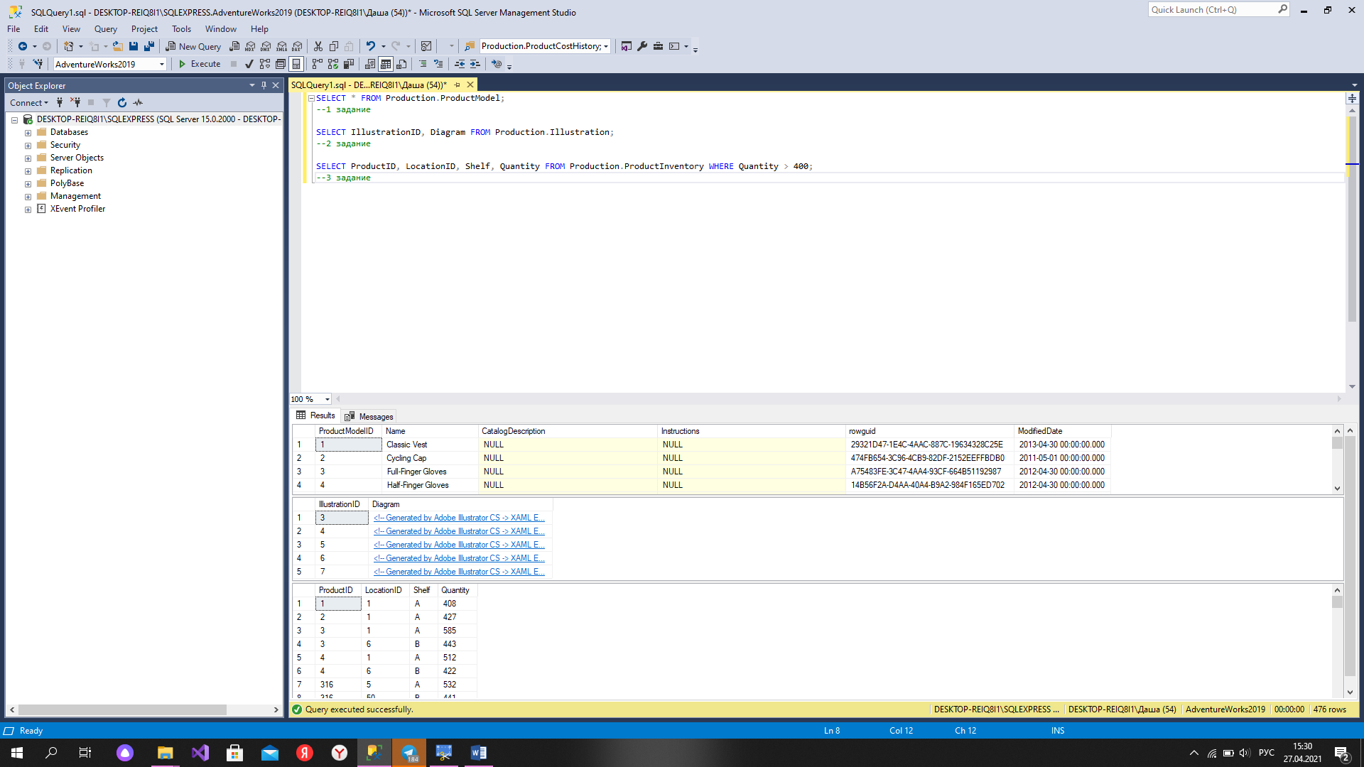

Рисунок 1 – запросы 1,2,3

1. SELECT AddressID , AddressLine1, City FROM Person.[Address] WHERE AddressLine2 IS NOT NULL

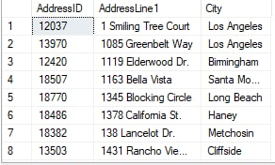

Рисунок 2 – запрос 4

1. SELECT CreditCardID, CardType, CardNumber FROM Sales.CreditCard WHERE name LIKE ‘%Card%’

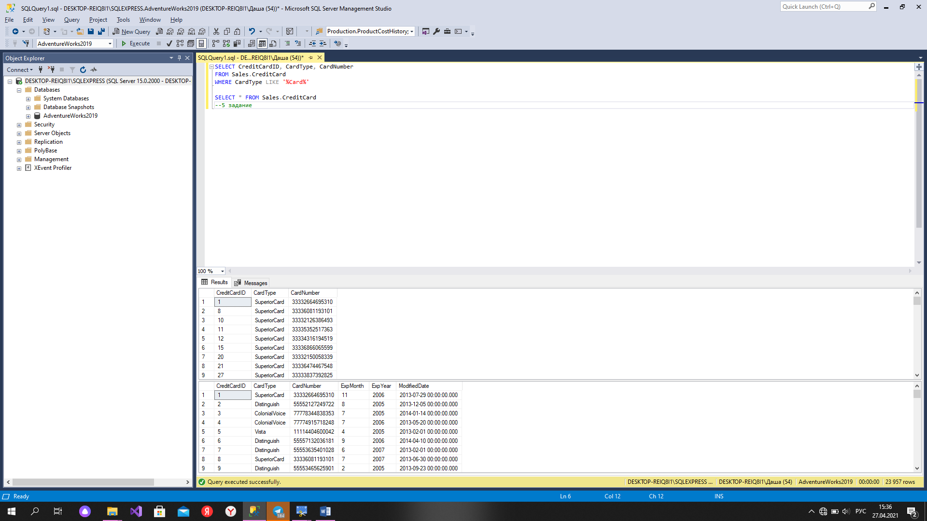

Рисунок 3 – запрос 5

1. SELECT \* FROM Production.ProductReview WHERE ProductID IN (798, 937)
2. SELECT FirstName, ISNULL (MiddleName, '---'), LastName, ISNULL (Suffix, 'NO') FROM Person.Person

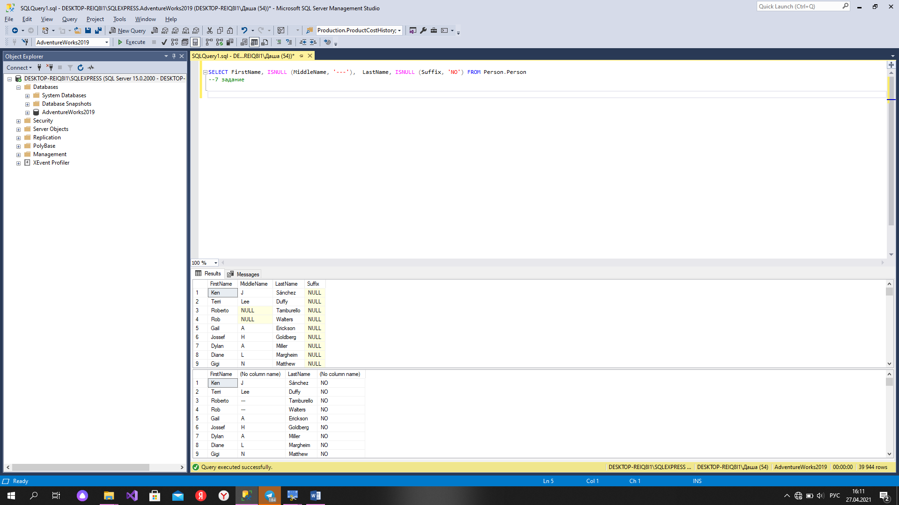

Рисунок 4 – запрос 7

1. SELECT ProductID,[Name] ,COALESCE(Color, CAST([Weight] AS VARCHAR(30)),'UNKNOWN') AS Meauserement FROM Production.Product

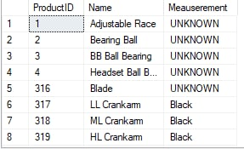

Рисунок 5 – запрос 8

1. SELECT TerritoryID, [Name], CountryRegionCode FROM Sales.SalesTerritory ORDER BY name

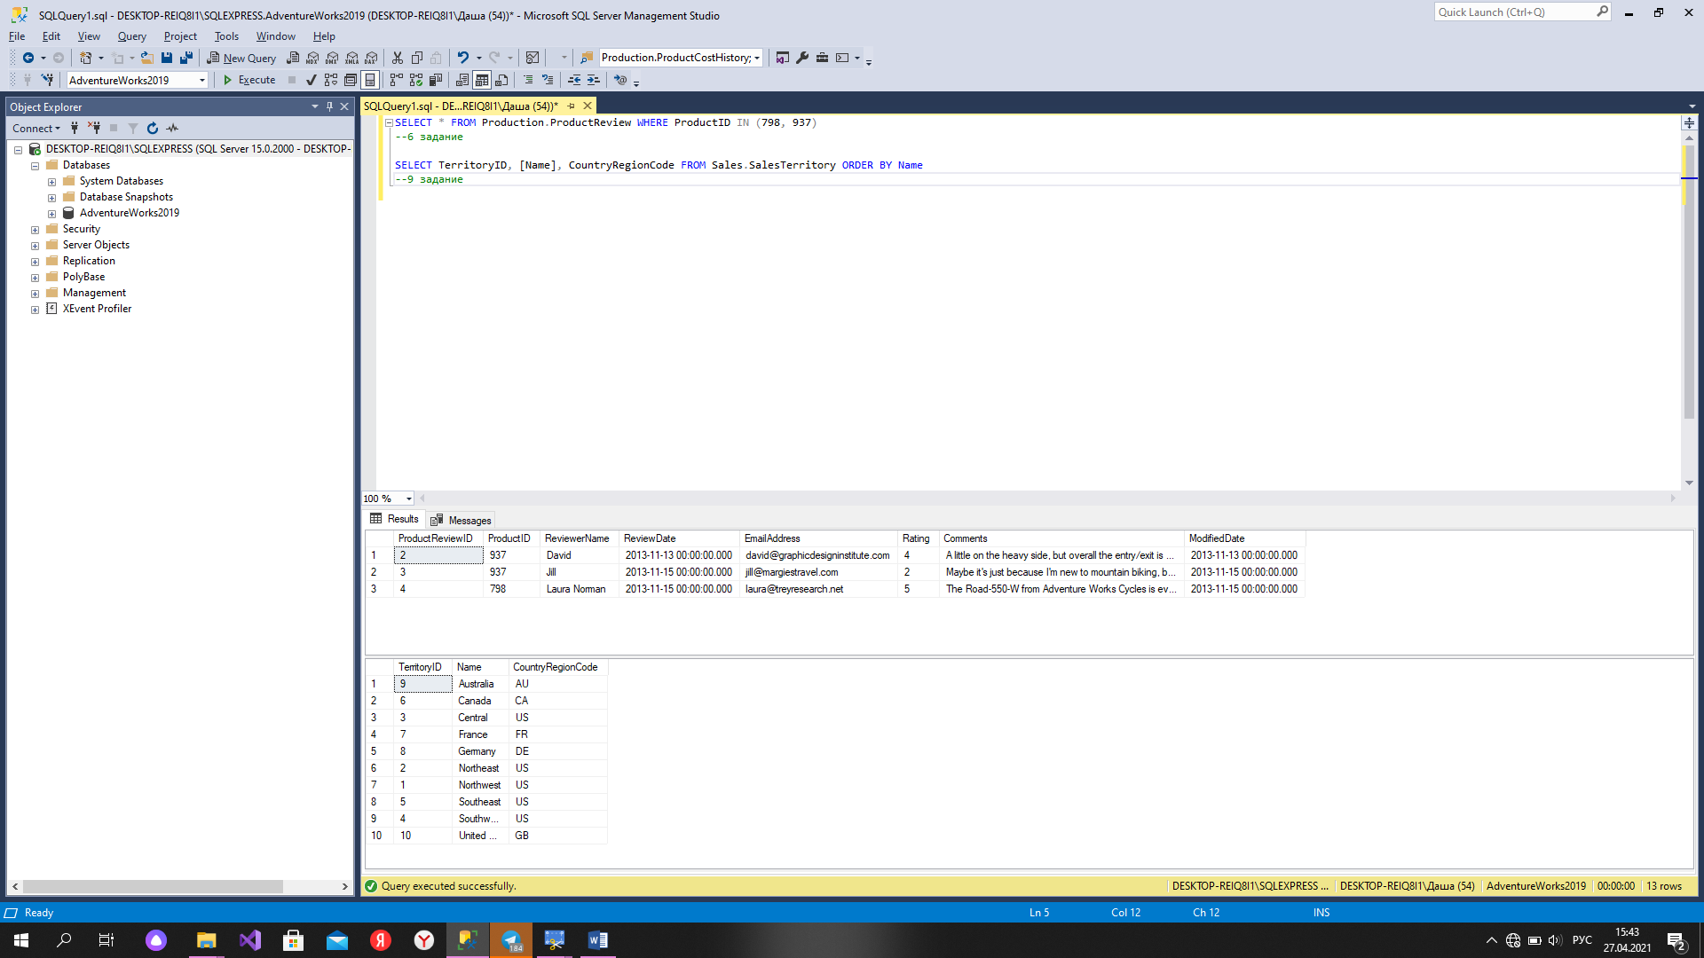

Рисунок 6 – запросы 6, 9

1. SELECT NULLIF (TaxType, 2) AS TaxType, TaxRate , [Name] FROM Sales.SalesTaxRate

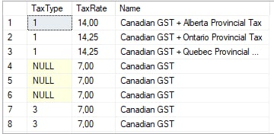

Рисунок 7 – запрос 10