1. SELECT MAX(ListPrice) AS MaxPrice FROM Production.Product;
2. SELECT MIN(Weight) AS MinWeight FROM Production.Product WHERE Weight IS NOT NULL;
3. SELECT Gender, AVG (DATEDIFF(YEAR, BirthDate, GETDATE()))  AS AvgOld FROM HumanResources.Employee WHERE Gender IS NOT NULL AND BirthDate IS NOT NULL GROUP BY Gender;
4. SELECT CountryRegionCode, COUNT(Name) AS Count FROM Person.StateProvince WHERE CountryRegionCode IS NOT NULL GROUP BY CountryRegionCode HAVING COUNT(Name) = 1;

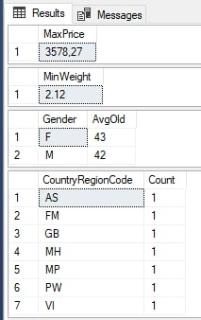

Рисунок 1 – запросы 1,2,3,4

1. SELECT BusinessEntityID, LastReceiptDate, AVG(StandardPrice) as AvgPrice FROM Purchasing.ProductVendor GROUP BY ROLLUP(BusinessEntityID, LastReceiptDate);

