# CPSC 427 Team05 Milestone Test Plans

**CPSC 427 Team05 Milestone Test Plans 1**

**Milestone 1 Test Plans 2**

Expected Behaviors 2

Test List 4

1. Player moves on A, D, space input 4

2. Player movement by gun recoil 4

3. Enemy detects Player in patrol area 4

4. Enemy follows Player in patrol area 4

5. Player Gun Reload 4

6. Player Collision with Enemy 4

7. Enemy Collision with Bullets 5

8. Player Collision with Walls 5

9. Player Collision with the Floor 5

**Milestone 2 Test Plans 6**

Expected Behaviors 6

M1 - Test List 9

Player recoil movement 9

M2 - Test List 9

Player walk 9

Player wall jump 9

Player health (invincibility frames) 10

Player outside level bounds 10

Weapon - auto-reload 10

Enemy AI - patrolling, player undetected 11

Enemy AI - patrolling, player detected but not seen 11

Enemy AI - attack by collision 11

Enemy AI - attack by shooting 12

Enemy AI - retreat 12

Enemy - death 13

**Milestone 3 Test Plans 14**

Expected Behaviors 14

M3 - Test List 16

Player - Air Spin 16

Weapon - Swap 16

Weapon - Grenade Launcher 16

Weapon - Grenade Launcher: Grenade 17

Weapon - Reload Signal 17

Enemy Flyer - Death 17

Enemy - type: BOID 17

Enemy - type: Boss 18

Particle System - Enemy Flyers 18

In game HUD - Player Health 19

Menu System - Main Menu 19

Menu System - Level Select 19

Menu System - Pause 19

# 

# Milestone 1 Test Plans

## Expected Behaviors

**Player Keyboard Inputs:**

* A: Moving to the left
* D: Moving to the right
* Space: Jump

**Player Mouse Inputs:**

* Move: Player’s weapon rotates along with the cursor
* Left Click: Shoot
* Right Click: Reload the weapon

**Player Behaviour:**

* Airborn state:
  + Player should fall due to gravity
* Collide state:
  + Player stands on the floor upon colliding
    - No friction, player slides on ground/wall after gun recoil movement
  + Player gets bounced out/blocked out of the wall upon colliding
  + Player dies instantly upon colliding with an enemy
* Death state:
  + Player’s death immediately triggers the world restart

**Weapon Behaviour:**

* Movement:
  + Player’s mouse act as a crosshair
  + Weapon rotates alongside with the crosshair angle
* Shoot:
  + Mag contains 5 bullets. When it’s empty, right click to reload
  + Bullet travels in a straight line according to where the gun was pointing at
* Reload:
  + Reload takes 2.5 seconds to finish
* Recoil Momentum:
  + Makes player travel to the opposite direction upon shooting
  + Bullet velocity should be relative to player’s speed
  + The level of the momentum is affected by player movement or the direction of the shot.
    - Momentum to the left slows down when the player presses D and moves to the right
    - Momentum to the left will be strengthened if the player shoots to the right

**Enemy Behaviour:**

* Patrol state: enemy constantly moves in its invisible patrol area along its fixed x-axis patrol line with random direction changes
  + If Player is in the patrol area and is located in the direction the enemy is facing, enemy switches to collide state
  + If bullet touches enemy, switch to death state
  + If enemy is near its patrol area boundary, it momentarily slows down before turning (implemented via linear interpolation)
* Collide state: enemy moves towards and follows player at same speed as player (moving along fixed patrol line) until in collision range to kill Player
  + If Player leaves its patrol area, switch to patrol state
  + If bullet touches enemy, switch to death state
  + No slowing down at patrol area boundary
* Death state: enemy instantly disappears after death

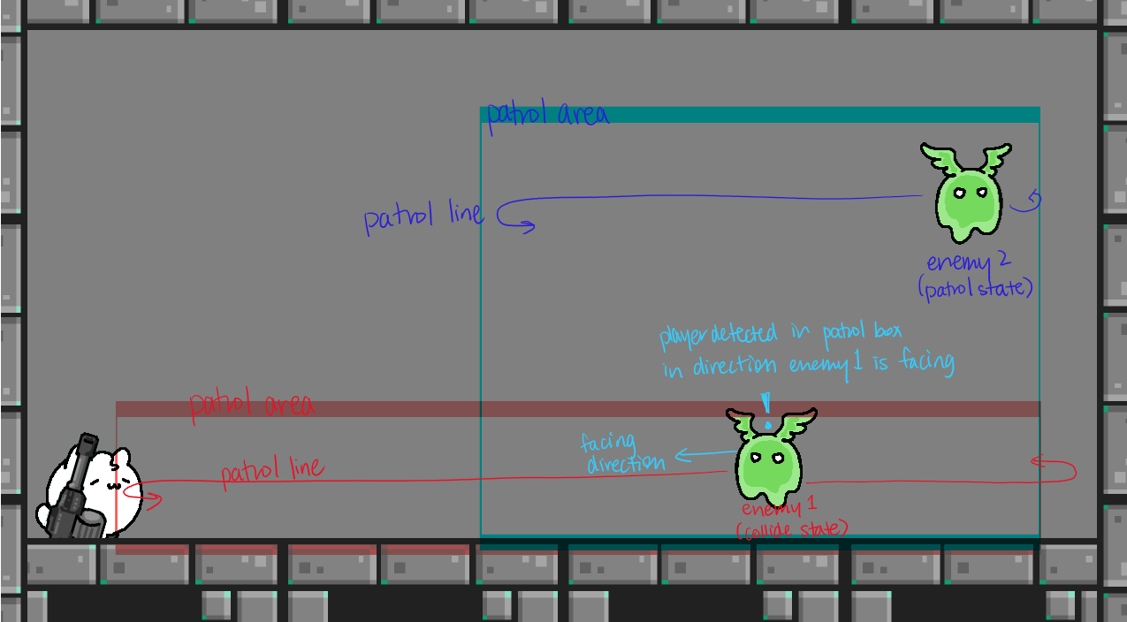

**Camera Behaviour:**

* The camera should always be focused/centered on player as they move
* Recoil is calculated accurately regardless of camera position

## 

## Test List

List of tests for key features of the game.

### Player moves on A, D, space input

1. Preconditions: game is loaded, player is alive
2. Steps:
   1. Press A, D to move left, right and space to jump
3. Expected Result:
   1. Pressing A and D changes constant velocity to right or left, respectively, and switches Player and gun direction to correspond to velocity.
   2. Pressing space allows one jump and preserves x-axis motion.

### Player movement by gun recoil

* 1. Preconditions: Gun has ammo
  2. Steps:
     1. Using the cursor, point the gun in the opposite direction that you want to go.
     2. Left click the mouse to fire the gun.
  3. Expected Result: Player is launched in the opposite direction of gunpoint when it was fired.

### Enemy detects Player in patrol area

1. Preconditions: Player is outside enemy patrol area
2. Steps:
   1. Player moves into enemy patrol area
   2. If enemy is not facing towards player, wait until it turns around
3. Expected Result: Enemy begins moving towards player

### Enemy follows Player in patrol area

* 1. Preconditions: Player in enemy patrol area
  2. Steps: Player dodges enemy and moves along x-axis within patrol area
  3. Expected results: Enemy’s direction of motion on patrol line moves to follow the Player. If Player is directly above or below Enemy (buffer of ½ Player’s width), enemy remains stationary.

### Player Gun Reload

* 1. Preconditions:Gun is missing at least one bullet from magazine
  2. Steps:
     1. Right click on mouse
  3. Expected results:
     1. Gun should be fully reloaded after 2.5 seconds has elapsed

### Player Collision with Enemy

* 1. Preconditions: Player is beside enemy
  2. Steps:
     1. Player moves towards enemy
     2. Player and Enemy collide
  3. Expected results:
     1. Player dies and game restarts immediately

### Enemy Collision with Bullets

1. Preconditions: Player is able to shoot gun, and at least one enemy is alive on screen
2. Steps:
   1. Player shoots at enemy
   2. Bullet collides with enemy
3. Expected results: Enemy instantly dies and disappears

### Player Collision with Walls

* 1. Preconditions: Player not colliding with walls
  2. Steps: Player walking towards the wall and triggers collision
  3. Expected results: Player should be stopped

### Player Collision with the Floor

* 1. Preconditions: Player is in the air
  2. Steps: Player falls due to gravity and eventually lands on the floor
  3. Expected results: Player should stand on the floor

# 

# Milestone 2 Test Plans

## Expected Behaviors

**Player Keyboard Inputs:**

* A: Moving to the left
* D: Moving to the right
* Space: Jump

**Player Mouse Inputs:**

* Move: Player’s weapon rotates along with the cursor
* Left Click: Shoot
* Right Click: Reload the weapon

**Player Behaviour:**

* Wall Jump:
  + Player is able to press space while colliding with wall for wall-jump to opposite direction
* Collision:
  + Mesh-based Collision: initial AABB collision detection using player bounding box, then check for mesh-box collision between player mesh and other entity’s bounding box
* Velocity:
  + Velocity is based on recoil.
  + In the air velocity is affected by air drag
  + On the ground player velocity is affected by friction
* Invincibility-frames:
  + When player receives health damage, their opacity flickers for 0.5s to indicate i-frames are activated
* Health:
  + Player starts with health = 3
  + Collision with enemy decreases health by 2
  + Collision with enemy slime bullet decreases health by 1

**Weapon Behaviour:**

* Reload:
  + Auto Reload now can be triggered at 0 ammo count.
  + Manual reload can still be triggered anytime no matter what ammo counted is currently at.
  + Reload takes ~2s with a reload sound being played
* Recoil:
  + Player moves in opposite direction of firing

**Animation Behaviour:**

* Player:
  + Idle: When the player is not moving + on the ground, the idle animation will play
  + Walk: When the player is on the ground and is moving, will transition from another animation state to walk animation.
  + Jump:When the player is in the air due to jumping (regular jump or wall jump), will transition from another animation state to jump animation.
* Weapon:
  + Shoot: When left clicking, the shoot animation will play once.
  + Empty Mag: Weapon animation stays at IDLE.
* Enemy:
  + Flying: Enemy entity’s flying (wings flapping) animation will continuously play.

**Enemy Behaviour:**

Behavior tree: designed to prioritize attacking player first, then preserve health if close to death

* Attack subtree (left subtree):

If player is in the patrol box and player is currently seen by enemy either:

* + If player has enough health to attack (currently set to health >= 2) enter attack sub-subtree
    - If player is in range to collide with, accelerate to player using lerp
    - Else enter attack-shoot sub-sub-subtree
      * Approach player and pace/hover at safe distance while shooting at player
  + Else enter retreat sub-sub tree (health == 1, one shot away from death)
    - Accelerate away from player using lerp
    - Stay at furthest point in patrol box and keep shooting at player
* Patrol subtree (right subtree):
  + Move (nop since movement handled by physics)
  + Every 2s, random chance to turn or not
  + Turn if at patrol box bounds

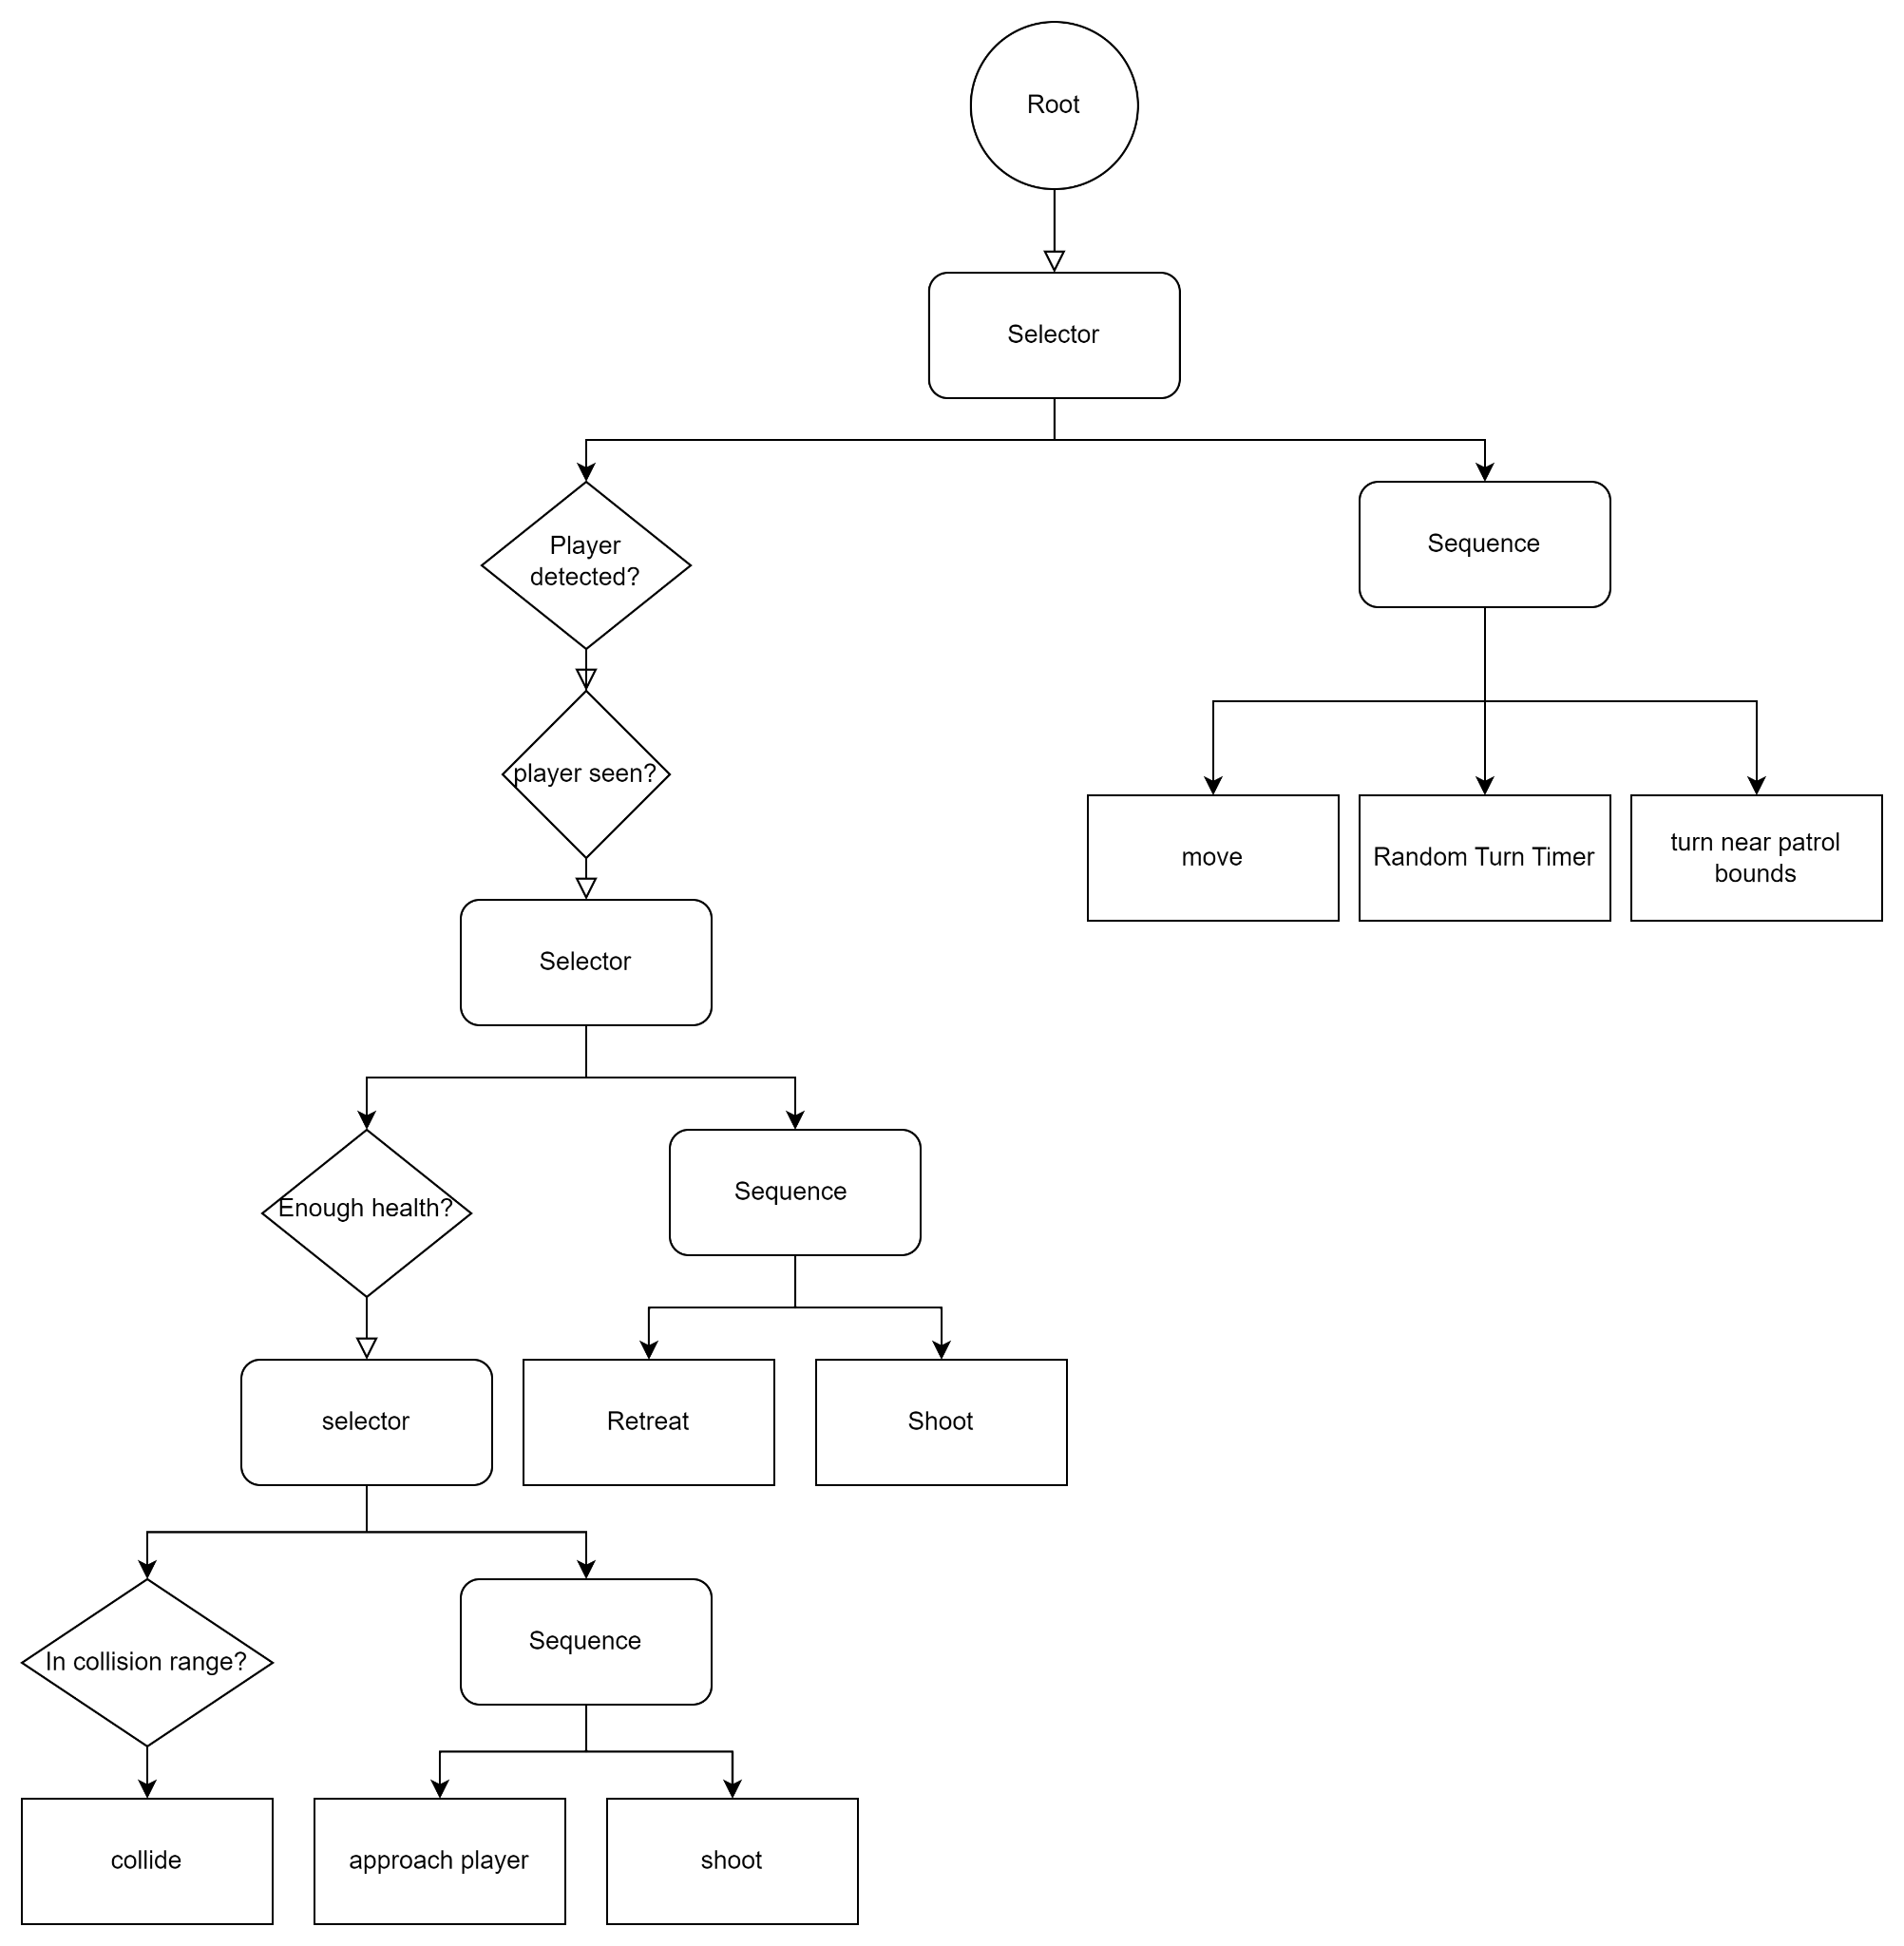

## 

## M1 - Test List

List of tests for key game features introduced in Milestone 1.

### Player recoil movement

**Objective:** Player is able to move using gun recoil

**Game State Preconditions:**

* Player is inside the play area at game start

**Steps:**

1. Player moves mouse to aim in opposite direction of intended movement
2. Left-click to shoot
3. Observe movement

**Expected Result:**

* Player’s velocity is added with gun recoil velocity

## M2 - Test List

List of tests for key game features introduced / updated in Milestone 2.

### Player walk

**Objective:** player should move according to what A and D buttons are pressed

**Game State Preconditions:**

* Player must be on the ground

**Steps:**

1. Press A or Press D
2. Observe player movement

**Expected Result:**

* Player should move left if A is pressed and should move right if D is pushed
* Player moves at constant speed
* Player animation changed from current animation state to WALKING

### Player wall jump

**Objective:** player should jump off the wall when they press space while colliding with a wall

**Game State Preconditions:**

* Player is alive

**Steps:**

1. Walk, jump or propel yourself to a wall
2. Once colliding with a wall press SPACE
3. Observe player jump

**Expected Result:**

* Player will jump away from the wall, with small y-velocity added
* Player animation changed from current animation state to JUMPING

### Player health (invincibility frames)

**Objective:** Any type of damage dealt to player, should cause the opacity of player’s sprite to flicker, indicating player is invincible during this window

**Game State Preconditions:**

* Player is alive and near an enemy

**Steps:**

1. Move player near enemy to trigger its attack
2. Get hit by multiple enemy bullets or collide with multiple enemies at the same time
3. Observe player i-frame flicker

**Expected Result:**

* Player’s opacity flickers for 0.5 seconds, and in the meantime, no damage can be dealt to the player during the invincibility window.
  + Player should not die even with multiple enemy bullets or enemy collisions while i-frame is activated

### Player outside level bounds

**Objective:** Killbox prevents the player from going outside the designated play area.

**Game State Preconditions:**

* Player is inside the play area at game start

**Steps:**

1. Player recoils themself back up the shoot where they dropped from at game start
2. Observe player death

**Expected Result:**

* Player dies immediately when they try to pass through the shoot

### Weapon - auto-reload

**Objective:** weapon should reload automatically if player is out of bullets

**Game State Preconditions:**

* Game start, player is alive with bullets

**Steps:**

1. Player left-clicks mouse until window bar shows 0 bullets left
2. Stop left-clicking, wait for reload (window bar shows “Ammo: 9/9”)
3. Left-click again to shoot

**Expected Result:**

* After all bullets are used in step 2 (window shows “Ammo: 0/9”), shooting animation stops, no bullets are shot, and no shooting sound
* Bullet reload sound plays, and after ~2s window bar shows bullets fully reloaded (“Ammo: 9/9”), and able to resume shooting as before
  + Known bug (#6): continuing to left-click shoot during reload can cause reload sound to be clipped out

### Enemy AI - patrolling, player undetected

**Objective:**

* Ensuring repeated random patrol behavior by enemy while player is not detected

**Game State Preconditions:**

* Player: is outside enemy patrol box, but near enough to have it in view
* Enemy: is not dead, spawned inside its patrol box, not inside a wall

**Steps:**

1. Press “L” to enable debug boxes
2. Keep player outside enemy’s patrol box
3. Observe enemy behavior

**Expected Result:**

* Enemy moves horizontally at set x-value at constant speed, and turns randomly every few seconds
* Enemy stays inside patrol box, and turn to move in other direction if it hits the bounds of its patrol box
* Should not have rapid turning jitter motion
* Enemy flying animation should flip with the switch in velocity direction during turns

### Enemy AI - patrolling, player detected but not seen

**Objective:** Ensure enemy does not react to player if player has not been seen - allows for player to sneak up to enemy

**Game State Preconditions:**

* Player: is outside enemy’s patrol box
* Enemy: is not dead, spawned inside its patrol box, not inside a wall

**Steps:**

1. Press “L” to view debug lines of enemy’s patrol box
2. Wait until enemy is facing away from player, and far away from its patrol box edge so that it can move for a couple seconds without needing to turn around at the edge
3. Move player into enemy’s patrol box, keeping position behind the enemy and wait

**Expected Result:**

* Unless the enemy turned around because of random patrol movement or due to being at patrol box edge, enemy should continue moving away from player
  + Chance for random turn during patrolling is every 2s, so enemy should not turn or shoot at player for at least 2 seconds

### Enemy AI - attack by collision

**Objective:** Check that enemy prioritizes to attack by colliding (doing more damage) with player if it is possible (i.e. player is within certain x and y range)

**Game State Preconditions:**

* Player: is outside enemy’s patrol box
* Enemy: is alive, has full health (has not been shot by player yet), is patrolling (not seen player yet), and is flying high above ground

**Steps:**

1. Press “L” to view debug lines of enemy’s patrol box
2. Find an enemy that is flying high enough that it cannot collide horizontally with player
3. When enemy is at furthest horizontal point from player, move player into the enemy’s patrol box, staying on the ground
4. Wait until enemy faces the player so that player is seen
5. Player jumps or uses recoil to be within 130px from enemy’s y-coordinate (approximately aligned on y-coordinate to collide with)
6. Stay aligned with enemy’s y-coordinate until within x-range for collision (~ 500px)
7. Observe enemy behavior

**Expected Result:**

* One within x-range of player and aligned with player on y-coordinate, enemy will begin to accelerate towards player
* Enemy should not be shooting at player once acceleration has begun
* If player leaves the x or y range of collision, enemy resumes patrol speed

### Enemy AI - attack by shooting

**Objective:** Check enemy chooses to attack by shooting if player was seen but out of reach to collide with

**Game State Preconditions:**

* Player: is outside enemy’s patrol box
* Enemy: is alive, has full health (has not been shot by player yet), is patrolling (not seen player yet), and is flying high above ground

**Steps:**

1. Press “L” to view debug lines of enemy’s patrol box
2. Find an enemy that is flying high enough that it cannot collide horizontally with player
3. Move player into collision box and wait for enemy to face the player so that player is seen
4. Observe enemy behavior while staying on ground in the patrol box and moving left/right to dodge enemy slime bullets

**Expected Result:**

* Once enemy sees player, it should approach player at constant patrol speed while firing slime bullets (every 2 seconds) at player’s location
* Enemy should keep a safe x-value distance away from player while it is pacing back and forth while shooting
* Enemy should be facing player while shooting
* When player moves far away, enemy should follow to maintain its safe x-value distance

### Enemy AI - retreat

**Objective:** Ensure enemy prioritizes its health if close to death by fleeing from player

**Game State Preconditions:**

* Player: is outside enemy’s patrol box
* Enemy: is alive, has full health (has not been shot by player yet), is patrolling (not seen player yet)

**Steps:**

1. Press “L” to view debug lines of enemy’s patrol box
2. Move player into enemy’s patrol box
3. Shoot enemy twice with bullet (enemy health should now be at 1)
4. Observe enemy behavior when it sees player (i.e. facing player that is in patrol box) when its health is at 1

**Expected Result:**

* As soon as enemy sees player (unless it was already facing player) while health is at 1, it should accelerate in opposite x-direction of player while facing the player
* Enemy should stay / move to furthest x-position from player, within its patrol box
* Enemy shoots at player every 2 seconds

### Enemy - death

**Objective:** Ensure enemy dies at 0 health

**Game State Preconditions:**

* Player: is outside enemy’s patrol box
* Enemy: is alive, has full health (has not been shot by player yet)

**Steps:**

1. Player shoots enemy three times with bullet (enemy health should now be at 0)
2. Observe enemy death

**Expected Result:**

* As soon as enemy is hit 3 times, it dies and disappears

### 

# Milestone 3 Test Plans

## Expected Behaviors

**Player Keyboard Inputs:**

* A: Moving to the left
* D: Moving to the right
* Space: Jump
* Shift in air: air spin/parry
* E: swap weapons in between Rifle and Grenade Launcher

**Player Mouse Inputs:**

* Move: Player’s weapon rotates along with the cursor
* Left Click: Shoot
* Right Click: Reload the weapon

**Player Behaviour:**

* Air Spin: Reflect enemy bullets and cat should spin

**Weapon Behaviour:**

* Weapon Types: Rifle and Grenade Launcher
* Swap: Swap between rifle and grenade launcher using ‘1’ and ‘2’ respectively
* Grenade Launcher: Fires a grenade
* Grenade Launcher - Grenade: Damages enemy and blasts player away from it
* Reload Signal: Displays while equipped weapon is reloading.

**Enemy Behaviour:**

* Flyer (from M2):
  + Use behavior tree implemented in M2
  + Movement only on fixed x-axis
* Boid:
  + Flying enemy type that can move in 2D
  + Flocking behavior of separation, alignment, and cohesion
  + Swarming behavior:
    - If player is detected, depending on boss and player health, boids will swarm boss or player
  + Shoots slime bullets at player
* Boss:
  + If player is in reach, boss will jump vertically up
  + Spawns boids every couple seconds
  + Higher health than boids/flyers (requires 5 shots from player)

**Animation Behaviour:**

* Player:
  + Spin: hold shift, player will spin once.
* Grenade Launcher:
  + Shoot: When left clicking, the shoot animation will play once.
  + Empty Mag: Weapon animation stays at IDLE.
* Grenade Launcher - Grenade:
  + Explosion: explosion animation plays once when grenade timer runs out
* Enemy:
  + Enemy Flyer Death: Enemy Flyer’s death animation will trigger after its health becomes 0, component will destroy after the animation is played once.
  + Enemy Boss Idle: Enemy boss’s idle animation will play continuously when the enemy boss is on ground or moving.
  + Enemy Boss Jump:Enemy boss’s jump animation will play once when the enemy boss is trying to attach the player.

**Particle System Behaviour:**

* Particles: When the enemy gets hit, 5 green square particles will spawn in a fan shape falling due to gravity, and will be cleaned up after 3 seconds.

**Level World Behaviour:**

* Exit trigger box: When Player reaches the end of a level, they will be transited to the next level automatically.
* Respawn point: Player will respawn at the start of the current level if dies.

**Camera Behaviour:**

* Smoothly zooming out: move the cursor to the corner of the window to see a smooth zoom out. Move back to center and zoom back.

**Menu System and HUD Behaviour:**

* Main Menu:
  + Press Enter key to proceed to Level Selection.
* Level Selection:
  + Left Click on buttons will bring the player to corresponding level (the actual game play state).
* GamePlay & HUD:
  + Player health icon now displaying at the top left corner of the screen.
* Pause:
  + Pressing the ESC key during gameplay will pause the game, press again to resume.

## M3 - Test List

List of tests for key game features introduced / updated in Milestone 3.

### Player - Air Spin

**Objective:** Upon pressing ‘shift’, the player should parry the enemy bullet

**Game State Preconditions:**

* Player is in the air (jumping or free falling)

**Steps:**

1. Press shift
2. Observe player animation

**Expected Result:**

* Player should parry the incoming enemy bullet if shift is pressed while in the air
* Player animation changed from current animation state to SPIN, and the animation only plays once.
* There will be a cool down timer to avoid constant deflections

### Weapon - Swap

**Objective:** Be able to swap to different weapons

**Game State Preconditions:**

* Player is alive

**Steps:**

1. Click ‘E’ to swap to the rifle
2. Click ‘E’ to swap to the grenade launcher

**Expected Result:**

* Player should be holding the weapon they selected based on the key pressed

### Weapon - Grenade Launcher

**Objective:** Fire a grenade using the grenade launcher

**Game State Preconditions:**

* Have the grenade launcher equipped

**Steps:**

* Click ‘E’ to equip the grenade launcher
* Aim in the direction you want to fire
* Click the left mouse button to fire

**Expected Result:**

* Grenade launcher should shoot a grenade in that direction

### Weapon - Grenade Launcher: Grenade

**Objective:** Grenade explodes, damages enemies and blasts player back

**Game State Preconditions:**

* Grenade should have been fired from grenade launcher

**Steps:**

1. Player blast back:
   1. Get close to a grenade
   2. Wait for it to explode
2. Damages enemies:
   1. Get a grenade close to an enemy
   2. Get it to explode near the enemy

**Expected Result:**

Player blast back:

* Player should blast away from the grenade
* The closer you are to the grenade the more you will be blasted back

Damages enemies:

* The closer the enemy is to the grenade the more damage they will take

### Weapon - Reload Signal

**Objective:** When ran out of ammo, there should be a marker indicating when the reload is not ready and when it’s done.

**Game State Preconditions:** player run out of ammos, or is manually reloading.

**Steps:**

1. Wait for the ammo to auto reload when it reaches 0, or right click to reload.

**Expected Result:**

A small bullet icon will appear on the player and rotate, indicating its reloading. When done, a text “reloaded” will appear on the player and disappear after 2 seconds.

### Enemy Flyer - Death

**Objective:** Trigger death animation when enemy dies at 0 health

**Game State Preconditions:**

* Player: is outside enemy’s patrol box
* Enemy: is alive, has full health (has not been shot by player yet)

**Steps:**

1. Player shoots enemy three times with bullet (enemy health should now be at 0)
2. Observe enemy death

**Expected Result:**

* As soon as the enemy is hit 3 times, it triggers the death animation. Once the animation is played, the enemy disappears

### Enemy - type: BOID

**Objective:** swarms the player and/or boss while maintaining flock behavior

**Game State Preconditions:**

* In level 3 - boss level
* Player is alive with full health (3 lives) and is outside boss/boid patrol box
* Boss is alive with full health (has never been shot by player yet - 5 lives left)
* At least 3 boids are existing

**Steps:**

1. Player is outside of patrol box, and observes boid flocking behavior
2. Player steps inside patrol box, and observes boid swarm behavior
3. Player successfully shoots boss 4 times (or at least until boss’s health < player health)
4. Observe shift in boid swarm behavior
5. Kill boss, but leave some boids alive to observe their behavior

**Expected Result:**

* In step 1: boids are moving around randomly in patrol box area, mostly sticking together in flocks
* In step 2: boids detect player, so 75% of boid begin swarming towards player while maintaining flocking behavior - they also maintain a safe distance from the player; other 25% are swarming near boss
* In step 3: boss health is low so 50% of boids stay with boss while 50% swarm player
* In step 4: all boids without boss swarm player

### Enemy - type: Boss

**Objective:** spawns new boids and attack player using vertical jump

**Game State Preconditions:**

* In level 3 - boss level
* Player is alive and is outside boss/boid patrol box
* Boss is alive

**Steps:**

1. Player steps into boss patrol box
2. Kill boids (keep number of boids below 10)
3. Player moves near above boss to trigger vertical jump

**Expected Result:**

* Once player is detected by boss, boss begins spawning boids (is number of existing boids < 10) every 2s
* When player is near and above the boss, boss will jump up to collide with player (boss jump has 3s cooldown period)

### Particle System - Enemy Flyers

**Objective:** Green particles should spawn when damage is dealt to the enemy, and particles will splashed out and disappear

**Game State Preconditions:** At least one enemy flyer in the scene, regardless of its health status.

**Steps:**

1. Player shoots at the enemy flyer

**Expected Result:**

Enemy Flyer will spawn 5 green square particles. Affected by gravity, particles will free fall and will not be affected by collision, eventually disappearing outside the game window.

### In game HUD - Player Health

**Objective:** Player should see their real time health container icons at the top left corner of the screen

**Game State Preconditions:** Player in game and has at least 1 health

**Steps:**

1. Player gets hit by enemy bullet, or collide with enemies
2. Observe the update in health UI

**Expected Result:**

When Player’s at health above 1 and damage is dealt, it will lose heart containers that correspond to the damage (1 or 2).When Player loses all health, player will respawn and the health containers will reset to 3.

### Menu System - Main Menu

**Objective:** When first running the game, a simple main menu will show up.

**Game State Preconditions:** Game not running

**Steps:**

1. Click on Build and Run in VS 2022
2. The game runs

**Expected Result:**

The player will see a main menu upon entering the game, pressing “Enter” will take them to the Level Select page. Pressing keys other than “Enter” will do nothing.

### Menu System - Level Select

**Objective:** Player can select from levels to enter the game play

**Game State Preconditions:** Player is at level select menu

**Steps:**

1. Click on the “Level 1” button

**Expected Result:**

The player will be taken to the level select menu upon pressing the enter key from the main menu. Pressing the button will take them to the corresponding level (currently only level1 is selectable from this menu). Pressing anywhere else outside the button will do nothing.

### Menu System - Pause

**Objective:** Player should pause and resume anytime during the gameplay

**Game State Preconditions:** Player is in game play state

**Steps:**

1. Press “Esc” key during gameplay or during pause state

**Expected Result:**

1. When the game is unpaused, pressing “Esc” will pause the game and the player will be taken to the pause menu.
2. When the game is paused, pressing “Esc” will resume the game and the player will be taken back to the gameplay.