Palanquin Auto:
Pre-Owned Vehicle Price Prediction Using Lasso Regression
Worrel Lee
Houston Christian University
BUSA 6321: Data Analytics: Cases and Insights
Dr. Richard “Chad” Kniffen
September 13, 2026

Palanquin Auto: Pre-Owned Vehicle Price Prediction Using Lasso Regression

Executive Summary
Palanquin Auto is a national pre-owned vehicle retailer seeking a more consistent, data-driven approach to estimating vehicle sales prices. A lasso-regularized linear regression model was developed using 21,647 vehicle records and 11 original predictor variables: Year, Manufacturer, Model, Condition, Cylinders, Fuel, Odometer, Drive, Type, Paint, and State. Half of the observations were reserved as an independent test set, while the other half were used for model training and validation.
Ten-fold cross-validation identified an optimal lasso penalty of λ = 35.99447. At this setting, the validation RMSE was $8,084.68. When the selected model was evaluated on the 10,824 previously unseen test observations, the test RMSE was $7,780.07. The test RMSE was approximately $304.61 lower than the validation RMSE, a difference of about 3.8%, indicating that predictive performance remained stable when the model was applied to unseen data.
Lasso also substantially reduced model complexity. Because categorical predictors were converted to dummy variables, the 11 original predictors expanded to 4,808 modeled predictor terms. Lasso shrank 3,033 terms, or 63.1%, to zero and retained 1,775 nonzero predictor terms. This result demonstrates the feature-selection role of lasso while preserving a broad set of signals needed to predict prices across a highly varied vehicle market.

Business Problem and Objective
The central business question is whether Palanquin Auto can use observable vehicle characteristics to produce reliable estimates of pre-owned vehicle prices. A useful pricing model should balance predictive accuracy with model simplicity. A model that is overly complex may fit the historical sample well but perform poorly on future vehicles, while a model that is too simple may ignore meaningful differences among vehicles.
The analysis therefore had three objectives: (a) determine the lasso regularization penalty that minimizes validation error, (b) evaluate the selected model on an independent test set, and (c) assess how strongly lasso reduced the number of active model terms by shrinking coefficients to zero.

Data Overview
The dataset contained 21,647 vehicle records and 14 raw columns. Vehicle was treated as an identifier rather than a predictor, and Transmission was not included in the Problem 29 predictor specification used for this analysis. The remaining variables included the outcome, Price, and 11 predictors. No missing values were found in any of the raw columns.
Data characteristic | Value
Total vehicle records | 21,647
Training/validation records | 10,823
Independent test records | 10,824
Original predictors used | 11
Missing values | 0
Mean vehicle price | $14,622.41
Median vehicle price | $10,000.00
Observed price range | $500 to $169,999
Manufacturers represented | 41
Vehicle models represented | 4,688
States represented | 51

The large number of unique vehicle models is especially important. Regression cannot use text labels such as a model name directly, so categorical variables are represented through dummy-variable terms. This transformation explains why 11 original business predictors expanded to thousands of modeled terms. The use of a sparse model matrix allowed those mostly-zero dummy-variable columns to be represented efficiently.

Methodology

Lasso Regression
Linear regression estimates how predictor variables are associated with a quantitative outcome. Each estimated coefficient, or B value, represents the contribution of a model term to the predicted outcome while the remaining modeled terms are held constant. Lasso regression extends ordinary linear regression by adding a penalty to the coefficient-estimation process. The penalty is controlled by lambda (λ): smaller penalties allow coefficients to remain relatively unrestricted, while larger penalties shrink coefficients more aggressively.
A defining feature of lasso is that some coefficients can be reduced exactly to zero. A zero coefficient means that the corresponding modeled term no longer contributes to the prediction. This makes lasso both a prediction method and an embedded feature-selection method.

Training, Validation, and Testing
The observations were randomly divided into two nearly equal groups using a fixed random seed for reproducibility. The training/validation set contained 10,823 observations, and the independent test set contained 10,824 observations. The test set was not used to choose the regularization penalty. Instead, 10-fold cross-validation was performed only on the training half of the data.
Cross-validation repeatedly fits the model on most of the training data and evaluates it on the held-out fold. This process allows candidate lambda values to be compared without using the final test data. Mean-squared error was used internally by cv.glmnet, and the square root of the minimum cross-validated MSE was taken to obtain RMSE in dollars. Lower RMSE indicates better predictive performance.

Results

Part A: Optimal Lasso Penalty
The cross-validation procedure selected λ = 35.99447 as the penalty associated with the lowest average validation error. The corresponding validation RMSE was $8,084.68. This value represents the root-mean-square prediction error observed during the model-selection process.
Model-selection measure | Result
Cross-validation method | 10-fold cross-validation
Selected lambda (λ) | 35.99447
Validation RMSE | $8,084.68
Selection rule | Minimum cross-validated error (lambda.min)

Figure 1
Cross-Validation Error Across Lasso Regularization Penalties
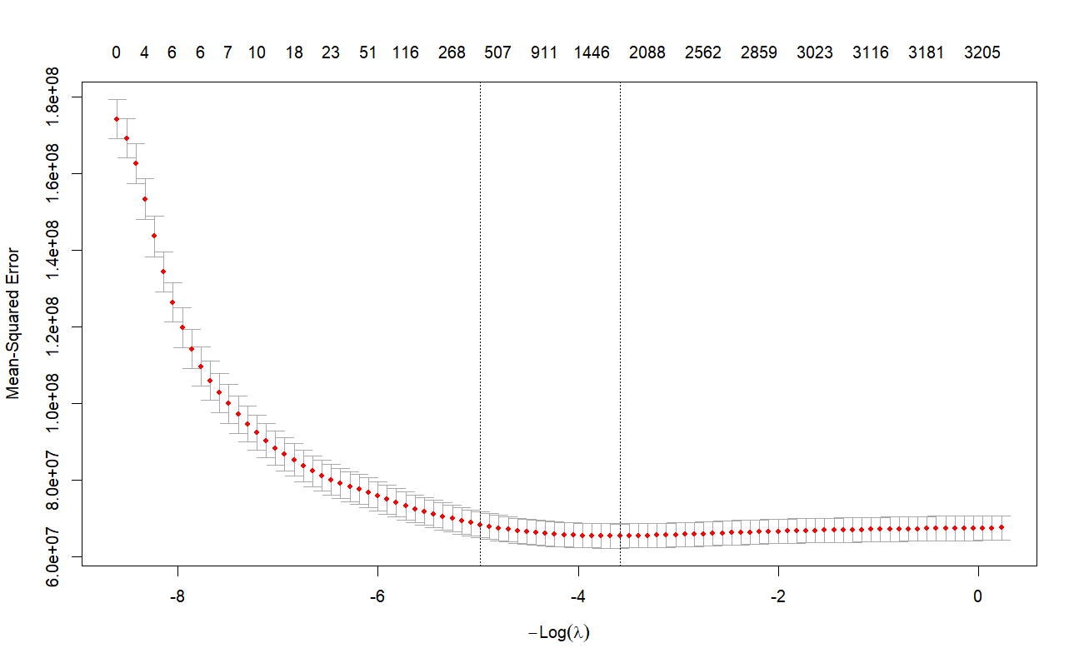
Note. Red points show mean cross-validated mean-squared error for candidate penalty values, with gray error bars showing uncertainty around those estimates. The right dashed vertical line corresponds to lambda.min, the penalty used for the final model. The left dashed line represents the more conservative one-standard-error alternative. Because the assignment asks for the penalty that minimizes prediction error, lambda.min was used.
The curve shows a substantial decline in prediction error as the penalty moves away from the most heavily regularized region, followed by a relatively flat minimum and then a gradual increase. This pattern indicates that there is a meaningful middle range of regularization: too much shrinkage discards useful signal, while too little regularization provides no further improvement in validation performance.

Part B: Independent Test-Set Performance
After lambda was selected, the model was applied to the independent test set. The test RMSE was $7,780.07. This was $304.61 lower than the validation RMSE, or approximately 3.8% lower. Because test performance was very similar to validation performance, there is no obvious evidence of severe overfitting in this split.
Evaluation sample | RMSE | Role in analysis
Cross-validation | $8,084.68 | Model selection
Independent test set | $7,780.07 | Final out-of-sample evaluation

RMSE should not be interpreted as the average absolute pricing error. Rather, it is a root-mean-square measure that gives greater weight to large misses. For management, the test RMSE is best viewed as a summary of the model’s predictive risk across a heterogeneous vehicle portfolio rather than as a guaranteed error band for every individual vehicle.

Part C: Coefficients and Feature Selection
The 11 original predictors expanded to 4,808 modeled predictor terms after categorical variables were represented by dummy variables. At the selected penalty, 3,033 predictor terms had B = 0 and 1,775 predictor terms had nonzero B values. The intercept is excluded from these predictor counts.
Feature-selection result | Count | Percent
Predictor terms removed (B = 0) | 3,033 | 63.1%
Predictor terms retained (B ≠ 0) | 1,775 | 36.9%
Total modeled predictor terms | 4,808 | 100.0%

The reduction is substantial: nearly two-thirds of the expanded predictor terms were set to zero. However, this should not be described as removing 3,033 original business variables. Many of the zero coefficients are individual dummy-variable levels created from Model, Manufacturer, State, Paint, and other categorical predictors. For example, a zero coefficient for one specific vehicle model means that particular dummy term was eliminated at the selected penalty; it does not automatically mean that the entire Model predictor was removed.

Managerial Interpretation
The analysis supports the use of lasso regression as a decision-support tool for pre-owned vehicle pricing. The model is able to incorporate a broad set of vehicle characteristics while automatically reducing the influence of many weak or redundant category-level terms. This is especially valuable in a dataset with 4,688 distinct model names, where a conventional unregularized model would be highly complex.
The close agreement between validation and test RMSE suggests that the selected model is not relying solely on quirks of the training sample. The out-of-sample RMSE of $7,780.07 nevertheless remains economically meaningful relative to many vehicle prices in the dataset. Therefore, the model should support, rather than fully replace, pricing judgment.
- Use the model as a consistent starting point for pricing rather than as an automatic final price.
- Flag vehicles with unusual characteristics or large expected uncertainty for additional human review.
- Monitor prediction error over time as the used-vehicle market changes and retrain the model when performance deteriorates.
- Retain market and operational context that is not captured in the current predictor set, such as local demand, vehicle history, trim/package details, and time-sensitive market conditions.
- Preserve the independent-test discipline when comparing future versions of the model so that reported performance remains credible.

Limitations
Several limitations should be considered when using the results. First, the model is predictive rather than causal; a coefficient does not establish that changing a vehicle characteristic would cause price to change. Second, categorical variables with thousands of levels create a very high-dimensional model, which makes coefficient-by-coefficient interpretation impractical for reporting. Third, the analysis is based on a single 50/50 test split, so the exact test RMSE may vary under a different random split even when the overall modeling procedure is sound.
Finally, the observed prices range from $500 to $169,999, indicating substantial heterogeneity. A single overall RMSE can hide differences in performance across low-price and high-price vehicles. Future analysis could examine error by price band, manufacturer, vehicle type, or age to determine where the model performs best and where additional modeling improvements are needed.

Recommendations
Palanquin Auto should treat the lasso model as a scalable benchmark for data-driven pricing and continue to validate it before operational deployment. The strongest next step would be to examine prediction errors by important vehicle segments and compare lasso with other predictive methods covered in the course, such as regression trees or other supervised-learning approaches. If a future model produces materially lower test RMSE while remaining stable across validation samples, it would provide evidence for replacing or supplementing the current lasso benchmark.

Conclusion
The lasso-regularized regression model successfully addressed the three objectives of the Palanquin Auto analysis. Ten-fold cross-validation selected λ = 35.99447, with a validation RMSE of $8,084.68. The selected model achieved a test RMSE of $7,780.07 on 10,824 unseen vehicles, indicating stable out-of-sample performance relative to validation. Lasso also reduced model complexity by shrinking 3,033 of 4,808 predictor terms to zero, a 63.1% reduction in active terms.
For management, the model provides a disciplined and reproducible pricing benchmark that can combine thousands of category-level signals without requiring all of them to remain active. Its prediction error is still large enough that professional judgment and additional market information should remain part of final pricing decisions.

Appendix A: R Code for Lasso Regression Analysis
# Load Packages

library(pacman)
pacman::p_load(tidyverse, glmnet, Matrix, rio)

# Load Data

palanquin <- import("palanquin-3.csv")
glimpse(palanquin)

# Check for Missing Values

colSums(is.na(palanquin))

# Convert Categorical Variables to Factors

palanquin <- palanquin |>
mutate(
Manufacturer = as.factor(Manufacturer),
Model = as.factor(Model),
Condition = as.factor(Condition),
Fuel = as.factor(Fuel),
Drive = as.factor(Drive),
Type = as.factor(Type),
Paint = as.factor(Paint),
State = as.factor(State)
)

# Set Price as the Outcome Variable

Y <- palanquin$Price

# Specify the Predictors

car_formula <- ~ Year +
Manufacturer +
Model +
Condition +
Cylinders +
Fuel +
Odometer +
Drive +
Type +
Paint +
State

# Convert Predictors into a Matrix That glmnet Can Use

X <- Matrix::sparse.model.matrix(
car_formula,
data = palanquin
)[, -1]

# Split the Data 50/50 for Training and Testing

set.seed(6321)

train_rows <- sample(
1:nrow(palanquin),
size = floor(0.50 * nrow(palanquin))
)

X_train <- X[train_rows, ]
X_test <- X[-train_rows, ]

Y_train <- Y[train_rows]
Y_test <- Y[-train_rows]

# Check the Size of Both Groups

length(Y_train)
length(Y_test)

# A. Select the Lasso Penalty Using Cross-Validation

# Run 10-fold cross-validation to find the best lasso penalty

lasso_cv <- cv.glmnet(
x = X_train,
y = Y_train,
alpha = 1,
nfolds = 10,
type.measure = "mse",
standardize = TRUE
)

# Visualize the Cross-Validation Results

plot(lasso_cv)

# Retrieve the Lambda with the Lowest Validation Error

best_lambda <- lasso_cv$lambda.min
best_lambda

# Calculate the Validation RMSE for the Best Lambda

best_index <- which.min(lasso_cv$cvm)

validation_rmse <- sqrt(
lasso_cv$cvm[best_index]
)

validation_rmse

# The best lambda is the one that produces the lowest validation RMSE.

# B. Evaluate the Selected Model on the Test Data

# Use the best lasso model to predict prices in the test set

test_predictions <- predict(
lasso_cv,
newx = X_test,
s = best_lambda
)

# Calculate RMSE on the Test Data

test_rmse <- sqrt(
mean(
(Y_test - test_predictions)^2
)
)

test_rmse

# This shows how well the selected lasso model performs on unseen data.

# C. Examine the Lasso Coefficients

# Retrieve the coefficients from the best lasso model

lasso_coefficients <- coef(
lasso_cv,
s = best_lambda
)

# Convert the Coefficients into a Readable Table

coefficient_table <- data.frame(
Variable = rownames(lasso_coefficients),
B = as.numeric(lasso_coefficients)
)

View(coefficient_table)

# Identify Terms Removed by Lasso

removed_terms <- coefficient_table |>
filter(B == 0)

View(removed_terms)

# Identify Terms Retained by Lasso

kept_terms <- coefficient_table |>
filter(B != 0)

View(kept_terms)

# Count the Removed and Retained Terms

nrow(removed_terms)
nrow(kept_terms)

