Consumer Research, Inc.:
Predicting Annual Credit Card Charges
Worrel Lee
Houston Christian University
BUSA 6321: Data Analytics: Cases and Insights
Dr. Richard “Chad” Kniffen
September 13, 2026

Consumer Research, Inc.: Predicting Annual Credit Card Charges

Executive Summary
Consumer Research, Inc. examined whether annual income and household size can be used to predict annual credit card charges. The sample contains 50 consumers. Average annual income was $43,480, average household size was 3.42 persons, and average annual credit card charges were $3,964.06.
The analysis shows that both annual income and household size are positively associated with annual credit card charges. When evaluated separately, household size was the stronger predictor, explaining approximately 56.7% of the variation in annual charges compared with 39.8% for income. When both variables were included in the same multiple regression model, explanatory power increased substantially: the model explained 82.6% of the variation in annual credit card charges, with an adjusted R-squared of 81.8%.
For a three-person household earning $40,000 annually, the multiple regression model predicts annual credit card charges of approximately $3,699.11. Overall, the results indicate that credit card spending is better understood by considering both financial resources and household demands together rather than relying on either characteristic alone.

Purpose and Methodology
The purpose of this analysis is to identify consumer characteristics that may help predict annual credit card charges. The case provides three quantitative variables: annual income measured in thousands of dollars, household size, and annual amount charged. The analysis follows the five requirements of the managerial report: descriptive statistics, two simple linear regressions, one multiple linear regression, a point prediction, and a discussion of additional variables that may improve prediction.

Descriptive Statistical Summary
Descriptive statistics were first used to establish the central tendency, spread, and range of the three variables. Because income is recorded in thousands of dollars in the source data, the values shown in Table 1 are expressed in actual dollars for readability.
Table 1
Descriptive Statistics for the Consumer Sample
Variable | M | Mdn | Minimum | Maximum | SD
Annual income | $43,480 | $42,000 | $21,000 | $67,000 | $14,550.74
Household size | 3.42 | 3.00 | 1 | 7 | 1.74
Annual amount charged | $3,964.06 | $4,090 | $1,864 | $5,678 | $933.49
Note. N = 50. Income was recorded in thousands of dollars in the source dataset and is displayed here in actual dollars.

Annual income ranges from $21,000 to $67,000, indicating that the sample includes consumers across a fairly broad income range. The mean income of $43,480 is close to the median of $42,000, suggesting that the center of the distribution is not being driven by a small number of extremely high or low observations.
Household sizes range from one to seven people, with a mean of 3.42 and a median of three. Annual credit card charges range from $1,864 to $5,678. The mean charge of $3,964.06 and median of $4,090 are also reasonably close. The standard deviation of annual charges is $933.49, showing meaningful dispersion in spending across consumers. This variation provides a useful basis for investigating whether income and household size explain differences in annual charges.

Simple Linear Regression Models

Income as the Independent Variable
The first simple linear regression model uses annual income to predict annual credit card charges. The estimated regression equation is:
Predicted Charge = 2,204.00 + 40.48(Income)
Income is measured in thousands of dollars. Therefore, the slope of 40.48 means that each additional $1,000 of annual income is associated with an estimated $40.48 increase in annual credit card charges.
Table 2
Regression Coefficients for the Income-Only Model
Term | B | SE | t | p
Intercept | 2,204.00 | 329.05 | 6.70 | 2.14e-08
Income | 40.48 | 7.18 | 5.63 | 9.01e-07
Note. Dependent variable = annual amount charged. Income is measured in thousands of dollars.

The income coefficient is statistically significant, p < .001, indicating strong evidence of a positive relationship between income and annual charges in this sample. The model has an R-squared of .398 and an adjusted R-squared of .386. Thus, annual income by itself explains approximately 39.8% of the observed variation in annual credit card charges. The residual standard error is approximately $731.71.
Figure 1
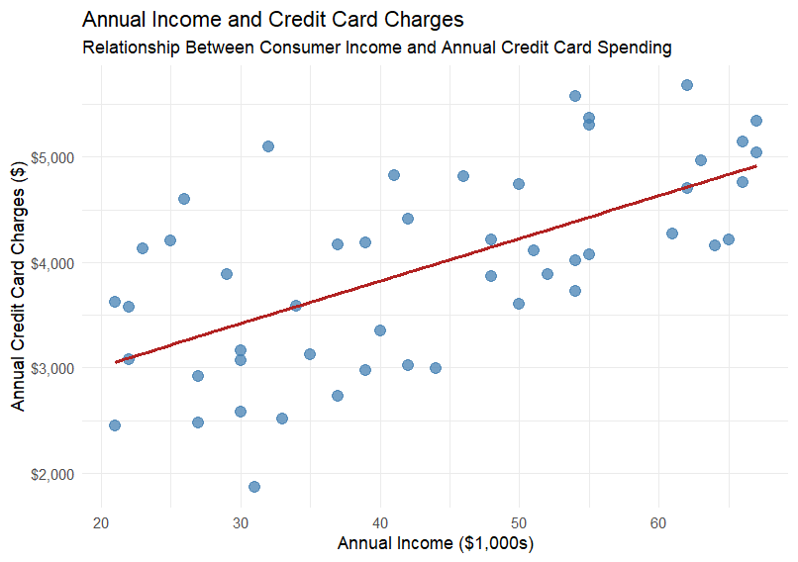

Household Size as the Independent Variable
The second simple linear regression model uses household size to predict annual credit card charges. The estimated regression equation is:
Predicted Charge = 2,581.94 + 404.13(Household Size)
The slope indicates that each additional person in the household is associated with approximately $404.13 in additional annual credit card charges.
Table 3
Regression Coefficients for the Household-Size Model
Term | B | SE | t | p
Intercept | 2,581.94 | 195.26 | 13.22 | < 2e-16
Household size | 404.13 | 51.00 | 7.92 | 2.86e-10
Note. Dependent variable = annual amount charged.

Household size is also statistically significant, p < .001. This model has an R-squared of .567 and an adjusted R-squared of .558, meaning household size alone explains approximately 56.7% of the variation in annual charges. Its residual standard error is approximately $620.79, lower than the residual standard error for the income-only model.
Figure 2
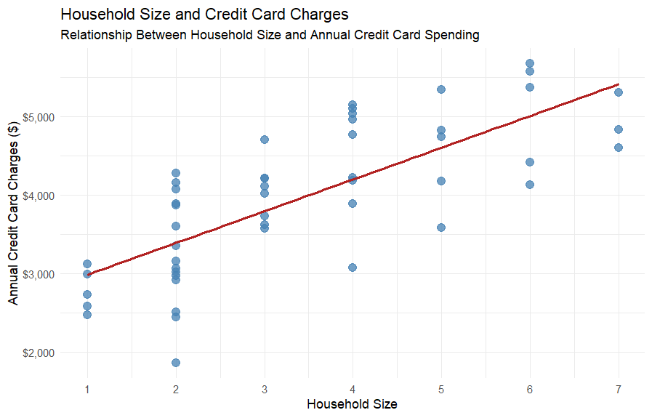

Comparison of the Simple Models
Table 4
Comparison of the Two Simple Regression Models
Model | R² | Adjusted R² | Residual SE
Income only | .398 | .386 | $731.71
Household size only | .567 | .558 | $620.79

Household size is the better single predictor of annual credit card charges. It explains 56.7% of the variation in charges, compared with 39.8% for annual income, and it produces a smaller residual standard error. The correlation between household size and annual charges is approximately .753, compared with approximately .631 between income and annual charges. Both relationships are positive, but household size has the stronger bivariate association with spending.

Multiple Linear Regression
A multiple linear regression model was estimated using annual income and household size simultaneously. This model evaluates the contribution of each predictor while holding the other predictor constant.
Predicted Charge = 1,304.90 + 33.13(Income) + 356.30(Household Size)
Table 5
Regression Coefficients for the Multiple Regression Model
Term | B | SE | t | p
Intercept | 1,304.90 | 197.65 | 6.60 | 3.29e-08
Income | 33.13 | 3.97 | 8.35 | 7.68e-11
Household size | 356.30 | 33.20 | 10.73 | 3.12e-14
Note. Dependent variable = annual amount charged. Income is measured in thousands of dollars.

Holding household size constant, each additional $1,000 of annual income is associated with an estimated $33.13 increase in annual credit card charges. Holding income constant, each additional household member is associated with an estimated $356.30 increase in annual charges. Both coefficients are statistically significant at p < .001, so each variable contributes useful information after accounting for the other.
The multiple model has an R-squared of .826 and an adjusted R-squared of .818. Accordingly, annual income and household size together explain approximately 82.6% of the variation in annual credit card charges. The overall model is statistically significant, F(2, 47) = 111.22, p < .001. The residual standard error falls to approximately $398.09, a substantial improvement over either simple regression model.
Table 6
Comparison of All Estimated Regression Models
Model | R² | Adjusted R² | Residual SE
Income only | .398 | .386 | $731.71
Household size only | .567 | .558 | $620.79
Income + household size | .826 | .818 | $398.09

The increase in explanatory power is substantial. Income and household size are only weakly correlated with one another, r = .173, so each contributes largely distinct information about credit card spending. This helps explain why the combined model performs considerably better than either predictor alone.

Predicted Annual Credit Card Charge
The case asks for the predicted annual credit card charge for a three-person household with an annual income of $40,000. Because income is recorded in thousands of dollars, the value entered into the model is 40.
Predicted Charge = 1,304.90 + 33.13(40) + 356.30(3)
Predicted Charge = $3,699.11
Therefore, the estimated annual credit card charge for a three-person household earning $40,000 per year is approximately $3,699.11. This is a point prediction produced by the fitted model and should be interpreted as the expected annual charge for a consumer with those characteristics rather than as a guaranteed amount for every such consumer.

Additional Independent Variables
Although the two-predictor model performs well, approximately 17.4% of the variation in annual credit card charges remains unexplained. Additional variables may capture differences in consumer behavior, access to credit, debt obligations, and spending needs that are not represented by income and household size alone.
Table 7
Potential Variables for an Expanded Predictive Model
Potential variable | Potential contribution
Credit limit and number of credit cards | Directly measure access to revolving credit and capacity to charge purchases.
Outstanding balances and debt obligations | May affect available credit and willingness or ability to make additional charges.
Credit score | May reflect creditworthiness and access to credit.
Age and life-cycle stage | Spending patterns may vary across stages of adulthood even at similar income levels.
Marital status and number of children | Could provide more detail about household financial responsibilities.
Housing status and housing costs | Rent or mortgage obligations may affect discretionary spending.
Occupation and employment stability | May capture income security not reflected by annual income alone.
Shopping frequency and card-use behavior | Behavioral measures may directly explain how often and why credit is used.

Future research should balance predictive improvement against data availability, collection cost, privacy, and the practical usefulness of added variables. An expanded model should also be evaluated for regression assumptions, influential observations, multicollinearity, and performance on observations not used to estimate the model.

Conclusion and Managerial Implications
The analysis provides evidence that annual income and household size are useful predictors of annual credit card charges. Household size is the stronger predictor when considered by itself, but the most effective model uses both variables together. The combined model explains 82.6% of the observed variation in annual charges, and both predictors remain statistically significant after controlling for the other.
From a managerial perspective, the findings suggest that consumer spending cannot be understood solely as a function of income. Household demands also matter substantially. A consumer with greater income may have more financial capacity to spend, while a larger household may create more opportunities and needs for purchases. Considering both dimensions together therefore produces a more useful profile of expected annual credit card activity.
Consumer Research, Inc. should use the two-variable model as the preferred model among those evaluated in this case, while recognizing that additional financial and behavioral variables could further improve predictive accuracy and managerial usefulness.

Appendix A: R Code for Consumer Credit-Card Charge Regression Analysis

# Load Packages
ibrary(readxl)
library(tidyverse)

# Load Data

consumer <- read_excel("consumer.xlsx")
consumer

# Standardize Column Names to Account for Carriage-Return Characters

names(consumer) <- c(
"Income",
"HouseholdSize",
"AmountCharged"
)

consumer

# Q1. Descriptive Statistics

# Summarize the data, including minimums, maximums, means,
# medians, and quartiles

summary(consumer)

# Calculate Standard Deviations

sd(consumer$Income)
sd(consumer$HouseholdSize)
sd(consumer$AmountCharged)

# Q2. Simple Linear Regression Using Income

# Use income to predict annual credit-card charges

income_model <- lm(
AmountCharged ~ Income,
data = consumer
)

summary(income_model)

# Approximately 39.8% of the variation in annual charges
# is explained by income.

# Create the Income Model Visualization

# The relationship appears linear, so a regression line is appropriate.

ggplot(
consumer,
aes(x = Income, y = AmountCharged)
) +
geom_point() +
geom_smooth(method = "lm", se = FALSE)

# Q2. Simple Linear Regression Using Household Size

# Use household size to predict annual credit-card charges

household_model <- lm(
AmountCharged ~ HouseholdSize,
data = consumer
)

summary(household_model)

# Approximately 56.7% of the variation in annual charges
# is explained by household size.
#
# Household size explains more variation in charges than income.

# Create the Household-Size Model Visualization

# The relationship also appears linear, so a regression line is appropriate.

ggplot(
consumer,
aes(x = HouseholdSize, y = AmountCharged)
) +
geom_point() +
geom_smooth(method = "lm", se = FALSE)

# Q3. Multiple Regression

multiple_model <- lm(
AmountCharged ~ Income + HouseholdSize,
data = consumer
)

summary(multiple_model)

# Income and household size together explain approximately 82.6%
# of the variation in annual credit-card charges.

# Q4. Predict Charges for a Hypothetical Consumer

# Create a hypothetical consumer with an income of $40,000
# and a three-person household.

new_customer <- data.frame(
Income = 40,
HouseholdSize = 3
)

# Generate the Predicted Annual Charges

predict(
multiple_model,
newdata = new_customer
)

# The predicted annual credit-card charges for this customer
# are approximately $3,699.11.

# Q5. Other Potential Predictors

# Many other factors could contribute to annual credit-card charges,
# including a person's age, number of credit cards, credit limits,
# homeownership status, number of children, monthly expenses,
# occupation, and location.
#
# Adding some of these factors could improve the model further.

