### **National Software Academy – Changing Default Laptop Language Settings to English (UK)**

Click on Cortana from the taskbar below, type **language** into the search box and select **Region & language settings** from the list of results that appears.

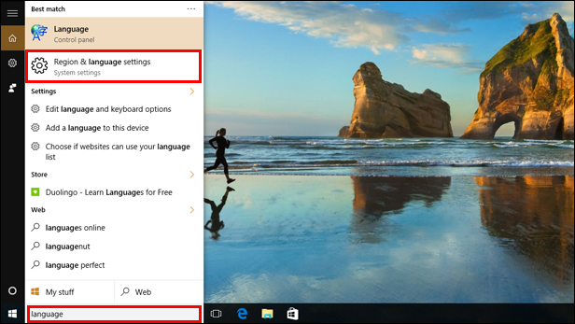

Select **United Kingdom** from the drop-down list under **Country or region**.

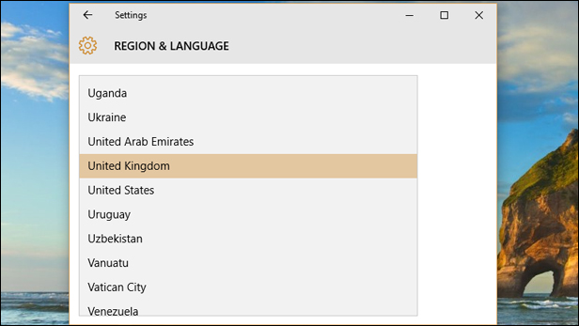

Next, if you don’t see **English (United Kingdom)** under the **Languages** section, click the **Add a language** button.

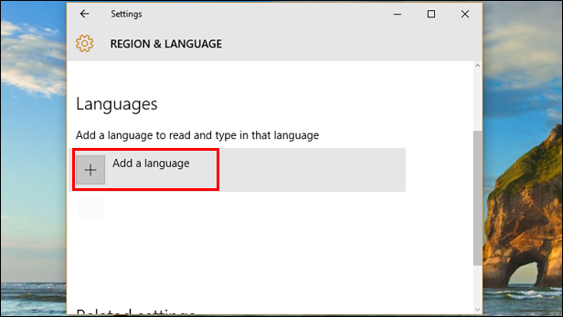

Scroll through the list of languages that appears to find **English**.

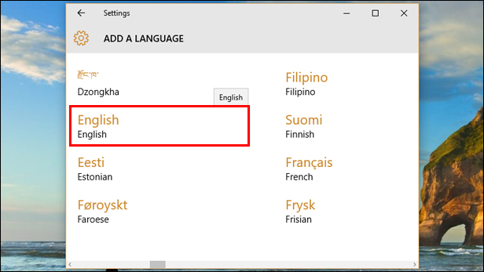

Select the **English (United Kingdom)** option that’s just been added under **Languages** and click the **Set as default** button. You can now select any unwanted languages in this section and click the **Remove** button.

