**Class notes for assessment**

HTML, CSS, Jinja, Templating, routes

Make sure all of the content is between the {{ jinja }} elements.

Use Float to position divs and then use width % or px to specify the width.

To inherit data use the {%extends ‘nameofthepage.html’%}

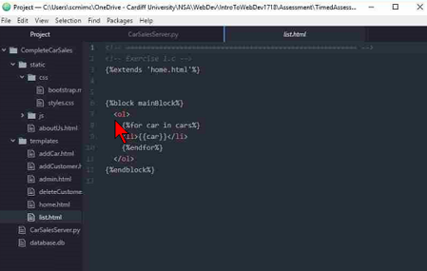

The route for it:

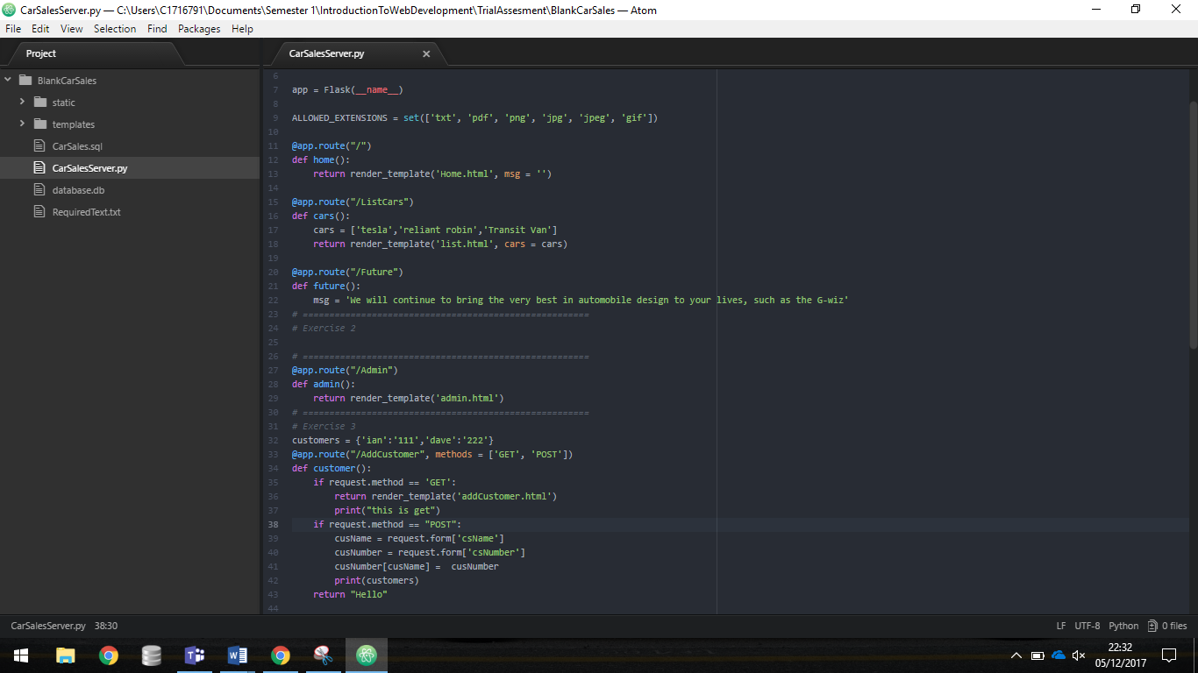

JavaScript

Using routes to call text into the html page.

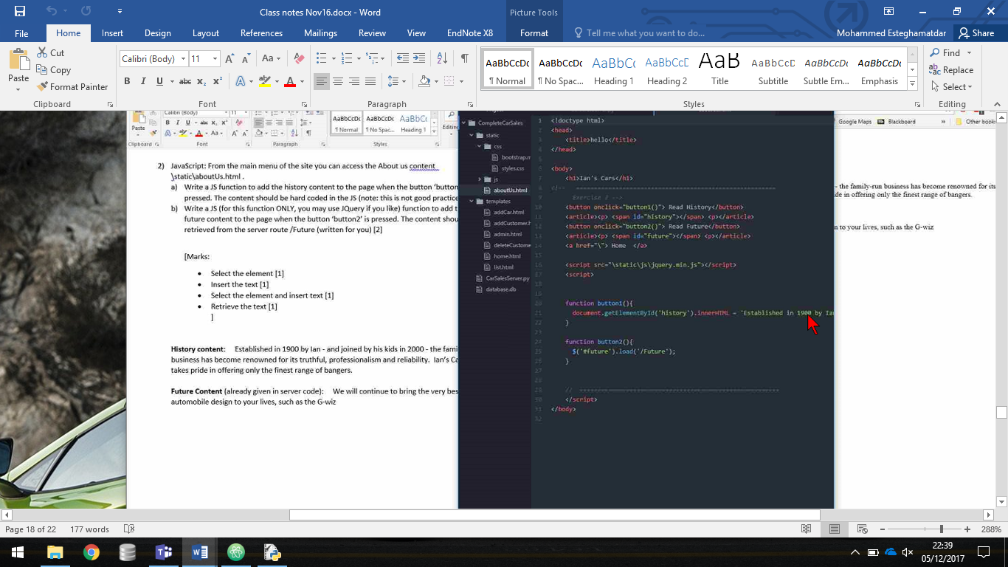

JavaScript, adding and removing from a dictionary.

Adding to a dictionary:

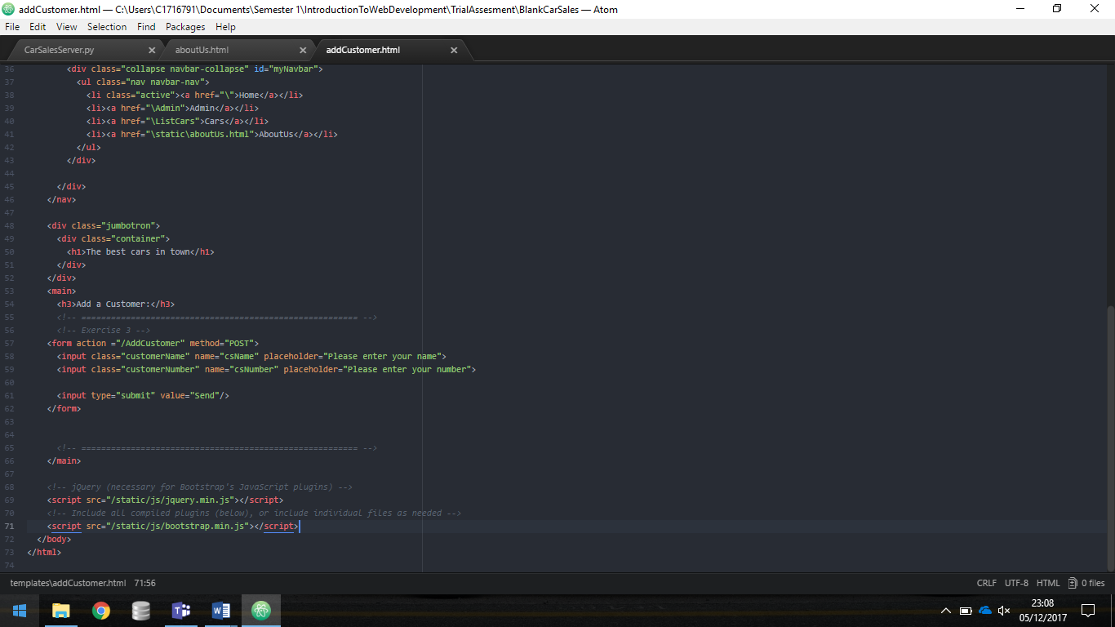

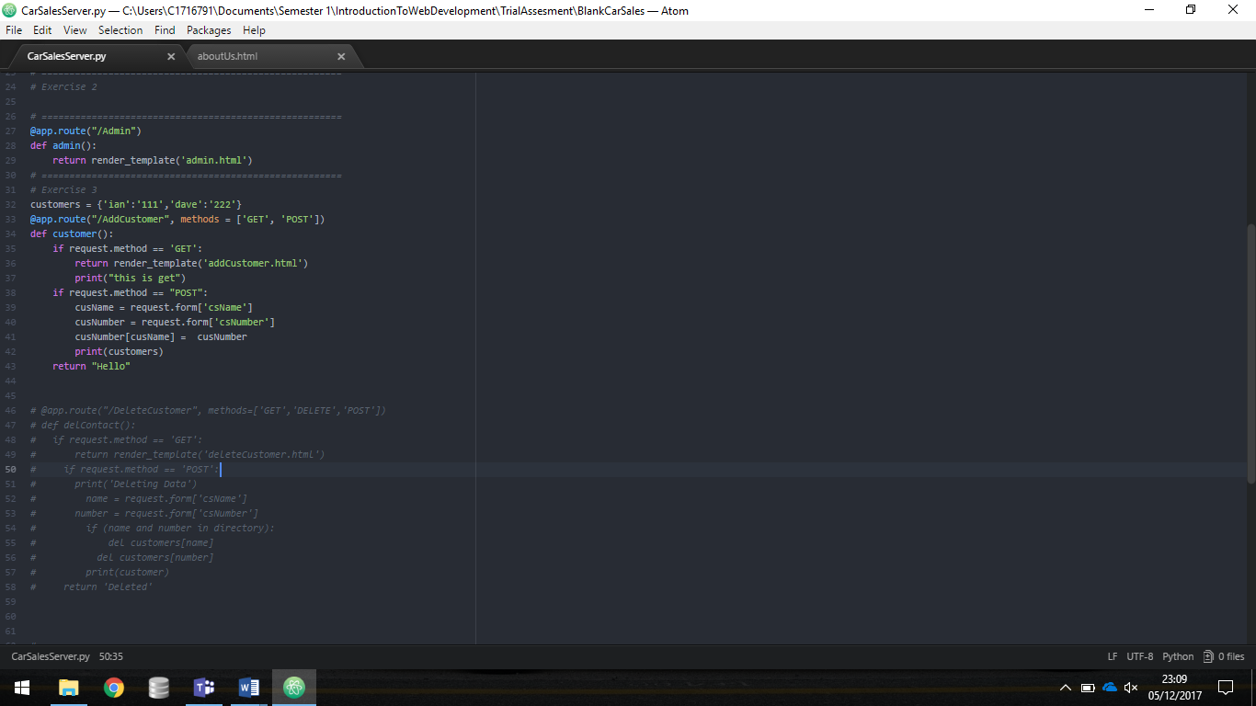

Removing from a dictionary:

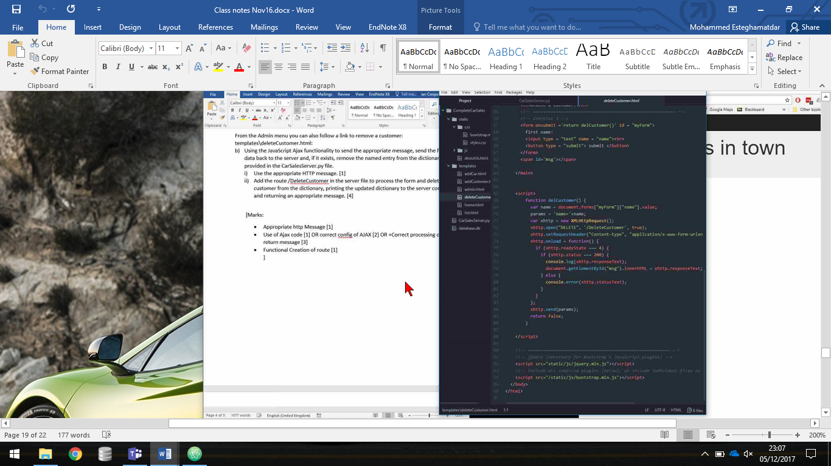

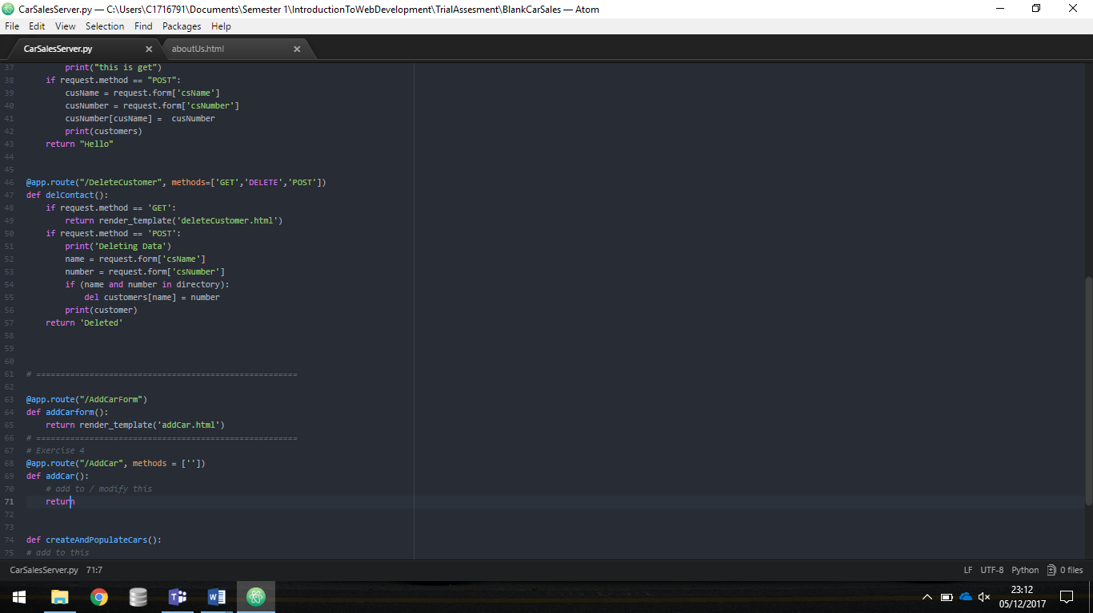

Databases, SQL, creating tables, passing data into a database.

