

**IDEAL INSTITUTE OF BUSINESS & SCIENCE- 6599**

House # 23/24, Avenue # 01, Block# A, Section # 11, Pallabi, Mirpur, Dhaka- 1216, Pallabi - 1216

**“CLASS ATTENDANCE MANAGEMENT SYSTEM”**

A project submitted towards for partial fulfillment of the requirements for the Degree of Bachelor of Science (B.Sc.) in Computer Science and Engineering.

**SOFTWARE LAB**

SYTEM ANALYSIS & DESIGN LAB

Department of Computer Science & Engineering

**SUBMITTED BY**

**TYPE YOUR NAME**

Reg. No. : XXX-XXX

Session : 2017-18

Ideal Institute Business & Science, Dhaka

**SUBMITTED TO**

**SAMSUL HAQUE**

Lecturer,

Department of Computer Science & Engineering

Ideal Institute Business & Science, Dhaka.

**CERTIFICATE**

This is to certify that this report embodies the original work done by **TYPE YOUR NAME** during this project submission as a lab report of System Analysis & Design Lab.

**……………………………………………….**

**SAMSUL HAQUE**

Lecturer,

Department of Computer Science & Engineering

Ideal Institute Business & Science, Dhaka.

**ABSTRACT**

Attendance Management System is software developed for daily student attendance in schools, colleges and institutes. If facilitates to access the attendance information of a particular student in a particular class. The information is sorted by the operators, which will be provided by the teacher for a particular class. This system will also help in evaluating attendance eligibility criteria of a student.

**ACKNOWLEDGEMENT**

The satisfaction that accompanies that the successful completion of any task would be incomplete without the mention of people whose ceaseless cooperation made it possible, whose constant guidance and encouragement crown all efforts with success.

We are grateful to our project guide SAMSUL HAQUE Sir for the guidance, inspiration and constructive suggestions that helpful us in the preparation of this project.

We also thank our colleagues who have helped in successful completion of the project.

**TABLE OF CONTENTS**

| **SL#** | **CHAPTER NAME** | **PAGE NO.** |
| --- | --- | --- |
| 1 | Introduction | 6 |
| 2 | Feasibility Study | 9 |
| 3 | Working Of Present System | 10 |
| 4 | Characteristics of The Proposed System | 11 |
| 5 | Data Tables | 12 |
| 6 | Data Flow Diagrams | 15 |
| 7 | Entity Relationship Diagram | 18 |
| 8 | Screen Shots Of Form | 20 |
| 9 | Conclusion | 27 |
| 10 | Bibliography | 28 |

INTRODUCTION

**Introduction:-**

Attendance Management System is software developed for daily student attendance in schools, colleges and institutes. If facilitates to access the attendance information of a particular student in a particular class. The information is sorted by the operators, which will be provided by the teacher for a particular class. This system will also help in evaluating attendance eligibility criteria of a student.

**Purpose:-**

The purpose of developing attendance management system is to computerized the tradition way of taking attendance. Another purpose for developing this software is to generate the report automatically at the end of the session or in the between of the session

**Scope:-**

The scope of the project is the system on which the software is installed, i.e. the project is developed as a desktop application, and it will work for a particular institute. But later on the project can be modified to operate it online.

**Technology Used:-**

Frontend:-HTML, CSS, JS, Bootstrap 4

Backend: - PHP

Database: - MySQL

**System Requirement:-**

Minimum RAM:-256 MB Hard Disk:-40 GB

Processor:-Intel Pentium 4 Operating System:-Windows 10 Pro

**Overview:-**

Attendance Management System basically has two main modules for proper functioning

* First module is admin which has right for creating space for new batch. Any entry of new faculty, Updating in subject if necessary, and sending notice.
* Second module is handled by the user which can be a faulty or an operator. User has a right of making daily attendance, generating report.

**Attendance can be taken in two ways:**

* On the basis of Subject and month.
* On the basis of Class.

FEASIBILITY STUDY

**Economically Feasibility:**

The system being developed is economic with respect to School or Collage’s point of view. It is cost effective in the sense that has eliminated the paper work completely.

The system is also time effective because the calculations are automated which are made at the end of the month or as per the user requirement.

The result obtained contains minimum errors and are highly accurate as the data is required.

**Technical feasibility:**

The technical requirement for the system is economic and it does not use any other additional Hardware and software.

**Behavioral Feasibility:**

The system working is quite easy to use and learn due to its simple but attractive interface. User requires no special training for operating the system.

**Working of Present System**

In the present system all work is done on paper. The whole session attendance is stored in register and at the end of the session the reports are generated. We are not interested in generating report in the middle of the session or as per the requirement because it takes more time in calculation. At the end of session the students who don’t have 75% attendance get a notice.

**DISADVANTAGES OF PRESENT WORKING SYSTEM**

* **Not User Friendly:** The existing system is not user friendly because the retrieval of data is very slow and data is not maintained efficiently.
* **Difficulty in report generating:** We require more calculations to generate the report so it is generated at the end of the session. And the students not get a single chance to improve their attendance.
* **Manual control:** All calculations to generate report are done manually so there is greater chance of errors.
* **Lots of paperwork:** Existing system requires lot of paper work. Loss of even a single register/record led to difficult situation because all the papers are needed to generate the reports.
* **Time consuming:** Every work is done manually so we cannot generate report in the middle of the session or as per the requirement because it is very time consuming.

**CHAREACTERSTIC OF THE PROPOSEDSYSTEM**

* **User Friendly:** The proposed system is user friendly because the retrieval and storing of data is fast and data is maintained efficiently. Moreover the graphical user interface is provided in the proposed system, which provides user to deal with the system very easily.
* **Reports are easily generated:** Reports can be easily generated in the proposed system so user can generate the report as per the requirement (monthly) or in the middle of the session. User can give the notice to the students so he/she become regular.
* **Very less paper work:** The proposed system requires very less paper work. All the data is feted into the computer immediately and reports can be generated through computers. Moreover works become very easy because there is no need to keep data on papers.
* **Computer operator control:** Computer operator control will be there so no chance of errors. Moreover storing and retrieving of information is easy. So work can be done speedily and in time.

DATA TABLES

##### **Admin Table:**

|  |  |  |  |
| --- | --- | --- | --- |
| S.No. | Field name | Data Type | Description |
| 1. | User name | Text | Store user name for checking correct username |
| 2. | Password | Text | Store password corresponding to username |
| 3. | User Type | Text | User Type Administrator or User |

**Faculty Members Table:**

|  |  |  |  |
| --- | --- | --- | --- |
| S.No. | Field name | Data Type | Description |
| 1. | Teacher Id | Number | Unique key for Every Teacher |
| 2. | Teacher Name | Text | Name of Teacher |
| 3. | Teacher Email | Text | Email of Teacher |
| 2. | Teacher Contact Number | Text | Mobile Number of Teacher |

##### **Attendance Table:**

|  |  |  |  |
| --- | --- | --- | --- |
| S.No. | Field name | Data  Type | Description |
| 1. | Student Name | Text | Name of Student |
| 2. | Status | Number | Total number classes attended by particular Student |
| 3. | Semester | Text | In which Semester Student is Studying |
| 4. | Subject | Text | The Subject Wise Attendance Is maintained |

**Subject Table:**

|  |  |  |  |
| --- | --- | --- | --- |
| S.No. | Field name | Data Type | Description |
| 1. | Code | Number | Subject code a unique key |
| 2. | Subject Name | Text | Name of Subjects in all semester |
| 3. | Semester | Text | In which Semester student is studying |
| 4. | Faculty | Text | In which Subject Teacher is teaching |

##### **Student Table:**

|  |  |  |  |
| --- | --- | --- | --- |
| S.No. | Field name | Data Type | Description |
| 1. | Student ID | Number | This is the roll no of the student |
| 2. | Student Name | Text | This is the name of student |
| 3. | Course | Text | This is the course in which the students are studying .By default course is MCA |
| 4. | Semester | Text | This is the semester in which Students are Studying. |

DATA FLOW DIAGRAM

**0-LEVEL DFD**

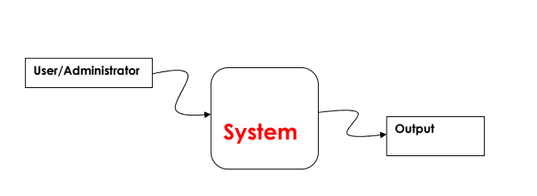

**1-LEVEL DFD**

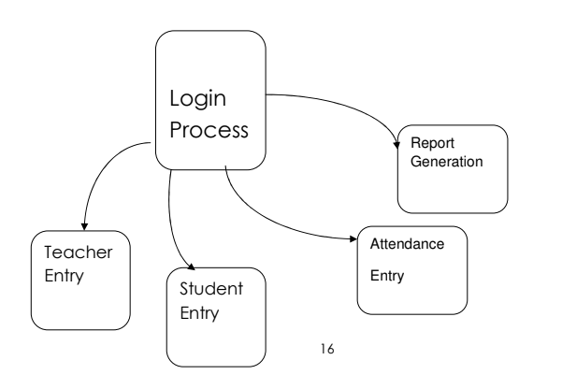

**2-LEVEL DFD**

**2.1**

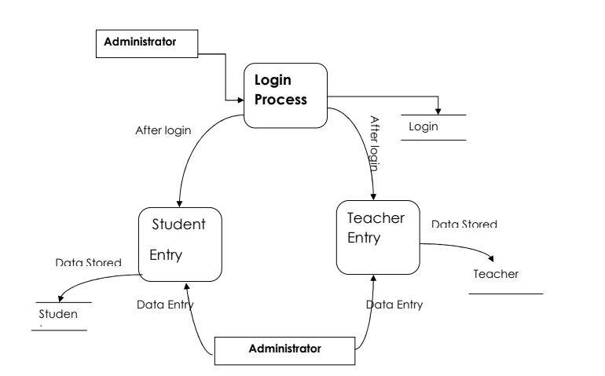

**2.2**

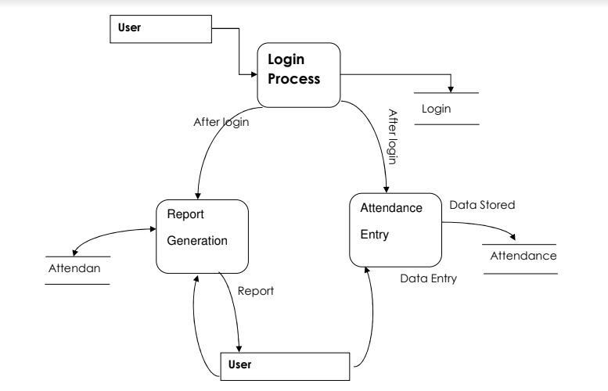

ER-DIAGRAM

**ENTITY RELATIONSHIP DIAGRAM:**

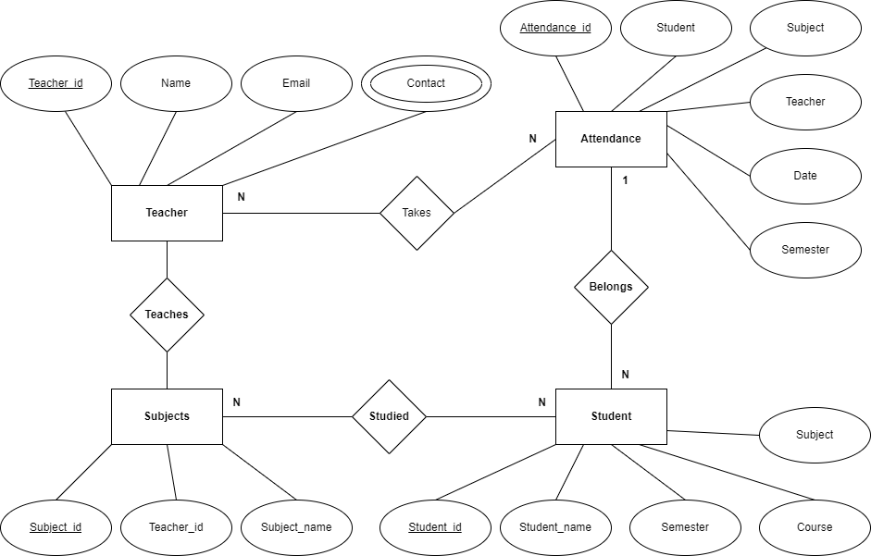

SCREENSHOTS

##### **LOGIN PAGE:**

This login Form is made For Security purpose. So only authenticated User only Access in to the Project. There are two type of persons can enter in the project

* Admin
* User/ Teacher

**FECULTY MEMBERS:**

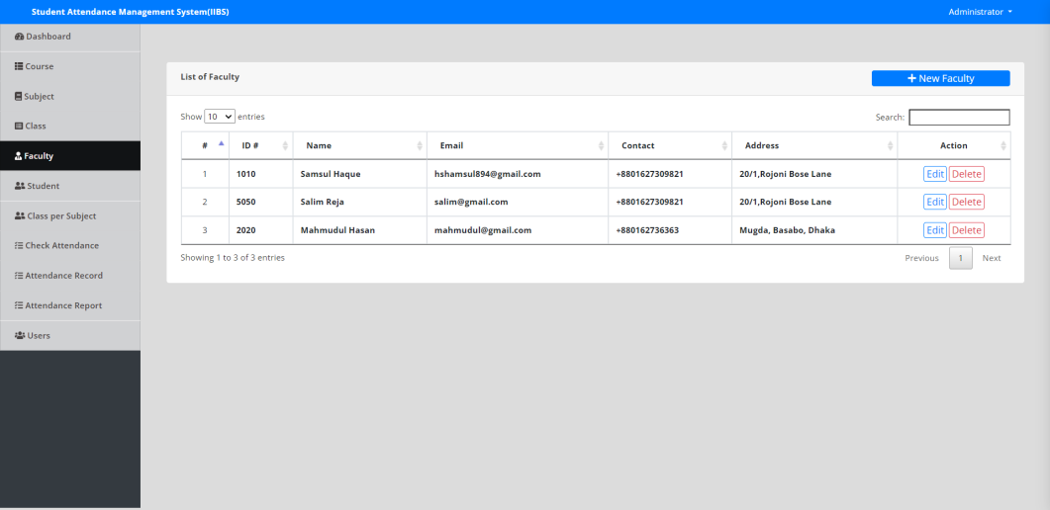

This page shows faculty members or teachers.

**STUDENT INFORMATION:**

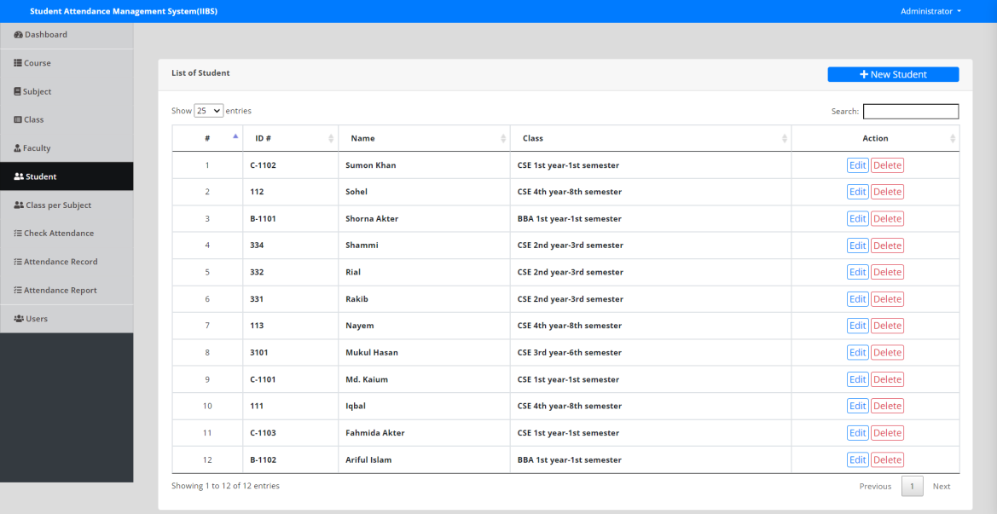

**ASSIGN TEACHER PER CLASS:**

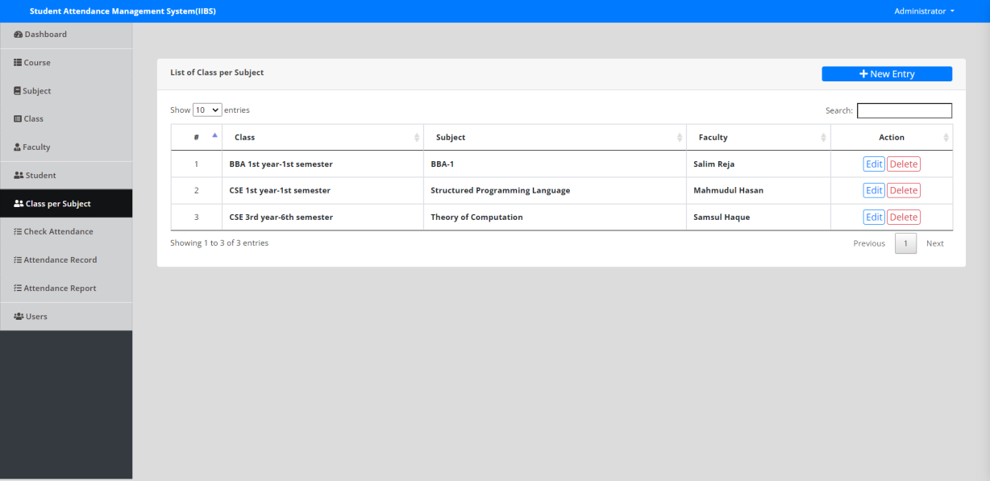

**USER INFORMATION:**

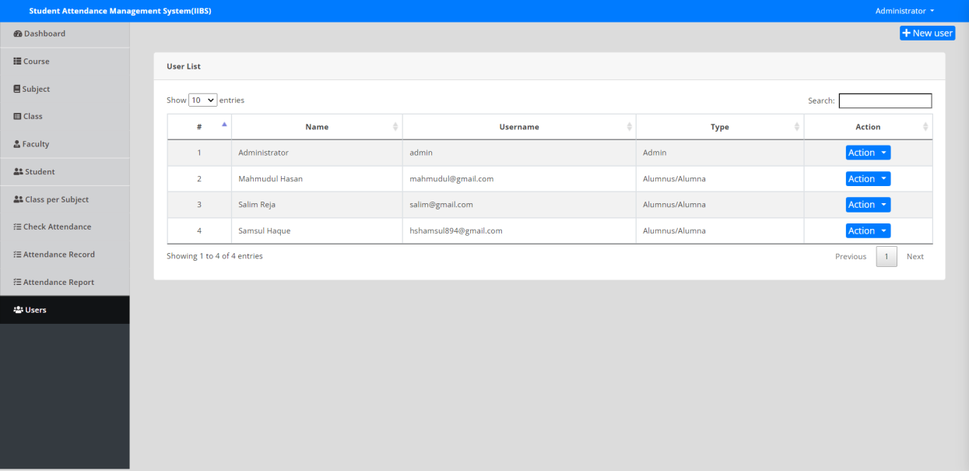

**SEMESTER OR CLASS INFORMATION:**

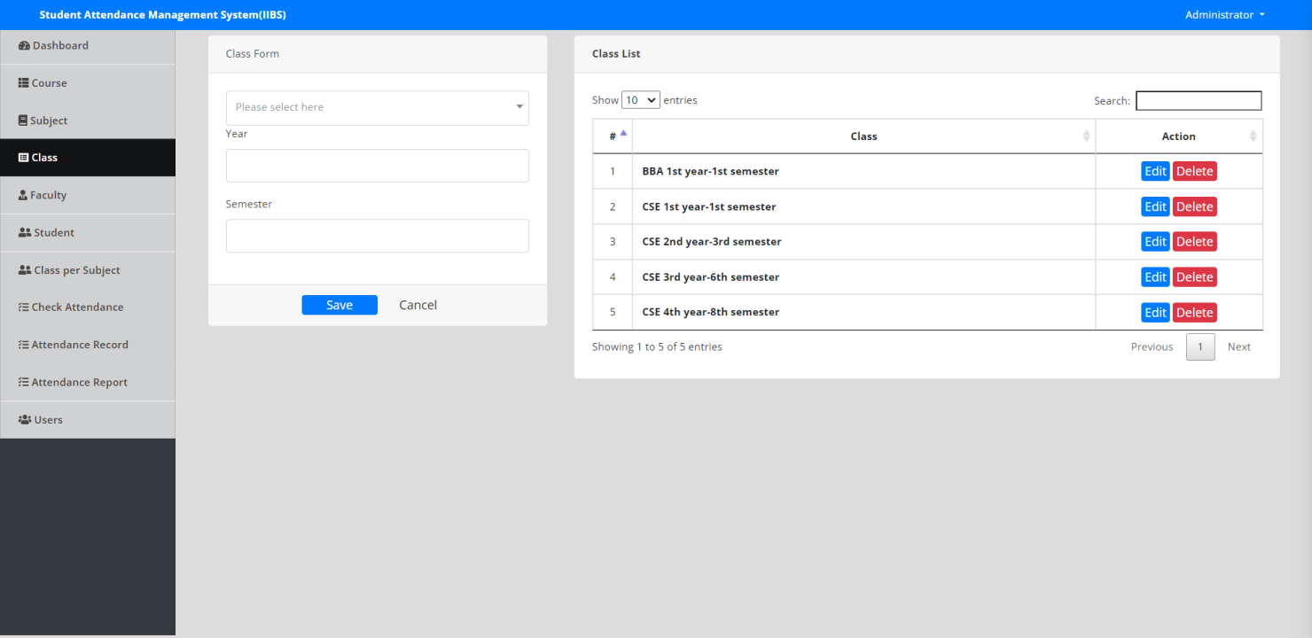

**ATTENDANCE FORM:**

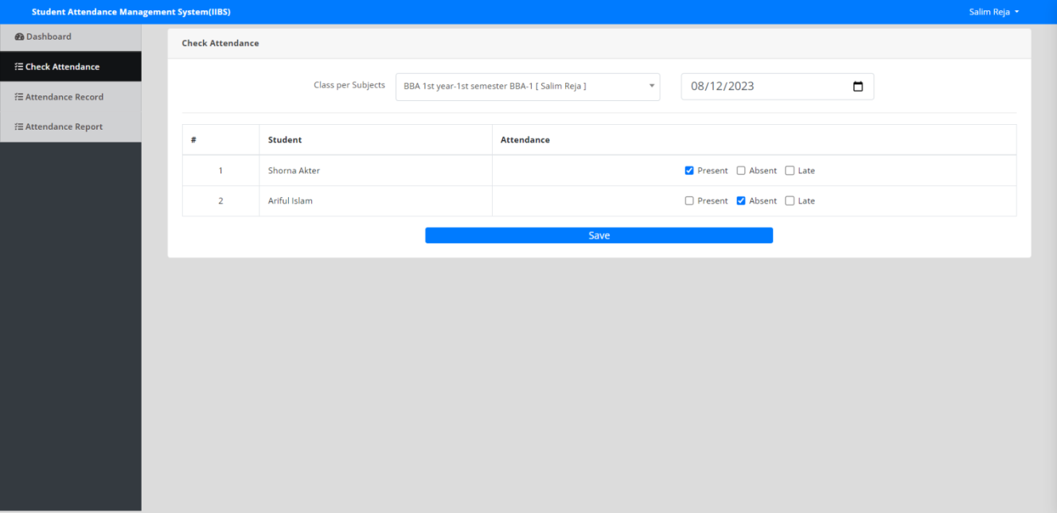

**REPORT FORM:**

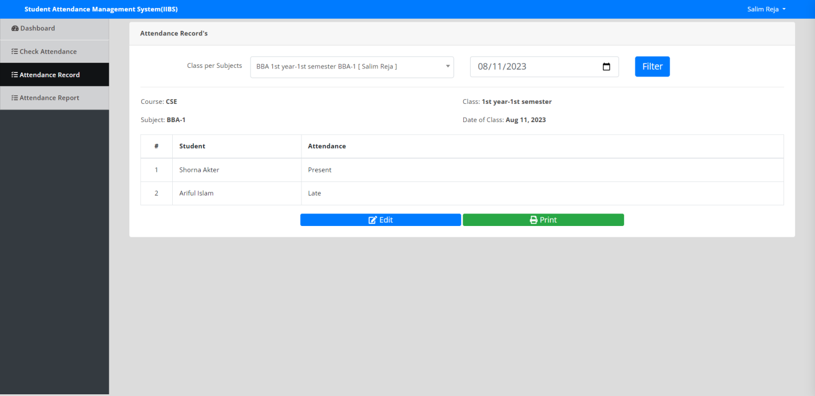

**ATTENDANCE STATUS FORM:**

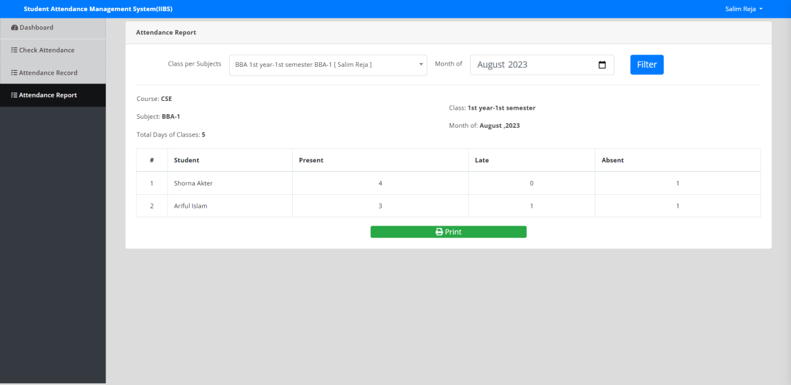

**SUBJECTS:**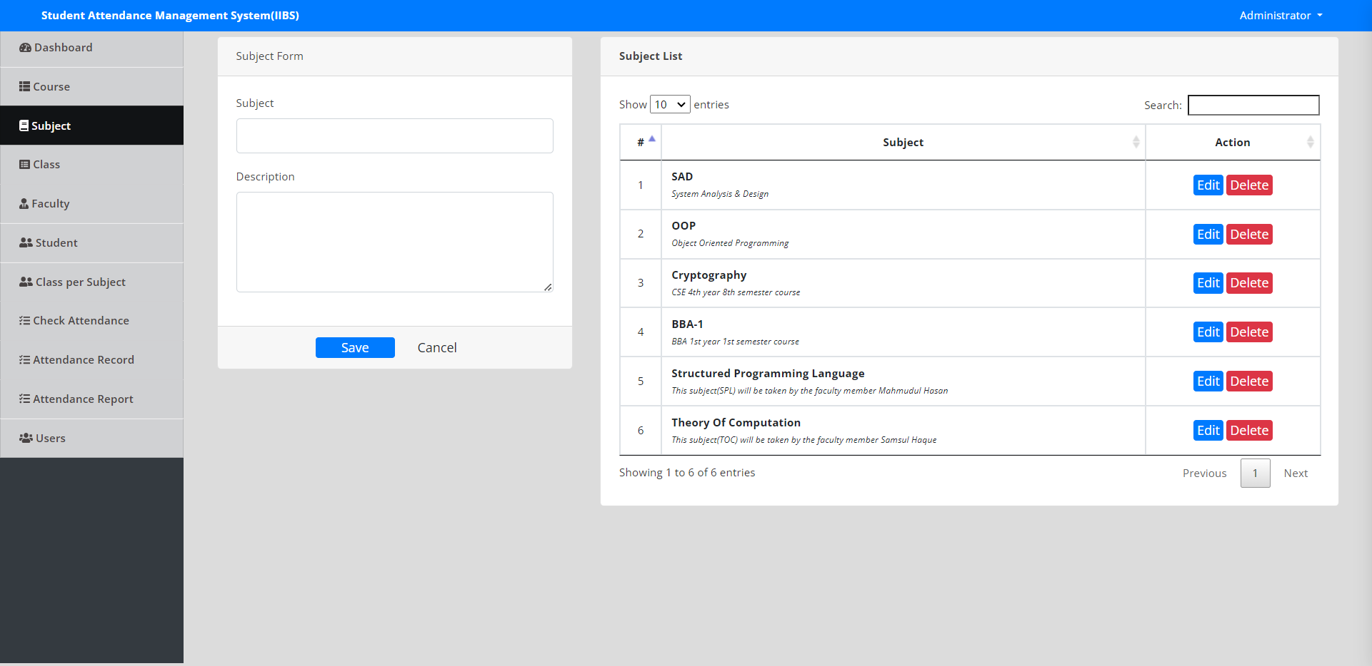

**ALL AVAILABLE COURSES:**

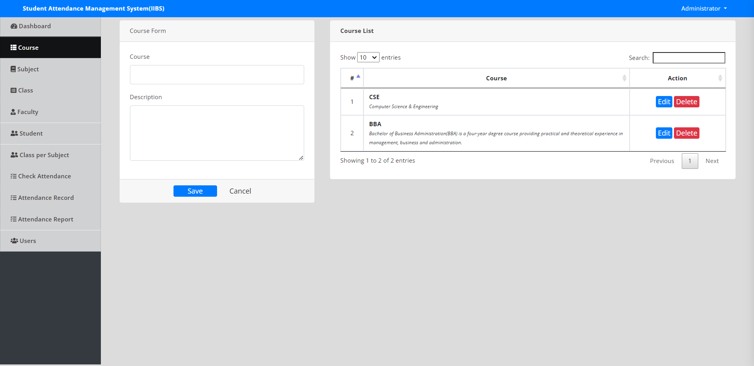

**ADMIN DASHBOARD:**

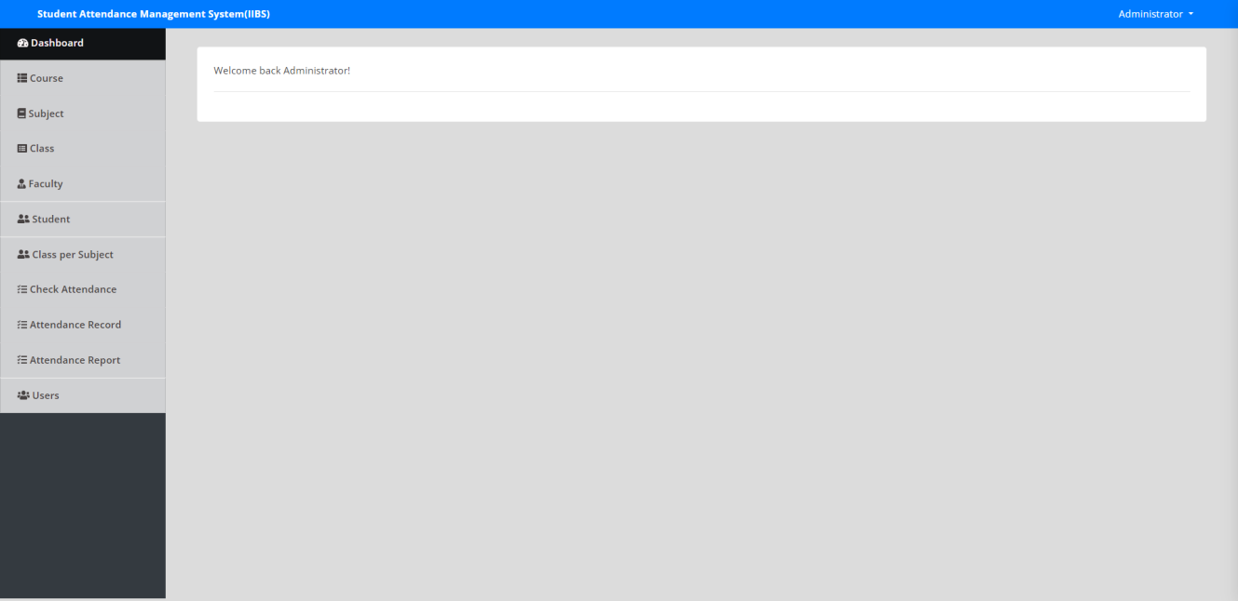

**CONCLUTION**

The Attendance Management System is developed using PHP fully meets the objectives of the system which it has been developed. The system has reached a steady state where all bugs have been eliminated. The system is operated at a high level of efficiency and all the teachers and user associated with the system understands its advantage. The system solves the problem. It was intended to solve as requirement specification.

**BIBLIOGRAPHY**

1. The complete Reference of PHP

2. System Analysis and Design – Alias M. Awad

3. Software Engineering – Roger Pressman

**Websites**

1. www.microsoft.com

2. www.w3schools.com

3. www.stackoverflow.com