ONLINE JUDGE SYSTEM
High Level Design Document
Version 1.0

1. Objective 1
2. Scope of Version 1 1
2.1 Included Features 1
2.2 Explicitly Out of Scope (Version 2) 1
3. Technology Stack 1
4. System Architecture 1
4.1 Request Flow Summary 1
5. Database Design 1
5.1 users 1
5.2 questions 1
5.3 testcases 1
5.4 submissions 1
6. Submission Workflow 1
6.1 Step-by-Step Description 1
6.2 Verdict Types 1
7. API Design 1
7.1 Authentication Endpoints 1
7.2 Questions Endpoints 1
7.3 Submissions Endpoints 1
7.4 Leaderboard & User Endpoints 1
8. Docker Execution Engine 1
8.1 Single Judge Image 1
8.2 Execution Constraints 1
8.3 Security Considerations 1
9. Leaderboard & Scoring 1
9.1 Scoring Formula 1
10. Non-Functional Requirements 1
11. Future Scope — Version 2 1

1. Objective
Develop a basic Online Judge (OJ) platform capable of handling approximately 30 concurrent students submitting solutions simultaneously. The system evaluates submitted code automatically, tracks performance metrics, and maintains a global leaderboard.

2. Scope of Version 1

2.1 Included Features
- User Authentication (JWT-based signup/login/logout)
- Problem Management with difficulty tags and topic categories
- Code Submission with multi-language support (C, C++, Java, Python)
- Automatic Evaluation via Docker-based sandboxed execution
- Verdict generation: AC, WA, CE, RE, TLE, MLE, SYSTEM_ERROR
- Global Leaderboard with difficulty-weighted scoring
- Execution Time and Coding Time tracking per submission
- Submission Cooldown (30 seconds between consecutive submissions)
- Sample test case display on problem page
- Submission history per user and per problem

2.2 Explicitly Out of Scope (Version 2)
- Contest Mode with timed competitions
- Distributed Judge Workers (RabbitMQ / Kafka)
- Redis caching layer
- Plagiarism detection (MOSS)
- Rating / Elo system
- Real-time WebSocket updates

3. Technology Stack
Layer | Technology | Purpose
Frontend | React + Vite | UI, routing, JWT storage in localStorage
Backend | Node.js + Express | REST API server, business logic, auth middleware
Database | MongoDB | Documents for users, problems, submissions, test cases
Auth | JWT (jsonwebtoken) | Stateless authentication, 24h token expiry
Execution | Docker | Isolated sandboxed code execution with resource limits
Judge Image | gcc, g++, javac, python3 | Single image bundling all supported language runtimes

4. System Architecture
The system follows a classic three-tier architecture: a React SPA on the frontend, a Node.js/Express REST API in the middle, and MongoDB as the persistence layer. Code execution is offloaded to Docker containers managed by the API server.

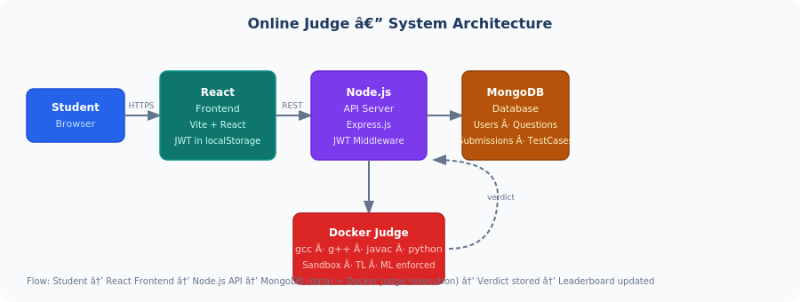
Figure 1: High-level system architecture and data flow.

4.1 Request Flow Summary
- The student selects a problem from the problem list and reads the problem statement, constraints, and sample test cases.
- The student writes the solution in the built-in code editor and selects the desired programming language (C, C++, Java, or Python).
- When the student clicks the Submit button, the React frontend sends a submission request containing the problem ID, selected language, source code, and other relevant metadata to the Node.js backend through a secure REST API.
- The request includes a JWT Bearer token in the Authorization header, allowing the backend to verify the identity of the student.
- The API server validates the JWT token, checks submission cooldown rules, validates the request payload, and retrieves the corresponding problem and hidden test cases from MongoDB.
- A submission record is created and stored in the database with an initial status indicating that evaluation is in progress.
- The backend launches a Docker container using the predefined judge image. The submitted source code is copied into the container and compiled when required (C, C++, and Java).
- Once compilation succeeds, the system executes the program against all hidden test cases while enforcing predefined execution constraints such as CPU limits, memory limits, and time limits.
- During execution, the system captures standard output, compilation logs, runtime errors, execution time, and memory usage information.
- The generated output for each test case is compared with the expected output stored in MongoDB. Based on the comparison results and execution behavior, the appropriate verdict is generated.
- Possible verdicts include Accepted (AC), Wrong Answer (WA), Compilation Error (CE), Runtime Error (RE), Time Limit Exceeded (TLE), Memory Limit Exceeded (MLE), and System Error.
- After evaluation is completed, the submission record is updated with the final verdict, execution statistics, and timestamp information.
- If the solution is accepted, the user's solved-problem count, score, and ranking information are updated according to the platform's scoring rules.
- The backend returns the final evaluation result to the React frontend, where the student can view the verdict, execution details, and submission history.
- Leaderboard and user statistics are fetched from MongoDB and displayed on demand, allowing students to track their progress and compare their performance with other users.

5. Database Design
MongoDB is used as the database. All collections are described below. Relationships are maintained via ObjectId references (Foreign Keys in relational terms).

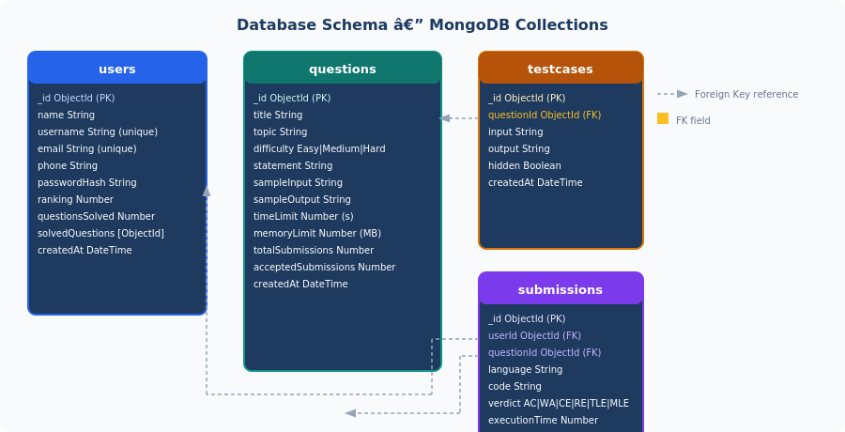
Figure 2: MongoDB collection schema with foreign key relationships.

5.1 users
Field | Type | Notes
_id | ObjectId | Primary Key (auto-generated)
name | String | Full name
username | String | Unique, used for display
email | String | Unique, used for login
phone | String | Optional
passwordHash | String | bcrypt hash, never stored plain
ranking | Number | Derived score; update on every AC verdict
questionsSolved | Number | Count of unique problems AC'd
solvedQuestions | [ObjectId] | Array of question IDs solved
createdAt | DateTime | Auto-set on document creation

5.2 questions
Field | Type | Notes
_id | ObjectId | Primary Key
title | String | Display name of the problem
topic | String | Category: Arrays, Trees, DP, etc.
difficulty | String | Easy / Medium / Hard
statement | String | Full problem description (Markdown supported)
sampleInput | String | Shown publicly on problem page
sampleOutput | String | Shown publicly on problem page
timeLimit | Number | Seconds; default 2
memoryLimit | Number | MB; default 256
totalSubmissions | Number | Counter, incremented on each submit
acceptedSubmissions | Number | Counter, incremented on AC verdict
createdAt | DateTime | Auto-set on creation

5.3 testcases
Field | Type | Notes
_id | ObjectId | Primary Key
questionId | ObjectId (FK) | References questions._id
input | String | Input fed to program via stdin
output | String | Expected stdout output for comparison
hidden | Boolean | true = used for judging; false = shown as sample
createdAt | DateTime | Auto-set on creation

5.4 submissions
Field | Type | Notes
_id | ObjectId | Primary Key
userId | ObjectId (FK) | References users._id
questionId | ObjectId (FK) | References questions._id
language | String | c / cpp / java / python
code | String | Raw source code submitted
verdict | String | AC / WA / CE / RE / TLE / MLE / SYSTEM_ERROR
executionTime | Number | Milliseconds taken by Docker execution
codingTime | Number | Seconds from problem open to submission (sent by frontend)
submittedAt | DateTime | Auto-set on creation

6. Submission Workflow
The following diagram details every step from the moment a student clicks 'Submit' to the verdict being stored in the database.

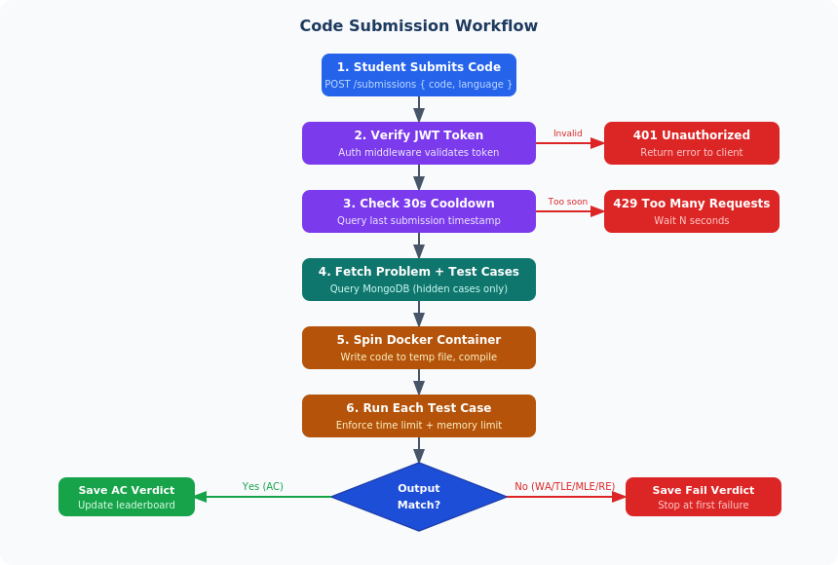
Figure 3: End-to-end code submission and evaluation workflow.

6.1 Step-by-Step Description
- Student submits code — React frontend sends POST /submissions with { questionId, language, code, codingTime } and a JWT Bearer token.
- JWT verification — Auth middleware validates the token. Returns 401 if invalid or expired.
- Cooldown check — API queries the last submission timestamp for this user. If under 30 seconds, returns 429.
- Fetch test cases — All hidden test cases (hidden: true) for the problem are fetched from MongoDB.
- Docker container setup — Code is written to a temp file. A container is started from the judge image with memory and CPU limits.
- Compile (if needed) — For C/C++/Java, the code is compiled first. A compilation error yields CE verdict immediately.
- Run test cases — Each test case is fed via stdin. Output is captured and compared to expected output. Stop at first failure.
- Verdict generation — AC if all cases pass; WA, TLE, MLE, or RE otherwise.
- Store result — Submission saved to MongoDB with verdict and execution time. User ranking updated if AC.

6.2 Verdict Types
Code | Meaning | Trigger
AC | Accepted | All test cases pass within time and memory limits
WA | Wrong Answer | Output does not match expected for at least one test case
CE | Compilation Error | Code fails to compile (C/C++/Java)
RE | Runtime Error | Program crashes (segfault, exception, non-zero exit code)
TLE | Time Limit Exceeded | Execution exceeds the problem's timeLimit (default 2s)
MLE | Memory Limit Exceeded | Execution exceeds the problem's memoryLimit (default 256MB)
SYSTEM_ERROR | System Error | Docker failure or unexpected server-side error

7. API Design
All endpoints are prefixed with /api/v1. Authentication is enforced via a JWT Bearer token in the Authorization header. Endpoints marked with ★ are additions beyond the original V1 spec.

7.1 Authentication Endpoints
Method | Endpoint | Description
POST | /auth/signup | Register new user. Body: { name, username, email, password }
POST | /auth/login | Login. Returns JWT token. Body: { email, password }
POST | /auth/logout | Invalidate token (client-side clear)
GET | /auth/me | ★ Get currently logged-in user profile from token
PUT | /auth/change-password | ★ Update password. Body: { oldPassword, newPassword }

7.2 Questions Endpoints
Method | Endpoint | Description
GET | /questions | List all questions (title, topic, difficulty only)
GET | /questions?difficulty=&topic= | ★ Filter questions by difficulty or topic
GET | /questions/:id | Get full problem details including sampleInput/Output
GET | /questions/:id/testcases/sample | ★ Get non-hidden (sample) test cases for display

7.3 Submissions Endpoints
Method | Endpoint | Description
POST | /submissions | Submit code. Triggers full evaluation pipeline. Auth required.
GET | /submissions/:id | ★ Get single submission detail (verdict, code, timing)
GET | /submissions/user/:id | Get all submissions by a user
GET | /submissions/question/:qid | ★ Get current user's submissions for a specific problem

7.4 Leaderboard & User Endpoints
Method | Endpoint | Description
GET | /leaderboard/global | Get global leaderboard (all users, ranked by score)
GET | /leaderboard/global?limit=10 | ★ Paginated leaderboard with configurable limit
GET | /users/:id | Get public user profile
PUT | /users/:id | ★ Update own profile (name, phone). Auth required.
GET | /users/:id/stats | ★ Get user stats: solved count, breakdown by difficulty

8. Docker Execution Engine

8.1 Single Judge Image
A single Docker image bundles all four runtime environments. This keeps the system simple for V1 while supporting all required languages.
- Base image includes: gcc, g++ (C/C++), javac + JRE (Java), python3
- Image is built once and reused for all submissions
- Tradeoff: larger image size (~500MB) versus simplicity of managing one image

8.2 Execution Constraints
Default Time Limit | 10 seconds
Default Memory Limit | 256 MB
CPU Limit | 1 CPU core (--cpus=1)
Network Access | Disabled (--network none)
Container lifetime | Killed after execution completes or TLE
Temp file cleanup | On every execution, regardless of verdict
Container Removal | Automatic (--rm); container is deleted immediately after execution completes
Resource Cleanup | Temp directory and all written files purged after each execution; no state persists between runs

8.3 Security Considerations
- Network is disabled inside containers — malicious code cannot make outbound requests.
- Memory limits prevent runaway processes or infinite allocation attacks from consuming host system memory.
- Containers run as a restricted, low-privilege user (ContainerUser) inside Docker Desktop for Windows, preventing access to host system resources.
- Temp files are stored in an isolated directory and deleted after execution.
- Time limit kills the container process if code runs infinitely.

9. Leaderboard & Scoring

9.1 Scoring Formula
Score = Sum of difficulty weights for all uniquely solved problems.
Difficulty | Points
Easy | 10
Medium | 20
Hard | 50

Only the first accepted submission per problem counts. Resubmissions do not increment the score.
Leaderboard is refreshed on page load (polling). WebSocket real-time updates are deferred to V2.

10. Non-Functional Requirements
Requirement | Details
Concurrency | ~30 simultaneous student submissions on a single server
Deployment | Single server (no horizontal scaling in V1)
Auth | JWT with 24-hour expiry; bcrypt password hashing
Data isolation | Docker containers fully isolate code execution from host
Execution safety | Network disabled, memory capped, time-limited per container
API response time | < 300ms for all non-execution endpoints
Submission feedback | Verdict returned within 10s for typical programs

11. Future Scope –version 2
The following capabilities are intentionally deferred to Version 2 to keep the initial release scope manageable.
Platform Enhancements
- Contest Mode — Support for timed contests with contest-specific leaderboards and rankings.
- User Profiles & Statistics — Detailed user statistics including solved problems by topic, acceptance rate, and activity history.
- Problem Discussion Section — Allow users to discuss approaches, ask doubts, and share learning resources.
- Bookmarks & Problem Lists — Users can save problems for later practice and create custom practice lists.
Evaluation Enhancements
- Custom Test Case Execution — Users can run solutions against their own test cases before final submission.
- Submission Comparison — Compare multiple submissions of the same problem based on execution time and memory usage.
- Partial Scoring Support — Problems can award scores based on the number of test cases passed.
- Plagiarism Detection — Basic code similarity detection for academic and contest use cases.
Performance & Scalability
- Message Queue Integration — RabbitMQ or Kafka for asynchronous submission processing.
- Redis Caching — Cache frequently accessed data such as leaderboards and problem lists.
- Multiple Judge Workers — Support multiple execution workers for handling higher submission loads.
- Distributed Execution — Separate judge servers from the main API server for improved scalability.
Real-Time Features
- WebSocket Updates — Real-time verdict updates and leaderboard refreshes without page reloads.
Administrative Features
- Bulk Problem Import — Import problems and test cases using predefined templates.
- Problem Versioning — Track and manage updates to problem statements and test cases.
- Advanced Analytics Dashboard — Monitor submission trends, popular problems, and system usage metrics.

