Hi Lokesh, this is obviously a message for you for tomorrow morning ;-)

I found that when validating club name in 'step by step launch', it checks if the club name already exists. We can NOT do this!

The problem is that a competitor might use this to find out which clubs are using our system. For example they want to know if G13 is using our system, so they type "G13" there and can see that the name is taken. So please remove this kind of validation - same with e-mail address. We cannot risk "giving away client data" in this public process.

**Front end**

1. On new-club-1.php, when a user clicks 'Other', an input field should appear where they can type in the value.s

**Done**

2. There are some issues with validation:

- Phone number should not validate as number, because this only allows numbers. A user migth input for example: "+34 654 445 325". Please allow text input.

- Validation on Website, Facebook, Instagram inputs are too strict. Right now you have to put "http://" as well as a full link for it to validate. If my Instagram is 'https://www.instagram.com/exampleClub', then I should be able to just put 'exampleClub' in the 'Instagram' box. This can be accomplished by letting those fields validate as text.

**Done**

**Back end**

A) I gave the ccs_masterdbu account sufficient privileges, so it doesn't throw an error on the select command on line 146 in club-launch.php.

B) I created a club "Andy's Sweatshop", and the system then used this exact name for the folder names. This is no good, we need to avoid spaces for compatibility reasons and avoid capitalization to keep the same structure as other folders. As such, the process should be:

1. Take the 'short name' submitted by client

2. Remove all spaces and special characters, and force lowercase.

3. Check if folder already exists. If it exists, append a number to the end.

**Done**

C) For some reason I found 532 files in the folder under _club. There should only be 1 file there, contract.php.

**Done**

D) The folders under 'images' was created succesfully, but the logo doesn't copy to that folder.

**Done**

1. When approving a club in the Nefos tool, I get this error: "Error fetching user4: SQLSTATE[42000]: Syntax error or access violation: 1064 You have an error in your SQL syntax; check the manual that corresponds to your MySQL server version for the right syntax to use near ':3306 identified by 'Eibog5JikyQLJ'' at line 1". It comes from the query on line 174 in club-launch.php.

**Working on it**

2. Yes, we can use duplicate e-mails. In "users" table in ccs_masterdb, we have duplicate e-mails, but different passwords. An example is my e-mail berrern@gmail.com, which - depending on which password I use, logs me into different systems. A good idea would be to highlight this in bold and red letters in the Nefos tool, that a duplicate e-mail has been used.

I cant give you an example on why this is happening - because it has happened in the past! For example a girl Lisa works in one club, where she is working as a manager. One day she opens her own club - but she continues managing the 'old' club, so now she works in two clubs with the same e-mail address :-)

**Done**

I've been testing the image upload functionality, and found some issues:

1. When resizing a large image, the quality takes a ****big hit****, the resulting output is pixelated.

**Done**

2. When I upload a really tall - or really wide - image, the thumbnail generator adds black bars around it. The "bars" shouldn't be black - they should be transparent.

**Done**

3. From what I can see, only a resized image is saved. Please make it so that both the original and the resized versions are saved. This is important, because in some cases a client will upload a logo with a lot of white space around it, so in this case I would need to work with the original uploaded image myself, manually.

**Done**

4. There is no handling of "fake file" uploads. Example: I make a Notepad file on my desktop and call it "abc.txt". I then rename it to "abc.jpg". When doing this, the system DOES let me upload the file, but when I click Continue, the next page doesn't load correctly and no error is displayed. What's worse is that I believe this can present a security risk - if a user uploads a malicious file, "pretending" that it's a jpg when in reality it's not. I'm not sure what the best action to prevent this would be - perhaps process it through the GD library? That should eradicate the security issue... I'm no expert on this, so please advice.

**Done**

Regarding points 1 and 2 above, this example illustrates it perfectly:

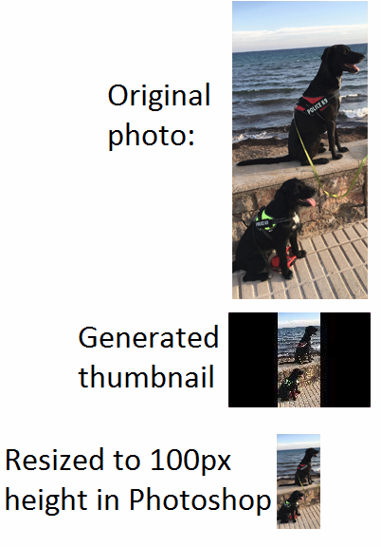

And here's another example - this time using a large-size version of our logo:



Can you please add a Captcha (I am not a robot) on the final page, where a club confirms their details?

**Done**