BoxPick2

1. Purpose of this Document 2
2. Intended Audience 2
3. Overview 2
4. Proposed changes in existing BOXPICK to incorporate PUL UI 2
5. Existing BOXPICK Program 4
6. TO Discuss 5
7. Document Change History 6

Purpose of this Document
This document describes how BoxPick module can pick cartons for ADRE and ADR process which are currently done using PUL module. If this approach is successful we will be able to remove the PULLTODOCK part completely from PUL module. ADRE process can be thought of as a special case of ADR process. Therefore in the remainder of the document we will use ADR only.

Intended Audience
This document is useful for managers and technical staff at Maidenform and business analysts and developers at Eclipse involved in designing pulling process.

Need of ADRE pulling process
It can be discussed that why we need ADRE process at all? Why not pre-print labels and use ADREPPWSS process?
When carton sizes are large, cartons are pulled using ADRE process. A separate expediting step increases overhead in this scenario because labels can easily be affixed after cartons are picked.

Overview

PULLTODOCK feature in DCMS allows full cases to be picked from carton reserve area (BIR) for shipping to customer. UCC/CCL Labels are also printed and affixed to these cartons. There are two UI choices for using PULLTODOCK process.
- BOXPICK: This UI allows pre-printed pallets to be picked. Labels are affixed as the cartons are picked. ADREPPWSS process uses this UI currently to pick cartons.
- PUL: This UI allows the cartons to be picked first and then prints them. ADR process uses this UI to pick cartons at present.
We intend to provide ADR process in BOXPICK because they are conceptually same except the printing part. BOXPICK will provide UI similar to PUL module.

Proposed changes in existing BOXPICK to incorporate PUL UI

BOXPICK UI allows pre-printed pallets to be picked and UCC labels are instantly applied to the cartons being picked. This saves a lot of time when the cartons in question are small because pallet is not handled again. For further details on process you can refer BOXPICK section.

In ADR process (using PUL UI) the UCC labels are printed at the end of the pulling operation. The operator is then required to visually match the UCC label to the correct carton.

We have envisioned that both these UIs can be incorporated in existing BOXPICK module.
The current UI choices in BOXPICK will remain unchanged. In addition the UI would be tweaked to incorporate PUL portion.

Basic Steps to perform ADR pulling in Box Pick:
- Scan building.
- Scan destination area.
- Scan a pallet. If this pallet does not already exist in the database, the user will be asked whether he wants to use this pallet for picking ADR boxes.
- Upon receiving confirmation, a pallet will be created and the correct number of unpicked boxes will be assigned to it.
- BOXPICK UI suggests the first carton to pick.
- User scans the picked carton. Substituting cartons will be allowed. If the carton qualifies, the database will be immediately updated to reflect that the carton has been picked.
- UI suggests the next carton to pick and this process continues until all cartons are picked.
- After the last carton is picked, the option to print the pallet is offered.

Additional Functionality Available
- The pallet can be put on hold simply by exiting the program.
- The pallet can be underpicked by scanning the pallet at any time. The program will offer to remove remaining cartons from the pallet.
- After a pallet has been put on hold, it can be resumed simply by scanning it again any time later.
- A completed pallet can be reprinted by scanning it at the start of the program.

Advantages of over existing Pulling program:
- Provides modern UI.
- Easy support and more scalable design.
- Makes the existing telnet based PUL obsolete for box picking purposes.

Proposed process screenshots:
- Option to create pallet when, scanned palled doesn’t exists

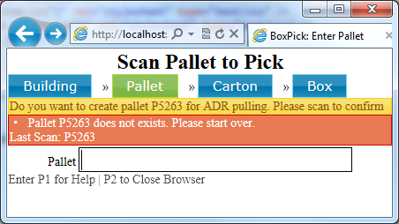
- Expecting carton to be scanned after pallet is created.

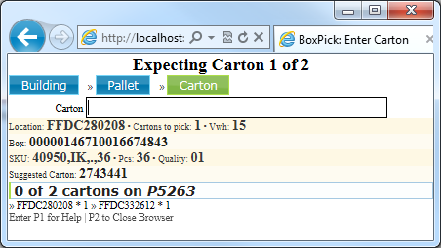

- When carton is scanned

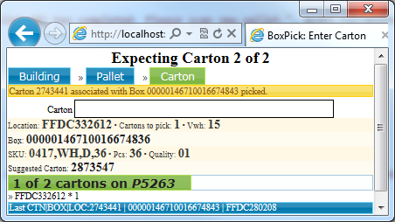

- After pulling process is completed, program will ask for the Printer to print pallet if wants to do so or can skip it.

- After print process is completed or skipped program will take user to Pallet View where user can enter pallet and will results in picking iteration to restart.

- Partial picking of pallet is permitted and also on demand printing for pallet is feature available.

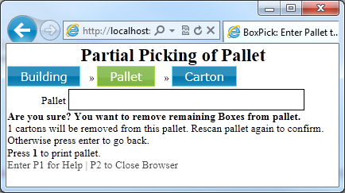

Existing BOXPICK Program
This is a process which provides the perspective of Box Picking as opposed to Carton Pulling. Picker picks up a stack of preprinted UCC/CCL labels and scans associated pallet in the Box Picking module.
After scanning the pallet id, picker will initiates the box picking process. Box Picking guides the picker to a location to pull the desired cartons. It also validates that picker is affixing correct UCC labels on the cartons.

Box Pick process flow (ADREPPWSS):
- Picker picks a stack of labels already printed by the print box wave process.
- Start box picking by scanning the pallet label.
- RF Program displays the destination location along with what needs to be picked from there. For example: Pick 4 6-packs of SKU xxx from Location1.
- Picker picks one of the cartons from that location and scans it.
- Picker scans UCC label he intends to place on the carton.
- He affixes the label carton after hearing the acceptance beep. If an error beep is heard, he must investigate the reason for the problem.
- He repeats this for each carton being picked from that location.
- The screen indicates the next location from which cartons need to be picked.
- This process is repeated till all the cartons printed in the stack are picked and the remaining cannot be picked.
- When the pallet is fully picked, the picker is informed that all the cartons are picked and drops pallet at ADR.

In case of under picking, all UCCs with red dot should be placed in a designated tray within the ADR area. A supervisor should scan each red dot UCC and decide what must be done with each of these boxes.
- He can remove the box from the pallet. This will mark the pallet as fully picked and the box will become a candidate for getting picked in the future on some other pallet.
- He can cancel the box to indicate that this box need not be picked again.
Both of these options will be available in the web application which will be delivered along with this release.

TO Discuss
- Do we need to create pallet, if yes which bucket will be used to create pallet.
- Existing PUL programs allows user to put more cartons on Pallet if it exists.
- Cartons are assigned to pallet, thus will remain unavailable to other, when picker leaves PICK process midway.
- Currently we don’t support incomplete pick of pallets. We will provide option in DCMSWeb to remove unpicked cartons from pallet (Partial picking of pallet).
- How to replace temp_pul_carton and if we keep lock at request level how do we implement it.
- Concurrency issue needs to be handled
- Current Pulling program allows Automatic printing and reprint options.
- Further UI discussions.
- Earlier we needed the source area for PUL process now do we need it
- Accept Building/Destination Area or to accept destination area and infer building.
- It was discussed in the meeting that we will do crowd management for pullers. We have to discuss it further.

Document Change History
S. No. | Modified Date | Modified By | Description
1. | 21-May-2011 | Satpal Singh | Initial document

