Carton Locating

Contents
1. Intended Audience 1
2. Need of Locating Cartons 1
3. Overview 1
4. Process Flow 1
5. Carton Locating UI 2
6. Document Changes History 2

Intended Audience
This document is intented for warehouse managers, supervisors and technical team supporting DCMS.

Need of Locating Cartons
Cartons are received at receiving station from the sewing plant and pass to the verification station. After the verification, verified cartons are placed at un-numbered location. These cartons are located to a numbered location by locating program.

Overview
The cartons received successfully are located to inventory reserve area using locating module.Carton locating is optimized for locating cartons individually. We expect that user would like to scan each carton and place it to a location. In most of the cases, the location where the carton is placed would contain a single carton.
A carton must be located correctly so that they can be pulled efficiently as and when required. The pulling is easy and faster if the carton to be pulled is found at the correct location. This also helps in keeping the inventory picture correct since orders are taken by looking at the inventory.

Process Flow
- Scan Pallet: Locator scans the pallet which contains the cartons. Put all these cartons in suspense. Now ask user to scan location. If user skipped the pallet scan move to the step 2.
Scan Location: Locator scans a location. Now ask user to scan carton. User can quit
locating cartons by pressing enter. It moves to location page and if user
scan Pallet, we will put all Cartons in suspense.
- Scan Carton: If user scanned the pallet in step 1 then user must scan the cartons belong to that pallet only, if user scans another carton UI ask for confirmation to locate anyway; if confirmed then carton is located. Otherwise if user already skipped the pallet scan then scanned carton is directly placed on the location scanned in step 2 and we ask user to scan next location.

Begin Locating
Scan
Pallet
Scan Carton
Locate Carton
Scan
Location
Skipped pallet scan
Pallet scanned, Put all cartons in suspense of this pallet.
User scanned Pallet in step 1
No
Yes
Carton belongs to scanned pallet
Ask for confirmation
No
Yes
Confirmed
Not
Confirmed
If user press enter

After this successfully locates a carton, updates SRC_CARTON table where Location ID of the carton is set as the presently scanned location id and the Pallet ID for that particular carton is set to NULL. Simultaneously, Suspense Date is also set to NULL and Storage Area of the carton is set as the area of Location.

Carton Locating UI
1: Scan Pallet
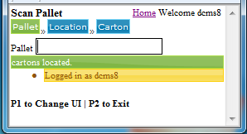

2: Scan Location
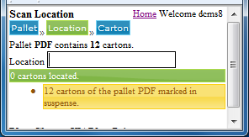
3: User can quit to locate remaining carton
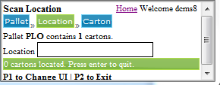

4: Ask user to scan Pallet. All remaining cartons of pallet will put in suspense.
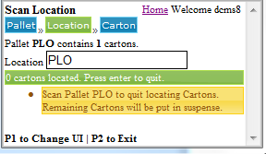

5: All carton of pallet have been put in suspense.
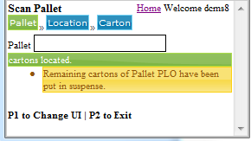

6: Scan Carton
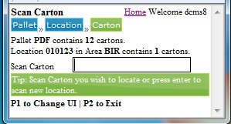

7: Carton located successfully at scanned location ans ask user to scan new location.
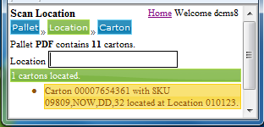

FAQs
- The location I scaaned is unavailable in DCMS. What do I do?

Document Changes History
S. No. | Modified Date | Modified By | Description
1. | 14th Jul 2012 | Rajesh Kandari | Initial document
2. | 14th Aug 2012 | Binod Kumar | New feature is implemented to locate cartons of pallet.

