DOC No.

CONFIDENTIAL

PRELIMINARY

MODEL:
e-BRIDGE X/N
TITLE: <Project> <Component Name> Design Description

Rev. 0.40
Issued: 13/09/2019 18:00

Approved | Checked | Written

Document Info

履歴：
Revision | Date | Description | Author | Page | 担当
0.01 | 14/10/2014 | Initial Version | Rajasekaran P | All
0.1 | 17/10/2014 | Internal review comments incorporated | Rajasekaran P | All
0.2 | 23/02/2015 | Initial version for L6.0 requirements | Rajasekaran P | All
0.21 | 16/11/2015 | Print error log support update for L6.0 | Rajasekaran P | 12
0.22 | 08/08/2016 | Erasable Blue toner, AirPrint v1.6 requirements support for L6.03. SLFP details are merged. | Rajasekaran P | 8,9, 13 & 14
0.23 | 23/11/2016 | Performance improvement details update | Rajasekaran P | 19,20
0.24 | 08/03/2017 | Mac OSX Multi-station print support details update | Rajasekaran P | 17,32,33
0.25 | 06/09/2017 | AirPrint 1.7 requirements | Rajasekaran P | 8,10,11,19,20,21,38
0.26 | 18/09/2017 | Review comments updated | Rajasekaran P | 19, 20, 21, 22, 23
0.27 | 09/09/2017 | Review comments updated | Rajasekaran P | 20, 21
0.28 | 29/12/2017 | Updated MutiStationPrint_Interface_Attribute_Mapping.xlsx file for L6.11 & inserted it. | Rajasekaran P | 10, 32
0.29 | 23/05/2018 | Updated hibernation boot-up sequence & other review comments | Rajasekaran P | 42,20
0.30 | 11/07/2018 | Updated details about finishings specification for mobile print | Rajasekaran P | 25
0.31 | 21/08/2018 | Updated info about max connections | Rajasekaran | 12
0.32 | 10/09/2018 | Updated info about HCD-PP requirement for entropy counter clear before TLS handshake when MFP is in high security mode | Rajasekaran P | 12, 26
0.33 | 15/11/2018 | Updated details about media supported | Rajasekaran | 12,13
0.34 | 22/02/2019 | Updated details about L6.5 AirPrint & Mopria requirements | Rajasekaran | Sections 1.5,  2.2.9, 2.2.10, 2.2.11, 2.2.12, 2.2.13, 3.1.17, 3.1.18, 3.1.19, 3.1.20, 3.1.21, 3.1.22, 3.1.23, 6.3.2.9
0.35 | 16/05/2019 | Updated details about HDD access Reduction. | Vidhyasri | Sections  2.2.14  3.1.24  6.3.2.10
0.36 | 21/06/2019 | Updated details about Resource leak fix. | Vidhyasri | Sections  2.2.15  3.1.25  6.3.2.11
0.37 | 02/08/2019 | Updated Regarding Toshibamedia.txt file to fix TA issue for B650.36 | Vidhyasri | Section  3.1.20.2
0.38 | 13/08/2019 | AirPrint v1.9 TBD is removed and v1.8 is finalized for L6.5 Matterhorn | Rajasekaran | Sections  1.5  2.2.10  3.1.17  3.1.19
0.39 | 30/08/2019 | Updated details for the fix of EBX_DTFR_19854 | Vidhyasri | Section  2.2.11  3.1.20.2
0.40 | 13/09/2019 | Updated details for the fix of EBX_DTFR_19882 and EBX_DCR_63978 | Vidhyasri | Section  2.2.10  3.1.18.2
配布先：
Location | Rules

略語：
Term | Description

Table of Contents

1. Introduction 9
1.1 Purpose 9
1.2 Document Conventions 9
1.3 Overview of the Document 9
1.4 Revision History 10
1.5 References 10
1.6 Terms and Definitions 10
2. Overview of the component 11
2.1 Identification 11
2.2 Function 12
2.2.1 Authentication Extension Support 12
2.2.2 Erasable Blue Toner Support 12
2.2.3 Airprint 1.6 & Mopria Certification Support 13
2.2.4 Server Less Location Free Printing Support 13
2.2.5 L6.02/L6.03 requirements: 14
2.2.6 L6.11/L6.13 Multi-station Print SSL mode support 14
2.2.7 L6.11/L6.13 AirPrint v1.7 support 14
2.2.8 L6.13 HCD-PP requirements 15
2.2.9 IPP Media Supported 15
2.2.10 L6.5 AirPrint 1.8 Requirements 15
2.2.11 L6.5 Toshiba Original media type support 16
2.2.12 L6.5 Custom media size support 17
2.2.13 L6.5 Mopria Requirements 17
2.2.14 L6.141 HDD Access Reduction 18
2.2.15 L6.15 Resource Leak Issue Fix 18
3. Use Case Realization 19
3.1 Use Cases 19
3.1.1 Handling Print-Job/Send-document 20
3.1.1.1 Pre Conditions 20
3.1.1.2 Realization 20
3.1.1.3 Post Conditions (Success Case) 21
3.1.1.4 Post Conditions (ErrorCase) 21
3.1.2 Handling Cancel-Job, Get-Job-Attribute, Get-Jobs & Close-Job 21
3.1.2.1 Pre Conditions 21
3.1.2.2 Realization 21
3.1.2.3 Post Conditions (Success Case) 21
3.1.2.4 Post Conditions (ErrorCase) 22
3.1.3 Handling other IPP operations (Get-Printer-Attribute, Validate-Job, Create-Job, Get-Printer-Attribute, Get-Printer-Supported-Values, Set-Printer-Attribute and Identify-Printer) 22
3.1.3.1 Pre Conditions 22
3.1.3.2 Realization 22
3.1.3.3 Post Conditions (Success Case) 22
3.1.3.4 Post Conditions (ErrorCase) 22
3.1.4 Updating Printer Error Logs (Connection timeout, Max connection occurred, Job near full occurred & Hard disk near full occurred) 22
3.1.4.1 Pre Conditions 22
3.1.4.2 Realization 23
3.1.4.3 Post Conditions (Success Case) 23
3.1.4.4 Post Conditions (ErrorCase) 23
3.1.5 Support for Erasable Blue toner 23
3.1.5.1 Pre Conditions 23
3.1.5.2 Realization 23
3.1.5.3 Post Conditions (Success Case) 23
3.1.5.4 Post Conditions (ErrorCase) 24
3.1.6 Support for AirPrint v1.6 24
3.1.6.1 Pre Conditions 24
3.1.6.2 Realization 24
3.1.6.3 Post Conditions (Success Case) 24
3.1.6.4 Post Conditions (ErrorCase) 24
3.1.7 IPP_C to IPP_S custom command execution 24
3.1.7.1 Pre Conditions 24
3.1.7.2 Realization 24
3.1.7.3 Post Conditions (Success Case) 25
3.1.7.4 Post Conditions (ErrorCase) 25
3.1.8 Receive Job Data 25
3.1.8.1 Pre Conditions 25
3.1.8.2 Realization 25
3.1.8.3 Post Conditions (Success Case) 25
3.1.8.4 Post Conditions (ErrorCase) 25
3.1.9 Multi-station Print Support for Mac OSX 25
3.1.9.1 Pre Conditions 25
3.1.9.2 Realization 25
3.1.9.3 Post Conditions (Success Case) 26
3.1.9.4 Post Conditions (ErrorCase) 26
3.1.10 Multi-station Print SSL mode support 26
3.1.10.1 Pre Conditions 26
3.1.10.2 Realization 26
3.1.10.3 Post Conditions (Success Case) 27
3.1.10.4 Post Conditions (ErrorCase) 27
3.1.11 Wi-Fi Setup via IPP-USB 27
3.1.11.1 Pre Conditions 27
3.1.11.2 Realization 28
3.1.11.3 Post Conditions (Success Case) 29
3.1.11.4 Post Conditions (ErrorCase) 29
3.1.12 AirPrint v1.7 support for ipp-features-supported attribute 29
3.1.12.1 Pre Conditions 29
3.1.12.2 Realization 29
3.1.12.3 Post Conditions (Success Case) 29
3.1.12.4 Post Conditions (ErrorCase) 29
3.1.13 AirPrint v1.7 support for printer-firmware-name extension 29
3.1.13.1 Pre Conditions 29
3.1.13.2 Realization 30
3.1.13.3 Post Conditions (Success Case) 30
3.1.13.4 Post Conditions (ErrorCase) 30
3.1.14 AirPrint v1.7 support for IPP SSL as default 30
3.1.14.1 Pre Conditions 30
3.1.14.2 Realization 30
3.1.14.3 Post Conditions (Success Case) 31
3.1.14.4 Post Conditions (ErrorCase) 31
3.1.15 Mobile Print Finishing’s supported 31
3.1.15.1 Pre Conditions 31
3.1.15.2 Realization 31
3.1.15.3 Post Conditions (Success Case) 31
3.1.15.4 Post Conditions (ErrorCase) 31
3.1.16 HCD-PP requirements Support 32
3.1.16.1 Pre Conditions 32
3.1.16.2 Realization 32
3.1.16.3 Post Conditions (Success Case) 32
3.1.16.4 Post Conditions (ErrorCase) 32
3.1.17 L6.5 AirPrint v1.8 support for “ipp-features-supported” attribute 32
3.1.17.1 Pre Conditions 32
3.1.17.2 Realization 32
3.1.17.3 Post Conditions (Success Case) 32
3.1.17.4 Post Conditions (ErrorCase) 32
3.1.18 L6.5 waste toner level support 32
3.1.18.1 Pre Conditions 32
3.1.18.2 Realization 33
3.1.18.3 Post Conditions (Success Case) 33
3.1.18.4 Post Conditions (ErrorCase) 33
3.1.19 L6.5 AirPrint v1.8 Media sizes support 33
3.1.19.1 Pre Conditions 33
3.1.19.2 Realization 33
3.1.19.3 Post Conditions (Success Case) 33
3.1.19.4 Post Conditions (ErrorCase) 33
3.1.20 L6.5 Toshiba Original media type support 33
3.1.20.1 Pre Conditions 33
3.1.20.2 Realization 34
3.1.20.3 Post Conditions (Success Case) 34
3.1.20.4 Post Conditions (ErrorCase) 34
3.1.21 L6.5 Custom Media sizes support 34
3.1.21.1 Pre Conditions 34
3.1.21.2 Realization 34
3.1.21.3 Post Conditions (Success Case) 34
3.1.21.4 Post Conditions (ErrorCase) 34
3.1.22 L6.5 Mopria version 35
3.1.22.1 Pre Conditions 35
3.1.22.2 Realization 35
3.1.22.3 Post Conditions (Success Case) 35
3.1.22.4 Post Conditions (ErrorCase) 35
3.1.23 L6.5 Mopria Media sizes support 35
3.1.23.1 Pre Conditions 35
3.1.23.2 Realization 35
3.1.23.3 Post Conditions (Success Case) 35
3.1.23.4 Post Conditions (ErrorCase) 35
3.1.24 L6.141 HDD Access Reduction 35
3.1.24.1 Pre Conditions 35
3.1.24.2 Realization 36
3.1.24.3 Post Conditions (Success Case) 36
3.1.24.4 Post Conditions (ErrorCase) 37
3.1.25 L6.15 Resource Leak Issue Fix 37
3.1.25.1 Pre Conditions 37
3.1.25.2 Realization 37
3.1.25.3 Post Conditions (Success Case) 37
3.1.25.4 Post Conditions (ErrorCase) 37
4. Design Methodology 38
4.1 Component Attributes 39
4.1.1 Identification 39
4.1.2 Function 39
4.1.3 Interface 39
4.1.4 Processing 40
4.1.5 Data 41
4.2 Design Views 42
5. Interface Description View 43
5.1 Interfaces 43
5.1.1 Interfaces between IPP Server & Authentication Plugin 43
5.1.1.1 Authenticate & Get Roles 43
5.1.2 Interfaces between IPP Client & IPP Server 44
5.1.3 Custom Operations in IPP_S 44
5.1.3.1 IPP_CUSTOM_SLFP_OP 44
5.1.3.2 IPP_PRINT_JOB 45
6. Detailed Design Description View 47
6.1 Theory of operation 47
6.2 Class Model 47
6.3 Collaboration Model 47
6.3.1 State chart Diagram 47
6.3.2 Sequence Diagram 48
6.3.2.1 Handling Print-Job request 48
6.3.2.2 Handling Cancel-Job 49
6.3.2.3 Handling other operations 50
6.3.2.4 Execution of IPP_CUSTOM_SLFP_OP from IPP_C to IPP_S 51
6.3.2.5 Execution of IPP_PRINT_JOB from IPP_C to IPP_S 52
6.3.2.6 Multi-Station Print job support from Mac OSX 52
6.3.2.7 Wifi Setup via IPP-USB 54
6.3.2.8 Hibernation boot-up sequence 55
6.3.2.9 L6.5 Toshiba Original media type support 56
6.3.2.10 L6.141 HDD Acess Reduction by subscribing to Controller DOM xpaths 57
6.3.2.11 L6.15 Resource Leak issue Fix 58
6.3.3 Activity Diagram 58
6.3.4 Flowchart Diagram 58
6.4 Execution Model 58
6.4.1 Deployment Diagram 58
6.4.2 Start/Stop Sequence 58
6.5 UI Flows 59
6.6 Error Handling 59
7. Appendix 60

Introduction

Purpose
The purpose of this document is to describe the design of IPP Server with respect to new Authentication mechanism extension in eBN mentioned as per the IPP Server specification and design of IPP Server with respect to Server-less Location Free Printing in eBX mentioned as per the IPP Server specification.

Document Conventions
None

Overview of the Document
This section presents the organization of this document, indicating the contents of each chapter.
Chapter 1 – Introduction
Chapter 1 presents the purpose of the document its structure, revision history and reference information.
Chapter 2 – Use Cases
Chapter 2 presents use cases that apply to the component.
Chapter 3 – Design Methodology
Chapter 3 presents the necessary information content and organization of a Software Design Description.
Chapter 4 – Interface Description View
Chapter 4 presents the details of the component’s external and internal interfaces.
Chapter 5 – Detailed Design Description View
Chapter 5 presents the component’s internal details.

Note: Please be aware that the program interfaces, direct interface and messaging interface are now part of the architecture design document.

Revision History
Please refer to the revision history section in the beginning of the document.

References
Document | Version | Notes
Requirement_IPP_L6 0.docx | Ver 1.00 | Documented by TTEC
CRS_Serverless_LocationFree_Network.doc | Ver 1.00 | Documented by TTEC
AD0067_Serverless_LocationFree_ACR_Eng.doc | Ver 1.0 | Documented by TTEC
02_Requirement\SRS\JEA-04008_AirPrintV1.8_ExternalSpecifications_Eng.doc | Ver 12.0
02_Requirement\SRS\JEA-04009_Mopria_Certification_ExternalSpecifications_Matterhorn_Eng.doc | Ver 9.0
02_Requirement\SRS\JEA-03999_SupportedPaperSizeType_Specifications_Matterhorn_Eng.doc |  | Documented by TTEC

Terms and Definitions
Term | Definition
AL | Application Layer
SSL | Secure Sockets Layer
IPP | Internet Printing Protocol
CUPS | Common Unix Printing System
IPPLIB | IPP Library for accessing eBX/eBN components
SPP | Shared Print Plugin
IPP_C | IPP Client
IPP_S | IPP Server

Overview of the component
IPP Server is the module which handles CUPS printing in eBX/eBN. IPP Server is extended the support of Basic Authentication mechanism as per new requirement. IPP Server is enhanced to support Server-less Location Free Printing feature
This document describes the changes with respect to Basic Authentication extension support & Server-less Location Free Printing requirement.

Identification
IPP Server module in eBX/eBN is identified as below
- IPP Server executable: alipp
- Source Location (ThirdParty): SYSROM_SRC/ThirdParty/cups
- Source Location (IPP Library) : SYSROM_SRC/dev/AL/Network/ipp/ipplib
- Config file: SYSROM_SRC/NoBuildItems/AL/Network/cupsd.conf , SYSROM_SRC/NoBuildItems/AL/Network/cupsd-multistation.conf
- Log Files: /work/log/al/ipp_error_log, /work/log/al/ipp_access_log, /work/log/al/ipp_page_log & ipp.log.txt
- Startup Script: SYSROM_SRC/build/common/bin/networkservice/ipprinting
- SSL Certificate Location: /var/ssdk/certs/ca_cert_chain

Function

Authentication Extension Support
IPP Server is extended to support User authentication based on below conditions:
- IPP authentication is enabled
- IPP SSL is enabled
- User authentication (for print function) is enabled
If either of the above setting is disabled, then existing basic authentication (IPP internal) will be used.
IPP server will get the credentials for authentication from incoming HTTP header.

Erasable Blue Toner Support
IPP server is updated to support Erasable blue toner on L6.03 Caspian based on diagnostic code 08-9168 sub-code 7 (Toner Mode of Mobile Print 0: BLACK 1: Erasable Blue).
- Based on Toner mode, IPP will set the supported “media-type” attribute as below:
BLACK  (08-9168-7-0) | Erasable Blue  (08-9168-7-1)
Plain  Recycled  UserType 1  UserType 2  UserType 3  UserType 4  UserType 5  UserType 6  UserType 7  UserType 8  UserType 9  UserType 10  Thick  Thick 1  Thick 2  Thick 3  Transparency  Thin  Plain (Back)  Recycled (Back)  Thick (Back)  Thick 1 (Back)  Thick 2 (Back)  Thick 3 (Back)  Thin (Back)  Tab  Envelope  Envelope (Back) | Plain  Recycled  UserType 1  UserType 2  UserType 3  UserType 4  UserType 5  UserType 6  UserType 7  UserType 8  UserType 9  UserType 10
- Based Toner mode, IPP will support toner remaining ("marker-levels" printer attribute) of erasable blue toner by referring new XPATH
BLACK : MFP/Printer/Toner/K/RemainingQuantityDetails (Existing XPATH)
Erasable Blue : MFP/Printer/Toner/EB/RemainingQuantityDetails (TBD)
- Based on toner mode, IPP will support Finishing Exclusive Control for Erasable Blue ("finishing-template-supported", "finishings-col-ready", "finishings-col-database" "urf-supported" and "finishings-supported" printer attributes)
If user sets 08-9196-0 and 08-9168-7-1 (Erasable Blue), Finishing Options (Hole Punch, Staple, Saddle Stich and Folding) will be disabled.
If user sets 08-9196-1 and 08-9168-7-1 (Erasable Blue), then Finishing Options of Erasable Blue is same as Finishing Options of BLACK.

Airprint 1.6 & Mopria Certification Support
IPP server is updated to support AirPrint 1.6 certification with below changes:
- Based on 08-8798 value, IPP server will support AirPrint version 1.6 for “ipp-features-supported” printer attribute
- IPP Server will support new printer attribute “jpeg-features-supported” (1setOf type2 keyword) with keywords {“none”, “arithmetic”, “cmyk”, “icc”, “progressive”}. Keywords “deep”, “lossless” and “hierarchical” are not supported.
- IPP Server will support “printer-input-tray” attribute with SubUnitStatus value as “19” from previous value “12”.
- IPP server will support new printer attribute “mopria-certified” with value “1.3”
- IPP server will support additional envelop sizes as below
Name / Paper size | Self-Describing Name | x-dimension (mm) | y-dimension (mm)
Env-C4(Kaku-20) 229x324mm | iso_c4_229x324mm | 22900 | 32400
Env-C5(Kaku-6) 162x229mm | iso_c5_162x229mm | 16200 | 22900
Env-C6(YOU2) 114x162mm | iso_c6_114x162mm | 11400 | 16200
Env-ISO-B5 176x250mm | iso_b5_176x250mm | 17600 | 25000
Env-KAKU2 240x332mm | jpn_kaku2_240x332mm | 24000 | 33200
Env-KAKU3 216x277mm | jpn_kaku3_216x277mm | 21600 | 27700
Env-ISO-B6 125x176mm | iso_b6_125x176mm | 12500 | 17600

Server Less Location Free Printing Support
IPP Server supports below new custom commands with respect to Server-less Location Free Printing:
- IPP_CUSTOM_SLFP_OP (typedef enum ipp_op_e - Value:0x0043)
Below existing event will be updated to support new job info attributes:
- IPP_PRINT_JOB
IPP server is supported to work with CA certificates when SSL is enabled.
Below attached file defines the interface & attribute mapping between IPP client & IPP Server.


L6.02/L6.03 requirements:
IPP server is supported with additional parameter “TonerMode” to ‘tUpdatedJobInfo’ structure. IPP server will set command with value “<TonerMode>NORMAL or ERASABLE</TonerMode>” to SPP.

L6.11/L6.13 Multi-station Print SSL mode support
When multi-station print setup is configured with SSL mode & MFP’s IPP print server is not configured with non-SSL mode, hen IPP needs to handle it by invoking new server process. CUPS will invoke 2 IPP processes (one for normal IPP Print operations & one for multi-station print operations). Here is the possible cases to start 2nd server process:
 | IPP print setting |  | Multi-Station print setting
 | Enable/Disable | Port number  (Select active port depend on SSL setting) | Enable/Disable | Port number | Process start
1 | Enable | 631 | Disable | 30631 | Start 1 process for IPP Print
2 | Disable | 631 | Enable | 30631 | Start 1 process for Multi-Station Print
3 | Enable | 631 | Enable | 30631 | Start 2 processes
4 | Enable | 631 | Enable | 631 | Start 1 process for IPP Print
5 | Enable | 30631 | Enable | 30631 | Start 1 process for IPP Print
6 | Disable | 631 | Disable | 30631 | Not start process
Multi-station print setting is based on the value of XPATH “Controller/Settings/AdminSystemSettings/PrintServiceSetting/AnywhereJob/Enable” (true/false).

L6.11/L6.13 AirPrint v1.7 support
CUPS is supported with below AirPrint 1.7 requirements:
- Wi-Fi setup via USB
- ipp-features-supported
- IPP Get-Printer-Attribute “printer-firmware-name” extension
- Enable SSL usage of IPP printing
Maximum Connections Support
Maximum number of connections handling in CUPS is updated as below on L6.14

Diagnostic code | XPATH | Default Value | Description
08-3725 | Network/Services/IPP/maxConnection | 16 | Number of jobs that can be spooled simultaneously using IPP print
08-3726 | Network/Services/IPP/activeConnection | 100 | Number of connections allowed, including print-jobs

L6.13 HCD-PP requirements
When MFP is in high security mode, CUPS is updated to clear entropy counter before TLS handshake for HCD-PP requirement.

IPP Media Supported
IPP server supports media described in attached file
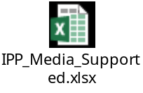

L6.5 AirPrint 1.8 Requirements
IPP server is updated to support below features for AirPrint 1.8 requirements.

AirPrint version:
AirPrint version is updated to “1.8” for IPP printer attribute “ipp-features-supported”.

Waste toner level support
Waste toner level are updated as below for IPP printer attributes
Printer attribute | Old value | New value
marker-low-levels | {3,3,3,3,0} | {3,3,3,3,0}
marker-high-levels | {100,100,100,100,0} | {100,100,100,100,98}
marker-levels | {100,100,100,100,-3*}  * -3: unknown but has not yet reached capacity | {100,100,100,100,X}  X value meaning:  0 : Waste Toner Empty  80 : Waste Toner Near Full  98 :Waste Toner Full

Waste toner level for marker-high levels and marker-level are updated according to airprint 1.8 specification for EBX_DCR_63978.

Printer-icons support
New printer icons for Matterhorn in “printer-icons” Printer attribute are updated in below path:
$EB2/TopAccess/AirPrint/images

Media sizes support
For Matterhorn MFP, only below mentioned media sizes are supported.
Media Name | Media Name (ISO) | X Dimension (mm) | Y Dimension (mm) | Media Name (Rotated)
A4 | iso_a4_210x297mm | 21000 | 29700 | A4-R
A5 | iso_a5_148x210mm | 14800 | 21000 | A5-R
A6 | iso_a6_105x148mm | 10500 | 14800 | A6-R
DL | iso_dl_110x220mm | 11000 | 22000 | DL-R
CHOU3 | jpn_chou3_120x235mm | 12000 | 23500 | CHOU3-R
LEGAL | na_legal_8.5x14in | 21590 | 35560 | LEGAL-R
LETTER | na_letter_8.5x11in | 21590 | 27940 | LETTER-R
SH10 | na_number-10_4.125x9.5in | 10477 | 24130 | SH10-R
B5 | jis_b5_182x257mm | 18200 | 25700 | B5-R
FOLIO | om_folio_210x330mm | 21000 | 33000 | FOLIO-R
16K | roc_16k_7.75x10.75in | 19685 | 27305 | 16K-R
SQ85 | om_invite_220x220mm | 22000 | 22000 | 8.5SQ
LEGAL13 | na_foolscap_8.5x13in | 21590 | 33020 | 13inchLEGAL-R
STATEMENT | na_invoice_5.5x8.5in | 13970 | 21590 | STATEMENT-R
YOU4 | jpn_you4_105x235mm | 10500 | 23500 | YOU4-R
MONARCH | na_monarch_3.875x7.5in | 9842 | 19050 | MONARCH-R
JPOST/Postcard (only for JPD model) | jpn_hagaki_100x148mm | 10000 | 14800 | JPOST-R/Postcard-R

IPP server printer attributes "media-col-ready", "media-ready", “media-size-supported” and “media-supported” are updated with above media sizes information. Device Capabilities DOM provide “SH10-R” instead of “COM10-R” as media size as fixed in EBX_DTFR_19882.

L6.5 Toshiba Original media type support
MacOSX 10.14 Mojave supports original media types such as Recycled paper. For support the feature, IPP server is updated to support a new printer attribute “printer-strings-uri” (URI type) with the URL of text file (http://10.10.1.10/MediaInfo/ToshibaMedia.txt). IPP server also updated with new original media types along with existing types. [Updated for fix for EBX_DTFR_19854]
The media information text file is prepared with the fixed content of supported Toshiba original media types.

The text file is requested by MacOSX client by using HTTP_GET_SEND request. Configuration file “virtualhostp.conf“ is updated to support this request.

L6.5 Custom media size support
When user defines custom media size in input drawer, then IPP prepares “media-ready” & “media-col-ready” printer attributes with ”custom_current.trayN_XXxYYmm” value for “Get-Printer-Attribute” operation.
Below table defines exact value for each Input Tray based in its installation status:

Input Drawer | Printer attribute value
Tray 1 | custom_current.tray1_XXxYYmm
Tray 2 | custom_current.tray2_XXxYYmm
Tray 3 | custom_current.tray3_XXxYYmm
Tray 4 | custom_current.tray4_XXxYYmm

LCF does not support custom media size.
This change is common for both AirPrint and Mopria requirements.

L6.5 Mopria Requirements
IPP server is updated to support below features for Mopria 2.0 requirements.

Mopria version:
Mopria version is updated to “2.0” for IPP printer attribute “mopria-certified”.

Media sizes support
For Matterhorn MFP, only below mentioned media sizes are supported.
Media Name | Media Name (ISO) | X Dimension (mm) | Y Dimension (mm) | Media Name (Rotated)
A4 | iso_a4_210x297mm | 21000 | 29700 | A4-R
A5 | iso_a5_148x210mm | 14800 | 21000 | A5-R
B5 | jis_b5_182x257mm | 18200 | 25700 | B5-R
LETTER | na_letter_8.5x11in | 21590 | 27940 | LETTER-R
LEGAL | na_legal_8.5x14in | 21590 | 35560 | LEGAL-R
JPOST/Postcard | jpn_hagaki_100x148mm | 10000 | 14800 | JPOST-R/Postcard-R

L6.141 HDD Access Reduction
IPP Server and IPP LIB is updated to reduce HDD access as described in the attached file.
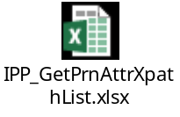

L6.15 Resource Leak Issue Fix
IPP Server and IPP LIB is updated to fix Resource (Shared Memory) leak issue in IPP Printing. Shared memory is deleted after fetching workflow ID for every print job.

Use Case Realization
This chapter presents use cases that apply to this requirement.

Use Cases
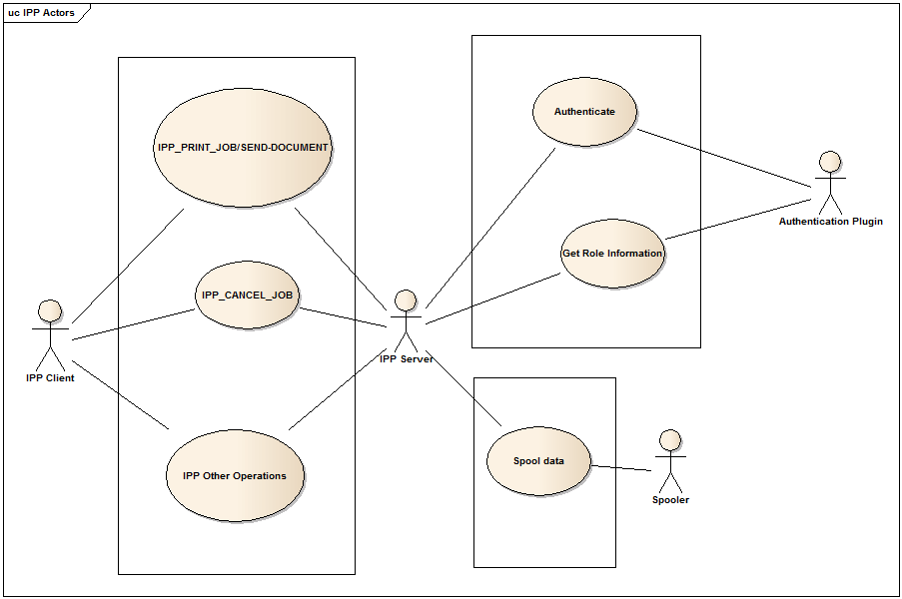
Figure 1: Use case model for Authentication extension in IPP Printing

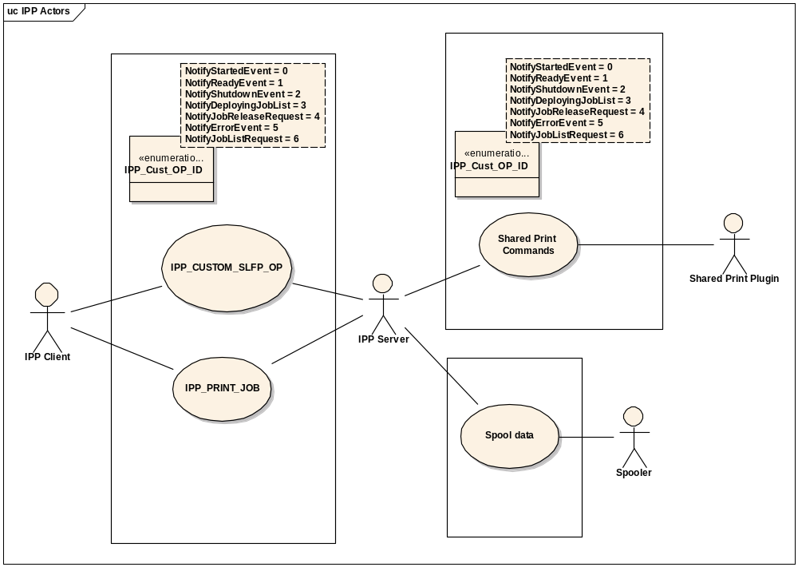
Figure 2: Use case model for IPP Printing (SLFP support)

Handling Print-Job/Send-document

Pre Conditions
- IPP Server is running.
- IPP SSL is enabled.
- IPP authentication is enabled.
- MFP user authentication is enabled for print function.

Realization
- IPP server receives the authentication information in HTTP header.
- Parse the authentication information and authenticate using Authentication Plugin
- Check the requested user’s role using Authentication Plugin.
- If authentication & role are OK, then prepare PJL commands header based on authentication type.
- Submit the prepared PJL header to Spooler
- Submit the print job to Spooler
- Update the internal job list (JobStatus → struct ipp_job_status) with username, password & hostname for the current job.
- If authentication failure is observed, IPP server will reject the print job with error client-error-not-authorized.
- If MFP user authentication is disabled, then IPP will fall back to its Basic authentication.

Post Conditions (Success Case)
IPP Server will send IPP_OK to IPP Client.

Post Conditions (ErrorCase)
IPP Server will send “client-error-not-authorized” to IPP Client.

Handling Cancel-Job, Get-Job-Attribute, Get-Jobs & Close-Job

Pre Conditions
- IPP Server is running.
- IPP with SSL is enabled.
- IPP authentication is enabled.
- MFP user authentication is enabled for print function.

Realization
- IPP server receives the authentication information in header.
- From the internal job list (JobStatus → struct ipp_job_status), validate whether the request is from the same user.
- Parse the authentication information and authenticate using Authentication Plugin
- Check the requested user’s role using Authentication Plugin
- If authentication & role are OK, perform the requested operation from client.
- If authentication failure is observed, IPP server will reject the print job with error client-error-not-authorized.
- If MFP user authentication is disabled, then IPP will fall back to its Basic authentication.

Post Conditions (Success Case)
IPP Server will send IPP_OK to IPP Client.

Post Conditions (ErrorCase)
IPP Server will send “client-error-not-authorized” to IPP Client.

Handling other IPP operations (Get-Printer-Attribute, Validate-Job, Create-Job, Get-Printer-Attribute, Get-Printer-Supported-Values, Set-Printer-Attribute and Identify-Printer)

Pre Conditions
- IPP Server is running.
- IPP with SSL is enabled.
- IPP authentication is enabled.
- MFP user authentication is enabled for print function.

Realization
- IPP server receives the authentication information in header.
- Parse the authentication information and authenticate using Authentication Plugin
- Check the requested user’s role using Authentication Plugin
- If authentication & role are OK, perform the requested operation from client.
- If authentication failure is observed, IPP server will reject the print job with error client-error-not-authorized.
- If MFP user authentication is disabled, then IPP will fall back to its Basic authentication.

Post Conditions (Success Case)
IPP Server will send IPP_OK to IPP Client.

Post Conditions (ErrorCase)
IPP Server will send “client-error-not-authorized” to IPP Client.

Updating Printer Error Logs (Connection timeout, Max connection occurred, Job near full occurred & Hard disk near full occurred)

Pre Conditions
- IPP Server is running.

Realization
- When connection timeout occurs, IPP will update internal job log with error code "4511" & set the connection timeout XPATH (Network/Status/PrintErrorState/ConnectionTimeout) to “true”.
- When Maximum number of clients are connected already, then IPP will update internal job log with error code “4521” & set the maximum connection XPATH (Network/Status/PrintErrorState/MaxConnection/IPP) to “true”. When IPP server is able to accept connection again, this XPATH will be set with “false”.
- When Workflow near full occurs, then IPP will update internal job log with error code “4522” & set the Workflow full XPATH (Network/Status/PrintErrorState/WorkflowFull) to “true”. When IPP server is able to accept connection again, this XPATH will be set with “false”.
- When Hard disk near full occurs, then IPP will update internal job log with error code “4522” & set the Workflow full XPATH (Network/Status/PrintErrorState/HDDFull) to “true”. When IPP server is able to accept connection again, this XPATH will be set with “false”.
- IPP will use libcommonutil module to update the job log error code.

Post Conditions (Success Case)
IPP Server will send IPP_OK to IPP Client.

Post Conditions (ErrorCase)
NA

Support for Erasable Blue toner

Pre Conditions
- IPP Server is running.

Realization
- Based on Toner mode, IPP will set the supported “media-type” attribute.
- Based Toner mode, IPP will support toner remaining ("marker-levels" printer attribute) of erasable blue toner.
- Based on toner mode, IPP will support Finishing Exclusive Control for Erasable Blue ("finishing-template-supported", "finishings-col-ready" , "finishings-col-database" "urf-supported" and "finishings-supported" printer attributes).

Post Conditions (Success Case)
IPP Server will send IPP_OK to IPP Client.

Post Conditions (ErrorCase)
IPP Server will send IPP_BAD_REQUEST/IPP_INTERNAL_ERROR/IPP_OK_SUBST to IPP Client.

Support for AirPrint v1.6

Pre Conditions
- IPP Server is running & AirPrint is enabled.

Realization
- Based on 08-8798 value, IPP server will support AirPrint version 1.6 for “ipp-features-supported” printer attribute
- IPP Server will support new printer attribute “jpeg-features-supported” (1setOf type2 keyword) with keywords {“none”, “arithmetic”, “cmyk”, “icc”, “progressive”}.
- IPP Server will support “printer-input-tray” attribute with SubUnitStatus value as “19”.

Post Conditions (Success Case)
IPP Server will send IPP_OK to IPP Client.

Post Conditions (ErrorCase)
IPP Server will send IPP_BAD_REQUEST/IPP_INTERNAL_ERROR/IPP_OK_SUBST to IPP Client.

IPP_C to IPP_S custom command execution

Pre Conditions
- IPP Server is running.
- IPP with SSL is enabled.

Realization
- IPP Client will request IPP server for the custom operation IPP_CUSTOM_SLFP_OP
- IPP Server will identify the event by parsing the custom printer attribute (ipp-slprn-attr)
- IPP Server will notify SPP one of below operations with appropriate parameters (passed from IPP Client):
  - NotifyStartedEvent
  - NotifyReadyEvent
  - NotifyShutdownEvent
  - NotifyDeployingJobList
  - NotifyJobReleaseRequest
  - NotifyErrorEvent
  - NotifyJobListRequest

Post Conditions (Success Case)
IPP Server will send IPP_OK to IPP Client.

Post Conditions (ErrorCase)
IPP Server will send IPP_INTERNAL_ERROR to IPP Client.

Receive Job Data

Pre Conditions
- IPP Server is running.
- IPP with SSL is enabled.

Realization
- IPP Client will send request IPP_PRINT_JOB with custom attributes for current job.
- IPP server will Acquire Spooler instance (new type), pass custom job details & spool the current job data.

Post Conditions (Success Case)
IPP Server will send IPP_OK to IPP Client.

Post Conditions (ErrorCase)
IPP Server will send IPP_INTERNAL_ERROR to IPP Client.

Multi-station Print Support for Mac OSX

Pre Conditions
- IPP Server is running.
- Latest version of Mac PPD is installed on Mac OSX

Realization
- If IPP printer is added via Bonjour discovery or using “ipp/print” queue, then Mac OSX will check for job status of submitted Multi-station print job.
- Since the Multi-station print job will not have workflow ID, it is not possible to get the print job status in IPP server. After all the data is spooled (HTTP_POST_SEND state), IPP used to call ipp_get_wfid() without timeout value (blocking call), which caused print job to be not cleared from Mac OSX spooler queue. In current design, it is implemented to call ipp_get_wfid() with 1000ms timeout value. Thus IPP will not wait multi-station print job and return job-completed status immediately.
- For every print data request from Mac OSX, ipp_get_wfid() was called with 500ms timeout value previously, which caused performance impact. IPP internally supports 256KB print data buffer & calls spooler write interface once buffer is full. Currently, it is modified to call ipp_get_wfid() only when spooler write is called. This will reduce the number of calls to ipp_get_wfid() (with 500ms timeout) and improving the performance.

Post Conditions (Success Case)
IPP Server will send IPP_OK to IPP Client.

Post Conditions (ErrorCase)
IPP Server will send IPP_INTERNAL_ERROR to IPP Client.

Multi-station Print SSL mode support

Pre Conditions
- IPP Server is running.
- Multi-station Print is enabled

Realization
- To handle multi-station print SSL requests despite of IPP SSL settings, CUPS will be started with 2 instances in different port numbers.
- Legacy IPP server will use port number 631 (SSL/non-SSL) and multi-station IPP server will use 30631 (user configurable)
- Multi-station IPP server will handle only multi-station print requests.
- IPP NMO will subscribe to XPATH “Controller/Settings/AdminSystemSettings/PrintServiceSetting/AnywhereJob/Enable”, which will have details about Multi-station print settings. Upon receiving notification, IPP NMO will decide to start two IPP server processes or single process based on Multi-station print settings.
- IPP NMO will handle below additional XPATHs for multi-station IPP server and start-up sequence and different configuration file (cupsd-multistation.conf).
Port Number: Network/Services/IPP/MultiStationPortNo
Enable SSL: Network/Services/IPP/MultiStationEnableSSL
Authentication: Network/Services/IPP/MultiStationAuthenticationMethod
User Name: Network/Services/IPP/MultiStationUserName
Password: Network/Services/IPP/MultiStationUserPassword

- IPP NMO will manage 2 IPP processes based on the multi-station print SSL settings as below

 | IPP print setting |  | Multi-Station print setting
 | Enable/Disable | Port number  (Select active port depend on SSL setting) | Enable/Disable | Port number | Process start
1 | Enable | 631 | Disable | 30631 | Start 1 process for IPP Print
2 | Disable | 631 | Enable | 30631 | Start 1 process for Multi-Station Print
3 | Enable | 631 | Enable | 30631 | Start 2 processes
4 | Enable | 631 | Enable | 631 | Start 1 process for IPP Print
5 | Enable | 30631 | Enable | 30631 | Start 1 process for IPP Print
6 | Disable | 631 | Disable | 30631 | Not start process

- IPP NMO will use new arguments with ipprinting start-up script (start_multi, stop_multi & restart_multi). In start-up script, second IPP process will be invoked with new configuration file cupsd-multistation.conf.

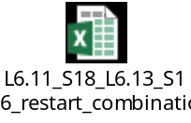

Post Conditions (Success Case)
IPP Server will send IPP_OK to IPP Client.

Post Conditions (ErrorCase)
IPP Server will send IPP_INTERNAL_ERROR to IPP Client.

Wi-Fi Setup via IPP-USB

Pre Conditions
- IPP Server is running.
- Wi-Fi is configured at Mac OSX side
- Wireless kit is installed on MFP
- MFP is connected to Mac OSX (Sierra or later) using USB cable
- Mac OSX client must provide both “printer-wifi-ssid” and “printer-wifi-password” printer attributes.
- Below XPATHs are checked in order to achieve the functionality

XPATH | Expected value
Network/Services/USBDirectPrintServer/enableIPP | 1
MFP/System/WirelessLAN/Installation | Installed
Network/Services/USBWifiSetup/enabled | 1

Realization
- When MFP is connected with Mac using USB cable, IPP will send the printer attributes ("printer-wifi-state" value:4,”printer-state-reasons” value: ‘wifi-not-configured-report’ , "printer-wifi-ssid" and "printer-wifi-password" with value NULL & List "printer-wifi-ssid" and "printer-wifi-password" to "printer-settable-attributes-supported" attribute).
- After detecting the printer attributes, Mac will prompt user to access key chain & configure Toshiba MFP with current Wifi settings.
- If user chooses “YES”, then Mac will send "printer-wifi-ssid" and "printer-wifi-password" attributes with “set-printer-attribute” operation.
- Since main IPP print process will be restarted as dependent service after configuring Wireless, wireless configuration response cannot be sent. This will cause wireless configuration failure, which is fixed by launching new IPP process listening on port number 20631 for handling only requests on “localhost” interface (requests from IPP-USB & Port 80 forward). This IPP process will not be restarted as dependent service.
- Upon receiving "printer-wifi-ssid" and "printer-wifi-password" attributes, IPP server will set XPATHs (“printer-wifi-ssid” to “Network/Adapters/Wireless/ssid” and “printer-wifi-password” to “Network/Adapters/Wireless/Autoconfigpasswd”) and send “Commit” command to NSM (Wireless NMO).
- Sending “Commit” command using API ExecuteCommand() is a blocking call until wireless is configured successfully & Mac OSX will expect wireless configuration status continuously after sending configuration details. Hence sending Commit command is performed in a new thread & main thread will process the requests from Mac OSX.
- If Mac requests for “printer-wifi-state” attribute during configuration of wireless network, IPP will read Network DOM (Network/Adapters/Wireless/currentStatus) for current status & reply to Mac appropriately (values: 3-8). After successful configuration, IPP will set value 8 (joined to the configured wireless network).
XPATH Network/Adapters/Wireless/currentStatus Value | “printer-wifi-state” value | Current wireless network state
Disconnected | 3 (off) | Wireless networking is turned off.
Disconnected | 4 (not-configured) | Wireless networking is not yet configured.
Disconnected | 5 (not-visible) | The configured wireless network is not visible.
Disconnected | 6 (cannot-join) | Unable to join the configured wireless network.
Connecting | 7 (joining) | Joining the configured wireless network.
Connected | 8 (on) | Joined to the configured wireless network.
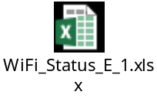
- Since Mac OSX expects response for “printer-wifi-state” immediately after sending configuration, IPP will set value "USBConfigConnecting" to "Network/Adapters/Wireless/currentStatus" XPATH & return ‘joining’ (7) to Mac OSX until Wireless NMO updates the value later.

Post Conditions (Success Case)
IPP Server will send values (7 and 8) described in above table for “printer-wifi-state” along with return value of IPP_OK to Mac OSX.

Post Conditions (ErrorCase)
IPP Server will send values (6) described in above table for “printer-wifi-state” along with return value of IPP_OK to Mac OSX for Get-Printer-Attribute operation.
For Set-Printer-Attribute operation, IPP will return IPP_OK.
In case MFP is not able to join the network, IPP will send the value 6 for “printer-wifi-state” printer attribute request.
If Mac OSX client does not provide both of “printer-wifi-ssid” and “printer-wifi-password” printer attributes, then CUPS will return “client-error-bad-request” error.

AirPrint v1.7 support for ipp-features-supported attribute

Pre Conditions
- IPP Server is running.
- AirPrint is enabled

Realization
- If IPP client requests for printer attribute “ipp-features-supported”, then set the value as “airprint- 1.7” along with other values ( e.g: "icc-color-matching", "faxout").

Post Conditions (Success Case)
IPP Server will send IPP_OK to IPP Client.

Post Conditions (ErrorCase)
IPP Server will send IPP_INTERNAL_ERROR to IPP Client.

AirPrint v1.7 support for printer-firmware-name extension

Pre Conditions
- IPP Server is running.
- AirPrint is enabled

Realization
- If IPP client requests for printer attributes “printer-firmware-name” & “printer-firmware-string-version”, then set the value additional values of "IPP Server", "JPEG Interpreter", "PDF Interpreter", and "URF Interpreter" along with existing "Copier Firmware Version".
- For “printer-firmware-string-version”, Printer firmware version is currently read using diagnostic code 08-9900 and set.
- Printer attribute “printer-firmware-version” also updated with additional firmware version values in order to avoid APVT warning.

Post Conditions (Success Case)
IPP Server will send IPP_OK to IPP Client.

Post Conditions (ErrorCase)
IPP Server will send IPP_OK for any XPATH read issues and IPP_INTERNAL_ERROR in case of any internal memory allocation or resource related errors to IPP Client.

AirPrint v1.7 support for IPP SSL as default

Pre Conditions
- IPP Server is enabled.

Realization
- From the MFP models Weiss3/Reuss2/Shasta2/Shastina2 or later, IPP SSL will be enabled by default & port number will be changed to 631 instead of 443. IPP NMO will update the configuration file (cupsd.conf) before CUPS is started.
- IPP NMO will change the settings based on diagnostics code 08-9550.
- Below settings are considered for normal mode & high security mode:
Normal Mode:
SSL setting of the IPP server  (08-9550) | Port Number:  631 | SSL Port Number :  631 | SSL Port Number :  443 | IPP  (Port Number) | Bonjour  (Port Number)
Disable | Open | Close | Close | IPP(631) | IPP(631)
Enable  (Default) | Open | Open | Close | IPP(631)/IPPS(631) | IPPS(631)
High Security Mode:
SSL setting of the IPP server  (08-9550) | Port Number:  631 | SSL Port Number :  631 | SSL Port Number :  443 | IPP  (Port Number) | Bonjour  (Port Number)
Disable | Open | Close | Close | IPP(631) | IPP(631)
Enable  (Default) | Close | Open | Close | IPPS(631) | IPPS(631)
- For supporting IPP-USB & IPP port-80 printing, IPP will be listening on “localhost:20631” port number for all the cases.
- CUPS with default configuration value “DefaultEncryption Ifrequested” can accept both SSL & non-SSL communications. In order to restrict SSL communication when SSL is disabled, below parameters are added to cupsd.conf file & CUPS patch:
DefaultEncryption Value | Connection accepted
Never | Only non-SSL
Required | Only SSL on SSLPort <portNo>
IfRequested | Both SSL & Non-SSL

Post Conditions (Success Case)
NA

Post Conditions (ErrorCase)
NA

Mobile Print Finishing’s supported

Pre Conditions
- IPP Server is running.
- AirPrint is enabled

Realization
- When mobile print is executed with print –job finishings (staple, punch), IPP will prepare PJL command based on attached specification.
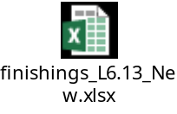

Post Conditions (Success Case)
IPP Server will send IPP_OK to IPP Client.

Post Conditions (ErrorCase)
NA

HCD-PP requirements Support

Pre Conditions
- MFP is in high security mode
- IPP Print is enabled

Realization
- When MFP is in high security mode, CUPS is updated to clear entropy counter before every TLS hanshakes by executing below command:
/home/SYSROM_SRC/bin/PltSramDefault CEC

Post Conditions (Success Case)
IPP Server will send IPP_OK to IPP Client.

Post Conditions (ErrorCase)
NA

L6.5 AirPrint v1.8 support for “ipp-features-supported” attribute

Pre Conditions
- IPP Server is running.
- AirPrint is enabled

Realization
- If IPP client requests for printer attribute “ipp-features-supported”, then set the value as “airprint-1.8” along with other values ( e.g: "icc-color-matching", "faxout").

Post Conditions (Success Case)
IPP Server will send IPP_OK to IPP Client.

Post Conditions (ErrorCase)
IPP Server will send IPP_INTERNAL_ERROR to IPP Client.

L6.5 waste toner level support

Pre Conditions
- IPP Server is running.
- AirPrint is enabled

Realization
- IPP server will set “marker-high-levels” attribute with the value {100,100,100,100,100} for Get-Printer-Attributes operation
- IPP server will set “marker-levels” attribute with the value {C, M, Y, K, 0} for Get-Printer-Attributes operation when waste toner level is empty.
- IPP server will set “marker-levels” attribute with the value {C, M, Y, K, 80} for Get-Printer-Attributes operation when waste toner level is near full.
- IPP server will set “marker-levels” attribute with the value {C, M, Y, K, 98} for Get-Printer-Attributes operation when waste toner level is full.

Post Conditions (Success Case)
IPP Server will send IPP_OK to IPP Client.

Post Conditions (ErrorCase)
IPP Server will send IPP_INTERNAL_ERROR to IPP Client.

L6.5 AirPrint v1.8 Media sizes support

Pre Conditions
- IPP Server is running.
- AirPrint is enabled

Realization
- If IPP client requests for printer attributes "media-col-ready", "media-ready", “media-size-supported” and “media-supported”, then IPP server will reply only media sizes defined in section 2.2.10 table. For unsupported media-size requests, A4 media size will be assumed by default.

Post Conditions (Success Case)
IPP Server will send IPP_OK to IPP Client.

Post Conditions (ErrorCase)
IPP Server will send IPP_INTERNAL_ERROR to IPP Client.

L6.5 Toshiba Original media type support

Pre Conditions
- IPP Server is running.
- AirPrint is enabled

Realization
- New text file (ToshibaMedia.txt) is prepared with supported Toshiba original media types and is copied from $EB2/NoBuildItems/AL/Network to /work/al/network/AirPrint//mediaInfo.
- Install_al-net.sh script is modified to create /work/al/network/AirPrint//mediaInfo folder and to copy file from $EB2/NoBuildItems/AL/Network. [Updated When TA issue is fixed for B650.36]
- If Mac OSX client requests for printer attributes attribute “printer-strings-uri”, then IPP server will return URI of the text file as http://[MFP_IP or HOSTNAME]/MediaInfo/ToshibaMedia.txt . [Updated for fix of EBX_DTFR_19854]

- If Mac OSX client sends HTTP_GET_SEND request for the text file, then text file data is transferred to Mac OSX. New entry is added to virtualhostp.conf file with text file location to support HTTP GET command from Mac OSX.
- Mac OSX will use Toshiba Custom media type information to display the media types in Print preferences window.

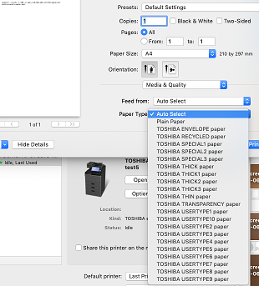

Post Conditions (Success Case)
IPP Server will send IPP_OK to IPP Client.

Post Conditions (ErrorCase)
IPP Server will send IPP_INTERNAL_ERROR to IPP Client.

L6.5 Custom Media sizes support

Pre Conditions
- IPP Server is running.
- AirPrint is enabled

Realization
- If IPP client requests for printer attributes “media-ready” or “media-col-ready” and user defined custom media size in input drawer, then IPP server will reply with value ”custom_current.trayN_XXxYYmm” for “Get-Printer-Attribute” operation.

Post Conditions (Success Case)
IPP Server will send IPP_OK to IPP Client.

Post Conditions (ErrorCase)
IPP Server will send IPP_INTERNAL_ERROR to IPP Client.

L6.5 Mopria version

Pre Conditions
- IPP Server is running.
- AirPrint is enabled

Realization
- If IPP client requests for printer attribute “mopria-certified”, then set the value as “2.0”.

Post Conditions (Success Case)
IPP Server will send IPP_OK to IPP Client.

Post Conditions (ErrorCase)
IPP Server will send IPP_INTERNAL_ERROR to IPP Client.

L6.5 Mopria Media sizes support

Pre Conditions
- IPP Server is running.
- AirPrint is enabled

Realization
- If Mopria client requests for printer attributes "media-col-ready", "media-ready", “media-size-supported” and “media-supported”, then IPP server will reply only media sizes defined in section 2.2.10 table (AirPrint requirements).
- IPP server has common mechanism to handle incoming Get-Printer-Attribute request from both AirPrint and Mopria clients. Hence, IPP server will return media information defined for AirPrint requirements for Mopria requests also. It is up to Mopria client on Mobile device to display only media sizes defined in section 2.2.13 table (mopria requirements) for the user.

Post Conditions (Success Case)
IPP Server will send IPP_OK to IPP Client.

Post Conditions (ErrorCase)
IPP Server will send IPP_INTERNAL_ERROR to IPP Client.

L6.141 HDD Access Reduction

Pre Conditions
1. IPP Server is running.

Realization
1. HDD access Reduction is accomplished by following methods,
- Xpaths “Network/Services/IPP/port80Enabled”,“Network/Services/IPP/enableSSL” are read during process startup itself and the values are cached. Only the cached values are used for further Get Printer Attributes requests.
- Printer attributes whose values are based on following Controller DOM xpaths are read by subscribing to Controller DOM XPATH in a new thread and by reading the values only when updated. In normal cases, cached value can be used to avoid HDD access.
- Controller/Information/physicalLocation
- Controller/Information/adminMessage
- Controller/Information/Manufacturer
- Controller/Settings/AdminSystemSettings/Printer/DefaultRawJobSetting/DuplexPrinting
- Controller/Settings/AdminSystemSettings/Printer/DefaultRawJobSetting/Orientation
- Controller/Settings/AdminSystemSettings/Printer/DefaultRawJobSetting/PaperSize
- Controller/Settings/AdminSystemSettings/Printer/DefaultRawJobSetting/PaperSize
- Controller/Information/GeoLocation
- Controller/Settings/AdminSystemSettings/Printer/DefaultRawJobSetting/Stapling
- Controller/Settings/AdminSystemSettings/Fax/TerminalId/idName
- Controller/Settings/AdminSystemSettings/Fax/TerminalId/faxNumber
- Controller/Settings/AdminSystemSettings/Report/CommReport/MemoryTX
- GetAirPrintICCProfileInformationList command will be executed during first Get Printer Attributes Request or after Set-Printer-Attributes (RegisterICCProfile) operation is performed to update cache value.
For further Get-Printer-Attributes operation request, cached value will be used, which will avoid HDD access.

- For Get Printer Attrbutes Request, Printer Status is read using xpath “MFP/System/NetworkReception/StatusForPrintJob” to avoid HDD access instead of ci::systeminformation::SysInfoRef->GetAvailableSize() to determine the remaining HDD space.
- Xpaths “Network/Services/IPP/portNo” and “Network/Services/IPP/sslPortNo” which are not used are removed.

Post Conditions (Success Case)
NA.

Post Conditions (ErrorCase)
NA.

L6.15 Resource Leak Issue Fix

Pre Conditions
1. IPP Server is running.

Realization
• IPP will create and use one dynamic message port for communication with PJM.
• IPP will create a new thread to handle notifications from PJM.
• IPP will create and maintain list of structure with Spooler job id, WFID for shmemory destroy.
• When a print job is received, IPP will call StartJob() with fixed message port and continue spooling the job data in the main thread
• IPP will add entry with Spooler job id in its structure (WFID = -1)
• In the secondary thread, IPP will wait for notifications from PJM
• When WFIDNotification is received at the time of RIP start, IPP will compare the Spooler job id with WFIDNotification->SequenceID. The matching structure will be updated with WFID.
• Main thread can intermediately check the structure and update WFID (similar to existing mechanism, but without timeout) and susbscribe to workflow id notifications.
• When WEPNotificationMsg is received (at the time of 1st page RIP completed), IPP will compare the Spooler job id with WFIDNotification->SequenceID. IPP will call Destroy of shmem,
• Any abnormal condition is detected, then IPP process will exit without destroying pending shmemory. This is applicable for other modules also.

Post Conditions (Success Case)
NA.

Post Conditions (ErrorCase)
NA.

Design Methodology
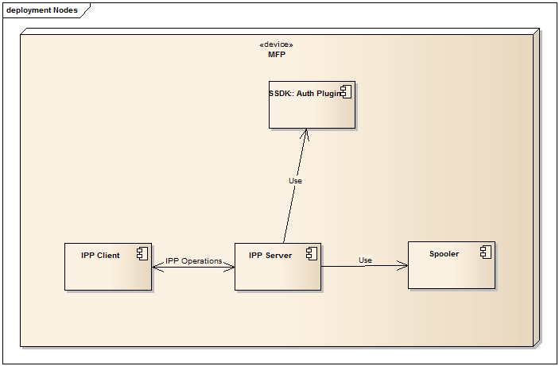
Figure 3. IPP Authentication extension
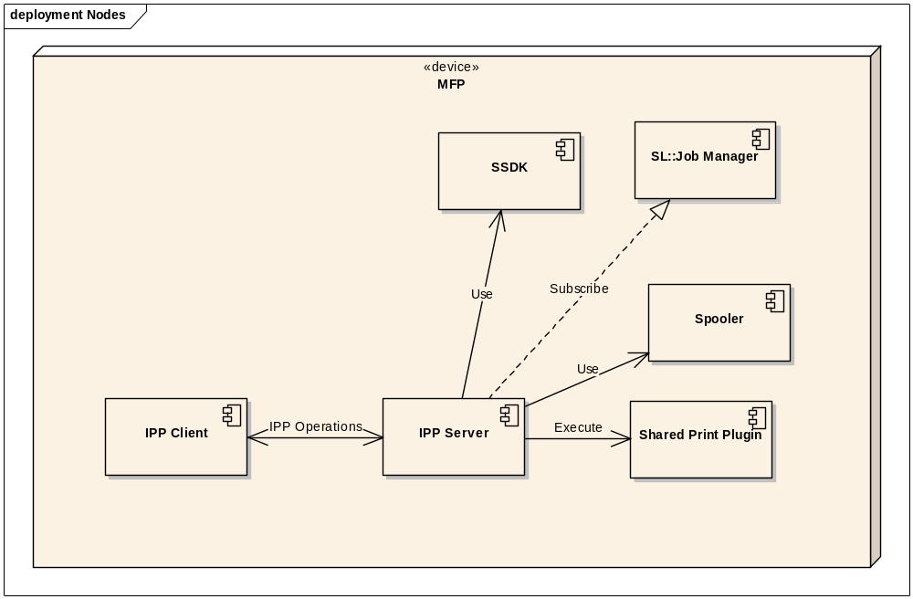
Figure 4. IPP SLFP support

Component Attributes

Identification
There is no namespace identified for IPP Server.

Function
The below functional modules have been implemented as sub modules for realizing Server-less Location Free Printing features.
- IPP Server – Open source based CUPS server, patched for eBX/eBN specific requirements to support features such as AirPrint, IPP Fax, Server-less Location Free Printing, Mopria Print support etc.
- IPP Library – Dynamically loaded library for accessing eBX/eBN specific XPATHs & handling subscription with other eBX/eBN modules (SL).

Interface
IPP Authentication extension is implemented in 2 modules.
- IPP Server
- IPP Client

Server-less Location Free Printing is implemented in 2 modules.
- IPP Server
- IPP Client
The interface between IPP Server and IPP Client is bound by the below mechanism
- IPP Operations (IPP supported & custom commands)
  - IPP attributes (IPP supported & custom attributes)
  - Meta-data file
  - Print data file

Processing
IPP-MFP Authentication
- IPP server will receive the credential details in HTTP header
- IPP server will pass the credentials to Authentication plugin for both authentication & role validation.
Print Job Processing
- IPP server will authenticate using Authentication plugin.
- IPP server will populate the PJL commands with credential details and pass it to Spooler before sending actual print job data.
- IPP server will update its internal job list with current user’s credential details for handling job related operations.
Custom Command Processing
- IPP Client in MFP-A will receive the requests from SPP & send it to IPP Server on MFP-B.
- IPP Server will receive these requests and send it to SPP on MFP-B
Print Job Processing
- IPP Client will send Print-data with additional job attributes to IPP Server
- IPP Server will pass the job info details to Spooler & spool the current job.
Print Performance Improvement Using Internal Buffer
- It is observed that IPP client available in Windows & Mac OS sends small amount of data chunks for many times for huge Print job. Previous mechanism used to send the received data directly to AL::Spooler. For huge print data files, number of spooler write calls become more and thus causing performance impact in IPP Printing.
- Here is the comparison of number of spooler write calls between existing mechanism & current mechanism:

 | total time taken (sec) | total number of spooler write calls
IPP (eBX) | 1313 | 31888
IPP (eBX) + 256KB buffer | 373 | 2057

- To improve the performance, IPP defines internal buffer of size 256KB and reduce the number of spooler write calls from about 31000 to 2000.
- If AirPrint is enabled & IPP prepares PJL data for the print job and its size is more than 256KB, then it will be spooled immediately to spooler. If the size is less than 256KB, then it will be copied to internal buffer.
- As soon as the print data is received from client, it is copied to internal buffer up to maximum size of 256KB.
- Once internal buffer is about to become full, then CUPS will call Spooler Write API with internal buffer. Internal buffer is initialized & ready to receive next chunk of print data.
- Once job end is detected, remaining data in internal buffer is spooled & buffer is freed.
- The Print job performance is improved by reducing number of calls to Spooler’s write () call which internally involved with file I/O.
- If any error is encountered during spooler write calls of internal buffer, then current print job will be aborted with error.

Data
Data exchanged between IPP Server & Authentication is in the form of string & user authentication token. IPP server will populate the PJL command in string format & send it to Spooler.
Data exchanged between IPP Client and IPP Server is in the form of IPP attributes & Metadata file. Metadata will be sent similar to Print-Job from IPP Client by using custom IPP command. IPP server will handle the Metadata differently and pass it to SPP.

Design Views

Design View | Scope | Attributes | Example Representation
Interface Description
Detail Description
Table 1 – Design Views

Parameter Modifiers | Parameter Type | Parameter Name | Parameter Initializer | Description | Scope | Optional
Table 2 – Parameter Table

Interface Description View

Interfaces

Interfaces between IPP Server & Authentication Plugin
The below operation is defined for IPP_C and IPP_S for supporting Server-less Location Free Printing.
.

Authenticate & Get Roles
Function Prototype | int authenticate_get_roles(char* username, char *passwd, int ipp_operation, char *domain)
Description | This function will perform below operations:  - authenticate with SSDK Authentication plugin using the provided credentials.  - Get the role of provided user  - Validate the role against the requested IPP operation.
Input Parameters | Username, password and IPP operation enum value
OutPut parameters | LDAP Domain info
Return Value | Status of operation (OK,FAILED, DENIED,ERROR)
Pseudo Code:
int authenticate_get_roles(char* username, char *passwd, int ipp_operation)
{
// Acquire BOProxy
// Populate XML payload with user credentials
// Execute ‘Authentication’ command using BOProxy Ref
// if command failed, return FAILED
//Validate the user permission for Admin or print job
// If the authentication is LDAP or domain, get the default server’s domain name (for PJL)
// if role is not valid, return DENIED
// return ERROR in case of any other error case
}

Interfaces between IPP Client & IPP Server
The below operations are defined for IPP_C and IPP_S for supporting Server-less Location Free Printing.

Custom Operations in IPP_S

IPP_CUSTOM_SLFP_OP
Function Prototype | static void process_slprn_op(cupsd_client_t *con)
Description | This function processes custom IPP request from IPP client. IPP client will add custom attribute & metadata (optional) file for this operation. IPP server will parse the custom attribute “ipp-slprn-attr” value & invoke SPP APIs accordingly
Input Parameters | IPP Connection structure which contains all requested attributes
OutPut parameters | None
Return Value | IPP_INTERNAL_ERROR – If any failure is encountered  IPP_OK – If handling of request is successful
Pseudo Code:
static void process_slprn_op(cupsd_client_t *con)
{
// Get the value of attribute ipp-slprn-attr
if( (attr= ippFindAttribute(con->request, " ipp-slprn-attr ", IPP_TAG_INTEGER)) != NULL)
{
switch(attr->values[0]. integer){
case 0:
//parse & prepare parameters from attributes
NotifyStartedEvent();
break;
case 1:
//parse & prepare parameters from attributes
NotifyReadyEvent();
break();
case 2:
//parse & prepare parameters from attributes
NotifyShutdownEvent()
break();
case 3:
//parse & prepare parameters from attributes
NotifyDeployingJobList();
break;
case 4:
//parse & prepare parameters from attributes
NotifyJobReleaseRequest();
break;
case 5:
//parse & prepare parameters from attributes
NotifyErrorEvent();
break;
case 6:
//parse & prepare parameters from attributes
NotifyJobListRequest();
break;
case 7:
//parse & prepare parameters from attributes
NotifyRefreshResponse();
break;
}
}
}

IPP_PRINT_JOB
Function Prototype | static void print_job(cupsd_client_t *con, ipp_attribute_t *uri)
Description | This function handles Print-Job request from IPP Client
Input Parameters | IPP connection structure & IPP URI
OutPut parameters | Void
In/Out parameters | None
Return Value | IPP_INTERNAL_ERROR – If any failure is encountered  IPP_OK – If handling of request is successful
Pseudo Code:
static void print_job(cupsd_client_t *con, ipp_attribute_t *uri)
{
// Get the value of attribute ipp-slprn-attr
if( (attr= ippFindAttribute(con->request, " ipp-slprn-attr ", IPP_TAG_INTEGER)) != NULL)
{
if(attr->values[0]. Integer == 7){
// get custom attributes with job info passed by IPP_C
//Acquire new type of spooler interface & set the new job info
}
}
// spool data
}

Detailed Design Description View

Theory of operation

Class Model

Collaboration Model

State chart Diagram
NA

Sequence Diagram

Handling Print-Job request

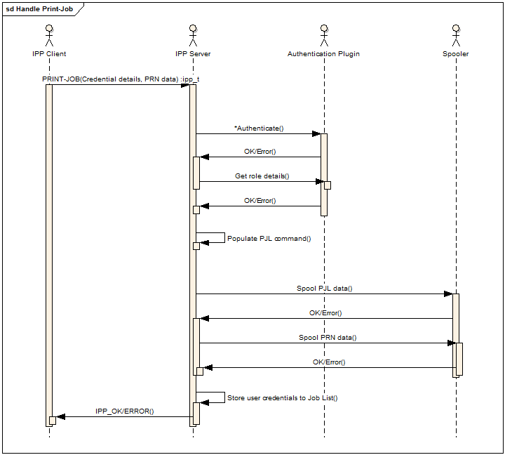
Figure 5: Handling Print-Job

Handling Cancel-Job
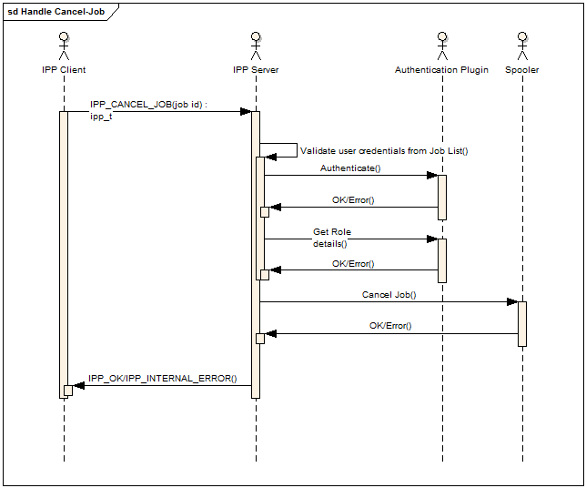
Figure 6: Handle Cancel-Job

Handling other operations
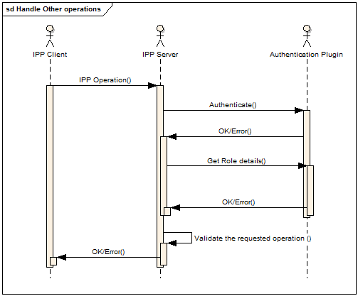
Figure 7: Handle other IPP Operations

Execution of IPP_CUSTOM_SLFP_OP from IPP_C to IPP_S

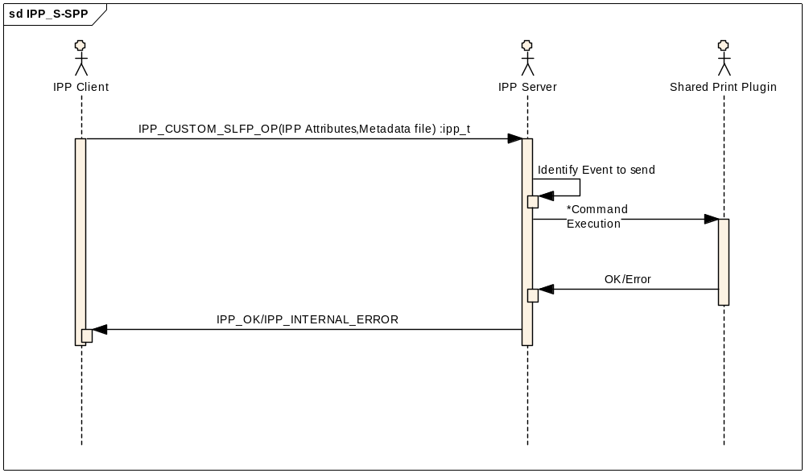
Figure 8: Execution of IPP_CUSTOM_SLFP_OP

Execution of IPP_PRINT_JOB from IPP_C to IPP_S
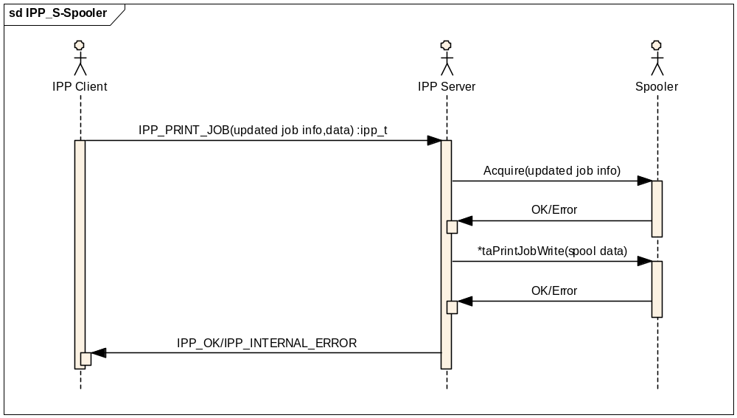
Figure 9: Execution of IPP_PRINT_JOB from IPP_C to IPP_S

Multi-Station Print job support from Mac OSX

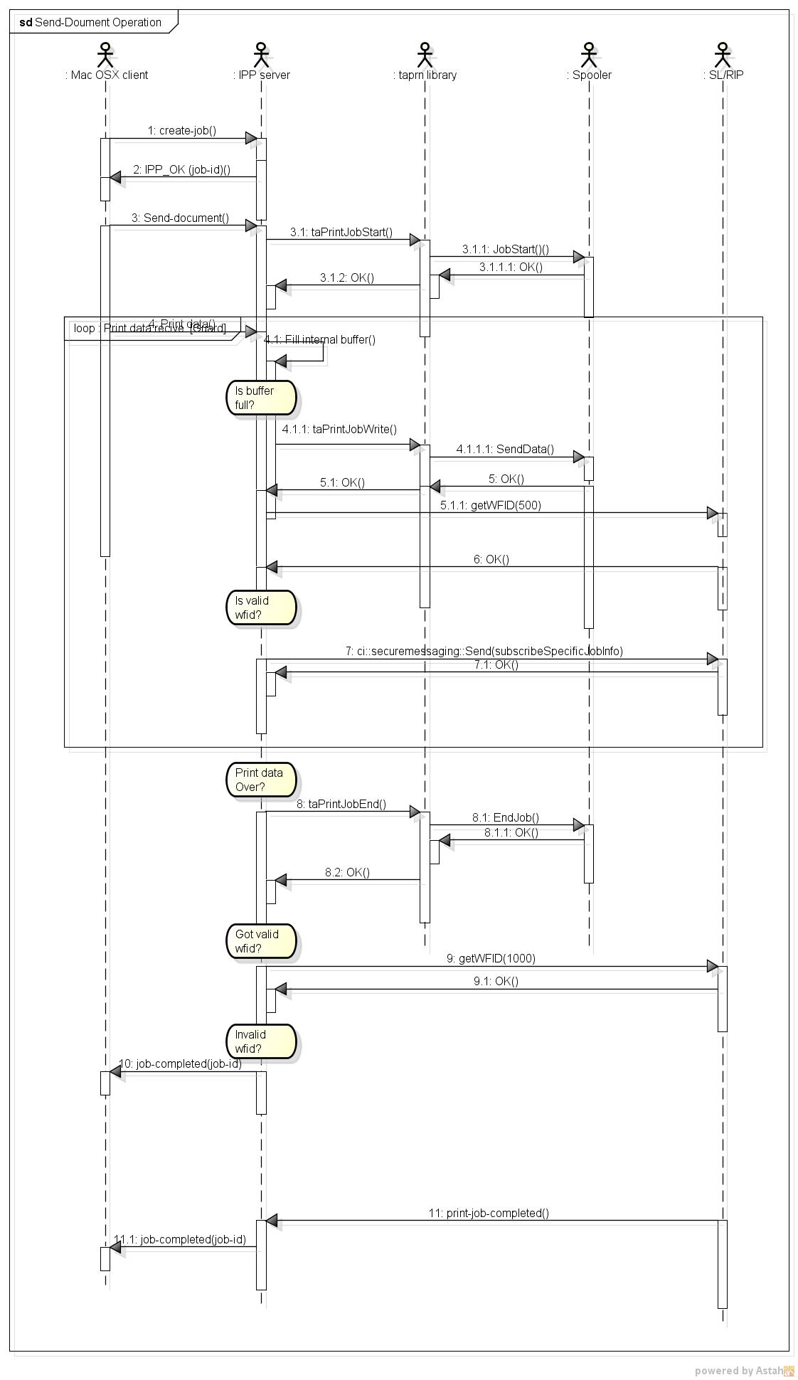
Figure 10: Send-Document Operation

Wifi Setup via IPP-USB
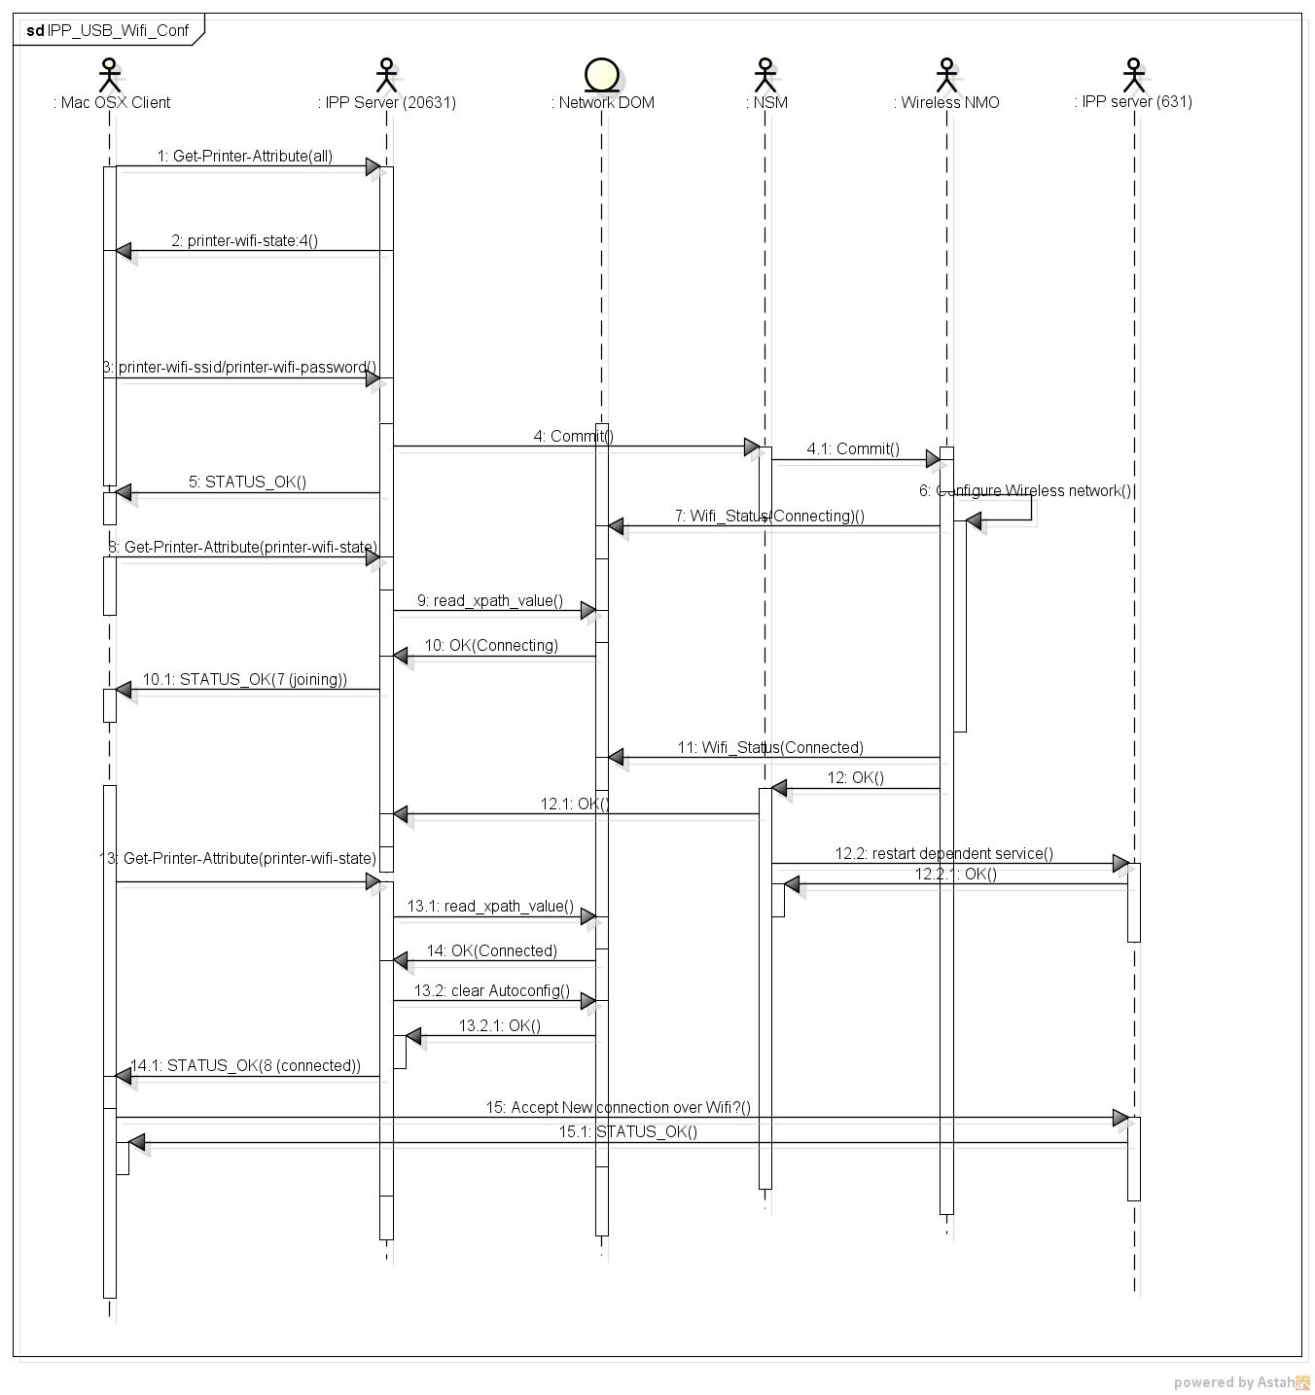
Figure 11: Wifi setup via IPP-USB

Hibernation boot-up sequence
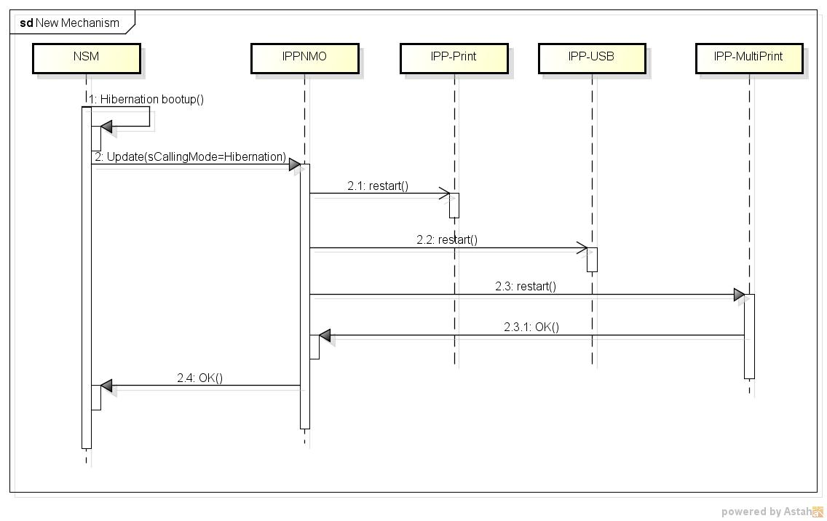
Figure 12: Hibernation boot-up sequence

L6.5 Toshiba Original media type support
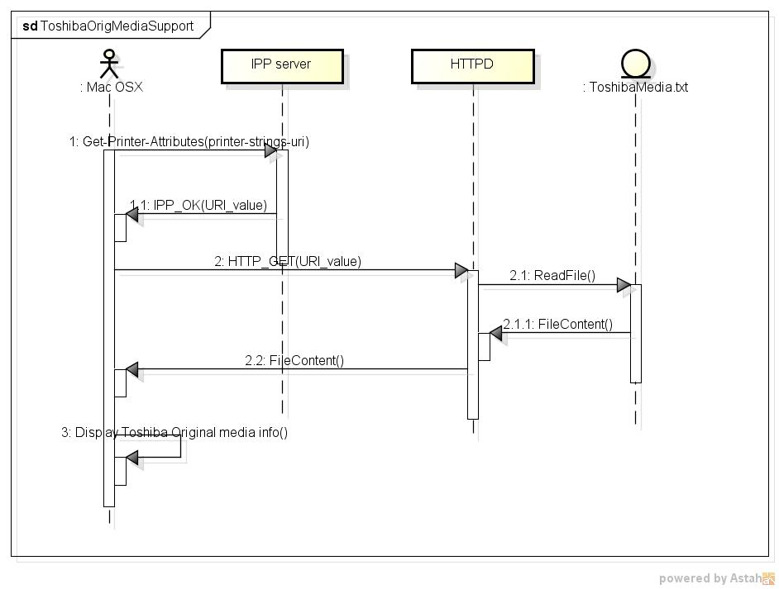
Figure 13: Toshiba Original Media types support

L6.141 HDD Acess Reduction by subscribing to Controller DOM xpaths

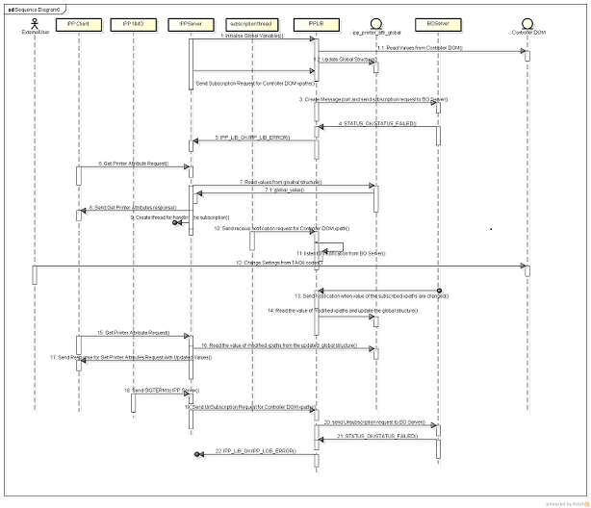

L6.15 Resource Leak issue Fix
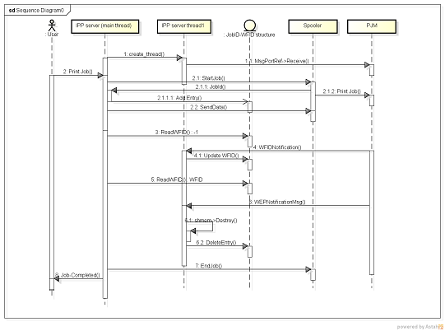

Activity Diagram
NA

Flowchart Diagram
NA

Execution Model

Deployment Diagram
NA

Start/Stop Sequence
NA

UI Flows
NA

Error Handling

NA

Appendix

