DOC No. JEE-01449

CONFIDENTIAL

PRELIMINARY

MODEL:
e-BRIDGE X
TITLE:
<Project> <Component Name> Design Description

Rev. 1.6
Issued: 04/07/2019 15:30

Approved | Checked | Write

Document Info

履歴：
Revision | Date | Description | Page | 担当
V 0.1 | 06/03/2009 | Initial Document | 01
V 0.2 | 03/07/2014 | Function based User Authentication support | 19
V0.2 | 03/14/2014 | BCC support for iFax Transmission | 20
V0.3 | 03/19/2014 | Updated with review comments from MSM
V0.4 | 04/04/2014 | Updated with review comments from MSM | 25
V0.5 | 11/26/2014 | mixed Email destination support for iFax Frwd | 21
V0.6 | 12/08/2014 | Updated with review comments
V0.7 | 06/10/2015 | OCR file format support in iFaxRx Forward | 22
V0.8 | 07/01/2015 | Updated with MSM review comments
V0.9 | 07/08/2015 | Changed xpath for OCR settings of primary Language, secondary language and AutoRotaion
V1.0 | 29/08/2017 | Support for changed interface for WriteJobLogEntry() in eMailCtrl | 27, 32
V1.1 | 26/09/2017 | Support for EmailDirectPrint | 28-37, 44, 53
V1.2 | 04/12/2017 | Support xpath for RIP_JOB_TYPE WEP
V1.3 | 11/12/2017 | Support for DocumentName node settings and SecurityStamp Print settings | 40, 47
V1.4 | 23/02/2018 | Support to Ignore Comments String in Mime Version value | 42, 49
V1.5 | 05/10/2018 | Added additional StatusReasons to handle SL changes in L6.14 SING18 models | 49
V1.6 | 04/07/2019 | Support for California Mode | 51, 44

配布先：

：

略語
Term | Description
PSTN | Public Switched Telephone Network
IFAX | Internet FAX
SMTP | Simple Mail Transfer Protocol
POP3 | Post Office Protocol 3
SSL | Secure Sockets Layer
SSM | Service Startup Manager
MDN | Message Disposition Notification
MFP | Multi-Function Peripheral
OCR | Optical Character Recognition
Table of Contents
1. Introduction 6
1.1 Purpose 6
1.2 Document Conventions 6
1.3 Overview of the Document 6
1.4 Revision History 7
1.5 References 7
1.6 Terms and Definitions 8
2. Overview of the component 9
2.1 Identification 9
2.2 Function 9
3. Use Case Realization 10
3.1 Use Cases 10
3.1.1 Mail Retrieval 10
3.1.1.1 Pre Conditions 10
3.1.1.2 Realization 11
3.1.1.3 Post Conditions 11
4. Design Methodology 12
4.1 Component Attributes 12
4.1.1 Identification 12
4.1.2 Function 12
4.1.3 Interface 12
4.1.4 Processing 12
4.1.5 Data 12
4.2 Design Views 12
5. Interface Description View 14
5.1 Interfaces 14
5.1.1 CI::Schedular::eCommandList 14
5.2 Pseudo Code 15
5.2.1 User Based Authentication Support 15
5.2.2 BCC Support in iFax Transmission 18
5.2.3 Mixed Email destination support for iFaxFrwd 20
5.2.4 New function Get_08Code support in eMailController for Mixed Email destination 23
5.2.5 Optical Character Recognition support for iFaxFrwd(Save As File & Forward as Email) 24
5.2.6 Support of Error flag “ECCErrLog” added as argument of WriteJobLogEntry() 28
5.2.7 Support of Jpeg-PDF Support(EmailDirectPrint Function) 29
5.2.7.1 SpoolTheMail() 29
5.2.7.2 StartSpoolerSequence() 34
5.2.7.3 SetIfaxForwardSettings() 38
5.2.7.4 Get_08Code() 39
5.2.7.5 SetIfaxExtSettings() 41
5.2.8 New function in eMailctrl for Ignoring Comment strings in mime Version 43
5.2.9 Support for California Mode 44
6. Detailed Design Description View 46
6.1 Theory of operation 46
6.1.1 User Based Authentication Support 47
6.1.2 BCC Support in iFax Transmission 47
6.1.3 Mixed Email destination support for iFax 48
6.1.4 Optical Character recognition support for iFaxFrwd 48
6.1.5 Support for changed interface for WriteJobLogEntry() 49
6.1.6 Support for EmailDirectPrint Functionality (EBX_RCR_447) 49
6.1.7 Support for ignoring comment strings and spaces in MIME Version value 50
6.1.8 Added additional StatusReasons to handle SL changes in L6.14 SING18 models 51
6.1.9 Support for California Mode 52
6.2 Class Model 53
6.3 Collaboration Model 54
6.3.1 Sequence Diagram 54
6.3.1.1 Sequence Diagram for iFaxRx 54
6.3.1.2 Sequence Diagram for iFax Transmission with BCC support 55
6.3.1.3 Sequence Diagram for iFax Transmission without BCC support 56
6.3.1.4 Sequence Diagram for Mixed Email destination support for iFaxFrwd 57
6.3.1.5 Sequence Diagram for OCR File Format support 58
6.3.1.6 Sequence Diagram for OCR File Format support for MemorySize less than 4GB 59
6.3.1.7 Sequence Diagram for OCR File Format support-License Manager returns Fail 60
6.3.2 Flow Chart 61
6.3.2.1 Flowchart for User Based Authentication support in iFaxRx 61
6.3.2.2 Flowchart for EmailDirectPrint in iFax 62
6.4 Execution Model 65
6.4.1 Deployment Diagram 65
6.4.2 Start/Stop Sequence 65
6.5 UI Flows 66
6.6 Error Handling 66
7. Appendix 67
7.1 Use Database Table (DOM) 67

Introduction

Purpose
The purpose of this document is to describe the design of iFaxReceive. This design specification should be for the design and development iFaxReceive.
.

Document Conventions
Diagrams which are not legible when the CDD document is printed can be viewed online, by using the zoom feature.

Icons that contain the text None identify sections that do not require a graphical illustration
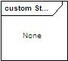

Overview of the Document
This section presents the organization of this document, indicating the contents of each chapter.
Chapter 1 – Introduction
Chapter 1 presents the purpose of the document its structure, revision history and reference information.
Chapter 2 – Use Cases
Chapter 2 presents use cases that apply to the component.
Chapter 3 – Design Methodology
Chapter 3 presents the necessary information content and organization of a Software Design Description.
Chapter 4 – Interface Description View
Chapter 4 presents the details of the component’s external and internal interfaces.
Chapter 5 – Detailed Design Description View
Chapter 5 presents the component’s internal details.

Note: Please be aware that the program interfaces, direct interface and messaging interface are now part of the architecture design document.

Revision History
Version | Date | Author | Notes
V 0.1 | 21/03/2009 | Vishnu Priya
V0.2 | 10/03/2014 | Manasa D S  Vidyashankar H V | Function based User Authentication support
V 0.2 | 14/03/2014 | Manasa D S  Vidyashankar H V | BCC support for iFax Transmission
V 0.3 | 19/03/2014 | Manasa D S  Vidyashankar H V | Updated with comments from MSM
V 0.4 | 04/04/2014 | Manasa D S  Vidyashankar H V | Correction in Flow Chart showing User Based Authentication support in iFaxRx
V0.5 | 11/26/2014 | Manasa D S | mixed Email destination support for iFax
V0.6 | 08/12/2014 | Manasa D S | Updated with comments from MSM
V0.7 | 10/06/2015 | Manasa D S | OCR file format support in iFaxRx Forward
V0.8 | 08/07/2015 | Manasa D S | Updated review comments from MSM
V0.9 | 07/08/2015 | Manasa D S | Changed xpath for OCR settings of primary Language, secondary language and AutoRotaion
V1.0 | 18/08/2017 | Manasa D S | Support for changed interface for WriteJobLogEntry() in eMailCtrl
V1.1 | 28/09/2017 | Manasa D S | New Workflow EmailDirectPrint support
V1.2 | 04/12/2017 | Manasa D S | Support xpath to set RIP_JOB_TYPE WEP
V1.3 | 11/12/2017 | Manasa D S | Support for DocumentName node settings and SecurityStamp Print settings
V1.4 | 23/02/2018 | Manasa D S | Support to Ignore Comments String in Mime Version value
V1.5 | 05/10/2018 | Swaathi S V | Added additional StatusReasons to handle SL changes in L6.14 SING18 models
V1.6 | 04/07/2019 | Manasa D S | Support for Californai Mode L6.15

References
Document | Version | Notes
http://tec-mssd001/Network_Document/L4.63_L4.64/CRS/CRS_iFaxReception_L4.63_FunctionBase_UserAuthentication20131022.doc
http://tec-mssd001/Network_Document/L4.73/CRS/CRS_iFaxReception_L4.73_iFaxTransmission_BCC_Support20140313.doc

http://tec-mssd001/Network_Document/Forms/AllItems.aspx?RootFolder=%2fNetwork%5fDocument%2fSampleROM%2fDisasterPreventionFAX%2fIndividualRelease&FolderCTID=&View=%7bEECD4A8D%2d7C7E%2d4B98%2dA1D2%2d0E86C9682552%7d
http://tec-mssd001/Network_Document/L6.0/CRS/CRS_iFaxRx_faxofframp_L6.0_20150428.doc
http://tec-mssd001/Network_Document/L6.1/CRS/CRS_eMailCtrl_faxofframp_L6.11_L6.13_20170714.docx

02_Requirement\SRS\JEA-03834_JpegPDF Support(eMail Print Function) External Specification.doc

03_Architecture\Responsibility Map\Responsibility Map_EBX_RCR_447_JpegPDF Support(eMail Print Function).xlsx
02_Requirement\SRS\JEA-04093_CaliforniaMode_Specifications.docx

Terms and Definitions
Term | Definition
AL | Application Layer
CI | Common Infrastructure Layer

Overview of the component
IFAX is method of sending and receiving fax data through INTERNET rather than PSTN line. IFAX is bound by protocol. IFAX-RX is method of receiving IFAX from POP3 Server and process the received data.
This document covers the Component Design of IFAXRX component used in eBX for IFAX receiving functionality.

Identification
Component described in this document is named iFaxRx and it resides in AL Layer. Component complete name is:
AL::Network::iFaxRx

Function
This component connects to POP3 mail server, download new mails, and submit the mail for printing. This action is taken on the timer event or on the user request from the LCD panel.

Use Case Realization
This chapter presents use cases that apply to this component.

Use Cases

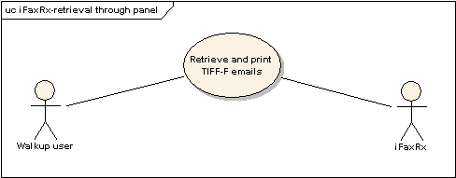
Mail Retrieval
Figure 1: iFaxRx-retrieval through Panel

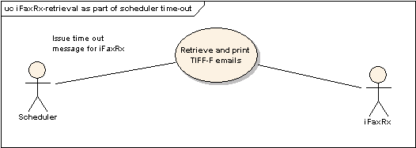
Figure 2: iFaxRx-retrieval as part of scheduler time-out

Pre Conditions
- MFP should be up.
- POP3Client should be configured.

Realization
- Send a TIFF attached mail using PC mail Client.
- Connect to the server.
- Fetch new mails.
- The Received mails are stored in the /imagedata/email/ifaxrx/ path.
- The alifaxreceive process will check the mail storage path for any of the received mails
- Various Work flow execution parameters are set in the Queues DOM for the print user
- Check for MDN is performed and appropriate xpaths are mentioned in Queues path
- Set Error print settings xpath if error print is enabled
- Set Error Transfer settings xpath if error transfer is enabled
- Send the mail data to the spooler and spool the mail

Post Conditions
- The mail received should be printed with the attachment.
- The mail should be forwarded if iFax forward is configured.

Design Methodology

Component Attributes

Identification

Function

Interface

Processing

Data

Design Views
The description of a design can be organized in views that reveal design details from different perspectives and viewpoints. Together these views provide a comprehensive description of the design in a comprehensive and concise manner. The following table illustrates the characteristics of the Interface Design view and of the Detail Description view:

Design View | Scope | Attributes | Example Representation
Interface Description | List of everything a designer, programmer, or tester needs to know to use the components that make up the system. | Identification, Function, Interfaces | Interface Files, Parameter Tables
Detail Description | Description of the internal design details of a component | Identification, Processing, Data | Flows, PDL
Table 1 – Design Views

Example of Parameter table is shown in Table 2.
Parameter Modifiers | Parameter Type | Parameter Name | Parameter Initializer | Description | Scope | Optional
[IN] | INT | Parameter1 | = 1 | Enable or disable timer | 0: Disable  1: Enable | NO
[OUT] | DOUBLE | Parameter2 | = 0 | Time out value in mili-seconds | 0: Initial timeout value  N: N mili-seconds, Max. 3,600,000 | NO
Table 2 – Parameter Table Example

Interface Description View

Interfaces

CI::Schedular::eCommandList
Messages
Message name:
BASE

Documentation:
Base contract ID
Message name:
SUBSCRIBE

Documentation:
Message used to subscribe to the Scheduler.
Message name:
UNSUBSCRIBE

Documentation:
Message used to unsubscribe from the Scheduler.
Message name:
RENEW
Documentation:
Message used to renew the subscription to the Scheduler.
Message name:
TIMEREVENT

Documentation:
Notification which conveys that the Scheduler has to send a message to the destination client.
Message name:
SCHEDULERNOTIFICATION

Documentation:
Notification sent by the Scheduler to the destination component as requested by the subscribed component at the pre-defined time and sends back the status of the operation to the subscribed Component.
Message name:
REGISTER

Documentation:
Message used to register to the Timer.
Message name:
UNREGISTER

Documentation:
Message used to unregister from the Timer.

Pseudo Code

User Based Authentication Support
Function name: SpoolTheMail();
Prototype | Status iFaxReceive::SpoolTheMail(const MailRef& mail, CString& sCmdSessionId, const bool bMDNMail, CString errCode)
Input Parameters | const MailRef& mail – Reference to the mail file object  CString& sCmdSessionId -- Session ID  const bool bMDNMail – Check for kind of mail(True=MDN mail, False=not an MDN mail)  CString errCode – Codes defined for specific errors
Output Parameters | None
In/Out parameters | None
Return Value | Status (For error codes, please refer Section 6.6)
Description | This function will Process and send the mail to the spooler for printing.

Status iFaxReceive::SpoolTheMail (const MailRef& mail, CString& sCmdSessionId, const bool bMDNMail, CString errCode)
{
From mail header, using GetMailHeaders, check for MIME Version
Get Message Id from mailHeader
Check if partial mail
Set work flow name to EmailReceive
Set from name in Work flow Information Parameter Reference obtained from mailHeader
Set Work flow Information Parameters using SetWorkflowInfoParams
If (errCode!= “” )
{
Set error code to Work flow Information Parameter Reference and Session Information Reference
}
if (errCode == "" && (mimeVer == "" || mimeVer != "1.0"))
{
Set errCode = 3A10
Set this errCode in Work flow Information Parameter Reference and Session Information Reference
}
Get ContentType from mailHeader and set it to ctype
Set sFrom obtained from mailHeader, from name
If (mailHeader->MessageId!= "")
{
Set tmpID from CUtilities HandleSpecialCharsinMsgID
mFile += tmpID + "/"
mFile += "mail"
}
else
{
if(errCode == "")
{
Set errCode to 3A20
Set this errCode in Work flow Information Parameter Reference and Session Information Reference
}
mFile += sCmdSessionId
}
mFile += .MIME

Acquire a BOProxy Session
If Acquire fails
{
Return STATUS_FAILED
}
Set mFile name to Session Information Reference Original MailPath;
iFax forward settings are done using SetIfaxForwardSettings;
//Xpath settings for OwnerInformation required by LogManager
Create transaction document with the xpath SecurityConfiguration/SecuritySettings/isLoginReqd”
Execute the following command “<Command><LoginRequired><commandNode>SecurityConfiguration /SecuritySettings</commandNode></LoginRequired></Command>” using BOProxy->ExecuteCommand ()
Read the transaction DOM and Get value from the xpath “SecurityConfiguration/SecuritySettings/is LoginReqd” in val variable
if(val == "TRUE")
{
Set Queues/Print/WorkflowExecutionParameter/OwnerInformation/Authenticated to true
}
Else
{
Set Queues/Print/WorkflowExecutionParameter/OwnerInformation/Authenticated to false
}
Set Xpath Queues/Print/WorkflowExecutionParameter/DataStream/@Enabled to TRUE
Set the workflow name based on enabled Output agents using SetWorkflowName
Update Workflow policy information using GetIfaxNotificationInfo and Set Notification Information in WorkFlowPolicy.
Set Language Information
Get start time, end time & calculate Transfer time using GetFormattedDiffTime
Set Language and Time Information using SetLangAndTimeInfo
Set Address Book Information using SetAddressBookInfo
If(Not an MDN mail)
{
Set iFax Forward Settings using SetIfaxExtSettings
}
Else
{
Set iFax MDN settings using SetIfaxMdnSettings
}
If (powefailure Error)
{
Set error print & error forward to false in Session Information Reference
Set mdn and error to true in Session Information Reference
}
Generate Fax Reception Number using GenerateFaxReceptionNumber
If (errorCode!= ””)
{
Generate a Fax number used for Transmit & receive of fax mail using GenerateFaxConsecutiveNumber
Set this num to Work flow Information Parameter Reference faxConsNum
}
Write Job related info such as Start time, End time, Fax Journal, Job state, Type of Job, Fax Reception num and Error code for pre-job
Acquire a IfaxJobMetaDataHandler session
If Acquire fails
{
Return STATUS_FAILED
}
Initialize and Write into meta data entry
If (errCode!=””)
{
If errCode=3A50
{
Handle Disk Full scenario & return STATUS_DISK_FULL
}
Else
{
Handle Pre Job error & return its Status
}
}
Start Spooling mail using StartSpoolerSequence
If StartSpoolerSequence returns STATUS_FAILED
{
if Status was STATUS_DISK_FULL
{
Set errCode as 3A50 and Handle Disk Full scenario
Return STATUS_DISK_FULL
}
Return Status
}
Subscribe to Workflow parameter
Return STATUS_MAIL_AVAILABLE
}

BCC Support in iFax Transmission
Function name: GetSerializedRelayDestinationInfo();
Prototype | Status GetSerializedRelayDestinationInfo(const BOProxyRef& boproxy, CString& value)
Input Parameters | const BOProxyRef& boproxy – BOProxy Reference.
Output Parameters | None
In/Out parameters | CString& value -- string containing the serialized data of “Output” node in controller DOM
Return Value | Status (For error codes, please refer Section 6.6)
Description | This function will get all the details required for forwarding the IFax such as email address, From address, From name from Controller DOM

Status Utils::GetSerializedRelayDestinationInfo (const BOProxyRef& boproxy, CString& value)
{
If (! boproxy)
{
Return STATUS_FAILED;
}
Try
{
Do SetValue for Controller/Settings/AdminSystemSettings/Registration/IFAXForward to true
If SetValue fails
{
Throw Exception;
}
Do ExecuteCommand to the same path as SetValue
If ExecuteCommand fails
{
Throw Exception;
}
GetValue from Controller/Settings/AdminSystemSettings/Registration/IFAXForward/RelayDestination/Output and put in relayOutputNode
If (! relayOutputNode)
{
Return STATUS_FAILED;
}
Acquire HDB ref
If Acquire HDBRef fails
{
Return STATUS_FAILED;
}
relayHdbRef->SerializeToString (relayOutputNode, value);
Set Xpath = “Controller/Settings/AdminSystemSettings/IFax/targetAddressType"
GetValue from Xpath and put the value in respTo
If (GetValue !=STATUS_OK)
{
Return STATUS_FAILED;
}
If respTo is NULL
{
Return STATUS_FAILED;
}
If respTo is Bcc
{
Replace <To> with <Bcc> & Replace </To> with </Bcc> in Queues DOM of WorkflowExecutionParameter of iFaxSend
}
}
Catch
{
If Exception found, set error = true
}
If (error)
{
Return STATUS_FAILED;
}
Return STATUS_OK;
}

Mixed Email destination support for iFaxFrwd
Function name: GetSerializedRelayDestinationInfo();

Prototype | Status GetSerializedRelayDestinationInfo(const BOProxyRef& boproxy, CString& value)
Input Parameters | const BOProxyRef& boproxy – BOProxy Reference.
Output Parameters | None
In/Out parameters | CString& value -- string containing the serialized data of “Output” node in controller DOM
Return Value | Status (For error codes, please refer Section 6.6)
Description | This function will get all the details required for forwarding the IFax such as email address, From address, From name from Controller DOM

Status Utils::GetSerializedRelayDestinationInfo (const BOProxyRef& boproxy, CString& value)
{
If (! boproxy)
{
Return STATUS_FAILED;
}
Try
{
Do SetValue for Controller/Settings/AdminSystemSettings/Registration/IFAXForward to true
If SetValue fails
{
Throw Exception;
}
Do ExecuteCommand to the same path as SetValue
If ExecuteCommand fails
{
Throw Exception;
}
GetValue from Controller/Settings/AdminSystemSettings/Registration/IFAXForward/RelayDestination/Output and put in relayOutputNode
If (! relayOutputNode)
{
Return STATUS_FAILED;
}
Acquire HDB ref
If Acquire HDBRef fails
{
Return STATUS_FAILED;
}
relayHdbRef->SerializeToString (relayOutputNode, value);
Set Xpath = “Controller/Settings/AdminSystemSettings/IFax/targetAddressType"
GetValue from Xpath and put the value in respTo
If (GetValue !=STATUS_OK)
{
Return STATUS_FAILED;
}
If respTo is NULL
{
Return STATUS_FAILED;
}
If respTo is Bcc
{
Replace <To> with <Bcc> & Replace </To> with </Bcc> in Queues DOM of WorkflowExecutionParameter of iFaxSend
}
Get value of 08-3810 using CUtilities::Get_08Code
if (mulAddressCodeVal is 2)
{
GetValue from xpath Controller/Settings/AdminSystemSettings/IFax/fromAddrForMixed
If (mulAddrPathVal == NULL)
{
GetValue from xpath Controller/Settings/AdminSystemSettings/Registration/IFAXForward/RelayDestination/Output/IfaxSend/IfaxSendParameter/FromAddress
mulAddrPathVal = norAddrPathVal
}
add <FromAddressForMixed> node set with mulAddrPathVal in Queues DOM of WorkflowExecutionParameter of iFaxSend
}
}
Catch
{
If Exception found, set error = true
}
If (error)
{
Return STATUS_FAILED;
}
Return STATUS_OK;
}

New function Get_08Code support in eMailController for Mixed Email destination
Function Name: Get_08Code();
Prototype | Status Get_08Code(CString code, CString &keyValue)
Input Parameters | CString code – 08 code whose value is needed
Output Parameters | CString &keyValue – value of the 08 code read from Diagnostic mode
In/Out parameters | None
Return Value | Status (For error codes, please refer Section 6.6)
Description | This function will get the value set to the 08 code

Status CUtilities::Get_08Code(CString code, CString &keyValue)
{
Acquire BOProxy session
if (!pBO)
{
DEBUGL1("Get_08Code(), Failed to Acquire BOProxy.\n");
return STATUS_FAILED;
}
ci::operatingenvironment::Ref<ssdk::SSDKUserTokenInterface> puserToken = NULL;
pBO->GetUserToken(puserToken);
Create XML setting;
setXmlValue = “<SetValue><Payload XMLPayLoad=\"true\"overideDelta=\”true”><path></path><value><DiagnosticMode><Category><Mode>08</Mode><MainCode><Code>CString(temp1)</Code></MainCode></Category></DiagnosticMode></value></Payload></SetValue>”;
Set XML string using SetValue;
If(STATUS_OK != SetValue)
{
Return STATUS_FAILED;
}
Create GetDiagnosticMode command XML;
strCommandMsg = "<Command> <GetDiagnosticMode> <commandNode>DiagnosticMode</commandNode> </GetDiagnosticMode> </Command>";
perform ExecuteCommand on strCommandMsg;
If(STATUS_OK != ExecuteCommand)
{
Return STATUS_FAILED;
}
GetValue from DiagnosticMode/Category/MainCode/ValueList/Value/Value and assign to value;
If(STATUS_OK != GetValue)
{
Return STATUS_FAILED;
}
keyValue= nodeVal.c_str());
return STUATUS_OK;
}

Optical Character Recognition support for iFaxFrwd(Save As File & Forward as Email)
Function name: GetSerializedRelayDestinationInfo();
Prototype | Status GetSerializedRelayDestinationInfo(const BOProxyRef& boproxy, CString& value)
Input Parameters | const BOProxyRef& boproxy – BOProxy Reference.
Output Parameters | None
In/Out parameters | CString& value -- string containing the serialized data of “Output” node in controller DOM
Return Value | Status (For error codes, please refer Section 6.6)
Description | This function will get all the details required for forwarding the IFax such as email address, From address, From name from Controller DOM

Status Utils::GetSerializedRelayDestinationInfo (const BOProxyRef& boproxy, CString& value)
{
If (! boproxy)
{
Return STATUS_FAILED;
}
Try
{
Do SetValue for Controller/Settings/AdminSystemSettings/Registration/IFAXForward to true
If SetValue fails
{
Throw Exception;
}
Do ExecuteCommand to the same path as SetValue
If ExecuteCommand fails
{
Throw Exception;
}
GetValue from Controller/Settings/AdminSystemSettings/Registration/IFAXForward/RelayDestination/Output and put in relayOutputNode
If (! relayOutputNode)
{
Return STATUS_FAILED;
}
GetValue from Controller/Settings/AdminSystemSettings/Registration/IFAXForward/RelayDestination/Output/LocalStore/LocalStoreParameter/FileFormatInformation/FileFormat in fileTypeStore
GetValue from Controller/Settings/AdminSystemSettings/Registration/IFAXForward/RelayDestination/Output/EmailSend/EmailSendParameter/FileFormatInformation/FileFormat in fileTypeEmail
GetValue from Controller/Settings/AdminSystemSettings/Registration/IFAXForward/RelayDestination/Output/SMBStore/SMBStoreParameter/FileFormatInformation/FileFormat in fileTypeSMB
GetValue from Controller/Settings/AdminSystemSettings/Registration/IFAXForward/RelayDestination/Output/FTPStore/FTPStoreParameter/FileFormatInformation/FileFormat in fileTypeFTP
GetValue from Controller/Settings/AdminSystemSettings/Registration/IFAXForward/RelayDestination/Output /NetwareStore/NetwareStoreParameter/FileFormatInformation/FileFormat in fileTypeNetware

If (fileTypeStore or fileTypeEmail or fileTypeFTP or fileTypeSMB or fileTypeNetware is SearchablePDF)
Ref<ci::licensemanager::LicenseManager>licensemgr = ci::licensemanager::LicenseManager::Acquire();
CString licenseName = ELK_EMBEDDED_OCR_NAME;
Status result;
result = licensemgr >EnableCheck(licenseName);
if(result == STATUS_OK)
{
GetValue of MFP/System/MainMemory/Size in size
If(atoi(size) < 4096)
{
Get value of Controller/Settings/AdminSystemSettings/Registration/IFAXForward/RelayDestination/documentPrint;
If (nodeValue != Always)
setValue Queues/Print/WorkflowExecutionParameter/DataStream/Output/Print/@Enabled to “true”;
return STATUS_FAILED;
}
}
Else
{
Get value of Controller/Settings/AdminSystemSettings/Registration/IFAXForward/RelayDestination/documentPrint;
If (nodeValue != Always)
setValue Queues/Print/WorkflowExecutionParameter/DataStream/Output/Print/@Enabled to “true”;
return STATUS_FAILED;
}
GetValue of Controller/Settings/Functions/EmbeddedOCR/Language/primary and set to Queues/Print/WorkflowExecutionParameter/ EmbeddedOCR/Language/primary;
GetValue of Controller/Settings/Functions/EmbeddedOCR/Language/secondary and set to Queues/Print/WorkflowExecutionParameter/ EmbeddedOCR/Language/secondary;
GetValue of Controller/Settings/Functions/EmbeddedOCR/autoRotation and set to Queues/Print/WorkflowExecutionParameter/ EmbeddedOCR/autoRotation;

Acquire HDB ref
If Acquire HDBRef fails
{
Return STATUS_FAILED;
}
relayHdbRef->SerializeToString (relayOutputNode, value);

Set Xpath = “Controller/Settings/AdminSystemSettings/IFax/targetAddressType"
GetValue from Xpath and put the value in respTo
If (GetValue !=STATUS_OK)
{
Return STATUS_FAILED;
}
If respTo is NULL
{
Return STATUS_FAILED;
}
If respTo is Bcc
{
Replace <To> with <Bcc> & Replace </To> with </Bcc> in Queues DOM of WorkflowExecutionParameter of iFaxSend
}
Get value of 08-3810 using CUtilities::Get_08Code
if (mulAddressCodeVal is 2)
{
GetValue from xpath Controller/Settings/AdminSystemSettings/IFax/fromAddrForMixed
If (mulAddrPathVal == NULL)
{
GetValue from xpath Controller/Settings/AdminSystemSettings/Registration/IFAXForward/RelayDestination/Output/IfaxSend/IfaxSendParameter/FromAddress
mulAddrPathVal = norAddrPathVal
}
add <FromAddressForMixed> node set with mulAddrPathVal in Queues DOM of WorkflowExecutionParameter of iFaxSend
}
}
Catch
{
If Exception found, set error = true
}
If (error)
{
Return STATUS_FAILED;
}
Return STATUS_OK;
}

Support of Error flag “ECCErrLog” added as argument of WriteJobLogEntry()
Function name: CEmailController::WriteJobLog();
Prototype | Status CEmailController::WriteJobLog(NodeRef &jobInfo)
Input Parameters | NodeRef &jobInfo
Output Parameters | None
In/Out parameters | None
Return Value | Status (For error codes, please refer Section 6.6)
Description | This function will call ssdk WrieJobLogEntry() to register a Job log when error is encountered.

Status CEmailController::WriteJobLog(NodeRef &jobInfo)
{
SSDKStatus ssdkStatus;
SSDKSecurityManagerInterface* sec = GetSecurityManager();
Create a RefLogInterface log using ssdkStatus;

if (!log Or ssdkStatus is !OK)
{
Return STATUS_FAILED;
}

Create a SSDKUserTokenInterface Reference tok;
if (!tok )
{
Return STATUS_FAILED;
}

SSDKUserTokenInterface *userToken;
tok->Authenticate(SSDKUserTokenInterface::TOKEN_CONTEXT_AUTOPROCESSING, userToken);
Set LogLevel ll = LogInterface::llNone;
Set ProcessName = "EmailReceive";
Set ProcessID = 1;
ssdkStatus = log->WriteJobLogEntry(userToken,ll,jobInfo,ProcessName,ProcessID, ECCErrLog = true);

if (OK != ssdkStatus)
{
Return STATUS_FAILED;
}

Return STATUS_OK;
}

Support of Jpeg-PDF Support(EmailDirectPrint Function)

SpoolTheMail()
Function name: iFaxReceive::SpoolTheMail()
Prototype | Status iFaxReceive::SpoolTheMail(const MailRef& mail, CString& sCmdSessionId, const bool bMDNMail, CString errCode)
Input Parameters | const MailRef& mail – Reference to the mail file object  CString& sCmdSessionId -- Session ID  const bool bMDNMail – Check for kind of mail(True=MDN mail, False=not an MDN mail)  CString errCode – Codes defined for specific errors
Output Parameters | None
In/Out parameters | None
Return Value | Status (For error codes, please refer Section 6.6)
Description | This function will Process and send the mail to the spooler for printing.
Status iFaxReceive::SpoolTheMail (const MailRef& mail, CString& sCmdSessionId, const bool bMDNMail, CString errCode)
{
From mail header, using GetMailHeaders, check for MIME Version
Get Message Id from mailHeader
Check if partial mail
Set work flow name to EmailReceive
Set from name in Work flow Information Parameter Reference obtained from mailHeader
Set Work flow Information Parameters using SetWorkflowInfoParams
If (errCode!= “” )
{
Set error code to Work flow Information Parameter Reference and Session Information Reference
}
if (errCode == "" && (mimeVer == "" || mimeVer != "1.0"))
{
Set errCode = 3A10
Set this errCode in Work flow Information Parameter Reference and Session Information Reference
}
Get ContentType from mailHeader and set it to ctype
Set sFrom obtained from mailHeader, from name
If (mailHeader->MessageId!= "")
{
Set tmpID from CUtilities HandleSpecialCharsinMsgID
mFile += tmpID + "/"
mFile += "mail"
}
else
{
if(errCode == "")
{
Set errCode to 3A20
Set this errCode in Work flow Information Parameter Reference and Session Information Reference
}
mFile += sCmdSessionId
}
mFile += .MIME
Acquire a BOProxy Session
If Acquire fails { Return STATUS_FAILED }
directprint = false;
//EmailDirectPrint Support if No Mime Error or MsgID error is encountered
if(errCode == "" && !bMDNMail) {
CString autoPrintCode = "3830";
CString autoPrintSubCode = "0";
CString autoPrintCodeVal = "0";
if(STATUS_OK != CUtilities::Get_08Code(autoPrintCode,autoPrintSubCode,autoPrintCodeVal))
{
DEBUGL2("iFaxreceive::SpoolTheMail -- Not able to get 08 code\n");
}
if(autoPrintCodeVal == 1)
{
DEBUGL5("iFaxReceive::SpoolTheMail:: AutoPrint is Enabled\n");
wfInfo->wfname = "EmailDirectPrint"; directprint = true;
//Check The attachments using CI api. Check the file type of each file name. //
std::vector<CString> attachmentnames;
attachmentnames.clear();
mail->getAttachmentNames(attachmentnames);
int noOfAtt = attachmentnames.size();
if(attachmentnames.empty()) { wfInfo->wfname = "EmailReceive";
directprint = false; }
else {
std::vector<CString> extns;
for (std::vector<CString>::iterator it = attachmentnames.begin(); it != attachmentnames.end(); ++it)
{ CString aName = *it;
int index = aName.find_last_of(".");
CString attchType = aName.substr(index+1);
transform(attchType.begin(), attchType.end(), attchType.begin(),::tolower);
extns.push_back(attchType); }
DEBUGL5("Attached File Extensions are: \n");
for (std::vector<CString>::iterator it_a = extns.begin(); it_a != extns.end(); ++it_a)
{ CString extnType = *it_a;
DEBUGL5(" [%s] \n", extnType.c_str()); }
if ((std::find(extns.begin(), extns.end(), "tiff") != extns.end()) || (std::find(extns.begin(), extns.end(), "tif") != extns.end()))
{ wfInfo->wfname = "EmailReceive"; directprint = false; }
else if((std::find(extns.begin(), extns.end(), "xps") != extns.end()) || (std::find(extns.begin(), extns.end(), "pdf") != extns.end()) || (std::find(extns.begin(), extns.end(), "jpg") != extns.end()) || (std::find(extns.begin(), extns.end(), "jpeg") != extns.end()))
{ wfInfo->wfname = "EmailDirectPrint"; directprint = true; }
else { wfInfo->wfname = "EmailReceive"; directprint = false; }
}
DEBUGL5("iFaxReceive::SpoolTheMail --- Final wfname set as [%s] \n", wfInfo->wfname.c_str());
}
}
Set mFile name to Session Information Reference Original MailPath;
//Set forward settings
SetIfaxForwardSettings(m_boProxy, sFrom, bMDNMail);
//Xpath settings for OwnerInformation required by LogManager
/SecuritySettings</commandNode></LoginRequired></Command>” using BOProxy->ExecuteCommand ()
Read the transaction DOM and Get value from the xpath “SecurityConfiguration/SecuritySettings/is LoginReqd” in val variable
if(val == "TRUE")
{ Set Queues/Print/WorkflowExecutionParameter/OwnerInformation/Authenticated to true
} Else {
Set Queues/Print/WorkflowExecutionParameter/OwnerInformation/Authenticated to false
}
if(directprint) {
CString executecmd = "<Command><GetSecurityStampSettings><commandNode>SecurityConfiguration/SecurityStampSettings</commandNode></GetSecurityStampSettings></Command>"; CString response("");
if(STATUS_OK != m_boProxy->ExecuteCommand(executecmd.c_str(), response))
{ return STATUS_FAILED; }
if(STATUS_OK != m_boProxy->GetValue("SecurityConfiguration/SecurityStampSettings/TargetFunctions/Print/PrinterPrint",val))
{ return STATUS_FAILED; }
Utils::setValue("Queues/Print/WorkflowExecutionParameter/SecurityStampSettings/TargetFunctions/Print/PrinterPrint", val, m_boProxy);
Similarly read from below column 1 and set value to xpaths in column 2
Read From—Column 1 | Set To – Column2
SecurityConfiguration/SecurityStampSettings/TargetFunctions/Print/PrinterPrint | Queues/Print/WorkflowExecutionParameter/SecurityStampSettings/TargetFunctions/Print/PrinterPrint
SecurityConfiguration/SecurityStampSettings/StampOptions/Date | Queues/Print/WorkflowExecutionParameter/SecurityStampSettings/StampOptions/Date
SecurityConfiguration/SecurityStampSettings/StampOptions/CardID | Queues/Print/WorkflowExecutionParameter/SecurityStampSettings/StampOptions/CardID
SecurityConfiguration/SecurityStampSettings/StampOptions/UserName | Queues/Print/WorkflowExecutionParameter/SecurityStampSettings/StampOptions/UserName
SecurityConfiguration/SecurityStampSettings/StampOptions/JobID | Queues/Print/WorkflowExecutionParameter/SecurityStampSettings/StampOptions/JobID
SecurityConfiguration/SecurityStampSettings/StampOptions/SerialNumber | Queues/Print/WorkflowExecutionParameter/SecurityStampSettings/StampOptions/SerialNumber
SecurityConfiguration/SecurityStampSettings/StampOptions/DepartmentName | Queues/Print/WorkflowExecutionParameter/SecurityStampSettings/StampOptions/DepartmentName
SecurityConfiguration/SecurityStampSettings/StampOptions/OptionalText/Enabled | Queues/Print/WorkflowExecutionParameter/SecurityStampSettings/StampOptions/OptionalText/Enabled
SecurityConfiguration/SecurityStampSettings/StampOptions/OptionalText/Value | Queues/Print/WorkflowExecutionParameter/SecurityStampSettings/StampOptions/OptionalText/Value
}
Set Xpath Queues/Print/WorkflowExecutionParameter/DataStream/@Enabled to TRUE
Set the workflow name based on enabled Output agents using SetWorkflowName
if(!directprint) {
Update Workflow policy information using GetIfaxNotificationInfo and Set Notification Information in WorkFlowPolicy.
}
Set Language Information
Get start time, end time & calculate Transfer time using GetFormattedDiffTime
Set Language and Time Information using SetLangAndTimeInfo
Set Address Book Information using SetAddressBookInfo
sInfo->f_mdn = false;
sInfo->f_err = false;
sInfo->f_errp = false;
sInfo->f_errt = false;
If(Not an MDN mail)
{
Set iFax Forward Settings using SetIfaxExtSettings
}
Else
{
Set iFax MDN settings using SetIfaxMdnSettings
}
If (powefailure Error)
{
Set error print & error forward to false in Session Information Reference
Set mdn and error to true in Session Information Reference
}
Generate Fax Reception Number using GenerateFaxReceptionNumber
If (errorCode!= ””)
{
Generate a Fax number used for Transmit & receive of fax mail using GenerateFaxConsecutiveNumber
Set this num to Work flow Information Parameter Reference faxConsNum
}
Write Job related info such as Start time, End time, Fax Journal, Job state, Type of Job, Fax Reception num and Error code for pre-job
Acquire a IfaxJobMetaDataHandler session
If Acquire fails
{
Return STATUS_FAILED
}
Initialize and Write into meta data entry
If (errCode!=””)
{
If errCode=3A50
{
Handle Disk Full scenario & return STATUS_DISK_FULL
}
Else
{
Handle Pre Job error & return its Status
}
}
Check for PowerShutDown path. Spool if No shutdown Screen. Reject Print Job if shut Down Screen is Running.
//Start Spooling mail using StartSpoolerSequence
ret=StartSpoolerSequence(sCmdSessionId,mFile,wfInfo->faxRxNum,jobid);
If StartSpoolerSequence returns STATUS_FAILED
{
if Status was STATUS_DISK_FULL
{
Set errCode as 3A50 and Handle Disk Full scenario
Return STATUS_DISK_FULL
}
Return Status
}
Subscribe to Workflow parameter
Return STATUS_MAIL_AVAILABLE
}

StartSpoolerSequence()
Function name: iFaxReceive::StartSpoolerSequence()
Prototype | Status iFaxReceive::StartSpoolerSequence(const CString& sCmdSessionId, const CString& mFile, const CString& faxRxNum, uint32& jobid, const CString& wfname)
Input Parameters | const CString& sCmdSessionId – Session ID  const CString& mFile – mail File path  const CString& faxRxNum – faxRception Number  uint32& jobid – Job ID  const CString& wfname -- WorkFlow Name
Output Parameters | None
In/Out parameters | None
Return Value | Status (For error codes, please refer Section 6.6)
Description | This function will set the required Workflow Execution Parameters and send data to spooler
Status iFaxReceive::StartSpoolerSequence(const CString& sCmdSessionId, const CString& mFile, const CString& faxRxNum, uint32& jobid, const CString& wfname)
{
Status ret = STATUS_OK;
CString qName = SPOOLER_QUEUE_NAME;
Acquire Spooler Session with session ID sCmdSessionId;
DATA_DEFINITION stDataDefinition;
stDataDefinition.iSpoolId = 1;
stDataDefinition.sSpoolUnit = "file";
stDataDefinition.sDataType = "MIME";
stDataDefinition.sContentType="";
ret = m_Spooler->CreateSpool(stDataDefinition);
if(ret ==STATUS_OK)
{
if(STATUS_OK != (ret = (m_Spooler->StartJob())))
{
DEBUGL1("Spool Start job Failed\n");
return ret;
}
}
jobid = m_Spooler->getId();
// Set WorkflowID to queues DOM
ret = m_Spooler->setJobOption("WorkflowExecutionParameter/@WorkflowID", string_cast(jobid));
if(ret != STATUS_OK) {
DEBUGL1("Spooler JobOption failed for setting Job-ID\n");
return ret; }
Similarly Set Job-Option for below:
WorkflowExecutionParameter/@FaxReceptionNumber → faxRxNum
WorkflowExecutionParameter/DataStream/DataStreamParameter/Moniker → “”
WorkflowExecutionParameter/DataStream/DataStreamParameter/Context → “”
WorkflowExecutionParameter/DataStream/DataStreamParameter/DataType → “MIME”
//EmailDirectPrint related settings 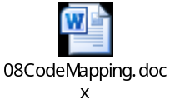
if(directprint)
{ //Start Fix for EBX_DTFR_17806
ret=m_Spooler->setJobOption("WorkflowExecutionParameter/DataStream/Output/Print/PrintParameter/DirectPrintSource","Email");
if(ret != STATUS_OK){ return ret; }
ret=m_Spooler->setJobOption("WorkflowExecutionParameter/DataStream/Output/Print/PrintParameter/DirectPrint","true");
if(ret != STATUS_OK) { return ret; }
//End Fix for EBX_DTFR_17806
CString code08 = "3829";
CString subCode = "0";
CString codeVal = "0";
CString codeSetting = "";
CUtilities::Get_08Code(code08, subCode, codeVal)
if(codeVal == 0)
codeSetting = "Auto Color";
if(codeVal == 1)
codeSetting = "Monochrome";
if(codeVal == 2)
codeSetting = "Full Color";

ret = m_Spooler->setJobOption ("WorkflowExecutionParameter/DataStream/DataStreamParameter/RIPParameter/UserColorMode",codeSetting);
if(ret != STATUS_OK)
{
DEBUGL1("Spooler setJobOption failed for UserColorMode \n");
return ret;
}
//Similarly set job options for below after reading value from respective 08 code
WorkflowExecutionParameter/DataStream/DataStreamParameter/RIPParameter/UserPrioritizeOriginalSize
WorkflowExecutionParameter/DataStream/DataStreamParameter/RIPParameter/UserPageScaling
WorkflowExecutionParameter/DataStream/DataStreamParameter/RIPParameter/UserMode
WorkflowExecutionParameter/DataStream/DataStreamParameter/RIPParameter/UserHeader
WorkflowExecutionParameter/DataStream/DataStreamParameter/RIPParameter/UserBody
}
Call Spooler StartDoc(),after StartDoc Successful,Bind to mail file.
while(true)
{
bytesRead = IFAX_BUFFER_SIZE;
Status diskStatus = fptr->Read(m_data, bytesRead);
if(bytesRead <= 0)
break;
return if (STATUS_OK != diskStatus)
diskStatus = m_Spooler->SendData(m_data, bytesRead, "MIME", true);
if(STATUS_OK != diskStatus)
{
if(STATUS_DISK_FULL == diskStatus)
{
m_Spooler->EndJob();
diskStatus = STATUS_OK;
}
delete[] m_data;
return diskStatus;
}
}//end of while loop

delete[] m_data;
if(STATUS_OK != (ret = m_Spooler->EndDoc()))
{
return ret;
}
if(STATUS_OK != (ret = m_Spooler->EndJob()))
{
return ret;
}
DEBUGL4("iFaxReceive::StartSpoolerSequence--EXIT\n");
return STATUS_OK;
}

SetIfaxForwardSettings()
Function name: iFaxReceive::SetIfaxForwardSettings()
Prototype | Status iFaxReceive::SetIfaxForwardSettings(const BOProxyRef& m_boProxy, const CString& sFrom, const bool bMDNMail, const CString& wfname)
Input Parameters | const BOProxyRef& m_boProxy → BoProxy ref  const CString& sFrom → Sender Address  const bool bMDNMail → If the mail is MDN or Not MDN  const CString& wfname → WorkFlow Name
Output Parameters | None
In/Out parameters | None
Return Value | Status (For error codes, please refer Section 6.6)
Description | This function will set the IFaxrx Forward settings and set File Name Info in WEP.

Status iFaxReceive::SetIfaxForwardSettings(const BOProxyRef& m_boProxy, const CString& sFrom, const bool bMDNMail, const CString& wfname)
{
Status relayInfoStatus = STATUS_OK;
CString sRelayDestinationInfo = "";
if(Utils::IsIfaxForwardEnabled(m_boProxy) && !bMDNMail && !directprint)
{
relayInfoStatus = Utils::GetSerializedRelayDestinationInfo(m_boProxy, sRelayDestinationInfo);
if(relayInfoStatus == STATUS_OK && !sRelayDestinationInfo.empty())
{
if(STATUS_OK != Utils::SetXmlPayload("Queues/Print/WorkflowExecutionParameter/DataStream", sRelayDestinationInfo, m_boProxy))
{
return STATUS_FAILED;
}
CString sFileNameInformation = sFrom;
NodeRef pOutputNode;
if(m_boProxy->GetValue("Queues/Print/WorkflowExecutionParameter/DataStream/Output",pOutputNode) == STATUS_FAILED)
{
return STATUS_FAILED;
}
SetFileNameInformationInWEP(pOutputNode,sFileNameInformation);
}
CString sDocPrint(IFAX_DOC_PRINT_ON_ERROR);
Utils::GetDocumentPrintNodeValue(m_boProxy, sDocPrint);

if(sDocPrint != IFAX_DOC_PRINT_ALWAYS)
{
sDocPrint = IFAX_DOC_PRINT_ON_ERROR;
}
Utils::setValue("Queues/Print/WorkflowExecutionParameter/WorkflowPolicy/HardCopySetting/Enabled",sDocPrint,m_boProxy);
}
else
{
//Enable the Output/Print node in DataStream node Utils::setValue("Queues/Print/WorkflowExecutionParameter/DataStream/Output/Print/@Enabled","true",m_boProxy);
}
return STATUS_OK;
}

Get_08Code()
Function Name: CUtilities::Get_08Code();
Prototype | Status Get_08Code(CString code, CString subcode, CString &keyValue)
Input Parameters | CString code – 08 code whose value is needed  CString subcode – subcode whose value is required
Output Parameters | CString &keyValue – value of the 08 code read from Diagnostic mode
In/Out parameters | None
Return Value | Status (For error codes, please refer Section 6.6)
Description | This function will get the value set to the 08 code

Status CUtilities::Get_08Code(CString code, CString subcode, CString &keyValue)
{
Acquire BOProxy session
if (!pBO)
{
DEBUGL1("Get_08Code(), Failed to Acquire BOProxy.\n");
return STATUS_FAILED;
}
ci::operatingenvironment::Ref<ssdk::SSDKUserTokenInterface> puserToken = NULL;
pBO->GetUserToken(puserToken);
Create XML setting;
setXmlValue = “<SetValue><Payload XMLPayLoad=\"true\"overideDelta=\”true”><path></path><value><DiagnosticMode><Category><Mode>08</Mode><MainCode><Code>CString(temp1)</Code></MainCode></Category></DiagnosticMode></value></Payload></SetValue>”;
Set XML string using SetValue;
If(STATUS_OK != SetValue)
{
Return STATUS_FAILED;
}
Create GetDiagnosticMode command XML;
strCommandMsg = "<Command> <GetDiagnosticMode> <commandNode>DiagnosticMode</commandNode> </GetDiagnosticMode> </Command>";
perform ExecuteCommand on strCommandMsg;
If(STATUS_OK != ExecuteCommand)
{
Return STATUS_FAILED;
}
DocumentRef pDoc = NULL;
HierarchicalDBRef phdb;
phdb = HierarchicalDB::Acquire(NULL);
if(!phdb)
{
return STATUS_FAILED;
}
if(STATUS_OK != phdb->CreateTempDocumentFromString(pDoc, sResponse.c_str()))
{
return STATUS_FAILED;
}
if("Normal" != chelper::GetNodeValue(pDoc,"statusOfOperation"))
{
return STATUS_FAILED;
}

if(subcode.empty())
{
xpath = "DiagnosticMode/Category/MainCode/ValueList/Value/Value";
}
else
{
xpath = "DiagnosticMode/Category/MainCode/SubCode[Code=\"" + subcode +"\"]/ValueList/Value/Value";
}
CString nodeVal = "";
if(STATUS_OK != pBO->GetValue(xpath.c_str(), nodeVal))
{
DEBUGL1("GetValue() failed for xpath [%s] in Get_08Code\n",xpath.c_str());
return STATUS_FAILED;
}
keyValue= nodeVal.c_str());
return STUATUS_OK; }

SetIfaxExtSettings()
Function Name: iFaxReceive::SetIfaxExtSettings();
Prototype | Status iFaxReceive::SetIfaxExtSettings(const BOProxyRef& boproxy, const MailHeaderRef& mailHeader,SessionInfoRef& sInfo, const CString& workFlowName)
Input Parameters | const BOProxyRef& boproxy → boProxy Ref  const MailHeaderRef& mailHeader → MailHeader Ref  SessionInfoRef& sInfo → Sessuion Info Ref  const CString& workFlowName → workflow name
Output Parameters | -
In/Out parameters | -
Return Value | Status (For error codes, please refer Section 6.6)
Description | This function will set iFax Extn settings such as MDN, Error wf etc.
Status iFaxReceive::SetIfaxExtSettings(const BOProxyRef& boproxy, const MailHeaderRef& mailHeader, SessionInfoRef& sInfo, const CString& workFlowName)
{ CString sessionId = boproxy->getSessionID();
bool flag = false; CString queue = "Queues/Print/"; CString xpath = "";
CString value = ""; CString finalvalue("");
if(!directprint)
{ // MDNReplySetting
value = CEmailController::IsMDNRequired()?"true":"false";
Utils::setValue(queue + WF_MDN_REPLY_PATH, value, boproxy);
if(value == "true") { sInfo->f_mdn = true; }
// MDNRequest
int i = mailHeader->DispositionNotification;
value = (i==1)?"ON":"OFF";
Utils::setValue(queue + WF_MDN_REQUEST_PATH, value, boproxy);
if(value == "OFF") {
sInfo->f_mdn = false; }
// MDNReplyToAddress
value = mailHeader->DispositionNotificationTo;
if(value == "") { value = mailHeader->From; }
CUtilities::EscapeChars(value,finalvalue);
Utils::setValue(queue + WF_MDN_TO_ADDRESS_PATH, finalvalue, boproxy);
if(!sInfo->partial)
{ flag = CEmailController::IsErrorTransferRequired();
value = (flag)?"true":"false";
Utils::setValue(queue + WF_ERROR_TRANSFER_PATH, value, boproxy);
sInfo->f_errt = flag; }
//ErrorTransferToAddress
value = CEmailController::GetErrorTransferDestination();
CUtilities::EscapeChars(value,finalvalue);
Utils::setValue(queue + WF_ERROR_TRANSFER_TO_PATH, finalvalue, boproxy);
//ErrorPrintSetting
flag = CEmailController::IsErrorPrintRequired();
value = (flag)?"true":"false";
Utils::setValue(queue + WF_ERROR_PRINT_SETTING_PATH, value, boproxy);
sInfo->f_errp = flag;
}
//OriginalMailPath
CString finalorigMailPath("");
CUtilities::EscapeChars(sInfo->origMailPath,finalorigMailPath);
Utils::setValue(queue + WF_ORIG_MAIL_PATH, finalorigMailPath, boproxy);
//OriginalDate
Utils::setValue(queue + WF_ORIG_DATE_PATH, mailHeader->Date, boproxy);
//OriginalFromAddress
value = mailHeader->From;
CUtilities::EscapeChars(value,finalvalue);
Utils::setValue(queue + WF_ORIG_FROM_ADDR_PATH, finalvalue, boproxy);
CString from,fromName;
if(workFlowName != "EmailSend")
{ CEmailController::GetEmailSettingsRev(from, fromName);
value = from; CUtilities::EscapeChars(value,finalvalue);
Utils::setValue(WF_FROM_ADDRESS_PATH,finalvalue, boproxy); }
CString temp = "";
if(STATUS_OK != chelper::Escape(mailHeader->Subject, temp))
{ temp = mailHeader->Subject; }
Utils::setValue(queue + WF_ORIG_SUBJECT_PATH, temp, boproxy);
if(directprint) {
Utils::setValue("Queues/Print/WorkflowExecutionParameter/DataStream/DataStreamParameter/DocumentName", temp, boproxy);
}
CString finalMessageId("");
CUtilities::EscapeChars(mailHeader->MessageId,finalMessageId);
Utils::setValue(queue + WF_ORIG_MSGID_PATH, finalMessageId, boproxy);
if(!directprint) {
//ErrorAttachmentName
Utils::setValue(queue + WF_ERROR_ATTACH_NAME,"",boproxy);

//Save the state
m_MDNContainer.insert(pair<CString, SessionInfoRef>(sessionId, sInfo));
}
DEBUGL4("iFaxReceive::SetIfaxExtSettings--EXIT\n");
return STATUS_OK;
}

New function in eMailctrl for Ignoring Comment strings in mime Version
Function Name: TrimMimeVer();
Prototype | Void TrimMimeVer(CString& value)
Input Parameters | CString value -- Incoming Mime version with/without Comment String
Output Parameters | None
In/Out parameters | None
Return Value | Void
Description | This function ignore the Comment strings and the spaces in Mime Version

void CUtilities::TrimMimeVer(CString& value)
{
if(value == "") {
return;
}
std::string::iterator iter;
for(iter = value.begin(); iter < value.end(); iter++)
{
if( (*iter) == '(' )
{
while( (*iter) != ')' )
{
value.erase(iter);
}
}
if(*iter == ')')
value.erase(iter);
for(int j=0; j<value.length(); j++)
if(value[j] == ' ')
value.erase(j,1);
}
}

Support for California Mode
Function name: DownloadMessagesandSpool()
Prototype | Status iFaxReceive::DownloadMessagesandSpool(CString sSession)
Input Parameters | CString sSession -> session name
Output Parameters | -
In/Out parameters | -
Return Value | Status (For error codes, please refer Section 6.6)
Description | This function will set iFax Extn settings such as MDN, Error wf etc.
Status iFaxReceive::DownloadMessagesandSpool(CString sSession)
{
//Check for Mail count
// Check for Print job near full, Return STATUS_FAILED if true
// Check for Storage Near Full , Return STATUS_FAILED if true
//Check for California Mode
if(al::softwarefunction::authenticationlibrary::CheckCaliforniaMode() == true)
{ DEBUGL2("California mode is Enabled .. cannot execure iFax jobs\n");
return STATUS_FAILED;
} //end of California Mode check
//Check for new mails
//Set panel Msg to eReceivingEMail if sSession is “CHECKMAIL”
//Retrive mail using:
Status retrStatus = m_pPOP3Client->Retrieve(1, mail, false);
//Return Status according to STATUS_DISK_FULL, STATUS_INVALID, !STATUS_OK or STATUS_OK.
If (STATUS_INVALID) { m_pPOP3Client->Delete(1); }
if(!mail) { return STATUS_FAILED; }
//Set panel Msg to eNewEmail if sSession is “CHECKMAIL”
//Check if Partial Mail, analyse accordingly and SpoolTheMail() and Register Errors for Partial Mail
// Check whether received mail is MDN or DSN.
//Save The Mail using SaveMailToDisk()
// Create and Update metadata
// Register Errors if any
// Delete mail from server only if retrieval is successful
if(!partialAssembled && File::Exists(fileName))
m_pPOP3Client->Delete(1);
ret = SpoolTheMail(mail, SessionId, bMDNMail, errCode);
mail_count++
//Set Continue Flag to true when Counter becomes 20 and stop to download email from POP3 server
Return ret;
}

Detailed Design Description View

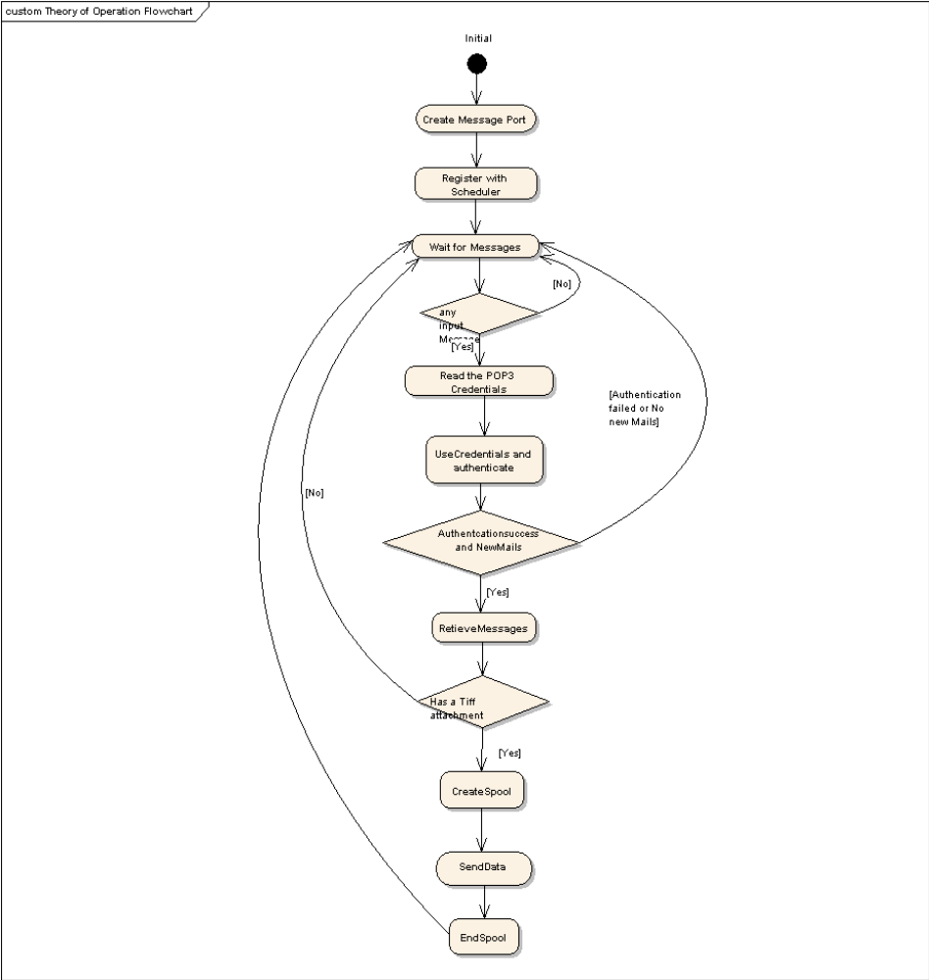
Theory of operation
Figure 3: iFaxRx operation
The iFaxReceive component basically sends the received mail for printing. There are 2 ways in which the reception can be initiated. One way is when the component receives a scheduler time-out and the second way is when the user clicks on "Check IFAX" through front panel.

In the first flow, the component registers itself with the scheduler with a time delay and waits for the messages from scheduler on a message port. Once the message is received, It reads the pop3 server configuration parameters from the repository, uses these credentials for authentication and checks for new messages in the pop3 server. If there are new messages in the server, retrieves them and deletes it from the server. It then serializes the mail and acquires a spooler interface and sends the serialized file to spooler.
In the second flow, the user clicks on the check IFax button and it initiates the same flow as explained above.

User Based Authentication Support
The User Authentication status “Enabled/Disabled” is obtained by using BOProxy Commands as follows.
- The Transaction DOM is created using BOProxy set-value and the following xml payload
“<SetValue sendNotification=\"true\"><Payload XMLPayLoad =\"false\"> <path> Security Configuration/SecuritySettings/isLoginReqd</path><value></value></Payload></SetValue>”
- The Transaction DOM created is passed to Security plugin by executing command using BOProxy with the following command string
“<Command><LoginRequired><commandNode>SecurityConfiguration/SecuritySettings</commandNode></LoginRequired></Command>”
- The security plugin updates the user Authentication status in the transaction DOM passed.
- The Status is read using get-value of BOProxy from transaction DOM with xpath “SecurityConfiguration/SecuritySettings/isLoginReqd”
- The obtained Status is updated in Queues DOM with xpath “WorkflowExecutionParameter/OwnerInformation/Authenticated”.

For Print Users:
When the User authentication is enabled the following xpath has to be set to true in Queues DOM
- Xpath “Queues/Print/WorkflowExecutionParameter/OwnerInformation/Authenticated” should be set to “true”.
When the User authentication is disabled the following xpath has to be set to false in Queues DOM
- Xpath “Queues/Print/WorkflowExecutionParameter/OwnerInformation/Authenticated” should be set to “false”.

Modified Functions
- SpoolTheMail();

BCC Support in iFax Transmission
If the user sets the IFax received forward setting to true, the received IFax is forwarded to the addresses set in TopAccess. The address is considered as “To” type address and the mail is forwarded. The Bcc support for IFax transmission helps user to set the forwarding address as “Bcc” type address.
The User is provided with the 08 code (08-3658) which is set to 0 if the addresses have to be considered as “To” type address while forwarding the mails. If the 08 code is set to 1 then the address is considered to be “Bcc” type. The 08 code has been mapped to an xpath in the controller DOM.
The type (To/Bcc) that has to be used for forwarding is read as follows.
- The BOProxy session is acquired.
- The xpath “Controller/Settings/AdminSystemSettings/IFax/targetAddressType” is read using BOProxy GetValue.
- If the value in the xpath is “Bcc”, the forwarding addresses in ChangeDOC prepared for iFax forward Workflow execution is set to Bcc type

Modified Functions
- GetSerializedRelayDestinationInfo()

Mixed Email destination support for iFax
IFax send is performed using two address formats. They are Normal email address format and Direct SMTP format. The mode is chosen by setting code (08-3810) to 0 and 1 respectively. For supporting Disaster Prevention Fax system, mixed destination mode was supported (by setting 08-3810 to 2). In mixed destination user can use both the Normal email address formats and Direct SMTP address formats simultaneously to send the mail. If IFax forward is enabled in TA, then the received mails will be forwarded to multiple destination address set in TA.
A new code (08-3809) is supported for setting from address in case of mixed destination address format. This code is mapped to xpath “Controller/Settings/AdminSystemSettings/IFax/fromAddrForMixed”.
The same “from address” has to be used for DSN and MDN reply also, in case if multiple destination format is supported. The following steps indicate the flow of operations.
- Check for 08-3810 value.
- If the value is 2, get from address using the following xpath “Controller/Settings/AdminSystemSettings/IFax/fromAddrForMixed”.
- If the value of fromAddrForMixed node is blank continue with the default FromAddress in the WF
- Set this address to the new node FromAddressForMixed and Set in the WEP.

No changes are required if 08-3810 value is 0 or 1.

Modified Functions
- GetSerializedRelayDestinationInfo()

Optical Character recognition support for iFaxFrwd
If user selects “Searchable PDF(Multi/Single)” format as File Format in iFaxRx Forward option(Save As File or Forward as Email). OCR should be executed.
For OCR to be executed, the below conditions are to be fulfilled:
- OCR license should be installed for OCR function
- Memory of 4 Gbyte or more should be installed.
iFaxRx should check for these conditions and allow the job to be executed if met.
The following is the flow of operations:
When iFax job is received,
- Check iFax received forward function is registered or not.
- If forward job is registered, GetValue of fileFormat from the respective path of SaveAsFile and ForwardAsEmail.
- If GetValue is Searchable PDF, check whether OCR license is installed or not using CI::LicenseManager.
- If OCR license is installed, check installed memory size is 4GB or more from the path
MFP/System/MainMemory/Size.
- If memory size is 4GB or more, perform forward job.
- Set the values of primary Language, secondary Language and Autorotation obtained from Controller DOM to Queues DOM of print workflow.
- If Searchable PDF is set and OCR license is not installed or memory size is less than 4GB, STATUS_FAILED is returned and Document Print is enabled. iFaxRx will execute normal iFax print job.

Modified Functions
- GetSerializedRelayDestinationInfo()

Support for changed interface for WriteJobLogEntry()
LogManager need to know whether registered Job Log is “SUCCESS” or “FALURE”. It is necessary to set error flag in interface for job log entry. In case of Email reception job, iFaxRx has responsibility to register Job Log only when error is detected before StartJob. Hence ECCErrLog=true is added in all cases calling WriteJobLogEntry().
The interface is used in
SYSROM_SRC\dev\AL\Network\eMailCtrl\cemailcontroller.cpp

Modified Functions
- CEmailController::WriteJobLog()

Support for EmailDirectPrint Functionality (EBX_RCR_447)
Currently the email Reception is supporting only the TIFF file format. If any other fileformat like PDF, JPEG is received in the email , MFP will throw the error.
This modification is to support the file formats PDF, JPEG , XPS in the email Receive function. PDF, JPG and XPS files can be submitted for printing to the MFP by sending them as attachments in an email. A separate Workflow is created for the same. This is known as email direct print workflow.
In case of email direct print workflow, the printing is controlled by auto print mode 08-3830 code.
If it is set as enabled, the job will be submitted for printing. If disabled, the job will be end with error. This is same as existing behavior EmailReceive WF behavior.
Error print job, error forward job and MDN/DNS reply job is not supported for new WF.
No forward settings are supported for new WF.
SecuritySettings to be read from column 1 and set to xpaths in column 2:
Read From (column 1) | Set To (column 2)
SecurityConfiguration/SecurityStampSettings/TargetFunctions/Print/PrinterPrint | Queues/Print/WorkflowExecutionParameter/SecurityStampSettings/TargetFunctions/Print/PrinterPrint
SecurityConfiguration/SecurityStampSettings/StampOptions/Date | Queues/Print/WorkflowExecutionParameter/SecurityStampSettings/StampOptions/Date
SecurityConfiguration/SecurityStampSettings/StampOptions/CardID | Queues/Print/WorkflowExecutionParameter/SecurityStampSettings/StampOptions/CardID
SecurityConfiguration/SecurityStampSettings/StampOptions/UserName | Queues/Print/WorkflowExecutionParameter/SecurityStampSettings/StampOptions/UserName
SecurityConfiguration/SecurityStampSettings/StampOptions/JobID | Queues/Print/WorkflowExecutionParameter/SecurityStampSettings/StampOptions/JobID
SecurityConfiguration/SecurityStampSettings/StampOptions/SerialNumber | Queues/Print/WorkflowExecutionParameter/SecurityStampSettings/StampOptions/SerialNumber
SecurityConfiguration/SecurityStampSettings/StampOptions/DepartmentName | Queues/Print/WorkflowExecutionParameter/SecurityStampSettings/StampOptions/DepartmentName
SecurityConfiguration/SecurityStampSettings/StampOptions/OptionalText/Enabled | Queues/Print/WorkflowExecutionParameter/SecurityStampSettings/StampOptions/OptionalText/Enabled
SecurityConfiguration/SecurityStampSettings/StampOptions/OptionalText/Value | Queues/Print/WorkflowExecutionParameter/SecurityStampSettings/StampOptions/OptionalText/Value

Modified Functions:
      - iFaxReceive::SpoolTheMail
      - iFaxReceive::SetIfaxForwardSettings
      - iFaxReceive::StartSpoolerSequence
      - Status iFaxReceive::SetWorkflowName
      - Utils:: GetSerializedRelayDestinationInfo
      - CUtilities::Get_08Code
      - iFaxReceive::SetIfaxExtSettings()

Support for ignoring comment strings and spaces in MIME Version value
Description
When MIME version value inlcudes comment string, MIME version check threw 3A10 error. But the following MIME version values are equivalent according to RFC.
MIME-Version: 1.0
MIME-Version: 1.0 (produced by MetaSend Vx.x)
MIME-Version: (produced by MetaSend Vx.x) 1.0
MIME-Version: 1.(produced by MetaSend Vx.x)0
Hence, before comparing MIME Version to "1.0", the commenst strings are to be ignored.
New function CUtilities::TrimMimeVer() is introduced in eMailCtrl to ignore the comment strings. This new function is called in iFaxRx before comparing to MIME version value to 1.0
Modified Functions
- Utils::GetMailHeaders()

Added additional StatusReasons to handle SL changes in L6.14 SING18 models
EBX_DTFR_19469 Changes
For L6.14, SL has made changes to forward the exact StatusReason sent by DL to above layers.
JobController is sending the changed StatusReasons to iFaxRx and faxofframp in error cases, in order to handle the changed error reasons ,Source code is modified in iFaxRx and faxofframp and accordingly the Error Print and MDN reply is initiated in error scenarios.
In iFaxRx source code the following status reasons are checked to handle the error cases.
CancelError
DataAnalysisError
FatalError
HDDAccessError
InsufficientMemory
InvalidMessage
ParameterError
DataConvertError
NoPrintData
DataGenerationError
EmailReceiveError

Modified Functions:
iFaxDefs.h
iFaxReceive::ProcessWorkFlowMessages

Support for California Mode
Description
Password request screen is displayed during normal startup after California Mode is enabled using 08 mode. iFaxRx should not accept any job until the password is input.
al::softwarefunction::authenticationlibrary::CheckCaliforniaMode() interface of Authentication Library is used to check if California Mode is enabled and password is not entered. If true, no jobs are accepted.

Modified Functions:
iFaxReceive::DownloadMessagesandSpool()

Related Request ID:
EBX_RCR_1223[California Mode]
EBX_DCR_63100 → [L6.15][iFaxRx][EBX_RCR_1223]California Mode Support

Class Model
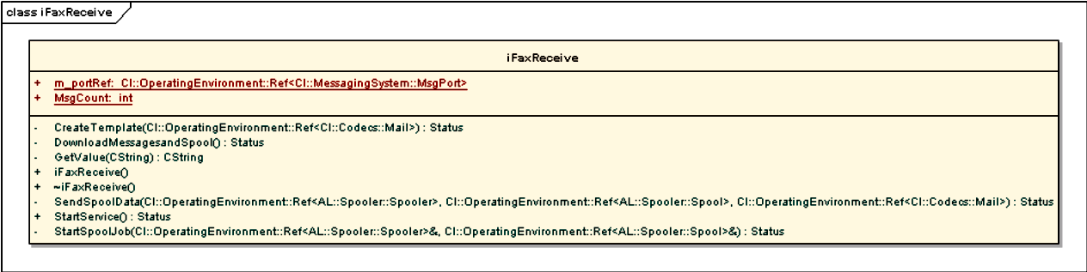

Collaboration Model

Sequence Diagram

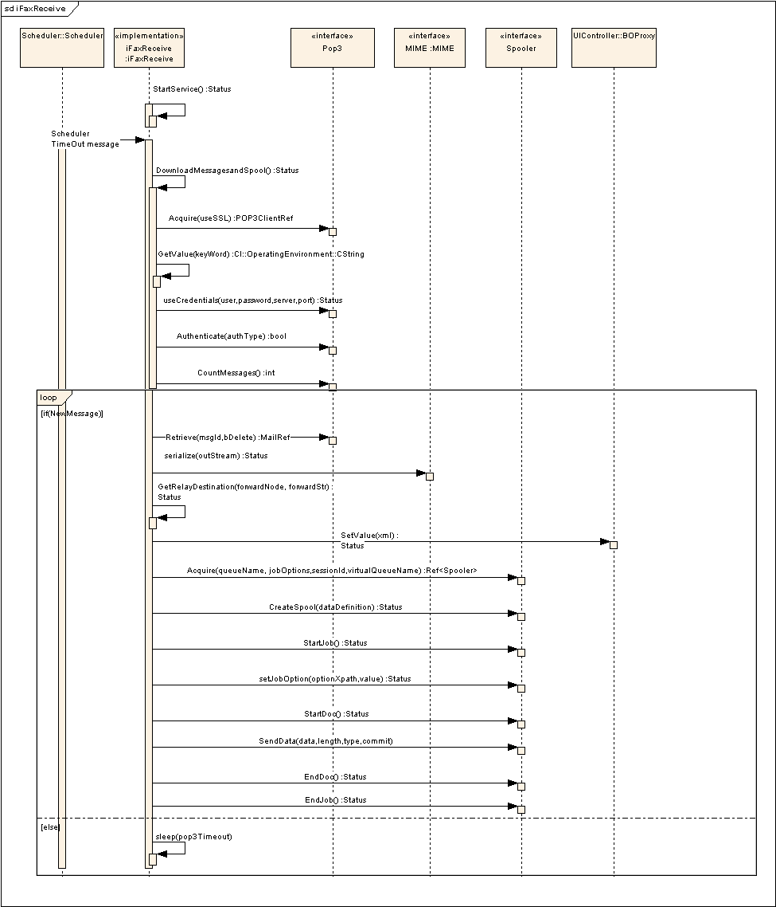
Sequence Diagram for iFaxRx
Figure 4 – Sequence Diagram for iFaxRx

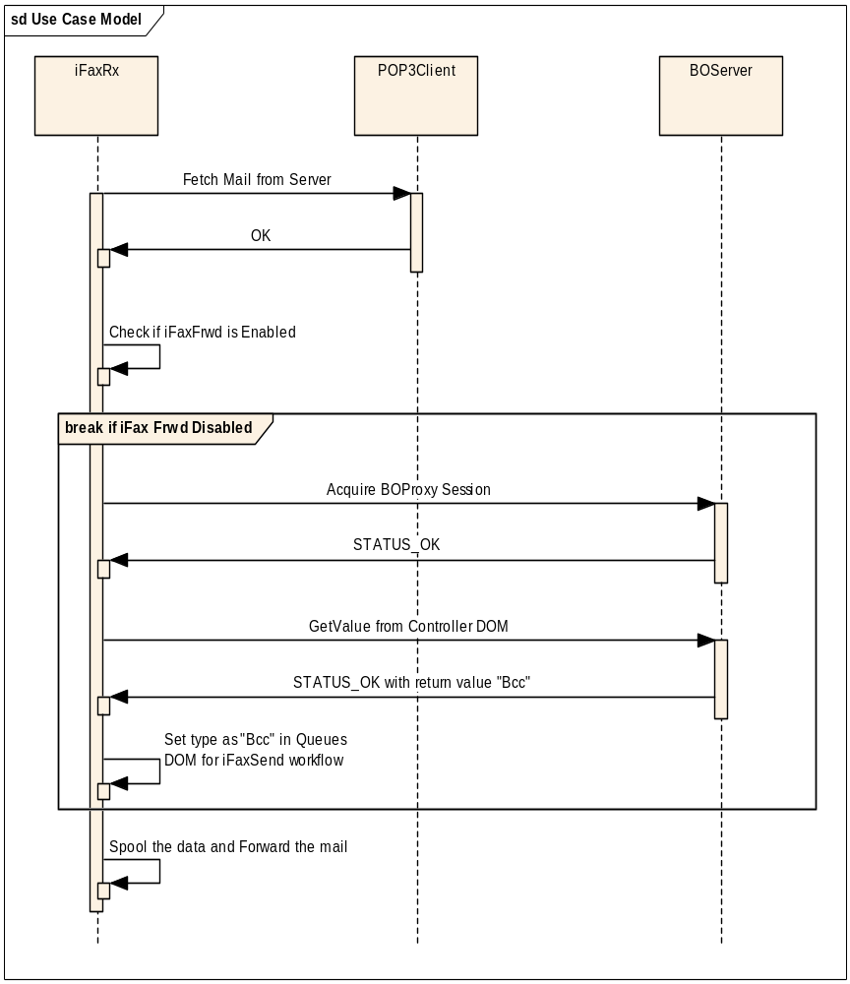
Sequence Diagram for iFax Transmission with BCC support
Figure 5 - Sequence Diagram for iFaxFrwd with BCC support

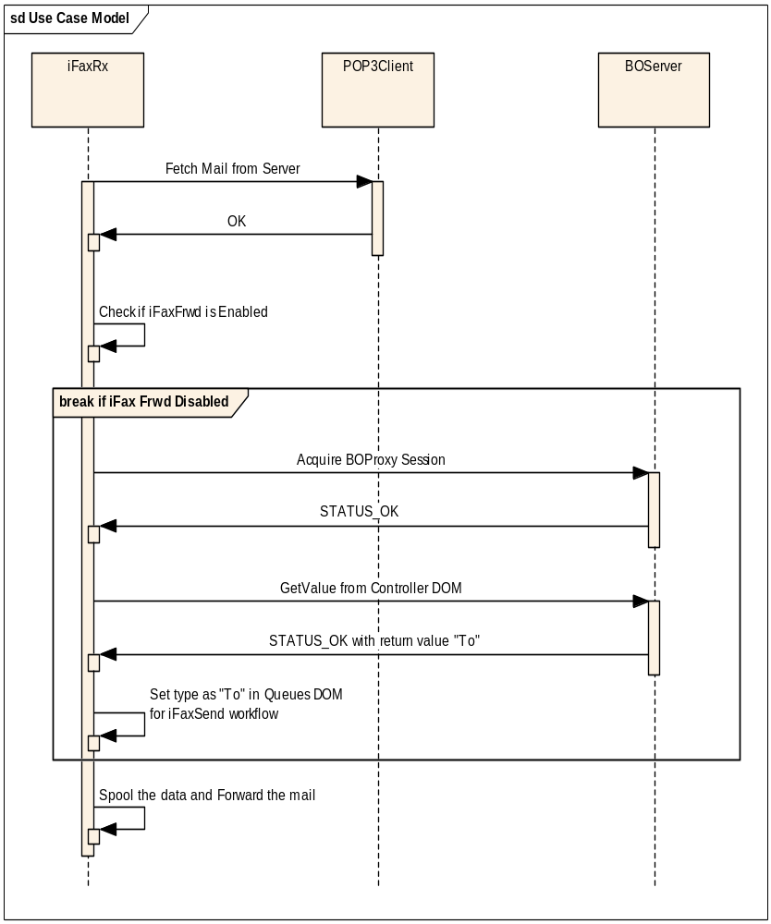
Sequence Diagram for iFax Transmission without BCC support
Figure 6 – Sequence Diagram for iFaxFrwd without BCC support

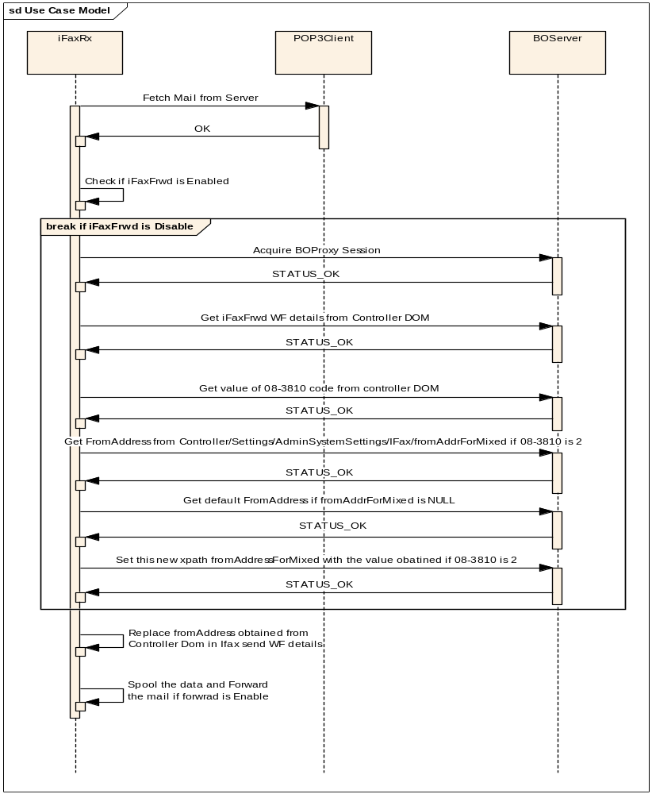
Sequence Diagram for Mixed Email destination support for iFaxFrwd

Figure 7 – Sequence Diagram for mixed Email destination support for iFaxFrwd

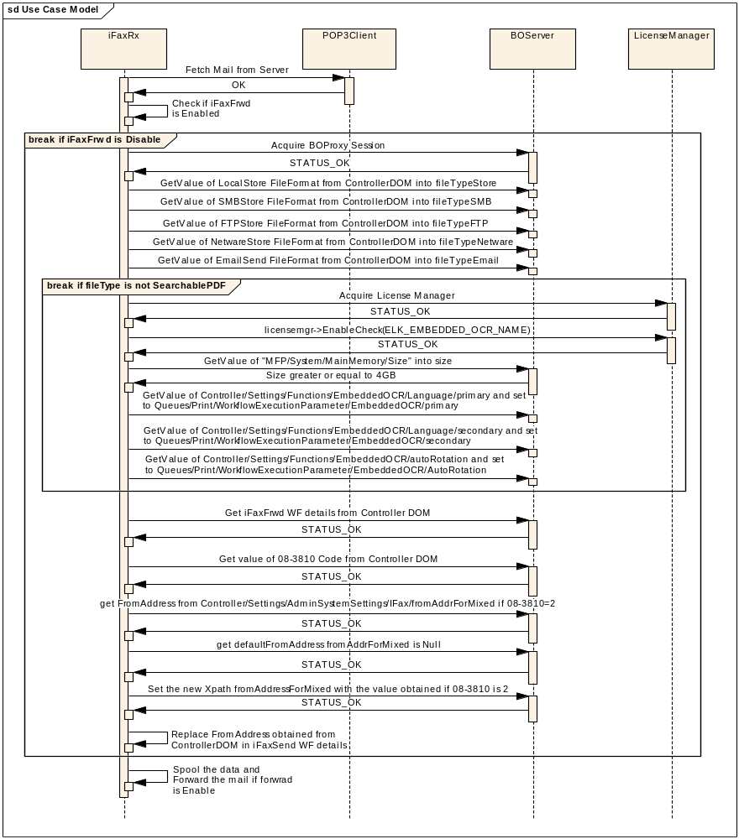
Sequence Diagram for OCR File Format support
Figure 8 – Sequence Diagram for OCR file format support for iFaxFrwd

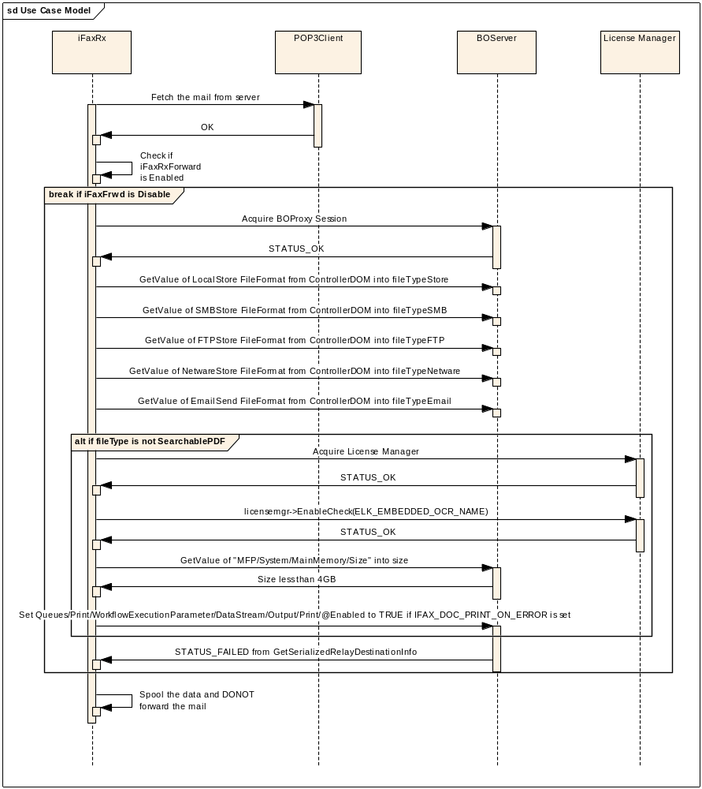
Sequence Diagram for OCR File Format support for MemorySize less than 4GB
Figure 9 – Sequence Diagram for for OCR file format support if MemorySize less than 4GB

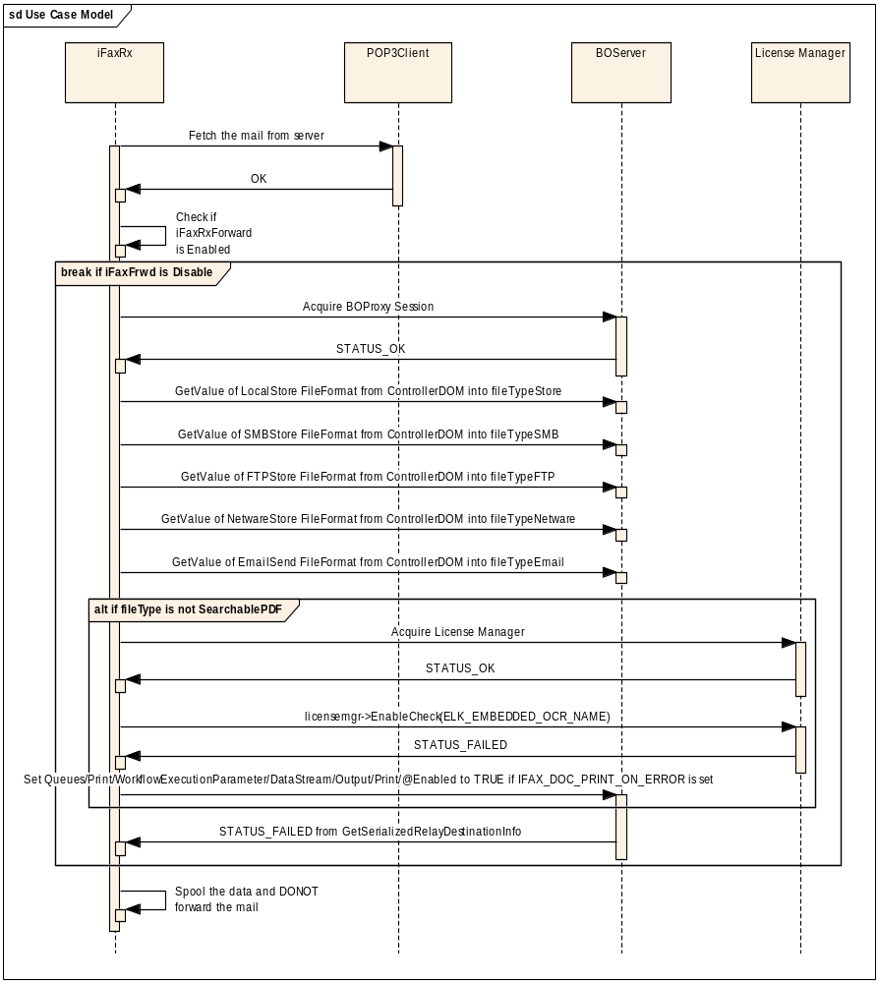
Sequence Diagram for OCR File Format support-License Manager returns Fail
Figure 10 – Sequence Diagram for for OCR file format support if License manager returns Fail

Flow Chart

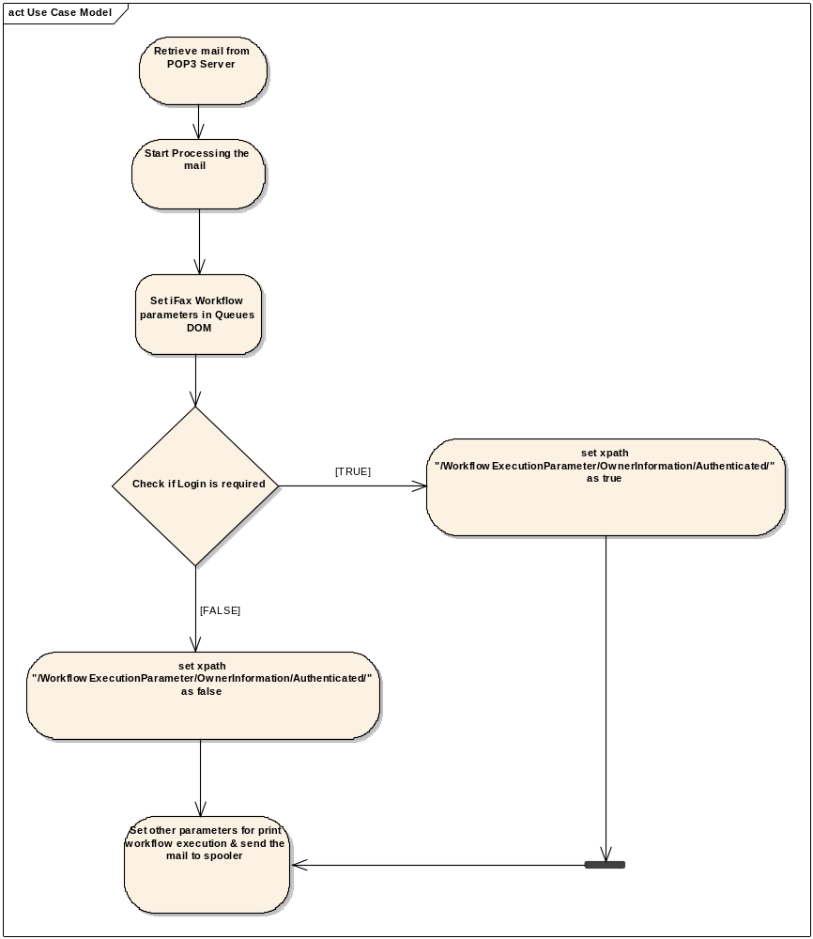
Flowchart for User Based Authentication support in iFaxRx
Figure 11 – Flow Chart showing User Based Authentication support in iFaxRx

Flowchart for EmailDirectPrint in iFax

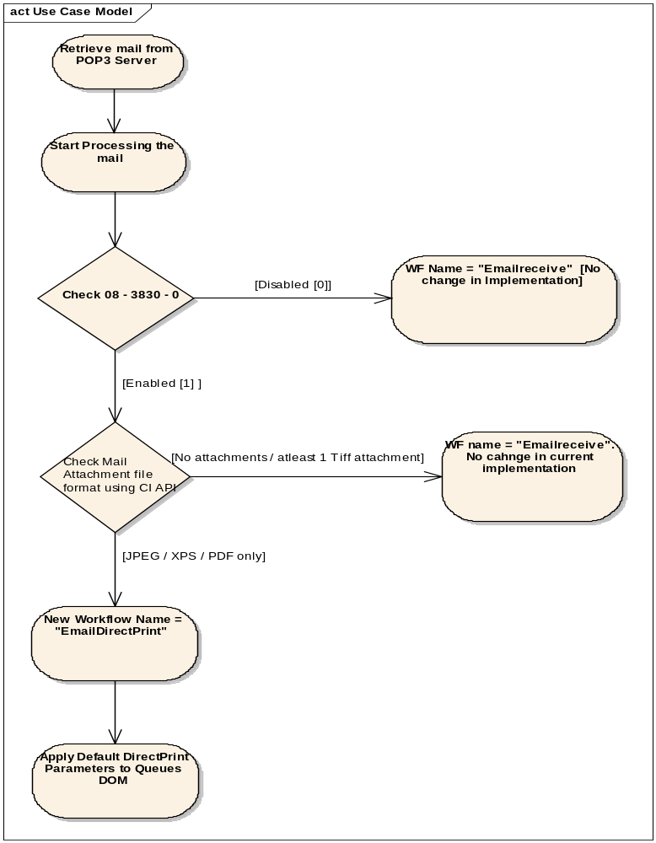
Figure 12 – Flow Chart showing New Workflow EmailDirectPrint support in iFaxRx

Message documentation
StartService()

iFaxReceive ----> iFaxReceive

The iFaxReceive calls StartService to start processing the incomming messages. It also notifies the SSM that it is in ready state

Scheduler TimeOut message

Scheduler ----> iFaxReceive

DownloadMessagesandSpool()

iFaxReceive ----> iFaxReceive

DownloadsMessages and Spool initiates pop3 activities by acquiring a pop3 object. It validates the user
credentials checks for the new messages and downloads them if any. Once the download operation is done then it starts the spooler and sends the information for print.

Acquire(bool)

iFaxReceive ----> Pop3

We acquire an instance of pop3 to start processing on pop3 message objects

GetValue(CString)

iFaxReceive ----> iFaxReceive

reads the smtp.conf file to get username and other credentials

useCredentials(CString, CString, CString, int)

iFaxReceive ----> Pop3

UseCredentials reads the credentials from $EB2/config/smtp.conf and validates them.

Authenticate(SMTP::eAuthenticationType)

iFaxReceive ----> Pop3

uses the authenticate type read from the smtp.conf file

CountMessages()

iFaxReceive ----> Pop3

Count messages checks the number of messages present in the server. by this we can check if there are any new messages

Retrieve(int, bool)

iFaxReceive ----> Pop3

retrieve downloads the messages

serialize(DataStreamRef)

iFaxReceive ----> MIME

Serialize the mail to a file

GetRelayDestination

iFaxReceive ----> iFaxReceive

Get the forward destination XML from configuration document.

SetValue(char*)

iFaxReceive ----> BOProxy

Set the forward options in WEP

Acquire(const CString &, const CString &, const CString &, const CString)

iFaxReceive ----> Spooler

Acquires a spooler instance

CreateSpool(DATA_DEFINITION)

iFaxReceive ----> Spooler

Creates a Spool for job submission

StartJob()

iFaxReceive ----> Spooler

Starts the spooler job initiation

setJobOption(CString &, CString)

iFaxReceive ----> Spooler

Set the different job options.

StartDoc()

iFaxReceive ----> Spooler

SendData(void*, uint32, CString, bool)

iFaxReceive ----> Spooler

Read the data from the serialized MIME file and send to spooler.

EndDoc()

iFaxReceive ----> Spooler

EndJob()

iFaxReceive ----> Spooler

End the job

Sleep

iFaxReceive ----> iFaxReceive

wait for some time specified in the smtp.com, then start the polling again

Execution Model
The Execution model describes the iFaxRx in terms of UML deployment diagrams.

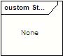
Deployment Diagram

Start/Stop Sequence

UI Flows

Error Handling
The Error handling is done for each of the following cases
- The Error codes are notified to the users in the job-logs. The Error codes used are listed in the attached excel sheet.
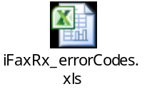
- The Errors returned by the other components or other layers are handled internally and proper error codes are updated in job-logs.
- Job Recovery is performed in case of errors like Power failure

Appendix

Use Database Table (DOM)
Use Database Table (DOM) describes which DOM is used by this component. The following table enumerates DOM name and access type (Read only/Read Write)

Example of use database tale is shown in Table 3.

DOM | Access Type
Transaction | Read Write
Queues | Write
Controller | Read
Table 3 – Database Table for User Authentication

