DOC No. JEE-01994

CONFIDENTIAL

PRELIMINARY

MODEL:
e-BRIDGE X
TITLE:
Network PowerManagement Service

Rev. 3.0
Issued: 23/12/2019

Approved | Checked | Write
Dheeraj | Dheeraj | Anoop

Document Info

History：
Revision | Date | Description | Page | Charge of
V 1.0 | 28/04/2011 | Initial document | 28 | Matsuoka
V2.0 | 31/10/2013 | IPV6 Statefulの対応とBonjour IPV6の追加 | 5 | Matsuoka
V2.01 | 22/04/2015 | L6.0 Requirements | 5 | Shivayogi, Vidhyasri
V2.02 | 20/02/2019 | Super Sleep support for Wireless [RCR 730] | 10 | Prashanth M N
V 3.0 | 23/12/2019 | Network 2 port support (RCR_614) |  | Anoop

Table of Contents

1. Introduction 5
1.1 Purpose 5
1.2 Document Conventions 5
1.3 Overview of the Document 5
1.4 Revision History 6
1.5 References 6
1.6 Terms and Definitions 6
2. Overview of the component 7
2.1 Identification 7
2.2 Function 7
3. Use Case Realization 9
3.1 Use Cases 9
3.1.1 Usage Scenarios:- 9
3.1.2 Illustration of usage scenarios: 10
Usage Scenario 1 10
Usage Scenario 2 10
4. Design Methodology 12
4.1 Component Attributes 12
4.1.1 Identification 12
4.1.2 Function 12
4.1.3 Interface 12
4.1.4 Processing 12
4.1.5 Data 13
4.2 Design Views 13
5. Interface Description View 15
5.1 External Interfaces 15
Please refer to the PowerManagement External Specification document. 15
5.1.1 CheckStatus 15
5.1.2 CheckNetworkType 15
5.1.3 pm_filter 15
5.2 Internal Interfaces 16
5.2.1 pm_set_filter 16
5.2.2 pm_checkService 17
5.2.3 pm_getPortNum 18
5.2.4 pm_make_NetBiosName 18
5.2.5 pm_getValue 18
5.2.6 pm_checkIPv6Addr 19
5.2.7 pm_getStatus 19
5.2.8 pm_AcquireShmem 19
5.2.9 pm_AttachShmemArea 19
5.2.10 pm_setValue 20
5.2.11 pm_ChangeLocaltime 20
5.2.12 pm_setWakeupTime 20
5.2.13 pm_make_regdata 20
5.2.14 pm_make_patterndata 21
5.2.15 pm_dispFilter 21
5.2.16 Change of Environment variable for eBN vMFP 21
5.2.17 Timing of setting for wake up pattern 21
5.2.18 Adding new wakeup factors for AirPrint 22
pm_make_patterndata() 22
5.2.19 Support for Auto response mechanism and a new structure setting to NIC 23
Pseudo code for set pattern function 24
Pseudo code for checkNetworkType function 26
5.2.20 Auto Response for SNMP packets 27
6. Detailed Design Description View 28
6.1 Theory of operation 28
6.2 Data 31
6.2.1 Wake up filter 31
6.2.2 CheckService 33
6.2.3 WakeUpTime 34
6.2.4 other 35
6.3 Class Model 38
6.3.1 Controller side 38
6.4 Collaboration Model 39
6.4.1 Statechart Diagram 39
6.4.2 Sequence Diagram 40
6.4.2.1 Change the Network Setting . 40
6.4.2.2 Before go to SuperSleep (before L6.0). 41
6.4.2.3 Setting the filter when the filter options are changed in TA. 41
6.4.2.4 Handling of checkstatus command 44
6.4.2.5 Auto Response mechanism 45
6.4.2.6 Wakeup without auto response 46
6.5 Execution Model 49
6.5.1 Deployment Diagram 49
6.5.2 Start/Stop Sequence 49
6.6 UI Flows 50
7. Appendix 51
7.1.1 DOM accessed and access modes 51
7.1.2 Diagnostic mode codes used 51

Introduction

Purpose
The purpose of this document is to describe the design of Power Management. This design specification should be for the design and development of Power Management.
This document is a specification that specializes in e-Bridge X project to take the interface with UI.

Document Conventions
Icons that contain the text None identify sections that do not require a graphical illustration

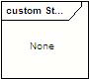

Overview of the Document
This section presents the organization of this document, indicating the contents of each chapter.
Chapter 1 – Introduction
Chapter 1 presents the purpose of the document its structure, revision history and reference information.
Chapter 2 – Overview of the component
Chapter 2 presents use cases that apply to the component.
Chapter 3 – Design Methodology
Chapter 3 presents the necessary information content and organization of a Software Design Description.
Chapter 4 – Interface Description View
Chapter 4 presents the details of the component’s external and internal interfaces.
Chapter 5 – Detailed Design Description View
Chapter 5 presents the component’s internal details.

Note: Please be aware that the program interfaces, direct interface and messaging interface are now part of the architecture design document.

Revision History
Version | Date | Author | Notes
1.0 | 30/09/2009 | Matsuoka | Initial document
2.0 | 31/10/2013 | Matsuoka | IPV6 Statefulの対応とBonjour IPV6の追加
V2.01 | 22/04/2015 | Shivayogi, Vidhyasri | L6.0 Requirements
V2.02 | 20/02/2019 | Prashanth M N, Shivayogi | MatterHorn and SING20 Requirements [RCR 730]
3.0 | 11/12/2019 | Anoop | Network 2 port support

References
Document | Version | Notes
JEA-02040_eBX_PowerSavingModeNetworkSpecifications_Eng | 2.3 | RCR 730

Terms and Definitions
Term | Definition

Overview of the component
The Super Sleep is a condition of the MFP wherein the power consumed by the MFP is very less (power consumption is less than 1W). The Power management component is used to control the MFP from going to supersleep and wakeup from the supersleep. The component decides the conditions on which the MFP has to wakeup from the super sleep and go into supersleep mode.

Identification
The Power management comprises of two components
- PowerManagement NMO library
  - Library -- alpowermanagementNMO.so.0
  - Source code location -- dev/AL/Network/NMO/PowerManagement
  - Logfile – nsm.log.(#).txt
- PowerManagement library
  - Library -- libalpmfilter.so.0
  - Source code location -- dev/AL/Network/ PowerManagement
  - Logfile – nsm.log.(#).txt

Function
PowerManagement component features are meant to,
- The MFP going to Super Sleep mode after the specific time interval.
- The conditions under which MFP Goes to SuperSleep.
- The interval after which MFP has to Wake up from SuperSleep.
- The network packets which when recieved, the MFP has to wake up.
- The MFP responds without waking up from the Super Sleep mode upon receiving a specific packet (From L6.0).
- Handle UICC commands when NSM delegates the command
- Set the specific pattern to the NIC controller for Wakeup
- The MFP going to Super Sleep mode when the Wireless infrastructure mode is enabled.
- From L7.0 onwards, 2 network ports (interfaces) will be supported. PowerManagement should support the following:
  - Supersleep and autoresponse support if only eth0 is present
  - Supersleep and autoresponse support if only wlan0 is present
  - Supersleep and autoresponse support if both wlan0 and eth0 are present. In this case, separate patterns should be set for each interface.
  - Supersleep is not supported if both eth0 and eth1 are present.
  - Supersleep is not supported if WifiDirect is enabled.

Use Case Realization
This chapter presents various usage scenarios and pictorial representation of the same that apply to this component.

Use Cases

Usage Scenarios:-

Usage Scenario 1:
Change the setting of IPV4 or IPV6 or Samba or POP3 in Panel UI or TopAccess.
Loire/AlabamaからSuperSleepに移行するときだけ呼ばれるように変更
Usage Scenario 2:
The check_status and pmfilter functionality is called before go to SuperSleep.

Usage Scenario 3:

Usage Scenario 4:
.

Illustration of usage scenarios:

Usage Scenario 1
Change the setting of IPV4 or IPV6 or Samba or POP3 in Panel UI or TopAccess.
This scenario not work From L3.2.
alpowermanagement
User change the setting by Panel or TopAccess.
<<UI>>

NSM
PowerManagement NMO Update
Handling Message.
PowerManagement service is started by this function.
This service function called.
Set the filter pattern for wake up by network from SuperSleep.

PowerManagement NMO

Update

Precondition
N/A

Postcondition
N/A

Usage Scenario 2
Go to SuperSleep

<<RestrictionMode>>
Go to SuperSleep by time or energy saver Bottum.
alpowermanagement

1.Check the status of network protocol

2.Set the filter for wake up by network from SuperSleep.

3.set next wake up time.
NSM
Handling Message.
PowerManagement NMO Update

PowerManagement service is started by this function..
This service function called with .

PowerManagement NMO
Update

Precondition
SuperSleep should be enabled.
and IPX , AppleTalk or IPSec(TBD) should be disable and IPV6 should be manual
and POP3 setting should be timer is 0 / login name is NULL / server name is Null.

Postcondition
N/A

Design Methodology
This chapter, which specifies the necessary information content and organization of a Software Design Description, represents only explanatory material that will aid in drafting the subsequent chapters of this document and therefore, should be left intact by users of this template.

Component Attributes
A component attribute is a named characteristic or property of a component. It provides a statement of fact about the component. The design view of a component is presented in terms of the attributes characteristic to the respective view. The following attributes are relevant to the design views presented in this document.

Identification
This attribute represents the name of the component. Two components shall not have the same name and these names may be selected to characterize their nature. This will simplify referencing and tracking in addition to providing identification.

Function
This attribute represents a statement of what the component does. The function attribute shall state the transformation applied by the component to inputs to produce the desired output. In the case of a data component, this attribute shall state the type of information stored or transmitted by the component.

Interface
This attribute represents a description of how other components interact with this component. The interface attribute shall describe the methods of interaction and the rules governing those interactions. The methods of interaction include the mechanisms for invoking or interrupting the component, for communicating through parameters, common data areas or messages, and for direct access to internal data. The rules governing the interaction include the communications protocol, data format, acceptable values, and the meaning of each value.
This attribute shall provide a description of the input ranges, the meaning of inputs and outputs, the type and format of each input or output, and output error codes. For information systems, it should include inputs, screen formats, and a complete description of the interactive language.

Processing
This attribute represents a description of the rules used by the component to achieve its function. The processing attribute shall describe the algorithm used by the component to perform a specific task and shall include contingencies. This description is a refinement of the function attribute. It is the most detailed level of refinement for this component.
This description should include timing, sequencing of events or processes, prerequisites for process initiation, priority of events, processing level, actual process steps, path conditions, and loop back or loop termination criteria. The handling of contingencies should describe the action to be taken in the case of overflow conditions or in the case of a validation check failure.

Data
This attribute represents a description of data elements internal to the component. The data attribute shall describe the method of representation, initial values, use, semantics, format, and acceptable values of internal data.
The description of data may be in the form of a data dictionary that describes the content, structure, and use of all data elements. Data information shall describe everything pertaining to the use of data or internal data structures by this component. It shall include data specifications such as formats, number of elements, and initial values. It shall also include the structures to be used for representing data such as file structures, arrays, stacks, queues, and memory partitions.
The meaning and use of data elements shall be specified. This description includes such things as static versus dynamic, whether it is to be shared by transactions, used as a control parameter, or used as a value, loop iteration count, pointer, or link field. In addition, data information shall include a description of data validation needed for the process.

各プロトコルの復帰するためのパターンは添付資料に記載。
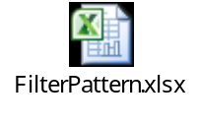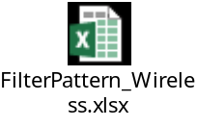

Design Views
The description of a design can be organized in views that reveal design details from different perspectives and viewpoints. Together these views provide a comprehensive description of the design in a comprehensive and concise manner. The following table illustrates the characteristics of the Interface Design view and of the Detail Description view:

Design View | Scope | Attributes | Example Representation
Interface Description | List of everything a designer, programmer, or tester needs to know to use the components that make up the system. | Identification, Function, Interfaces | Interface Files, Parameter Tables
Detail Description | Description of the internal design details of a component | Identification, Processing, Data | Flows, PDL
Table 1 – Design Views

Example of Parameter table is shown in Table 2.
Parameter Modifiers | Parameter Type | Parameter Name | Parameter Initializer | Description | Scope | Optional
[IN] | INT | Parameter1 | = 1 | Enable or disable timer | 0: Disable  1: Enable | NO
[OUT] | DOUBLE | Parameter2 | = 0 | Time out value in mili-seconds | 0: Initial timeout value  N: N mili-seconds, Max. 3,600,000 | NO
Table 2 – Parameter Table Example

Interface Description View

External Interfaces

Please refer to the PowerManagement External Specification document.

CheckStatus
Documentation:
NMO calls this function when receive CheckStatus message.
This function checks the status of network protocol.
It also sets the autoreponse patterns for SNMP and ICMP.
And set next wake up time for network module.

//Update for L7.0 Network 2 port support
This function should check the status of the protocols which are enabled in secondary network also. (Separate shared memory for each of SNMP process).
AutoResponse patterns should be set for secondary network as well.
Secondary network should also be considered which calculating the next wake up time.

Return Type:
Status
STATUS_OK : Network service not work case
STATUS_FAILED : Network service work case
Next wake up time is less than one minute.

Parameters:
N/A

CheckNetworkType
Documentation:
NMO calls this function to check whether it’s a wired network or wireless network connection.

Return Type:
int
INT_WIRED : When the connection type is wired
INT_WIRELESS : When the connection type is wireless
STATUS_FAIL : When there is no connection [wired/wireless]

pm_filter
Documentation:
NMO calls this function when receive CheckStatus message.
This function set the filter for wake up from SuperSleep.

The function will call the CheckNetworkType() to check whether the wired or wireless is enabled based on that this function will set the filter for wake up from super sleep

//Update for L7.0 Network 2 port support
NMO should check “Network/Protocols/TCP-IP/networkConfiguration” xpath to see if both networks are available . If the value of this xpath is “4”, then both networks are available.
NMO should call this function separately for Primary as well as secondary network, if both networks are available.
In Primary Network flow: Check if it is eth0 or wlan0 interface. If the xpath “Network/Protocols/TCP-IP/networkConfiguration” is “2” or “4”, it is wlan0 interface, else it is eth0 interface. Based on that set the wakeup patterns to either NIC or wireless driver.
In Secondary Network flow: Wakeup pattern has to set for NIC (as it is always eth0). Patterns should be set only for those protocols which are enabled in second network. (The following wakeup patterns are not supported in secondary network : SMB, LLTD, SLP, DPWS,AirPrint)

Return Type:
Status
STATUS_OK : The setting of the filter succeeds
STATUS_FAILED : The setting of the filter fails

Parameters:
bool isPrimaryNetwork; flag to identify if the function is called for primary network or secondary

Data

Internal Interfaces

pm_set_filter
Documentation:
This function make pattern filter. This function is called in pm_filter ()

Based on the network type this function will create the pattern filters for wired or wireless.

//Update for L7.0 Network 2 port support
This function will take an additional argument to specify whether it is called for Primary network or secondary network. The xpaths used to fetch the value should be identified based on the network. The following xpaths should be different for Primary and secondary networks.

Network/Adapters/Wire/macAddress
Network/Adapters/Wireless/macAddress

Network/Protocols/TCP-IP/ip
Network/Protocols/TCP-IP/Secondary/ip

Network/Protocols/TCP-IP/subnet
Network/Protocols/TCP-IP/Secondary/subnet

Network/Protocols/TCP-IP/gw
Network/Protocols/TCP-IP/Secondary/gw

Network/Protocols/IPV6/enabled
Network/Protocols/IPV6/Secondary/enabled

Network/Protocols/IPV6/linkLocalAddress
Network/Protocols/IPV6/Secondary/linkLocalAddress

Network/Protocols/IPV6/addressMode
Network/Protocols/IPV6/Secondary/addressMode

Network/Protocols/IPV6/Manual/IPAddress/ipAddress
Network/Protocols/IPV6/Secondary/Manual/IPAddress/ipAddress

Network/Protocols/IPV6/Manual/IPAddress/gateway
Network/Protocols/IPV6/Secondary/Manual/IPAddress/gateway

Network/Protocols/IPV6/Manual/IPAddress/prefix
Network/Protocols/IPV6/Secondary/Manual/IPAddress/prefix

Network/Protocols/IPV6/Stateful/IPAddress/ipAddress
Network/Protocols/IPV6/Secondary/Stateful/IPAddress/ipAddress

Network/Protocols/IPV6/Stateful/IPAddress/gateway
Network/Protocols/IPV6/Secondary/Stateful/IPAddress/gateway

Network/Protocols/IPV6/Stateful/IPAddress/prefix
Network/Protocols/IPV6/Secondary/Stateful/IPAddress/prefix

Network/Services/LLMNR/enabled
Network/Services/LLMNR/Secondary/enabled

Network/Services/Bonjour/servicename
Network/Services/Bonjour/Secondary/serviceName

Network/Services/Bonjour/hostname
Network/Services/Bonjour/Secondary/hostName

Return Type:
Status
STATUS_OK : The making of the filter succeeds
STATUS_FAILED : The making of the filter fails

Parameters:
REGDATA *reg_data : the structure of filter for SOC
PATTERNDATA *patt_data : fthe structure of filter for PHY
Int prot : protocol number
AL::UIController::BOProxy spBOProxy
Int NetworkType : Type of Network Connection Wired (1) or Wireless (2)

pm_checkService
Documentation:
This function checks the enable /disable of protocol service.

Return Type:
Status
STATUS_OK : check of service is success.
STATUS_FAILED : check of service is success fail

Parameter:
Int prot : A protocol number to check
AL::UIController::BOProxy spBOProxy
Int enable : result of check

pm_getPortNum
Documentation:
This function gets the port number from Network Dom.

Return Type:
Status
STATUS_OK : The getting of the port number is success.
STATUS_FAILED : The getting of the port number is fail.

Parameter:
Int prot : A protocol number to check
AL::UIController::BOProxy spBOProxy
Int enable : result of check

pm_make_NetBiosName
Documentation:
This function change NetbiosName to 2 Bytes code from 1Byte code.

Return Type:
Status
STATUS_OK : every time returns STATUS_OK.

Parameter
Char *aName : The name of the conversion object.
And a name after the conversion is stored.

pm_getValue
Documentation:
This function gets the value from Dom.

Return Type:
CI::OperatingEnvironment::CString:
The value that was got from Dom.

Parameter
CI::OperatingEnvironment::CString xpath
AL::UIController::BOProxy spBOProxy

pm_checkIPv6Addr
Documentation:
This functioncheck IPV6 address format.
And change the IPv6 address to binary format from text format

Return Type:
Status
STATUS_OK : IPv6 address is correct format.
STATUS_FAILED : IPv6 address is incorrect format

Parameter
Char *pIPv6Address : IPv6Address
int ipv6flag : address tyoe

pm_getStatus
Documentation:
This function get the status of network protocol from shared memory.

Return Type:
CI::OperatingEnvironment::CString

Parameter
CI::OperatingEnvironment::CString pShmName

pm_AcquireShmem
Documentation:
This function bind shared memory.

Return Type:
CI::OperatingEnvironment::SharedMemory : Shares memory bound

Parameter
CI::OperatingEnvironment::CString pShmName : Shared memory name

pm_AttachShmemArea
Documentation:
This function get the value from shared memory.

Return Type:
Status
STATUS_OK : success.
STATUS_FAILED : fail

Parameter
CI::OperatingEnvironment::SharedMemory& pSharedMem : Shares memory bound
Char *shm : the value get from hared memory

pm_setValue
Documentation:
This function set the value to Dom.

Return Type:
Status
STATUS_OK : success.
STATUS_FAILED : fail

Parameter
CI::OperatingEnvironment::CString xpath : The xpath which set a value
CI::OperatingEnvironment::CString value : The value to set

pm_ChangeLocaltime
Documentation:
This function convert time to time_t type from data type.

Return Type:
Status
Every time returns STATUS_OK.

Parameter
CI::OperatingEnvironment::CString sValue : A value to convert
Long int *iTime : A value after the conversion

pm_setWakeupTime
Documentation:
This function set the next wake up time to NetworkDom.

Return Type:
Status
STATUS_OK : next time set is success
STATUS_FAILED : When time is near to now or time is past

pm_make_regdata
Documentation:
This function make the filter for set to SOC.

Return Type:
Status
Every time returns STATUS_OK.

Parameter
REGDATA* reg_data : the structure for filter of SOC
int prot : protocol number
char* pData : data
int iPort : port number of protocol

pm_make_patterndata
Documentation:
This function make the filter for set to PHY.

Return Type:
Status
Every time returns STATUS_OK.

Parameter
PATTERNDATA* filter_data : the structure for filter of PHY
int prot : protocol number
char* pData : data
int iPort : port number of protocol

pm_dispFilter
Documentation:
This function is displayed filter setting.

Return Type:
void

Parameter
REGDATA* reg_data : the structure for filter of PHY
D3COLD_CONF *woldata : the structure for filter of PHY

Change of Environment variable for eBN vMFP
The environment variable used for distinguishing VMFP machines was PRODUCT=INTEL, before L6.0.
Since from L6.0 the compiler used is Intel based for MFP. All MFP have PRODUCT=INTEL flag.
Hence for eBN vMFP, the new environment variable was introduced as below.

[old]
MACHINE=INTEL_VMFP

[new]
VMFP=vMFP

To support the eBN vMFP Makefile needs to be modified to use the new flag.

Timing of setting for wake up pattern
Before L6.0, the wake up pattern was set for all the enabled protocols, for which the MFP has to wake-up, before going to SuperSleep. The filter was set every time when PowerManagement received the “check_status” request. The design was done as the filter settings were not retained in the firmware after WakeUp. From L6.0 the filter settings need not be set all the time before going to supersleep. Since the device settings are not deleted during wakeup the pattern needs to be set only when the corresponding filter is enabled/disabled from TA.

Refer Sequences diagram (6.4.2.3) for more details

Adding new wakeup factors for AirPrint
New wakeup factors are added for AirPrint, when AirPrint service and PMWakeUpFilterAirPrint are enabled by the user. The options will be added for both the IPv4 and Ipv6 sections. The following two factors will be added to pattern for wakeup from supersleep
- Query of the service name. The MFP service name is obtained from the Network DOM from xpath “Network/Services/Bonjour/servicename”.
- Query of own bonjour host name. The MFP hostname is obtained from the Network DOM from xpath “Network/ Services/Bonjour/hostname”.
- The values are populated in the pattern map as mentioned below.
  - 0x00000037 – This is the location in the MDNS packet, where the query is located.
  - We use this location and add the service name and hostname obtained from the xpath mentioned above to the filter array, before setting it to the NetworkFilter.
The pseudo code is as follows:

pm_make_patterndata()
Function Prototype | pm_make_patterndata(int prot, char *pData, int iPort)
Description | This function makes the pattern data relative to all filters.
Input Parameters | Prot – Protocol for which the filter needs to be set.  pData – Protocol specific data that needs set in the filter for the respective protocol  iPort – The port number that needs to be set
Output Parameters | None
In-out Parameters | None
Return value | Status – returns STATUS_OK

Status pm_make_patterndata(int prot, char *pData, int iPort)
{
…
case PM_AIRPRINT:
{
…
memcpy(&patt_data.pattData[PM_MDNSIPV4QUERYPOINT],Servicename,servicename.length());
memcpy(&patt_data.pattData[PM_MDNSIPV4HOSTNAMEPOINT],hostname,servicename.length());
}
case PM_AIRPRINTIPV6:
{
…
memcpy(&patt_data.pattData[PM_MDNSIPV6QUERYPOINT],Servicename,servicename.length());
memcpy(&patt_data.pattData[PM_MDNSIPV6HOSTNAMEPOINT],hostname,servicename.length());
}

Return STATUS_OK;
}

Support for Auto response mechanism and a new structure setting to NIC
The MFP wakes up from the supersleep mode whenever it receives the network packets. The wakeup from supersleep used to take time and was unnecessary for some of the packets received. Hence from L6.0 a new feature is introduced wherein the MFP automatically responds whenever specific packets are received. This saves more energy and also avoids unnecessary WakeUp. The Auto response functionality is valid only when the MAC and IP filtering are disabled.
The following is the list of the protocols which are supported for auto response form MFP.
- ICMPv6 neighbor solicitation packet
- ICMPv6 echo request packet
- ICMPv6 multicast listener query packet
- LLMNR for IPV4
- LLMNR for IPv6
- ARP
- SNMP (IPv4) for printer state
- SNMP (IPV6) for printer state
- Net Bios Name Service (NBNS)
For more details on the specific protocol please refer to the Specification document.

In order to indicate the kind of reply required (auto response/Complete Wake up), a new data structure is implemented. The structure should be set using the below format.
2bytes
Header
(OSoobHdr)
Data
(oobData_setIPInfo or oobData_setPatternInfo)

- The 2 bytes of data should be left unattended as a buffer.
- The Header is the data structure defined below. This structure indicates whether the data being set is IP information or pattern information
struct OSoobHdr
{
unsigned int len; // size of data section
unsigned char type; // set message type. SETIPINFO or SETPATTERNINFO
unsigned char flag;
unsigned char hostReqV;
unsigned char res;
};
- There are two kinds of data that needs to be set using two different filters as below
- IP information:
struct oobData_setIPInfo
{
unsigned int IPv4Enable;
unsigned long HostIP;
unsigned long SubnetMask;
unsigned long GatewayIP;
unsigned int IPv6Enable;
unsigned char HostIPv6[16];
unsigned char LocalIPv6[16];
unsigned char IPv6GateWay[16];
unsigned int IPv6PrefixLen;
unsigned char MacAddress[6]; //MAC address of the MFP
};
- Wakeup pattern information
struct oobData_setPatternInfo
{
char patternID;
unsigned char type;
struct wakeup_pattern wakeup;
struct auto_response auto_res;
unsigned char wakeup_unicast;
};

The data section can either contain the IP information or the Wakeup setting information.

The IP information is set first to the Network Filter with the following details.
  - IPv4 and IPv6 Enable/Disable status.
  - IP address (Both Link local and Global IPv6 address)
  - Gateway address
  - Subnet Mask
  - MAC address

The WakeUp pattern structure contains the following
- The patternID is the protocol identifier
- Type parameter is used as follows
  - 0x00 – Filter is disabled for the patternID
  - 0x01 – Auto response is enabled
  - 0x10 – Normal Wakeup is enabled
  - 0x11 – Auto response and Wakeup both are enabled

- wakeup_pattern -- This structure needs to be set with pattern information when Type is 0x10
- auto_response – This structure needs to be set with pattern information when Type is 0x01
- wakeup_unicast – This flag is used to indicate if MFP has to wakeUp from a Unicast packet.

The pattern data needs to be set for each protocol in the oobData_setPatternInfo structure and the structure has to be passed to CI::SystemInformation, which will appropriately set to the NIC.

Pseudo code for set pattern function
Function Prototype | Status pm_set_pattern (DocumentRef configDoc)
Description | This function makes the pattern data for eBN and sets it to SetNetworkFilter2()
Input Parameters | configDoc – This is REF variable to the Network DOM
Output Parameters | None
In-out Parameters | None
Return value | Returns STATUS_OK if filter setting is successful  Returns STATUS_OK if filter setting fails due to some reason

Status pm_set_pattern(DocumentRef configDoc)
{
// Declration of all the required structures
char * param_addr;
struct OSoobHdr *pOOBHdr;
struct oobData_setIPInfo *pIPInfo;
struct oobData_setPatternInfo *pPatternInfo;
struct in_addr IPaddr

ci::systeminformation::SystemInformationRef pSysInfo = ci::systeminformation::SystemInformation::Acquire();
param_addr = 0;

// Setting of the Ip information.
allocateParam for IP structure.

IP = GetValue(“Network/Protocols/ TCP-IP/ip”);
if(inet_aton(IP, &IPaddr)==0)
{
return STATUS_FAILED;
}
pIPInfo.HostIP = IPaddr.s_addr;
gw = GetValue(“Network/Protocols/ TCP-IP/gw”);
if(inet_aton(gw, &IPaddr)==0)
{
return STATUS_FAILED;
}
pIPInfo.GatewayIP = IPaddr.s_addr;

subnet = GetValue(“Network/Protocols/ TCP-IP/subnet”);
if(inet_aton(subnet, &IPaddr)==0)
{
return STATUS_FAILED;
}
pIPInfo.SubnetMask = IPaddr.s_addr;

check if IPv6 is enabled
Set the information similar to IPv4 to respective variables.

pSysInfo->SetNetworkFilter2(param_addr);
freeParam(param_addr,pOOBHdr,pIPInfo);

Update all the filters with the pattern information
for(int id=0; id<UNICAST_ID; id++)
{
Allocate memory for Pattern information structure
pPatternInfo.patternID = id;
pPatternInfo.wakeup_unicast=1;
switch(id)
{
case ARP_ID:
pPatternInfo.type = 0x01; //auto response
set_arp(pPatternInfo);
break;
case SNMP_ID:
pPatternInfo.type = 0x01; //auto response
set_snmp(pPatternInfo);
break;
case BONJOUR_ID:
pPatternInfo.type = 0x10; //wake up
set_bonjour(pPatternInfo);
break;
…
…
default:
break;
}
// set the patterin information
pSysInfo->SetNetworkFilter2(param_addr);
freeParam(param_addr,pOOBHdr,pPatternInfo);
}
// Setting the information for UNICAST packets
Allocate memory for pattern data of Unicast packets
pPatternInfo.patternID = UNICAST_ID;
pPatternInfo.wakeup_unicast=1;
pPatternInfo.type=0x10; // WakeUp when a unicast packet is received.

pSysInfo->SetNetworkFilter2(param_addr);
freeParam(param_addr,pOOBHdr,pPatternInfo);

return STATUS_OK;
}

Pseudo code for checkNetworkType function
Function Prototype | Status checkNeworkType(DocumentRef configDoc)
Description | This function will check which type of network is connected (wired/wireless)
Input Parameters | configDoc – This is REF variable to the Network DOM
Output Parameters | None
In-out Parameters | None
Return value | Returns INT_WIRED : if wired connection is enabled  Returns INT_WIRELESS if wireless connection is enabled  Returns STATUS_FAIL if no connection is found.

Status checkNetowrkType(DocumentRef configDoc)
{
………………………..
………………………..

device = GetValue(“Network/Protocols/ TCP-IP/device”);
switch(device)
{
case eth0:
return INT_WIRED;
case wlan0:
return INT_WIRELESS;
default:
return STATUS_FAIL;
}
………………………..
………………………..
}

Auto Response for SNMP packets
Client PCs query for the device state using SNMP protocol. Below are the 3 OIDs which are requested by Client PCs. MFP Auto responses to these requests in the SuperSleep state, without waking up.
- {0x2b,0x06,0x01,0x02,0x01,0x19,0x03,0x02,0x01,0x05,0x01}
- {0x2b,0x06,0x01,0x02,0x01,0x19,0x03,0x05,0x01,0x01,0x01}
- {0x2b,0x06,0x01,0x02,0x01,0x19,0x03,0x05,0x01,0x02,0x01}

Following additional OID is added for SNMP autoresponse feature.
{0x2b,0x06,0x01,0x04,0x01,0x88,0x69,0x02,0x03,0x32,0x01,0x02,0x04,0x01,0x48,0x01,0x01}
The Auto response values are set to the NIC interface by PowerManagement component using a new library called snmphelper. Snmphelper library exposes interface called GetMIBValue(), which returns the values of the respective OIDs. The values thus obtained are set to the NIC interface.

From L6.5 onwards additional OIDs are supported for SNMP autoresponse feature.
- hrMemorySize:
{0x2b,0x06,0x01,0x02,0x01,0x19,0x02,0x02,0x00}
- hrstorageType
{0x2b,0x06,0x01,0x02,0x01,0x19,0x02,0x03,0x01,0x02,0x01}
{0x2b,0x06,0x01,0x02,0x01,0x19,0x02,0x03,0x01,0x02,0x02}
{0x2b,0x06,0x01,0x02,0x01,0x19,0x02,0x03,0x01,0x02,0x03}
- prtMediaPathType
{0x2b,0x06,0x01,0x02,0x01,0x2B,0x0D,0x04,0x01,0x09,0x01,0x01}
{0x2b,0x06,0x01,0x02,0x01,0x2B,0x0D,0x04,0x01,0x09,0x01,0x02}
{0x2b,0x06,0x01,0x02,0x01,0x2B,0x0D,0x04,0x01,0x09,0x01,0x03}

Detailed Design Description View
Scope
The detailed design description contains the internal details of each component. These details include the attribute descriptions for identification, processing, and data.
Use
This description contains the details needed by programmers prior to implementation. The detailed design description can also be used to aid in producing unit test plans.
Representation
Following subsections describe the design of PowerManagement as standard UML2 diagrams.

Theory of operation

PowerManagement service is used to go to SuperSleep and wake up from SuperSleep
The PowerManagement service is library. This service called by PowerManagement NMO.

Business Logic：
PowerManagement NMO call powermanagement service, when restrictionmode send command or the network setting is changed.
(Please confirm below functions section.)

Functions :
Set Wake up filter
This function is called when change the network setting. This scenario is not work from EX-Loire/Alabama
This function set the filter pattern for wake up by network.
It always set filter for unicast.
The target service is as below:
ARP
SNMP (IPV4/IPV6)
NBNS
Bonjour (IPV4/IPV6)
AirPrint Discovery (IPV4/IPV6)
Neighbor Discovery (Manual / Stateful / Linklocal)
LLMNR
LLTD
SLP
Web Service (IPV4 / IPV6)
SMB

<Update for L7.0 2 network port support>
Wakeup filter should be set for primary and secondary network separately if both wired and wireless networks are connected. Check if the primary network is eth0 or wlan0.Based on that set the wakeup patterns to either NIC or wireless driver. If secondary network is available,wakeup pattern has to set for NIC (as it is always eth0). Patterns should be set only for those protocols which are enabled in second network.

The target service is as below:
ARP
SNMP (IPV4/IPV6)
Bonjour (IPV4/IPV6)
Neighbor Discovery (Manual / Stateful / Linklocal)
LLMNR

Check the network service status
This function is called before go to SupersSeep.
This function checked the network service status.
Each protocol write status(IDLE/BUSY) to shared memory.
this function read each shared memory.
If the protocol is disable, not check service status.
If LAN cable have disconnected , behave as all protocol is IDLE.
The service to check is as below:
RawPrint
LPD
IPP
FTP
SMTP
FileDownLoader
Telnet
RemotoScan
EBR
SNMP
SMB
WSDPrint
WSDScan
Bonjour
LLTD
SLP
USBPrint (only weiss)

<Update for L7.0 2 network port support>
Since separate process will be created for supporting SNMP in secondary network, status of this second SNMP process should also be checked before going to supersleep.

Set next wake up time
This function is called in checkStatus function
This function set next wake up time for network protocol need to wake up by RTC.
The service to check is as below:
eBR
SMB
DHCPV4
DHCPV6

<Update for L7.0 2 network port support>
DHCPV4 and DHCPV6 renew times should be considered from the secondary network also to set the next wakeup time.

Data

Wake up filter
各プロトコルで復帰要因の設定に必要な情報の参照先は表2になる。
表1．
Unicast
Mac Address | Network/Adapters/Wire/macAddress  Network/Adapters/Wireless/macAddress
ARP
IP Address | Network/Protocols/TCP-IP/ip  Network/Protocols/TCP-IP/Secondary/ip
SNMP
Port Number | Network/Protocols/SNMP/portNumber
NBNS
Port Number | 137 (固定)
NetBios Name | Network/Protocols/SMB/deviceName
Bonjour
Port Number | 5353 (固定)
DPWS
Port Number | Network/Protocols/DPWS/discoveryPort
Neighbor discovery
LinkLocal Address | Network/Protocols/IPV6/linkLocalAddress  Network/Protocols/IPV6/Secondary/linkLocalAddress
Manual Address | Network/Protocols/IPV6/Manual/IPAddress/ipAddress  Network/Protocols/IPV6/Secondary/Manual/IPAddress/ipAddress
Stateful Address | Network/Protocols/IPV6/Stateful/IPAddress/ipAddress  Network/Protocols/IPV6/Secondary/Stateful/IPAddress/ipAddress
SLP
Port Number | 427 (固定)
LMNR
Port Number | 5355 (固定)
NetBios Name | Network/Protocols/SMB/deviceName
AirPrint
Port Number | 5353 (固定)
query Name | ._universal._sub._ipp (固定)
Service Name | Network/Services/Bonjour/servicename
Hostname | Network/Services/Bonjour/hostname

Filterの設定の有効無効の参照先は表2
表2
Service | xpath
ARP | Network/Services/PowerManagement/PMWakeUpFilterARP
SNMP IPV4 | Network/Services/PowerManagement/PMWakeUpFilterSNMPv4
SNMP IPV6 | Network/Services/PowerManagement/PMWakeUpFilterSNMPv6
NBNS | Network/Services/PowerManagement/PMWakeUpFilterSMB
AirPrint IPV4 | Network/Services/PowerManagement/PMWakeUpFilterAirPrint
AirPrint IPV6 | Network/Services/PowerManagement/PMWakeUpFilterAirPrintIPV6
Bonjour IPV4 | Network/Services/PowerManagement/PMWakeUpFilterBonjour
Bonjour IPV6 | Network/Services/PowerManagement/PMWakeUpFilterBonjourIPV6
Neighbor Discovery (Linklocal) | Network/Services/PowerManagement/PMWakeUpFilterNeighborDiscovery
Neighbor Discovery (Manual / Stateful) | Network/Services/PowerManagement/PMWakeUpFilterNeighborDiscoveryForManual
LLMNR | "Network/Services/PowerManagement/PMWakeUpFilterLLMNR
LLTD | Network/Services/PowerManagement/PMWakeUpFilterLLTD
SLP | Network/Services/PowerManagement/PMWakeUpFilterSLP
DPWS IPV4 | Network/Services/PowerManagement/PMWakeUpFilterDPWSIPv4
DPWS IPV6 | Network/Services/PowerManagement/PMWakeUpFilterDPWSIPv6

Filters for Wireless super sleep support.
Service | xpath
ARP | Network/Services/PowerManagement/Wireless/PMWakeUpFilterARP
SNMP IPV4 | Network/Services/PowerManagement/Wireless/PMWakeUpFilterSNMPv4
SNMP IPV6 | Network/Services/PowerManagement/Wireless/PMWakeUpFilterSNMPv6
NBNS | Network/Services/PowerManagement/Wireless/PMWakeUpFilterSMB
AirPrint IPV4 | Network/Services/PowerManagement/Wireless/PMWakeUpFilterAirPrint
AirPrint IPV6 | Network/Services/PowerManagement/Wireless/PMWakeUpFilterAirPrintIPV6
Bonjour IPV4 | Network/Services/PowerManagement/Wireless/PMWakeUpFilterBonjour
Bonjour IPV6 | Network/Services/PowerManagement/Wireless/PMWakeUpFilterBonjourIPV6
Neighbor Discovery (Linklocal) | Network/Services/PowerManagement/Wireless/PMWakeUpFilterNeighborDiscovery
Neighbor Discovery (Manual / Stateful) | Network/Services/PowerManagement/Wireless/PMWakeUpFilterNeighborDiscoveryForManual
LLMNR | "Network/Services/PowerManagement/Wireless/PMWakeUpFilterLLMNR
LLTD | Network/Services/PowerManagement/Wireless/PMWakeUpFilterLLTD
SLP | Network/Services/PowerManagement/Wireless/PMWakeUpFilterSLP
DPWS IPV4 | Network/Services/PowerManagement/Wireless/PMWakeUpFilterDPWSIPv4
DPWS IPV6 | Network/Services/PowerManagement/Wireless/PMWakeUpFilterDPWSIPv6

CheckService
各サービスで使用する共有メモリは表3に記載。
サービスが動いていないときはIDLE、動いているときはBUSYを設定する
表3
サービス | 共有メモリ
LPR | SHM_NET_PM_LPR
RAW Print | SHM_NET_PM_RAW
IPP | SHM_NET_PM_IPP
FTP | SHM_NET_PM_FTP
WSD Scan | SHM_NET_PM_WSDSCN
WSD Print | SHM_NET_PM_WSDPRN
SNMP | SHM_NET_PM_SNMP → Primary Process  SHM_NET_PM_SNMP2 → Secondary Process
SMTP | SHM_NET_PM_SMTP
File Downloader | SHM_NET_PM_FD
Telnet | SHM_NET_PM_TELNET
Remote Scan | SHM_NET_PM_RS
eBR | SHM_NET_PM_EBR
SMB | SHM_NET_PM_SMB
Bonjour | SHM_NET_PM_MDNS
LLTD | SHM_NET_PM_LLTD
SLP | SHM_NET_PM_SLP
USB | SHM_NET_PM_USB

WakeUpTime
SuperSleep中にRTCを使用して復帰させる必要があるプロトコルは下記であり、各プロトコルは表4に記載するパスに復帰したい時刻を設定する。
このの中から最小の時間をRestrictionModeが読む下記パスに設定する。
保存先：Network/Services/PowerManagement/nextWakeupTime (format: time_t)
表4．RTCに時間を設定する必要があるサービス(format : year/month/date-hh:mm:ss)
サービス | Xpath /Shared Memory | Time zone
DHCPV4 Renew | SHM_DHCP_RENEW_TIME  TBD : Shared memory for secondary Network | UTC
eBR 定期通信 | Network/Services/eBR/FinalPollingTime | Local time
ホストアナウンスメント定期通信 | SHM_SMB_WAKEUP_TIME | Local time
DHCPV6 Renew | SHM_DHCPV6_RENEW_TIME  TBD : Shared memory for secondary Network | TBD

other
各サービスの有効無効は表5の値で判断する。
表5
The following table is for Primary Network
Service | Xpath | Judgment conditions
SNMP IPV4 | Network/Protocols/SNMP/snmpV1V2Enable | どちらかの設定がeffective when enabled
SNMP IPV4 | Network/Protocols/SNMP/snmpV3Enabled | どちらかの設定がeffective when enabled
SNMP IPV6 | Network/Protocols/IPV6/enabled | IPV6有効かつSNMPのどちらかの設定がeffective when enabled
SNMP IPV6 | Network/Protocols/SNMP/snmpV1V2Enable | IPV6有効かつSNMPのどちらかの設定がeffective when enabled
SNMP IPV6 | Network/Protocols/SNMP/snmpV3Enabled | IPV6有効かつSNMPのどちらかの設定がeffective when enabled
SMB | Network/Protocols/SMB/enabled | effective when enabled
Bonjour IPV4 | Network/Services/Bonjour/enabled | Effective when enabled
BonjourIPV6 | Network/Protocols/IPV6/enabled | 全ての設定がeffective when enabled ,
BonjourIPV6 | Network/Services/Bonjour/enabled | 全ての設定がeffective when enabled ,
AirPrint IPV4 | Network/Services/Bonjour/enabled | 全ての設定がeffective when enabled ,
AirPrint IPV4 | Network/Services/AirPrint/enabled | 全ての設定がeffective when enabled ,
AirPrint IPV4 | Network/Services/Bonjour/servicename
AirPrint IPV4 | Network/Services/Bonjour/hostname
AirPrint IPV6 | Network/Protocols/IPV6/enabled | 全ての設定がeffective when enabled ,
AirPrint IPV6 | Network/Services/Bonjour/enabled | 全ての設定がeffective when enabled ,
AirPrint IPV6 | Network/Services/AirPrint/enabled | 全ての設定がeffective when enabled ,
NeighborDiscovery | Network/Protocols/IPV6/enabled | effective when enabled
LLMNR | Network/Protocols/IPV6/enabled | 全ての設定がeffective when enabled ,
LLMNR | Network/Services/LLMNR/enabled | 全ての設定がeffective when enabled ,
LLTD | Network/Services/LLTD/enabled | effective when enabled
SLP | Network/Protocols/SLP/enabled | effective when enabled
WSD IPV4 | Network/Protocols/DPWS/printServiceStatus | どちらかの設定がeffective when enabled
WSD IPV4 | Network/Protocols/DPWS/scanServiceStatus | どちらかの設定がeffective when enabled
WSD IPV6 | Network/Protocols/IPV6/enabled | IPV6有効かつWSDのどちらかの設定がeffective when enabled
WSD IPV6 | Network/Protocols/DPWS/printServiceStatus | IPV6有効かつWSDのどちらかの設定がeffective when enabled
WSD IPV6 | Network/Protocols/DPWS/scanServiceStatus | IPV6有効かつWSDのどちらかの設定がeffective when enabled
RAW Print | Network/Services/HPJetDirect/enabled | effective when enabled
LPR | Network/Services/LPD/enabled | effective when enabled
IPP | Network/Services/IPP/enabled | effective when enabled
FTP | Network/Services/FTPServer/enabled | effective when enabled
SMTP | Network/Protocols/SMTP/Client/enabled | どちらかの設定がeffective when enabled
SMTP | Network/Protocols/SMTP/Server/enabled | どちらかの設定がeffective when enabled
FileDowonloader | 有効無効の設定なし
AddressBookViewer | 有効無効の設定なし
Telnet | Network/Services/Telnet/enabled | effective when enabled
RemoteScan | Network/Services/RemoteApplications/RemoteScan/enabled | effective when enabled
eBR | Network/Services/eBR/enabled | effective when enabled
WSD scan | Network/Protocols/DPWS/scanServiceStatus | effective when enabled*1
WSD Print | Network/Protocols/DPWS/printServiceStatus | effective when enabled*1
*1: サービスの状態確認の時に使用する

The following table is for Secondary Network:
Service | Xpath | Judgment conditions
SNMP IPV4 | Network/Protocols/SNMP/Secondary/enabled
SNMP IPV4 | Network/Protocols/SNMP/snmpV1V2Enable | どちらかの設定がeffective when enabled
SNMP IPV4 | Network/Protocols/SNMP/snmpV3Enabled | どちらかの設定がeffective when enabled
SNMP IPV6 | Network/Protocols/IPV6/Secondary/enabled | IPV6有効かつSNMPのどちらかの設定がeffective when enabled
SNMP IPV6 | Network/Protocols/SNMP/Secondary/enabled | IPV6有効かつSNMPのどちらかの設定がeffective when enabled
SNMP IPV6 | Network/Protocols/SNMP/snmpV1V2Enable | IPV6有効かつSNMPのどちらかの設定がeffective when enabled
SNMP IPV6 | Network/Protocols/SNMP/snmpV3Enabled | IPV6有効かつSNMPのどちらかの設定がeffective when enabled
SMB | NA | Disabled
Bonjour IPV4 | Network/Services/Bonjour/Secondary/enabled | Effective when enabled
BonjourIPV6 | Network/Protocols/IPV6/Secondary/enabled | 全ての設定がeffective when enabled ,
BonjourIPV6 | Network/Services/Bonjour/Secondary/enabled | 全ての設定がeffective when enabled ,
AirPrint IPV4 | NA | 全ての設定がeffective when enabled ,
AirPrint IPV6 | NA | 全ての設定がeffective when enabled ,
NeighborDiscovery | Network/Protocols/IPV6/Secondary/enabled | effective when enabled
LLMNR | Network/Protocols/IPV6/Secondary/enabled | 全ての設定がeffective when enabled ,
LLMNR | Network/Services/LLMNR/Secondary/enabled | 全ての設定がeffective when enabled ,
LLTD | NA | Disabled
SLP | NA | Disabled
WSD IPV4 | NA | Disabled
WSD IPV4 | NA | Disabled
WSD IPV6 | NA | Disabled
WSD IPV6 | NA | Disabled
WSD IPV6 | NA | Disabled
RAW Print | Network/Services/HPJetDirect/enabled | effective when enabled
LPR | Network/Services/LPD/enabled | effective when enabled
IPP | Network/Services/IPP/enabled | effective when enabled
FTP | NA | Disabled
SMTP | NA | Disabled
SMTP | NA | Disabled
FileDowonloader | 有効無効の設定なし
AddressBookViewer | 有効無効の設定なし
Telnet | NA | Disabled
RemoteScan | Network/Services/RemoteApplications/RemoteScan/enabled | effective when enabled
eBR | NA | Disabled
WSD scan | NA | Disabled
WSD Print | NA | Disabled
*1: サービスの状態確認の時に使用する

Class Model

Controller side

Collaboration Model

Statechart Diagram

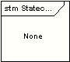

Sequence Diagram

6.4.2.1 Change the Network Setting .
This sequence is not work from EX-Loire/Alabama
Panel or
Top Access
UI Contoroller
NSM Object
PowerManagement NMO
PowerManagement Service
System
Information

Send trans doc
Delegate UI controller.

Call Update()
Pm_filter()

SetNetworkFilter ()

SetNetworkFilter2 ()
Return
Return
Return

6.4.2.2 Before go to SuperSleep (before L6.0).
Shared memory
Restrictionmode
UI Contoroller
NSM Object
PowerManagement NMO
PowerManagement
Send trans doc
Delegate UI controller.
Call Update()
Return
checkStatus ()
Network DOM
Response
Set next wake up time
Return
Return
check
Pm_filter()
Return
System
Information
SetNetworkFilter ()
SetNetworkFilter2 ()
Read next wake up time and set RTC.

6.4.2.3 Setting the filter when the filter options are changed in TA.

Wired Connection
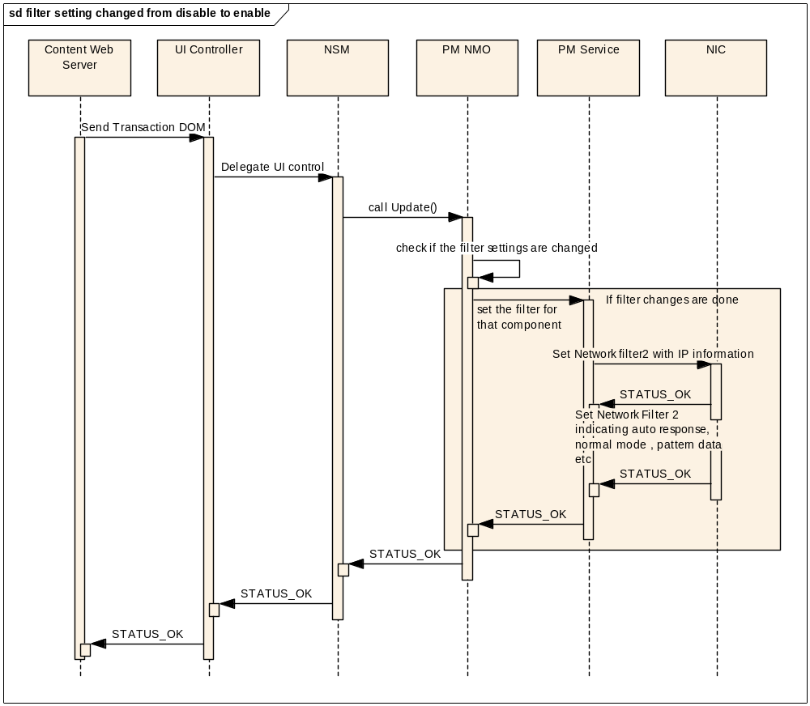

Wireless Connection
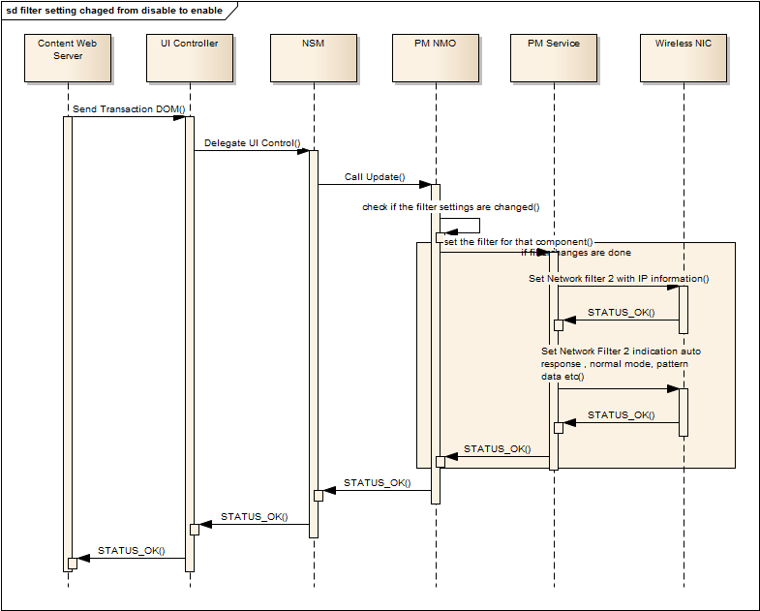

6.4.2.4 Handling of checkstatus command
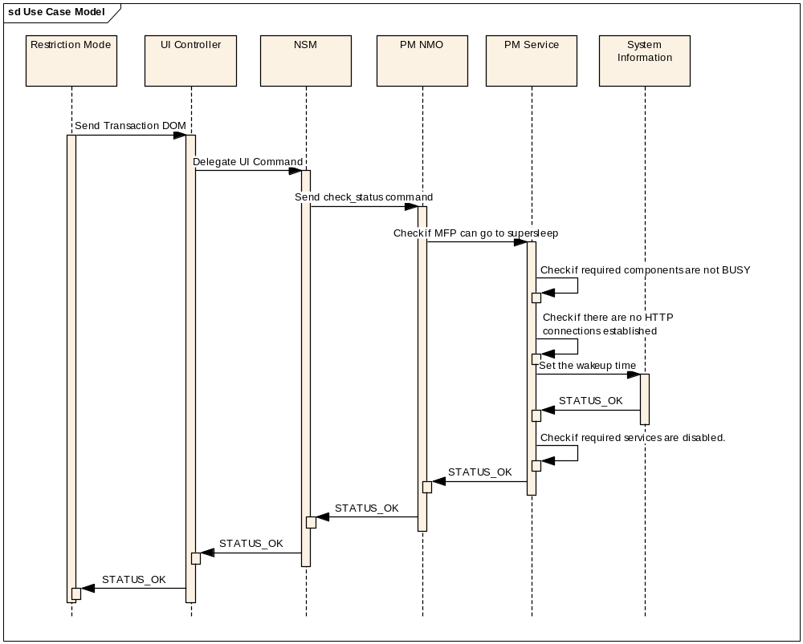

6.4.2.5 Auto Response mechanism
Wired Connection

sd Use Case Model
UI Controller
Content Web
Server
NSM
PM NMO
PM Service
NIC
Send Auto response packet
Send Transaction DOM
Delegate UIC command
Call Update()
Set the Network filter
Check if IP/MAC filtering is enabled
Set auto response
flag and pattern data
STATUS_OK
STATUS_OK
STATUS_OK
STATUS_OK
STATUS_OK
Check if the packets can be auto responded

Wireless Connection
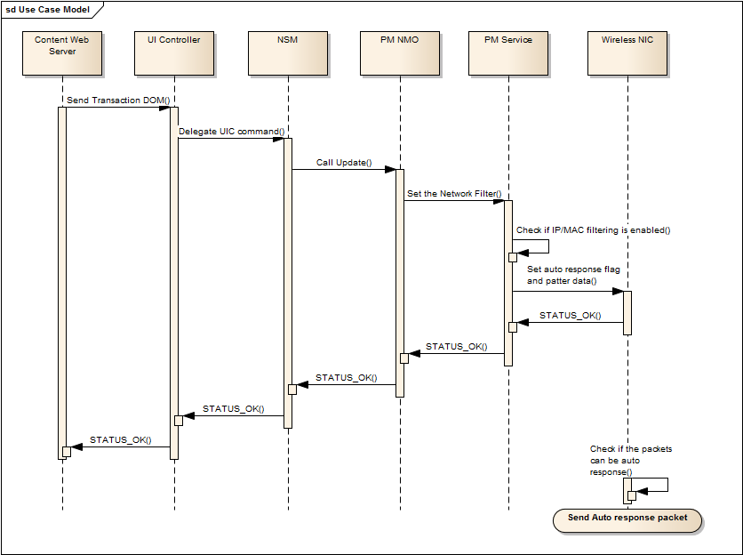

6.4.2.6 Wakeup without auto response
Wired Connection
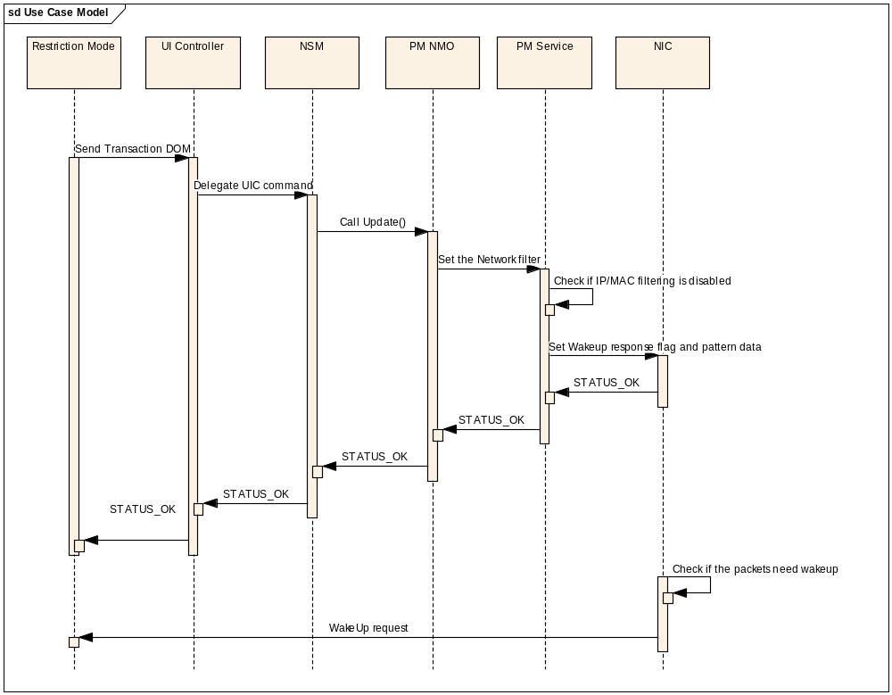

Wireless Connection
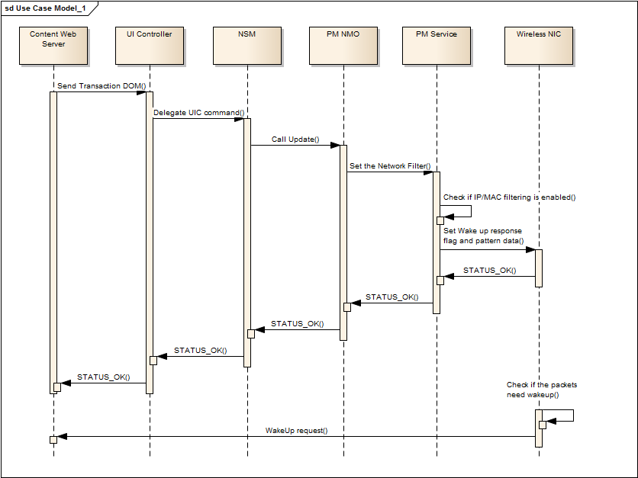

Execution Model

Deployment Diagram

Start/Stop Sequence

UI Flows

Appendix

DOM accessed and access modes
Sl No | DOM Name | Access Type
1 | Network | Read

Diagnostic mode codes used
Sl No | DOM Name | Access Type
1 | 08-8804(IP filtering enable/disable) | Read
2 | 08-8805(MAC filtering enable/disable) | Read

