Examination Results Monitoring Sytem
Final Evaluation Report

Registration Number | Name | Index Number
ICT/2024/144 | W.M.S.A.Ariyarathna | 6742
ICT/2024/082 | M.M.A.T.Maheepala | 6688
ICT/2024/145 | D.S.Dewmini | 6743
ICT/2024/002 | Isurika Aberathna | 6617
ICT/2024/100 | Asini Peeris | 6703
Team Name : The Syntax Squad
Table of Contents
1. Executive Summary & Problem Definition 3
1.1 Institutional Context & Problem Statement 3
1.2 System Purpose & Objectives 3
2. Regulatory Compliance & Academic By-Laws 4
2.1 Academic Rank & Seniority Hierarchy 5
2.2 Active Load Limits 5
2.3 Calendar-Month Calculation Algorithms 5
3. Physical Logistics & Detailed Workflow Execution 6
3.1 Phase 1: Physical Script Custody & Dual-OTP Handover 6
Step C & Step D: Post-Evaluation Script Return Handover 6
3.2 Phase 2: Second Marking & Courier Tracking 7
3.3 Phase 3: Final Marksheet Compilation 7
3.4 Phase 4: HOD Ratification & Permanent Locking 7
4. Security, Cryptography & Auditability 7
4.1 Cryptographic OTP Security Architecture 7
4.2 Role-Based Access Control (RBAC) Matrix 8
4.3 Document Storage & File Integrity Verification 9
5. Database Schema & Data Dictionary 9
6. Testing, Verification & Quality Assurance 10
6.1 Test Execution Summary 10
7. Quick Demonstration Guide 11
7.1 Key User Accounts 11
ER Digram 12
Relational Schema 13
Enhanced Entity Relationship Diagram 14

1. Executive Summary & Problem Definition

1.1 Institutional Context & Problem Statement
In higher education institutions—and specifically across faculties at Rajarata University of Sri Lanka (RUSL)—the examination results preparation cycle represents one of the most critical administrative and academic operations. Pursuant to RUSL Examination Regulations, every course offering must undergo rigorous independent evaluations: First Marking by the designated internal course lecturer, followed by Second Marking (moderation) by an appointed senior academic or external examiner, compilation of Continuous Assessment (CA) scores, and final ratification by the Head of Department (HOD) and Senate.
Historically, this entire lifecycle relied on paper-based ledger entries, physical dispatch chits, unmonitored courier mail, and fragmented email correspondence. This manual paradigm introduced severe operational risks:
1. Script Misplacement & Custody Ambiguity: Unclear handovers between the Examinations Branch (AR Office) and examiners created disputes over physical packet possession and script counts.
2. Deadline Overruns: Academic regulations mandate strict calendar deadlines (3 calendar months for First Marking, 1 calendar month for Second Marking). Without automated countdown timers, notifications, and escalating alerts, results often experienced protracted delays.
3. Premature or Unauthorized Alterations: Without automated state machines, marks and evaluation reports could be uploaded out of order, altered after submission, or modified post-approval.
4. Lack of Cryptographic Verification: Physical receipt of answer scripts lacked single-use authentication or non-repudiation.
5. Examiner Workload Imbalances & Rank Inconsistencies: Junior lecturers were occasionally appointed to moderate senior professors, violating academic seniority rules; or external examiners were over-assigned beyond capacity limits.

1.2 System Purpose & Objectives
The Examination Results Monitoring System (ERMS) is an enterprise-grade web application engineered to enforce 100% regulatory compliance, absolute physical custody tracking, cryptographic handovers, and permanent immutability.
Key objectives achieved:
• Cryptographic Dual-OTP Physical Handovers: Single-use 6-digit Time-based/Counter OTPs authenticate both initial script collection from the AR Office and post-marking return of scripts to the AR Office.
• Strict Sequential Phase Enforcement: Each step is gated by prerequisite checkpoints. For example, 1st marking reports cannot be uploaded before scripts are verified as collected; return OTPs cannot be generated before 1st marking reports are submitted; courier dispatch is locked until scripts are confirmed in AR custody.
• Academic Rank & Seniority Enforcement: The system strictly prevents assigning a Second Examiner who holds an academic rank lower than or equal to the First Examiner.
• Workload Throttling: Active concurrent second-marking allocations are capped at a maximum of 3 schedules per examiner.
• Irreversible Workflow Locking: Upon final HOD approval, the schedule is transitioned to APPROVED_LOCKED, permanently disallowing mutations, file re-uploads, or grade revisions.
• Role-Based Access Control (RBAC) with Academic Privacy: Examinations Branch (AR Office) personnel can manage physical custody, OTP verification, and courier dispatch, but are strictly prohibited from viewing or downloading evaluation PDF marksheets.

2. Regulatory Compliance & Academic By-Laws
The workflow enforces a strict four-phase state machine that mirrors the university examination by-laws:

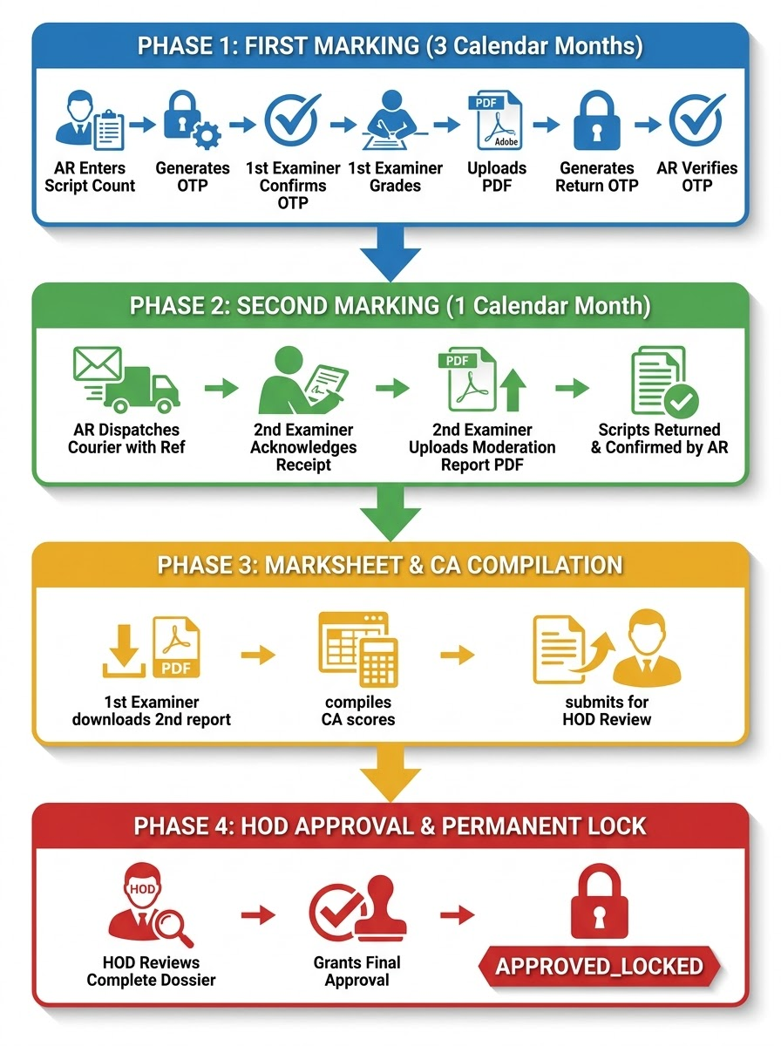

2.1 Academic Rank & Seniority Hierarchy
Under RUSL Faculty By-laws, a Second Examiner serves as a moderator and must hold an academic rank strictly senior to the First Examiner. The system assigns a deterministic numeric seniority weight to each recognized rank:
Seniority Weight | Academic Rank / Grade | Permitted as Second Examiner for
14 | Senior Professor / Chair Professor | All ranks below (1 to 13)
12 | Professor | Senior Lecturers & Probationary Lecturers (1 to 11)
10 | Associate Professor | Senior Lecturers & Probationary Lecturers (1 to 9)
8 | Senior Lecturer Grade I | Senior Lecturer Gr. II, Lecturers (1 to 7)
6 | Senior Lecturer Grade II | Lecturer (Unconfirmed), Probationary Lecturers (1 to 5)
4 | Lecturer (Unconfirmed) | Lecturer (Probationary) (1 to 3)
2 | Lecturer (Probationary) | Cannot serve as Second Examiner

2.2 Active Load Limits
To avoid evaluation fatigue and delays in results publication, the system enforces a strict load limit:
Active Schedules per Examiner < 3
Any examiner currently holding 3 active, non-locked schedules is automatically flagged with '3/3 slots filled (Maximum limit reached)' and disabled from candidate selector dropdowns.

2.3 Calendar-Month Calculation Algorithms
Pursuant to Section 6.3 of the RUSL Examination Regulations, grading deadlines must be computed using calendar months rather than arbitrary 30-day blocks, preserving the calendar day while clamping for shorter end-of-months and leap years:
• First Marking Due Date: Exactly 3 calendar months from physical collection timestamp (collected_at).
• Second Marking Due Date: Exactly 1 calendar month from courier dispatch timestamp (courier_dispatched_at).
Formula: DueDate(D, M) = Date(Year(D), Month(D) + M, min(Day(D), LastDayOfMonth(Year(D), Month(D) + M)))
Examples verified by automated unit tests:
• October 31 + 3 calendar months → January 31
• November 30 + 3 calendar months → February 28 (or February 29 in leap year)
• January 31 + 1 calendar month (2026) → February 28, 2026

3. Physical Logistics & Detailed Workflow Execution

3.1 Phase 1: Physical Script Custody & Dual-OTP Handover
Phase 1 eliminates physical answer script loss through two cryptographic OTP checkpoints:
[Concluded Exam]
│
▼
[Examinations Branch (AR Office)]
│ (Counts & logs physical packets)
▼
AR inputs script count & clicks "Generate Collection OTP"
│
├─► Database sets first_markings.script_count = 85
├─► Status updates to FIRST_COLLECTION_REQUESTED
├─► Single-use OTP generated (15-min expiry, max 3 attempts)
└─► Automated email dispatched to First Examiner
│
▼
First Examiner visits AR Office counter in person
│ (Inspects physical bundle: 85 scripts read-only)
▼
First Examiner inputs OTP & clicks "Confirm Collection & Start Marking"
│
├─► System verifies cryptographic OTP hash
├─► Sets first_markings.collected_at = NOW()
├─► Calculates original_due_date = collected_at + 3 calendar months
└─► Workflow transitions to FIRST_MARKING_ACTIVE

Step C & Step D: Post-Evaluation Script Return Handover
First Examiner completes grading
│
▼
First Examiner uploads First Marking Report (PDF)
│
├─► System validates %PDF- magic bytes & checks SHA-256
├─► Links document to schedule
└─► Report upload input locks permanently (no re-uploads permitted)
│
▼
First Examiner clicks "Generate Handover OTP for AR Office"
│
├─► System generates 6-digit Return OTP (e.g. 592814)
├─► OTP displayed in highlighted card on Lecturer screen
└─► Code persisted in sessionStorage for quick recall
│
▼
First Examiner brings physical scripts to AR Office counter
│
▼
AR Officer enters Return OTP into AR Console & clicks "Confirm Return"
│
├─► System verifies cryptographic OTP hash
├─► Sets first_markings.returned_at = NOW()
├─► Locks Phase 1 permanently (Green Verified)
└─► Workflow advances to SECOND_MARKING_READY

3.2 Phase 2: Second Marking & Courier Tracking
1. Courier Dispatch by AR: AR Office packages scripts, enters courier consignment note (e.g., SPEEDPOST-LK-88391). Clicking Dispatch Parcel stamps courier_dispatched_at = NOW(), starts the 1-calendar-month deadline countdown, transitions status to SECOND_MARKING_ACTIVE, and notifies the Second Examiner via email.
2. Parcel Receipt Acknowledgement: Second Examiner accesses portal and confirms parcel arrival by clicking Acknowledge Script Receipt (acknowledged_at = NOW()).
3. Moderation Report Upload: Second Examiner reviews markings, uploads Second Marker Report PDF, and returns parcel. Upload is locked permanently upon submission.
4. AR Return Confirmation: AR Office receives moderated scripts back, confirming receipt (ar_received_at = NOW()), moving workflow to SECOND_MARKING_COMPLETE.

3.3 Phase 3: Final Marksheet Compilation
1. First Examiner downloads the Second Marker Report.
2. First Examiner combines Continuous Assessment (CA) scores with final examination marks.
3. First Examiner uploads the compiled Final Marksheet PDF and clicks Submit Marksheet for HOD Review.
4. Status transitions to FINAL_MARKSHEET_SUBMITTED, triggering an automated alert to the Head of Department.

3.4 Phase 4: HOD Ratification & Permanent Locking
1. HOD Comprehensive Dossier Review: HOD verifies that all prerequisite documents (First Report, Second Report, Final Marksheet) are in place, and confirms examiner qualifications.
2. Revision Request (Optional): If discrepancies exist, HOD clicks Request Revisions with a structured reason. Status reverts to FINAL_MARKSHEET_CHANGES_REQUESTED for examiner correction.
3. Final Approval & Irreversible Locking: HOD clicks Grant Final Approval. System stamps workflow_status = 'APPROVED_LOCKED' and locked_at = NOW(). Any subsequent mutation attempts are rejected with HTTP 409 Conflict (WORKFLOW_LOCKED).

4. Security, Cryptography & Auditability

4.1 Cryptographic OTP Security Architecture
• Algorithm: Cryptographically secure pseudo-random 6-digit generation (crypto.randomInt(100000, 999999)).
• Hash Storage: Plaintext OTP codes are never stored in the database. Only the SHA-256 hash digest is persisted (otp_transactions.code_hash).
• Single-Use Invalidation: Upon verification, verified_at = NOW() is stamped, preventing replay attacks.
• Expiration Window: 15 minutes TTL (expires_at = NOW() + INTERVAL 15 MINUTE). Expired codes cannot be verified.
• Brute-Force Protection: Capped at attempt_count >= 3. Exceeding 3 incorrect attempts immediately invalidates the transaction (invalidated_at = NOW()).

4.2 Role-Based Access Control (RBAC) Matrix
Operation / Endpoint | HOD | First Examiner | Second Examiner | AR Office | Dean
Plan / Activate Exam Schedule | Allowed | Denied | Denied | Denied | Read-Only
Nominate / Review 2nd Examiner | Approve/Reject | Nominate | Accept/Decline | Denied | Read-Only
Input Script Count & Issue Collection OTP | Allowed | Denied | Denied | Allowed | Denied
Confirm Script Collection via OTP | Allowed* | Allowed | Denied | Assisted | Denied
Upload First Marking Report PDF | Allowed* | Allowed | Denied | Denied | Denied
Generate Script Return OTP | Allowed* | Allowed | Denied | Denied | Denied
Verify Script Return OTP | Denied | Denied | Denied | Allowed | Denied
Courier Dispatch to Second Marker | Denied | Denied | Denied | Allowed | Denied
Acknowledge Courier Receipt | Denied | Denied | Allowed | Denied | Denied
Upload Second Marker Report PDF | Denied | Denied | Allowed | Denied | Denied
Confirm AR Script Receipt | Denied | Denied | Denied | Allowed | Denied
Submit Final Marksheet | Allowed* | Allowed | Denied | Denied | Denied
HOD Review / Final Approval & Lock | Allowed | Denied | Denied | Denied | Read-Only
View / Download Evaluation PDFs | Allowed | Allowed | Allowed | Denied | Allowed

4.3 Document Storage & File Integrity Verification
• PDF Magic Byte Signature Check: All uploaded files are inspected on the server for the leading %PDF- binary magic bytes, rejecting renamed executables or malicious payloads.
• SHA-256 Checksum: A unique SHA-256 hash is generated for each uploaded document and stored in documents.sha256_checksum.
• UUID Storage Key: Files are stored on the filesystem using isolated, non-predictable UUID private storage keys (uploads/<uuid>.pdf).

5. Database Schema & Data Dictionary
The relational database is built on MySQL 8.0 using the InnoDB storage engine to guarantee ACID transaction safety, foreign key referential integrity, and row-level locking.
-- Master examination schedule table
CREATE TABLE `exam_schedules` (
`id` int(11) NOT NULL AUTO_INCREMENT,
`course_offering_id` int(11) NOT NULL,
`exam_date` datetime(3) DEFAULT NULL,
`first_examiner_user_id` int(11) DEFAULT NULL,
`second_examiner_profile_id` int(11) DEFAULT NULL,
`workflow_status` varchar(191) NOT NULL DEFAULT 'DRAFT',
`workflow_started_at` datetime(3) DEFAULT NULL,
`locked_at` datetime(3) DEFAULT NULL,
`row_version` int(11) NOT NULL DEFAULT 1,
PRIMARY KEY (`id`),
FOREIGN KEY (`first_examiner_user_id`) REFERENCES `users` (`id`),
FOREIGN KEY (`second_examiner_profile_id`) REFERENCES `examiner_profiles` (`id`)
) ENGINE=InnoDB DEFAULT CHARSET=utf8mb4 COLLATE=utf8mb4_unicode_ci;

-- Phase 1 physical custody and 3-month tracking
CREATE TABLE `first_markings` (
`id` int(11) NOT NULL AUTO_INCREMENT,
`exam_schedule_id` int(11) NOT NULL UNIQUE,
`script_count` int(11) DEFAULT NULL,
`collection_requested_at` datetime(3) DEFAULT NULL,
`collected_at` datetime(3) DEFAULT NULL,
`original_due_date` datetime(3) DEFAULT NULL,
`returned_at` datetime(3) DEFAULT NULL,
`report_document_id` int(11) DEFAULT NULL,
PRIMARY KEY (`id`),
FOREIGN KEY (`exam_schedule_id`) REFERENCES `exam_schedules` (`id`) ON DELETE CASCADE
) ENGINE=InnoDB DEFAULT CHARSET=utf8mb4 COLLATE=utf8mb4_unicode_ci;

-- Phase 2 moderation and courier tracking
CREATE TABLE `second_markings` (
`id` int(11) NOT NULL AUTO_INCREMENT,
`exam_schedule_id` int(11) NOT NULL UNIQUE,
`courier_dispatched_at` datetime(3) DEFAULT NULL,
`courier_reference` varchar(191) DEFAULT NULL,
`original_due_date` datetime(3) DEFAULT NULL,
`acknowledged_at` datetime(3) DEFAULT NULL,
`report_document_id` int(11) DEFAULT NULL,
`ar_received_at` datetime(3) DEFAULT NULL,
PRIMARY KEY (`id`),
FOREIGN KEY (`exam_schedule_id`) REFERENCES `exam_schedules` (`id`) ON DELETE CASCADE
) ENGINE=InnoDB DEFAULT CHARSET=utf8mb4 COLLATE=utf8mb4_unicode_ci;

-- Cryptographic OTP verification ledger
CREATE TABLE `otp_transactions` (
`id` int(11) NOT NULL AUTO_INCREMENT,
`exam_schedule_id` int(11) NOT NULL,
`user_id` int(11) NOT NULL,
`action_type` varchar(191) NOT NULL,
`code_hash` varchar(191) NOT NULL,
`attempt_count` int(11) NOT NULL DEFAULT 0,
`expires_at` datetime(3) NOT NULL,
`verified_at` datetime(3) DEFAULT NULL,
PRIMARY KEY (`id`),
FOREIGN KEY (`exam_schedule_id`) REFERENCES `exam_schedules` (`id`) ON DELETE CASCADE
) ENGINE=InnoDB DEFAULT CHARSET=utf8mb4 COLLATE=utf8mb4_unicode_ci;

6. Testing, Verification & Quality Assurance

6.1 Test Execution Summary
Test Suite | Test Case Description | Result
businessRules.test.ts | Standard date + 3 calendar months preserves day of month | PASSED
businessRules.test.ts | End of month clamp: Jan 31 + 1 month clamps to Feb 28 in non-leap year (2026) | PASSED
businessRules.test.ts | End of month clamp: Oct 31 + 3 months gives Jan 31 | PASSED
businessRules.test.ts | End of month clamp: Nov 30 + 3 months gives Feb 28 (2027) | PASSED
businessRules.test.ts | Second marking exactly 1 calendar month from courier dispatch | PASSED
businessRules.test.ts | Generated OTP is exactly 6 numeric digits | PASSED
businessRules.test.ts | OTP hash matches candidate and fails incorrect codes | PASSED
businessRules.test.ts | Validates %PDF- signature magic bytes | PASSED
businessRules.test.ts | Rejects non-PDF file buffers | PASSED
api.test.ts | GET /api/health returns status UP with institutional metadata | PASSED
api.test.ts | POST /api/auth/login succeeds with valid credentials | PASSED
api.test.ts | POST /api/auth/login fails with invalid password | PASSED
api.test.ts | PUT /api/auth/profile updates personal data and avatar | PASSED
api.test.ts | PUT /api/auth/profile rejects unauthenticated requests | PASSED
api.test.ts | Seniority rule: Rejects Second Examiner less senior than First Examiner | PASSED
api.test.ts | Seniority rule: Accepts Second Examiner strictly more senior than First Examiner | PASSED
api.test.ts | Candidate selector reports correct X/3 active load status | PASSED
api.test.ts | Locks: Blocks any mutation on APPROVED_LOCKED schedule with 409 Conflict | PASSED
api.test.ts | RBAC: Rejects HOD requesting Collection OTP when not assigned First Examiner | PASSED
api.test.ts | RBAC: Rejects HOD uploading Second Marking Report when not assigned Second Examiner | PASSED
api.test.ts | RBAC: Rejects HOD submitting Final Marksheet when not assigned First Examiner | PASSED
api.test.ts | Phase 1 Flow: AR generates OTP with script count, First Examiner confirms OTP | PASSED
api.test.ts | HOD approves COM1302 with all required PDF prerequisites and locks permanently | PASSED
api.test.ts | Complete 100% End-to-End Workflow from DRAFT to APPROVED_LOCKED | PASSED

7. Quick Demonstration Guide

7.1 Key User Accounts
Username | Name | Role / Designation | Department
hod | Dr. Kasun Bandara | Head of Department / Senior Lecturer Gr. I | Department of Computing
ar | Mr. K. M. Wickramasinghe | Senior Assistant Registrar (Examinations) | Examinations Branch
charith | Dr. Charith Jayasundara | Senior Lecturer Grade I (First Examiner) | Department of Computing
palliya | Dr. Thilina Palliyaguruge | Senior Lecturer Grade II (First Examiner) | Department of Computing
skumara | Dr. Suneth Kumara | Senior Lecturer Grade II (First Examiner) | Department of Computing
gunathilake | Prof. Nihal Senanayake | Professor (Second Examiner) | External / University of Peradeniya
ranasinghe | Prof. Anura Ranasinghe | Professor (Second Examiner) | External / University of Colombo

ER Digram
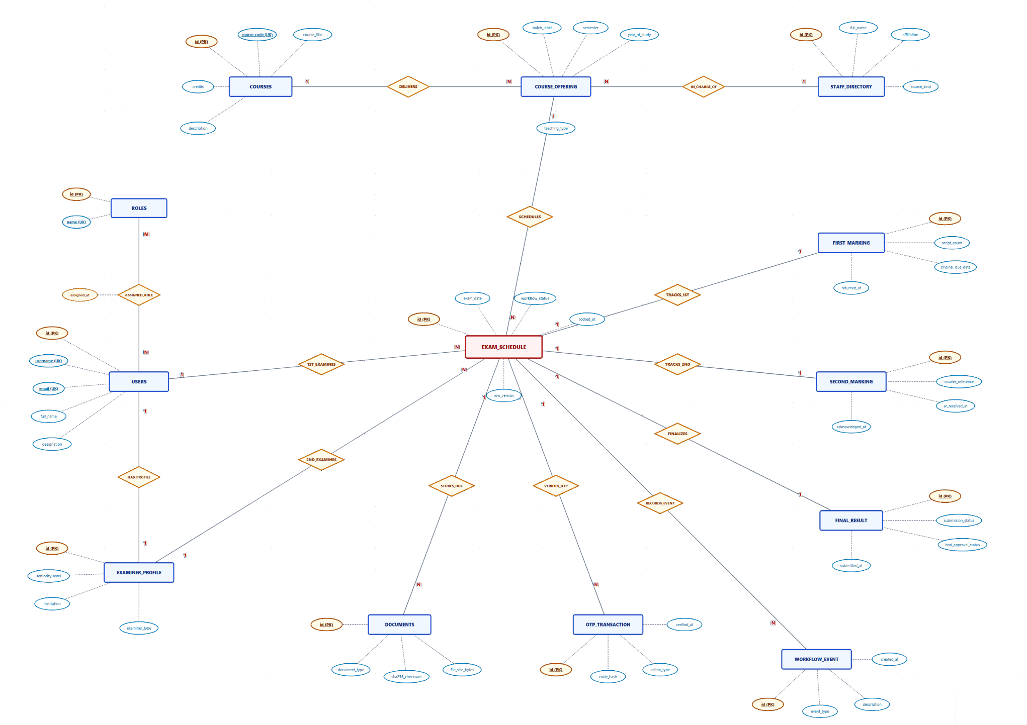

Relational Schema
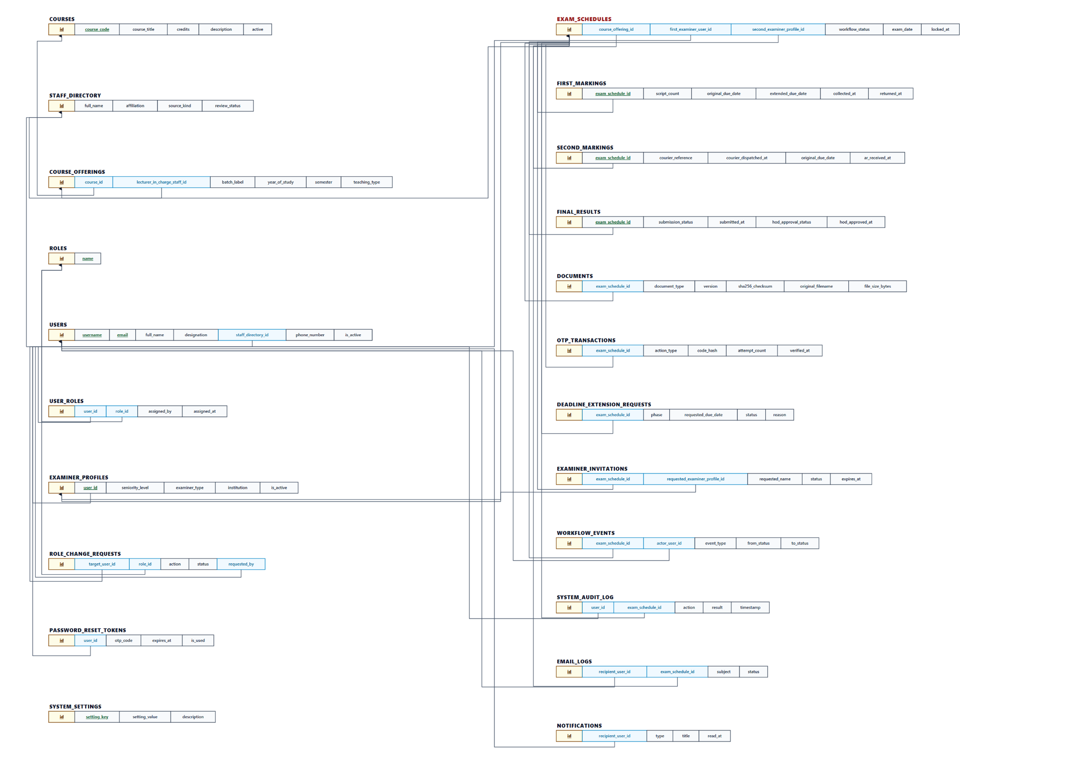

Enhanced Entity Relationship Diagram
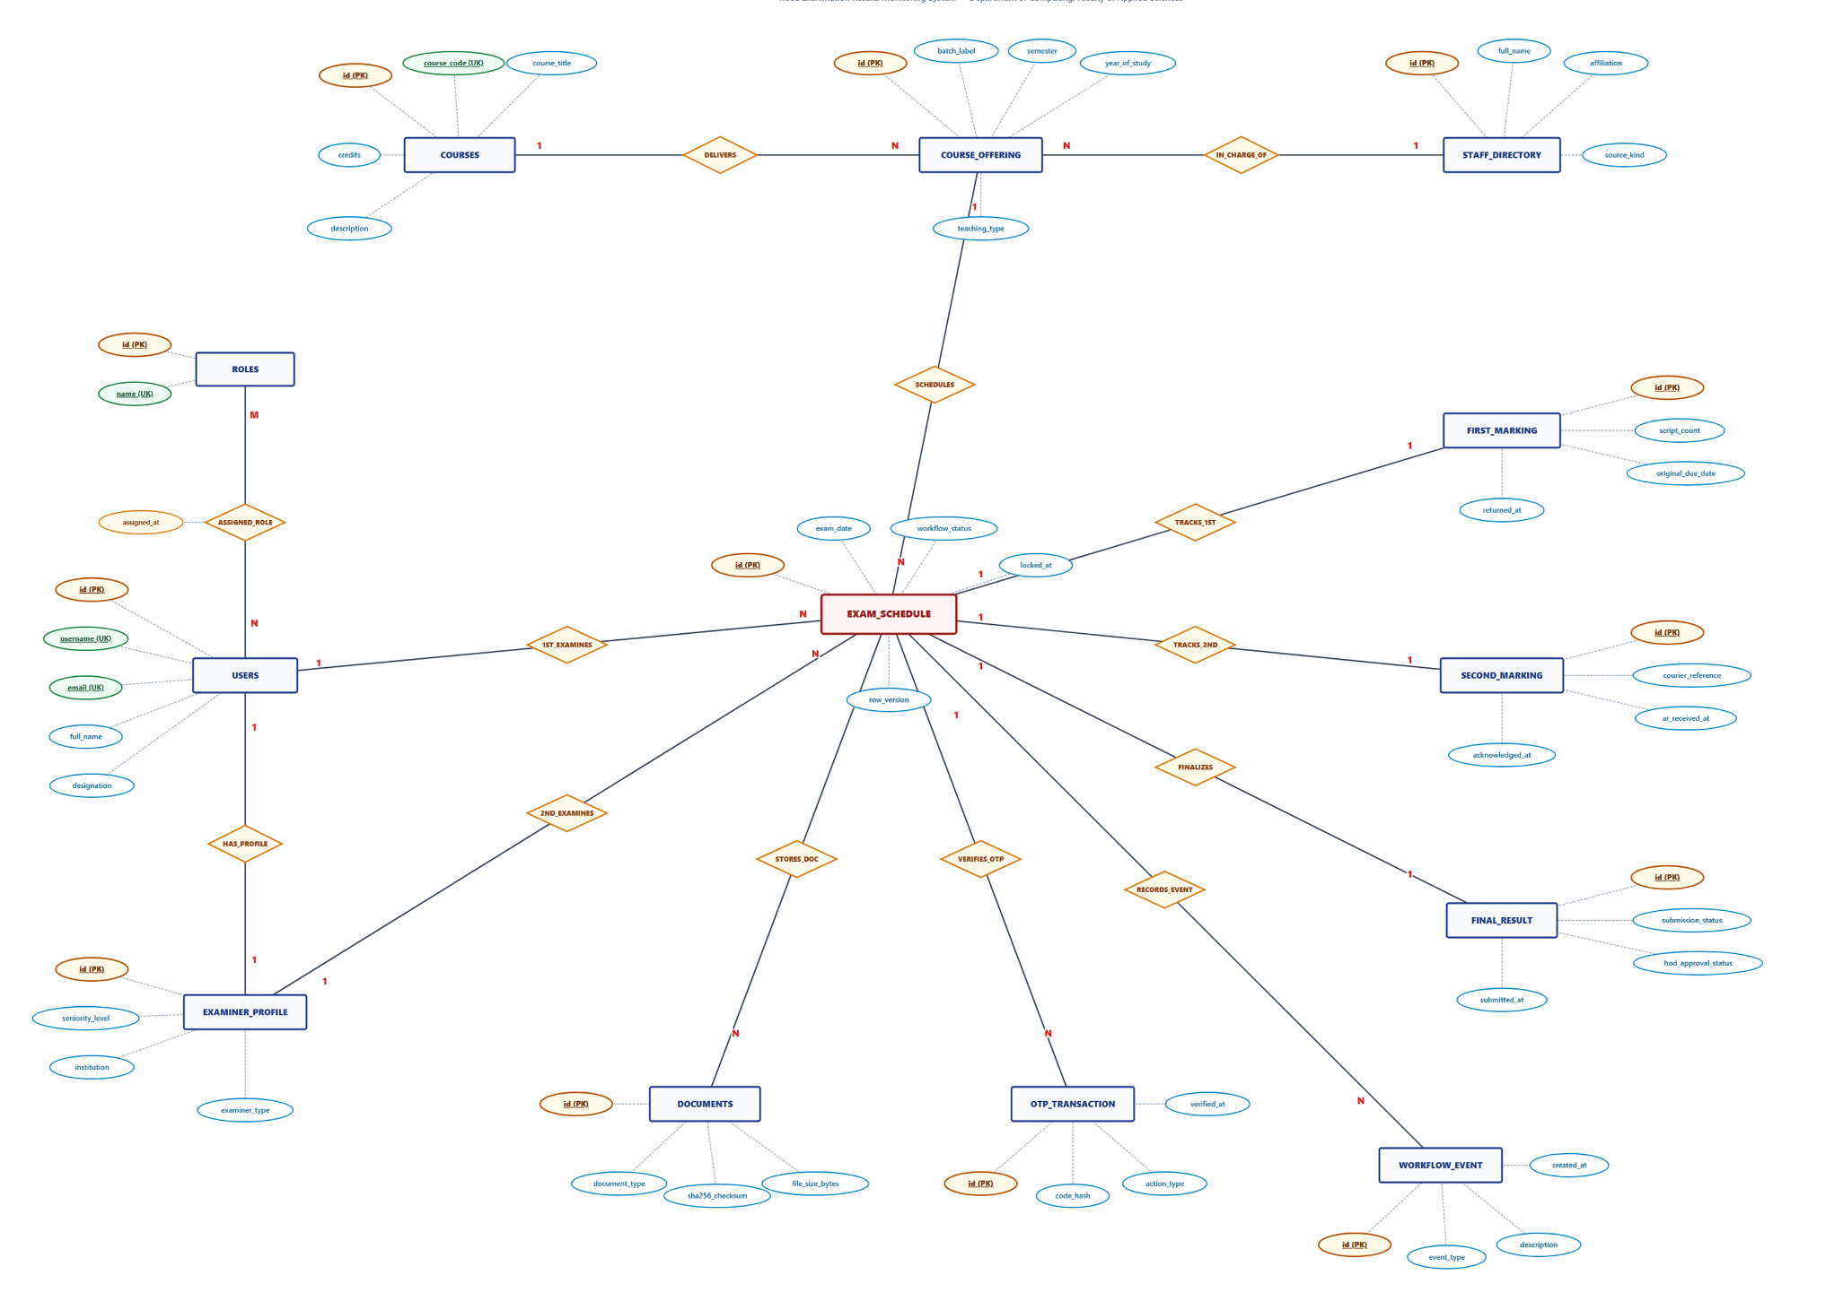
****End of The Document****

