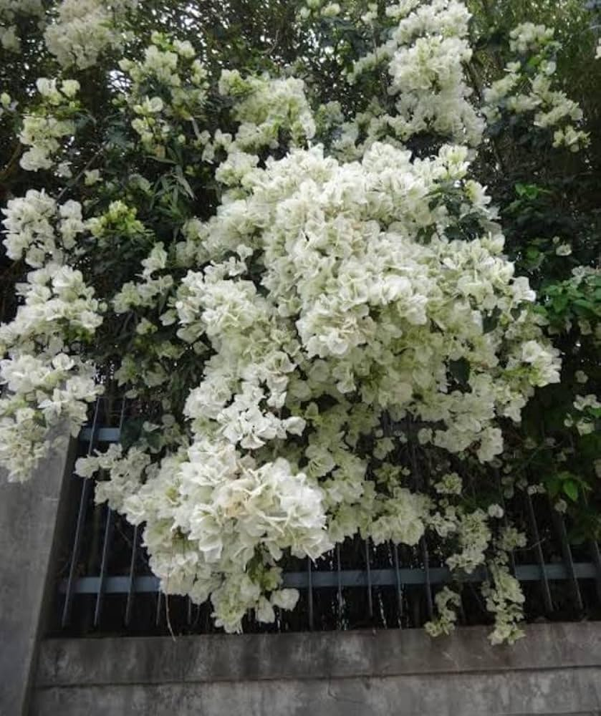
White Bougainvillea
Scientific Name: Bougainvillea spectabilis (sometimes also Bougainvillea glabra, depending on the variety)

Family
- Nyctaginaceae

Plant Type
- Thorny woody climber / shrub

Flower Description
- The white papery parts are called bracts
- The true flowers are tiny, tube-shaped, and cream/yellowish in color
- Flowers appear in clusters

Habitat & Climate
- Native to South America
- Widely grown in India, Nepal, Sri Lanka
- Prefers full sunlight and warm climate

Water & Soil
- Low water requirement
- Needs well-drained soil
- Overwatering reduces flowering

Uses
- Ornamental plant (gardens, fences, walls)
- Used for landscaping and decoration

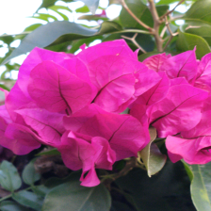

This flower is Bougainvillea
(The bright pink parts you see are actually bracts, not true petals.)

Scientific Name
Bougainvillea spectabilis
(also commonly Bougainvillea glabra)

Family
Nyctaginaceae (Four o’clock family)

Plant Type
- Woody climbing shrub / vine
- Perennial
- Often grown as an ornamental plant, hedge, or climber

Flower Description
- The bright pink/purple parts are bracts (modified leaves)
- The true flowers are small, white or cream-colored, located inside the bracts
- Flowers bloom in clusters
- Very attractive and long-lasting

Habitat & Climate
- Native to South America
- Grows best in:
  - Tropical and subtropical climates
  - Warm, sunny regions
- Widely grown in India, Nepal, Southeast Asia, and Mediterranean regions
- Tolerates heat and drought very well

Water & Soil Requirements
Water:
- Moderate watering
- Drought-tolerant once established
- Avoid overwatering (can reduce flowering)
Soil:
- Well-drained soil
- Sandy or loamy soil preferred
- Slightly acidic to neutral pH

Uses
- Ornamental plant for gardens, fences, walls, and balconies
- Used as hedges and bonsai
- Popular for landscaping and decorative purposes
- Helps prevent soil erosion when grown as hedges

Medicinal Uses (Traditional)
(Used in folk and traditional medicine not a substitute for medical treatment)
- Leaves and flowers are used to:
  - Treat coughs and sore throat
  - Help with digestive problems
  - Reduce inflammation
- Leaf extracts have been studied for:
  - Antibacterial
  - Anti-inflammatory
  - Antioxidant properties

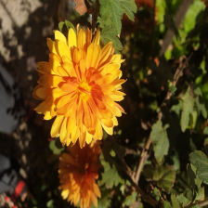

Chrysanthemum (Yellow)

General Description
Chrysanthemum is a popular ornamental flowering plant known for its bright, layered blooms and long flowering season. The yellow variety is especially valued for its cheerful color and neat, rounded shape.
Flower Structure
- Color: Golden yellow
- Shape: Round, pom-pom–like
- Petals: Numerous, densely packed, arranged in layers
- Center: Not clearly visible because petals cover it
- Texture: Soft and slightly waxy

Plant Characteristics
- Type: Herbaceous flowering plant
- Leaves: Green, lobed, slightly rough edges
- Stem: Soft but strong, supports single or clustered flowers
- Growth habit: Bushy and compact

Growing Conditions
- Climate: Mild to cool
- Sunlight: Full sun to partial shade
- Water: Moderate, well-drained soil
- Blooming season: Late autumn to winter

Uses
- Garden decoration
- Flower beds and pots
- Cut flowers for bouquets
- Festivals and cultural events

Symbolism (Yellow Chrysanthemum)
- Joy and happiness
- Friendship
- Positive energy

Medicinal Uses of Yellow Chrysanthemum
- Used in traditional medicine to reduce fever
- Helps relieve headache and dizziness
- Beneficial for eye problems like redness and irritation
- Used to treat common cold and flu
- Has anti-inflammatory properties
- Helps in detoxifying the body
- Supports liver health
- Rich in antioxidants, helps boost immunity

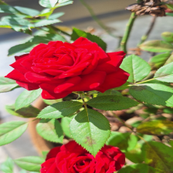

Red Rose

Basic Information
- Scientific name: Rosa spp.
- Family: Rosaceae
- Common name: Rose (Red)

Flower Description
- Color: Deep red
- Shape: Layered, spiral petals
- Petals: Soft, velvety, fragrant
- Leaves: Green, serrated edges
- Stem: Woody with thorns
- Appearance: Elegant and aromatic

Plant Characteristics
- Type: Woody shrub
- Growth: Bushy or climbing
- Climate: Mild to warm
- Sunlight: Full sun
- Water: Moderate

Medicinal Uses of Red Rose
- Rose petals are used in traditional medicine
- Helps in digestive problems
- Used to relieve sore throat and cough
- Has anti-inflammatory and antibacterial properties
- Rose water helps soothe eye irritation
- Useful in skin care for calming and healing
- Helps reduce stress and anxiety
- Rich in antioxidants

Rose Water & Rose Oil
- Rose water:
  - Cools the body
  - Refreshes skin
  - Reduces eye redness
- Rose oil:
  - Used in aromatherapy
  - Helps in relaxation and emotional balance

