Lab2(25.08.2025)

Sharada Koundinya(1BM23CS310)

Implement vaccum cleaner problem

def vacuum_cleaner()

A = int(input("Enter state of A (0 for clean, 1 for dirty): "))

B = int(input("Enter state of B (0 for clean, 1 for dirty): "))

location = input("Enter location (A or B): ").upper()

cost = 0

state = {'A': A, 'B': B}

if location == 'A':

if state['A'] == 1: # If A is dirty

print("Cleaned A.")

state['A'] = 0

cost += 1

else:

print("A is clean")

if state['B'] == 1: # If B is dirty

print("Moving vacuum right")

print("Cleaned B.")

state['B'] = 0

cost += 1

print("Is B clean now? (0 if clean, 1 if dirty):", state['B'])

print("Is A dirty? (0 if clean, 1 if dirty):", state['A'])

print("B is clean")

print("Moving vacuum left")

else:

print("Turning vacuum off")

elif location == 'B':

if state['B'] == 1: # If B is dirty

print("Cleaned B.")

state['B'] = 0

cost += 1

else:

print("B is clean")

if state['A'] == 1: # If A is dirty

print("Moving vacuum left")

print("Cleaned A.")

state['A'] = 0

cost += 1

print("Is A clean now? (0 if clean, 1 if dirty):", state['A'])

print("Is B dirty? (0 if clean, 1 if dirty):", state['B'])

print("A is clean")

print("Moving vacuum right")

else:

print("Turning vacuum off")

print("Cost:", cost)

print(state)

print(“Sharada Koundinya, 1BM23CS310”)

vacuum_cleaner()

**OUTPUT CASE1:**

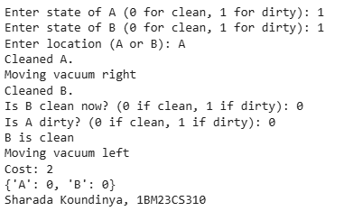

**OUTPUT CASE2:**

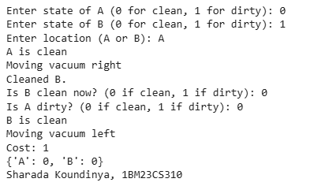

**OUTPUT CASE3:**

