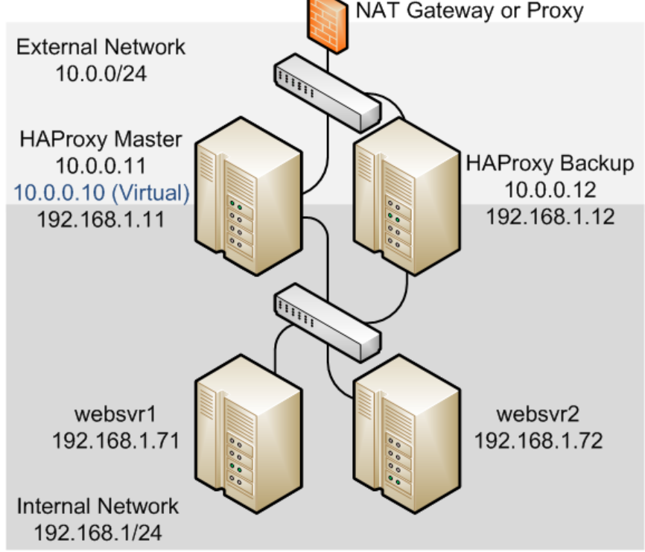

Once you have added your VPSs to a Private Network, you will first have to set up internal IP addresses before you can make full use of them.

In the examples, the **192.168.0.0/16** range is used. However, you can choose one of the [IP ranges defined](http://www.ietf.org/rfc/rfc1918.txt) in the RFC for use within private networks: **10.0.0.0/8**, **172.16.0.0/12** and **192.168.0.0/16**. The examples also use nano as an editor, but you are free to use your favorite editor.

KeepAlive configuration

[**https://www.unixmen.com/configure-high-available-load-balancer-haproxy-keepalived/**](https://www.unixmen.com/configure-high-available-load-balancer-haproxy-keepalived/)

[**https://linuxhandbook.com/load-balancing-setup/**](https://linuxhandbook.com/load-balancing-setup/)

**Configuring Virtual Floating IP on your machine**

**Step1: Request for a floating IP from your ISP or SysAdmin**

**Step2: Run the following command**

[root@e2e-39-92 ~]# ifconfig eth1:1 172.16.110.183 netmask 255.255.224.0

[root@e2e-39-92 ~]# arping -q -U -c 3 -I eth1 172.16.110.183

**Step3: Ping this IP from some other machine**

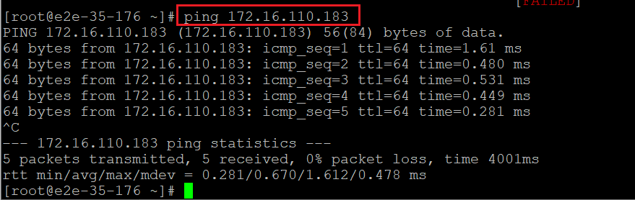

**Reference:**

[**https://www.jamescoyle.net/how-to/307-create-a-virtual-ip-address-in-linux**](https://www.jamescoyle.net/how-to/307-create-a-virtual-ip-address-in-linux)

### Setup load balancers with HAProxy

On the two HA Proxy systems, use the following commands to install HAProxy:



HAProxy configuration file is located at **/etc/haproxy**. Go to the directory and backup the file before edit.



Create a new haproxy.cfg file and open the file with any editor you like.



Now, paste the following lines into the file:

global

log /dev/log local0

log /dev/log local1 notice

chroot /var/lib/haproxy

stats timeout 30s

user haproxy

group haproxy

daemon

defaults

log global

mode http

option httplog

option dontlognull

timeout connect 5000

timeout client 50000

timeout server 50000

#frontend

#---------------------------------

frontend http_front

bind *:80

stats uri /haproxy?stats

default_backend http_back

#round robin balancing backend http

#-----------------------------------

backend http_back

balance roundrobin

#balance leastconn

mode http

server webserver1 10.13.211.169:80 check    # ip_address_of_1st_centos_webserver

server webserver2 10.13.211.158:80 check    # ip_address_of_2nd_centos_webserver

Now, enable and start HAProxy service.



Check the status of HAProxy:



Go to url in your browser to confirm the service of **haproxy: http://load balancer’s IP Address/haproxy?stats**. Example used here:



or in the terminal, use command $ curl  LoadBalancer_IP_Address



curl two times and you will see different outputs for the curl command. It is because of the response is coming from different web servers (one at a time), for your request at the load balancer.

The Output would look like this:



### Set up high availability with Keepalived

Keepalived must be installed to both HAProxy load balancer CentOS systems (which we have just configured above). One acts a master (main load-balancer) and another acts as the backup load-balancer.

On both system, run the following command:

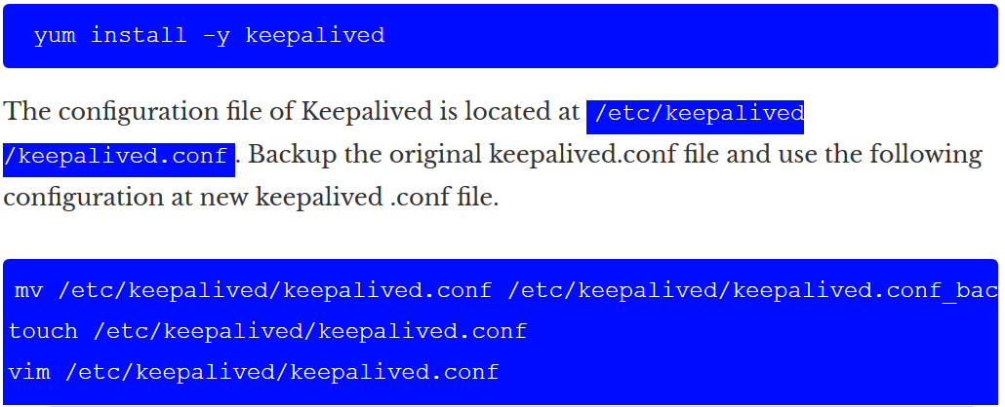

mv /etc/keepalived/keepalived.conf /etc/keepalived/keepalived.conf_bac

touch /etc/keepalived/keepalived.conf

vim /etc/keepalived/keepalived.conf

Paste the following lines to the configuration file (don’t forget to change the email addresses):

global_defs {

notification_email {

linuxhandbook.com

linuxhandbook@gmail.com

}

notification_email_from thunderdfrost@gmail.com

smtp_server 10.13.211.1

smtp_connect_timeout 30

router_id LVS_DEVEL

}

vrrp_instance VI_1 {

state MASTER

interface eth0 #put your interface name here. [to see interface name: $ ip a ]

virtual_router_id 51

priority 101 # 101 for master. 100 for backup. [priority of master> priority of backup]

advert_int 1

authentication {

auth_type PASS

auth_pass 1111 #password

}

virtual_ipaddress {

10.13.211.10 # use the virtual ip address.

}

}

**Note**: Virtual IPs can be any live IP inside your network. Near about the range of Loadbalancer’s IP Address. Here, the load balancer’s IP are: 10.13.211.194 & 10.13.211.120, and VIP is 10.13.211.10

Edit the configuration file as per the system assumption. Take care on master and backup configuration. Save the file and start and enable the Keepalived process:



Now to check the status of your high-availability load-balancer, go to terminal and hit:

while true; do ; curl 10.13.211.10 ; sleep 1; done;



### Setup the web servers with Nginx

Add a repository containing nginx and then install it from there:

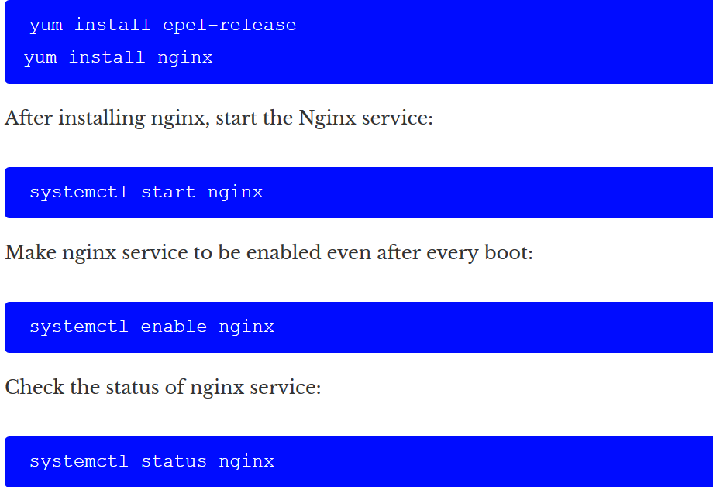

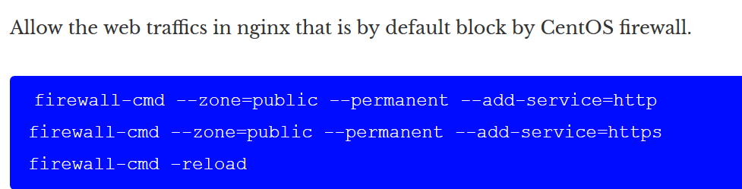

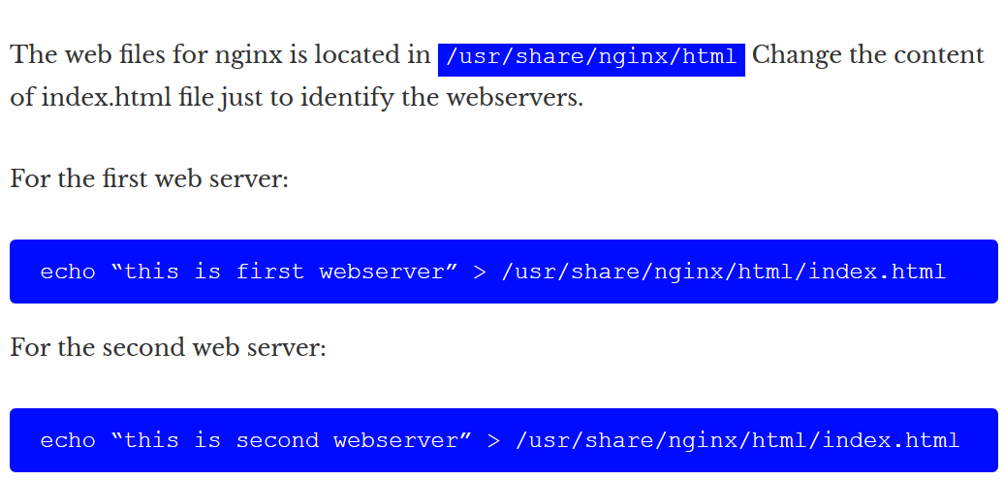

Now confirm the web server status by going to the following URL in your browser: **http://SERVER_DOMAIN_NAME** or **Local_IP_Address**. Example here:

