
Dept of Computer Science
Bowie State University, MD 20715

Sensor Network Laboratory at Bowie State

Manohar Mareboyana Bo Yang

General Descriptions

The sensor network laboratory consists of a number of temperature, humidity, motion, video sensors communicating on wireless network. Video sensor networks consists of stationary and mobile cameras with limited computational power and storage, but with a wireless interface to communicate and collaborate with each other in the network. The lab has a broad range of video camera sensors, communication devices and software development capabilities. Its data processing center is the Xseed, which is among TOP 200 fastest supercomputers in the world. Devices are available for measuring and monitoring humidity, motion, temperature, and live video among many others. In addition, the lab allows robotics experimentation and research in mobile, autonomous sensors and in mobile base station (MBS) technologies to facilitate communication between and among peer sensors and control stations where the sensor data is stored in a database and used for system decision making.

Lab Setting Overview

The Lab Equipments
The lab consists of a number temperature sensors, humidity sensors, motion sensors, and video cameras. The robot used as MBS is monitored by an IP-CAM whose field of view can be accessed via Internet. The IP-CAM provides pan-and-zoom capabilities using simple html scripts on the web. The video cameras have the capability freezing the video stream into image frames. Researchers working on several different projects will have accounts on IP-CAM and projects can be developed using this laboratory setting without having physical access to the laboratory.
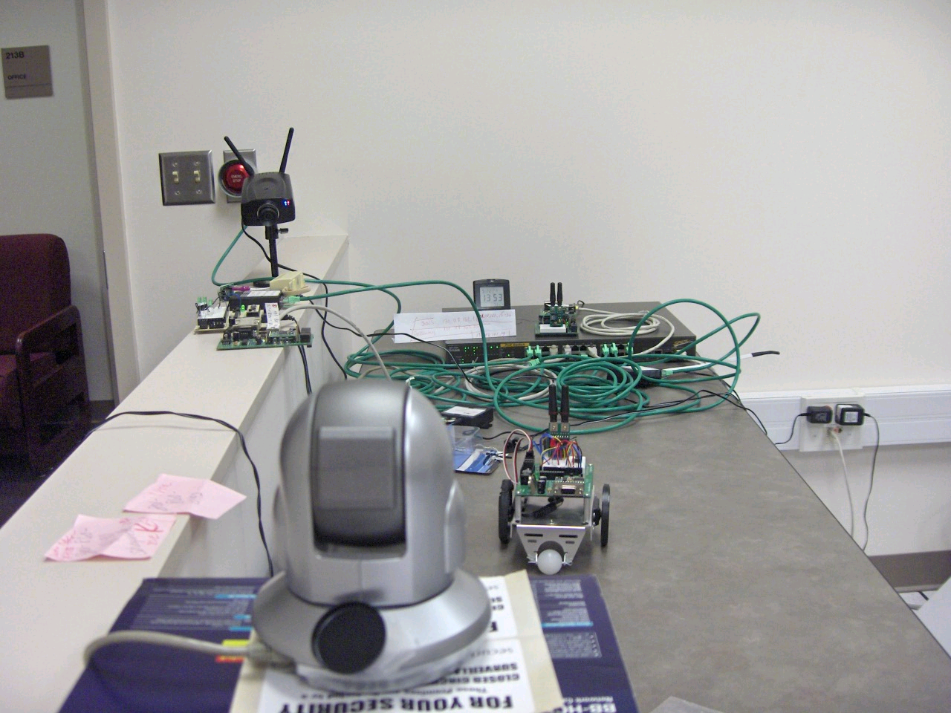

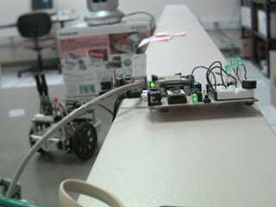

Typical projects that are designed based in the research lab are as follows:

- routing algorithms for video/image data delivery
- QoS considerations in multi-resolution video/image data streaming
- query processing on continuous stream and statistical data anomaly detection in sensor data streams or video streams, and
- object tracking by IP-CAM.

Research Approaches and Results

Sensor Network Infrastructure
Our paradigm of sensor vision network includes a number of sensors communicating over a short range of wireless interfaces to deliver observations over multiple hops to central location called central control station.



Sensor/Actuator Field

Wireless
Sensor
Nodes

Actuator/MBS

Central Control Station

User Interface

- QoS-based multi-resolution delivery:

The proposed approach provides a scheme that utilizes multi resolutions of the video/image data to perform content-based data processing with reduced cost and improved accuracy.

- Multi-source data fusion:

Using statistical machine learning modeling of image/video background, the data from various sensors (cameras, temperature sensors and infra-red sensors) can be integrated for data fusion and anomaly detection.
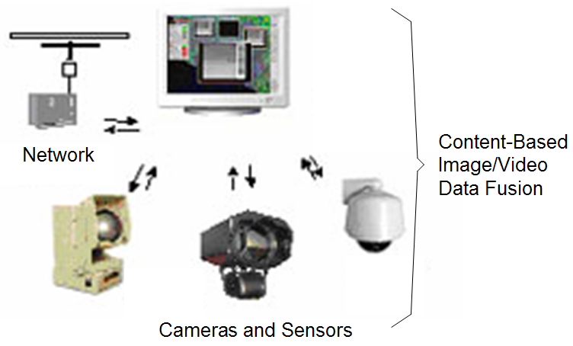
Sensor Data Delivery & Analysis

- Semantic-aware and QoS-aware data caching:

The semantic-aware and QoS-aware caching utilizes the multi-level semantic description and the access frequency in order to resolve similarity-based multimedia queries without incurring flooding in the network.

