Research Infrastructure for Doctoral Education in Computer Science (RIDECS)

- Introduction
As a member of the University System of Maryland (USM), Bowie State University has been designated as a comprehensive regional university offering Undergrad, Masters and Doctoral programs in computer science with a mission of continued commitment to its historical heritage and a goal to achieve excellence in computer and information technology. BSU ranks first in the Nation in graduating African Americans with Masters Degrees in computer and information sciences [Black Issues in Higher Education, 2002].
The department offers an accredited undergrad program in computer science and computer technology. The total enrollment in this program is approximately 400. The department has been offering a Masters program in computer science for approximately 20 years. Beginning Spring 2007 the department has admitted 10 students into its Doctoral program.
The goals of project RIDECS are to build a research infrastructure for newly approved Doctoral program in applied computer science, produce quality research, enhance the participation of minority students, and strengthen science and engineering awareness at other Historically Black Colleges & Universities.
1.1 Departmental Research
The department has been active in research in different areas of computer science. The department is planning to hire two new faculty to strengthen research areas. The department is actively involved in sponsored research. The sponsors included NASA, DoD, NSIT, NSF etc. The faculty generated research and publications in the following areas.
- Wireless Sensor Network: We are planning to build a sensor network lab for efficient video/image data delivery and real-time visual surveillance. The hardware of the lab involves a mobile base station mounted on a robot, video cameras, and various sensors. The network prototypes and data access schemes can be simulated in NS2 or other simulators.
- Image Processing and Compression: Image data processing and transmission is a challenging task in a mobile network, especially when the network is built on sensors through wireless connections. The technological limitations such as computation capability, storage, and bandwidth make it difficult to apply the conventional approaches to wireless sensor networks. We may tackle this problem with the considerations of quality of service, cooperative caching, data distribution profiling, and location-aware data accessing.
- Network Security: Security is an important area in wireless networks, considering the broadcasting nature of such networks. We have conducted research on protocols resilient to various attacks such as DoS and spooling.
- High Performance Computing: The University has built a $1 million super-computer system – Xeed – in conjunction with Apple Computer, Inc. The Xseed system is a 224-node cluster based on Apple’s Xserve G5. The combination of this cutting-edge technology puts Xseed among the world’s top 200 most powerful supercomputers on the TOP500 list, which serves as a benchmark for ranking high-performance computing systems.
- Database Systems and AI: We have proposed multiple content-based and semantic-aware schemes for distributed data access and information retrieval.
- Network traffic analysis, identification and prediction: This research relates to characteristics of network traffic, such as its self-similarity or long-range dependence, over various timescales, and then uses linear and nonlinear prediction schemes such as neural networks, genetic algorithms, Autoregressive Moving Average (ARMA), Fractional Integrated Moving Average (FARIMA), and the Discrete Wavelet Transform to simulate and implement real-time prediction of network traffic bandwidth.
- Research Projects
2.1 Wireless Sensor Networks (WSN) (M. Mareboyana, B. Yang)
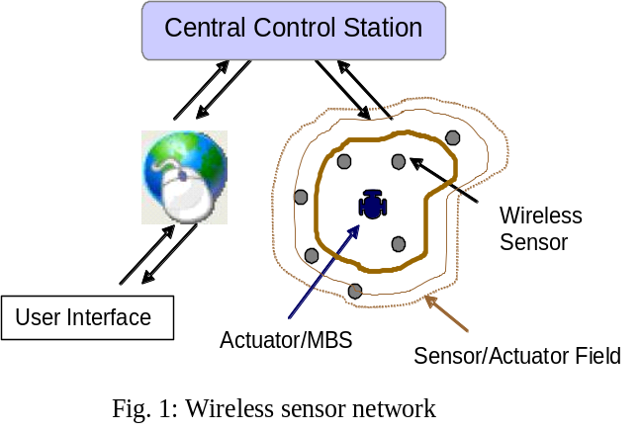The availability of cheap, low-power, and miniature sensors are leading to the emerging technology of Wireless Sensor Network (WSN), a considerably different paradigm from traditional wired and embedded systems, are widely used in various applications such as battle field surveillance, habitat and traffic monitoring[1], environmental and homeland security, eco-systems, etc. Wireless sensor networks also have a rich domain of active research involving network protocols, data collection and dissemination, security and assurance, streaming video data analysis, statistical modeling and anomaly detection, etc.
A typical paradigm of sensor network includes a large number of small and simple sensors communicating over a short range of wireless interfaces to deliver observations over multiple hops to central location called central control station (Fig. 1). The control station is connected to the external world via Internet. The user can access the data from the sensor field and control the actuators/mobile devices using an appropriate interface. Each sensor has limited storage, data processing, and communication capabilities. Mobile devices, also referred as Mobile Base Stations (MBS), are used to overcome the storage/range limitations of the network devices and collect the data. One such device that can be used is a robot (actuator) on wheels. Fig. 2 shows a typical robot with micro controller on wireless connectivity and Fig. 3 shows a typical wireless sensor used in this scenario. Having all these devices in a network poses some design challenges of connectivity, data collection, transmission of the data to the central data collection platform and data analysis.
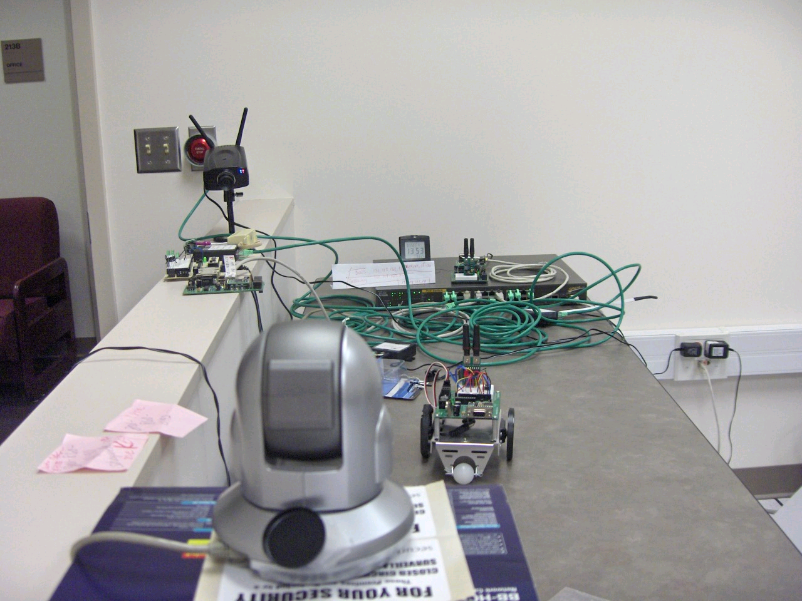
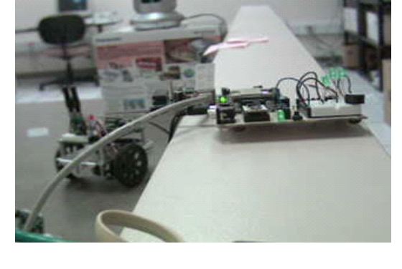
Fig. 2: A robot on wheels, and IP camera
Fig. 3: Wireless sensors

The WSN consists of a number temperature sensors, humidity sensors, motion sensors, and video cameras. The robot used as MBS is monitored by an IP-CAM whose field of view can be accessed via Internet. The IP-CAM provides pan-and-zoom capabilities using simple html scripts on the web. The video cameras have the capability freezing the video stream into JPEG image frames. Students working several different projects will have accounts on IP-CAM and projects can be developed using this laboratory setting without having physical access to the laboratory. Typical projects that can be designed are: (i) routing algorithms for video/image data delivery (ii) QoS considerations in multi-resolution video/image data streaming (iii) query processing on continuous stream and statistical data (iv) anomaly detection in sensor data streams or video streams, and (v) object tracking by IP-CAM.
WSN provides a smart environment for most applications. One of the main issues is how to make use of the measurements of the sensors. At the heart of the problem is how to integrate information from a number of sensors and make decisions based on this information. This process of making decisions by integrating the measurements from various sensors is called data fusion. A number of projects at undergraduate and graduate levels can be developed in fusing data from multiple sensors. The other aspect of sensor network is how to analyze the measurements in real-time as well as obtaining statistical measurements on stored data.
2.1.1 Video Transmission over the Wireless Network
— Routing algorithms for video/image data delivery
In a sensor network with disseminated data sources, the mobile base station (MBS) acts as a moving inspector that periodically travels around the sensor field to inspect and collect the data. Due to the limitation of resources, the major consideration is how to obtain the sensor data using the minimum distance or energy in the routing.
The existing routing algorithms can be grouped as two major categories: address-centric[2-3] and data-centric [4]. The main purpose of address-centric algorithms is finding the optimal path that has minimized number of wireless hops (or distance). However, some sensors on the optimal path may not have data or breaks down due to energy wearing-out, thereby making the address-centric path less efficient. Consequently, the data-centric routing algorithms were proposed to visit only the sensors that contain data [4].
We propose a semantic-based, self-stabilizing scheme that delivers video/image data in wireless sensor networks without incurring high traffic and energy consumption. Our goal is to provide a scheme that performs content-based video/image data processing with reduced cost and improved accuracy. The proposed approach utilizes the knowledge of content distribution in the wireless sensor network.
— QoS Considerations in Multi-Resolution Video/Image Transmission
With the limitations of wireless bandwidth and sensor memory storage, there need to be a QoS consideration for video/image data transmission in the sensor network. This makes it important to organize the sensor network’s resources into stratified multi-resolution services with graded QoS properties such that the QoS requirements of a series of multimedia applications (still/moving target tracking, temperature and infra-red sensing, etc.) can be effectively met.
Other important considerations when designing QoS provision are Forward Error Correction (FEC) and Automatic Repeat rQuest (ARQ) for packet dropouts. While studying the efficient FEC and ARQ technique for error resilient transmission, it is also important to code the video data for efficient bandwidth utilization. We plan to use light weight algorithms for differencing and coding using multi-resolution techniques.
2.1.2. Semantic-Aware and QoS-Aware Image/Video Data Caching
— Supporting content-based retrieval with caching approach
Caching is a technique to profile content distribution and improve system performance in the mobile environments. However, the traditional caching technique proposed for text data cannot be directly applied to image/video data processing.
Our goal is to design a content-based retrieval scheme that employ data content distribution knowledge to optimize the search cost, response time, and system overhead. Although these metrics are sometimes contradicting with each other, e.g., the relatively convenient content/location mapping of dynamic hash table at the price of formidable maintenance overhead, we propose a novel solution that leverage these metrics to obtain the optimal overall system performance.
The semantic-aware and QoS-aware caching utilizes the multi-level semantic description and the access frequency in order to makes use of the data content distribution and data popularity to resolve similarity-based multimedia queries without incurring flooding in the network.
2.1.3. Anomaly Detection from Video Stream
An important part of the anomaly detection algorithm is to model what we expect from the video stream under normal circumstances. This data corresponds to background data or normal activity data. If the video frame differs from the background data significantly, an alert signal is generated as anomaly. At the heart of the automatic surveillance is (i) background modeling and foreground detection by using appropriate distance metrics to compute deviation of the video frames from background model.
— Background modeling
In this project we are proposing dynamic region-based and frame-based background modeling. Also we propose cluster mean deviation metric to detect anomalies in video streams. We compare these methods with existing methods for some applications.
Background modeling: Background modeling has to account for movement of objects in the background, light conditions, and shadows. Precise modeling of the background is almost impossible. There are three approaches to modeling the background: pixel-based, region-based and frame-based [5]. The background images are acquired at different times of the day. A set of say, p images will constitute a background for a given scene. The background data of each pixel is s(x,y,t), where s is background image function. Pixel level algorithm makes prediction about the current background value using the least squares estimate.
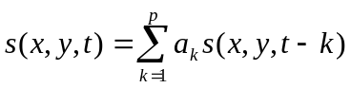
Where s(x,y,t) is the predicted value. The coefficients are determined by minimizing the error between observed values and estimated values at x, y. A pixel corresponds to anomalous activity when the difference between the predicted background and fore-ground is more than four times the prediction error.
Region-based algorithm is an extension of pixel-based algorithm. Let p temporal images constitute the background. The images are decomposed into non-overlapping blocks of r pixels scanned in raster scan. The current region at time, t is computed from past p regions using the linear prediction models as follows.
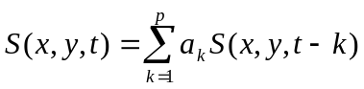
Where a_{k} is coefficient of each vector that is estimated using p background by least squared methods. S(x,y,t) is a vector from a square block positioned at x,y (position of the top-left pixel in the block) which is obtained by raster scan of the pixels in the block. If the Euclidean distance between the observed region and the predicted region is greater than a preset threshold. Region values can also be predicted using both temporal and spatial data. The spatio-temporal predictions are used when the background displacements are expected.
The frame-based is generalization of the region-based to the entire image if the background image, I stays relatively constant. If the observed image is I1, then the L2-norm ||I1-I|| gives the score for anomaly detection. In this simple method, any motion of background corresponds to anomaly. If the scene contains motion that should be considered as a part of background, more tolerant background models are required which require derivatives in spatial and temporal images.
Pixel-based detection is very sensitive to noise, as result there could be too many false alarms. Frame-based is too global and fore-ground objects may go undetected because of the scale. Region-based will have advantage being noise insensitive and at the same time having the localization of the fore-ground objects. In the research we study region-based algorithms in a greater detail. In the previous work relating to network security [6], we have used a number of different metrics such as Mahanabolis distance, Canberra distance, nearest-neighbor (nn-) distance, and k-nearest (k-nn) neighbor distance to compute anomalies (outliers). Using the background model, we estimate the normal, mean knn-distance and its variance. If the observed region deviates from the cluster of temporal vectors from the model by mean knn-distance +3*σ, we consider the observation to be anomalous.
— kNN-distance for anomaly detection
The knn-distance, D_{ik} = [d_{i1}, d_{i2}, d_{i3}, … d_{ik}]^{t} of a point, i in r-dimensional space is a vector with Euclidean distances to the first nearest neighbor, d_{i1} second nearest neighbor, d_{i2} and so on up to k-nearest neighbor. Nearest neighbor distance is a special case of knn-distance in which k=1. The vector norm of knn-distance for points in dense clusters is small compared to the points in sparse clusters. Points in the boundary of the clusters will have higher knn-distance vector norm compared to the ones inside the cluster. Distance based on nearest neighbor does not have this property. For the points farther away from the boundary of the cluster, the vector norm of knn-distance increases. The vector knn-distance thus characterizes the distribution of points around it in the k-neighborhood.
2.1.4 :Intellectual Merit :The research challenges in wireless sensor networks include: energy-efficient video/image transmission using data-centric routing, content-based retrieval using QoS-aware cooperative caching, real-time video stream data fusion and analysis, and background modeling and anomaly detection. Some of the algorithms we are working are novel and may result in publishable results.
2.1.5 Broader impact: The research provides an opportunity for under-represented population to be involved in cutting edge research in various aspects of wireless sensor network. The research has broad applications in traffic monitoring, battle field awareness, and habitat monitoring.
2.2. Design of Denial-of-Service Resistant Authentication Protocols in Wireless Sensor Networks (S. Choi)
Attacks against broadcast feature in sensor network will have the most catastrophic effects on power and other resource consumption in wireless sensor networks. As bogus broadcast packets are propagated through sensor nodes without being filtered out, sensor nodes will waste their powers on transmitting those false packets. In case there are complex DoS attacks launched against the network, the network should be able to limit its effects on resource consumptions in the network nodes. In addition to that, it is strongly required to identify the compromised sensor node which has injected invalid packets and to isolate the nodes such that no more DoS attack is possible through the compromised sensor node(s) in the future.
Also, data-centric sensor network technologies (such as visual sensor networks) have recently been drawing much attention due to their vast applicability in many systems. In those networks, due to huge amount of data collected by each sensor node, local caching of (recently) acquired visual data may be necessary. Also, closely located neighboring sensor nodes may need to coordinate with each other in carrying out more reliable object detection/classification algorithms, and the obtained information may either be delivered to the base station (if it requires immediate human attention), or may be stored in the gateway sensor node located near the sensor nodes which detected an object. At the same time, duplicated copies may be stored in a distributed manner as in [7] to reduce the object access time and bandwidth usages.
However, in the presence of duplicate copies of the object in one or more caches, multicast authentication becomes more difficult since multiple (duplicate) copies of the same object are allowed to be existent at different locations in the network. Also, path caching technique may be utilized to enable efficient query routing as in [7]. Another level of difficulty is introduced in order for us to utilize this technique since we need to authenticate the path information too.
A new secure broadcast (multicast) scheme for sensor networks will be developed based upon μTESLA approach [8] in this project with the following objectives:
- Authenticity of cached objects will be guaranteed: loose time synchronization is assumed to be in place in the network, which is a feasible assumption in many sensor networks. By utilizing a predictive hashing technique in [9-11], we will provide a security guarantee that the any local copy obtained through local query is authentic.
- Incorporation of authentication of cached path information: path information (leading to the closest cache copy) will be authenticated even before the query message is sent via that path. After a node obtains (or forwards) an authentic object copy, it locally broadcasts a path confirmation messages to its directly reachable nodes to enable them to store the current path information as an authentic path information.
- Broadcast packet authentication: μTESLA approach will be adapted by incorporating Predictive Hashing technique for broadcast packet authentication. This allows immediate authentication for data & key portions in each broadcast packet, while limiting the amount of information for delayed authentication to the MAC portion in each packet. This will greatly reduce the bandwidth and power waste from the DoS attacks.
- Prevention of spoofing attacks from arbitrary nodes: if there is no mechanism to (lightly) authenticate direct neighbors, any adversary who can sniff the network traffic may easily spoof the packets and inject the invalid packets as much as the underlying MAC protocol allows. Lightweight Hop Authentication Protocol [12] is adapted to allow each node to (lightly) authenticate its directly reachable neighbors. One-way key chain technique is also used in this protocol to verify that the received packet is really from the claimed neighbor (this may be a compromised node – this is why it is named as lightweight protocol.). If an adversary wants to inject invalid broadcast packet to the network, he needs to first compromise at least one node in the network.
- Limiting the forwarding level at each node: If there is no limit on the number of different broadcast packets that may be forwarded in one time interval (defined in μTESLA) by one node, then one compromised node may be utilized to inject as many invalid packets as possible. We will impose upper bound on the number of broadcast packets that may be forward by one node in one μTESLA time interval. This is named as forwarding limit and denoted as f. This means a node may forward up to f broadcast packets (either full-length or shortened packet) in one time interval.
- Resistance to various types of DoS attacks: Various attack techniques may be used or even combined to launch DoS attacks against broadcast services. For example, when an adversary succeeds in compromising α nodes in the network, then Sybil attack may be used combined with physical duplication of compromised nodes to inject many invalid broadcast packets into the network running μTESLA protocol for broadcast authentication. These invalid packets will be propagated through the network wasting bandwidth & power at each node. To allow each node to immediately authenticate most of the information contained in the packet, Prediction Hashing (PH) technique [9-11] will be utilized. By using this technique, invalid packets with altered message contents and/or altered will be detected immediately by an uncompromised sensor node. If an invalid packet has only predictive MAC field compromised, then the receiving node still needs to forward the packet. However, the receiver will forward shortened packet consisting only of predictive MAC field instead of the full length broadcast packet. This will result in significant savings of bandwidth, power, and memory usages in each node.
- Remediation via link isolation: In our proposed approach, the closest uncompromised nodes around the compromised node(s) will be able to isolate the faulty/malicious nodes (or links) upon detecting such message alterations immediately or at least by the time when the compromised MAC turns out to be invalid. The packets whose predictive hash value is only compromised will be allowed to be propagated through the network in one round, but, when the key is disclosed later, the sensor nodes will be able to identify the compromised node (or links) from which the attack was launched, and its neighboring uncompromised nodes will be able to isolate the compromised node in the future broadcasting. In this way, tighter upper limit may be imposed on the amount of bandwidth/power/memory that may be wasted due to the DoS attack.
- Minimal usage of buffer space in each node: the amount of memory space used in each node should be minimized as much as possible. To reduce the worst-case (and average case) memory requirements due to buffering, we will utilize Predictive Hashing and Packet Shortening techniques which will be introduced in the next section.
-- Intellectual Merit: Research will be conducted in the design of protocols integrating authentication of cached path information, μTESLA approach for broadcast packet authentication, one-way key chain technique for packet verification, and remediation via link isolation
--- Broader Impact: Security features developed in this research will make wireless sensor network robust. The research results may be used in defense and traffic monitoring applications.
2. 3 Self-Monitoring, Self-Correcting Reasoner (D. Josyula)
Reasoning takes time and knowledge used for reasoning may change during the reasoning process; this change may render some reasoning unnecessary, invalid or even erroneous. So, we need reasoners that can monitor changes in the evolving knowledge base and make targeted changes to the reasoning process as necessary. This requires the reasoner to have a concept of evolving time and mechanisms to monitor and change not only the knowledge base but the reasoning process as well during reasoning. In addition, since contradictory and probabilistic data are common in many applications, the reasoner needs to have methods to deal with contradictory data.

The proposed project aims to design and implement a reasoner that revises its beliefs
dynamically as new knowledge is obtained, incorporates the revised
beliefs in its ongoing reasoning to derive new knowledge, handles
contradictory and probabilistic knowledge elegantly, initiates and keeps track of actions or procedures and monitors its own reasoning to correct the reasoning process itself when necessary. The reasoner will be tested on various domains by writing programs for different applications and allowing these programs to be executed by the reasoner.
The proposed research will specify the language for writing the application programs that the reasoner can execute. In addition, it will provide the semantics of the reasoning process theoretically and prove the correctness of the various aspects of the reasoning process using theoretical methods.

Intellectual Merit
The proposed research will provide a reasoning component for various applications ranging from dialog management, task scheduling and planning. The unique features of the reasoning component include the ability to monitor the reasoning process, make changes to the reasoning process, incorporate changes in the set of formulas used in reasoning dynamically, track the passage of time during reasoning, deal with arbitrary contradictory formulas and deal with incomplete or probabilistic information. The proposed research will bring together and build upon previous work in BDI frameworks [13,14,19], meta-cognition[16,17,19] and Active logic [17-19].

Broader Impact
The proposed research will be carried out by the faculty members and students at the Computer Science Department at Bowie State University. The proposed research will challenge the researchers to examine and analyze their own reasoning components in a different light. This will provide insights on how to make sound judgments based on ever changing knowledge that we as humans deal with every day. The minority students in the department involved in this project will not only gain research experience but also understand their own decision making process. The latter can help them in real life to make sound decisions when faced with contradictory, incomplete and probabilistic information.

- Educational Activities and Faculty Development (S. Srivastava)
Faculty research will be integrated into teaching and curriculum at undergraduate, Masters and Doctoral level education.
3.1 Integration of Research:
-- Undergrad program: The undergraduate computer science program accreditation requires capstone course in the senior year. Research undertaken by the faculty will be integrated into theses courses which provide an opportunity for the students to work and make presentation of their results.
-- Graduate Program: Both Masters and Doctoral program requires thesis as part of the requirement for graduation. The Masters and Doctoral student will benefit from the research infrastructure in the development of their theses in their respective field of interest. Many courses at doctoral level are based on the current research topics. The faculty will be able to design the courses and offer them in their field of research.
-- Faculty Development: A separate budget was requested for the developmental activities. We encourage our non Ph.D faculty to obtain Ph.D in the field of their choice. The funds requested will be used to provide release time and partially support their tuition.
In-house workshops will be organized by inviting experts from different institutions. This will develop collaborations and broaden the research areas. Both faculty and doctoral students will benefit from these workshops.
--- Mini-grants and Summer institute: Budget provides funds for granting three to four mini-grants for the faculty to work during the summer and get a course release. Each mini-grant will be funded at the level of $15000.
- Project Management:
The PI will be responsible for overall project management. He will be assisted by the Co-PIs who are involved in their individual project development. The PI/Co-PIs will have review meetings every week with their respective research groups and summarize the activities of the projects. The PI will meet with the Co-PIs once every other week to monitor the progress and document the research results. The PI is responsible for reporting the results of research and publications in the annual report which will be submitted to the NSF.
An advisory board meeting will be held end of every semester. The reviews and recommendations of the board will be included in the annual report.
- 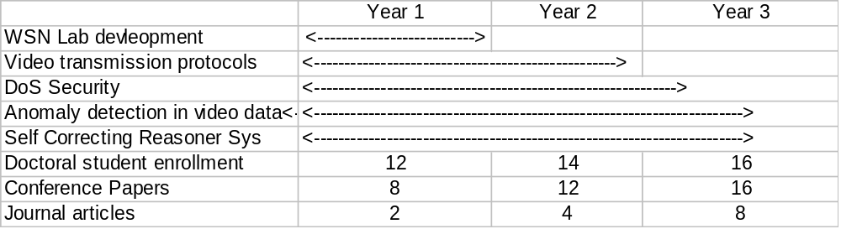Timeline and Expected Outcomes
6. Advisory Board and Assessment
The advisory board consists PI, five external members selected from universities, national laboratories and Co-PIs. Following is the list of external members of the board who have agreed to serve on the advisory board.
- Dr. Yelena Yesha, Professor, UMBC
- Mr. Jerome Bennett, Assoc Chief, Earth Science Data and Communication Div, Goddard Space Flight Center.
- Dr. Arun Sood, Professor, George Mason University
- Dr. Don Perlis, Professor, Univ of Maryland, College Park.
The project execution, outcomes, and impact will be assessed and reported in the annual report. Mr. David Bushnell will help the PI with assessment. Funds were included in the budget for supporting Mr. Bushnell for the assessment. Mr. Bushnell has extensive experience in education activities and assessment.

