required Information for it calculation of BMI Node app

**npm start for run the app**

**npm test for test cases**

please go to postman or any other API testing tool

select get method this url http://localhost:3001/feed/calculate after executing npm start command or when app is running

passing the body as raw

as given format as request then send the request

[{"Gender": "Male", "HeightCm": 171, "WeightKg": 50 }, { "Gender": "Male", "HeightCm": 161, "WeightKg":

85 }, { "Gender": "Male", "HeightCm": 180, "WeightKg": 77 }, { "Gender": "Female", "HeightCm": 166,

"WeightKg": 62}, {"Gender": "Female", "HeightCm": 150, "WeightKg": 70}, {"Gender": "Female",

"HeightCm": 167, "WeightKg": 82}]

and response should be like as below **with status code 200**

{

"level": "success",

"Message": "successfully calculate BMI",

"Data": [

{

"BMI": 29.239766081871345,

"BMI_Category": "Overweight",

"Health_risk": "Enhanced risk",

"WeightKg": 50,

"HeightM": 1.71,

"Gender": "Male"

},

{

"BMI": 52.795031055900616,

"BMI_Category": "Very severely obese",

"Health_risk": "Very high risk",

"WeightKg": 85,

"HeightM": 1.61,

"Gender": "Male"

},

{

"BMI": 42.77777777777778,

"BMI_Category": "Very severely obese",

"Health_risk": "Very high risk",

"WeightKg": 77,

"HeightM": 1.8,

"Gender": "Male"

},

{

"BMI": 37.34939759036145,

"BMI_Category": "Severely obese",

"Health_risk": "High risk",

"WeightKg": 62,

"HeightM": 1.66,

"Gender": "Female"

},

{

"BMI": 46.666666666666664,

"BMI_Category": "Very severely obese",

"Health_risk": "Very high risk",

"WeightKg": 70,

"HeightM": 1.5,

"Gender": "Female"

},

{

"BMI": 49.10179640718563,

"BMI_Category": "Very severely obese",

"Health_risk": "Very high risk",

"WeightKg": 82,

"HeightM": 1.67,

"Gender": "Female"

},

{

"total_number_of_overweight_people": 1

}

]

}

eg.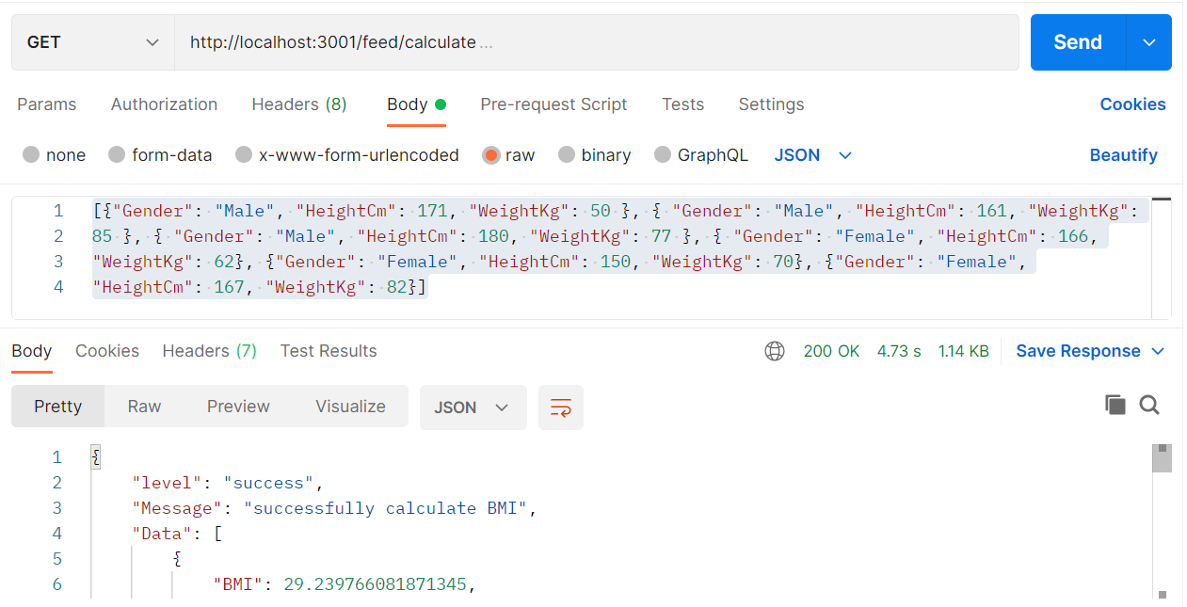

If having problem to calculate or we cant requested the body

then response should be like below **with status code 500**

{

"level": "error",

"Message": "Something went wrong",

"Data": ""

}

eg.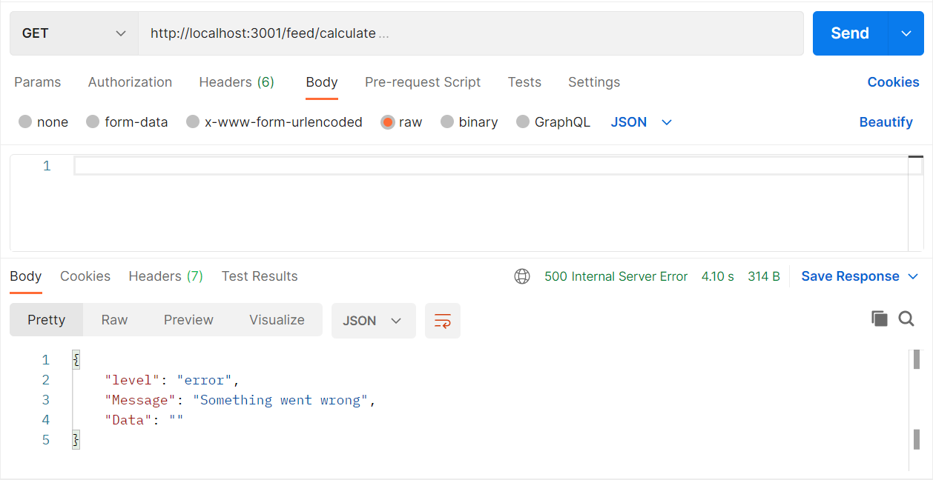

test cases also write as in 4 cases for this api

Before executing the command for testing make sure application not running

**npm test** command is executes in terminal

if test cases work properly it give response as pass and fail format

like passing in green and failed in red color

eg.

