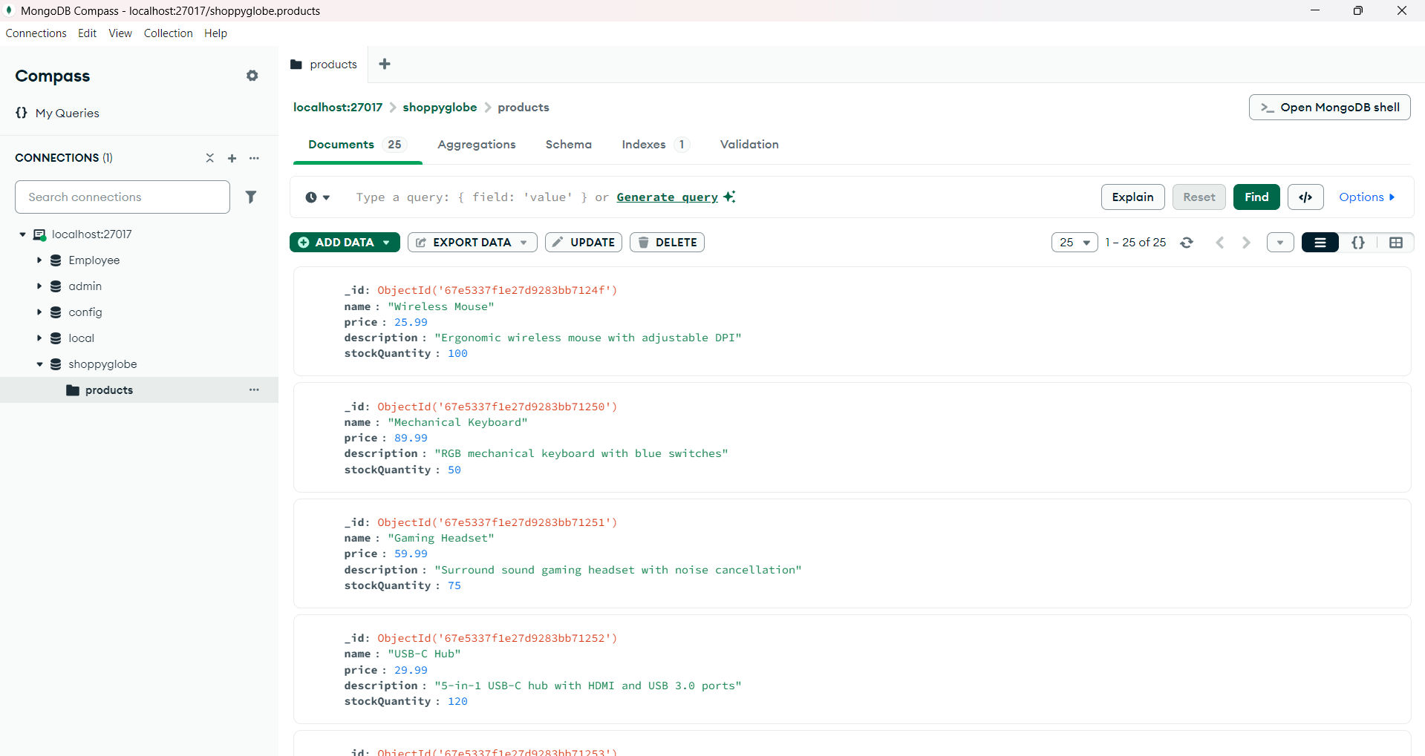

List of all products in MongoDB(products collection)

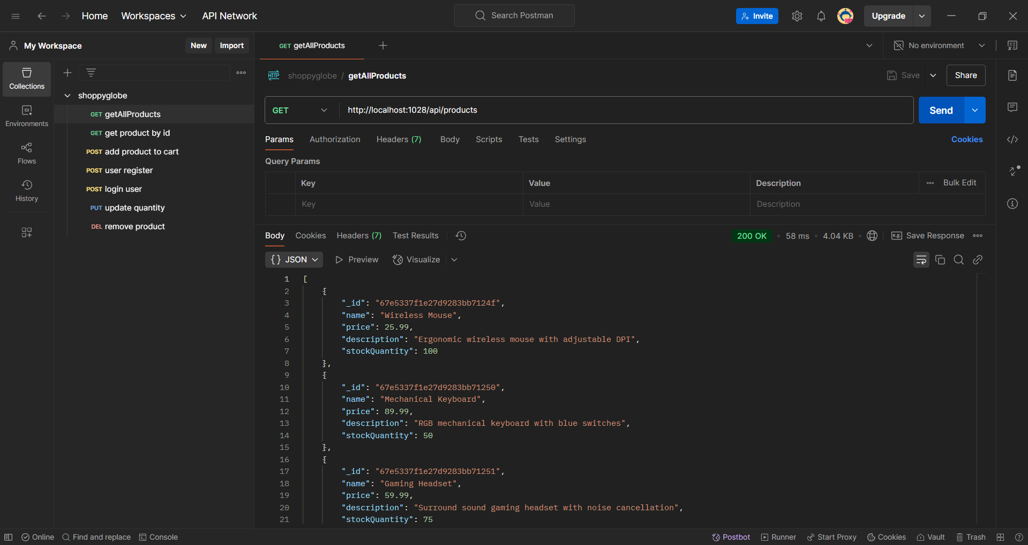

Get method to fetch all products(“/api/products”)

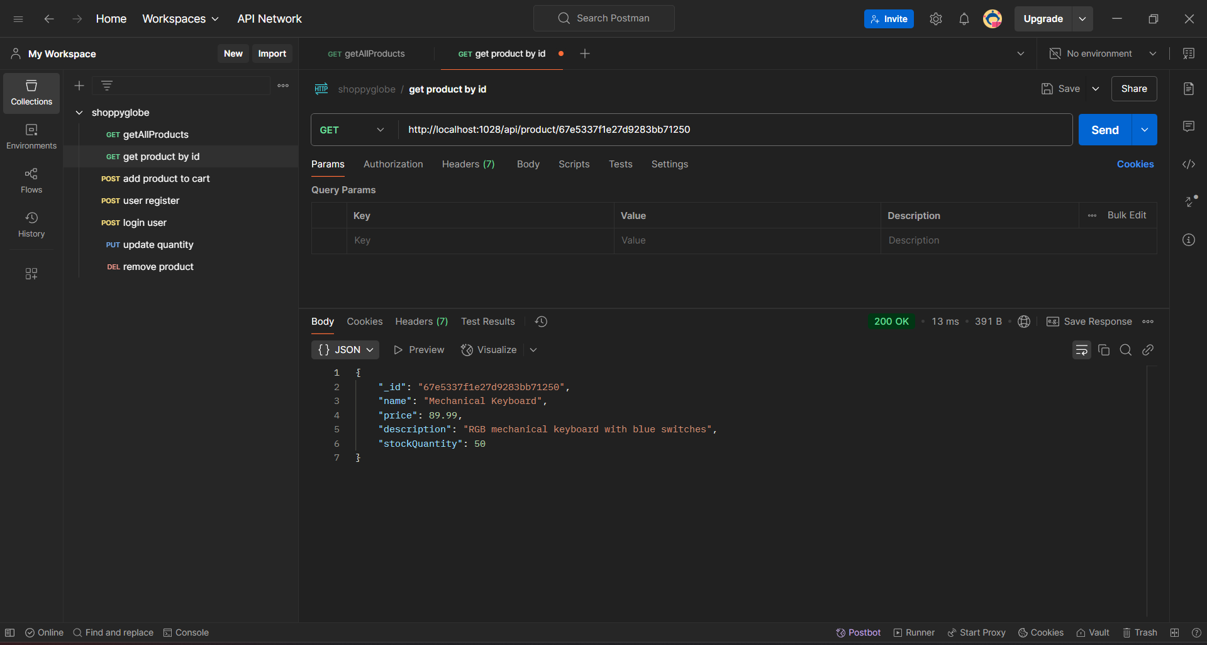

Get method to fetch product by id(“/api/product/:id”)

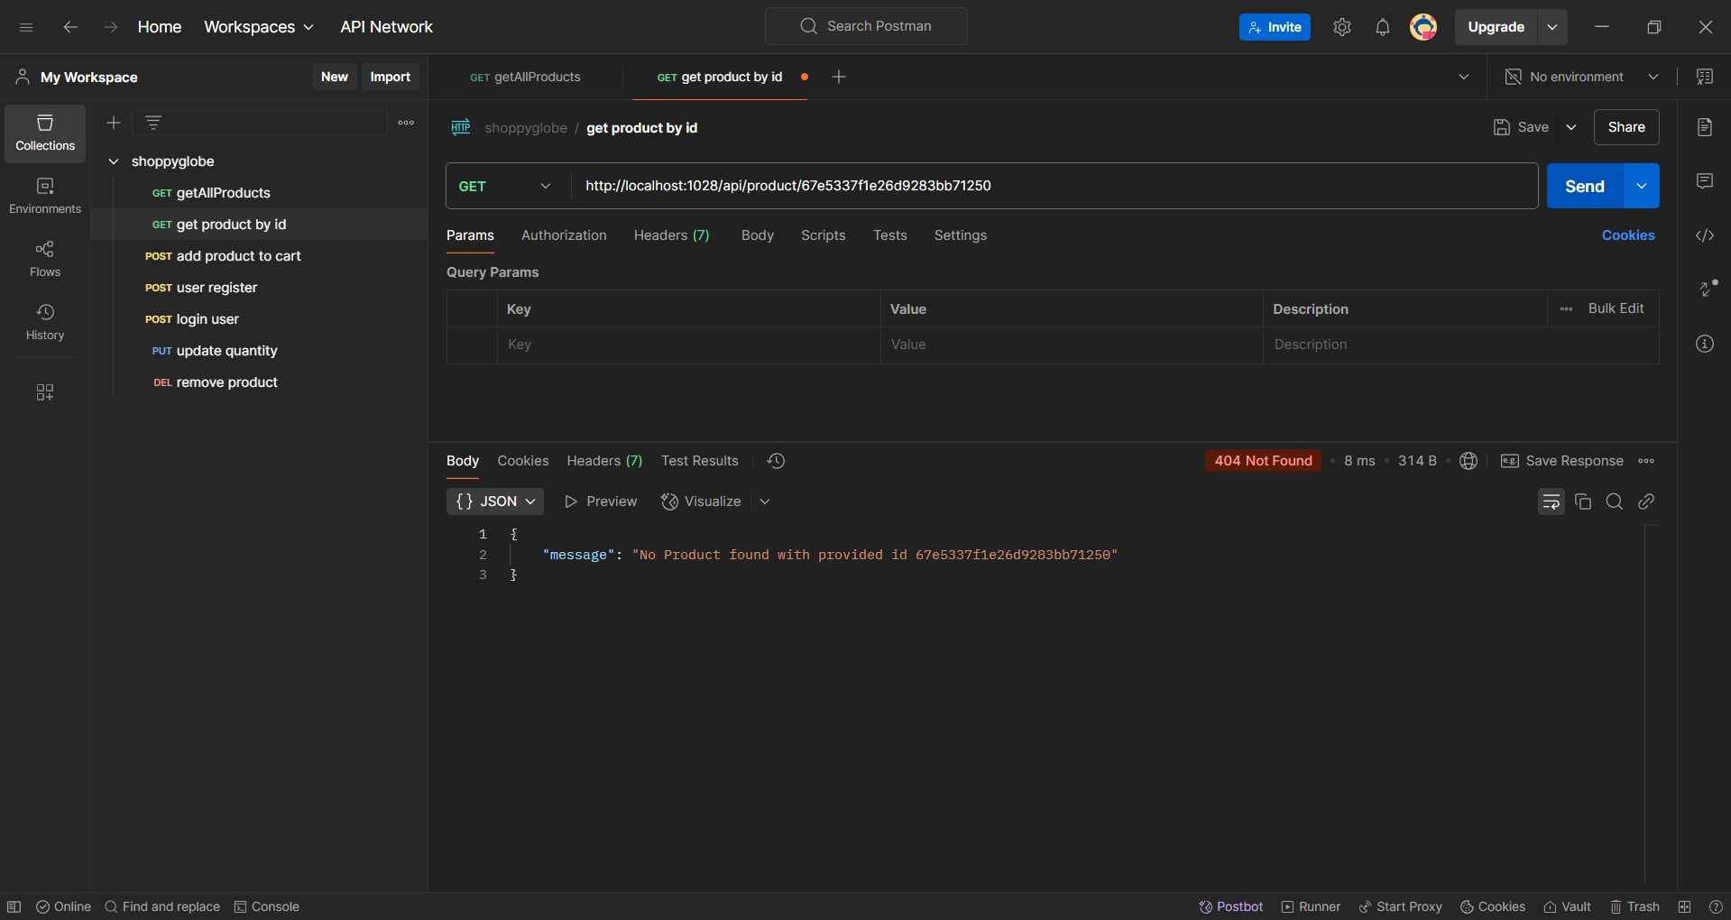

Get method to fetch productbyid id validation(“/api/product/:id)

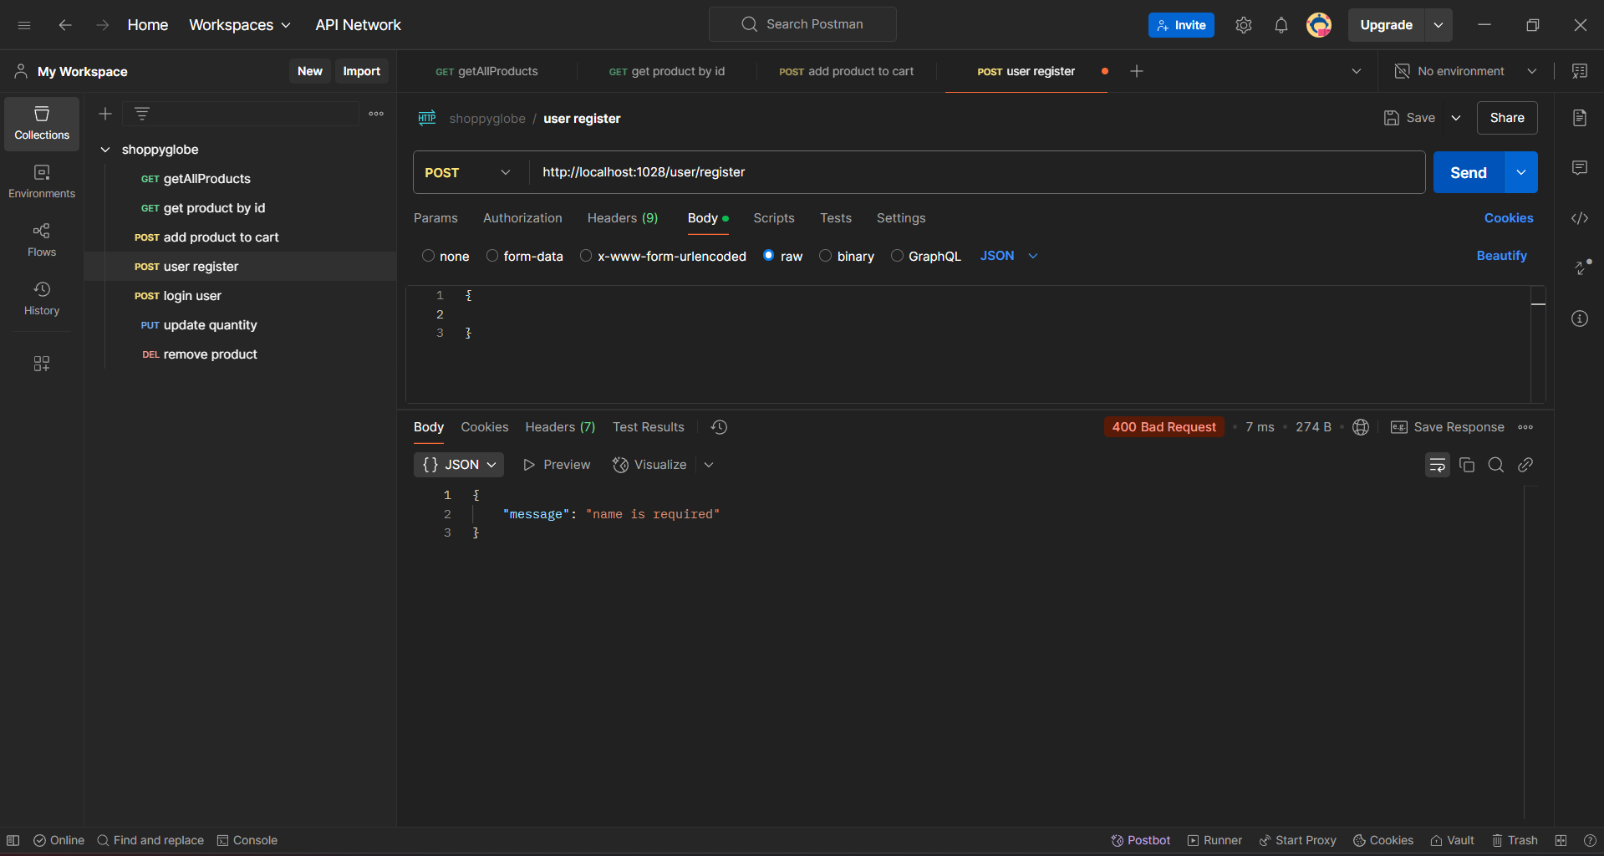

Post method User registration validation 1(“/user/register”)

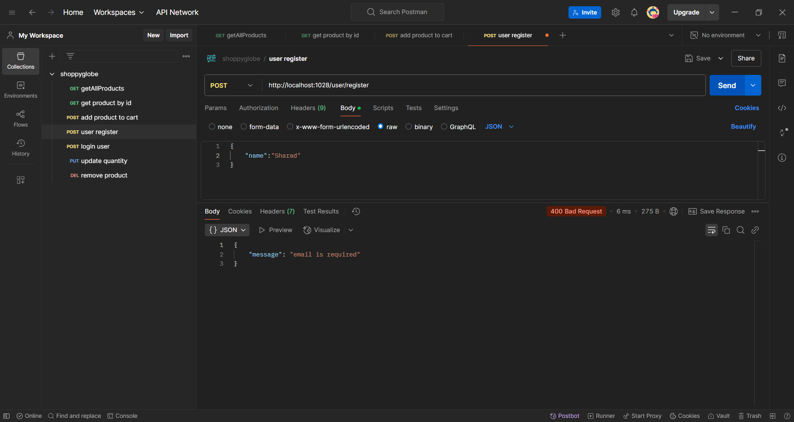

Post method User registration validation 2(“/user/register”)

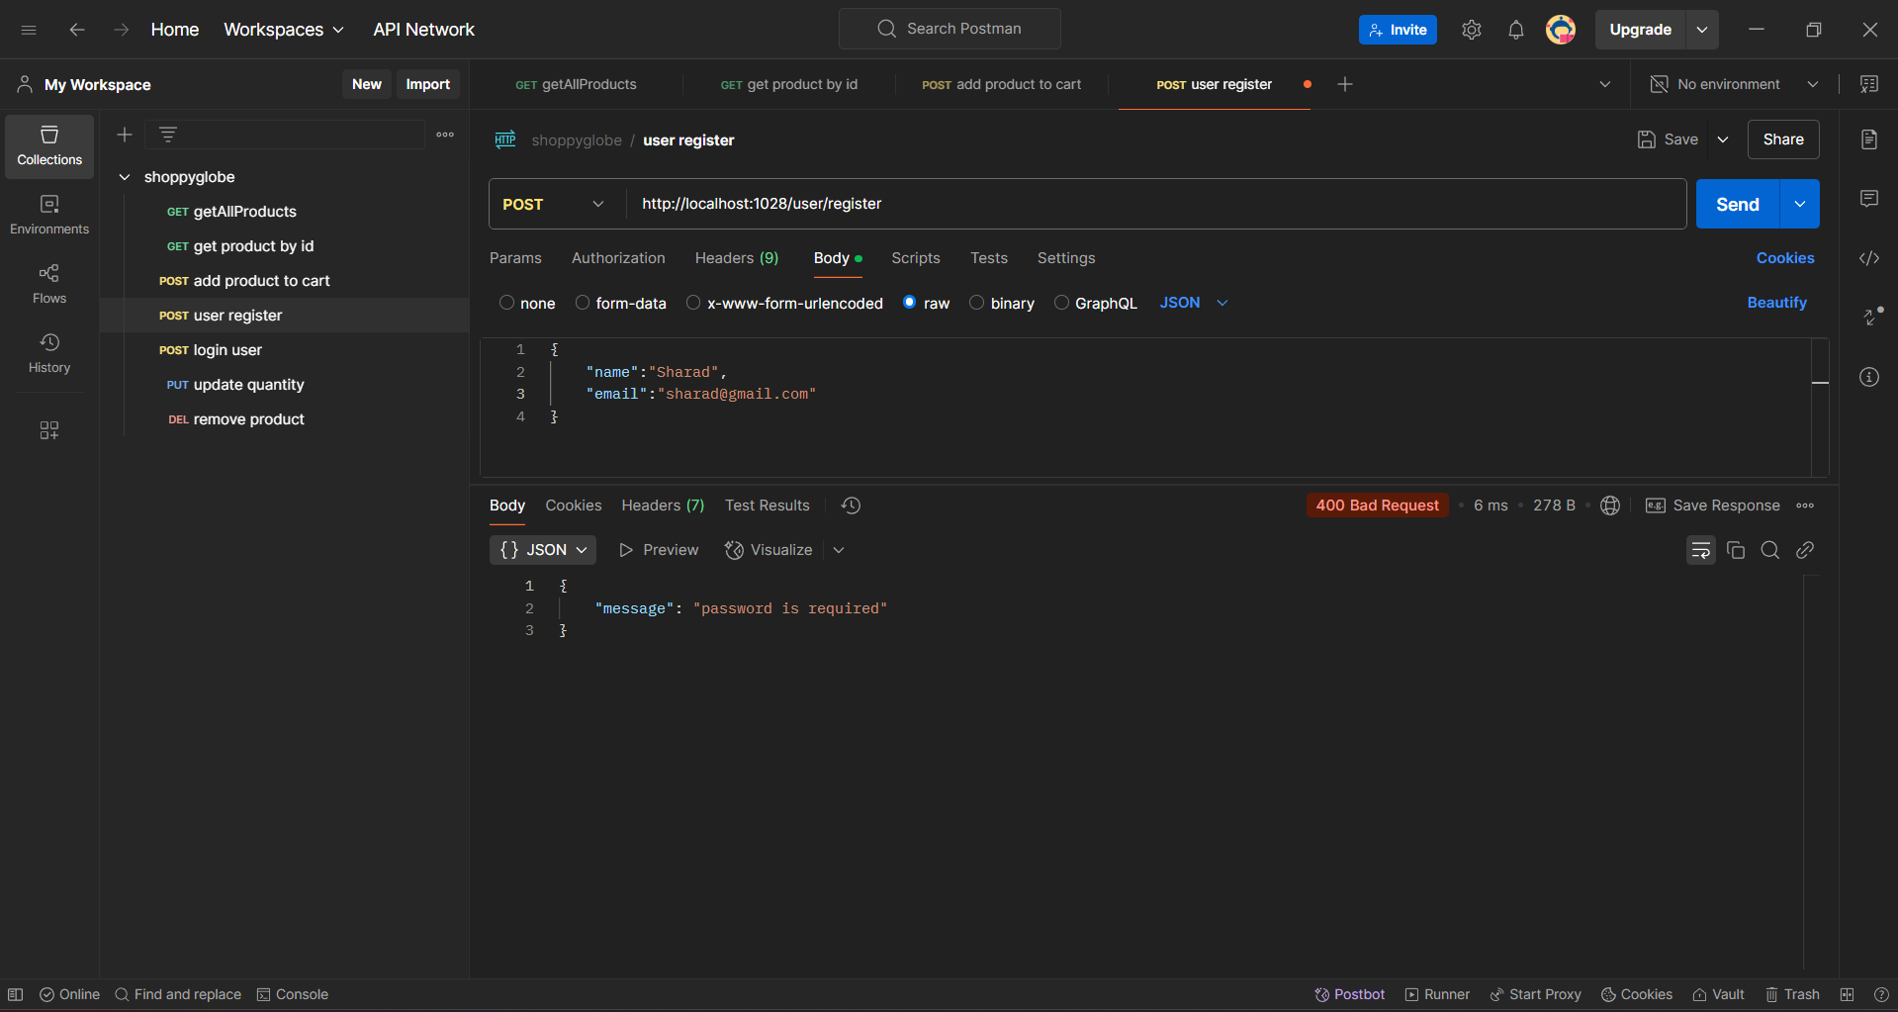

Post method User registration validation 3(“/user/register”)

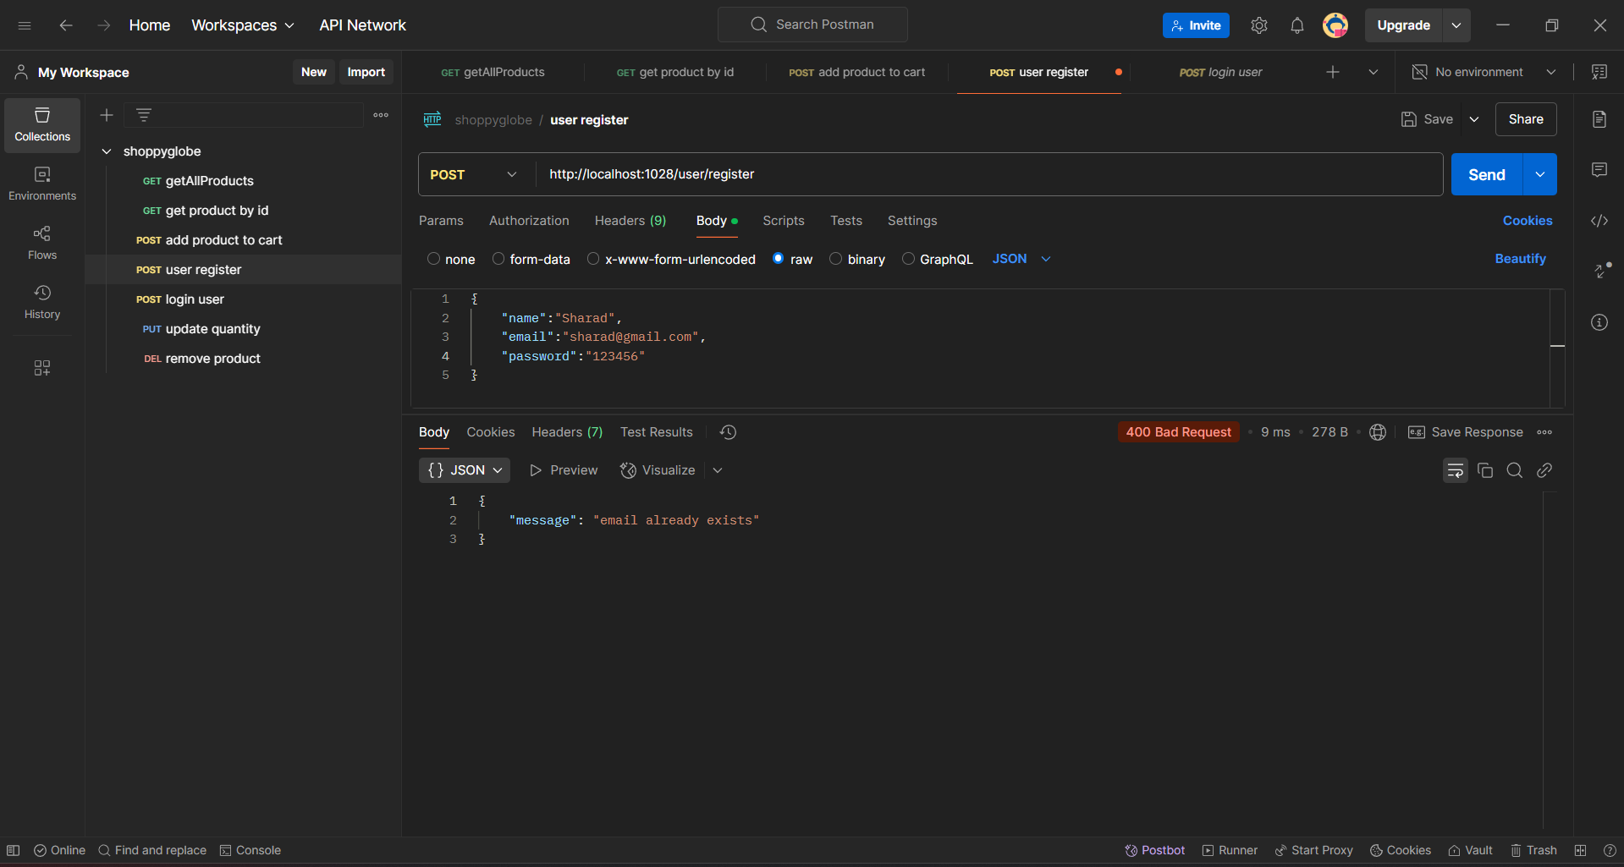

User registration validation 4 email should be unique (“/user/register”)

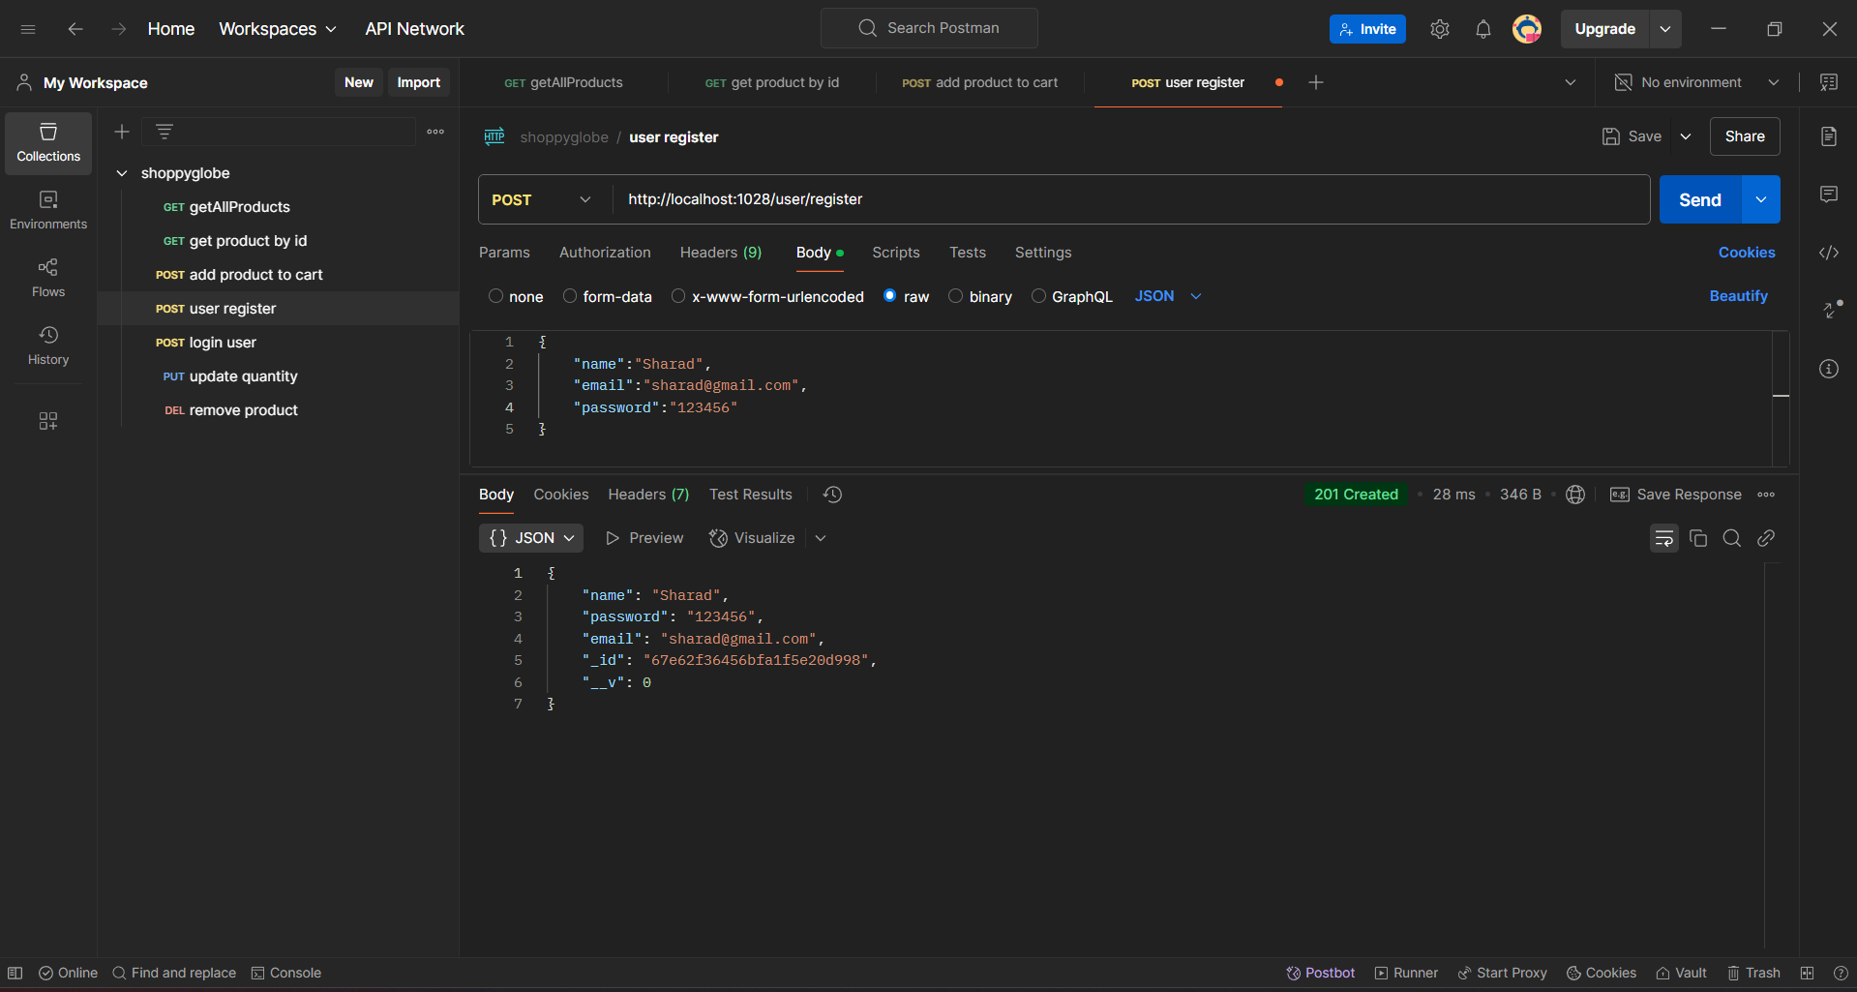

Post request user registration successful(“/user/register”)

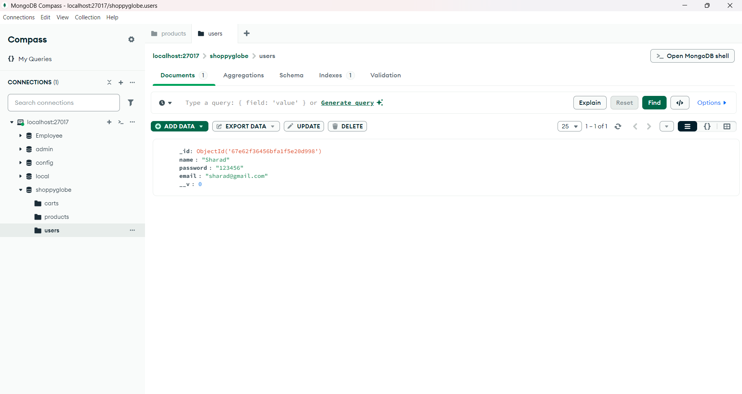

Post request user registration successful in db(“/user/register”)

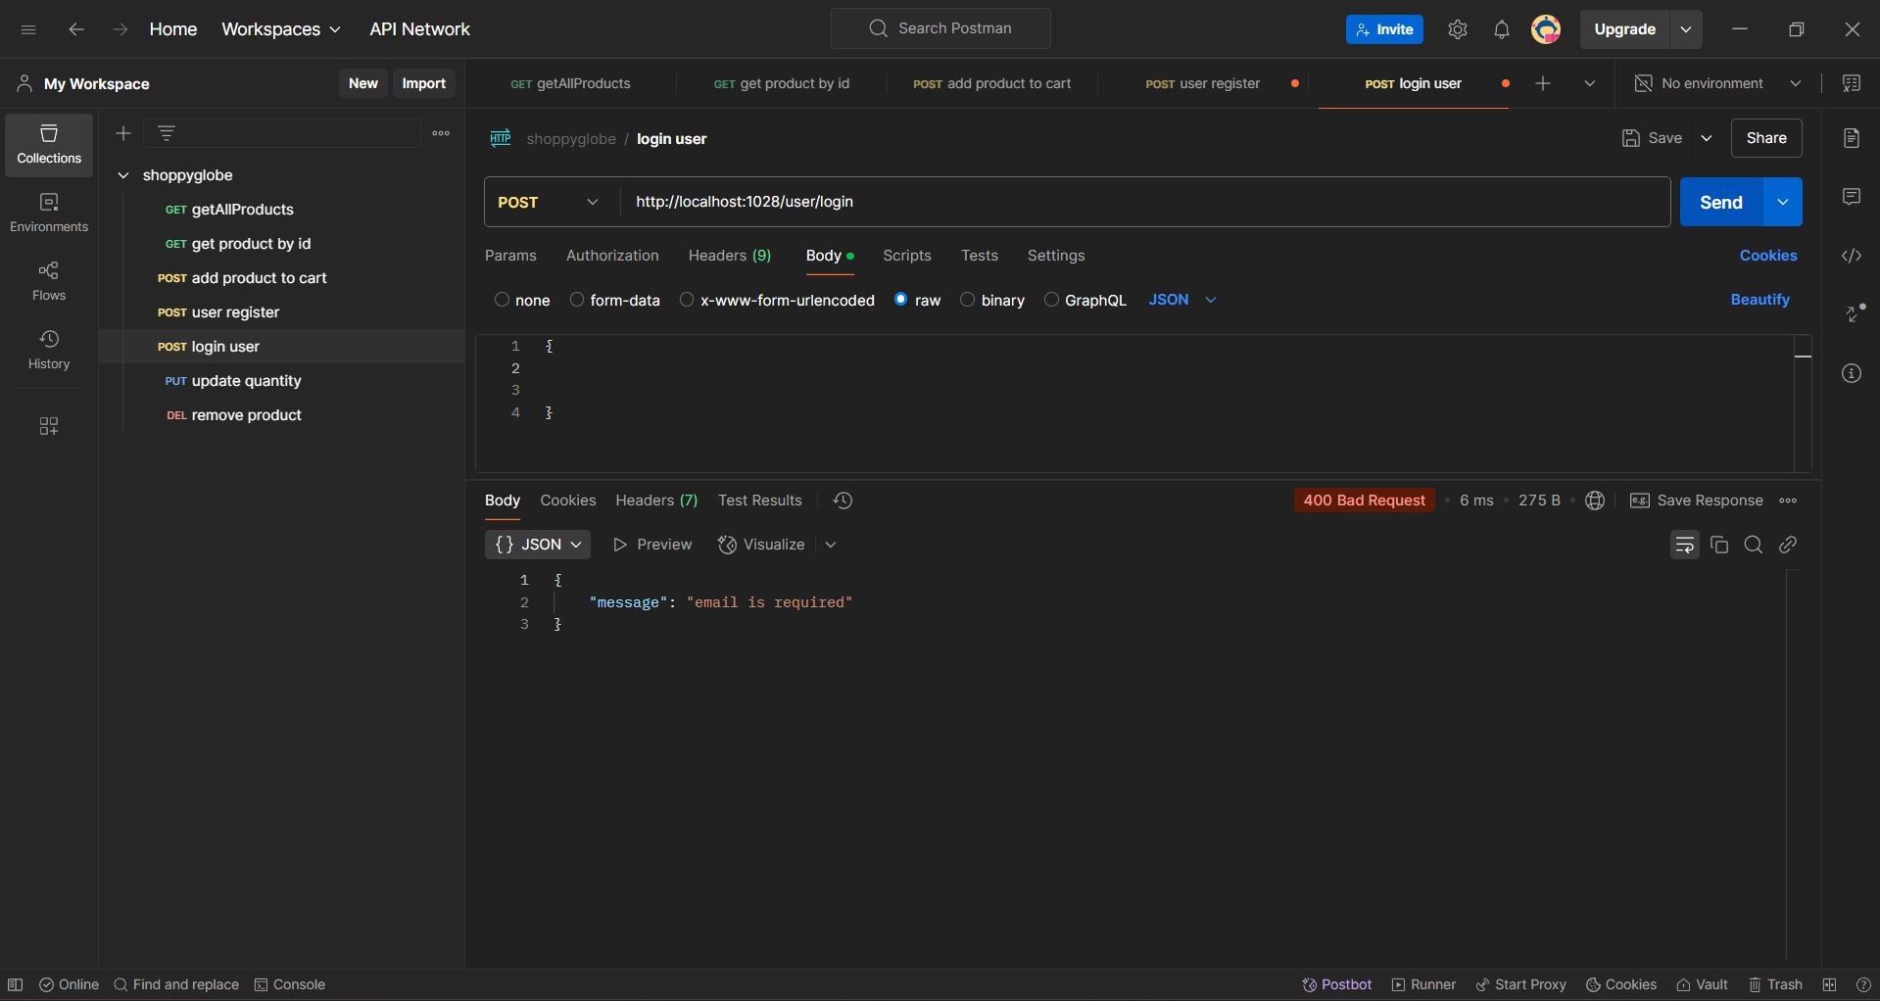

Post method User login validation 1(“/user/login”)

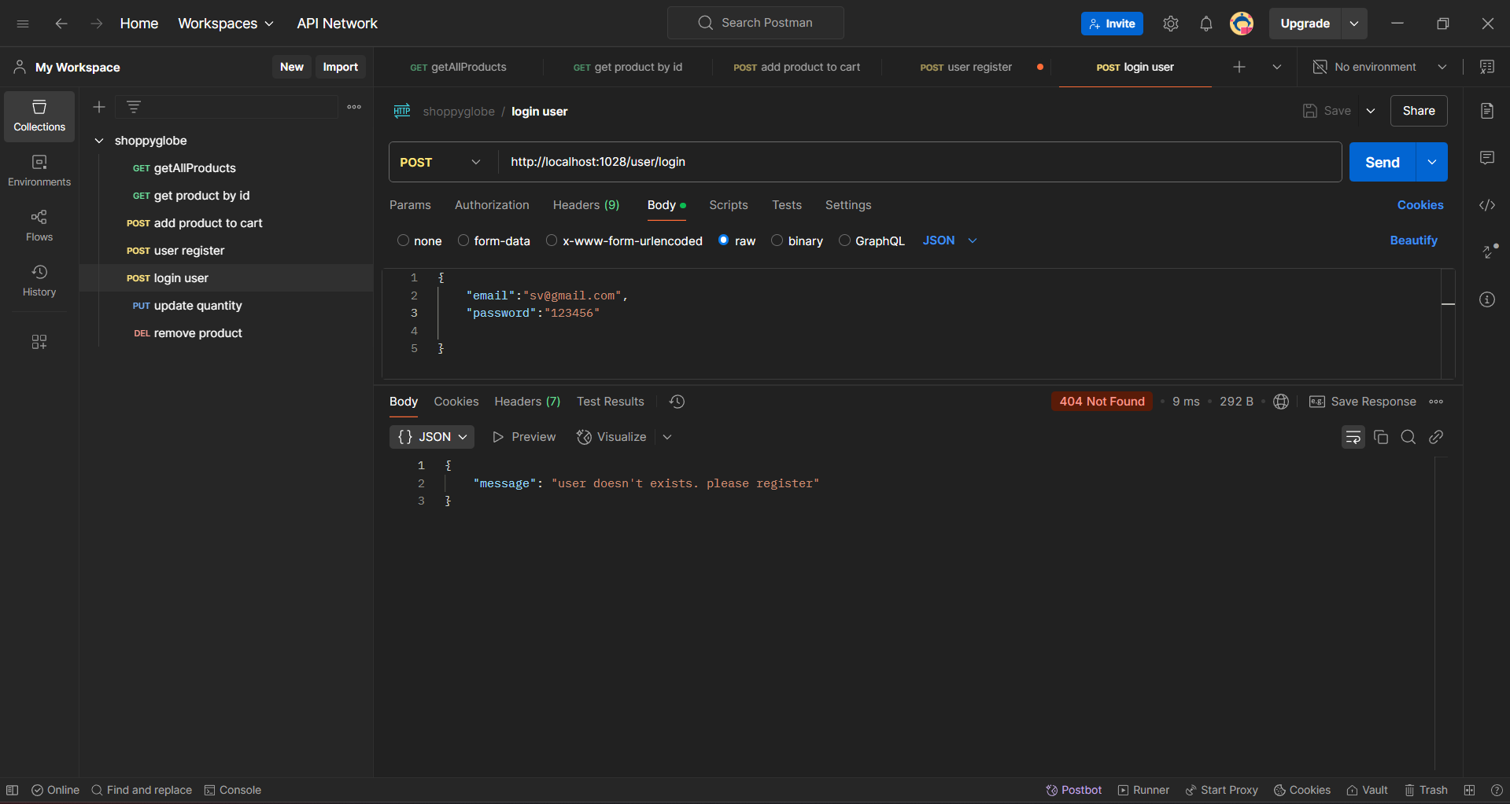

Post method User login email validation (“/user/login”)

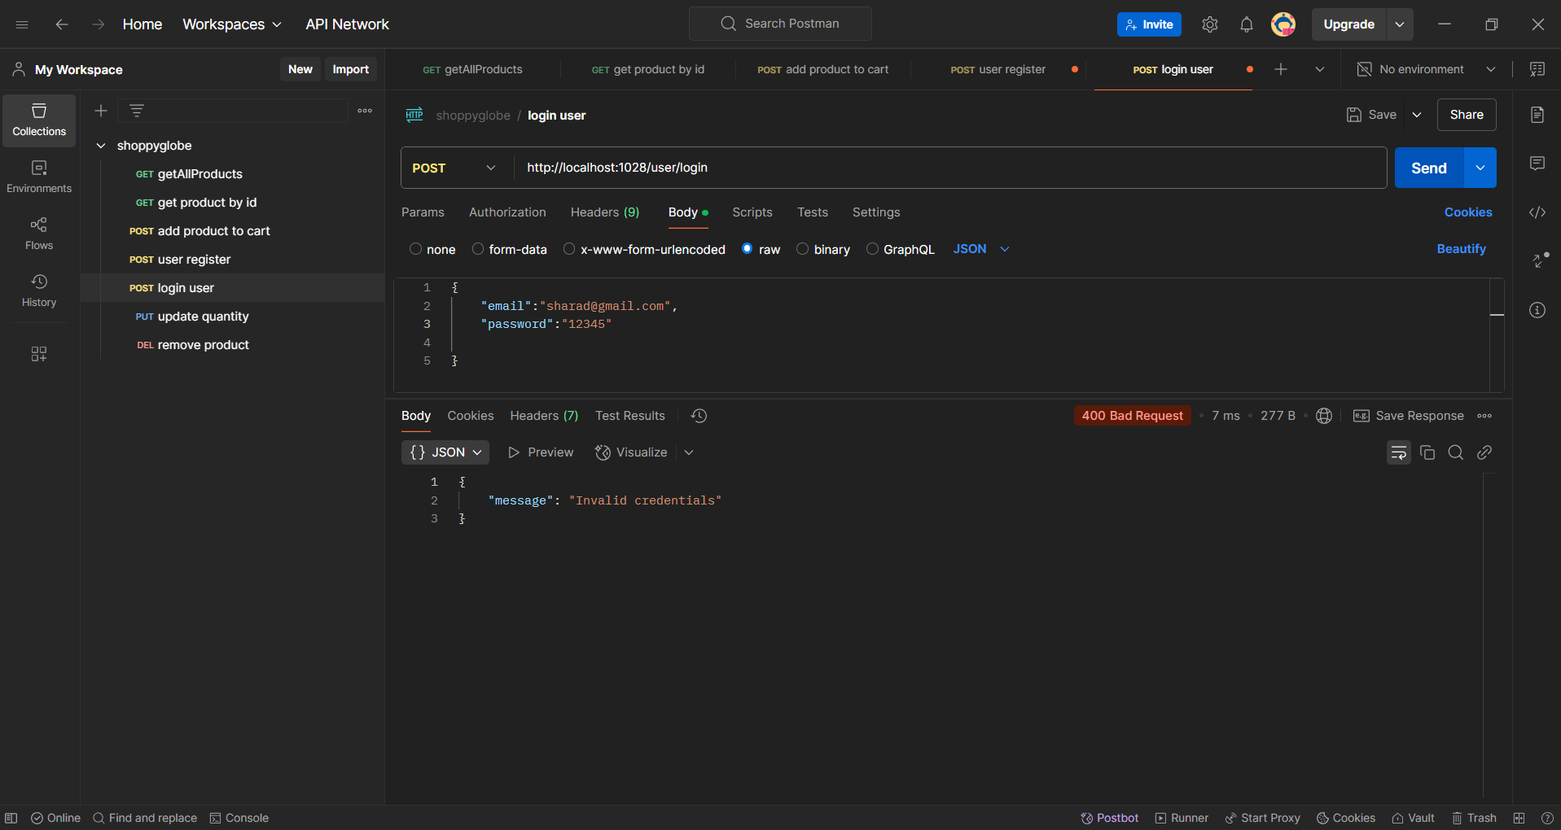

Post method User login password validation (“/user/login”)

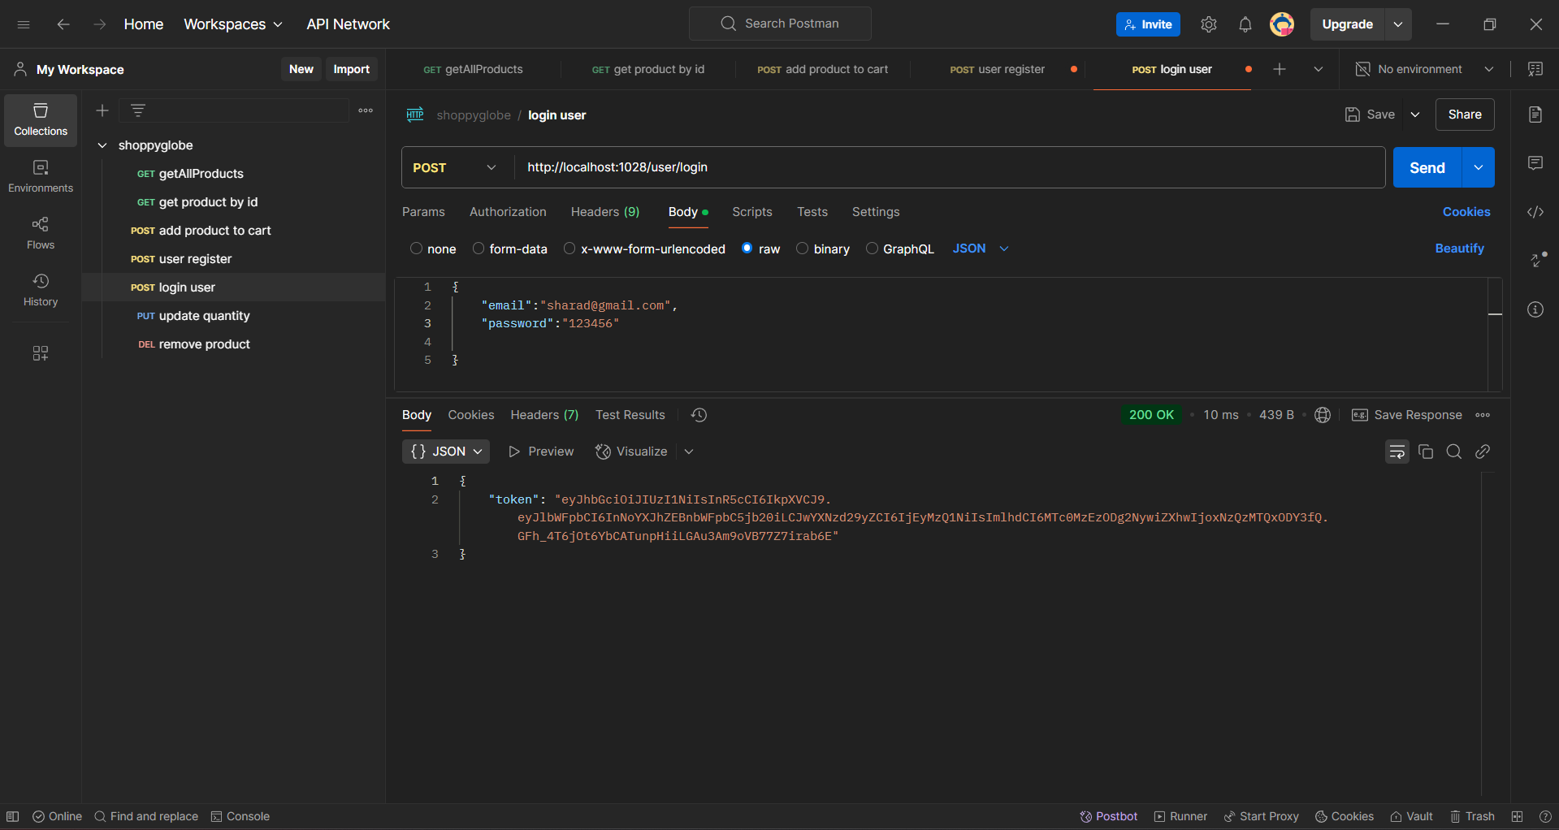

Post method User login success token generation(“/user/login”)

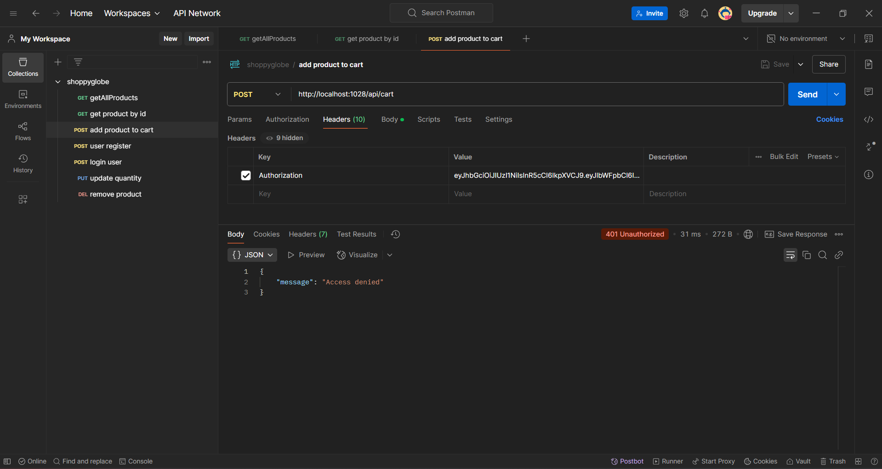

Post request Add item to cart jwt verification(“/api/cart”)

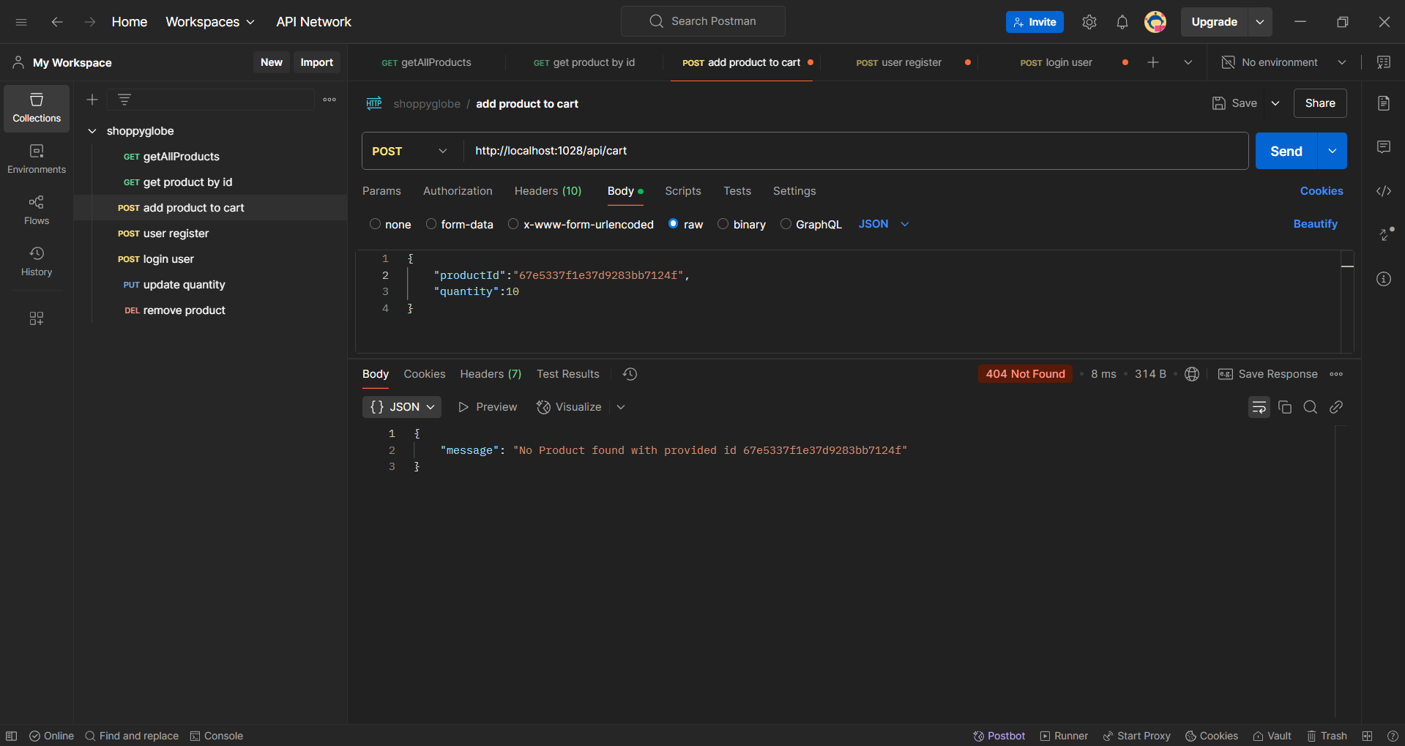

Post request Add item to cart productId verification(“/api/cart”)

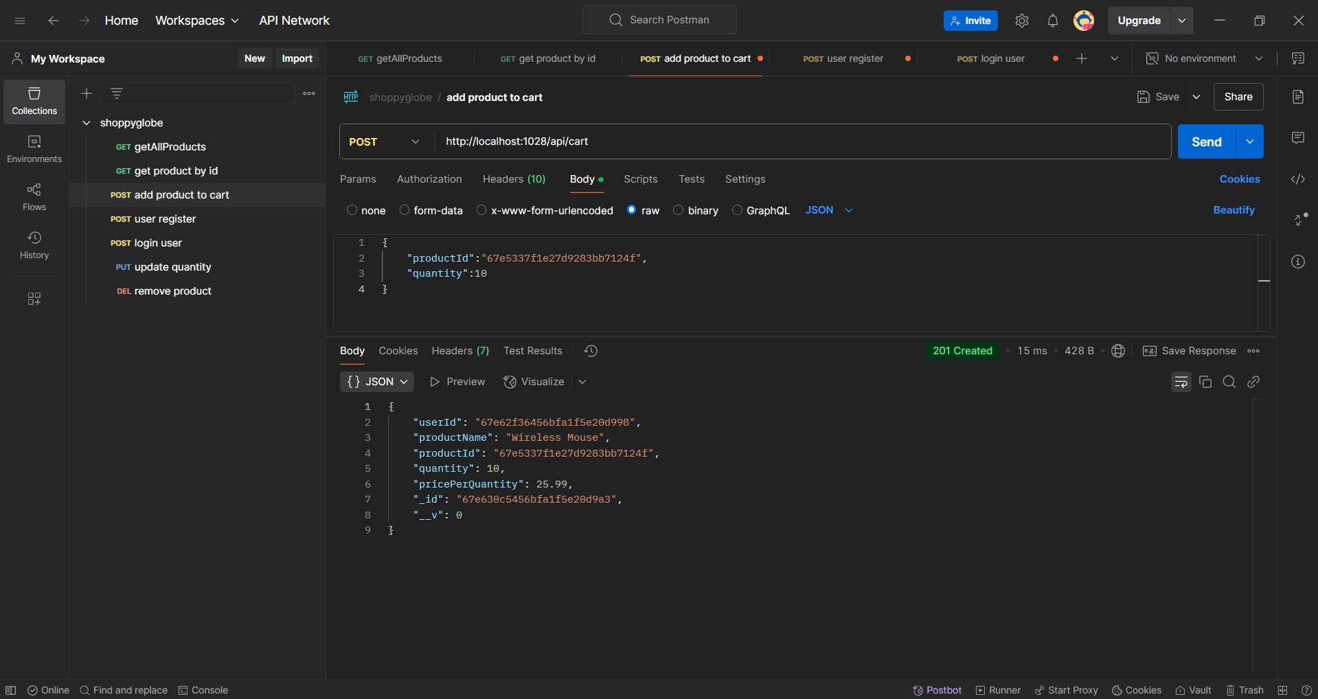

Post request Add item to cart success(“/api/cart”)

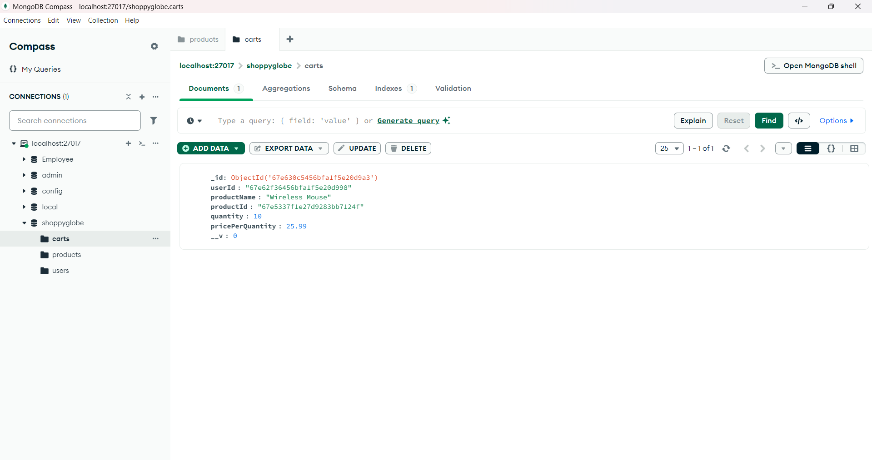

Post request Add item to cart in db(“/api/cart”)

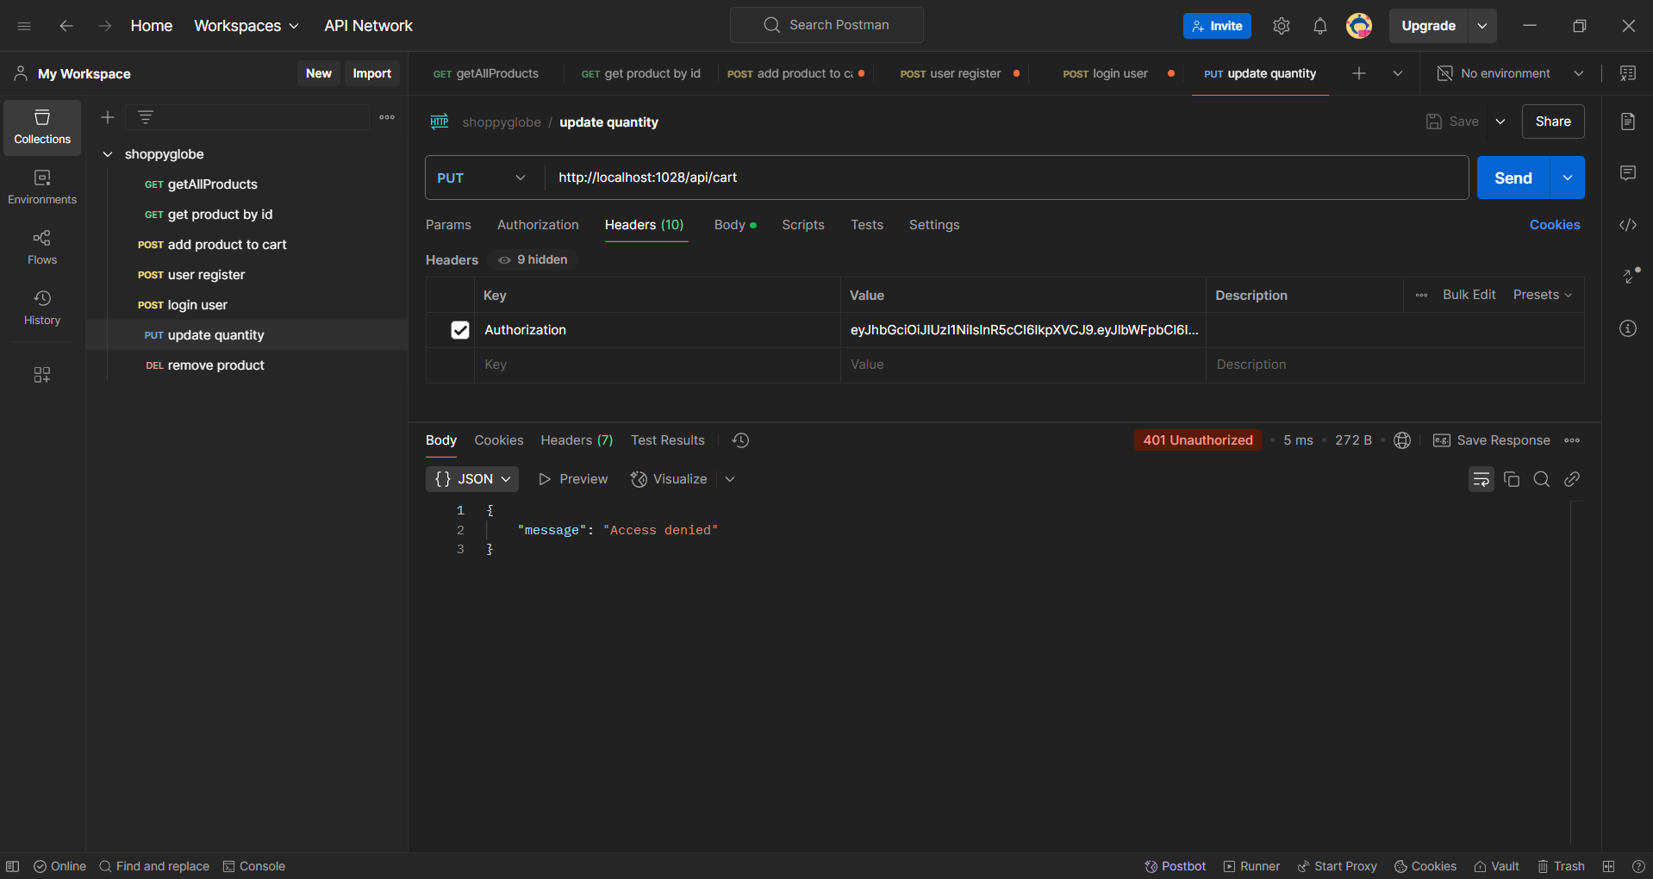

Put request update item quantity in cart jwt verification(“/api/cart”)

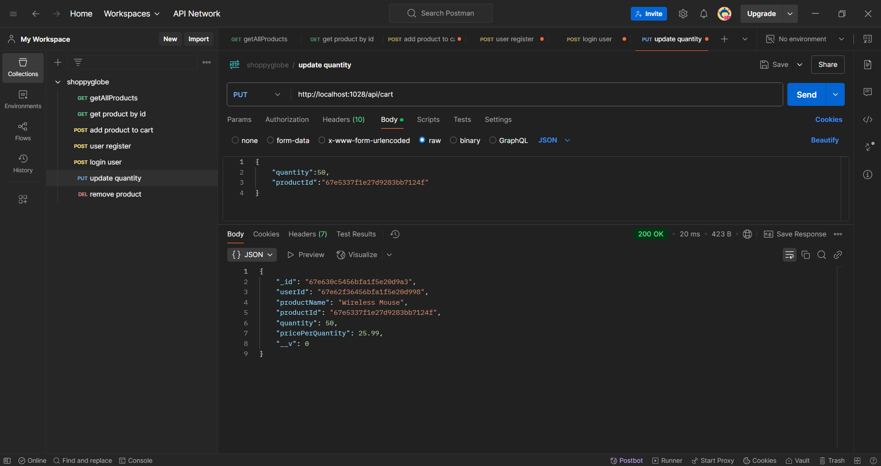

Put request update item quantity in cart success(“/api/cart”)



Put request update item before quantity in db(“/api/cart”)

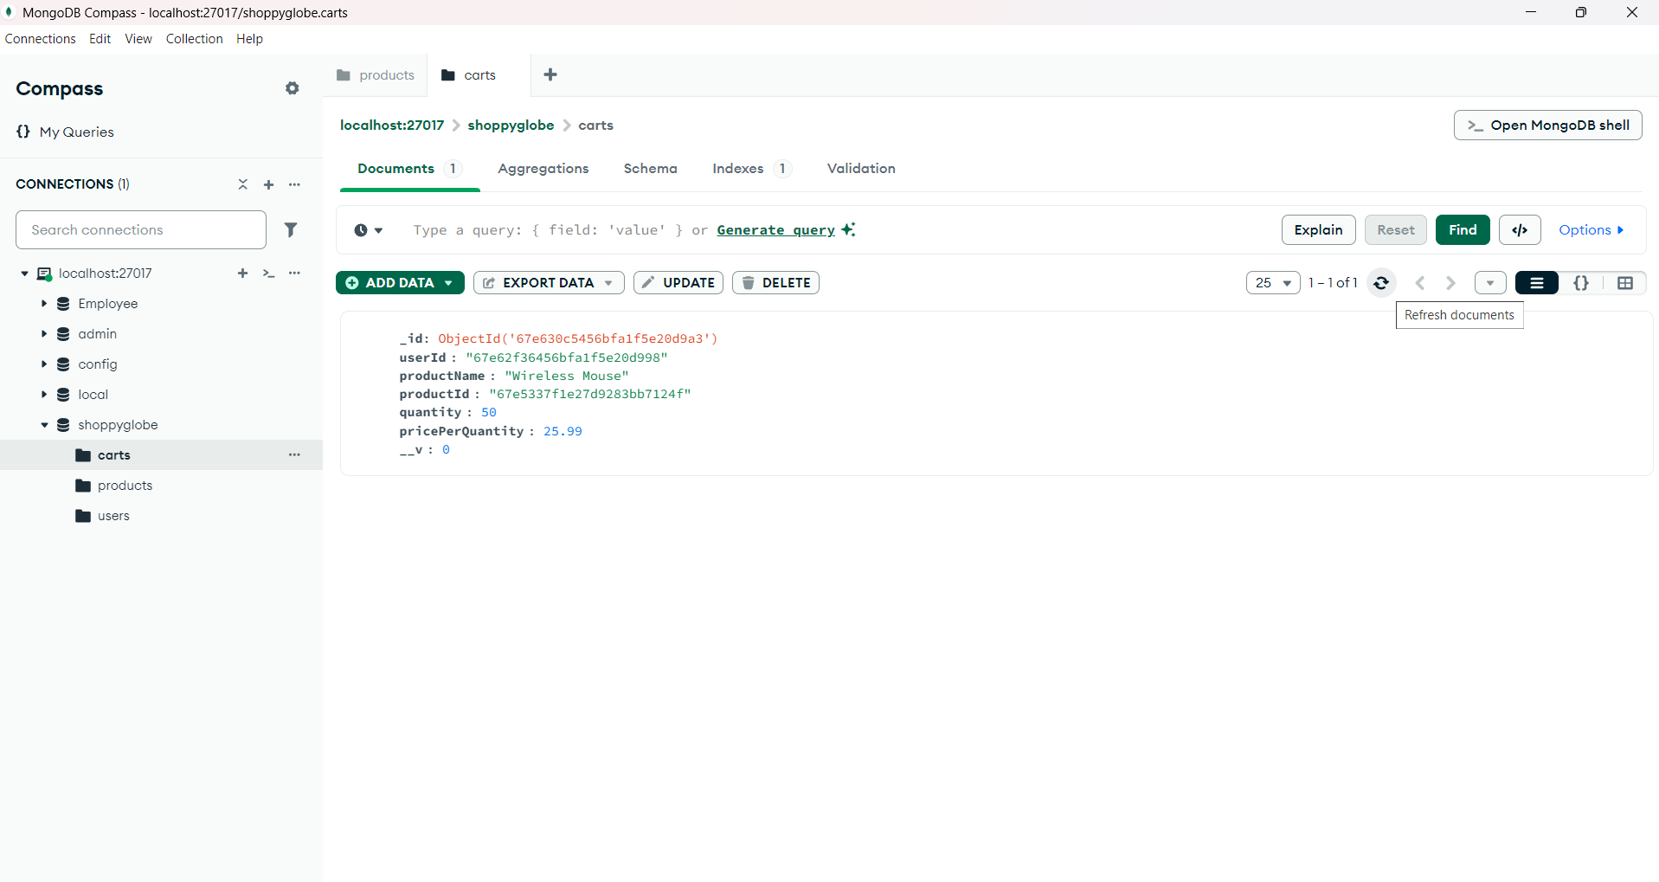

Put request update item quantity after updating in db(“/api/cart”)

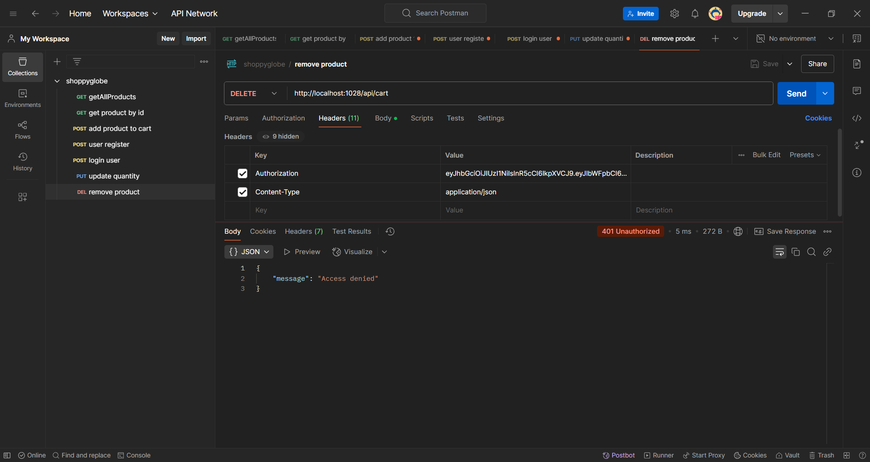

delete request remove product from cart jwt verification (“/api/cart”)

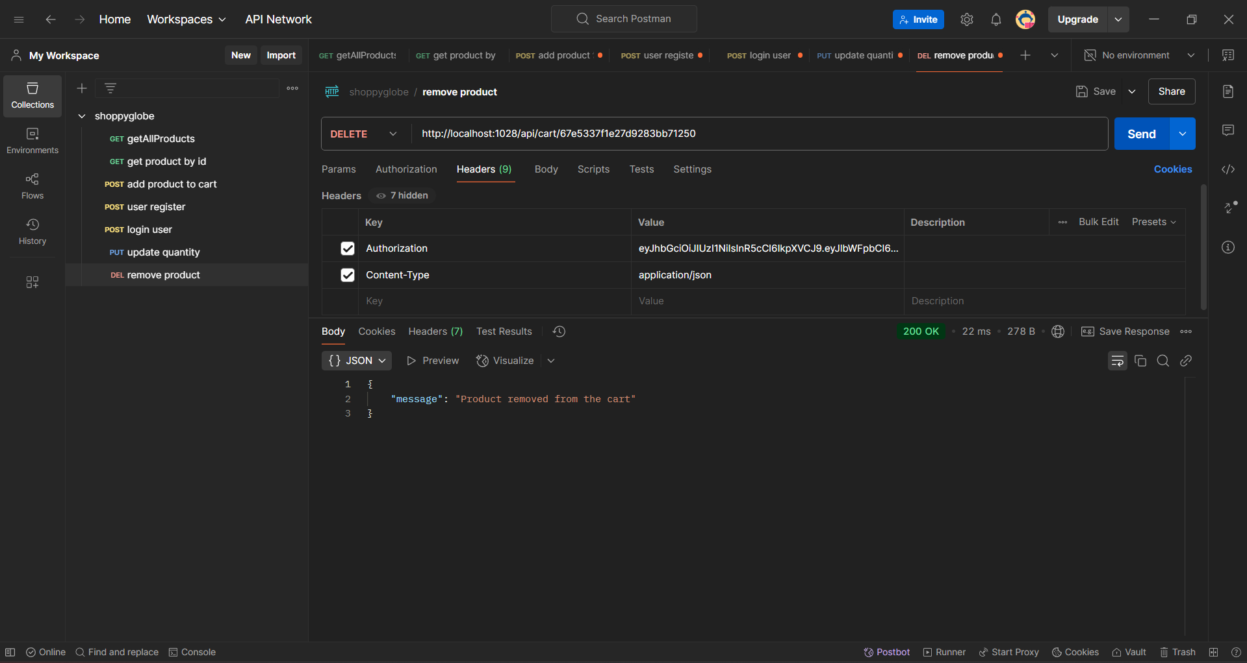

delete request remove product from cart success (“/api/cart”)

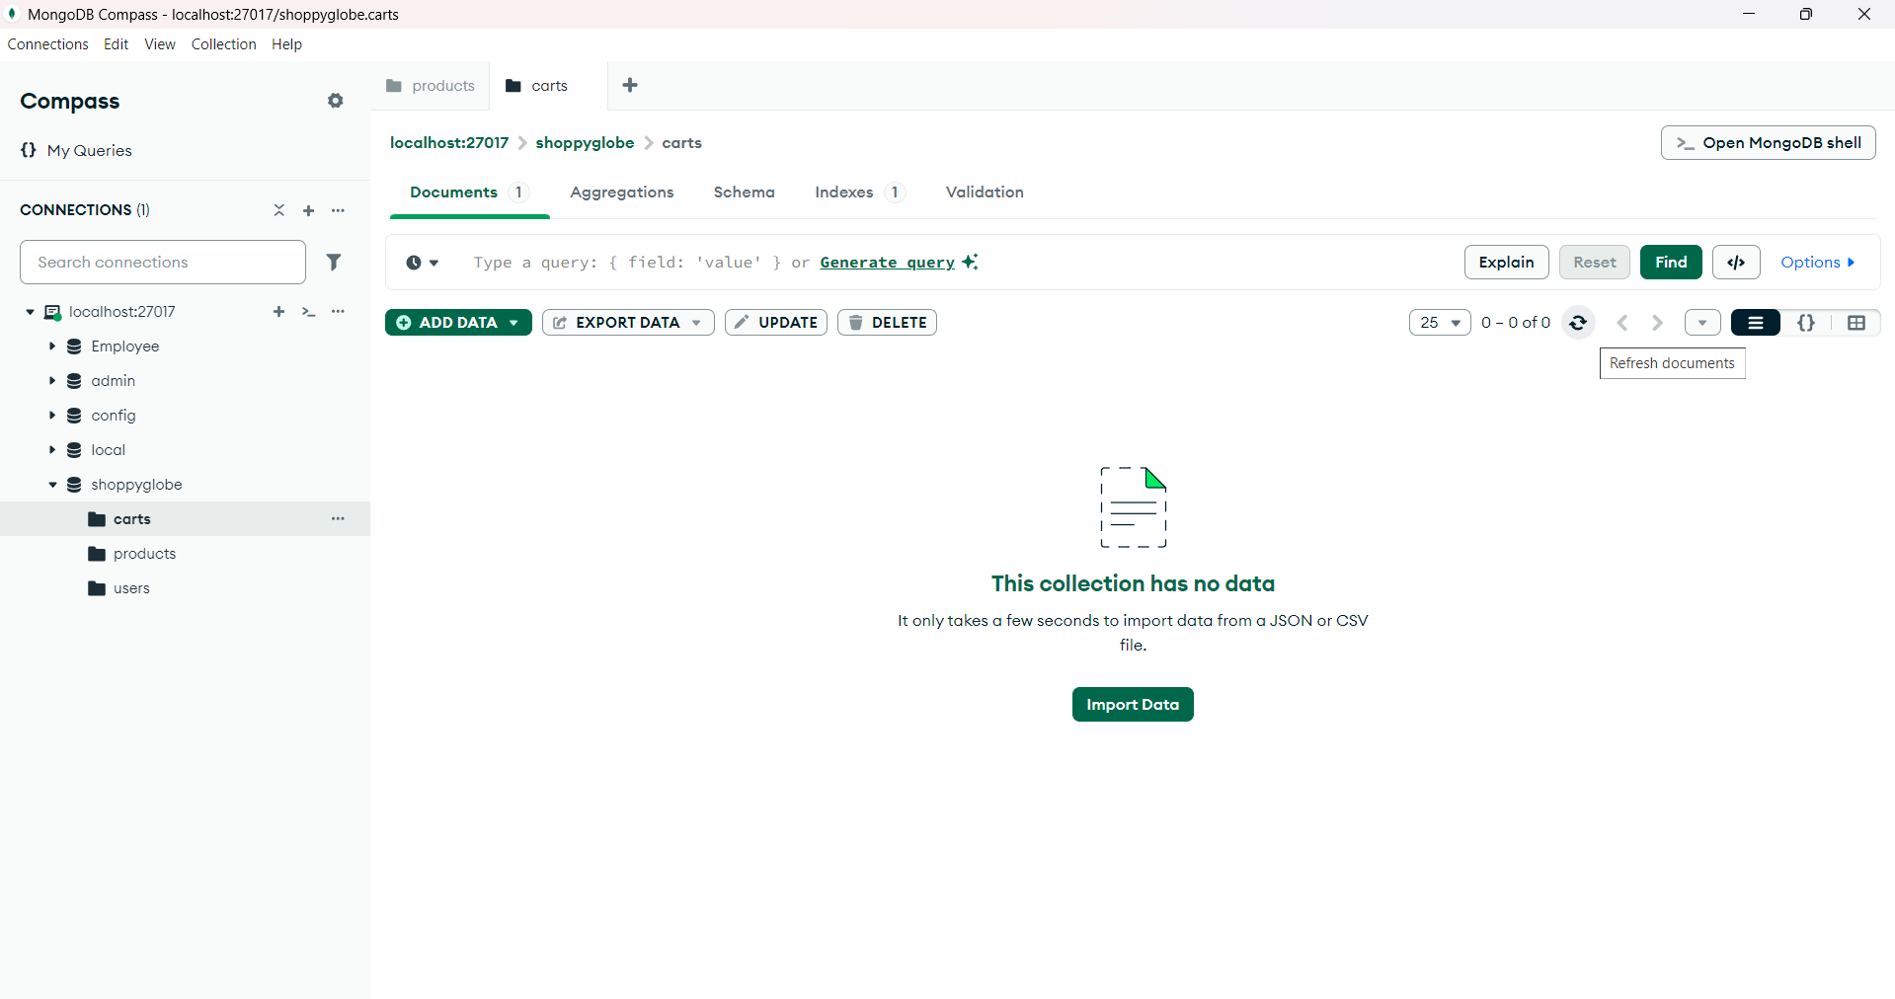

delete request remove product from cart in db(“/api/cart”)