Project Deliverable #1: Creational Design Patterns Project Name: ConstructFlow
Course: C-SW311 Software Design and Development

Introduction
ConstructFlow is a centralized construction management system designed to streamline project tracking, resource allocation, and communication between o ce managers and site engineers. This report documents the implementation of five Creational Design Patterns to address specific architectural challenges in object creation, resource management, and system scalability.

Assumptions

Multithreading: We assume the system will operate in a concurrent environment where multiple users (managers and site engineers) access the system simultaneously. This necessitates thread- safe Singleton implementations for shared resources.
Platform Diversity: We assume that notification delivery and report generation must support multiple output formats (Email/Push, PDF/Excel) without tight coupling to the core business logic.
Database: The system connects to a local Microsoft SQL Server instance ( ConstructFlowDB )
using the sha user for authentication.

Singleton Design Pattern

Case 1: Database Connector

Problem: Connecting to a relational database is a resource-intensive operation. If every Data Access Object (DAO) were to create its own connection instance, the system would quickly exhaust available database connections, leading to performance degradation and potential crashes.
Solution: We applied the Singleton pattern to the DatabaseConnector class. This ensures that only one instance of the connection pool exists throughout the application's lifecycle. All DAOs share this single instance, optimizing resource usage and ensuring thread safety.
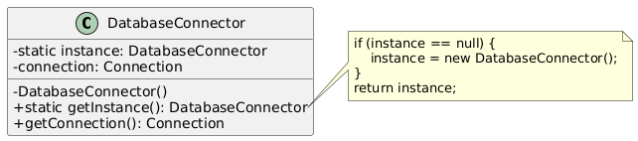

Case 2:Notification Service

Problem: The system triggers notifications from multiple controllers (e.g., when a task is overdue or stock is low). Having multiple instances of a notification dispatcher could lead to race conditions, duplicate alerts, or inconsistent logging of sent messages.
Solution: We implemented the NotificationService as a Singleton. This provides a global access point for all controllers to dispatch messages through a centralized service, ensuring consistency in how alerts are processed and logged.
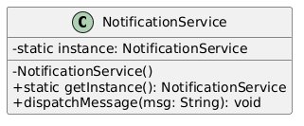

Factory Method Design Pattern

Case: Resource Creation (Materials vs. Equipment)

Problem: In the administration module, users need to add resources to the library. However, resources can be of different types: Material (consumable) or Equipment (reusable asset). The
AdministrationController should not need to know the specific initialization logic for every subclass of Resource .
Solution: We applied the Factory Method pattern. We defined an abstract ResourceFactory with a
createResource() method. Concrete subclasses ( MaterialFactory and
EquipmentFactory ) handle the specific instantiation logic. This decouples the controller from the concrete resource classes, adhering to the Open/Closed Principle—new resource types can be added without modifying existing controller code.
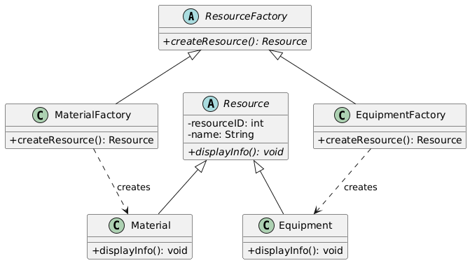

Abstract Factory Design Pattern

Case 1: Notification Channels (Cross-Platform)

Problem: The system must send TaskReminders and LowStockAlerts . However, the format and delivery mechanism depend on the user's platform. O ce managers prefer Email, while site engineers require mobile Push Notifications. Hardcoding these variations would lead to complex conditional logic ( if-else chains).
Solution: We used the Abstract Factory pattern to define a NotificationChannelFactory interface. Concrete factories ( EmailChannelFactory and PushChannelFactory ) create families of related products ( EmailReminder / EmailAlert vs. PushReminder / PushAlert ).
This ensures that a user always receives a consistent family of notification objects without the client code knowing the specific classes.
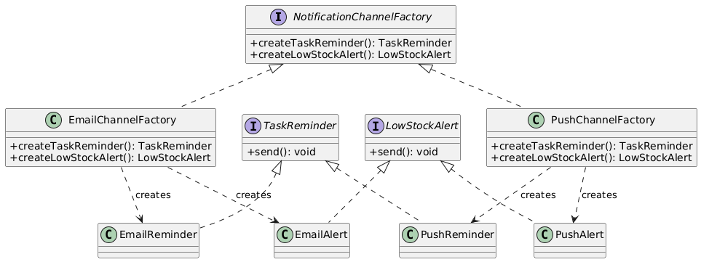

Case 2: Report Generation (Format Flexibility)

Problem: Clients require project reports ( WorkloadReport and SummaryReport ) in different file formats. Some stakeholders need PDF documents for printing, while others need Excel spreadsheets for data analysis.
Solution: We implemented a ReportFactory interface. Concrete factories ( PDFReportFactory and ExcelReportFactory ) are responsible for creating the corresponding family of report objects. This allows the system to switch the entire reporting engine dynamically based on user preference, ensuring flexibility and maintainability.
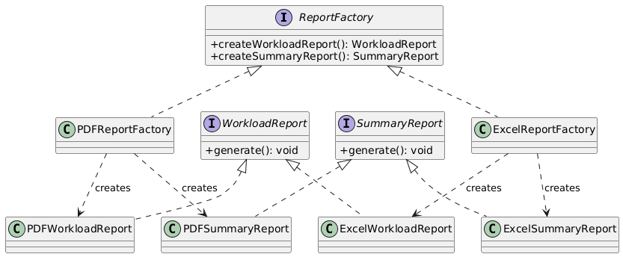

Implementation Verification
The Java implementation successfully connects to the MS SQL Server database and executes all design patterns without errors. The Main.java class serves as a comprehensive test suite, validating:
  - Singleton: Successful database connection and instance uniqueness.
  - Factory Method: Correct instantiation of Material and Equipment objects.
  - Abstract Factory: Correct generation of Email/Push notifications and PDF/Excel reports based on the selected factory.

