ConstructFlow System – Structural Design Patterns Technical Report

1. Introduction
ConstructFlow is a construction management system designed to handle complex operations such as project management, resource allocation, reporting, and notifications. To ensure scalability, maintainability, and flexibility, several structural design patterns were implemented.
This report presents a detailed analysis of the implemented patterns, including:
- Problem identification
- Pattern selection justification
- UML class diagrams (provided)
- Implementation explanation
The patterns implemented are:
- Bridge (2 cases)
- Adapter (2 cases)
- Flyweight (1 case)
- Decorator (2 cases)

2. Bridge Pattern – Notification System

Problem
The system must support multiple notification types (e.g., task notifications, alerts) and multiple delivery channels (email, push). Without proper design, this leads to class explosion such as:
- EmailTaskNotification
- PushTaskNotification
- EmailAlertNotificatio

Solution
The Bridge pattern separates:
- Abstraction → Notification types
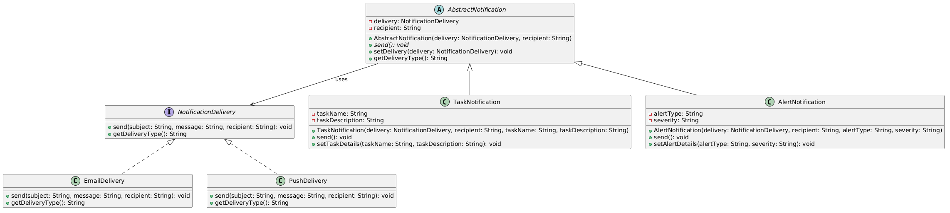
- Implementation → Delivery mechanisms

How It Works
- AbstractNotification holds a reference to NotificationDelivery
- Concrete notifications (TaskNotification, AlertNotification) delegate sending to delivery objects
- Delivery types (EmailDelivery, PushDelivery) implement sending logic

Why Bridge
- Avoids combinational class explosion
- Allows independent extension of:
  - notification types
  - delivery methods

Result
- Runtime switching of delivery channels
- Clean separation of responsibilities

3. Bridge Pattern – Database System

Problem
The system must support multiple databases (MSSQL, PostgreSQL) without rewriting business logic.

Solution
Bridge separates:
- Abstraction → database operations
- Implementation → database drivers
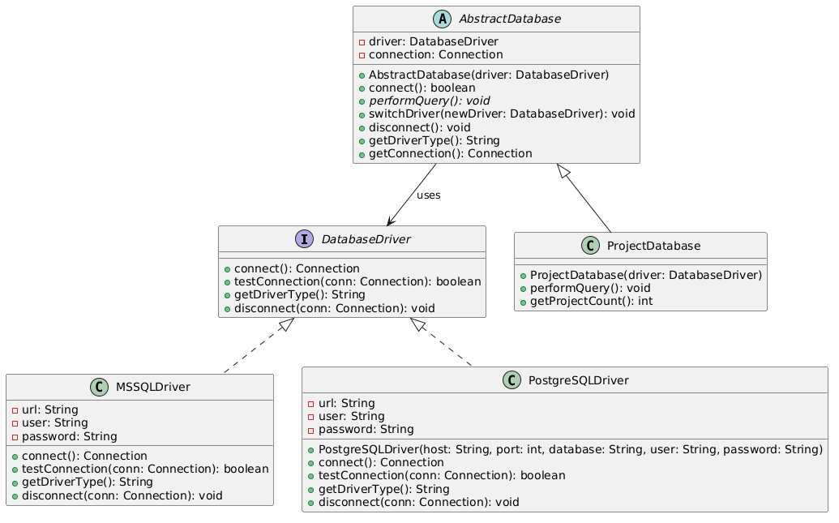

How It Works
- AbstractDatabase uses a DatabaseDriver
- ProjectDatabase defines operations
- Drivers (MSSQLDriver, PostgreSQLDriver) implement connection logic

Why Bridge
- Enables database independence
- Allows switching database drivers at runtime

Result
- Flexible and scalable data layer
- Easy integration of new database systems

4. Adapter Pattern – Report Engine Integration

Problem
External report engines (Jasper, Crystal Reports) have incompatible APIs.

Solution
Adapter converts each engine’s interface into a common interface (ReportFactory).
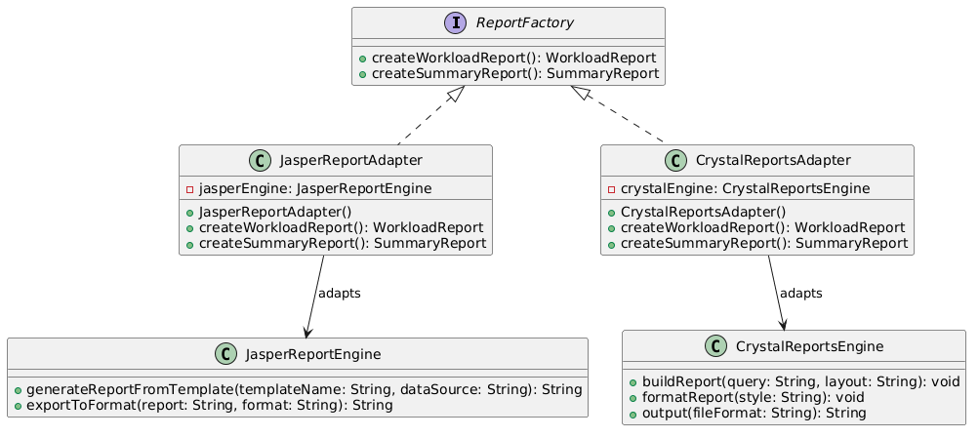

How It Works
- JasperReportAdapter wraps JasperReportEngine
- CrystalReportsAdapter wraps CrystalReportsEngine
- Both implement a unified interface

Why Adapter
- Allows reuse of third-party libraries without modification
- Ensures consistent system interface

Result
- Seamless integration of different reporting tools
- Easy replacement or extension

5. Adapter Pattern – Data Import System

Problem
The system must import data from:
- SAP
- Autodesk
- CSV
Each uses different formats.

Solution
Adapter standardizes data into a unified Project object.

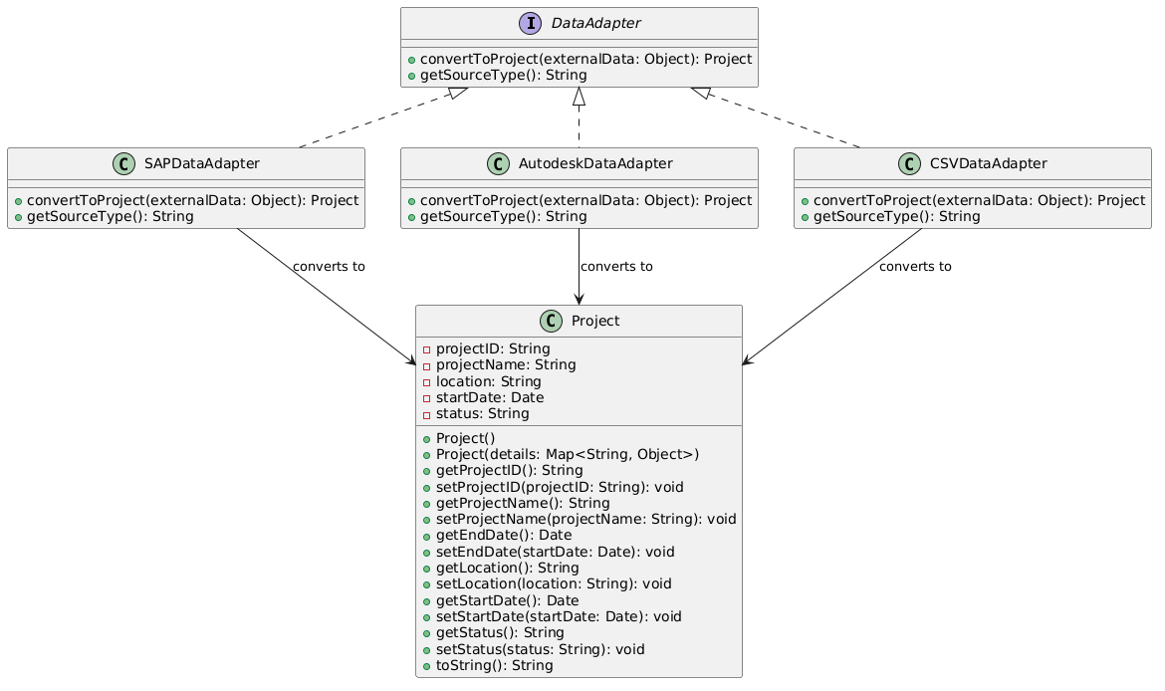

How It Works
- DataAdapter defines conversion interface
- Each adapter converts external data → internal model

Why Adapter
- Decouples external systems from internal logic
- Simplifies integration of new data sources

Result
- Clean data transformation layer
- Improved system interoperability

6. Flyweight Pattern – Resource Management

Problem
Repeated creation of identical objects (employees, materials, equipment) wastes memory.

Solution
Flyweight shares objects using a central factory.
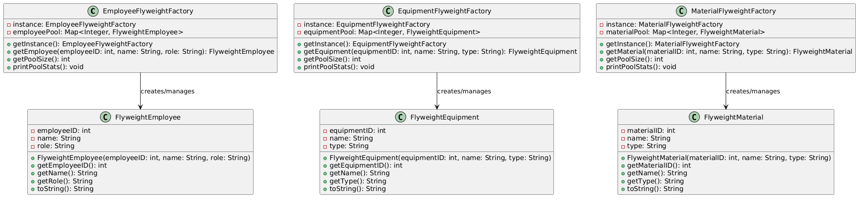

How It Works
- Factories store objects in a map (pool)
- If object exists → reuse
- If not → create and store

Why Flyweight
- Reduces memory usage
- Avoids duplicate objects

Result
- Efficient resource handling
- Improved performance in large-scale systems

7. Decorator Pattern – Task System

Problem
Tasks need dynamic features:
- Priority
- Audit logs
- Restrictions
- Escalation
Inheritance would create too many classes.

Solution
Decorator wraps tasks with additional behavior dynamically.
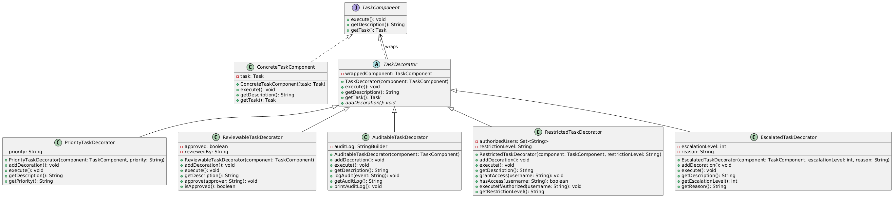

How It Works
- TaskComponent → base interface
- TaskDecorator → wraps component
- Concrete decorators add behavior

Why Decorator
- Adds features at runtime
- Avoids subclass explosion

Result
- Flexible task enhancement system
- Clean and modular code

8. Decorator Pattern – Report Enhancement

Problem
Reports require multiple optional features:
- Watermark
- Encryption
- Signature
- Metadata

Solution
Decorator allows combining features dynamically.
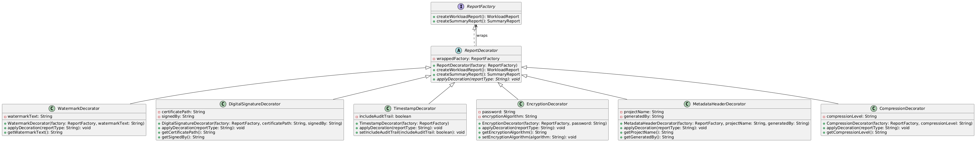

How It Works
- Base report is wrapped with decorators
- Each decorator adds functionality

Why Decorator
- Supports multiple feature combinations
- Keeps report generation clean

Result
- Highly customizable reporting system
- Modular enhancement pipeline

9. Overall Benefits

Architecture
- Loose coupling
- High extensibility
- Clear separation of concerns

Performance
- Reduced memory usage (Flyweight)
- Efficient runtime behavior (Decorator)

Maintainability
- Modular design
- Easy debugging and testing

10. Conclusion
The implementation of structural design patterns in ConstructFlow significantly improves system flexibility, scalability, and maintainability. Each pattern was carefully selected to address real-world challenges in construction management systems.
The combination of Bridge, Adapter, Flyweight, and Decorator patterns results in:
- A robust and extensible architecture
- Efficient resource management
- Flexible feature composition
- Seamless integration with external systems
This demonstrates strong application of software engineering principles and design pattern best practices.

