C-SW311 Software Development Spring 2024

CTRL ALT ELITE:

Omar Wafa (23-101281)

Omar Sharaf (24-101236)

Omar Shafiy (23-201356)

Eiad Essam (23-101108)

Youssef Elsayed (23-101227)

Project: Construct Flow a Contracting Company Information System

**System Vision**

**Problem Description**

Small to medium-sized construction companies frequently struggle with project management due to a reliance on manual and disconnected communication methods like phone calls, emails, and paper forms. This leads to poor coordination between the main office and job sites, delayed progress updates, and inefficient resource allocation. The lack of a centralized, real time source of information results in costly errors, project delays, and budget overruns, ultimately impacting profitability and client satisfaction.

**System Capabilities**

The ConstructFlow system will be a web platform designed to streamline and centralize core project management functions. The new system will be capable of:

* Creating and managing detailed project plans with milestones, task dependencies, and timelines.
* Assigning and tracking the status (like pending, in progress, completed) of individual tasks for site crews via a mobile-friendly interface.
* Managing and monitoring the allocation and usage of key resources, including materials, equipment, and labor.
* Providing a secure, version controlled repository for essential project documents like blueprints, contracts, and permits.
* Facilitating real-time communication through a central announcement board and automated notifications for task assignments and updates.

**Business Benefits**

It is anticipated that the deployment of this new system will provide the following key business benefits to the company:

* Increase operational efficiency by reducing time spent on manual reporting and administrative tasks, allowing teams to focus on core construction work.
* Improve decision-making by providing project managers with a real-time, accurate dashboard of project health, enabling proactive issue resolution.
* Enhance accuracy and accountability through centralized digital records that minimize errors and create a clear audit trail for all tasks and changes.
* Reduce project delays and costs through better resource planning, improved visibility of potential bottlenecks, and faster communication.

**Stakeholder Identification**

Stakeholders are all individuals or groups who have an interest in the successful implementation of the system. To analyze their needs effectively, they can be classified using two dimensions: their location relative to the organization (Internal vs. External) and their level of interaction with the system's daily functions (Operational vs. Executive).

This creates four distinct categories of stakeholders, each with unique perspectives and requirements for the ConstructFlow system. The following table identifies the key stakeholders for this project and describes their specific interests.

|  |  |  |
| --- | --- | --- |
| **Stakeholder Category** | **Stakeholder Role** | **Interest in the System (What matters to them)** |
| **Internal Operational** | **Site Engineer** | As a primary daily user, their interest is in a simple, reliable mobile interface. They need to easily view assigned tasks, submit progress reports with photos from the field, and quickly access up-to-date blueprints or technical documents. Their focus is entirely on **usability and day-to-day operational efficiency**. |
| **Internal Operational** | **Construction Supervisor / Foreman** | Interested in features that simplify team management. They need to see the tasks assigned to their crew, mark them as complete, log work hours, and manage daily resource needs (e.g., requesting materials). Their focus is on **task execution and crew coordination**. |
| **Internal Executive** | **Project Manager** | Does not perform daily tasks in the system but uses its information output for control. They require a high-level dashboard to monitor project timelines, budgets, and resource allocation across multiple projects. Their interest lies in **reporting, risk management, and overall project health visibility** to make timely decisions. |
| **Internal Executive** | **Company Owner / CEO** | Interested in the system's strategic value. They need summary-level reports on overall company performance, project profitability, and key performance indicators (KPIs). Their focus is on **financial outcomes and long-term business strategy**, not project details. |
| **External Operational** | **Subcontractor** | An external party who needs to interact with the system to perform their work. They require limited, secure access to view their specific scope of work, relevant project schedules, and necessary technical documents. Their interest is **access to information that is strictly relevant to their contract**. |
| **External Executive** | **Client or Property Owner** | An external party with a financial interest but no direct interaction with the system's operational functions. They want a high-level, simplified view of project progress, confirmation that major milestones are being met, and a way to see progress photos without needing to contact the project manager. Their focus is on **final outcomes and project transparency**. |

**Agenda A: Interview with Internal Operational Stakeholder**

**Walk me through a typical day managing a construction task.**

→ Reveals workflow sequences for activity diagrams and task dependencies.

**Can you describe your role and typical daily responsibilities on a construction project?**→ Establishes baseline understanding of their work scope to contextualize all subsequent answers.

**Which teams or roles do you interact with most frequently during a project?**  
→ Identifies key collaboration points, critical for designing the communication and task assignment features.

**How do you currently receive new tasks or updates about project changes?**

→ reveals current communication channels (e.g., WhatsApp, paper, email), highlighting inefficiencies the system should replace.

**What tools or systems (digital or manual) do you currently use to manage your work?**→ Uncovers legacy processes and potential integration needs or resistance points.

**Have you ever experienced schedule conflicts (e.g., two tasks assigned at once)? How were they resolved?**→ Identifies need for automated conflict detection in the scheduling module.

**How often do project schedules change? What triggers those changes?**→ Informs need for real-time rescheduling alerts and version control.

**What information do you need to see in a schedule to do your job effectively?**→ Guides UI/UX design of the scheduling dashboard

**How are individual tasks assigned to you or your team today?**→ Reveals current assignment method (verbal, paper, Excel), supports need for digital task assignment.

**How do you track task progress or mark something as “completed”?**→ Highlights gaps in real-time status tracking, a core feature of the task module.

**Do you ever work on tasks from multiple projects simultaneously? How do you manage that?**→ Validates need for multi-project task views and workload balancing.

**What happens when a task is delayed? Who gets notified, and how?**→ Informs automated escalation rules and notification logic.

**Would you find it useful to see task dependencies (e.g., “Task B can’t start until Task A finishes”)?**

→ Tests demand for workflow logic beyond simple to-do lists.

**How do you know what materials, equipment, or labor are available for your tasks?**→ Exposes visibility gaps in resource inventory, justifies real-time resource dashboards.

**Who decides how resources are allocated across projects?**→ Clarifies approval workflows, needed for resource request/approval functionality.

**Do you track resource usage (e.g., how much cement was used)? If so, how?**→ determines if the system needs consumption logging for cost control.

**Would it help to get alerts when a resource is running low?**→ Validates automated reorder/replenishment triggers.

**Have you ever used an outdated document by mistake? What was the consequence?**→ Quantifies risk of poor document control, strengthens business case.

**How do you currently share updates or issues with the project manager?**→ Reveals communication silos, supports need for integrated messaging/boards.

**What types of documents do you create or update regularly?**→ Identifies document types the system must support (e.g., daily logs, inspection reports).

**If you could change one thing about how your team communicates or shares files, what would it be?**→ captures unmet needs in their own words, gold for user-centered design.

**Agenda B: Interview with Internal Executive Stakeholder**

**What are your top 3 business objectives for improving construction project management?**→ Aligns system capabilities with organizational strategy.

**How do you currently measure the success of a construction project?**→ Identifies KPIs (on-time delivery, budget adherence), guides reporting/dashboard design.

**What’s the biggest operational risk you face across projects today?**→ Highlights areas where the system must reduce risk (e.g., delays, cost overruns).

**How many active projects do you typically oversee at once?**→ Determines scale and validates need for portfolio-level views.

**How are high-level project plans created? Who is involved?**→ why: Maps planning workflow, identifies approvers and collaborators for the planning tool.

**How often do projects finish behind schedule? What are the common causes?**→ Quantifies problem severity, builds case for automated scheduling logic.

**Do you adjust resource allocation based on project priority? How?**→ Validates need for priority-based resource leveling in the system.

**What level of detail do you need in schedules to make decisions?**→ Balances executive (summary) vs. operational (granular) views.

**How do you currently monitor task completion across projects?**→ Reveals manual reporting burdens and justifies automated progress tracking.

**Are you able to see resource utilization rates (e.g., % of equipment in use)?**→ Validates need for resource analytics to optimize CAPEX (Capital Expenditure).

**How do cost overruns typically occur? Can they be traced to specific tasks or resources?**→ Links task/resource data to financial outcomes, supports future cost module.

**Do you have standard task templates for common project types (e.g., residential vs. commercial)?**→ informs reusable workflow templates in the task module.

**How important is it to enforce standardized processes across all projects?**→ determines if the system should include workflow enforcement.

**How do you ensure compliance with safety or contractual requirements across sites?**→ May reveal need for compliance checklists or audit trails.

**What reports do you review weekly/monthly? Who creates them?**→ Identifies automated reporting needs to reduce manual effort.

**Have you ever faced legal or financial issues due to document version confusion?**→ Strengthens justification for strict version control and access logs.

**How critical is it to have a single source of truth for all project data?**  
→ validates the core value proposition of the unified platform.

**Do subcontractors currently have access to your planning or document systems?**→ informs external user access controls and collaboration boundaries.

**What’s your expected ROI from this system? (e.g., 10% faster delivery, 15% cost reduction)**→ establishes measurable success criteria for the project.

**Are there any regulatory or industry standards the system must comply with?**→ identifies non-functional requirements (security, auditability).

**What’s your tolerance for system downtime or data loss?**  
→ Defines reliability and backup requirements.

**Would you prefer a cloud-based or on-premise solution? Why?**  
→ Guides deployment architecture decisions.

**If you could only have three features in Phase 1, what would they be?**  
→ Forces prioritization, critical for iterative development.

**Questionnaire for Operational Users**

**Project:** Contracting Company Information System  
**Target Audience:** Site Engineers, Construction Supervisors, Task Coordinators

**Part I: Multiple Choice & Quantitative Questions**

1. **What is your primary role on construction projects?**  
   ☐ Site Engineer  
   ☐ Construction Supervisor  
   ☐ Task Coordinator  
   ☐ Field Crew Lead  
   ☐ Other: _______________
2. **How often do you experience work delays due to unclear task assignments?**  
   ☐ Never  
   ☐ Rarely  
   ☐ Sometimes  
   ☐ Often  
   ☐ Very often
3. **Which method is MOST commonly used to assign tasks to you?**  
   ☐ Verbal instruction  
   ☐ WhatsApp / SMS  
   ☐ Printed work order  
   ☐ Email  
   ☐ Existing software
4. **How often do you stop work because materials or equipment are unavailable?**  
   ☐ Never  
   ☐ Rarely  
   ☐ Weekly  
   ☐ Daily
5. **When a project schedule changes, how quickly are you usually informed?**  
   ☐ Immediately  
   ☐ Within a few hours  
   ☐ By end of day  
   ☐ Next day or later
6. **How many times per week do you need to access blueprints, permits, or work orders?**  
   ☐ 1–2  
   ☐ 3–5  
   ☐ Daily  
   ☐ Multiple times per day
7. **Which document do you access MOST frequently? *(Select one)***  
   ☐ Blueprints / drawings  
   ☐ Work orders  
   ☐ Safety checklists  
   ☐ Material delivery notes  
   ☐ Inspection reports
8. **How comfortable are you using digital tools (e.g., tablets, mobile apps) on-site?**☐ Very comfortable  
   ☐ Somewhat comfortable  
   ☐ Neutral  
   ☐ Prefer paper-based methods

| **Part II: Agreement Scale**  ***(1 = Strongly Disagree → 5 = Strongly Agree)*** |  |  |  |  |  |
| --- | --- | --- | --- | --- | --- |
| Seeing task dependencies (e.g., “Formwork must finish before concrete pour”) would help me avoid delays. | 1 | 2 | 3 | 4 | 5 |
| Real-time alerts about low material or equipment availability would improve my efficiency. | 1 | 2 | 3 | 4 | 5 |
| A single digital place for all documents (blueprints, contracts, permits) would reduce errors. | 1 | 2 | 3 | 4 | 5 |
| Current communication methods (WhatsApp, verbal, paper) cause frequent misunderstandings. | 1 | 2 | 3 | 4 | 5 |
| I spend too much time tracking down the latest version of documents or task updates. | 1 | 2 | 3 | 4 | 5 |

**Part III: Open-Ended Feedback:**

**What is your biggest frustration with current project management processes?**

**__________________________________________________________________________________________________________________________________________________________________________________________________**

**What ONE feature would make your daily work significantly easier?**

**__________________________________________________________________________________________________________________________________________________________________________________________________**

**WorkFlow Documentation**

This workflow shows how field staff and management interact with each other every day in a very important way. It shows how a Site Engineer sends in a progress log, which the system checks and sends to a Project Manager for a review and approval based on a decision.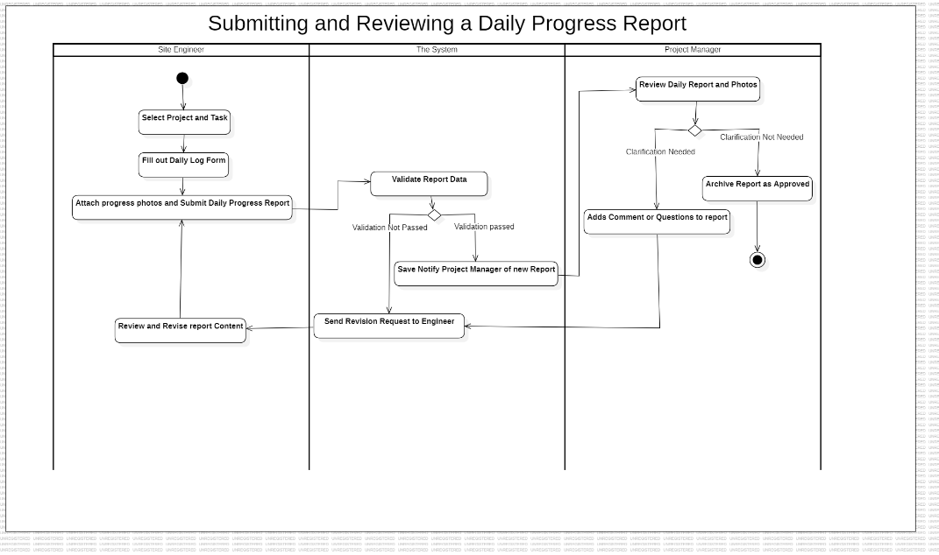

This process shows all the complicated, simultaneous tasks that need to be done to start a new project. It shows a Project Manager setting up schedules, assigning teams, and uploading documents all at once. All of these things must be done before the system can start the project and let the team know. 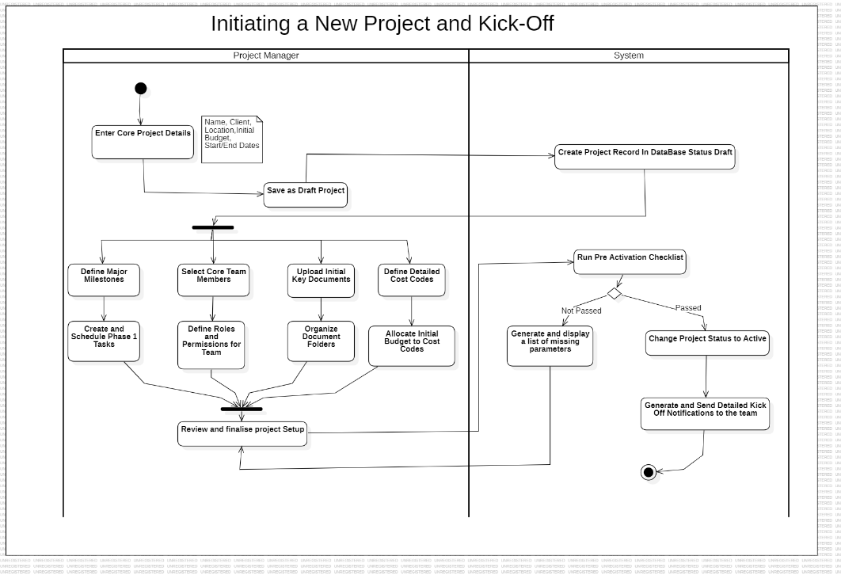

**Jira**

We used Jira to manage the project and keep track of the progress of this deliverable. We started by dividing the project's needs into separate tasks, like the System Vision Document, stakeholder identification, and Activity diagrams. We gave each task to a different team member and used Jira's project board to keep track of its progress from "To Do" to "Done." This method gave us a real-time view of our progress as a group, made sure that each person was responsible for their own work, and helped us work together to meet the submission deadline.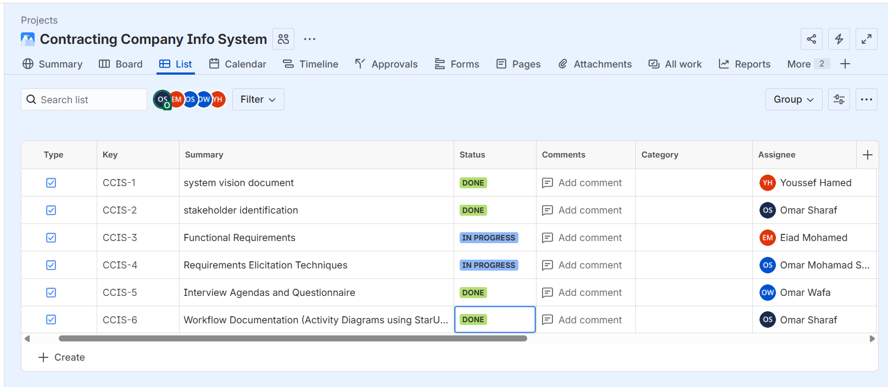

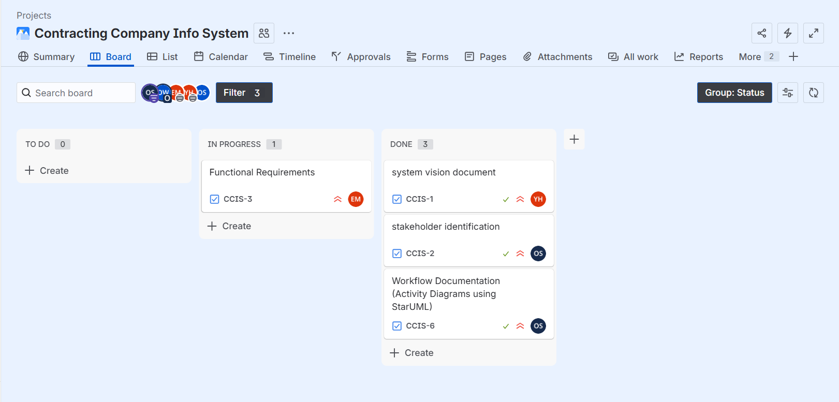

**Github**

**Link:** [**https://github.com/sharaf-omar/Contracting-Company-Info-System**](https://github.com/sharaf-omar/Contracting-Company-Info-System)