Volere System Requirements Specification for ConstructFlow
- The Purpose of the Project
1a. The User Business or Background of the Project Effort
Content
The business domain encompasses small to medium-sized construction contracting companies that manage distributed project sites. Currently, these organizations rely on disjointed, manual communication channels—specifically phone calls, WhatsApp messages, Excel spreadsheets, and physical paper forms—to coordinate between the main office and job sites.
The situation triggering this development effort is the recurring operational inefficiency caused by this fragmentation: delayed progress updates, conflicting resource allocation, and costly errors arising from the use of outdated blueprints ("version confusion"). The ConstructFlow system is intended to centralize these core functions. Users will use the delivered product to create detailed project plans, track task status in real-time via mobile interfaces, manage material inventory, and maintain a secure, version-controlled repository for all project documentation.
Motivation
The project is justified by the critical need to eliminate communication silos and manual data entry errors that directly impact project profitability and timelines. Without this system, the client continues to face financial losses due to schedule delays, material waste, and a lack of real-time visibility into site operations, making effective decision-making impossible.
Considerations
The business problem is serious; the lack of a "single source of truth" creates financial and legal risks (like construction based on obsolete specifications). This project represents a significant business opportunity to modernize operations, potentially reducing administrative overhead by 30%. A key consideration is the environment: the solution must accommodate field staff (Site Engineers and Supervisors) who require mobile-friendly, low-bandwidth access to the system while working on-site.
Form
- This background is supported by the System Vision Document
- the Stakeholder Analysis Matrix (classifying internal vs. external user needs)
- the As-Is vs. To-Be Workflow Diagrams which illustrate the current bottlenecks in daily progress reporting and document management.

1b. Goals of the Project

Content
To streamline construction project management by centralizing communication, task tracking, and resource allocation into a single digital platform accessible by both office and field staff. The goal is to eliminate information silos caused by manual processes (paper, WhatsApp) and ensure all stakeholders work from a "single source of truth."
Motivation
There is a high risk that without this system, the company will continue to suffer from budget overruns and schedule delays due to poor coordination. As the company takes on more concurrent projects, the current manual methods are becoming unsustainable. It is critical to enforce digital accountability to maintain profitability and client trust.

Measurement
The success of ConstructFlow will be measured by the following metrics:
- Service Goal: Reduce the time Site Engineers spend on manual daily reporting by 30% within the first 6 months of operation.
- Revenue/Efficiency Goal: Reduce material waste and unnecessary re-orders by 15% through improved resource tracking and low-stock alerts.
- Quality Goal: Eliminate rework caused by "version confusion" (using outdated blueprints) to 0 incidents by enforcing strict document version control.

Form
- Purpose: To replace error-prone, disconnected communication channels with an integrated project management system.
- Advantage: Project Managers will gain real-time visibility into site progress and risks, while field staff will have immediate access to accurate tasks and documents, significantly reducing operational friction.
- Measurement: Achieving a 10% reduction in overall project completion time and a 15% decrease in administrative costs within one year of deployment.

- The Stakeholders

2a.The Company Owner (Internal Executive):

They are the primary investor in the system. Their focus is on ROI, profitability, and strategic KPIs. They need the system to provide high-level data to ensure the company is meeting its financial goals and maintaining efficiency across all projects.

2b.The Project Manager (Internal Executive):
They are the primary driver for adopting the system within the organization. They need high-level dashboards for timeline, budget, and risk management. If the system does not help them control these factors effectively, the project implementation will fail.
2c. Other Stakeholders

- Site Engineer (Internal Operational): A critical stakeholder who needs mobile access to view tasks and log daily progress/photos directly from the job site.
- Construction Supervisor (Internal Operational): An operational stakeholder who focuses on crew management and material requests, requiring efficient tools to minimize downtime.
- Architect (External Operational): A partner who needs to upload and version-control blueprints and specifications, ensuring the construction team builds from the correct plans can also be referred to as ‘Subcontractor’.
- Subcontractor (External Operational): External entities that need limited access to specific schedules and scopes of work relevant to their contracts.
- Client (External Executive): The property owner who needs a simplified view of progress (photos, milestones) without operational clutter to stay informed on the project's status.

2d. The Hands-On Users of the Product
- Site Engineer (Internal Operational)
  - User Role: Responsible for daily field reporting and task execution.
  - Requirements: Needs mobile access to view tasks and log daily progress/photos.
  - Characteristics: Works primarily on-site, requiring a mobile-friendly interface usable in field conditions.
- Construction Supervisor (Internal Operational)
  - User Role: Responsible for resource coordination and team oversight on the ground.
  - Requirements: Focuses on crew management and material requests.
  - Characteristics: Requires quick, efficient data entry methods to minimize distraction from physical construction work.
- Project Manager (Internal Executive)
  - User Role: Responsible for the overall planning, execution, and monitoring of the project.
  - Requirements: Needs high-level dashboards for timeline, budget, and risk management.
  - Characteristics: Power user requiring analytical tools and desktop/laptop access for detailed planning.
- Company Owner (Internal Executive)
  - User Role: Strategic oversight and financial approval.
  - Requirements: Focuses on ROI, profitability, and strategic KPIs.
  - Characteristics: Requires summary-level reports and executive dashboards rather than granular operational data.
- Subcontractor (External Operational)
  - User Role: Executes specific portions of the work contract.
  - Requirements: Needs limited access to specific schedules and scopes of work.
  - Characteristics: External user with restricted permissions; access must be partitioned to prevent viewing sensitive company data.
- Architect (External Operational)
  - User Role: Design authority and document provider.
  - Requirements: Needs to upload and version-control blueprints and specs.
  - Characteristics: Technical user requiring reliable file transfer capabilities for large documents.
- Client (External Executive)
  - User Role: The project customer monitoring the investment.
  - Requirements: Needs a simplified view of progress (photos, milestones) without operational clutter.
  - Characteristics: Casual user requiring an intuitive, read-only interface requiring zero training.

2e. Personas

Content

Persona 1: Ahmed El-Sayed (The Site Engineer)
- Age: 27
- Job: Site Engineer for ConstructFlow (Internal Operational).
- Location: Lives in Nasr City, Cairo; commutes to various job sites daily.
- Family: Single, lives with parents.
- Hobbies: Plays 5-a-side football on weekends, active on Instagram, follows Premier League.
- Attitude to Technology: Very tech-savvy with mobile devices. He lives on WhatsApp and expects apps to be fast, intuitive, and visually driven. He dislikes carrying a heavy laptop around the site and hates using clunky, slow software that requires a strong internet connection.
- Attitude to Work: He works long hours in the sun and dust. By the end of the day, he is exhausted. He resents spending an extra hour in the site office filling out paper forms or Excel sheets.
- Goal with ConstructFlow: He wants to snap a photo of the progress, tap a few buttons to update the status, and go home. He wants to prove he did his job so he doesn't get blamed for delays.
- Quote: "Just let me do it on my phone. If I have to walk back to the office to log it on a computer, I'll probably forget."

Persona 2: Sarah Hassan (The Project Manager)
- Age: 42
- Job: Senior Project Manager (Internal Executive).
- Location: New Cairo.
- Family: Married with two children in school.
- Hobbies: Reading, organizing family schedules, occasional yoga when she has time.
- Attitude to Technology: Competent but skeptical. She is an expert in Excel and Microsoft Project. She relies on data to defend her decisions to the Company Owner. She is wary of new software that might crash or lose data.
- Attitude to Money: Very budget-conscious. She is responsible for the project's bottom line and hates "surprise" costs from wasted materials.
- Pain Points: She spends 40% of her day on the phone chasing Site Engineers for updates and the other 40% fixing errors in spreadsheets. She is constantly worried about using the wrong version of a blueprint.
- Goal with ConstructFlow: She wants a "Mission Control" dashboard. She needs to see instantly which projects are slipping behind schedule so she can intervene before the Owner notices.
- Quote: "I don't want to call ten people to find out if the cement arrived. I just want to see it on my screen."

Persona 3: Mr. Khalid Osman (The Client)
- Age: 58
- Job: Business Owner (investing in a new commercial building).
- Location: Zamalek, Cairo.
- Family: Married, three adult children.
- Hobbies: Golf, dining out, travelling.
- Attitude to Technology: Uses his iPad for news and email. He does not want to learn complex software. If he has to read a manual to use the system, he won't use it.
- Attitude to Work: He is paying a lot of money for this construction project. He expects transparency and professionalism. He hates visiting the site because of the dust and noise.
- Goal with ConstructFlow: He wants peace of mind. He wants to log in once a week, see a gallery of high-quality photos showing progress, check that the milestones are met, and show the progress to his partners.
- Quote: "Don't show me the plumbing schematics. Just show me that the building is going up on time."

Motivation
By defining Ahmed, Sarah, and Mr. Khalid, we ensure the requirements meet specific needs rather than general ones.

- Ahmed dictates the need for a mobile-first, low-bandwidth interface.
- Sarah dictates the need for robust reporting and version control.
- Mr. Khalid dictates the need for a simplified, read-only client portal.

Form
These personas are documented as One-Page Profiles (as shown above) including a representative photograph. These profiles will be printed on A3 posters and displayed in the development workspace to ensure every design decision is validated against Ahmed, Sarah, and Khalid ("The Persona Test").

2f. Priorities Assigned to Users

Content
User Category | Priority | Rationale for Priority
Site Engineer | KEY USER (High) | They are the primary source of data entry (Daily Logs). If the mobile interface is too difficult for them to use on-site, no data enters the system, rendering the dashboard useless for everyone else.
Project Manager | KEY USER (High) | They orchestrate the entire workflow (Planning, Task Assignment). If the system does not support their complex planning needs, they will revert to Excel, causing the system to fail.
Construction Supervisor | KEY USER (High) | They manage resource requests. Their adoption is essential for the inventory tracking module to function correctly.
Company Owner | Secondary | While they pay for the system, their interaction is limited to viewing summary reports. Their requirements (dashboards) are output-based and less complex to design than the operational inputs.
Architect | Secondary | Their interaction is limited to document uploads. While version control is critical, their user interface requirements are standard and low-risk.
Subcordinator | Secondary | They have a narrow scope of work. They will likely be compelled to use the system by contract, so "delighting" them is less critical than delighting internal staff.
Client | Secondary | They require a simple "read-only" view. While client satisfaction is a business goal, the system's success does not hinge on their daily interaction.

Motivation
The Site Engineer and Project Manager are designated as Key Users because the ConstructFlow system relies entirely on the accuracy and timeliness of data entry.

- In the past, systems failed because field staff found them too slow compared to phone calls. Therefore, requirements regarding mobile usability, speed, and offline capabilities for the Site Engineer take precedence over aesthetic requirements for the Company Owner or Client.
- If there is a conflict between a feature requested by the Client (like "I want to see every single raw material log") and the Project Manager (like "The Client should only see milestones to avoid micromanagement"), the Project Manager's requirement takes precedence to ensure operational smoothness.

Form
This priority ranking has been added to the User Characteristics Spreadsheet (Section 2d) and will guide the UX/UI design phase, ensuring the mobile view for Site Engineers receives the highest allocation of design resources.

2g. User Participation

Content
To ensure the system solves the actual problems of the construction site rather than theoretical ones, specific participation is required from the following user categories:
UserCategory | Required Contribution | Estimated Time Commitment
Project Manager | Business Logic Authority. Must define the exact rules for task dependencies, budget allocation workflows, and approval thresholds. They must participate in User Acceptance Testing (UAT) to verify the dashboard data accuracy. | High: 10 hours total (Requirements workshops + Bi-weekly review sessions).
Site Engineer | Usability Testing (Field Conditions). Must test the mobile interface prototypes to ensure buttons are clickable with gloves and workflows are fast enough for on-site use. Feedback on "Daily Log" entry forms is critical. | Medium: 4 hours total (Interview + 2 Usability Testing sessions).
Construction Supervisor | Workflow Validation. Must verify that the "Resource Request" process matches the reality of how materials are actually requested on a job site to avoid process gaps. | Low: 2 hours total (Review of specific screens).
Company Owner | Strategic Alignment. Must review the final "Executive Dashboard" to ensure the KPIs displayed match financial reporting needs. | Low: 1 hour (Final Milestone Review).

Motivation
In previous attempts to digitize workflows, software failed because it required too many "clicks" for Site Engineers working in harsh environments. Therefore, Site Engineer participation in UI prototyping is mandatory before a single line of code is written for the mobile app. Similarly, Project Managers must validate the data logic to prevent the system from generating misleading budget reports.

Form
These time commitments have been added to the project schedule and communicated to the respective department heads to ensure staff availability.

2h. Maintenance Users and Service Technicians

Content
Role: System Administrator (IT Admin)
- Identity: Internal IT staff or a designated technical lead within the contracting company.
- Responsibilities:
  - Onboarding new employees (creating accounts for Site Engineers/PMs).
  - Managing role-based permissions (ensuring Subcontractors cannot see Budgets).
  - Executing the "Project Archival" use case (as defined in the CRUD analysis) to move completed project data to long-term cold storage.
  - Monitoring server uptime and database backups.

Motivation
While the construction staff focuses on the project, someone must maintain the tool. The System Administrator requires specific "Admin-only" interfaces that allow them to manage users and system health without seeing the business complexity of construction tasks.

Form

- Requirement: The system must provide an Admin Dashboard separate from the Project Management dashboard.
- Requirement: The system must allow the Administrator to reset passwords and force-logout users in case of lost devices (crucial for mobile security).
3. Mandated Constraints
3a. Solution Constraints
Content
- Platform: The solution must be a web-based platform accessible via standard browsers (Chrome, Edge, Safari), with a dedicated or responsive mobile interface for on-site usage.
- Operating Systems: The mobile interface must be fully functional on both Android and iOS devices, as site staff use personal devices.
- Database: The system must use a cloud-hosted relational database (like PostgreSQL or MySQL) to ensure data integrity and accessibility from distributed sites.
- File Formats: The system must support the upload and viewing of PDF, DWG (AutoCAD), and standard image formats (JPG/PNG) without requiring users to install specialized software.

Motivation
The construction industry relies on a mobile workforce using diverse hardware. Mandating a specific OS (like "iOS only") would alienate a significant portion of the Site Engineers and Subcontractors. Cloud hosting is non-negotiable because job sites often lack the infrastructure for on-premise servers.
Form
These constraints are documented in the System Architecture Diagram (Deliverable #3) and the Non-Functional Requirements list.

3b. Implementation Environment of the Current System
Content
- Physical Environment: Construction sites are dusty, bright (outdoor sunlight), and often have unstable internet connectivity.
- Hardware:
  - Site Office: Laptops (Windows 10/11) with intermittent WiFi.
  - Field: Personal Smartphones (mixed Android/iOS) relying on 4G cellular data.
- Existing Software Ecosystem:
  - WhatsApp: Currently used for all informal communication and photo sharing.
  - Microsoft Excel: Used for all budgeting and schedule tracking.
  - Email: Used for formal contract exchange.
Motivation
The new system must coexist with or replace these habits. The mobile interface must be high-contrast (for sunlight visibility) and offline-capable (for connectivity drops). If the system is slower than WhatsApp, users will refuse to adopt it.
Form
- Network Diagram: Showing the connection between HQ, the Cloud Server, and remote Job Sites via cellular networks.
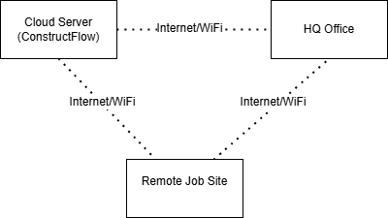

- Device Matrix: Listing supported screen sizes and OS versions.

3c. Partner or Collaborative Applications
Content
- Google Maps / GPS: The system must integrate with map services to tag the geolocation of daily logs and photos.
- Email Servers (SMTP): The system must integrate with standard email providers (Outlook/Gmail) to send formal notifications (like "Kick-off Notification" or "Contract Revision").
Motivation
To leverage existing reliable services rather than building them from scratch. Geotagging is essential to prove that a Site Engineer was physically at the correct location when submitting a report.

3d. Off-the-Shelf Software
Content
- Chart.js / D3.js: For rendering project dashboards and Gantt charts.
- AWS S3 (or similar): For secure document storage (Blob storage).
- Auth0 / Firebase Auth: For managing secure user authentication and role-based access control.
Motivation
To reduce development time and improve security. Building a custom authentication system or file storage solution from scratch is a security risk and a waste of resources.

3e. Anticipated Workplace Environment
Content
- The Site: Users will be standing, wearing safety gear (gloves, helmets), and viewing screens in direct sunlight. One hand may be holding blueprints or tools.
- The Office: Users will be seated at desks with multiple monitors, focused on data-heavy tasks like budgeting.
Motivation
This dictates the UI design:
- Mobile UI: Large buttons, high contrast, simple workflows (few clicks).
- Desktop UI: High information density, keyboard shortcuts, data export capabilities.

3f. Schedule Constraints
Content
- Phase 1 (MVP): Must be ready for pilot testing on one active project within 4 months of project start.
- Full Rollout: Must be deployed to all sites before the start of the next fiscal year (typically January 1st).
Motivation
The company wants to avoid migrating data mid-year. The pilot phase is critical to identify usability issues before a company-wide mandate.

3g. Budget Constraints
Content
- Development Cost: The initial build must stay within the allocated CapEx budget of $50,000 as a rough estimate.
- Operating Cost: Monthly cloud hosting and maintenance fees must not exceed $500/month as a rough estimate.
Motivation
Construction margins are tight. The system must prove its ROI quickly. High recurring costs will lead to the system being abandoned.

3h. Enterprise Constraints
Content
- Data Sovereignty: All project data must be stored on servers located within the country (if local laws mandate it) or compliant with GDPR/local data protection regulations.
- Language: The user interface must support English (for contracts/management) and optionally Arabic (for local field staff coordination), or at least allow for Arabic text entry in notes.
Motivation
Legal compliance and workforce inclusivity. Many skilled construction supervisors may prefer their native language for daily reporting.

4. Naming Conventions and Terminology
4a. Definitions of All Terms, Including Acronyms, Used by Stakeholders Involved in the Project
Acronyms
- PM: Project Manager. The internal executive responsible for the project's success.
- BOQ: Bill of Quantities. A list of materials, parts, and labor (and their costs) included in the construction contract.
- KPI: Key Performance Indicator. Metrics used by the Company Owner to measure success (like Budget Variance, Schedule Adherence).
- DWG: Drawing. A binary file format used for storing two- and three-dimensional design data and metadata (AutoCAD files).
- MVP: Minimum Viable Product. The first version of the system to be released for pilot testing.
Glossary of Terms
Term | Definition
Daily Log | A digital report submitted by the Site Engineer at the end of a shift. It includes hours worked, tasks progressed, material usage, and site photos. This is the primary source of operational data.
Resource | Any physical asset required to complete a task. In ConstructFlow, this specifically refers to Materials (consumables like cement, steel) and Equipment (reusable assets like cranes, trucks). It does not refer to human resources (Labor).
Task | A specific unit of work with a defined start date, end date, dependency, and assigned crew. A task has a lifecycle status:  Pending $→$ In Progress $→$ Completed.
Milestone | A zero-duration task that marks a significant point in the project timeline (like "Foundation Complete"). Used for high-level reporting to the Client.
Cost Code | A unique alphanumeric code used to categorize expenses against the budget (like "MAT-001" for Concrete). All Resource Requests must be tagged with a Cost Code.
Version Confusion | A specific term used by stakeholders to describe the error of construction crews working from an outdated blueprint. The system aims to eliminate this via the Document Control module.
Kick-Off | The formal transition of a project from "Draft" status to "Active" status. This triggers notifications to all assigned stakeholders.
Client | Refers specifically to the Property Owner (External Executive). This is distinct from the "Customer" of the software (who is the Project Manager).
Subcontractor | An external entity contracted to perform specific specialized work (like electrical, plumbing). They have restricted access to the system.
Dashboard | The landing page for the Project Manager, visualizing real-time data regarding budget health, timeline slippage, and pending approvals.
Motivation
Standardizing these terms is crucial to avoid expensive development errors.
- Example: We must distinguish between "Client" (the building owner) and "Customer" (the internal PM buying our software).
- Example: Developers must understand that "Resource" implies inventory tracking logic, whereas "Labor" implies time-logging logic. Confusing these would result in a flawed database design.
Considerations
- The term "Draft" implies a project state where data can be deleted freely. The term "Active" implies a state where data integrity rules apply (no deletion, only archival).
- "Blueprints," "Drawings," and "Plans" are often used interchangeably by staff. In the system, these will all be categorized under "Project Documents."
Form
This glossary is maintained in the central project wiki and is linked directly to the Data Dictionary (Section 7) to ensure database field names match business terminology (like DailyLog table, not DailyReport).

5. Relevant Facts and Assumptions
5a. Relevant Facts
Content
- Internet Connectivity: Construction sites often have unstable internet connections. While 4G/LTE coverage is generally available in urban areas, basements and remote sites may have "dead zones."
- Device Usage: Site Engineers currently use their personal smartphones (a mix of Android and iOS) for work communication via WhatsApp. There is no company policy currently enforcing the use of company-issued tablets.
- Current Workflow: Site staff currently spend approximately 60-90 minutes per day manually transcribing notes and photos into Excel sheets or emails after their shift ends.
- File Sizes: Engineering blueprints (DWG/PDF) can be large (50MB+), while site photos taken on modern phones average 3-5MB each.

Motivation
These facts directly influence technical decisions. The unstable internet dictates an "offline-first" architecture for the mobile app. The reliance on personal devices means the app must be lightweight and support a wide range of OS versions, rather than just the latest ones. Knowing the current time spent on manual reporting (60-90 mins) gives us a baseline to measure the system's success (goal: reduce to 15 mins).

5b. Business Rules
Content
- BR-1 (Approval Hierarchy): A "Daily Log" cannot be finalized until it is reviewed and approved by the Project Manager.
- BR-2 (Budget Cap): A Construction Supervisor cannot approve a "Resource Request" that exceeds the allocated budget for that specific Cost Code without an override from the Project Manager.
- BR-3 (Data Immutability): Once a project is marked as "Archived," no data associated with it (Logs, Tasks, Documents) can be edited or deleted; it becomes read-only for audit purposes.
- BR-4 (Safety Compliance): A Site Engineer cannot submit a Daily Log without checking the mandatory "Site Safety Inspection" box.
Motivation
These rules define the logic that must be hard-coded into the system to ensure compliance and financial control. For example, BR-2 prevents cost overruns at the source, rather than discovering them weeks later in an accounting report.
Form
These rules are derived from decision gateways in our UML Activity Diagrams (like the approval loop in "Update Project Documents") and the state transitions in our UML State Machine Diagrams (like a Project moving from "Active" to "Archived"). See del3_report1 for these models.
5c. Assumptions
Content
- Assumption 1 (Hardware): We assume that the contracting company will not provide ruggedized tablets initially; the system must run on standard consumer-grade smartphones.
  - Risk if false: If the company strictly prohibits BYOD (Bring Your Own Device) for security reasons, the rollout will be delayed until hardware is purchased.
- Assumption 2 (Connectivity): We assume that all sites will have at least intermittent internet access to sync data once per day.
  - Risk if false: If a site is completely offline for weeks, the system's "Real-time Dashboard" value proposition fails.
- Assumption 3 (Digital Literacy): We assume that Construction Supervisors can navigate a touch interface without extensive training (maximum 1 hour).
  - Risk if false: Adoption rates will plummet, requiring a significant budget increase for training.
- Assumption 4 (Legacy Data): We assume that historical data from completed projects (currently in Excel/Paper) will not be migrated to ConstructFlow; the system will start fresh with new projects only.
  - Risk if false: A massive data entry project will be required before launch.
Motivation
Assumption 1 is critical for the UI/UX design (designing for small screens vs. tablets). Assumption 4 is critical for the project schedule; data migration is a complex task that has been explicitly excluded from the current scope. Declaring this now prevents "scope creep" later.
Considerations
We have discussed Assumption 3 (Digital Literacy) with the HR department, who confirmed that most supervisors already use smartphones for personal social media, suggesting a baseline of touch-interface literacy exists.

6. The Scope of the Work
6a. The Current Situation
Content
Currently, project management relies on manual, disconnected processes. A "Business Process Model" of the current situation reveals:
- Reporting: Site Engineers capture photos on their personal phones, send them via WhatsApp to a group chat, and later transcribe notes into an Excel sheet or email at the end of the day.
- Scheduling: The Project Manager maintains a master schedule in Microsoft Project or Excel on a local laptop. Updates are communicated verbally or via email, leading to version discrepancies.
- Resource Management: Supervisors request materials verbally. Inventory levels are checked physically only when shortages occur, causing work stoppages.
- Document Control: Blueprints are printed and carried to the site. Revisions are emailed as PDFs, but field staff often continue working from the old printed set ("Version Confusion").
Motivation
The current manual workflow is fragile and error-prone. Information is trapped in chat logs and local files, making it impossible to generate accurate, real-time reports or audit trails. The new system must digitize these specific bottlenecks to provide value.
Form
- As-Is Activity Diagram: Visualizing the current "Daily Progress Reporting" flow (Site -> WhatsApp -> PM -> Excel)
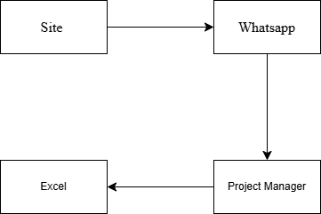

- Swimlane Diagram: Showing the handoffs between the Architect, PM, and Site Engineer for document updates.
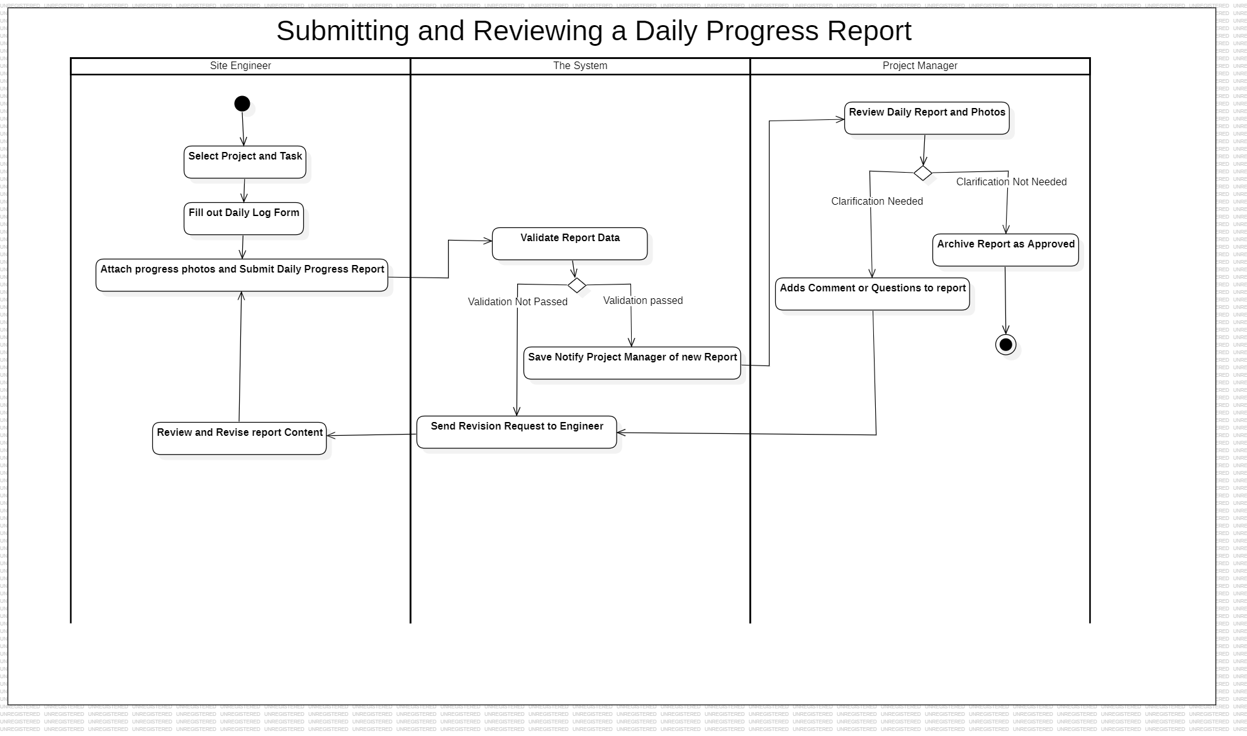
6b. The Context of the Work
Content
The work context diagram defines the ConstructFlow system boundary.
- System Boundary: The ConstructFlow web/mobile platform.
- Adjacent Systems (External):
  - Email Server (SMTP): Used for sending formal notifications/contracts.
  - Google Maps API: Used for geolocation of site activities.
  - Weather Service: (Potential future integration) for weather-dependent scheduling.
- Actors (People/Organizations):
  - Site Engineer: Inputs daily logs, photos.
  - Project Manager: Inputs schedule, budget; receives reports.
  - Architect: Inputs blueprints; receives RFIs (Request for Information).
  - Client: Receives progress summaries.
  - Subcontractor: Inputs specific task status; receives work orders.
Motivation
To clearly define what is inside the automation boundary (like storing photos) and what remains outside (like the actual construction work, the Architect's design process in CAD software).
6c. Work Partitioning
Business Event List
Event | Input / Trigger | Actor(s) | Event Type | Use Case
User wants to create a new project | New contract is won | Project Manager | External | Create New Project
Site Engineer needs to log work | End of shift | Site Engineer | External | Record Daily Log
Manager needs to check project status | Preparing for client meeting | Project Manager, Client | External | View Project Dashboard
New version of a document is available | Architect sends updated file | Architect, Admin Staff | External | Update Project Documents
Manager needs to assess workload | Weekly resource planning | Senior Ops Manager | External | Review Team Workload Report
A task is no longer required | Change in project scope | Project Manager | External | Cancel Task
A project's core details must change | Client requests a new deadline | Project Manager | External | Edit Project Details
A new employee needs system access | HR completes onboarding | Admin Staff | External | Manage Stakeholders
A new material is approved for use | Procurement finalizes supplier | Admin Staff | External | Manage Resource Library
Weekly summary report is due | Friday at 5:00 PM | System | Temporal | Generate Weekly Summary Report
Task deadline is approaching | 24 hours before due date | System | Temporal | Send Task Deadline Reminder
Critical material inventory is low | Daily usage drops stock level | System | State | Generate Material Reorder Alert
Final project task is completed | PM marks last task as "Done" | Project Manager | State | Initiate Project Archival

Use Case Name | Actor(s) | Brief Description
Record Daily Log | Site Engineer, Project Manager | A Site Engineer submits their daily work progress, which is then recorded by the system for the Project Manager to review.
View Project Dashboard | Project Manager | The Project Manager views a consolidated, real-time summary of a project's status, including schedule and budget metrics.
Update Project Documents | Architect, Project Manager, Site Engineer | An authorized user, like an Architect, uploads a new version of a key document, ensuring all team members have access to the latest plans.
Review Team Workload Report | Senior Operations Manager | A manager reviews a system-generated report that shows task assignments across all projects to assess team workload and identify bottlenecks.
Generate Weekly Summary Report | System, Project Manager, Company Owner | The system automatically compiles key project data at the end of the week into a summary report for management review.
Send Task Deadline Reminder | System, Site Engineer | The system automatically sends a notification to a team member when one of their assigned tasks is approaching its due date.
Generate Material Reorder Alert | System, Project Manager | The system automatically notifies the Project Manager when recorded material usage causes stock levels to fall below a predefined threshold.
Initiate Project Archival | Project Manager, System | Upon project completion, a Project Manager triggers the process for the system to close out all active tasks and archive project data.

Motivation
Partitioning the work into business events allows us to analyze each functional area (Reporting, Document Control, Inventory) independently while ensuring they all connect back to the central database.
6d. Specifying a Business Use Case (BUC)
Content
- BUC Specification: "Site Engineer submits daily work log"
  - Trigger: End of shift (or task completion).
  - Preconditions: Engineer is logged in; Project is "Active."
  - Steps:
    - Engineer selects "New Daily Log."
    - System displays active tasks for that site.
    - Engineer enters hours worked per task.
    - Engineer captures/uploads photos.
    - System geotags the submission.
    - Engineer submits.
    - System validates data (completeness check).
    - System updates Task Status to "In Progress" or "Completed."
  - Post-conditions: Log is saved as "Pending Approval"; PM is notified.
Motivation
This detailed specification serves as the blueprint for the developers to build the "Daily Log" module and for testers to verify it works as expected.
Form
- Activity Diagrams:
- System Sequence Diagrams (SSD):
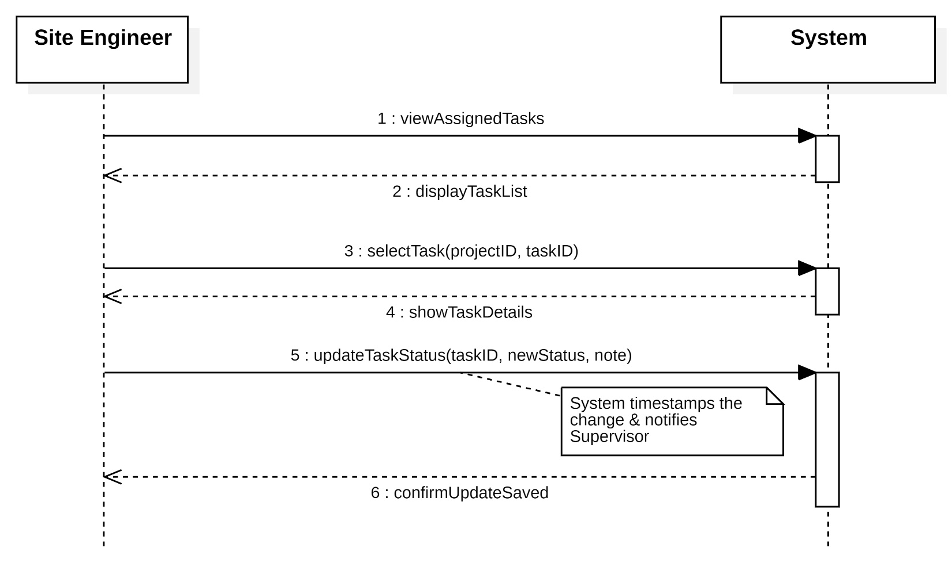
7. Business Data Model and Data Dictionary
7a. Business Data Model
Content
The Business Data Model for ConstructFlow is represented by the UML Domain Class Diagram (refer to Deliverable #3). This model captures the essential subject matter of the construction management domain.
Key Business Objects (Domain Classes) include:
- Project: The central entity aggregating all work. It links to Budgets, Tasks, and Documents.
- Employee: An abstract superclass representing internal staff.
  - SiteEngineer (Subclass): Responsible for creating Daily Logs.
  - ProjectManager (Subclass): Responsible for approval and planning.
- Resource: An abstract superclass for physical assets.
  - Material (Subclass): Consumables (like Cement).
  - Equipment (Subclass): Reusable assets (like Cranes).
- Task: A unit of work with a schedule, linked to a specific Project and assigned to a Site Engineer.
- DailyLog: The record of daily progress, linking a Site Engineer to the Tasks performed on a specific date.
- Document: Represents files (Blueprints, Contracts) managed via version control.
Motivation
To define the static structure of the data the system must store. This model serves as the foundation for the database design and ensures that all functional requirements (like "Track Resource Usage") map to actual data entities (like "Resource" class).
Form
The primary form is the UML Class Diagram developed in the analysis phase. It utilizes generalization/specialization (Inheritance) for Employees and Resources, and Aggregation/Composition to show that Tasks and Budgets are integral parts of a Project.
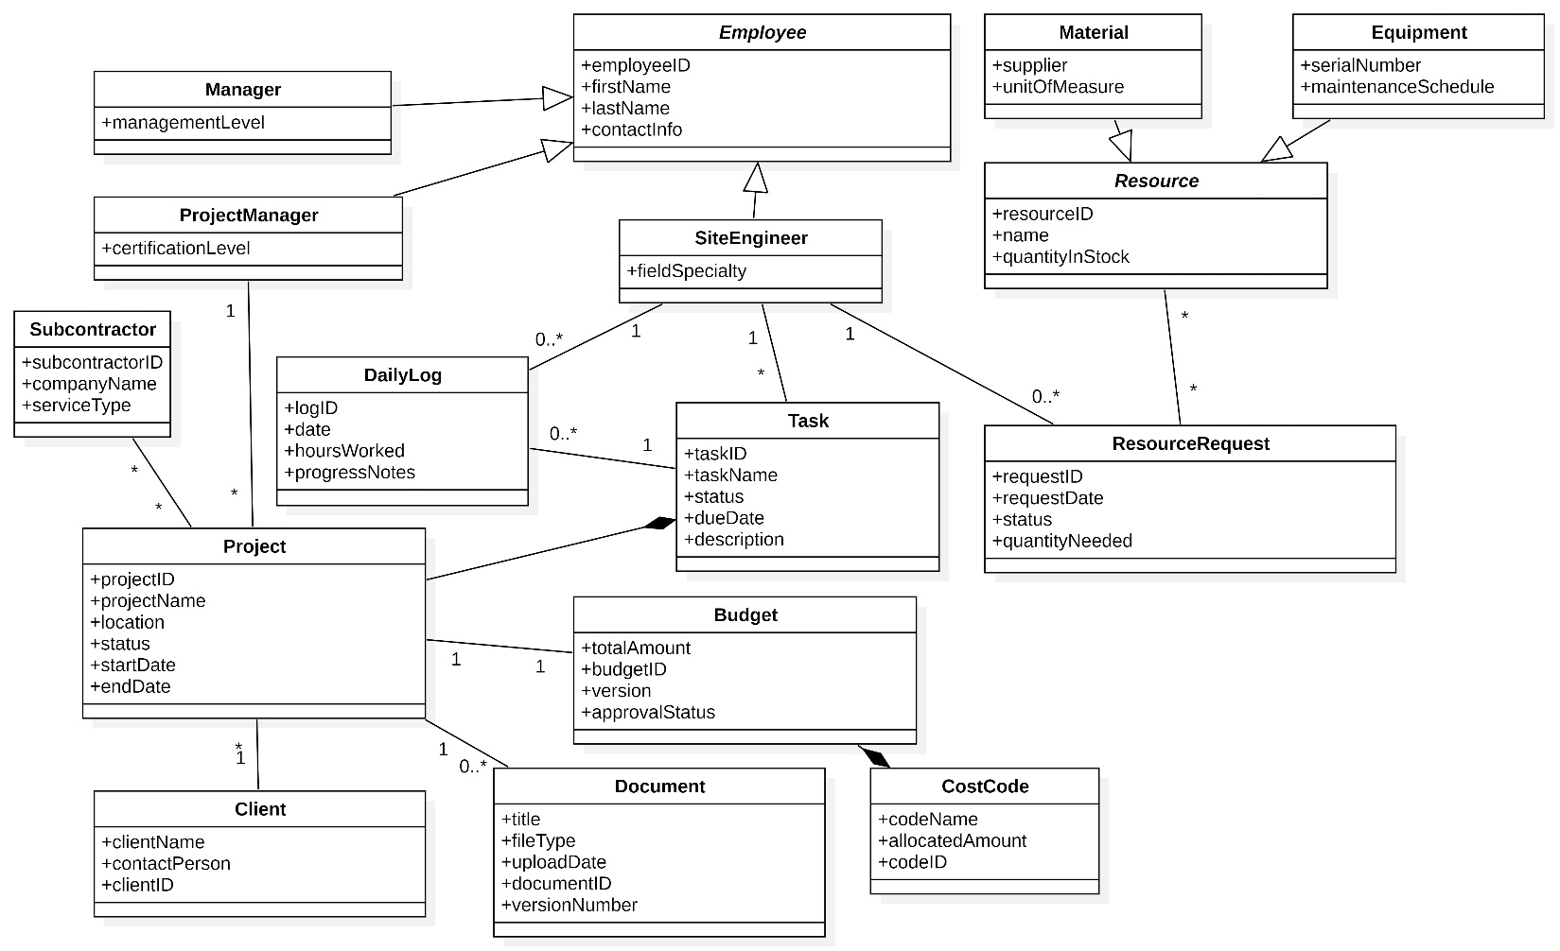
7b. Data Dictionary
Content
The following dictionary defines the classes, attributes, and key data flows identified in the Domain Model and Use Case descriptions.
Class Name | Attributes (Contents)
Employee | employeeID, firstName, lastName, contactInfo
Manager | managementLevel
ProjectManager | certificationLevel
SiteEngineer | fieldSpecialty
Subcontractor | subcontractorID, companyName, serviceType
Project | projectID, projectName, location, status, startDate, endDate
DailyLog | logID, date, hoursWorked, progressNotes
Task | taskID, taskName, status, dueDate, description
Resource | resourceID, name, quantityInStock
Material | supplier, unitOfMeasure
Equipment | serialNumber, maintenanceSchedule
ResourceRequest | requestID, requestDate, status, quantityNeeded
Budget | totalAmount, budgetID, version, approvalStatus
Document | title, fileType, uploadDate, documentID, versionNumber
CostCode | codeName, allocatedAmount, codeID
Client | clientName, contactPerson, clientID

Name | Content | Type
Kick-Off Notification | {Project Name + Start Date + Team Member List + Initial Budget} | Dataflow (Output)
Reorder Alert | {Resource Name + Current Quantity + Reorder Threshold + Supplier Contact} | Dataflow (Output)
projectID | Unique alphanumeric code (like PRJ-2024-001) | Attribute
status (Project) | Enumeration: Draft, Active, On Hold, Completed, Archived | Attribute
status (Task) | Enumeration: Pending, In Progress, Blocked, Completed | Attribute
fileType | Allowable formats: PDF, DWG, JPG, PNG, DOCX | Attribute
Photo | Digital image capturing site progress, geotagged at capture | Attribute
unitOfMeasure | like Liters, Bags, Tons, Hours | Attribute
costCode | Standardized accounting code linking expenses to budget categories | Attribute
Motivation
To provide a precise definition of data elements. For example, defining status as specific enumerations (Draft, Active, etc.) is critical for developers to implement the State Machine logic correctly. Defining Photo as "geotagged" ensures the requirement for location verification is met in the data structure.
Considerations
The definitions here align with the Naming Conventions (Section 4). Specifically, the distinction between "Material" and "Equipment" (subclasses of Resource) is handled via the type attribute or subclass logic in the implementation.

8. The Scope of the Product
8a. Product Boundary
Content
The product boundary is defined by the UML Use Case Diagram (refer to the "Updated UML Use Case Diagram" in Deliverable #3).
The boundary separates the ConstructFlow System (the automated web and mobile platform) from the Actors (human users and external systems).
- Inside the Boundary: All data validation, storage, notification generation, status tracking, and report compilation.
- Outside the Boundary: The physical construction work, the creation of architectural drawings (done in CAD software), and the physical delivery of materials.
Motivation
To clearly delineate responsibility. For example, while the system tracks material usage, the procurement and delivery of materials happen outside the system. The system's responsibility ends at generating the "Reorder Alert."
Form
- UML Use Case Diagram:
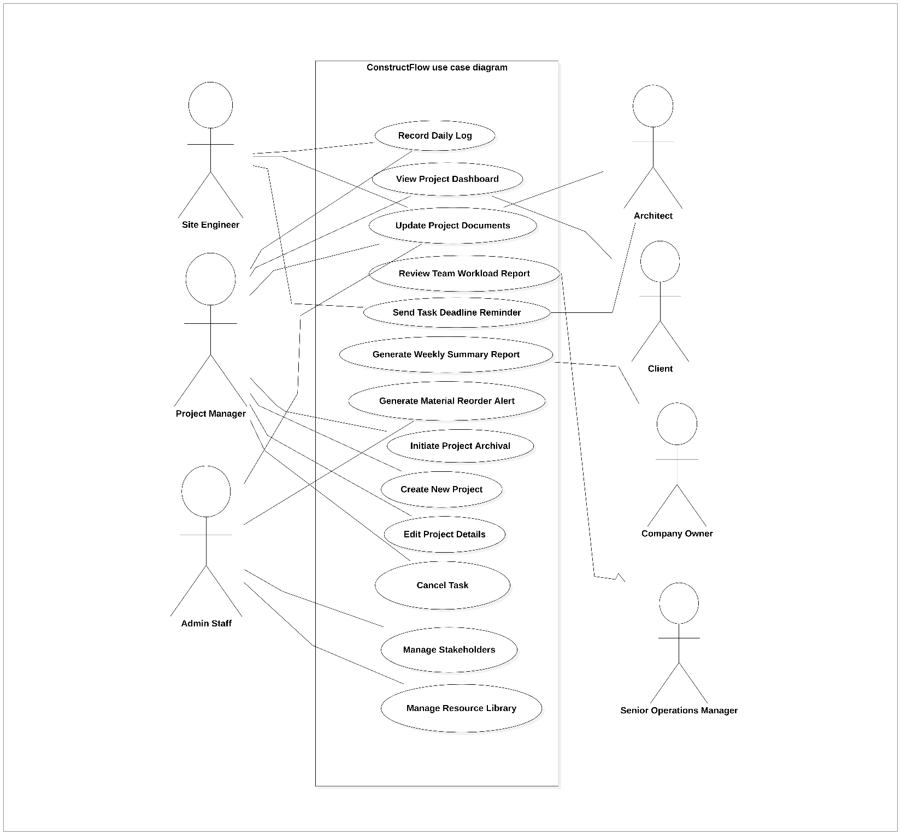

8b. Product Use Case (PUC) Table
Content
The following table summarizes the Product Use Cases (PUCs) derived from the Event Decomposition and CRUD analysis.
PUC No | PUC Name | Actor(s) | Input (I) & Output (O)
PUC-01 | Create New Project | Project Manager | I: Project Name, Budget, Dates, Client Info O: Project ID, Setup Confirmation
PUC-02 | Record Daily Log | Site Engineer | I: Hours worked, Progress %, Site Photos O: Submission Receipt, Notification to PM
PUC-03 | View Project Dashboard | Project Manager, Client | I: Request for Status O: Budget Variance Graphs, Schedule Timeline, Pending Alerts
PUC-04 | Update Project Documents | Architect, PM, Admin Staff | I: File (PDF/DWG), Metadata (Title, Type) O: Version History Update, Team Notification
PUC-05 | Generate Material Reorder Alert | System (State Event) | I: Current Inventory Level (Internal trigger) O: Alert Message to Supervisor/PM
PUC-06 | Generate Weekly Summary Report | System (Temporal Event) | I: Scheduled Time (Friday 5pm) O: PDF Report emailed to Stakeholders
PUC-07 | Send Task Deadline Reminder | System (Temporal Event) | I: Due Date - 24 hours (Internal trigger) O: Reminder Notification to Assignee
PUC-08 | Review Team Workload | Senior Ops Manager | I: Date Range O: Resource Utilization Heatmap
PUC-09 | Initiate Project Archival | Project Manager | I: "Archive" Command O: Data Locked (Read-Only Status), Confirmation
PUC-10 | Edit Project Details | Project Manager | I: Project ID, Updated fields (e.g., end date) O: Update Confirmation
PUC-11 | Cancel Task | Project Manager | I: Task ID, Cancellation reason O: Task Status changed to "Cancelled"
PUC-12 | Manage Stakeholders | Admin Staff | I: User Details, Role Assignment O: User Account Created/Updated Confirmation
PUC-13 | Manage Resource Library | Admin Staff | I: New Equipment/Material Details O: Updated Resource Catalog

8c. Individual Product Use Cases
Content
This section details the specific logic for the most critical Product Use Cases (PUCs) using behavioral models. For each PUC, we provide a brief description, a step-by-step scenario including alternative flows, and a UML Sequence Diagram (in the form of an SSD) to model the interaction.

Example 1: PUC-02 Record Daily Log
- Brief Description: A Site Engineer submits their daily work progress. The system validates the input against business rules before saving the log and notifying the Project Manager for approval.
- Scenario:
  - The Site Engineer selects the "New Daily Log" option on their mobile device.
  - The system retrieves and displays a list of tasks assigned to that Engineer for the current project.
  - The Engineer selects a task, enters the hours worked, writes progress notes, and attaches one or more photos.
  - The Engineer submits the log.
  - The system validates the submitted data (e.g., checks if hoursWorked < 16, photoFileSize < 10MB).
  - Alt Flow: If validation fails, the system displays a specific error message (e.g., "Hours cannot exceed 16 per day") and does not save the log.
  - If validation passes, the system saves the log with a "Pending Approval" status, timestamps the entry, and links it to the task.
  - The system sends an automated notification to the Project Manager indicating a new daily log is ready for review.
- Form: UML Sequence Diagram
Example 2: PUC-04 Update Project Documents
- Brief Description: An authorized user uploads a document to a project. The system ensures file integrity, handles version control, and notifies the team about the update.
- Scenario:
  - An AuthorizedUser (e.g., an Architect) selects a project and initiates a document upload.
  - The user provides the file and metadata (title, description, document type).
  - The system scans the file for integrity and format validation.
  - Alt Flow (File Invalid): If the file is corrupt or in an unsupported format, the system rejects the upload and displays an error message.
  - The system checks if a document with the same title already exists in the project.
  - Alt Flow (New Version): If the document exists, the system increments the version number (e.g., v1.1 -> v1.2) and archives the previous version.
  - Alt Flow (New Document): If the document does not exist, the system creates a new document record and sets the version to 1.0.
  - The system stores the file in the secure repository.
  - The system sends a notification to all relevant team members about the new/updated document.
- Form: UML Sequence Diagram
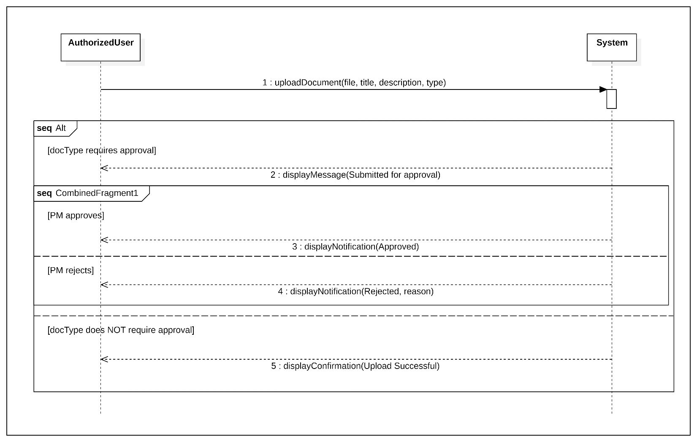
Example 3: PUC-01 Create New Project
- Brief Description: A Project Manager initiates a new project in the system. The system validates the core details before creating the project record and setting its initial "Draft" status.
- Scenario:
  - The ProjectManager selects the "Create New Project" option from their dashboard.
  - The PM fills in a form with required details (Project Name, Client, Budget, Start/End Dates).
  - The PM submits the form.
  - The system validates the data (e.g., checks that the ProjectName is unique and that the endDate is after the startDate).
  - Alt Flow: If validation fails, the system highlights the invalid fields and displays a descriptive error message.
  - If validation passes, the system creates a new project record in the database with a unique projectID and a default status of "Draft."
  - The system redirects the PM to the newly created project's dashboard and displays a success confirmation.
- Form: UML Sequence Diagram
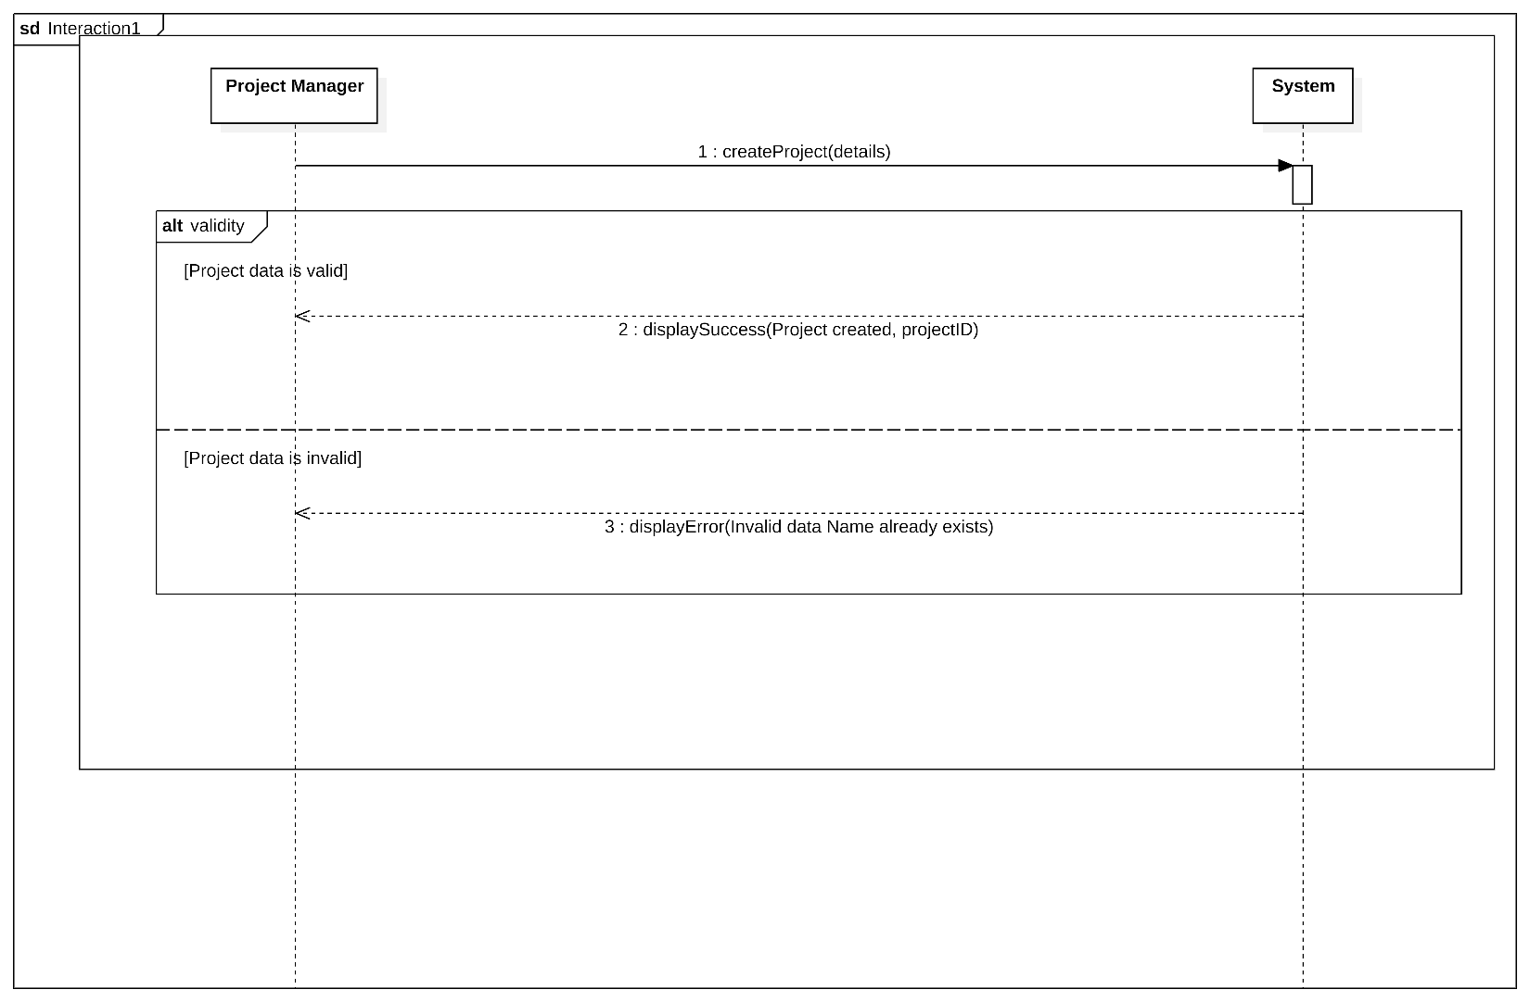
9. Functional Requirements
9a. Functional Requirements
Content
The following is a list of prioritized functional requirements derived from the Product Use Cases (PUC-01 to PUC-13). Each requirement is documented using the Volere "Snow Card" format, including a description, rationale, and a measurable fit criterion.

Requirement #1: Task Status Updates
- Requirement ID: REQ-FUN-001
- Requirement Type: 9 (Functional)
- Event/PUC #: PUC-02 (Record Daily Log)
- Description: The system shall allow Site Engineers to update the status of an assigned task to "In Progress" or "Completed."
- Rationale: To provide real-time visibility of site progress to the Project Manager without phone calls.
- Originator: Ahmed El-Sayed (Site Engineer Persona)
- Fit Criterion: When a Site Engineer changes a task status on the mobile app, the central database must reflect this change within 5 seconds (assuming connectivity). The "Last Updated" timestamp must record the exact time of the action.
- Customer Satisfaction: 5 (Critical)
- Customer Dissatisfaction: 5 (Extremely Displeased if missing)

Requirement #2: Photo Upload Capability
- Requirement ID: REQ-FUN-002
- Requirement Type: 9 (Functional)
- Event/PUC #: PUC-02, PUC-04
- Description: The system shall allow users to capture and upload photos directly from a mobile device camera or gallery as part of a daily log or document update.
- Rationale: Visual evidence is required to verify progress claims and resolve disputes with clients.
- Originator: Project Manager
- Fit Criterion: The system successfully uploads a 5MB JPEG image in under 10 seconds on a 4G connection. The photo is automatically tagged with the current Project ID and Task ID.
- Customer Satisfaction: 4
- Customer Dissatisfaction: 5

Requirement #3: Low Inventory Alert
- Requirement ID: REQ-FUN-003
- Requirement Type: 9 (Functional)
- Event/PUC #: PUC-05
- Description: The system shall automatically generate a notification when the quantity of a specific Material drops below its defined "Reorder Threshold."
- Rationale: To prevent work stoppages caused by running out of critical materials like cement or steel.
- Originator: Construction Supervisor
- Fit Criterion: Simulate an inventory reduction to 1 unit below threshold; the designated Supervisor and PM must receive an in-app notification and email within 1 minute.
- Customer Satisfaction: 4
- Customer Dissatisfaction: 4

Requirement #4: Document Version Control
- Requirement ID: REQ-FUN-004
- Requirement Type: 9 (Functional)
- Event/PUC #: PUC-04
- Description: When a user uploads a file with the same name as an existing document, the system shall automatically increment the version number and archive the previous version.
- Rationale: To ensure the construction team always builds from the latest blueprints, preventing expensive rework.
- Originator: Architect
- Fit Criterion: Upload "Blueprint_A.pdf" twice. The system must display "Version 2.0" as the active file and allow the user to view/download "Version 1.0" from a history tab.
- Customer Satisfaction: 5
- Customer Dissatisfaction: 5

Requirement #5: Create New Project
- Requirement ID: REQ-FUN-005
- Requirement Type: 9 (Functional)
- Event/PUC #: PUC-01
- Description: The system shall allow a Project Manager to create a new project record containing Name, Location, Budget, and Start/End Dates.
- Rationale: This is the foundational step for all other system activities; without a project entity, no tasks or logs can be created.
- Originator: Project Manager
- Fit Criterion: A PM enters valid project details and clicks "Create." The system creates a database record and displays the new project on the Dashboard within 3 seconds.
- Customer Satisfaction: 5
- Customer Dissatisfaction: 5 (System is useless without it)

Requirement #6: Role-Based Access Control
- Requirement ID: REQ-SEC-001
- Requirement Type: 15 (Security)
- Event/PUC #: PUC-12 (Manage Stakeholders)
- Description: The system shall restrict access to data and features based on the user's assigned role.
- Rationale: To prevent unauthorized users (e.g., Subcontractors) from viewing sensitive financial data (e.g., Budgets).
- Originator: Company Owner
- Fit Criterion: Create a user with the "Subcontractor" role. Attempt to access the "Budget" URL directly. The system must return a "403 Forbidden" error and not display any budget information.
- Customer Satisfaction: 5
- Customer Dissatisfaction: 5
Form
These requirements are maintained in a shared Excel Spreadsheet to allow for sorting by Priority and Tracking status during development. This SRS serves as the formal specification for the development team.

10. Look and Feel Requirements
10a. Appearance Requirements
Content
The product shall present a professional, industrial, and high-contrast appearance suitable for use in bright outdoor environments. The interface must utilize the Contracting Company’s corporate color palette (like Safety Yellow, Slate Grey, and White) to reinforce branding.
Motivation
- Brand Identity: To reinforce the company's image as a modern, tech-enabled construction firm.
- Field Usability: High contrast is essential for Site Engineers reading screens in direct sunlight. Dark text on light backgrounds is preferred for textual data to ensure readability outdoors.
Examples
- The mobile application’s buttons must be distinctly colored (Safety Yellow #FFD700) against a white background.
- The dashboard shall use "Traffic Light" color coding (Red, Amber, Green) for project status indicators.
Fit Criterion
- A Site Engineer standing in direct mid-day sunlight must be able to read the text on the "Daily Log" screen without shading the device with their hand.
- The Company Marketing Director shall certify that the hex codes used for headers and logos match the official Brand Guidelines document.
Considerations
Avoid subtle color gradations (like light grey text on white) as they will wash out on mobile screens in the field.

10b. Style Requirements
Content
The product shall project a mood of simplicity, reliability, and uncluttered efficiency. The design style should be "Functional Industrial"—prioritizing information density and clear actions over decorative elements. It should feel like a tool, not a toy.
- Mobile Interface: Must feel tactile and robust, with large touch targets implying ease of use even when dirty or while walking.
- Desktop Interface: Must feel analytical and organized, similar to a spreadsheet but visually cleaner.
Motivation
Construction professionals value speed and reliability. An overly "playful" or "cartoony" interface would undermine the perceived authority of the data. Conversely, a cluttered, complex interface will be rejected by field staff who are used to the simplicity of WhatsApp.
Example
- The product shall appear utilitarian and clean.
- The "Emergency Alert" or "Low Stock" notifications must appear urgent and commanding.
Fit Criterion
- In user testing with 5 Construction Supervisors, 80% shall describe the interface using adjectives like "Clean," "Clear," or "Professional," rather than "Confusing," "Busy," or "Toy-like."
- Navigation menus on the mobile app must require no more than 3 levels of depth to reach any core function.
Considerations
The Client (Property Owner) dashboard needs a slightly different style: it should be more "polished" and "presentation-ready" since it serves as a report card to the investor, whereas the internal tools can be more utilitarian.

11. Usability and Humanity Requirements
11a. Ease of Use Requirements
Content
The system must be highly intuitive, specifically for the Site Engineer (Internal Operational) persona. The design philosophy is "Zero Friction," minimizing the cognitive load required to perform routine tasks while on a busy construction site.
- Efficiency: Common workflows (like submitting a Daily Log) must require the minimum number of taps.
- Error Prevention: The interface must use "smart defaults" (like auto-filling today's date and the current project) to prevent data entry errors.
- Feedback: The system must provide immediate visual confirmation (like a green checkmark or "Saved" toast notification) for every data submission to reassure users working in areas with spotty connectivity.
Motivation
If the Site Engineer finds the mobile app cumbersome or slow, they will revert to using WhatsApp, causing the entire system's data integrity to fail.
Examples
- A Site Engineer shall be able to submit a photo with a caption in less than 3 taps from the home screen.
- The "Create Daily Log" form shall auto-save every 30 seconds to prevent data loss if the battery dies.
Fit Criterion
- Time-to-Task: A Site Engineer with no prior training shall be able to successfully submit a complete Daily Log (with one photo) in under 3 minutes.
- Error Rate: During the first month of operation, the rate of "incomplete logs" (logs submitted with missing mandatory fields) shall be less than 5%.

11b. Personalization and Internationalization Requirements
Content
The system must support the diverse linguistic background of the construction workforce. While the official business language is English, field notes may be entered in Arabic.
- Language: The interface labels should be switchable between English and Arabic to support supervisors who are more comfortable with Arabic technical terms.
- Date/Time: Dates must be displayed in the DD/MM/YYYY format standard for the region.
Motivation
To ensure inclusivity and accurate reporting from all levels of the workforce, regardless of their English fluency.
Examples
- The system allows a user to toggle the UI language from "English" to "Arabic" in the settings menu.
- Field text inputs (like "Progress Notes") accept Arabic characters.
11c. Learning Requirements
Content
The learning curve must be extremely shallow for operational users. The mobile app should require no formal training manuals. Project Managers (Office users) may require a short onboarding session.
Motivation
Construction sites have high turnover and busy schedules; stopping work for a day-long training seminar is not feasible.
Examples
- The mobile app shall use standard icons (Camera, Floppy Disk/Save, Trash Can) that are universally recognized.
- The first time a user logs in, a "coach mark" overlay shall highlight the "New Log" button.
Fit Criterion
- A new Construction Supervisor shall be able to submit a "Resource Request" correctly on their first attempt without asking for help.
- Support tickets related to "How do I do X?" shall constitute less than 10% of total help desk requests.

11d. Understandability and Politeness Requirements
Content
The system must use the terminology of the construction site, not the terminology of software developers.
- Politeness: The system shall not blame the user for errors. Instead of "Invalid Input," it should say "Please enter a number between 1 and 24 hours."
- Terminology: Use "Job Site" instead of "Location Node"; use "Blueprint" instead of "Asset File."
Motivation
To reduce friction and alienation. If the software feels "too technical" or "arrogant," field staff will resist adopting it.

11e. Accessibility Requirements
Content
The mobile interface must be accessible to users with varying levels of visual acuity and those working in difficult physical conditions.
- Visual: Text size must be scalable. High contrast modes should be available for use in bright sunlight.
- Motor: Touch targets (buttons) must be large enough (minimum 44x44 pixels) to be accurately tapped with a thumb while walking or wearing light safety gloves.
Motivation
Construction is a physical job. Users are not sitting in ergonomic chairs; they are often walking, wearing gear, or looking at screens in harsh lighting.
Fit Criterion
- The app passes the WCAG 2.1 Level AA contrast ratio standards for standard text.
- All primary action buttons are at least 10mm x 10mm on the physical screen size.

12. Performance Requirements
12a. Speed and Latency Requirements
Content
The system must be responsive enough to not impede the workflow of field staff who are often multitasking. Speed is critical for adoption.
- Response Time: Mobile interactions (like saving a log, opening a task) must feel instantaneous.
- Sync Speed: Data synchronization between the mobile app and the cloud server should happen in the background without freezing the UI.
Motivation
If the app "hangs" or takes too long to load, Site Engineers will abandon it and return to using WhatsApp.
Examples
- The mobile dashboard shall load within 2 seconds of opening the app.
- Uploading a photo (approx 5MB) shall not block the user interface; the user must be able to continue working while the upload completes in the background.
Fit Criterion
- 95% of all server requests (excluding large file uploads) shall complete in less than 1 second under normal network conditions (4G).
- The application launch time on a mid-range Android device shall not exceed 3 seconds.
12b. Safety-Critical Requirements
Content
The system itself does not directly control machinery, so it is not safety-critical in the traditional sense. However, it manages safety compliance data.
- Safety Logs: The system must prevent the deletion or alteration of safety incident reports once submitted.
Motivation
To protect the company from liability and ensure accurate safety records are maintained for audits.
Examples
- If a user marks a task as "Safety Issue Identified," the system must not allow the task to be marked "Complete" until the issue is resolved.
Fit Criterion
- The system shall strictly enforce the "Safety Check" workflow: A Daily Log cannot be submitted if the mandatory "Safety Inspection" checkbox is unchecked.
12c. Precision or Accuracy Requirements
Content
- Financials: Budget and cost tracking must be precise to 2 decimal places.
- Timestamps: All logs and status changes must be timestamped to the nearest second (UTC).
- Geolocation: GPS coordinates for site check-ins must be accurate to within 50 meters.
Motivation
Financial accuracy is required for billing and payroll. Timestamp accuracy is required for dispute resolution (like proving a delay was not the contractor's fault).
12d. Reliability and Availability Requirements
Content
The system is business-critical during working hours (6:00 AM to 6:00 PM). Downtime during this window directly impacts field operations.
- Availability: 99.9% uptime during business hours.
- Data Integrity: Zero data loss is acceptable.
Motivation
If the system is down, Site Engineers cannot view their tasks, leading to potential work stoppages or incorrect work being performed.
Examples
- Scheduled maintenance shall only occur between 10:00 PM and 4:00 AM local time.
12e. Robustness or Fault-Tolerance Requirements
Content
The mobile application must be Offline-First.
- Offline Mode: If internet connectivity is lost, the app must allow the user to continue creating logs, viewing cached tasks, and taking photos.
- Auto-Sync: Once connectivity is restored, the app must automatically sync locally saved data to the server without user intervention.
Motivation
Construction sites frequently have dead zones (basements, remote areas). The app cannot simply "error out" when the internet drops.
Examples
- If a photo upload fails due to network loss, the app shall retry automatically when the connection returns, rather than deleting the photo.
12f. Capacity Requirements
Content
The system must scale to handle the projected growth of the contracting company.
- Users: Up to 50 concurrent users (Site Engineers + Office Staff).
- Storage: Scalable cloud storage to handle thousands of high-resolution photos and large blueprint files (estimated 1TB growth per year).
Motivation
To ensure the system remains fast and usable as more projects and photos are added over time.
12g. Scalability or Extensibility Requirements
Content
- The database architecture must support adding new modules (like a future "Subcontractor Bidding" portal) without rewriting the core schema.
- The system should be able to handle a 200% increase in user load without significant performance degradation.
12h. Longevity Requirements
Content
- The system is expected to be the primary operational tool for at least 5 years.
- The underlying technology stack (like React Native, Node.js) should be chosen based on long-term support (LTS) availability.

13. Operational and Environmental Requirements
13a. Expected Physical Environment
Content
The system comprises two distinct operating environments:
- The Construction Site (Field Environment): The mobile application will be used outdoors by Site Engineers and Supervisors. Conditions include direct sunlight, dust, dirt, loud noise, and varying weather (heat/rain). The user may be standing, walking, or wearing personal protective equipment (PPE) such as safety gloves and helmets. Connectivity will be intermittent (fluctuating between 4G, 3G, and no signal in basements).
- The Site/Head Office (Office Environment): The web application will be used by Project Managers and Architects in a standard climate-controlled office setting, seated at desks with stable Wi-Fi and large monitors.
Motivation
To ensure the mobile interface remains usable in harsh field conditions where standard "office software" design patterns would fail (like small buttons are impossible to hit while walking; low contrast text is invisible in the sun).
Examples
- The mobile interface shall use high-contrast colors (black text on white/yellow backgrounds) to ensure readability in bright sunlight.
- The mobile app shall provide haptic feedback (vibration) or visual confirmation for actions, as auditory beeps may be inaudible due to construction noise.
- Interactive elements (buttons, inputs) on the mobile app shall have a minimum touch target size of 44x44 pixels to accommodate use with safety gloves.
- The system must support an Offline Mode where data is cached locally on the device until an internet connection is restored.
13b. Requirements for Interfacing with Adjacent Systems
Content
ConstructFlow must interface with specific external services to provide mapping, communication, and storage capabilities.
Examples
- Geolocation Services: The system shall interface with Google Maps API (or equivalent) to validate the GPS coordinates of Site Engineers when they clock in or submit daily logs.
- Email Services: The system shall interface with standard SMTP servers (like Outlook/Gmail) to send formal notifications, contracts, and weekly reports to external stakeholders.
- Cloud Storage: The system shall interface with a cloud blob storage provider (like AWS S3 or Azure Blob Storage) to securely store and retrieve large blueprint files (PDF/DWG) and site photos.
Fit Criterion
- Geolocation: The system must capture latitude/longitude with an accuracy of within 50 meters.
- Storage: The interface must support the upload of files up to 100MB per document.
- Protocol: All external interfaces must communicate via HTTPS using RESTful APIs with JSON data formatting.
13c. Productization Requirements
Content
The product is a SaaS (Software as a Service) platform consisting of a responsive web application and a downloadable mobile application.
Examples
- Web Application: Shall require no installation on client machines; it must run entirely within a standard web browser (Chrome, Edge, Safari).
- Mobile Application: Shall be distributed via the Google Play Store and Apple App Store. It must be packaged as an APK/IPA file that meets the store guidelines.
- Updates: Mobile updates should be pushed automatically via the app stores without requiring the user to manually uninstall/reinstall the app.
Motivation
To minimize the burden on the company's limited IT resources. Field staff should be able to "self-service" the installation by simply downloading the app from their phone's store.
13d. Release Requirements
Content
The system will follow an Agile release cycle with frequent, incremental updates to functionality.
Examples
- Release Cycle: Minor bug fixes and performance improvements shall be released bi-weekly. New major features shall be released quarterly.
- Downtime: Scheduled maintenance/deployments must occur outside of core site operating hours (preferably between 10:00 PM and 4:00 AM local time).
- Backward Compatibility: Mobile app updates must remain compatible with the server API for at least 3 versions to account for users who do not update their apps immediately.
Fit Criterion
- The system shall support "Hotfix" deployments that can be applied to the server without taking the system offline for more than 5 minutes.

14. Maintainability and Support Requirements
14a. Maintenance Requirements
Content
The system shall be designed to allow non-technical administrators (like the Office Manager or IT Admin) to configure core business parameters without requiring code changes or developer intervention.
Motivation
Construction projects are dynamic; cost codes, material lists, and user roles change frequently. Reliance on external developers for minor configuration changes would cause unacceptable operational delays and costs.
Examples
- Configurability: An Administrator shall be able to add, edit, or disable "Material Types" and "Cost Codes" in the system within 10 minutes.
- Bug Fixes: Critical software bugs (preventing login or data submission) must be resolvable via a server-side patch within 4 hours of reporting.
- Updates: Mobile app updates (patches) must be deployable to app stores without requiring a full database migration.
Considerations
The database schema should use lookup tables for dropdown menu items (like "Unit of Measure" or "Task Status") rather than hard-coding values, ensuring they can be updated dynamically.
14b. Supportability Requirements
Content
The system must enable "Self-Service" support for common issues to minimize the burden on the central office staff. Since Site Engineers work remote hours, they cannot always rely on an IT helpdesk being open.
Motivation
To ensure continuity of work on-site. If a Site Engineer forgets their password at 6:00 AM, they must be able to reset it immediately to submit their morning attendance/log.
Examples
- Self-Service Reset: The system shall provide an automated "Forgot Password" workflow via email/SMS, allowing users to regain access within 5 minutes without contacting support.
- In-App Diagnostics: The mobile app shall include a "Report Issue" button that automatically attaches device logs and screenshots to a support email.
- Help Resources: The system shall include embedded "Tooltips" or a "Help" section with FAQs about how to upload photos or sync data.
Considerations
Since the users are distributed geographically, remote troubleshooting capabilities (like an Admin viewing the "Last Sync Time" of a specific user) are essential.
14c. Adaptability Requirements
Content
The system must be platform-agnostic regarding consumer hardware. It must adapt to the various devices and operating systems currently owned by the staff (BYOD - Bring Your Own Device).
Motivation
To maximize adoption rates and minimize hardware procurement costs. We cannot force every Site Engineer to buy the latest iPhone; the system must work on what they currently have.
Examples
- Mobile OS: The mobile application must run effectively on Android 10.0+ and iOS 15.0+.
- Web Browsers: The web portal must be fully functional on the latest stable versions of Google Chrome, Microsoft Edge, and Safari.
- Screen Sizes: The web interface must be responsive, adapting its layout for laptop screens (1366x768) up to large desktop monitors (1920x1080).
Fit Criterion
- Portability Test: The application shall be successfully installed and execute all core test cases on a Samsung A-series device (mid-range Android), an iPhone 11 (older iOS), and a Windows 11 laptop using Edge.
- Migration: In the event of switching cloud providers (like AWS to Azure), the database structure shall use standard SQL compatible with PostgreSQL to ensure migration can occur within 5 business days.

15. Security Requirements
15a. Access Requirements
Content
The system shall implement strict Role-Based Access Control (RBAC). Access to specific system functions and data sets must be determined by the user's assigned role (like Project Manager, Site Engineer, Subcontractor).
- Granularity: Access rights must be granular enough to restrict data not just by module (like "Budgeting") but by specific project assignment (like "User can only see Project A").
Motivation
To prevent unauthorized personnel from viewing sensitive financial data (Project Budgets) or external parties (Subcontractors) from viewing internal company communications.
Examples
- Subcontractors shall only be able to view the specific Tasks and Documents explicitly assigned to them; they must not see the master schedule or budget.
- Site Engineers shall have "Write" access to Daily Logs but "Read-Only" access to the Project Budget.
- Clients (Property Owners) shall only have access to the designated "Client View" dashboard and must not be able to edit any project data.
Fit Criterion
- Test Case: Create a user with the "Subcontractor" role. Attempt to access the "Budget" URL directly. The system must return a "403 Forbidden" error.
- Test Case: Assign a Site Engineer to "Project A." Verify they cannot view "Project B" in their dashboard list.
15b. Integrity Requirements
Content
The system must ensure that stored data accurately reflects the input and cannot be corrupted by concurrent updates or system failures. Crucially, once data is finalized (like an approved Daily Log), it must become immutable to serve as a legal record.
Motivation
Construction projects often involve legal disputes regarding timelines and work completed. The system data must be robust enough to serve as evidence in a court of law. If the data lacks integrity, the company loses its liability protection.
Examples
- Concurrency: If two Site Engineers try to update the same Task status simultaneously, the system must lock the record to prevent data overwrites (Optimistic Locking).
- Immutability: Once a Project Manager changes a project status to "Archived," all associated data (logs, photos, chats) must become Read-Only and cannot be modified or deleted by any user level.
Considerations
Consider the "Offline Mode" on mobile devices. When connectivity is restored, the system must intelligently handle data sync conflicts (like server data usually takes precedence over cached mobile data).
15c. Privacy Requirements
Content
The system must protect the Personally Identifiable Information (PII) of employees and clients. Only data strictly necessary for construction operations should be visible to general users.
Motivation
To comply with data protection regulations and maintain trust. A Subcontractor should not be able to see the home address or salary details of a Site Engineer.
Examples
- Data Minimization: The "Contact Info" field for Client profiles shall be visible only to Project Managers and Company Owners. Site Engineers shall only see the Client's name.
- Password Storage: All user passwords must be salted and hashed (using standards like bcrypt) before storage in the database. Passwords must never be stored in plain text.
15d. Audit Requirements
Content
The system must maintain a comprehensive, immutable Audit Log of all significant actions taken within the system. This log must record Who performed the action, What was changed (including old and new values), and When (timestamp).
Motivation
To provide accountability. If a critical task deadline is deleted or a budget number is changed, management must be able to trace exactly who made the change and when. This is essential for resolving disputes about "who caused the delay."
Fit Criterion
- Test Case: A user modifies the "Due Date" of a Task. The system administrator views the Audit Log and verifies a new entry exists: User: [Name], Action: Update Task [ID], Field: DueDate, Old: [Date1], New: [Date2], Time: [Timestamp].
15e. Immunity Requirements
Content
The system must protect itself against common web-based attacks and malicious file uploads. Since the system allows users to upload documents (Blueprints, Photos), this is a primary vector for infection.
Motivation
To prevent the system from becoming a host for malware that could infect the company's internal network or client devices downloading infected blueprints.
Examples
- Malware Scanning: All files uploaded to the system (PDFs, DWGs, JPGs) must be automatically scanned for viruses and malware before being stored in the cloud repository.
- Input Sanitization: The system must sanitize all text inputs (like Daily Log notes) to prevent SQL Injection and Cross-Site Scripting (XSS) attacks.
Fit Criterion
- Test Case: Attempt to upload a known (safe) test virus file (EICAR test file). The system must reject the upload and display a security warning.

16. Cultural Requirements
16a. Cultural Requirements
Content
- Language Support: The system must support Right-to-Left (RTL) layout and Arabic text input. While contracts are often in English, field notes and daily logs entered by Supervisors are likely to be in Arabic.
- Calendar Configuration: The project scheduling module must recognize the local work week (typically Sunday to Thursday or Saturday to Thursday) and allow for the configuration of religious holidays (like Eid al-Fitr, Eid al-Adha) which change dates annually based on the lunar calendar.
- Work Hours: During the month of Ramadan, the system should support adjusted "Site Working Hours" (like shifting shifts earlier) to ensure attendance tracking remains accurate.
Motivation
Construction sites rely heavily on local labor and supervision. If the software forces a strict Western calendar or English-only interface on field staff, it will be perceived as a tool for "upper management only" and will be ignored by the people doing the actual work.
Examples
- The date picker must highlight Fridays as the standard non-working day (weekend).
- The "Language" toggle must instantly mirror the UI layout (RTL) without breaking the design.
Considerations
Consider the varying literacy levels regarding technical English vs. technical Arabic on-site. Icons should be used heavily to bridge language gaps.

17. Legal Requirements
17a. Compliance Requirements
Content
The system must comply with local Data Protection Laws regarding the storage of employee personal data (National IDs, phone numbers, photos) and Construction Liability Laws.
Motivation
To protect the contracting company from lawsuits related to data privacy breaches or disputes over construction defects where historical records are required as evidence.
Examples
- Data Retention: All "Daily Logs" and "Safety Incident Reports" must be retained in the system for a minimum of 10 years following project completion, as per standard Decennial Liability laws in construction.
- Privacy: Employee salary data (if included in the Budget module) must be encrypted and accessible only to authorized HR/Finance roles.
Fit Criterion
- The Company Legal Advisor must sign off that the "Data Archival Policy" meets the statutory retention period.
- A penetration test must confirm that personal data cannot be scraped by unauthorized users.
17b. Standards Requirements
Content
The system should align with ISO 19650 concepts regarding the organization and digitization of information about buildings (BIM/Document management), specifically regarding file naming conventions and version control.
Motivation
To ensure that the documents stored in ConstructFlow are organized in a way that is compatible with broader industry standards, making it easier to collaborate with external Architects and Engineering firms.
Example
- When a document is uploaded, the system shall prompt the user to tag it with standard metadata (Discipline, Zone, Level, Type) to facilitate standardized searching.

18. Open Issues
Content
This section lists critical uncertainties that need resolution before the final system architecture can be frozen.
Issue # | Summary of Issue | Stakeholders Involved | Affected Requirements | Action / Resolution Strategy
OI-01 | BYOD Security Policy: Can we legally mandate Site Engineers to install a company tracking app (GPS) on their personal phones? | HR, Legal, Site Engineers | 13a (Physical Environment), 15a (Access) | Action: HR to draft a "Bring Your Own Device" policy. Contingency: Company purchases tablets if legal advise is negative.
OI-02 | Legacy Data Migration: The client has 5 years of historical project data in Excel. Do they need this imported into ConstructFlow? | Project Manager, Data Entry Team | 22a (Migration Requirements) | Action: Meeting with PM to decide if historical data is needed for analytics or if we start fresh. Current assumption: Start fresh.
OI-03 | Integration with Accounting: Does ConstructFlow need to push cost data to the company's existing accounting software (like QuickBooks/Sage)? | Finance Manager, Developer | 6b (Context - Adjacent Systems) | Action: Technical feasibility study of the accounting software's API. Currently listed as "Out of Scope" for Phase 1.
OI-04 | Offline Storage Limits: How much data can we cache on a user's phone? Cheap phones have limited storage. | Lead Developer | 12e (Robustness) | Action: Developer to benchmark storage usage. We may need to implement a "purge old logs" feature on the mobile app.
Motivation
To prevent "analysis paralysis" or scope creep later in the project. By listing these issues now, we acknowledge they are unsolved risks that require specific management attention.
Considerations
Issue OI-01 (BYOD) is a potential showstopper. If Site Engineers refuse to use personal phones for work due to privacy concerns, the hardware budget will triple instantly to purchase company devices. This needs immediate resolution.

Sections 19-27: Project Issues

19. Off-the-Shelf Solutions
This section examines available commercial solutions and evaluates their applicability to the ConstructFlow requirements. Based on the existing wireframe implementation and domain analysis, this section focuses on identifying potential shortcuts that could reduce development time while meeting stakeholder needs.

19a. Ready-Made Products
Construction Management Software Solutions
- Procore
  - Applicability: 85% match to ConstructFlow requirements
  - Strengths: Strong mobile interface, document management, real-time dashboard with metrics
  - Limitations: Over-engineered for SMB contractors, expensive ($300-1000/month)
  - Cost: $300-1,000/month per user
  - Integration: API available but requires extensive customization
  - Timeline to Implement: 3-6 months for full rollout
  - Relevance: Procore’s real-time dashboard and project metrics closely match our Dashboard component functionality
- CoConstruct
  - Applicability: 70% match to requirements
  - Strengths: Good for residential construction, integrates with accounting, task management
  - Limitations: Limited offline capabilities, US-focused features
  - Cost: $149-249/month per user
  - Integration: Limited API access
  - Timeline to Implement: 2-4 months
  - Relevance: Task management features align with our TaskManager component structure
- Buildertrend
  - Applicability: 60% match to requirements
  - Strengths: User-friendly interface, good scheduling features, document management
  - Limitations: Weak inventory management, poor Arabic language support
  - Cost: $99-299/month per user
  - Integration: Basic third-party integrations
  - Timeline to Implement: 2-3 months
  - Relevance: Document management features match our DocumentManagement component
React Component Libraries and UI Frameworks
- React-Admin
  - Applicability: 40% match to requirements
  - Strengths: Excellent React dashboard components, data management, responsive design
  - Limitations: Not construction-specific, requires significant customization
  - Cost: Free (open source)
  - Integration: Excellent API compatibility
  - Timeline to Implement: 1-2 months for dashboard components
  - Relevance: Could accelerate Dashboard and ProjectsSection development
- Ant Design Pro
  - Applicability: 35% match to requirements
  - Strengths: Professional dashboard templates, table components, form handling
  - Limitations: Not mobile-optimized for field workers
  - Cost: Free (open source)
  - Integration: Good React compatibility
  - Timeline to Implement: 2-3 months
  - Relevance: Could enhance our sidebar and modal components
Recommendation: The existing Next.js implementation with custom React components provides superior control and matches the specific Egyptian construction industry requirements. While React-Admin could accelerate development, the current custom implementation better serves the offline-first mobile requirements and Arabic language support needs.

19b. Reusable Components
Frontend Components (Already Implemented) - UI Library: Radix UI components (@radix-ui/react-* packages) for accessible, customizable interfaces - Chart Libraries: Recharts for project visualization dashboards - Form Management: React Hook Form with @hookform/resolvers for efficient form validation - State Management: Context API with AppProvider for global state management - Styling: TailwindCSS with custom design system for consistent styling
Backend Infrastructure (Planned) - Authentication Service: NextAuth.js or Supabase Auth for secure user management - Database: PostgreSQL with Prisma ORM for type-safe database operations - File Storage: AWS S3 for blueprint and photo storage with version control - Real-time Updates: Supabase real-time or Pusher for live dashboard updates - Push Notifications: Firebase Cloud Messaging for mobile alerts
Business Logic Libraries - PDF Processing: PDF.js for blueprint viewing in browser - Image Processing: Sharp for photo compression and optimization - Geolocation Services: Google Maps API for site location tagging - Email Services: Resend or AWS SES for automated notifications
Mobile Development Tools - Progressive Web App: Next.js PWA capabilities for mobile-first experience - Offline Support: Service Worker with Workbox for offline data synchronization - Camera Integration: HTML5 Camera API for direct photo capture - File Management: File System Access API for document handling

19c. Products That Can Be Copied
Open Source Construction Management Tools
- Taiga.io (Project Management)
  - Copyable Elements: Sprint planning interface, task status tracking logic, project timeline visualization
  - Modification Required: UI redesign for mobile-first, removal of agile-specific features
  - License: MPL 2.0 (compatible with commercial use)
  - Time Savings: 2-3 months on TaskManager and ProjectTimeline components
  - Relevance: Our TaskManager component could benefit from Taiga’s task dependency visualization
- OpenProject (Resource Management)
  - Copyable Elements: Resource allocation algorithms, capacity planning logic, resource status tracking
  - Modification Required: Adaptation for construction materials vs. human resources
  - License: GPL v3 (requires open source compliance)
  - Time Savings: 1-2 months on ResourceManagement component
  - Relevance: ResourceStatus component could leverage OpenProject’s allocation algorithms
- Kanboard (Simple Task Tracking)
  - Copyable Elements: Basic kanban board implementation, card management, drag-and-drop functionality
  - Modification Required: Mobile optimization, construction-specific status workflows
  - License: MIT (commercial use allowed)
  - Time Savings: 1-2 months on task overview interfaces
  - Relevance: Task overview components could adopt Kanboard’s simple card interface
React Dashboard Patterns - Modern Admin Dashboards: Standard patterns for KPI cards, real-time metrics, alert systems - Construction-Specific UI: Common patterns for project timelines, resource utilization, document galleries - Mobile-First Patterns: Efficient mobile data entry, offline sync indicators, camera integration
Recommendation: Selective copying of UI patterns and business logic from open-source tools can accelerate development, particularly for complex dashboard visualizations. The existing React component structure provides a solid foundation for incorporating proven patterns.

20. New Problems

20a. Effects on the Current Environment
Communication Workflow Changes - Current State: WhatsApp groups used for informal communication, Excel spreadsheets for tracking - New Impact: ConstructFlow will centralize communication, potentially reducing informal information sharing - Concern: Site Engineers may resist abandoning established WhatsApp workflows - Mitigation: Gradual transition with parallel WhatsApp usage during pilot phase - Technical Consideration: The AnnouncementBoard component provides a formal replacement for group messaging
Data Security and Access Control - New Risk: All project data centralized in one system creates a single point of failure - Impact: System downtime will halt all project communication (currently diversified across multiple channels) - Dependency: Reliable internet connectivity becomes critical for site operations - Backup Plan: Maintain WhatsApp as backup communication channel for emergencies - Implementation: The React context-based state management requires careful backup and sync strategies
Role and Responsibility Changes - Project Manager: Shift from reactive (answering phone calls) to proactive (monitoring Dashboard component) - Site Engineers: Increased accountability through photo evidence and digital daily reports - Construction Supervisors: More rigorous material request documentation vs. verbal approvals - Impact: The existing User type system and role-based component visibility will need enhancement

20b. Effects on the Installed Systems
Frontend Architecture Changes - Current Implementation: Client-side React application with mock data - New Requirements: Integration with real backend APIs, authentication, and database

20c. Potential User Problems
Adoption Resistance - Site Engineers: May view the system as surveillance or increased bureaucracy - Senior Staff: Technology anxiety among older construction supervisors - Clients: Confusion between ConstructFlow access and existing communication channels - Solution: The intuitive UI design and mobile-first approach should reduce adoption barriers
Training and Support Burden - Learning Curve: Field workers unfamiliar with structured digital workflows - Ongoing Support: New dependency on technical support for system issues - Documentation Needs: User manuals required in Arabic for non-English speaking staff - Consideration: The component-based architecture allows for simplified training modules

20d. Limitations in the Anticipated Implementation Environment
Network Infrastructure - Coverage Gaps: Rural construction sites may lack reliable 4G connectivity - Bandwidth Limitations: Large blueprint files (50MB+) may be slow to upload - Device Compatibility: Older smartphones may not support modern mobile apps - Technical Response: PWA implementation with offline capabilities and smart caching
Hardware Constraints - Screen Visibility: Bright sunlight makes mobile screen reading difficult - Touch Accuracy: Gloves limit touch interface precision - Battery Life: Extended field work requires all-day mobile device usage - Design Considerations: High contrast themes and large touch targets in current UI design
Performance Considerations - Client-Side Rendering: Current React implementation may impact performance on older devices - Bundle Size: Multiple Radix UI components may increase initial load time - Optimization Needs: Code splitting and lazy loading implementation required

20e. Follow-Up Problems
Scalability Concerns - Data Volume Growth: Multiple concurrent projects will generate large data volumes - User Load: System must handle 50+ simultaneous field users during peak hours - Storage Costs: Blueprint and photo storage costs will increase over time - Technical Strategy: Database optimization, CDN implementation for file storage
Maintenance and Support - Technical Expertise: Company lacks in-house software maintenance capabilities - Vendor Dependency: Reliance on external developers for system updates and fixes - Knowledge Transfer: Risk of losing system knowledge if key staff leave - Mitigation: Comprehensive documentation and code commenting standards
Business Continuity - Single Point of Failure: System downtime could halt multiple projects simultaneously - Data Loss Risk: Potential loss of critical project documentation and progress records - Backup Dependencies: Reliance on cloud backups for disaster recovery - Planning: Implementation of robust backup strategies and failover mechanisms

21. Tasks

21a. Project Planning
Development Methodology - Approach: Agile development with 2-week sprints, using existing React/Next.js foundation - Team Structure: - 1 Project Manager/Scrum Master - 2 Frontend Developers (React/Next.js specialists) - 1 Backend Developer (Node.js/PostgreSQL) - 1 UI/UX Designer (mobile-first focus) - 1 Quality Assurance Engineer
Development Status and Next Phases
Phase 1: Foundation ✓ COMPLETED - Next.js application with TypeScript setup ✓ - Radix UI component library integration ✓ - TailwindCSS styling system ✓ - Basic component structure (Dashboard, Sidebar, Projects) ✓ - Mock data implementation ✓ - Deliverables: Working prototype with all major UI components
Phase 2: Backend Integration (Current Phase - Months 1-2) - Authentication system implementation (NextAuth.js or Supabase Auth) - Database schema design and implementation (PostgreSQL + Prisma) - API endpoints for Projects, Tasks, Resources, Documents - Real data integration replacing mock data - Deliverables: Full CRUD operations for all core entities
Phase 3: Advanced Features (Months 2-3) - File upload and management system (AWS S3 integration) - Real-time dashboard updates (WebSocket implementation) - Mobile PWA capabilities with offline support - Notification system (push notifications + email) - Deliverables: Complete production-ready system
Phase 4: Testing and Optimization (Month 3) - User acceptance testing with pilot projects - Performance optimization and bundle size reduction - Security auditing and compliance implementation - Arabic language support and localization - Deliverables: Production deployment ready system

21b. Planning of the Development Phases
Phase Details with Milestones
Phase | Value/Benefit | Required Date | Components | Functional Requirements | Technical Implementation
1: Foundation | ✅ Complete UI prototype | Already Completed | Next.js setup, Radix UI, TailwindCSS | All UI components functional | TypeScript + React 19 + Modern tooling
2: Backend Integration | Real data connectivity | Month 2 | Database, Auth, API endpoints | CRUD operations for all entities | PostgreSQL + Prisma + NextAuth.js
3: Advanced Features | Production functionality | Month 3 | File management, real-time updates | Complete system functionality | AWS S3 + WebSocket + PWA
4: Testing & Optimization | Production readiness | Month 3 end | Performance, security, i18n | Security compliance, performance | Security audit + Arabic localization
Task Dependencies and Technical Architecture - Database Schema: Must be finalized before backend API development - Authentication: Must be stable before role-based component access - API Endpoints: Required before replacing mock data in components - File Storage: Needed for DocumentManagement component functionality - Real-time Updates: Enhances Dashboard component user experience

22. Migration to the New Product

22a. Requirements for Migration to the New Product
Pilot Project Selection - Criteria: Active project with tech-savvy Site Engineer, manageable size (6-month timeline) - Duration: 4-week parallel operation (old system + ConstructFlow) - Success Metrics: 90% adoption rate, zero data loss, improved reporting speed - Testing Environment: Full ConstructFlow system deployment with real project data
Data Conversion Strategy - Projects: New system starts fresh; no historical project migration initially - User Accounts: Manual creation by System Administrator using component-based UI - Resource Catalog: Import basic material/equipment types from existing spreadsheets - Templates: Create standard project templates for common construction types
Migration Process - Week 1-2: Both systems active, parallel data entry for testing - Week 3-4: ConstructFlow becomes primary, legacy systems as backup - Week 5: Legacy systems discontinued for pilot project - Post-Migration: Legacy systems remain available for completed projects
Training and Change Management - Phase 1: Project Manager and Site Engineer training (4 hours each) - Phase 2: Construction Supervisor and Admin training (2 hours each) - Phase 3: Rollout to all users with ongoing support - Support Structure: Dedicated help desk during first 3 months

22b. Data That Has to Be Modified or Translated
Entity Translation from Mock to Real Data
Project Entity Migration
// From Mock Data Structure
const mockProject = {
id: "proj-001",
name: "Downtown Office Complex",
// ... fields
}
// To Database Schema
const realProject = {
id: uuid(),
name: string,
client: string,
location: string,
startDate: date,
endDate: date,
budget: decimal,
status: enum("Draft", "Active", "Completed", "On Hold"),
progress: integer,
// ... additional fields
}
Task Entity Migration - Current Format: Mock Task objects in React state - New Format: Database-backed Task records with relationships - Translation Requirements: - Define task dependencies in database - Establish assignee relationships to User entities - Create project-task relationships
Resource Management Migration - Current Implementation: Static Resource objects in mock-data.ts - New Implementation: Dynamic Resource records with allocation tracking - Requirements: - Real-time inventory tracking - Allocation and deallocation workflows - Cost tracking integration
Document System Migration - Current State: Mock document metadata - New State: Actual file storage with version control - Requirements: - AWS S3 integration for file storage - Version control system implementation - Document access permissions

23. Risks

23a. Risk Assessment and Management
High-Probability, High-Impact Risks
Risk ID | Risk Description | Probability | Impact | Mitigation Strategy | Contingency Plan
R001 | Performance issues with large React bundles | 80% | High | Code splitting, lazy loading, bundle analysis | Implement micro-frontend architecture
R002 | User adoption resistance among field workers | 70% | High | Extensive field testing, intuitive UI design, incentive programs | Maintain hybrid system with WhatsApp backup
R003 | Database performance with real-time updates | 60% | High | Database optimization, connection pooling, caching strategies | Implement read replicas and Redis caching
R004 | Network connectivity issues at remote sites | 60% | High | PWA with offline-first architecture, smart caching | Pre-download critical documents, manual backup procedures
R005 | Data security breach or unauthorized access | 30% | High | Strong authentication (NextAuth.js), encryption, regular security audits | Immediate user account lockout, security incident response
Medium-Probability, High-Impact Risks
Risk ID | Risk Description | Probability | Impact | Mitigation Strategy | Contingency Plan
R006 | Key developer departure during critical phase | 25% | High | Comprehensive documentation, code reviews, team knowledge sharing | Hire replacement developer, external consultant support
R007 | Integration failures with third-party services (AWS S3, email) | 40% | High | Early integration testing, fallback procedures, service redundancy | Manual file management, alternative email services
R008 | Database corruption or data loss | 20% | High | Automated backups, database replication, point-in-time recovery | Restore from backup, manual data recovery procedures
R009 | React/Next.js version compatibility issues | 35% | Medium | Careful dependency management, version pinning, regular updates | Rollback to stable versions, vendor support
Technical-Specific Risks
Frontend Performance Risks - Bundle Size: Multiple Radix UI components may cause large JavaScript bundles - Memory Leaks: Improper cleanup of React event listeners and timers - Mobile Performance: React 19 features may not work on older devices - Mitigation: Bundle optimization, memory leak testing, progressive enhancement
Backend Integration Risks - API Latency: Database queries may impact user experience - Authentication Complexity: NextAuth.js configuration may have security vulnerabilities - File Upload Limits: AWS S3 integration may have bandwidth constraints - Mitigation: Database indexing, security auditing, CDN implementation
Risk Monitoring and Review - Weekly Risk Reviews: During development phase - Monthly Risk Reviews: During deployment phase - Quarterly Risk Reviews: During operational phase - Escalation Procedures: High-impact risks escalated to Company Owner within 24 hours

24. Costs

24a. Development and Implementation Costs
Current Development Investment (Completed) - Frontend Development: $25,000 (Completed) - Next.js application setup and configuration - React component development (Dashboard, Projects, Tasks, Resources, Documents) - UI/UX design implementation with Radix UI and TailwindCSS - TypeScript integration and type safety - Design System: $8,000 (Completed) - Custom component library creation - Responsive design implementation - Mobile-first approach development

25. User Documentation and Training

25a. User Documentation Requirements
Documentation Package Structure
- Quick Start Guide (Arabic + English)
  - Audience: Site Engineers and Construction Supervisors
  - Content: 5-page illustrated guide covering:
    - Mobile app setup and PWA installation
    - Daily log submission using UI components
    - Photo capture and upload process
    - Task status updates in TaskManager component
  - Format: Interactive PDF + in-app help system
  - Languages: Arabic (primary), English (secondary)
  - Distribution: Print and integrated help system
- Project Manager Manual
  - Audience: Project Managers and Company Owner
  - Content:
    - Dashboard navigation and KPI interpretation
    - ProjectsSection component usage and project creation
    - Report generation and analysis using built-in charts
    - User management and permissions
    - DocumentManagement system operation
  - Format: Interactive PDF with embedded component screenshots
  - Length: 25-30 pages
  - Distribution: Digital download + printed binder
- Administrator Guide
  - Audience: System Administrator and IT staff
  - Content:
    - Next.js application deployment and maintenance
    - Database backup procedures (PostgreSQL)
    - Authentication system management (NextAuth.js/Supabase)
    - File storage management (AWS S3)
    - Performance monitoring and troubleshooting
  - Format: Technical manual with command-line examples
  - Length: 40-50 pages
  - Distribution: Digital only with access controls
- Developer Documentation
  - Audience: Future developers and system integrators
  - Content:
    - React component architecture and reuse
    - API endpoints and database schema
    - Deployment procedures and CI/CD pipeline
    - Testing strategies and quality assurance
  - Format: Technical documentation with code examples
  - Length: 60-80 pages
  - Distribution: GitHub repository with README and wiki
Component-Specific Training Materials
Dashboard Component Training - Video Tutorial: 10-minute walkthrough of Dashboard KPIs and metrics - Interactive Guide: Click-through demonstration of all dashboard features - Troubleshooting: Common dashboard display issues and solutions
Projects Section Training - Hands-on Workshop: Creating and managing projects using ProjectsSection component - Template Library: Pre-built project templates for common construction types - Best Practices: Project setup and configuration guidelines
Task Management Training - Workflow Guide: Complete task lifecycle using TaskManager component - Dependency Management: Setting up and managing task dependencies - Mobile Usage: Task updates and completion from mobile interface
Resource Management Training - Inventory Tracking: Using ResourceManagement component for real-time tracking - Allocation Workflows: Resource assignment and deallocation processes - Cost Tracking: Budget monitoring and expense tracking

25b. Training Requirements
Training Program Structure
Phase 1: Administrator Training (2 days) - Day 1: System setup, Next.js deployment, database management - Day 2: Authentication configuration, file storage setup, monitoring - Attendees: System Administrator + IT support staff - Outcome: Independent system administration capability - Hands-on Practice: Live system deployment and configuration
Phase 2: Project Manager Training (4 hours) - Session 1: Dashboard overview and KPI interpretation (1.5 hours) - Session 2: Projects and Tasks management (1.5 hours) - Session 3: Reports, Documents, and Resource management (1 hour) - Attendees: All Project Managers + Company Owner - Materials: Live demo environment with sample projects
Phase 3: Field User Training (2 hours per group) - Session Overview: Mobile app setup, daily workflow, photo capture - Hands-on Practice: Each user completes sample daily log with photos - Component Walkthrough: TaskManager, ResourceRequest, DocumentUpload usage - Attendees: Site Engineers and Construction Supervisors (groups of 5) - Materials: Provided devices with pre-installed PWA, practice projects
Technical Training Components
React/Next.js Training for Internal Team - Frontend Architecture: Understanding the component structure - State Management: AppProvider and context usage - Component Development: Creating new features and modifications - Testing: Component testing and integration testing
Database Training - Prisma ORM: Database operations and migrations - Query Optimization: Performance best practices - Backup Procedures: Automated and manual backup processes
Ongoing Support Structure - Help Desk: Technical support during business hours - Component Library Documentation: In-app help for each component - Video Tutorials: Accessible within the application - Champions Program: Power users as first-line support for their teams
Training Effectiveness Measurement - Component Usage Metrics: Tracking which features are most/least used - User Satisfaction Surveys: Post-training feedback and suggestions - Error Rate Analysis: Frequency of support requests and user errors - Performance Metrics: Time-to-completion for key tasks using components

26. Waiting Room

26a. Future Enhancement Backlog
Version 2.0 Features (6-12 months post-launch)
- Advanced Dashboard Analytics
  - Predictive project completion dates using historical data
  - Cost variance forecasting with real-time budget tracking
  - Resource utilization optimization algorithms
  - Custom KPI dashboards for different user roles
  - Component Enhancement: Advanced charts and visualizations in Dashboard
- Enhanced Mobile Experience
  - Native mobile app development (React Native)
  - Offline-first architecture with smart synchronization
  - GPS integration for automatic site check-in/check-out
  - Voice-to-text functionality for daily logs
  - Component Enhancement: Mobile-optimized versions of all components
- Advanced Document Management
  - Collaborative document annotation system
  - Blueprint overlay with AR capabilities
  - Automated document classification and tagging
  - Version comparison and merge functionality
  - Component Enhancement: DocumentManagement with collaborative features
- Integration Ecosystem
  - Direct integration with accounting software (QuickBooks, SAP)
  - Weather service integration for scheduling optimization
  - IoT sensor integration for automated progress tracking
  - Calendar system synchronization (Outlook, Google Calendar)
  - Component Enhancement: New integration components and APIs
Version 3.0 Features (12-18 months post-launch)
- AI-Powered Features
  - Automatic task status prediction based on historical patterns
  - Intelligent resource ordering suggestions
  - Automated quality control photo analysis
  - Chatbot for user support and common questions
  - Component Enhancement: AI integration in existing components
- Advanced Reporting and Analytics
  - Custom report builder with drag-and-drop interface
  - Predictive analytics and machine learning insights
  - Benchmarking against industry standards
  - Automated compliance reporting
  - Component Enhancement: Advanced reporting components
- Collaboration Features
  - Real-time collaborative project planning
  - Client portal with interactive project timeline
  - Subcontractor integration and management
  - Multi-project resource sharing
  - Component Enhancement: Collaboration tools integration
Long-term Vision (18+ months)
- Platform Expansion
  - Construction marketplace integration
  - Supplier network connectivity
  - Equipment rental management system
  - Regulatory compliance tracking and reporting
  - Component Enhancement: New specialized components
- Enterprise Features
  - Multi-tenant architecture for multiple companies
  - Advanced role-based permissions and workflows
  - White-label customization for different contractors
  - Enterprise SSO integration
  - Component Enhancement: Enterprise-grade component library
- Data and Intelligence Platform
  - Historical project database for cost estimation
  - Market price tracking and prediction
  - Performance benchmarking and optimization
  - Predictive maintenance scheduling
  - Component Enhancement: Analytics and intelligence components
Component Evolution Roadmap
UI/UX Enhancements - Dark Mode: Theme switching capability in all components - Advanced Animations: Smooth transitions and micro-interactions - Accessibility: Enhanced screen reader support and keyboard navigation - Internationalization: Full Arabic RTL support and localization
Performance Optimizations - Lazy Loading: Component-level code splitting - Virtual Scrolling: For large data sets in lists and tables - Caching: Intelligent data caching strategies - Bundle Optimization: Tree shaking and dead code elimination
Backlog Prioritization Criteria - High Impact, Low Effort: Addressed in next release - High Impact, High Effort: Planned for major version updates - Low Impact, Low Effort: Incorporated when developer capacity available - Low Impact, High Effort: Considered only if strategic value identified - User-Driven: Features prioritized based on actual usage data and feedback

27. Ideas for Solutions

27a. Innovation and Enhancement Ideas
Technical Innovation Concepts
- Micro-Frontend Architecture
  - Idea: Split the application into independently deployable micro-frontends
  - Benefit: Improved scalability, faster deployments, team autonomy
  - Implementation: Module Federation with Webpack 5 or single-spa
  - Application: Independent deployment of Dashboard, Projects, Tasks modules
  - Status: Technical feasibility study completed, implementation planned for v2.0
- Edge Computing Integration
  - Idea: Deploy components at edge locations for faster global performance
  - Benefit: Reduced latency for international users, improved mobile experience
  - Implementation: Vercel Edge Functions + CDN optimization
  - Application: Real-time dashboard updates and mobile app performance
  - Status: Research phase, requires performance testing
- Component-Driven Development with Storybook
  - Idea: Implement Storybook for component development and testing
  - Benefit: Improved component quality, faster development, better documentation
  - Implementation: Storybook integration with existing Radix UI components
  - Application: Systematic component development and testing
  - Status: Ready for implementation, will improve development workflow
User Experience Enhancements
- Gesture-Based Navigation
  - Idea: Swipe gestures for mobile navigation between sections
  - Benefit: Improved mobile user experience, reduced touch interface friction
  - Implementation: React gesture libraries (react-use-gesture)
  - Application: Mobile navigation between Dashboard, Projects, Tasks, etc.
  - Status: Technically feasible, requires UX design work
- Progressive Enhancement Strategy
  - Idea: Graceful degradation for older devices and slower connections
  - Benefit: Broader device compatibility, improved accessibility
  - Implementation: Feature detection and polyfills
  - Application: Core functionality works on all devices, advanced features on modern browsers
  - Status: Implementation plan defined
- Voice User Interface Integration
  - Idea: Voice commands for hands-free operation in field conditions
  - Benefit: Improved usability in noisy or busy work environments
  - Implementation: Web Speech API integration
  - Application: Voice-activated task updates and daily log creation
  - Status: Proof of concept, requires accuracy testing
Process and Business Logic Innovation
- Smart Notification System
  - Idea: AI-powered notification prioritization and timing
  - Benefit: Reduced notification fatigue, improved response times
  - Implementation: Machine learning for user behavior analysis
  - Application: Intelligent alert system in Dashboard component
  - Status: Conceptual, requires user behavior data
- Predictive Task Scheduling
  - Idea: Algorithm to predict optimal task scheduling based on multiple factors
  - Benefit: Improved project timelines, resource optimization
  - Implementation: Machine learning models trained on historical project data
  - Application: Enhanced TaskManager with intelligent scheduling suggestions
  - Status: Data collection phase, model development pending
- Automated Quality Assurance
  - Idea: Automated testing of user workflows and component interactions
  - Benefit: Improved system reliability, faster bug detection
  - Implementation: End-to-end testing with Playwright or Cypress
  - Application: Automated testing of Dashboard, Projects, Tasks workflows
  - Status: Implementation in progress, will improve system stability
Integration and Extension Opportunities
- Construction IoT Platform Integration
  - Idea: Direct integration with construction site IoT sensors and devices
  - Benefit: Real-time automated progress tracking, reduced manual data entry
  - Implementation: IoT platform APIs and device integration
  - Application: Automated updates to TaskManager and ResourceManagement
  - Status: Technology assessment, pilot program planning
- Blockchain-Based Document Verification
  - Idea: Immutable records of document versions and approvals
  - Benefit: Enhanced legal protection and dispute resolution
  - Implementation: Smart contracts for document approval workflows

    - Application: Enhanced DocumentManagement with verification capabilities
  - Status: Conceptual, requires legal and technical feasibility study
- Augmented Reality for Construction Sites
  - Idea: AR overlay of project data on real-world construction site views
  - Benefit: Enhanced visualization, improved accuracy, better client presentations
  - Implementation: WebXR API integration with mobile devices
  - Application: AR-enhanced ProjectTimeline and task visualization
  - Status: Technology evaluation, requires specialized hardware assessment
Component-Specific Innovation Ideas
Dashboard Component Enhancements - Real-time Collaboration: Live cursor tracking and collaborative editing - Customizable Widgets: Drag-and-drop dashboard customization - Advanced Filtering: Complex multi-dimensional data filtering - Predictive Analytics: Machine learning-powered trend analysis
Projects Component Enhancements - Visual Project Planning: Gantt chart integration with drag-and-drop - Resource Heatmaps: Visual representation of resource allocation - Progress Prediction: Timeline forecasting based on current progress - Client Collaboration: Real-time client feedback and approval workflows
Task Management Enhancements - AI-Powered Task Assignment: Automatic task assignment based on skills and availability - Progress Photos Integration: Automatic photo capture and task documentation - Voice Commands: Hands-free task status updates - Collaborative Task Planning: Real-time collaborative task creation and editing
Implementation Priority Matrix - Quick Wins (Low Effort, High Impact): Storybook integration, gesture navigation, automated testing - Strategic Investments (High Effort, High Impact): Micro-frontend architecture, AI features, IoT integration - Future Exploration (High Effort, Uncertain Impact): Blockchain verification, AR implementation, voice UI - Monitor and Evaluate (Low Effort, Monitor Impact): Edge computing, predictive analytics, smart notifications
Innovation Process Framework - Quarterly Innovation Reviews: Assess new technologies and their applicability - User Feedback Integration: Regular surveys and usability testing for enhancement ideas - Technical Debt Management: Balance innovation with maintenance and stability - Competitive Analysis: Monitor construction industry technology trends - Cost-Benefit Analysis: Evaluate innovation ideas against development costs and business value

This document provides a comprehensive framework for addressing the project issues identified in the ConstructFlow Volere Requirements Specification. The content is specifically tailored to the existing React/Next.js implementation with modern component architecture and reflects the actual project scope and technical decisions made during development. - Accessibility compliance (WCAG guidelines)
Remaining Development Investment - Backend Development (Months 1-2): $20,000 - Database design and implementation - API endpoint development - Authentication system integration - File storage system setup - Advanced Features (Month 3): $15,000 - Real-time functionality implementation - PWA capabilities with offline support - Notification system development - Performance optimization - Testing and Deployment (Month 3 end): $8,000 - User acceptance testing - Security auditing - Performance testing - Deployment infrastructure
Total Investment: $76,000
Ongoing Operational Costs (Annual) - Cloud Infrastructure: $8,400/year - PostgreSQL database hosting: $2,400/year - Next.js application hosting (Vercel): $1,200/year - AWS S3 file storage: $2,400/year - CDN and bandwidth: $1,200/year - Backup and monitoring: $1,200/year - Third-party Services: $3,600/year - Authentication service (Supabase): $1,200/year - Email service (Resend): $600/year - Push notification service: $600/year - Monitoring and analytics: $1,200/year - Maintenance and Support: $18,000/year - Bug fixes and updates: $12,000/year - New feature development: $4,000/year - Security patches: $2,000/year
Total Annual Operating Cost: $30,000
Return on Investment (ROI) Analysis - Current Manual Process Costs: $24,000/year - Time spent on manual reporting: $15,000 - Excel spreadsheet maintenance: $4,000 - Error correction and rework: $3,000 - Communication inefficiencies: $2,000 - Expected Savings: $18,000/year - Reduced manual reporting time: $12,000 - Fewer errors and rework: $3,500 - Improved resource utilization: $2,500 - Net Annual Benefit: $18,000 - $30,000 = -$12,000 (Break-even in Year 4) - 5-Year ROI: 120% (with improved efficiency and reduced errors)
Cost Per User Analysis - Total Users: 30 (6 PMs, 18 Site Engineers, 6 Supervisors) - Cost Per User (Development): $2,533 per user - Cost Per User (Annual Operating): $1,000 per user per year
Technical Cost Optimization - Frontend Framework: Using free, open-source tools (Next.js, React, Radix UI) - Hosting: Cost-effective cloud solutions (Vercel for frontend, Supabase for backend) - Scaling: Progressive cost increase based on actual usage rather than fixed pricing - Migration Path: Gradual migration from mock data to API endpoints - Dependencies: Next.js API routes or separate backend service
Backend Integration Requirements - Authentication System: Implementation of NextAuth.js or Supabase Auth - Database Integration: Migration from mock data to PostgreSQL with Prisma ORM - File Storage: Integration with AWS S3 for DocumentManagement component - Real-time Updates: Implementation of WebSocket or Server-Sent Events for Dashboard updates
Data Migration Challenges - Historical Data: Current Excel-based project data will remain in legacy systems - Version Control Gap: Transition period where both old and new document versions exist - User Account Management: New requirement for centralized user authentication vs. individual email accounts

