C-SW311 Software Development Spring 2024

CTRL ALT ELITE:
Omar Wafa (23-101281)
Omar Sharaf (24-101236)
Omar Shafiy (23-201356)
Eiad Essam (23-101108)
Youssef Elsayed (23-101227)

User Stories for ConstructFlow

ConstructFlow: A Contracting Company Information System

Table of Contents
- Introduction
- User Stories by Stakeholder Category
  - Internal Operational Stakeholders
  - Internal Executive Stakeholders
  - External Operational Stakeholders
  - External Executive Stakeholders
- Summary

Introduction
This document contains simplified, function-oriented user stories for the ConstructFlow system, focused on core construction management needs. Each user story follows the template: “As a [role] I want to [goal] so that [benefit]” (as specified) and includes acceptance criteria in Given-When-Then format.
The system focuses on project management, task tracking, and communication features suitable for small to medium-sized construction companies.

User Stories by Stakeholder Category

Internal Operational Stakeholders
User Story 1 - As a Site Engineer - I want to create and update task status (pending, in progress, completed) - So that I can track daily work progress and communicate task completion to my supervisor
Acceptance Criteria: - Given I am logged into the system - When I select a project and task from my assigned list - Then I should be able to change the status from pending to in progress or completed - And I should be able to add a brief note about what was accomplished - And the system should timestamp the status change - And my supervisor should receive a notification when I mark a task as completed

User Story 2 - As a Site Engineer - I want to log my daily work hours against specific tasks - So that I can accurately report time worked for payroll and project tracking
Acceptance Criteria: - Given I have tasks assigned to me for today - When I access the time logging section - Then I should be able to enter the number of hours worked on each task - And I should be able to log work for the current day only - And the system should validate that total hours don’t exceed 12 hours per day - And once submitted, my supervisor should be able to view my logged hours

Internal Executive Stakeholders
User Story 3 - As a Project Manager - I want to create new projects with basic details (name, client, location, start date) - So that I can organize construction work and assign tasks to the team
Acceptance Criteria: - Given I have authorization to create projects - When I click “Create New Project” - Then I should be able to fill in project name, client name, location, and start date - And the system should assign a unique project ID - And the project status should be set to “Draft” by default - And I should be able to save the project as draft or activate it immediately

User Story 4 - As a Project Manager - I want to view a simple list of all tasks across my active projects - So that I can monitor progress and identify overdue work
Acceptance Criteria: - Given I manage one or more active projects - When I access the tasks overview section - Then I should see a list showing project name, task name, assigned person, due date, and status - And tasks should be sortable by due date, status, or project - And overdue tasks should be highlighted in red - And I should be able to filter to show only overdue or upcoming tasks

External Operational Stakeholders
User Story 5 - As an Architect - I want to upload project documents (blueprints, specifications) to a specific project - So that the construction team has access to the latest plans
Acceptance Criteria: - Given I have been given upload permissions for a project - When I navigate to the documents section of that project - Then I should be able to select and upload files (PDF, DOC, DWG formats) - And I should be able to add a title and description for each uploaded file - And the system should store the file and make it available to project team members - And I should receive confirmation when the file is successfully uploaded

User Story 6 - As an Architect - I want to view the list of documents I have uploaded to each project - So that I can track what has been shared with the construction team
Acceptance Criteria: - Given I have uploaded documents to one or more projects - When I access my uploaded documents view - Then I should see a list showing project name, document title, upload date, and file size - And I should be able to download any document I previously uploaded - And I should be able to delete documents I no longer want to share - And the system should show how many times each document has been downloaded

External Executive Stakeholders
User Story 7 - As a Client - I want to view basic project information (name, start date, current status, progress percentage) - So that I can stay informed about my project’s basic details
Acceptance Criteria: - Given I am the client for one or more projects - When I log into the client portal - Then I should see a list of my projects showing name, start date, and current status - And I should be able to click on a project to see basic details and progress percentage - And the progress percentage should be calculated based on completed tasks - And I should be able to see the last date when the project status was updated

User Story 8 - As a Client - I want to view the documents that have been shared with me for my project - So that I can access blueprints and other important project files
Acceptance Criteria: - Given I am logged into the client portal for my project - When I navigate to the documents section - Then I should see a list of documents available to me with titles and upload dates - And I should be able to download any document in the list - And documents should be organized by type (blueprints, contracts, specifications) - And I should receive an email notification when new documents are added to my project

Summary
This document presents 8 function-oriented user stories covering all four stakeholder categories:
- Internal Operational (2 stories): Task status management and time logging
- Internal Executive (2 stories): Project creation and task monitoring
- External Operational (2 stories): Document upload and management
- External Executive (2 stories): Basic project information and document access

Use Cases Identification: Event Decomposition Technique

To define the functional requirements or Use cases for the ConstructFlow system, we applied the Event Decomposition Technique. This approach allows us to identify all the business events that require a response from our system and from it we identified the usecases for our system ConstructFlow. We have categorized these events into three types: External, Temporal, and State, and have followed the 'perfect technology assumption' by excluding system level controls like login or logout.

Here the events and how we identified them using checklist:

External Events
We started by identifying external events which occur by an external actor, we used this checklist as a guide in identifying external events related to system.
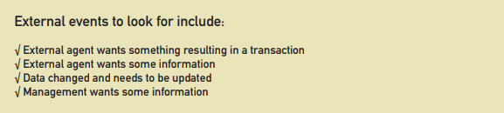
External agent wants something resulting in a transaction:
When a Site engineer wants to submit their daily work log as modelled in the first deliverables business processes
Trigger: site engineer finishes his shift and submits the report
Use case: record daily log
External agent wants some information:
When a project manager wants to check the status of a project that is ongoing
Trigger: project manager is preparing for a client meeting
Use case: view project dashboard
Data changed and needs to be updated:
When an architect wants to edit on the projects Blueprints or wants to add or edit specifications connected to the project
Trigger: specifications are changed or updated by client and architect reviewed the updates and changed the blueprints
Use case: update project documents
Management wants some information:
When A Senior Operations Manager wants to assess workload distribution and potential bottlenecks across all projects
Trigger: when the manager is conducting a weekly resource planning meeting
Use case: review team workload report

Temporal Events
Now we move on to temporal events identified by using this checklist
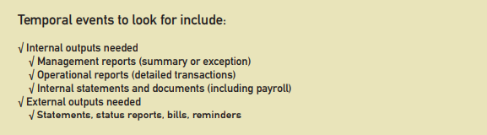
Internal outputs needed (Management reports):
When its time to generate the weekly project summary report.
Trigger: at the end of the week, or set at a specific time by management
Use Case: Generate Weekly Summary Report
External outputs needed (Reminders):
When its time to send a reminder for all members involved in the project for un upcoming tasks deadline
Trigger: deadline is approaching
Use case: send task deadline reminder

State Events
We used this guideline from the book: Consider the state events that the system might respond to, particularly if it is a real-time system in which devices or internal state changes trigger use cases
When the inventory of a critical material drops below the reorder point.
State Change: The quantity-on-hand changes from [above_threshold] to [below_threshold].
Use Case: Generate Material Reorder Alert
When a project's final task is completed.
State Change: The project's overall progress changes from In Progress to 100% Complete.
Use Case: Initiate Project Archival

Event table
This table categorizes the identified events, their triggers, the responsible actors, and the corresponding use cases required by the system.
Event | Trigger | Actor(s) | Event Type | Use Case
Site Engineer submits daily work log | Finishes day's work | Site Engineer | External | Record Daily Progress
Project Manager checks project status | Preparing for client meeting | Project Manager | External | View Project Dashboard
New blueprint version is available | Architect sends updated file | Admin Staff | External | Update Project Document
Management wants to assess workload distribution and potential bottlenecks | weekly resource planning meeting | Company management | External | review team workload report
Weekly summary report is due | Friday at 5:00 PM | System | Temporal | Generate Weekly Summary Report
Task is nearing its deadline | 24 hours before due date | System | Temporal | Send Task Deadline Reminder
Critical material inventory is low | Daily usage drops stock level | System | State | Generate Material Reorder Alert
Final project task is completed | PM marks last task as "Done" | Project Manager | State | Initiate Project Archival

Brief Use Case Description Table
Use Case Name | Actor(s) | Brief Description
Record Daily Log | Site Engineer, Project Manager | A Site Engineer submits their daily work progress, which is then recorded by the system for the Project Manager to review.
View Project Dashboard | Project Manager | The Project Manager views a consolidated, real-time summary of a project's status, including schedule and budget metrics.
Update Project Documents | Architect, Project Manager, Site Engineer | An authorized user, like an Architect, uploads a new version of a key document, ensuring all team members have access to the latest plans.
Review Team Workload Report | Senior Operations Manager | A manager reviews a system-generated report that shows task assignments across all projects to assess team workload and identify bottlenecks.
Generate Weekly Summary Report | System, Project Manager, Company Owner | The system automatically compiles key project data at the end of the week into a summary report for management review.
Send Task Deadline Reminder | System, Site Engineer | The system automatically sends a notification to a team member when one of their assigned tasks is approaching its due date.
Generate Material Reorder Alert | System, Project Manager | The system automatically notifies the Project Manager when recorded material usage causes stock levels to fall below a predefined threshold.
Initiate Project Archival | Project Manager, System | Upon project completion, a Project Manager triggers the process for the system to close out all active tasks and archive project data.

Use case modeling using UML Use Case Diagram
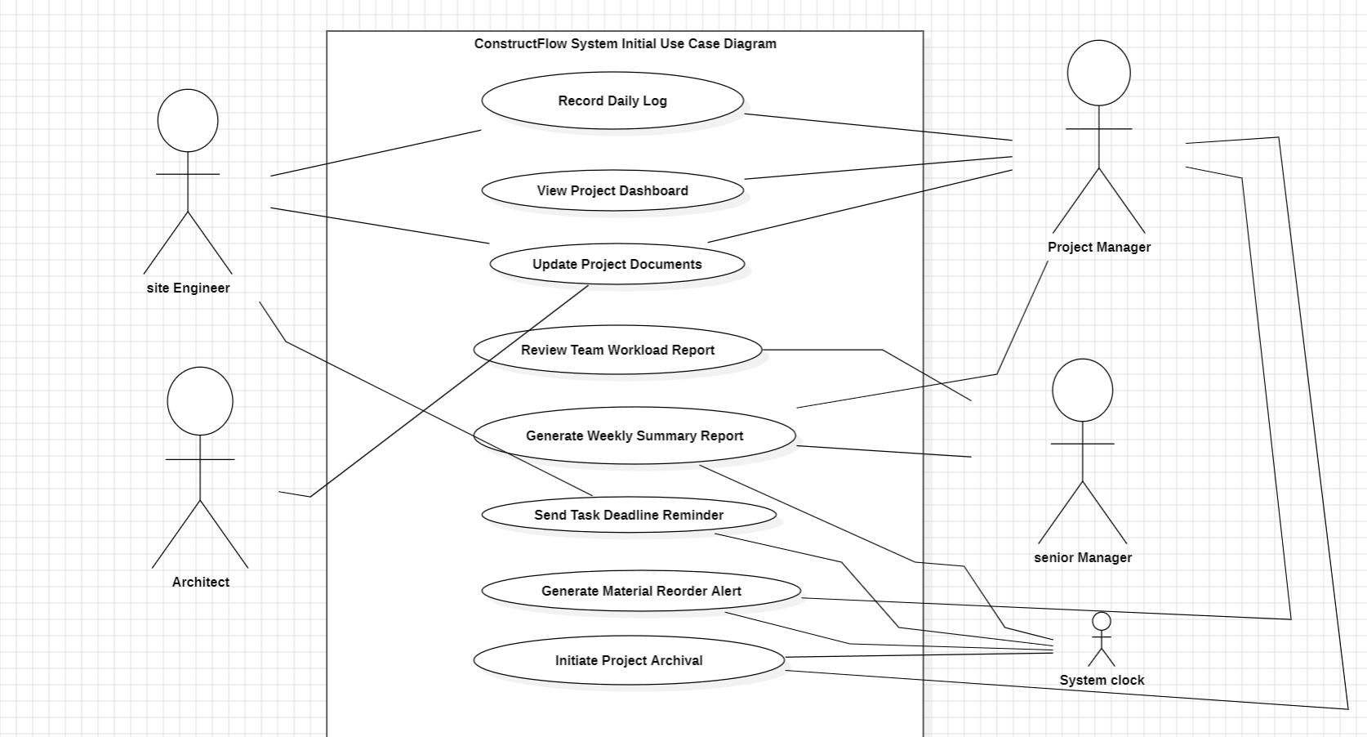

Use case modeling using UML Use Case Diagram (Updated)
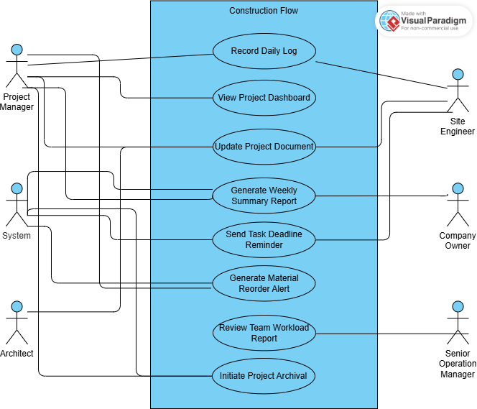

Jira
We used Jira to manage the project and keep track of the progress of this deliverable. We started by dividing the project's needs into separate tasks, like the System Vision Document, stakeholder identification, and Activity diagrams. We gave each task to a different team member and used Jira's project board to keep track of its progress from "To Do" to "Done." This method gave us a real-time view of our progress as a group, made sure that each person was responsible for their own work, and helped us work together to meet the submission deadline.
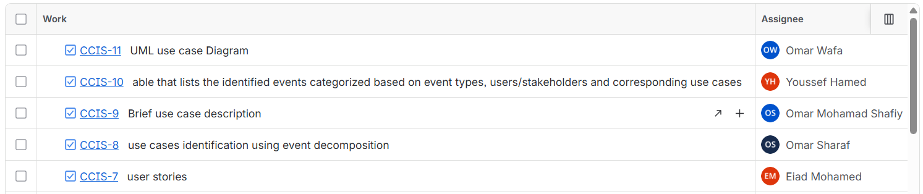

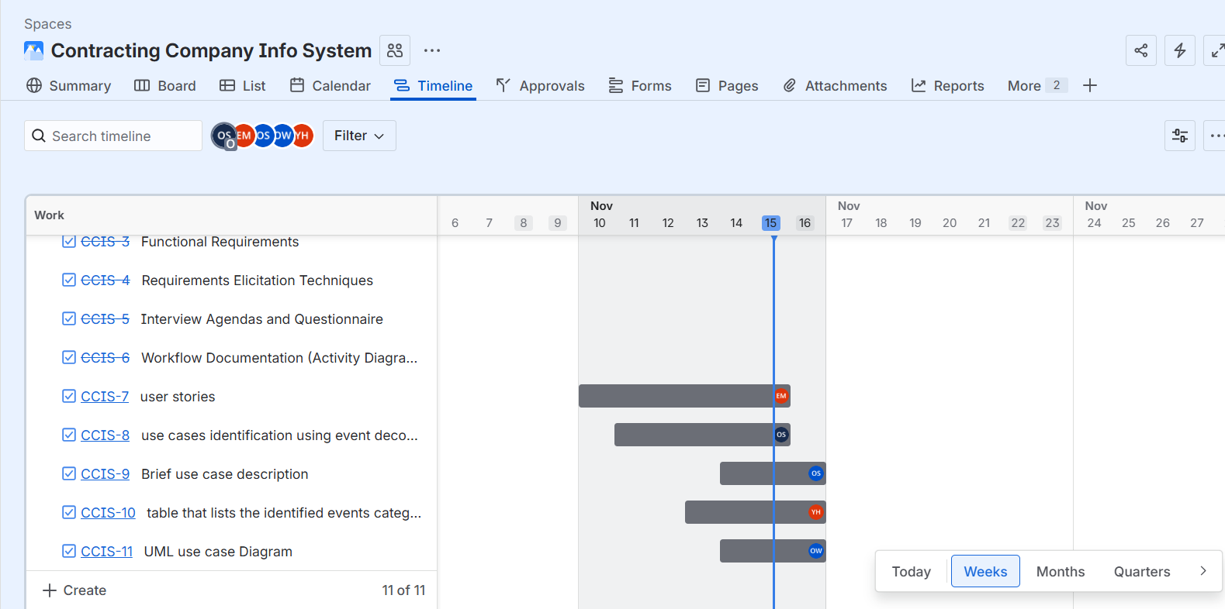
GitHub Link:
https://github.com/sharaf-omar/Contracting-Company-Info-System
