C-SW311 Software Development Spring 2025

CTRL ALT ELITE:
Omar Wafa (23-101281)
Omar Sharaf (24-101236)
Omar Shafiy (23-201356)
Eiad Essam (23-101108)
Youssef Elsayed (23-101227)

Domain Classes: Noun Technique Report

Introduction

To identify the core things or domain classes, that the ConstructFlow system must manage, we applied the Noun Technique. This systematic approach involves finding, classifying, and refining a list of nouns that appear in our project documentation to determine which represent unique domain classes, which are merely attributes, and which can be excluded. This report documents our step by step application of this technique.

Step 1 & 2: Identify Nouns (Initial List)
we began by reviewing our primary project documents from Deliverable #1 and #2. This included the System Vision Document, user stories, use cases, and functional requirements. We compiled a comprehensive raw list of all nouns representing potential actors, inputs, outputs, and other concepts to serve as our starting point.
we identified the following raw list of nouns (inputs, outputs, and actors):
Site Engineer | Project Manager | Client | Subcontractor
Project | Task | Start Date | End Date
Budget | Cost Code | Money | Invoice
Blueprint | Contract | Photo | Document
Material | Cement | Equipment | Truck
Work Log | Hours | Progress | Resource
WhatsApp | Email | Notification | Alert

Step 3 & 4: Refine and Filter (Analysis)

the next crucial step is to refine this raw list. For each candidate noun, we asked a series of questions to decide whether to include it as a domain class, exclude it (because it's an attribute, a synonym, or out of scope), or refine it (by grouping it under a more general class). This analytical process, showing our decisions and rationale, is documented in the master list below.
Candidate Noun | Decision | Reason / Analysis
Site Engineer, Project Manager, (Senior Operations) Manager | Refine | These are specific types of an Employee with distinct roles and permissions. We will model this using a Generalization/Specialization relationship, with Employee as a superclass and SiteEngineer, ProjectManager, and Manager as subclasses that inherit common attributes.
Start Date, End Date, Hours, Progress, Status | Exclude | These are not standalone things; they are specific pieces of information that describe other things. They were identified as attributes of classes like Project, Task, or DailyLog.
Money | Exclude | This is a synonym for other concepts we are already tracking, such as Budget or the cost attribute of a Resource. It's not a unique class itself.
WhatsApp, Email | Exclude | These are communication mechanisms, not data the system needs to store and remember. Our system will send notifications but won't store the WhatsApp message itself.
Blueprint, Photo, Contract, Invoice | Refine | These are all specific types of a more general concept. We grouped them all under a single, versatile Document class.
Material, Equipment, Cement, Truck | Refine | "Cement" and "Truck" are specific instances. Material and Equipment are types of "things" that share common properties We will model this with a Generalization/Specialization hierarchy, creating an abstract Resource superclass with Material and Equipment as subclasses.
Notification, Alert | Exclude | These are outputs produced by the system based on other information The system doesn't need to store a list of alerts but rather the event that triggers the alert.
Project | Include | This is a core concept. The system must know about and store information for many distinct projects.
Task | Include | This is a fundamental unit of work within a Project. The system must track many individual tasks.

Step 5: Final Domain Class List
After filtering and refining, the following list represents the final Domain Classes (Data Entities) required for the system.
Identified Domain Class | Notes on including noun as a thing to store
Project | Locate and identify the project (type, start/end dates, location).
Employee (Superclass) | Represents any internal staff member, containing common attributes like an ID, name, and contact information.
SiteEngineer (Subclass of Employee) | A specialized type of Employee who works on-site, logs daily progress, and manages field tasks.
ProjectManager (Subclass of Employee) | A specialized type of Employee who plans projects, monitors dashboards, and has executive oversight.
Manager (Subclass of Employee) | A specialized type of Employee, such as a Senior Operations Manager, who oversees multiple projects and reviews cross project reports on workload and resources.
Client | Contains useful info regarding the clients to allow access to the Client View.
Task | Stores individual work items, timelines, dependencies, and current status.
DailyLog | Records daily work hours, progress notes, and site activities submitted by supervisors.
ResourceRequest | Stores requests from site supervisors for specific materials or equipment needed.
Subcontractor | Contains info on external teams contracted for specific work packages.
Document | Contains info and records important documents such as blueprints, contracts, and site photos.
Budget | Stores financial limits and cost codes allocated to the project for cost control.
Resource (Abstract Superclass) | Represents any physical asset or consumable item used in construction. It contains common attributes like resourceID, name, and quantityInStock.
Material (Subclass of Resource) | A specialized type of Resource that is consumable, such as cement or steel. It has unique attributes like supplier and unitOfMeasure.
Equipment (Subclass of Resource) | A specialized type of Resource that is a reusable asset, such as a truck or excavator. It has unique attributes like serialNumber and maintenanceSchedule.

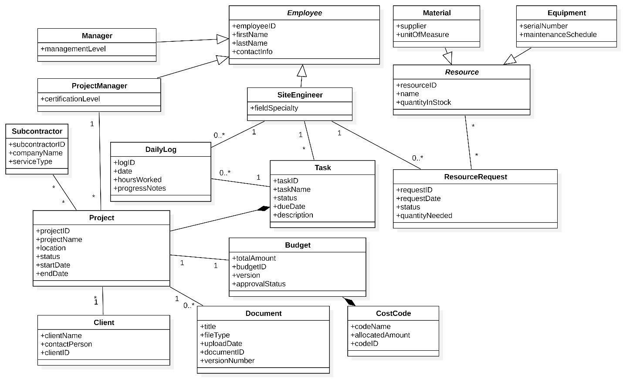

Use Cases and CRUD Technique

Introduction
We followed the specific steps for the CRUD technique to validate, refine, and cross check the list of use cases we identified in Deliverable #2 using the Event Decomposition technique. By ensuring that every core domain class has a complete lifecycle (Create, Read, Update, Delete), we can confirm the completeness of our system's functionality.
Step 1: Identify Core Domain Classes
First, we finalized the list of primary domain classes from our Noun Technique analysis. These classes represent the key things the system must manage Project, Task, Document, DailyLog, Employee (and subclasses), Resource (covering Material & Equipment), ResourceRequest, Budget, Client, and Subcontractor.
Step 2 & 3: Create the CRUD Matrix and Analyze for Gaps
To summarize our analysis, we created a Use Case vs. Domain Class matrix. This matrix maps the 8 use cases from Deliverable #2 against our domain classes.
Use Case vs. Domain Class | Project | Task | Document | DailyLog | Employee | Resource
Record Daily Log | R | U |  | C | R | U
View Project Dashboard | R | R | R | R | R | R
Update Project Documents | R |  | U, C
Review Team Workload Report | R | R |  |  | R
Generate Weekly Summary | R | R | R | R | R | R
Send Task Deadline Reminder |  | R |  |  | R
Generate Material Reorder Alert |  |  |  |  |  | R
Initiate Project Archival | U (archive) | U (archive) | U (archive) | U (archive)

Analysis of the Matrix and Identification of Gaps:
The CRUD analysis was highly effective. The matrix immediately exposed critical functional gaps in our initial list of 8 use cases:
- Missing Create Operations: The most significant gap is the lack of Create functionality for our most fundamental classes. There is no use case to Create a new Project or its initial Tasks. Without this, the system cannot function.
- Initially, one might assume that a use case like Update Project Documents would cover all 'updates' related to a project. However, our CRUD analysis forced us to think more precisely. We realized that managing the files of a project is a fundamentally different business process than editing the core data about a project the need for a new, distinct use case, which we have named Edit Project Details, to handle this separate and essential function. This refinement ensures our use cases are focused, secure, and accurately model the real world business processes.
- Missing Delete (Archive) Operations: Initiate Project Archival is a good end-of-project function, but it is too broad. There are no use cases for an administrator to Delete (or cancel) a single Task created in error or archive an obsolete Document.
- Incomplete Administrative Lifecycles: The matrix shows a major administrative gap. There are no use cases to manage the core data libraries that the system depends on, such as Employee accounts, the Client list, or the Resource library (materials and equipment).

Step 4: Add Overlooked Use Cases
Based on the functional gaps identified in the CRUD matrix analysis, we have added the following necessary use cases to our list. This refinement ensures that all core domain classes have a complete data lifecycle and that the system is administratively manageable. Each new use case represents a distinct Elementary Business Process (EBP) that was previously overlooked.

New/Refined Use Cases:
Use Case Name | Actor(s) | Brief Description | Justification (What gap it fills)
Create New Project | Project Manager | A Project Manager sets up a new construction project, defining its core details, budget, and initial tasks. | Fills the critical missing Create operation for the Project and Task classes.
Edit Project Details | Project Manager | A Project Manager modifies the core attributes of an existing project, such as its budget or end date. | Fills the missing Update operation for the Project class, distinct from document management.
Cancel Task | Project Manager | A Project Manager marks a task as cancelled, removing it from the active work plan while retaining its record. | Fills the missing Delete (archive) operation for the Task class.
Manage Stakeholders | Admin Staff | An administrator creates, updates, and deactivates accounts for all users (Employee, Client, Subcontractor). | Fills the missing C, U, D lifecycle for all user/stakeholder classes.
Manage Resource Library | Admin Staff | An administrator adds, updates, or removes resource types (Material, Equipment) from the system's central library. | Fills the missing C, U, D lifecycle for the Resource class.
Manage project tasks | Project manager | A project manager can add new tasks and delete tasks as well, they can assign these tasks to site engineers, subcontractors and construction site heads. | Fills the critical missing Create operation for Task class

Updated UML Use Case Diagram
The CRUD analysis has proven that our original list of 8 use cases from Deliverable #2 was insufficient to support a complete system. The UML Use Case Diagram must be updated to include the five critical use cases identified through this validation process. This updated diagram provides a more accurate and complete model of the ConstructFlow system's total functionality, directly reflecting the insights gained from our analysis.

Changes Reflected in the Updated Diagram:
- Five new use cases have been added to the system boundary: Create New Project, Edit Project Details, Cancel Task, Manage Stakeholders, and Manage Resource Library.
- New associations have been drawn connecting the Project Manager actor to the new project and task management use cases, and connecting the Admin Staff actor to the new administrative management use cases.

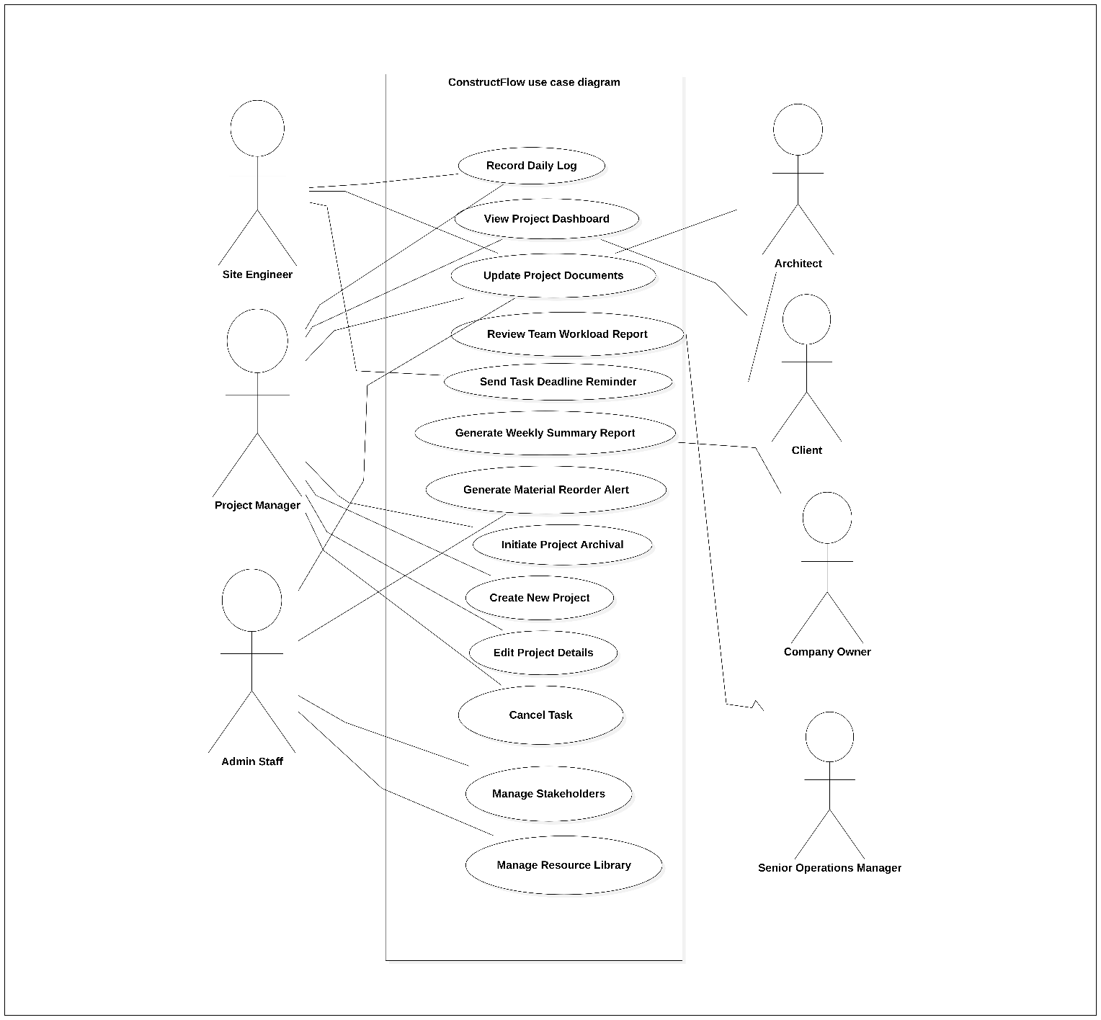

Activity diagrams modelling
For the activity diagrams modelling we modelled 3 use cases Create new project, update project documents, request resources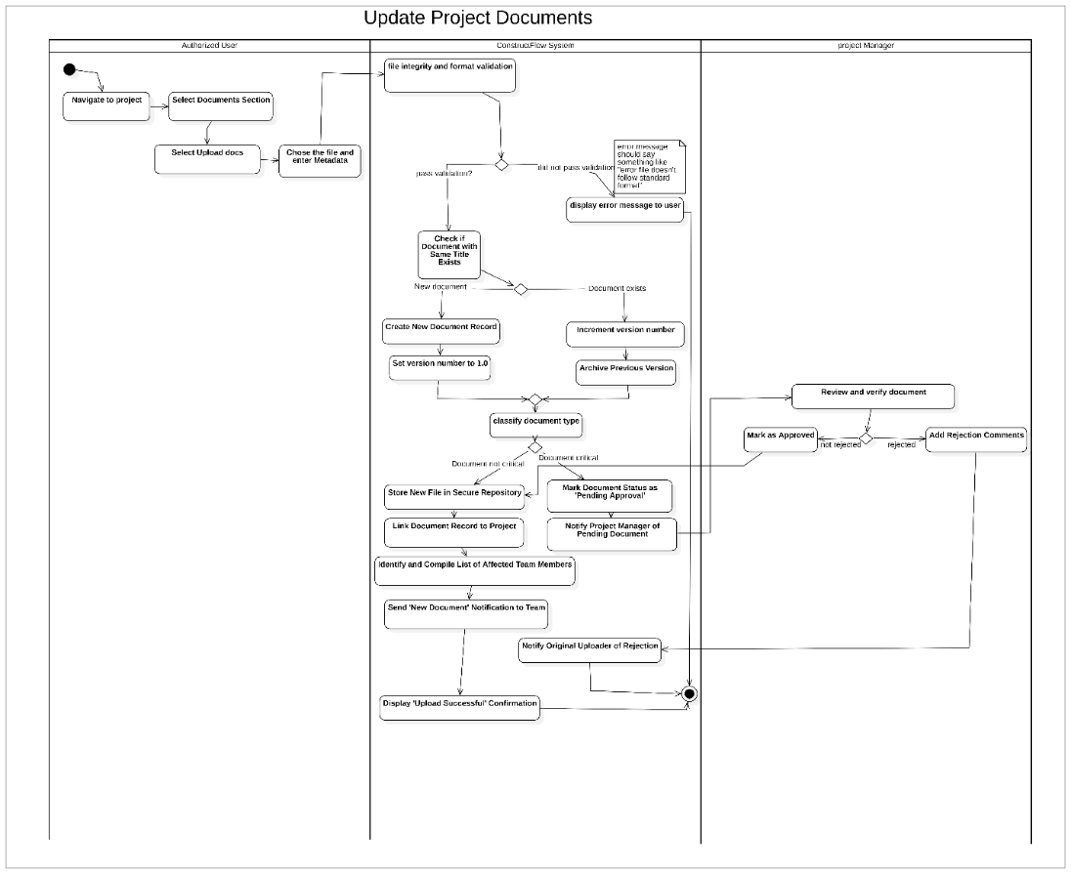
Request resources
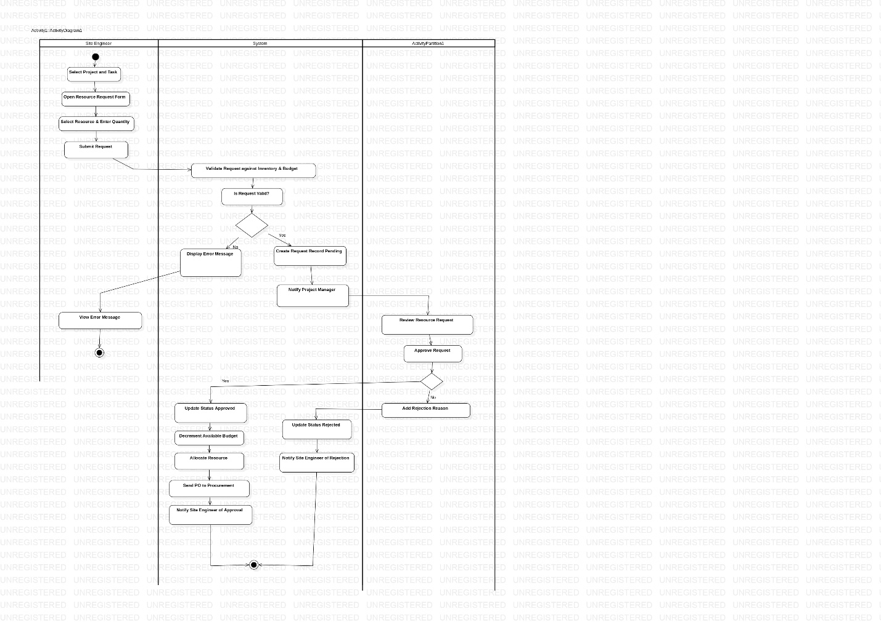

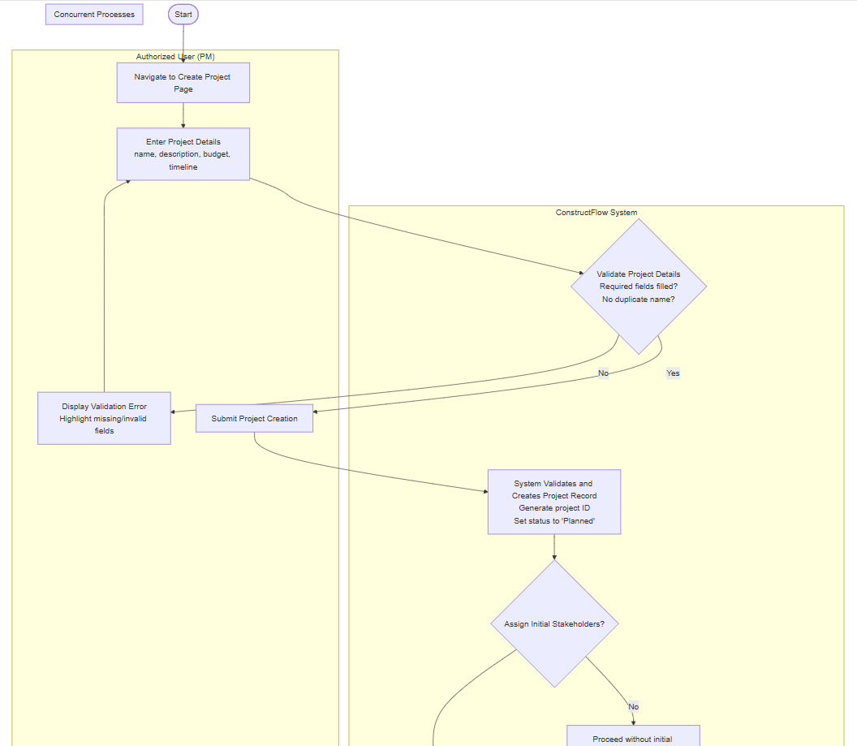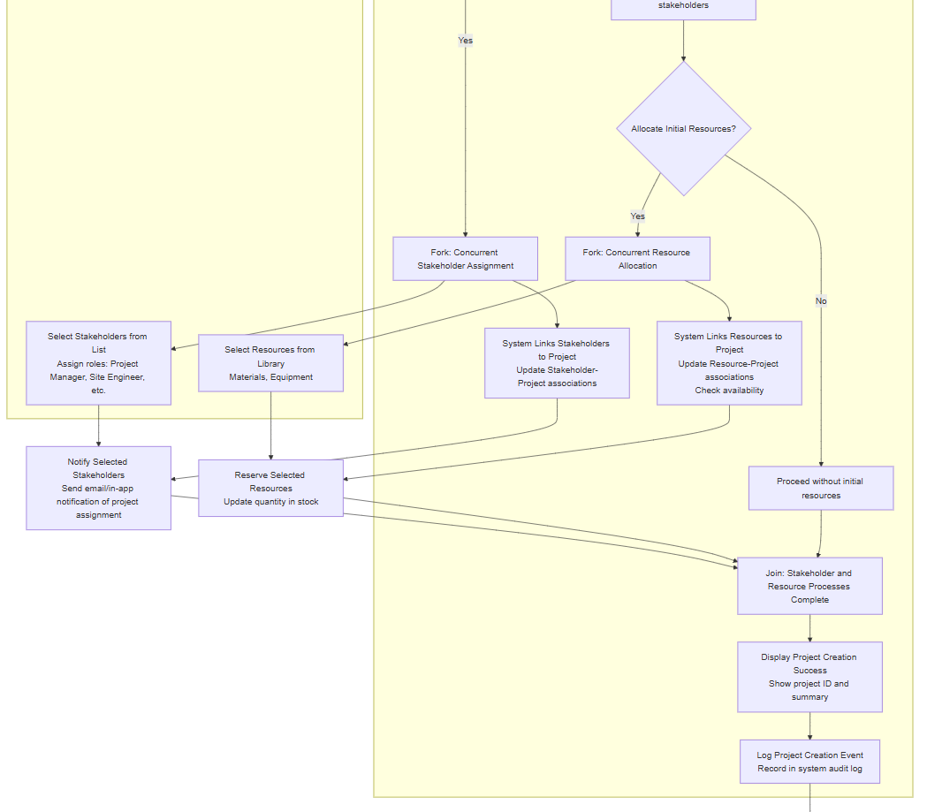

Use case System Sequence Diagram (SSD)
Original 8 Use Cases (from Event Decomposition in D2):
Record Daily Log
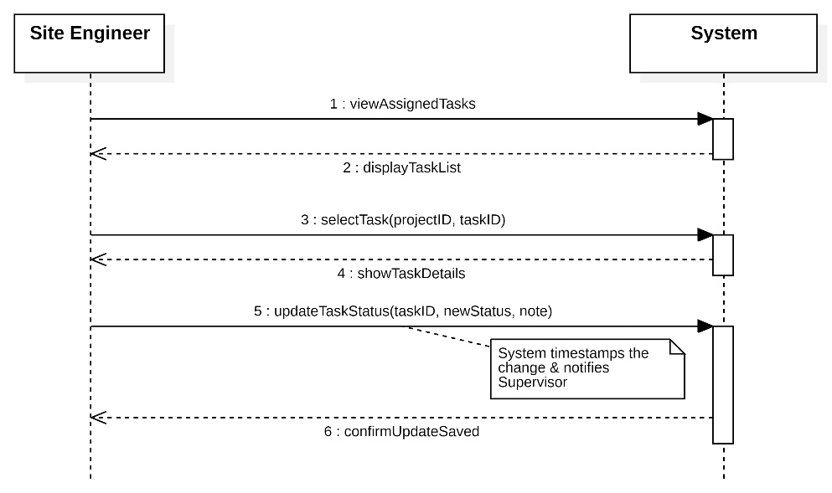
View Project Dashboard
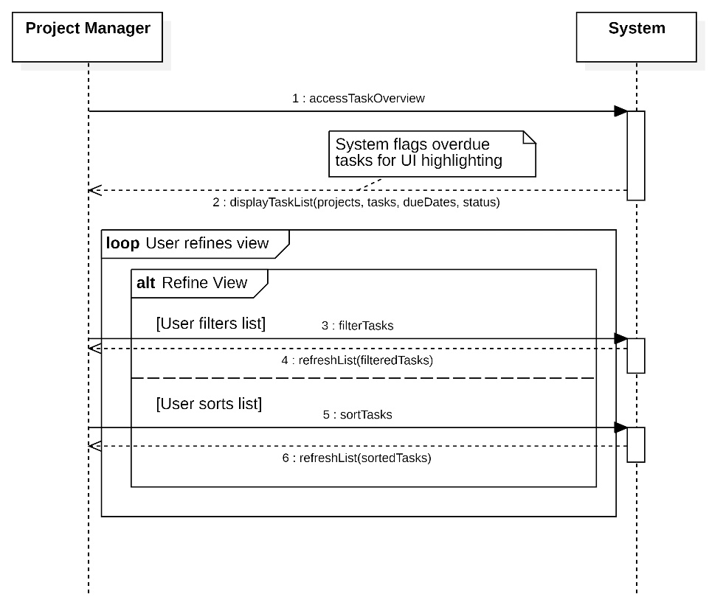

Update Project Documents
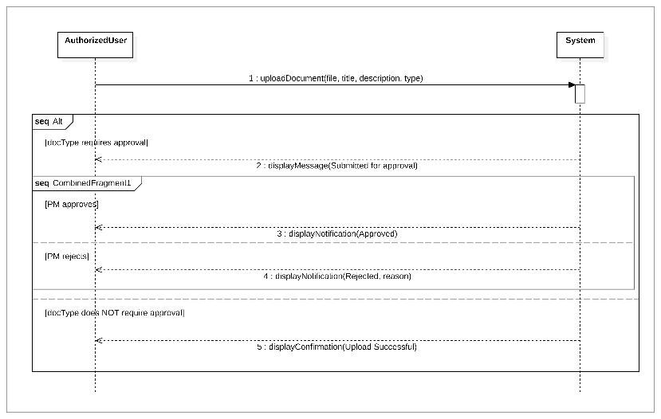
Review Team Workload Report
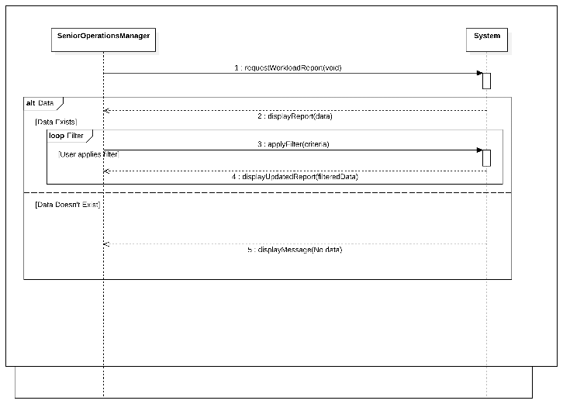
Generate Weekly Summary Report
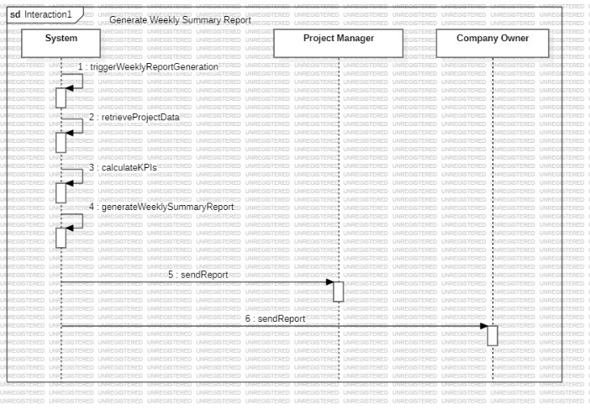
Send Task Deadline Reminder
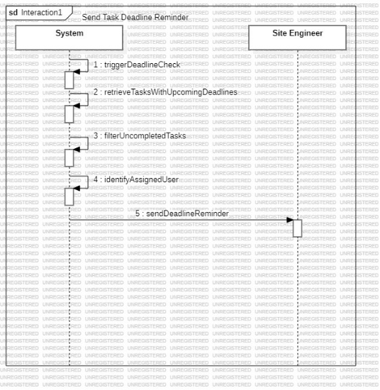
Generate Material Reorder Alert
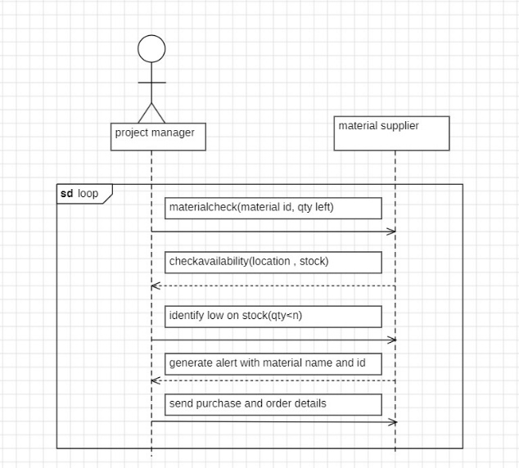
Initiate Project Archival
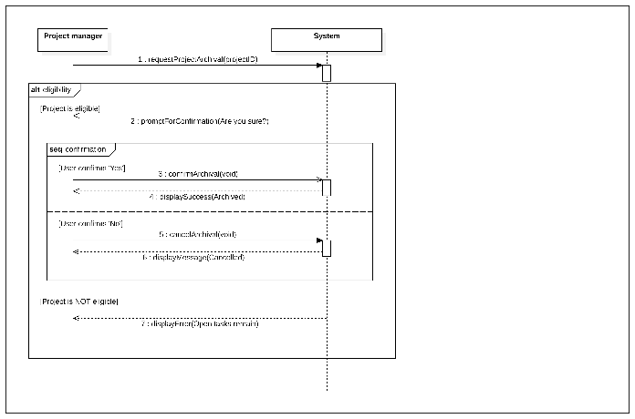
New 5 Use Cases (added after CRUD Analysis in D3):
Create New Project
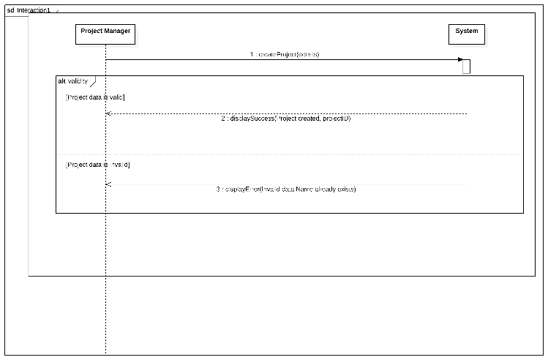
Edit Project Details
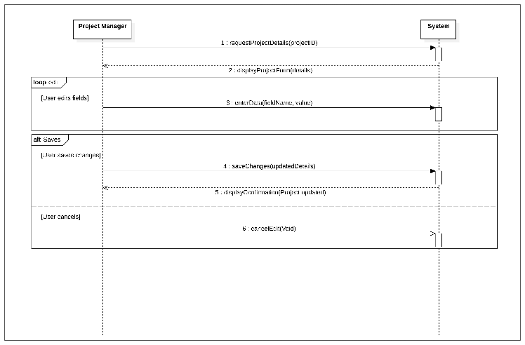
Cancel Task
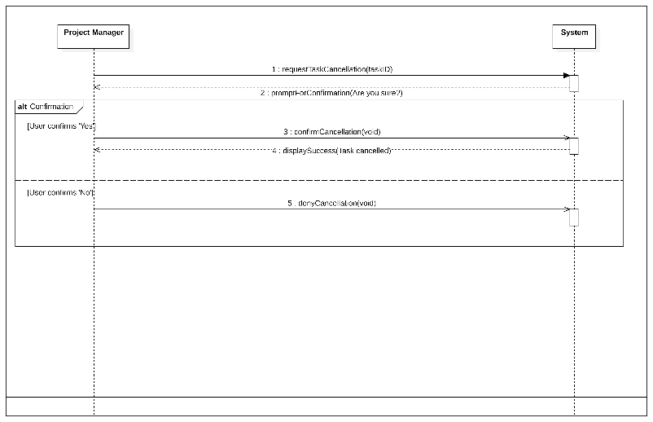
Manage Stakeholders
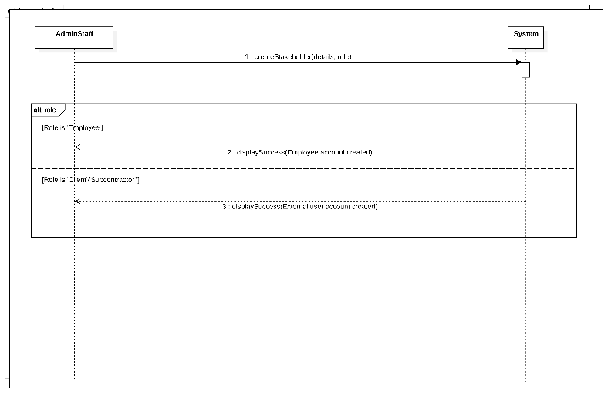
Manage Resource Library
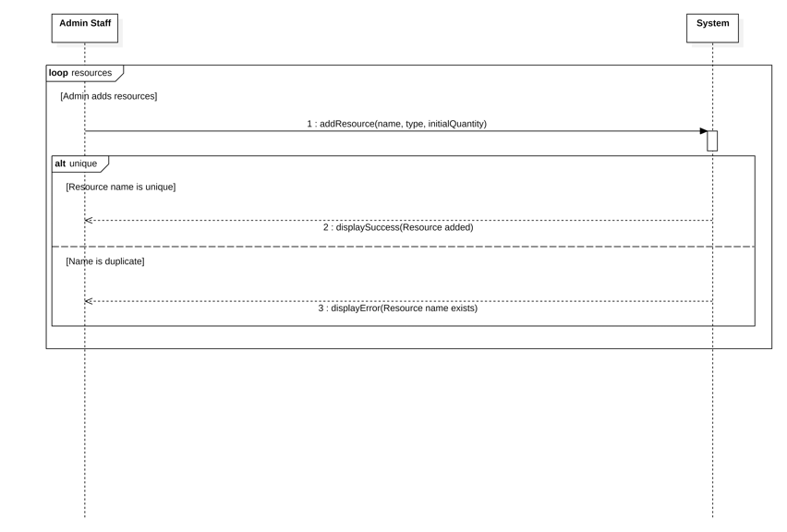

state machine diagrams
