C-SW311 Software Development Spring 2025

CTRL ALT ELITE:
Omar Wafa (23-101281)
Omar Sharaf (24-101236)
Omar Shafiy (23-201356)
Eiad Essam (23-101108)
Youssef Elsayed (23-101227)

1. Identify User and System Interfaces
This section identifies the user interfaces required to support the core functionalities of the ConstructFlow system. We have selected five core use cases from our validated list that represent a diverse range of user tasks: operational field work, project setup, management reporting, and administration.
The five selected use cases for this analysis are:
- Record Daily Log (Represents Task Management for field users)
- Create New Project (Represents Project setup)
- Review Team Workload Report (Represents reporting, covered by the Dashboard and Tasks views)
- Update Project Documents (Represents Document management)
- Manage Resource Library (Represents Resource management)
(a) User Interfaces
Based on an analysis of the required inputs for each selected use case, we have identified the following essential user interfaces (screens and forms) within our application:
- For Create New Project:
  - Projects List Screen
  - Create New Project Modal/Form
- For Record Daily Log:
  - Task Management Screen (To view and select tasks)
  - Daily Log Entry Form (Mobile-centric interface)
- For Review Team Workload Report:
  - Projects Dashboard (Shows critical tasks)
- For Update Project Documents:
  - Document Repository Screen
  - Upload Document Modal/Form
- For Manage Resource Library:
  - Resource Management Screen
  - Request Resource Modal/Form

2. User Interface Design
This section details the design of the user interface, starting with the high-level menu structure and progressing to storyboards and final screens from our live prototype.
(a) Menu Design
Our menu design provides a logical and intuitive navigation structure for the entire application, grouping all 13 use cases based on user roles and task types.
Menu Grouping Table
Menu Category | Use Cases Included in this Category | Intended User(s)
Dashboard | View Project Dashboard | Project Manager, Client, Senior Ops Manager
Projects | Create New Project, Edit Project Details, Cancel Task | Project Manager
Tasks | Record Daily Log | Site Engineer, Project Manager
Resources | Manage Resource Library, Generate Material Reorder Alert | Admin Staff, Project Manager
Documents | Update Project Documents | Architect, Project Manager, Admin Staff
Announcements | (Implicitly supports communication) | All Users
Administration | Manage Stakeholders | Admin Staff
Actual Menu Design (Navigation Flow)
The navigation flow is implemented as a persistent sidebar in our web application, providing clear and consistent access to the main system modules.
- Main Navigation Sidebar:
  - Dashboard (Landing page)
  - Projects
  - Tasks
  - Resources
  - Documents
  - Announcements
- Footer Navigation:
  - Settings
  - Logout
(b) Storyboards
The following storyboards illustrate the step-by-step interaction flow for each of our five selected use cases.
Storyboard 1: Create New Project
User (Project Manager) wants to add a new project.
- User clicks on the "Projects" tab in the main navigation.
- The Projects List Screen is displayed. User clicks the "+ New Project" button.
- The Create New Project modal form appears over the screen.
- User fills in the project details, chooses project status and clicks "Submit". The modal closes and the new project appears in the list.

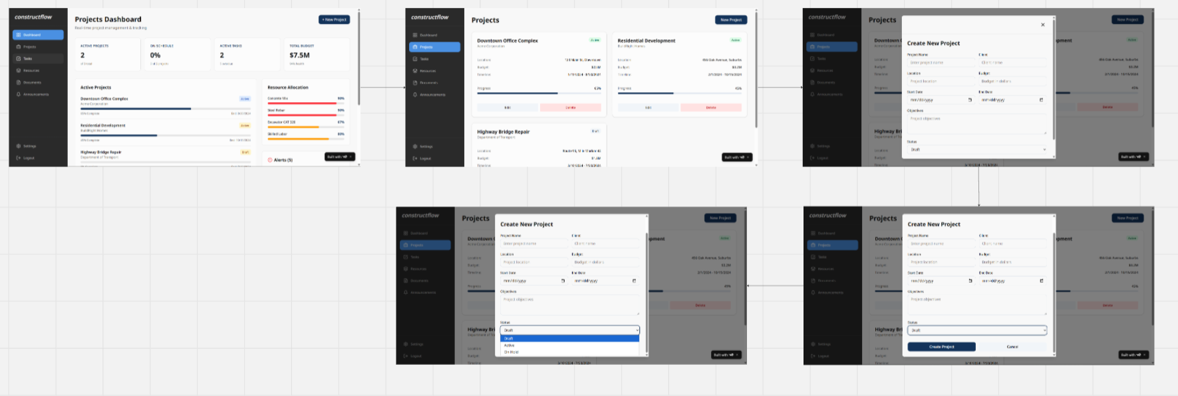
Storyboard 2: Record Daily Log
User (Site Engineer) wants to log their daily work.
- User taps on the "Tasks" tab in the mobile interface.
- The Task Management Screen is displayed, showing tasks assigned to them.
- User taps on a specific task (e.g., "Foundation Excavation").
- A view with task details appears. User taps "Log Work".
- The Daily Log Entry Form appears. User enters hours, notes, attaches a photo, and submits.
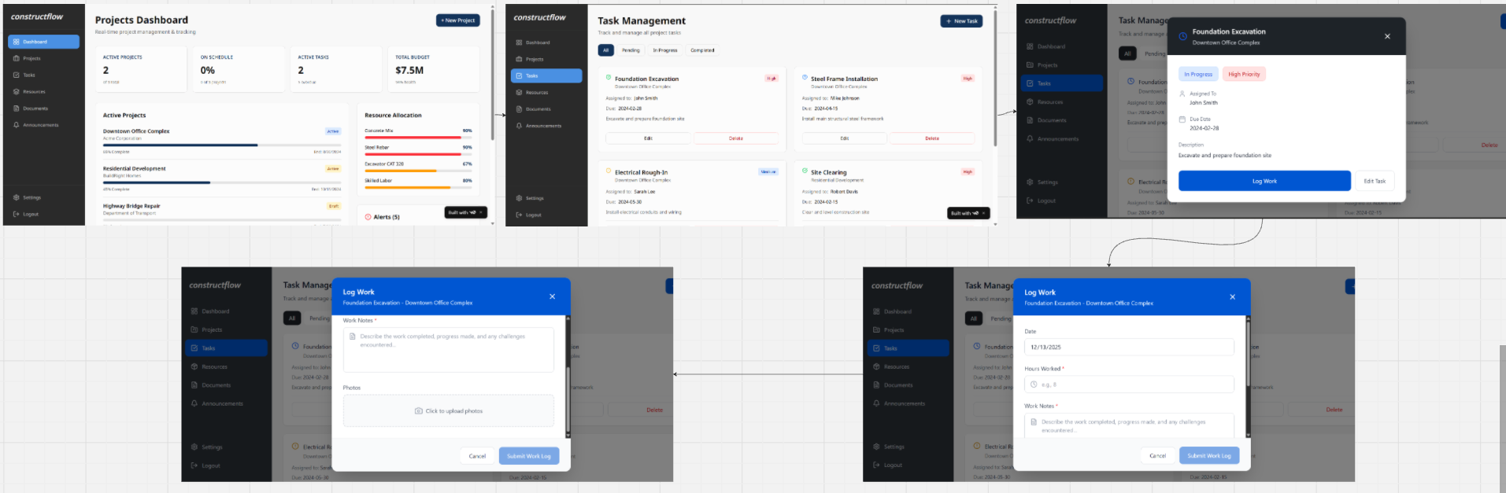

Storyboard 3: Review Team Workload Report
User (Senior Operations Manager) wants to see who is working on what.
- User clicks on the "Dashboard" tab.
- The Projects Dashboard is displayed. User scrolls down to the "Critical Tasks" widget to see high-priority tasks and their assignees.
- For more detail, user clicks the "Tasks" tab.
- The Task Management Screen appears. User uses the filter buttons (All, Pending, In Progress) to review workloads.
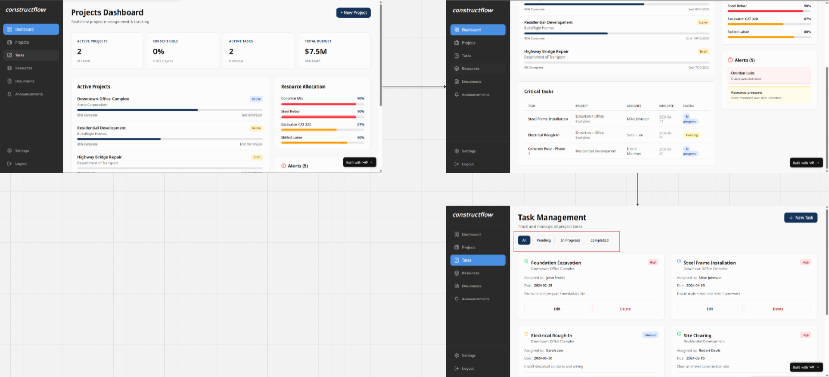
Storyboard 4: Update Project Documents
User (Architect) wants to upload a new version of a blueprint.
- User clicks on the "Documents" tab.
- The Document Repository Screen is displayed. User clicks the "Upload Document" button.
- The Upload Document modal form appears.
- User selects the project, enters metadata, chooses the file, and clicks "Upload Document". The modal closes and the new document appears in the repository list.
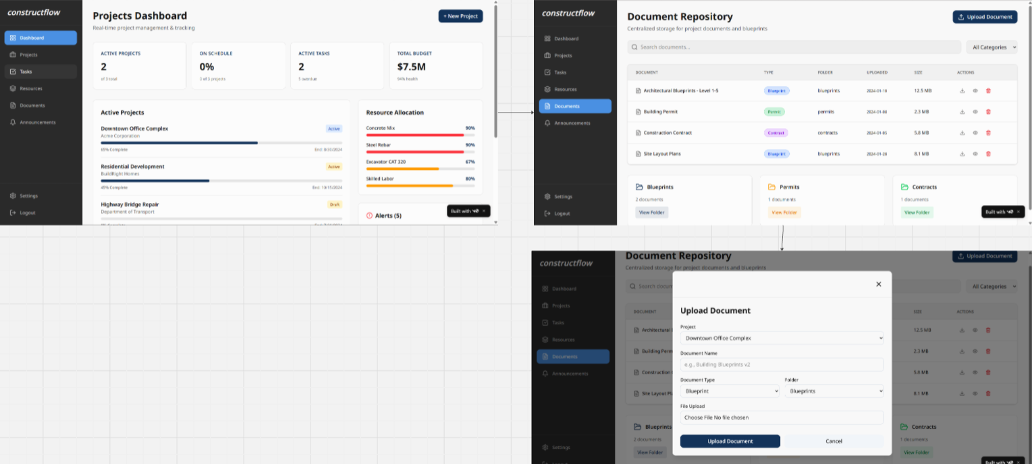
Storyboard 5: Manage Resource Library
User (Admin Staff) wants to add a new material to the system.
- User clicks on the "Resources" tab.
- The Resource Management Screen is displayed, showing a list of all materials and equipment.
- User clicks the "+ Add Resource" button.
- A modal form appears. User fills in the details for the new resource and clicks "Submit". The new resource is added to the main list.
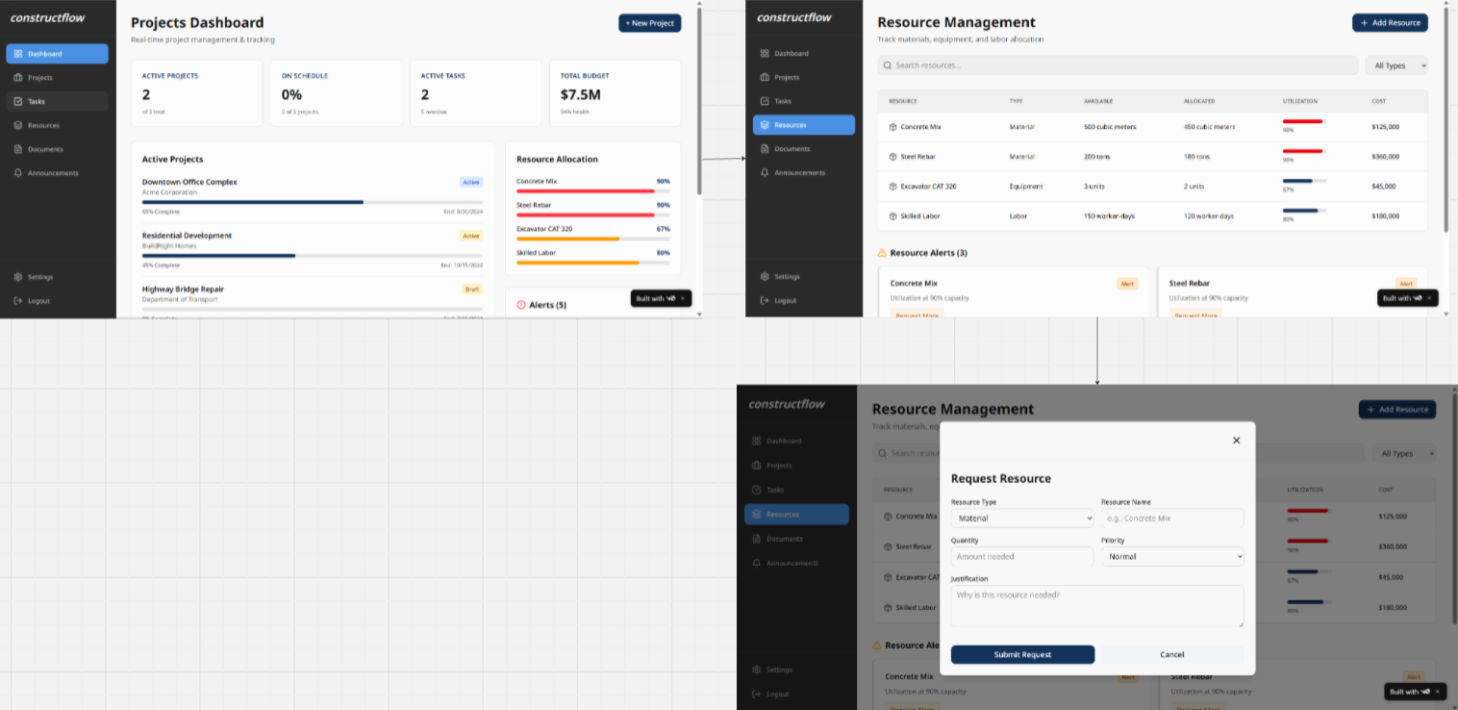
(c) User Interface Screens (Live Prototype)
Methodology:
Instead of static mockups, our team developed a dynamic, high-fidelity prototype of the ConstructFlow application using a modern web technology stack (React/Next.js) and hosted it on Vercel. This provides a realistic and interactive representation of the user interface. The following screenshots are taken directly from this live prototype.
Prototype Screen 1: Projects Dashboard (View Project Dashboard)
This screen serves as the "mission control" for managers, providing an at-a-glance summary of all project activity.
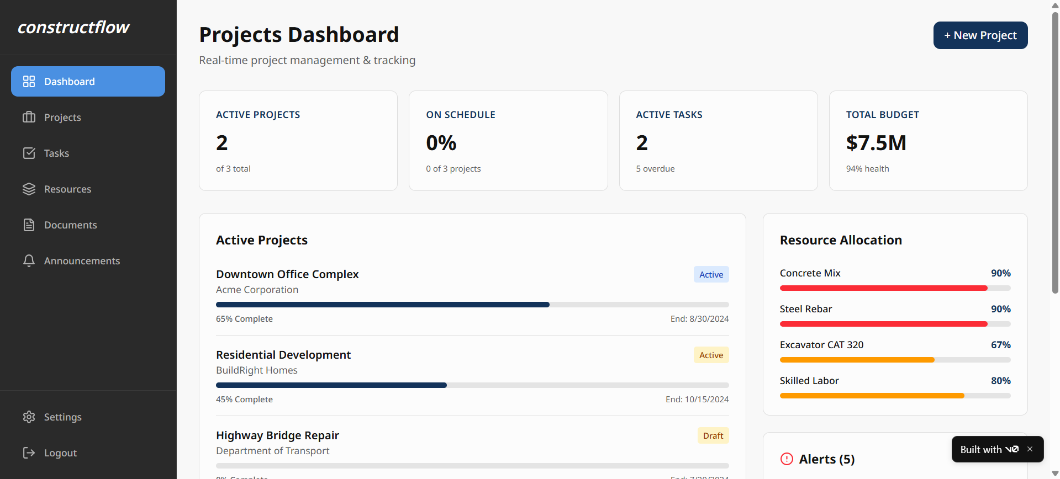

Prototype Screen 2: Projects List & Create New Project Form (Create New Project)
This screen shows the list of all projects and the modal form used to create a new one.
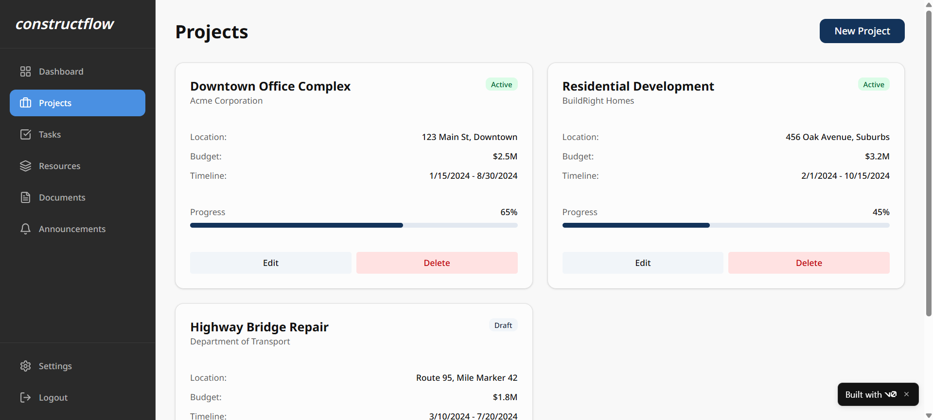’ 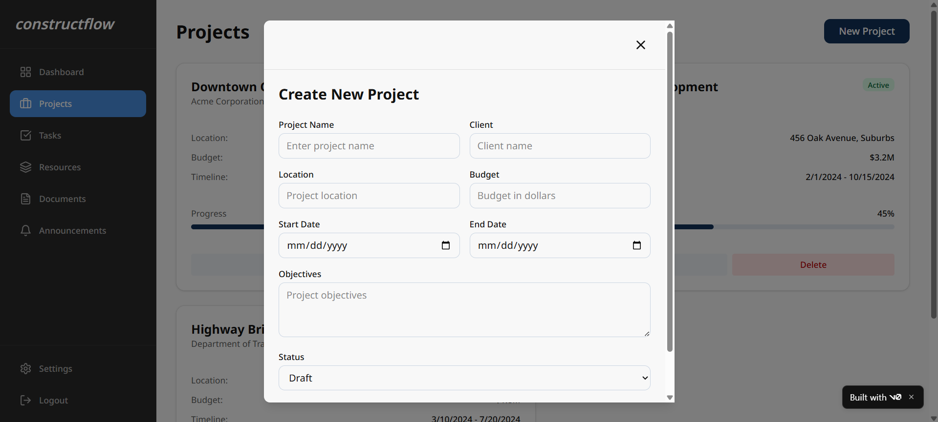

Prototype Screens 3: Task Management Screen (Record Daily Log & Review Workload)
This interface allows users to view all tasks and filter them by status. It's the starting point for a Site Engineer to log work and for a manager to review progress.
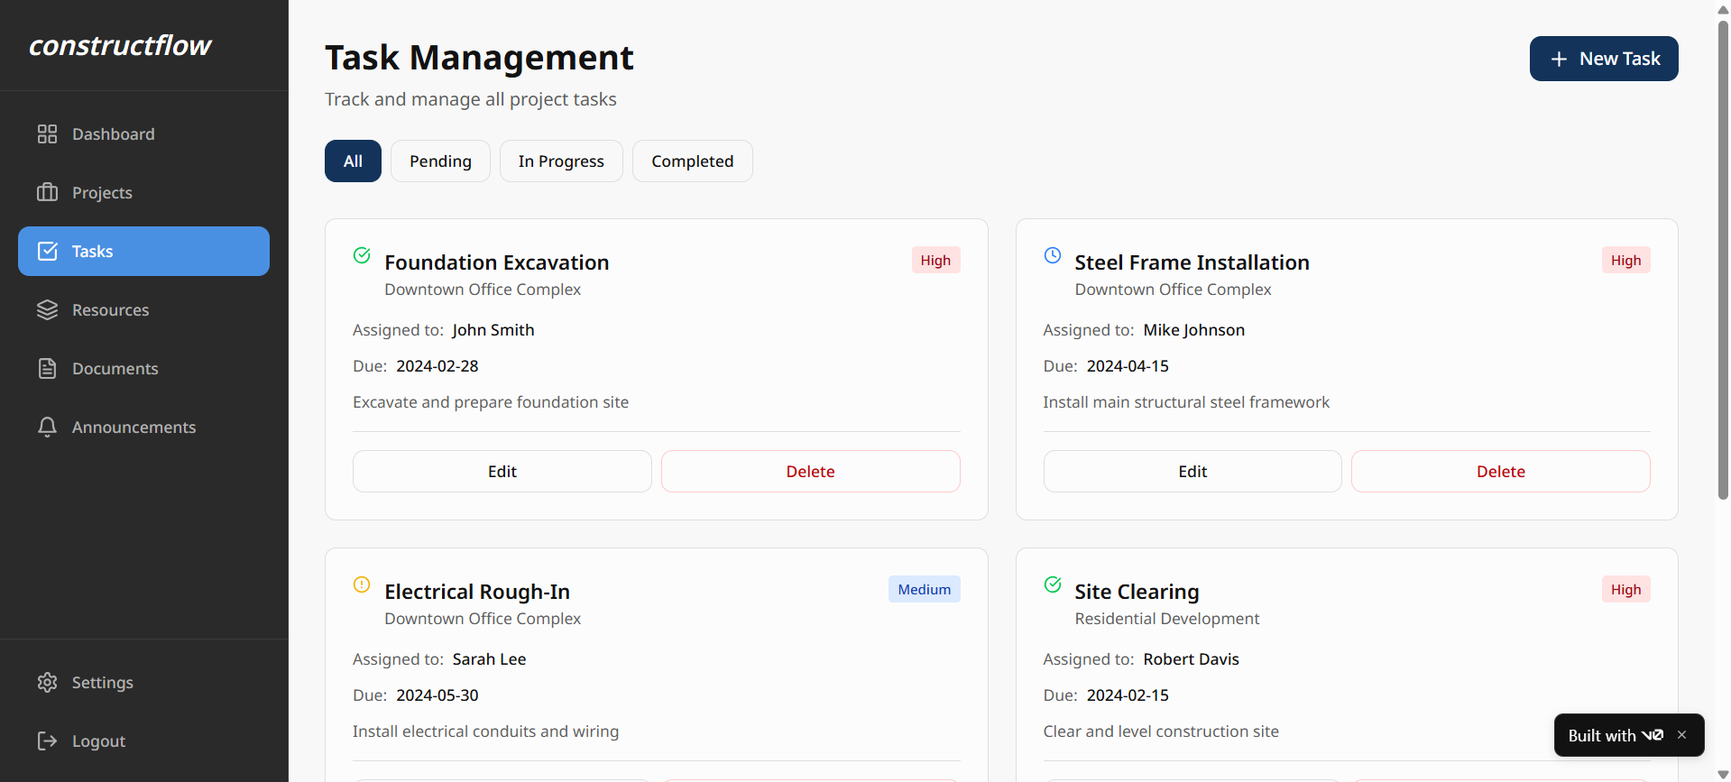
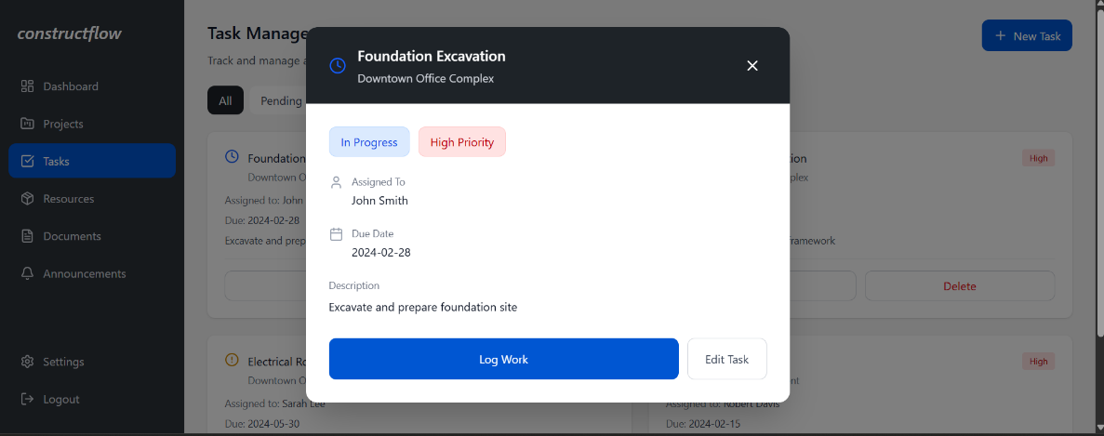
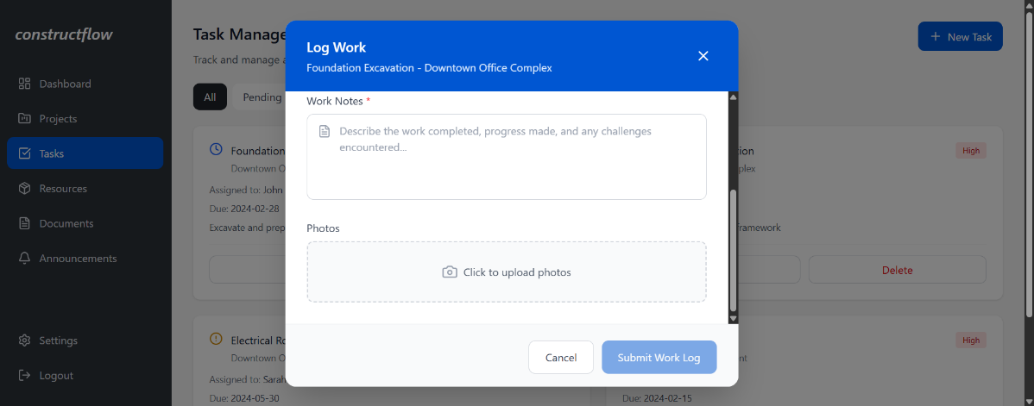
Prototype Screen 4: Resource Management Screen (Manage Resource Library)
This screen provides an overview of all project resources and includes the modal for requesting a new resource.
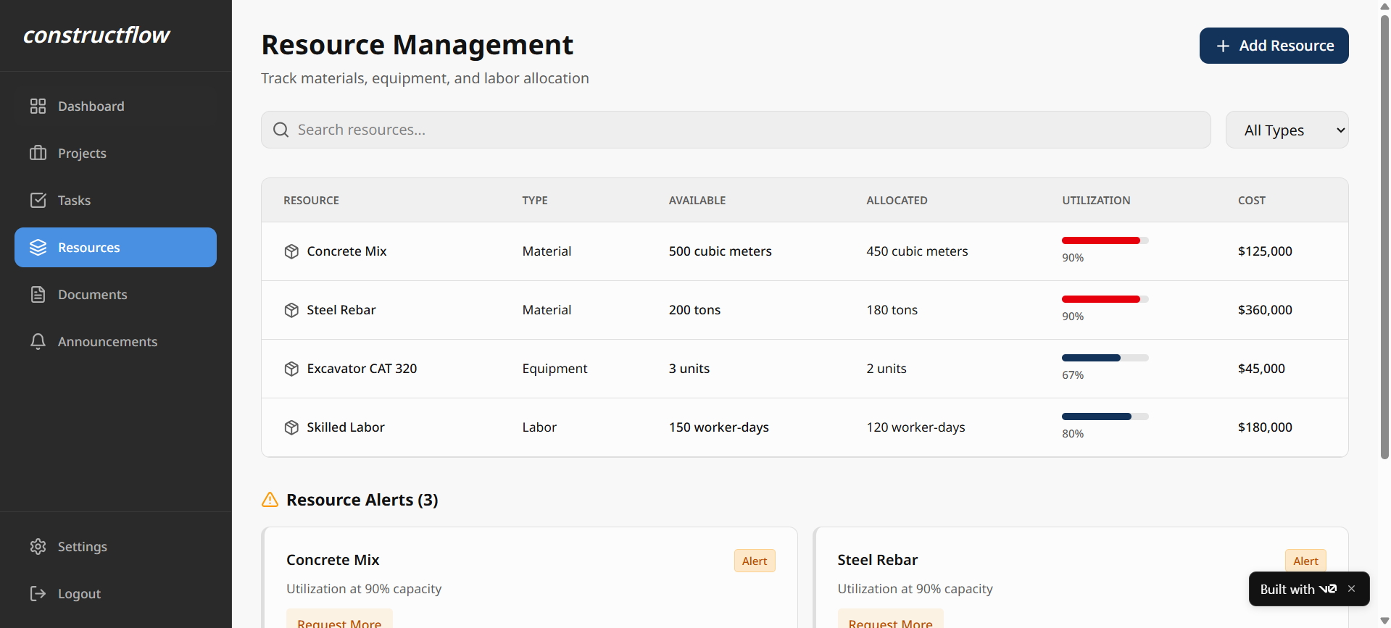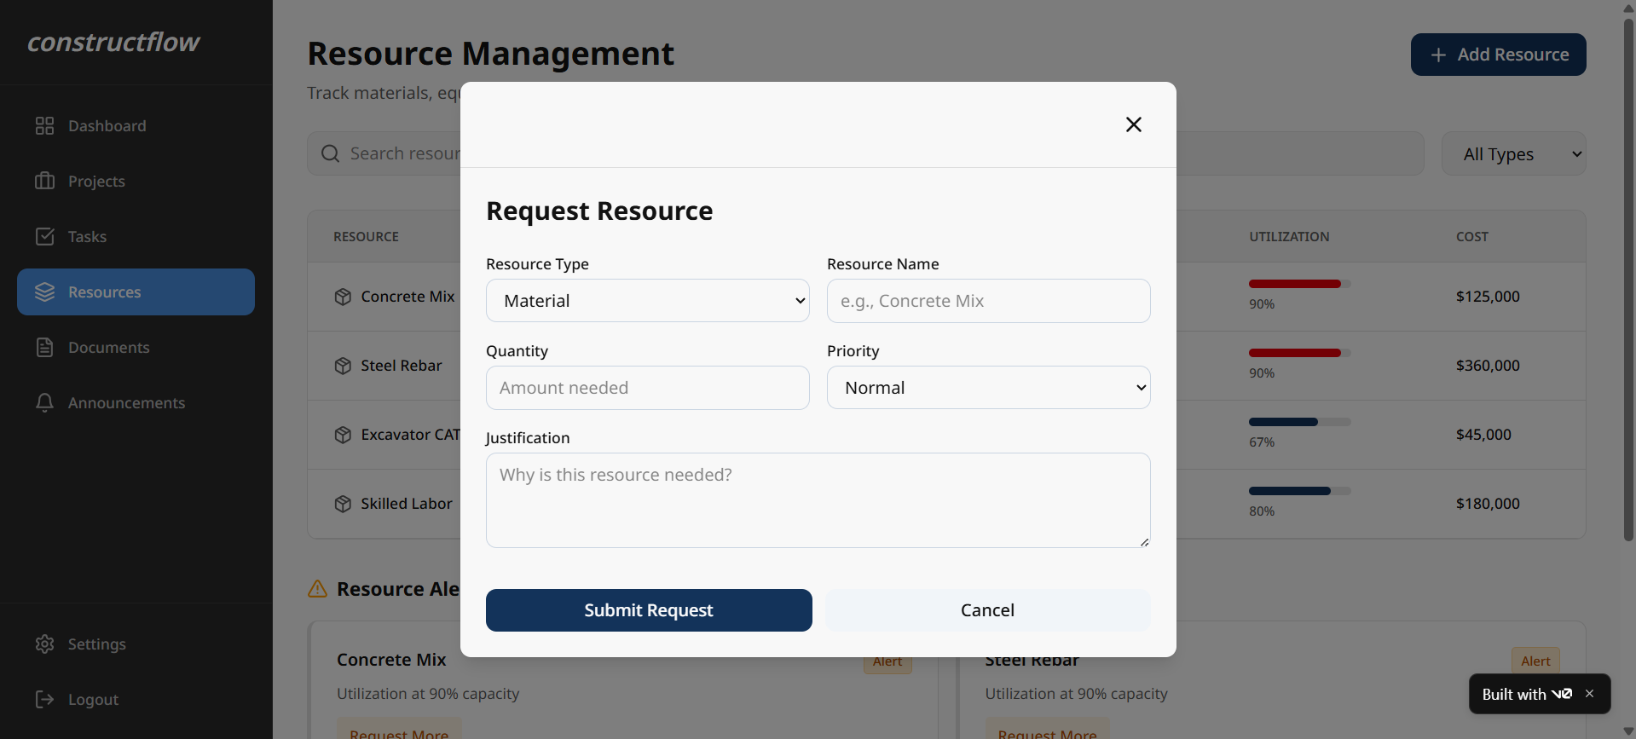

Prototype Screen 5: Document Repository & Upload Form (Update Project Documents)
This interface shows the centralized document storage system and the modal used to upload new files.
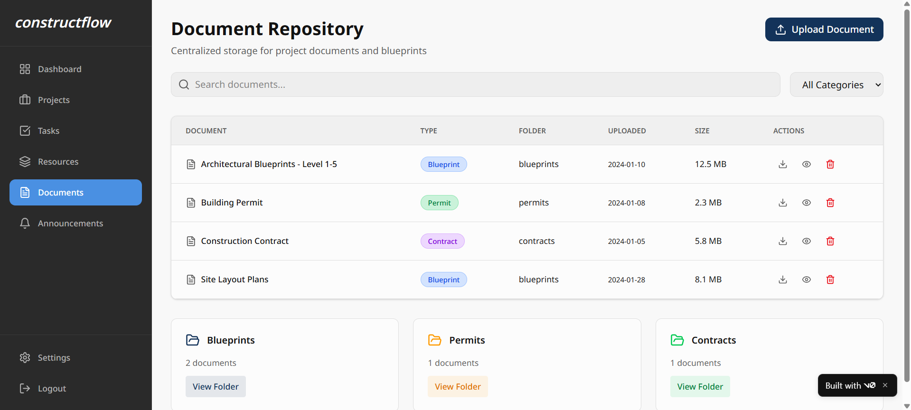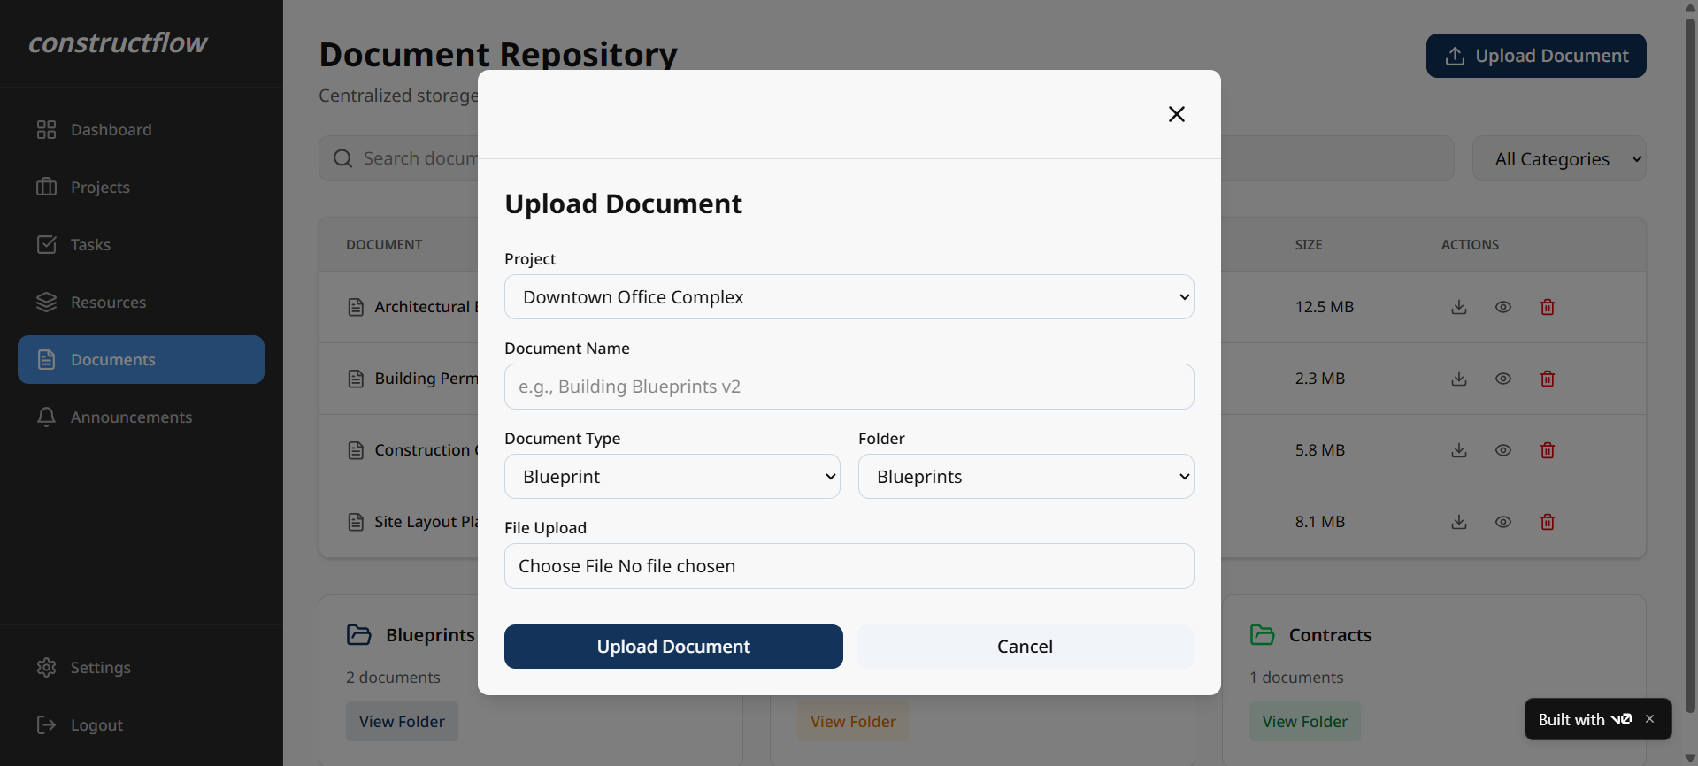

Project Management Artifacts
Jira Project Management
We have continued to use Jira to manage our project workflow for this deliverable. Tasks were created for each component of the report, assigned to team members, and tracked on our project board to ensure timely completion.
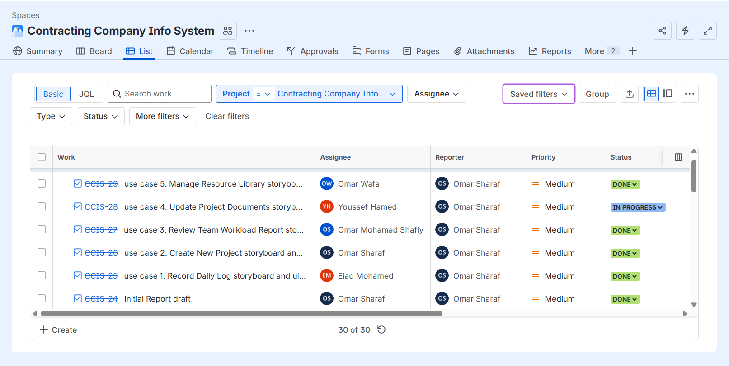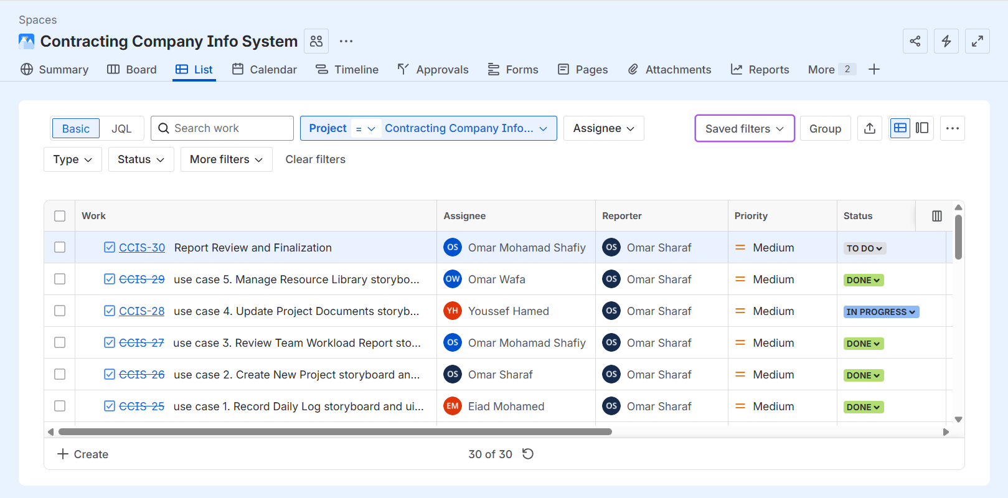
GitHub Repository
All work for this and previous deliverables is stored and version-controlled in our team's central GitHub repository.
Repository Link: https://github.com/sharaf-omar/Contracting-Company-Info-System

