**Keerthi Chekkera Yogireddy palem,Guntur Andhrapradesh - 522659**



**To secure a responsible and challeng ing position in a progressive organisation. That enables me to apply my knowledge and skills in various fields effectively for the mutual developm ent of the organisation and myself.**



**Education**

|  |  |
| --- | --- |
| [**keerthireddy55056@gmail.com**](mailto:keerthireddy55056@gmail.com) | **+91 9392354006** |
| **Career Objective** |  |



**Course Details**

**Degree: BSc**

**Specialization:**

**Computers & Statistics**

|  |  |  |  |  |
| --- | --- | --- | --- | --- |
| **Qualification** | **Instit ute** | **Board/** | **Year of** | **Percentage** |
|  |  | **University** | **Passing** |  |
| **BSc** | **Vasavi degre e College** | **Acharya Nagarjuna** | **2021** | **80** |
|  | **Narasar aopet** | **University (Guntur)** |  |  |
| **XII** | **Gitams Jr. College** | **Intermediate Board** | **2018** | **77.8%** |
| **X** | **AP Model school** | **Board of secondary school education** | **2016** | **75%** |

|  |  |  |
| --- | --- | --- |
| **●** | **Languages** | **: C, JAVA** |
| * **Operating System : Window s 7, Windows XP** | | |
| **●** | **Web Skills** | **: HTML** |



**Awards and Achievements**

* **First prize in Kabbadi at 2015-16**
* **First prize in Kho-Kho at 2016-17**



**Software Skills**



**Strengths**

* **Self Confidence**
* **Positive Attitude**
* **Keep on learning from every situation**
* **Good Communication Skills**
* **Team Work Skill & Time management**

**Hobbies**

* **Playing Outdoorgames**
* **Cooking food**
* **Discussing on a topic**



**Personal Details**

|  |  |
| --- | --- |
| **Father Name** | **: Mr. Veera areddy** |
| **Mother Name** | **: Aruna** |
| **Nationality** | **: Indian** |
| **Gender** | **: Female** |
| **Marital Status** | **: Single** |
| **Languages** | **: Telugu, English, Hindi** |

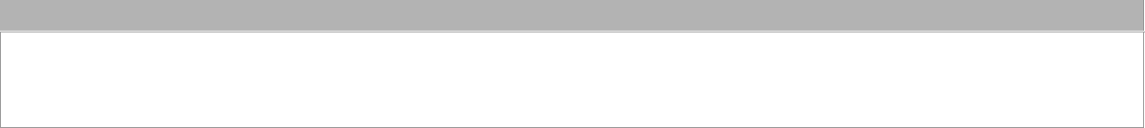

**Declaration**

**I hereby declare that all the particulars given above are true to the best of my knowledge and belief.**

Signature

**ch. keerthi**

**Place : Narasaraopet**

**Date :**