**SOFTWARE REQUIREMENT SPECIFICATIONS**

**VERSION 1.0**

**FEBRUARY 8th, 2021**

Movie Theatre E-Ticketing System



**TABLE OF CONTENTS**

**Table of Content**..........................................................................................................................................2

**1.0 Purpose**

1.1 Introduction................................................................................................................................3

1.2 Scope........................................................................................................................................4

1.3 References................................................................................................................................4

1.4 Document Overview..................................................................................................................4

**2.0 Overall Description**

2.1 Product Perspective..................................................................................................................5

2.2 Product Functions.....................................................................................................................6

2.3 User Characteristics..................................................................................................................6

2.4 Constraints................................................................................................................................7

2.5 Assumptions and Dependencies...............................................................................................7

**3.0 Requirement Specifications**

3.1 Functionality

3.1.1 Logon Capabilities.....................................................................................................7

3.1.2 Alerts.........................................................................................................................7

3.2 Usability.....................................................................................................................................8

3.3 Reliability

3.3.1 Availability..................................................................................................................8

3.3.2 Mean Time to Repair (MTTR)....................................................................................8

3.3.3 Accuracy....................................................................................................................8

3.3.4 Probable Bugs…………………..................................................................................8

3.4 Performance

3.4.1 Response Time.........................................................................................................9

3.4.2 Administrator Response............................................................................................9

3.4.3 Throughput................................................................................................................9

3.4.4 Resource Utilization..................................................................................................9

3.5 Supportability

3.5.1 Internet Protocols......................................................................................................9

3.5.2 Ticket Cancellation Flexibility.....................................................................................9

3.5.3 Maintenance..............................................................................................................9

3.5.4 Standards.................................................................................................................10

3.6 Design Constraint

3.6.1 Software Language Used........................................................................................10

3.7 System Evolution.....................................................................................................................10

**Software Requirements Specification**

1. **Introduction**

Movies have been a part of the entertainment industry for a long time. It creates a massive impact on people all over the world. Movie theatres have become one of the most preferred getaways in today’s world. And yet going to the theatre, selecting a movie, making sure the tickets aren’t sold out, could prove tedious. Any knowledge about the list of movies, show timings, or even seats can be attained by the customer only by being present physically.

An Online Movie Ticketing System brings the theatres closer to the customers. It eases and improves the booking experience. The system holds the database of all the movies being played along with their show timings and available seats. This system can be accessed using a website by the customers a few days prior to the show to book their seats of choice, and at the same time, keeps the theatre admins updated about the seats being booked. The purpose of this document is to analyze and elaborate on the high-level needs and features of the Online Movie Ticketing System. It focuses on the capabilities and facilities provided by a theatre. The details of what all are the needs of the Online Movie Ticketing System and if it fulfils these needs are detailed in the use-case and supplementary specifications.

**1.1. Purpose**

The purpose of Software Requirements Specification (SRS) document is to describe the external behavior of the Online Movie Ticketing System. Requirements Specification defines and describes the operations, interfaces, performance, and quality assurance requirements of the System. The expected audience for this document include, the theatre administrators, the Box Office Staff at the partnered theatres and the developer.The document captures the software requirements and user interfaces that are associated with this system.

**1.2 Scope**

The Software Requirements Specification captures all the requirements in a single document. The Movie Ticketing System that is to be developed provides the theatre staff and the customers with the movies being screened, show timings, seat availability and many other facilities. The Online Movie Ticketing System is supposed to have the following features:

* The Online Movie Ticketing System is up and running all day.
* The product provides the customers with online booking capabilities.
* The system provides a logon facility to the users.
* The system lets the Box Office staff to check seat bookings and seat availability for any screen during operating hours.
* The system allows the theatre staff to monitor screen details and update movies screening information.
* The transactions of the theatre are updated with every reservation or refund submitted.

The features that are described in this document are used in the future phases of the software development cycle. The features described here meet the needs of all the users. The success criteria for the system is based on the level up to which the features described in this document are implemented in the system.

**1.3 References**

The SRS document uses the following documents as references:

*1.Online Library System Software Requirements Specification, UHCL, Version 1.*

*2.Software Requirements Specification for ATM system for SBI Bank Version 1.1 December 22, 2011.*

**1.4 Document Overview**

The SRS will provide a detailed description of the Movie E-ticketing System. This document will provide the outline of the requirements, overview of the characteristics and constraints of the system.The remainder of this document is in two sections , the first providing a full description of the project for the Theatre Administrators. It lists the functions performed by the system. The final section concerns details of each of the system functions and actions in full for the software developers’ assistance. These two sections are cross-referenced by topic; to increase understanding by both groups involved.

**2.0 Overall description**

**2.1 Product Perspective**

The Online Movie Ticketing System is a package to be used by Administrators to improve the efficiency of the website for Box Office Staffs and Users. The Online Movie Ticket System to be developed benefits greatly the general public. The system provides movies and dates, from which the user can choose, as desired . The Administrator can keep the movie database and seating arrangements updated all the time so that the user gets the updated information all the time.

The complete overview of the system is as shown in the overview diagram below:

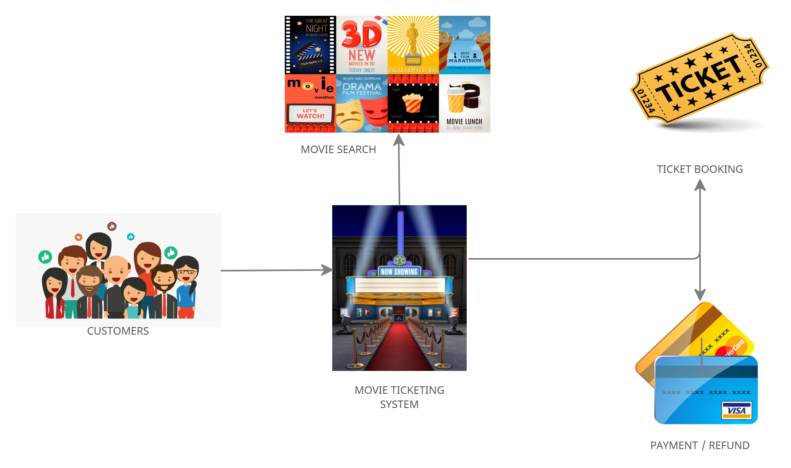

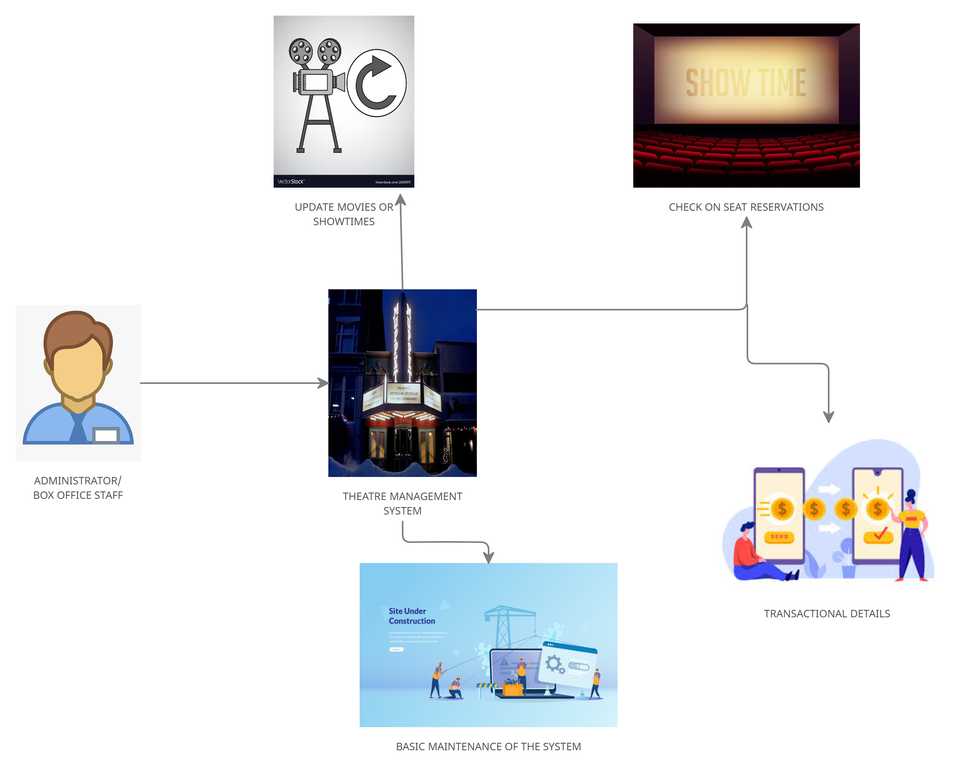

The Movie ticketing system encompasses various GUI menus, to provide a seamless facility for online booking of movie tickets. It provides secure access to the account of a customer. The system is connected to the theatre database.

**2.2 Product Functions**

The Online Movie Ticketing System provides online real time information about the movies available in the Theatre to the user. The Product functions are more or less the

same as described in the product perspective. The functions of the system include the system providing different types of services based on the type of users [User/ Administrator].

• The member should be provided with the updated information about the movie’s showtimes and seats available.

• Provisions for the user to book the movie they want, if all the other required rules hold good.

• The members are provided with the movie available roster and allowed to choose the movies, which they want to use in the coming up days.

• The Administrator is aware of all the tickets booked and also about the seats available.

• The Administrator is provided with interfaces to add/delete the movies and also update the seating arrangements accordingly.

• The user is also provided an option to claim a refund of 25% of the ticket rate, provided he/she cancels the ticket 24 hours before showtime.

**2.3 User characteristics**

The users of this system are the customers, box office staff and the administrators of the partnered theatres.The customers are assumed to have basic knowledge of the computers and Billing System Internet. The theatre staff are required to have more knowledge of the internals of the system and are able to rectify the small problems that may arise due to disk crashes, power failures and other catastrophes to maintain the system. The proper user interface, users manual, online help and the guide to install and maintain the system must be sufficient to educate the users on how to use the system without any problems.

**2.4 Constraints**

• The information of all the users must be stored in a database that is accessible by the Online Library System.

• The Movie Ticketing System information security system must be compatible with the Internet applications.

• The users access the Movie Ticketing System from any computer that has Internet browsing capabilities and an Internet connection.

• The billing system is connected to the Online Movie Ticketing System and the database used by the billing system must be compatible with the interface of the Online Movie Ticketing System.

• The users must have their correct usernames and passwords to enter into the Online Movie System

**2.5 Assumptions and dependencies**

• The users have sufficient knowledge of computers.

• The users know the English language, as the user interface will be provided in English.

**3.0 Requirement Specifications**

**3.1 Functionality**

**3.1.1 Logon Capabilities**

The system shall provide the users with logon capabilities

**3.1.2 Alerts**

The system can alert the administrator in case of any problems.

**3.2 Usability**

• The system shall allow the users to access the system from the Internet using HTML or it’s derivative technologies. The system uses a web browser as an interface.

• Since all users are familiar with the general usage of browsers, no specific training is required.

• The system is user friendly and self-explanatory.

**3.3 Reliability**

The system has to be very reliable due to the importance of data and the damages incorrect or incomplete data can do.

**3.3.1 Availability**

The system is available 100% for the user and is used 24 hrs a day and 365 days a year. The system shall be operational 24 hours a day and 7 days a week.

**3.3.2 Mean Time to Repair (MTTR)**

Even if the system fails, the system will be recovered back up within an hour or less.

**3.3.3 Accuracy**

The accuracy of the system is limited by the accuracy of the speed at which users of the library use the system and the administrator/ administrators.

**3.3.4 Probable Bugs**

* When the payment gateway elapses
* Unstable connectivity on the user’s side

**3.4 Performance**

**3.4.1 Response Time**

The home page, which displays the movies streaming should be loaded in less than 2 seconds. The theatre’s seating arrangement is refreshed after every successful transaction.The system shall respond to the member in not less than two seconds from the time of completing the payment . The system shall be allowed to take more time when doing bulk bookings.

**3.4.2 Administrator Response**

The system shall take as less time as possible to provide service to the administrator.

**3.4.3 Throughput**

The number of bookings is directly dependent on tickets being sold .The users may be the administrator or also the customer who uses the ticketing system for booking tickets.

**3.4.4 Resource Utilization**

The resources are modified according to the user requirements and also according to the movies requested by the users.

**3.5 Supportability**

**3.5.1 Internet Protocols**

The system shall comply with the TCP/IP protocol standards and shall be designed accordingly.

**3.5.2 Ticket Cancellation Flexibility**

The system allows the user to cancel tickets within a day prior to the date of booking.It also includes the provision to claim refunds, following the protocols listed by the system to the user.

**3.5.3 Maintenance**

The maintenance of the system shall be done on a weekly basis at scheduled intervals.

**3.5.4 Standards**

The coding standards and naming conventions will be as per the Industry standards.

**3.6 Design Constraints**

**3.6.1 Software Language Used**

The languages that shall be used for developing the front end of the system are HTML, CSS and JavaScript. The backend will be supported using Python, with additional support of MySQL for managing the database.

**3.7 System Evolution**

In the future this system could be partnered with other theatre administrators. Database access speed can be increased further.

****************************************************