PONG

User Manual

Bikramjit, Raman, Sharan, and William

TABLE OF CONTENTS

Introduction………………………………………………………………………………………..2

Controls……………………………………………………………………………………………2

Welcome Screen……………………………………………………………………………………………...3

Login Screen……………………………………………………………………………………………...3

Main Menu……………………………………………………………………………………………….4

Store Page………………………………………………………………………………………………...4

How To Play………………………………………………………………………………………………...5

Introduction

Thank you for downloading the game “PONG”. Pong is a virtual table tennis inspired game. Pong is a score based game, first to 11, where users can either play against our AI or each other via multilayer mode. Points are earned when a player is able to hit the ball past his/her opponent. Pong features 3 levels for the user to explore each level increasing in difficulty. Level 1 features a small block which the user must avoid in order to get the ball to the other side and attempt to score a point. Level 2 features a similar obstacle only much larger in size. Level 3 is designed for those who feel they have master our game. This level features moving blocks (up and down) going at high speeds. The user will have to time their shots perfectly in order to just get the ball across and try even harder to score a point. Continue reading for gameplay information.

CONTROLS

Player 1: In Pong player one will be using the “W” and “S” keys on their keyboard to move their paddle up and down. W is used to move up and S to move down.

Player 2: In Pong player two will be using the UP arrow and DOWN arrow keys on their keyboard to move their paddle up and down. UP is used to move up and DOWN to move down.

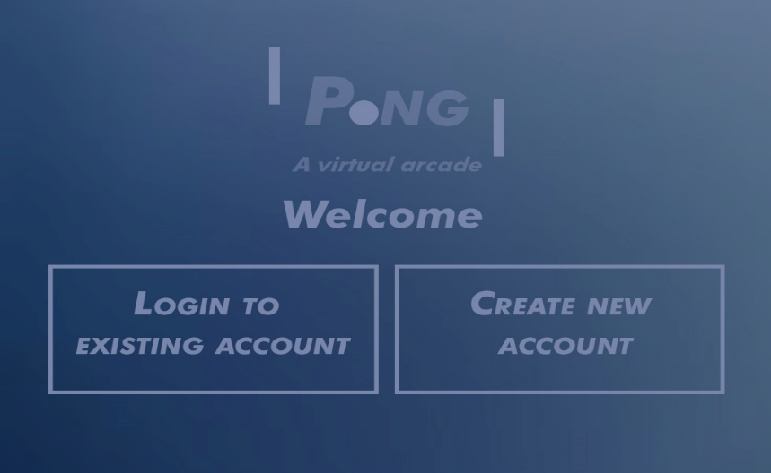WELCOME SCREEN

When users first open up our game they are welcomed with this page. This page features 2 options, a login and sign up. Existing users are prompted to login and new users are able to create an account.

Login SCREEN

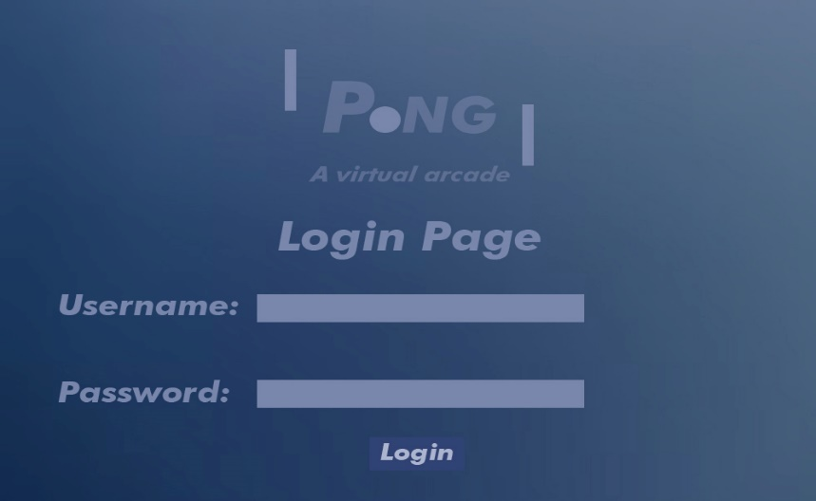When existing users return they are to log in to their account using their created username and password in order to access the main menu.

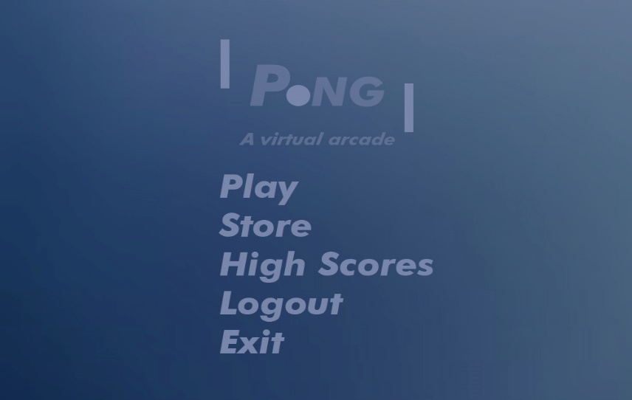MAIN MENU

In the main menu users will be able to go play the game, go to our token store, view high scores from other users, logout, and exit.

STORE PAGE

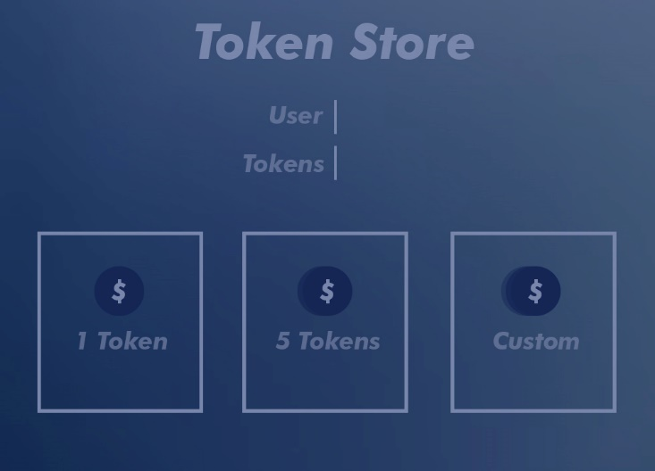This page is for the user store where users are able to purchase tokens needed to play the game.

HOW TO PLAY

1. To initiate the launch of the game you must press the space bar to get the ball of the paddle.

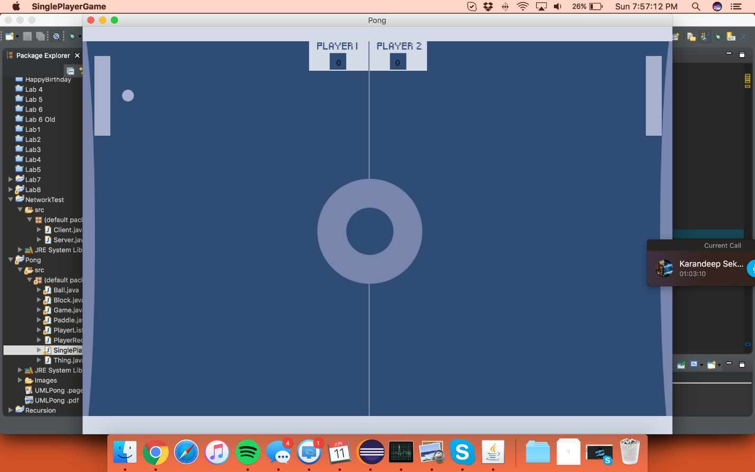

Paddle that goes up and

Down. Used to hit ball to the other

Side.