Final project-1

Step 1: instance created.

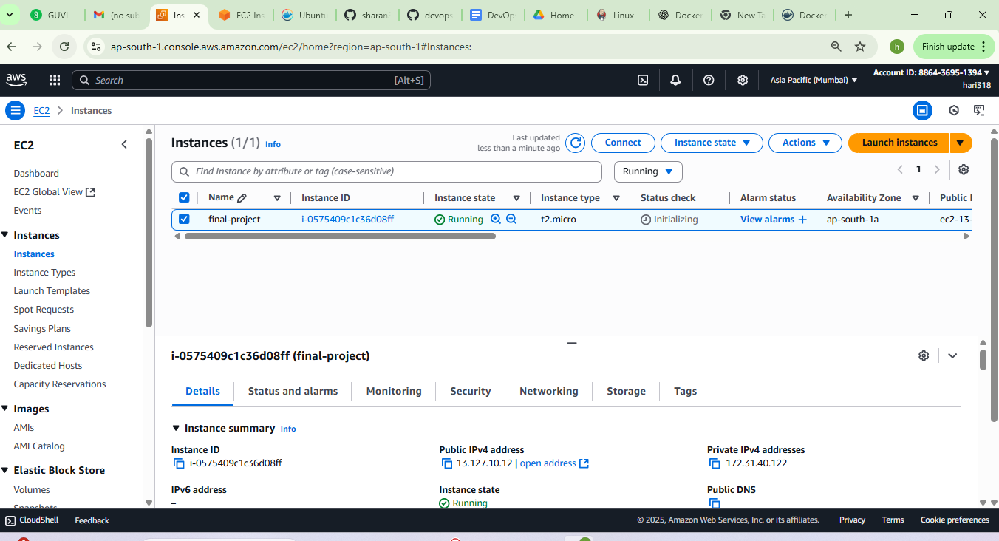

Step 2: Docker installed.

Stpe 3: Jenkins installed.

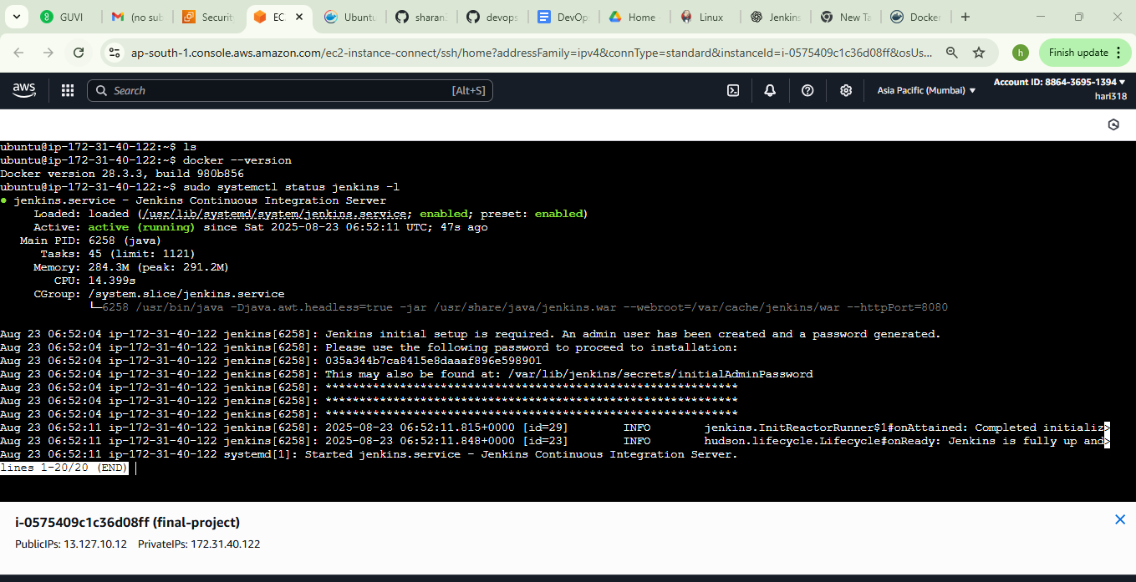

Step 4: Docker hub credential updated in Jenkins.

Step 5: docker compose. yml

Step 6 : Build.sh file

Step 7: New SG for My IP Address

Step 8 : Jenkins multibranch pipeline

Step 9: Dev branch

`

Step 10 : Main branch ( prod – deployed to server)

Step :

step 11: last build success

Step 12: Docker hub repository pushed for dev and prod.

Step 13: Output application

Step 14: Prometheus

Step15 : Jenkins added to Prometheus.

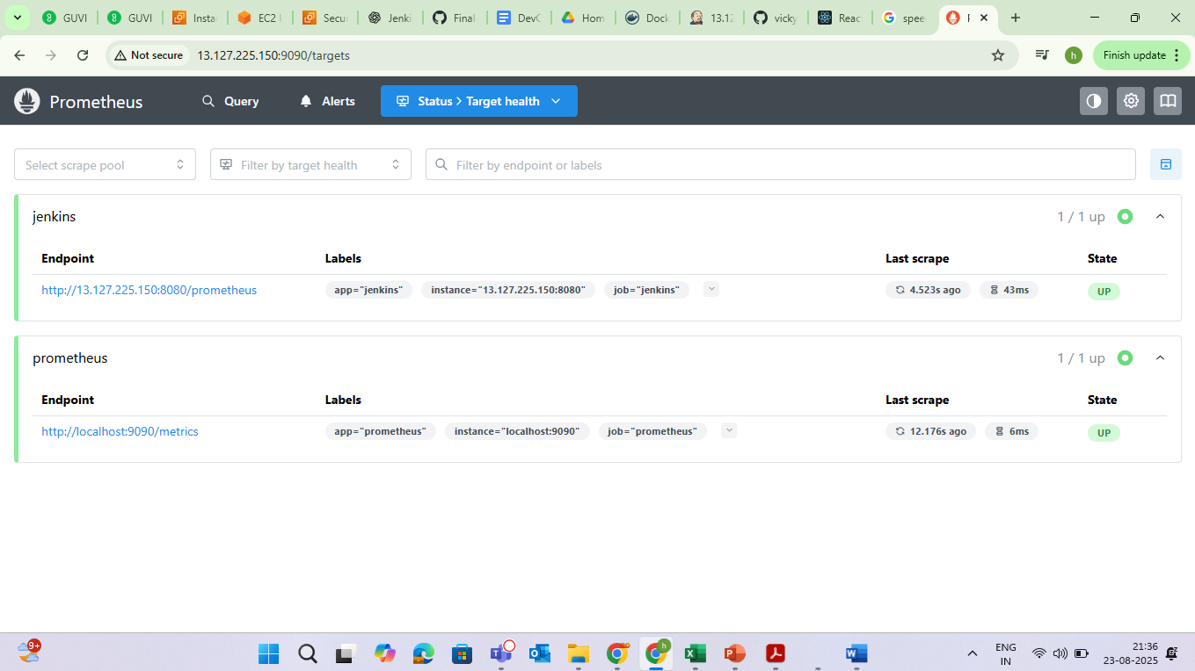

Step 16: Grafana dashboard for Jenkins using Prometheus.

