Recognition of Telugu & Sanskrit Characters
In propose work we are training Telugu & Sanskrit Hand written characters with CNN algorithm to build a model which can recognize characters from given input images. User can upload test image and then application will process each image using Morphological approach to segment characters and each segmented character will be input to CNN algorithm to recognize characters.
To implement propose work we have designed following modules
- Upload Language Dataset: using this module will upload hand written character dataset to application
- Preprocess Dataset: using this module will read all images and then perform image processing such as Resize, shuffle and normalize pixels of all dataset images
- Train & Test Split: Processed images will be input to this module to split them into train and test where application using 80% dataset for training and 20% for testing
- Train CNN Algorithm: using this module 80% training images will be input to CNN algorithm to train a model and this model will be applied on 20% test data to calculate model accuracy
- Train BI-LSTM Algorithm: using this module 80% training images will be input to BI-LSTM algorithm to train a model and this model will be applied on 20% test data to calculate model accuracy
- CNN & BI-LSTM Comparison: will plot comparison graph between CNN and BILSTM
- CNN Training Graph: using this module will plot CNN training and validation accuracy graph
- Telugu Character Recognition: using this module will upload hand written character image to application and then apply morphological approach to segment each character from the image and then input to CNN algorithm to recognize Telugu character from image.
- Sanskrit Character Recognition: using this module will upload hand written character image to application and then apply morphological approach to segment each character from the image and then input to CNN algorithm to recognize Sanskrit character from image.

SCREEN SHOTS
To run project double click on ‘run.bat’ file to get below screen
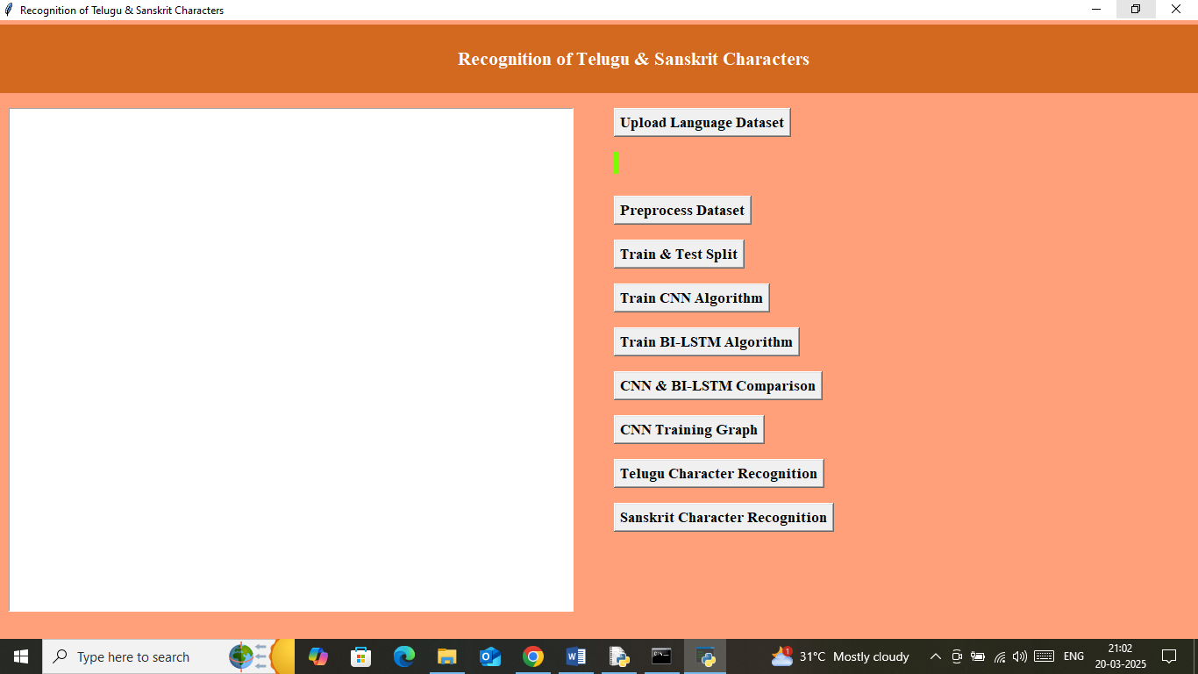
In above screen click on ‘Upload Language Dataset’ button to upload dataset and get below output
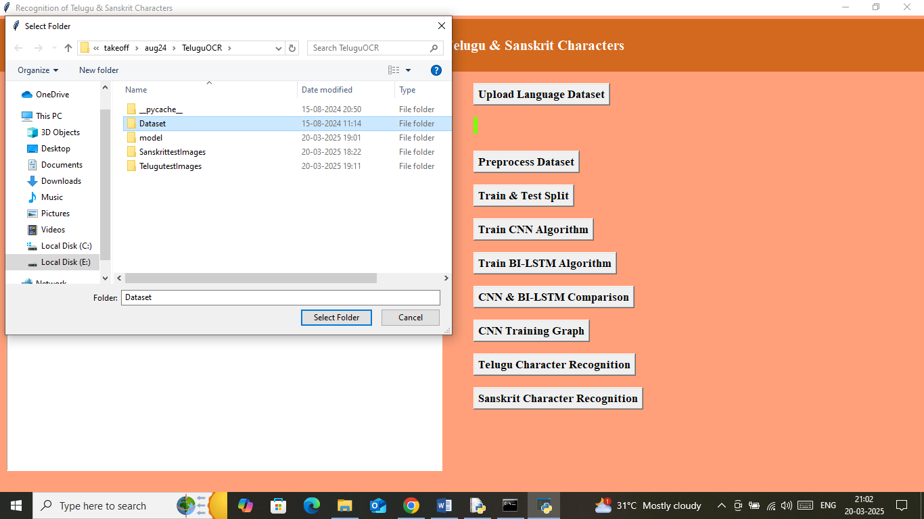
In above screen selecting and uploading dataset folder and then click on ‘Select Folder’ button to load dataset and get below output
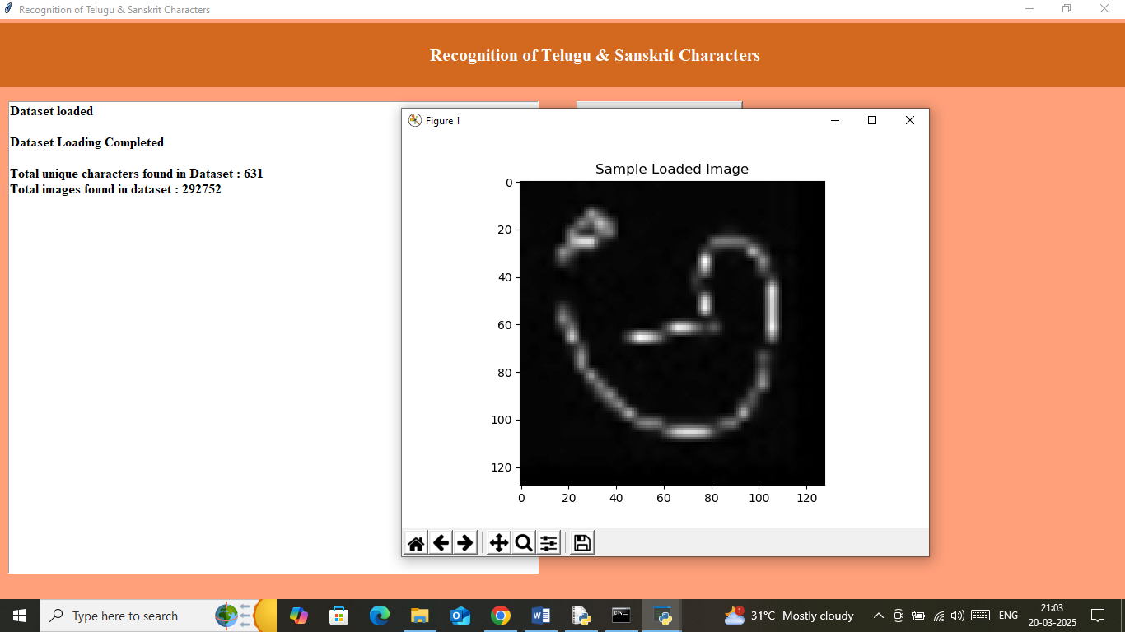
In above screen can see dataset contains 631 unique characters and can see total 292752 images loaded from dataset and then can see sample processed image and now click on ‘Pre-process Image’ button to shuffle, normalize and process images and get below output
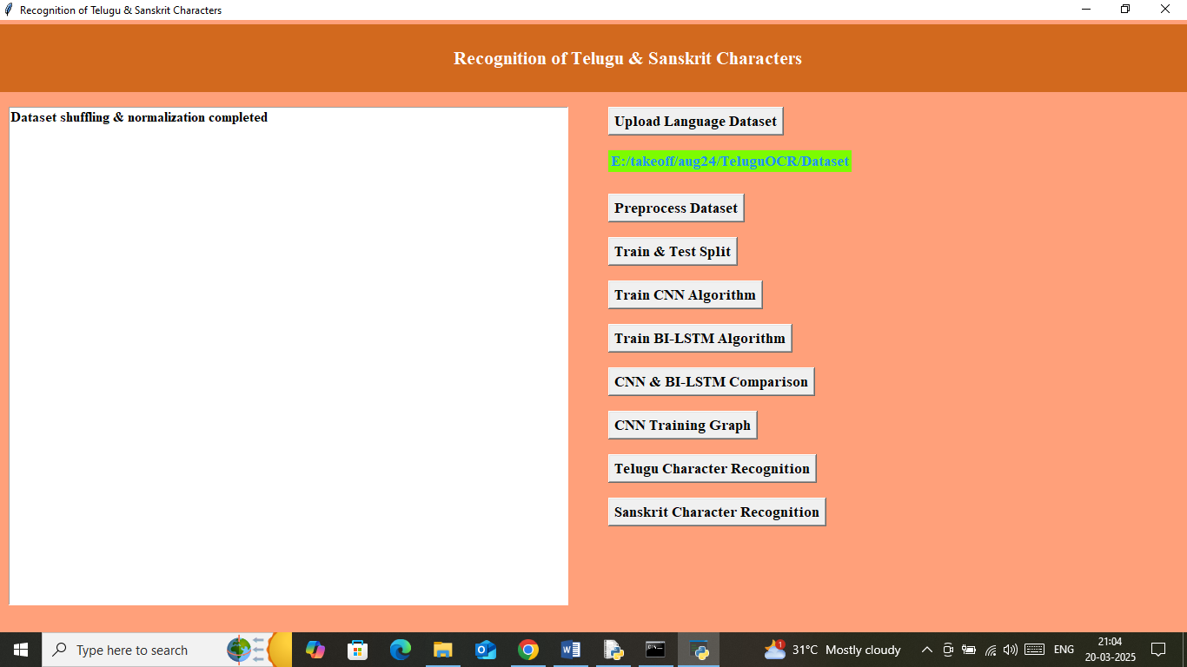
In above screen dataset processing completed and now click on ‘Train & Test Split’ button to split dataset into train and test and get below output
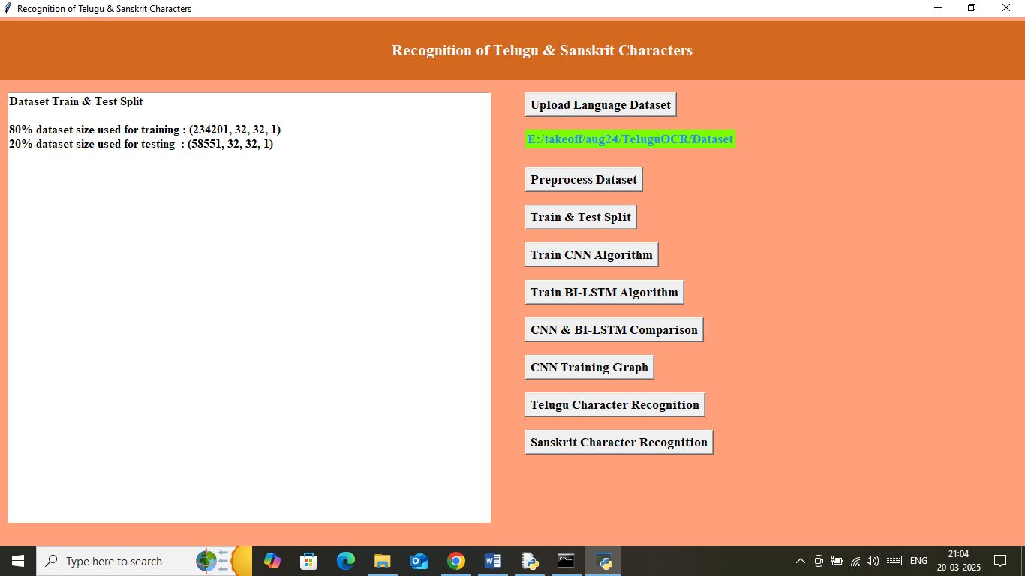
In above screen can see application using 80% (234201) images of size 32 X 32 for training and 20% (58551) images of size 32 X 32 for testing and now click on ‘Train CNN Algorithm’ button to train CNN model and get below output
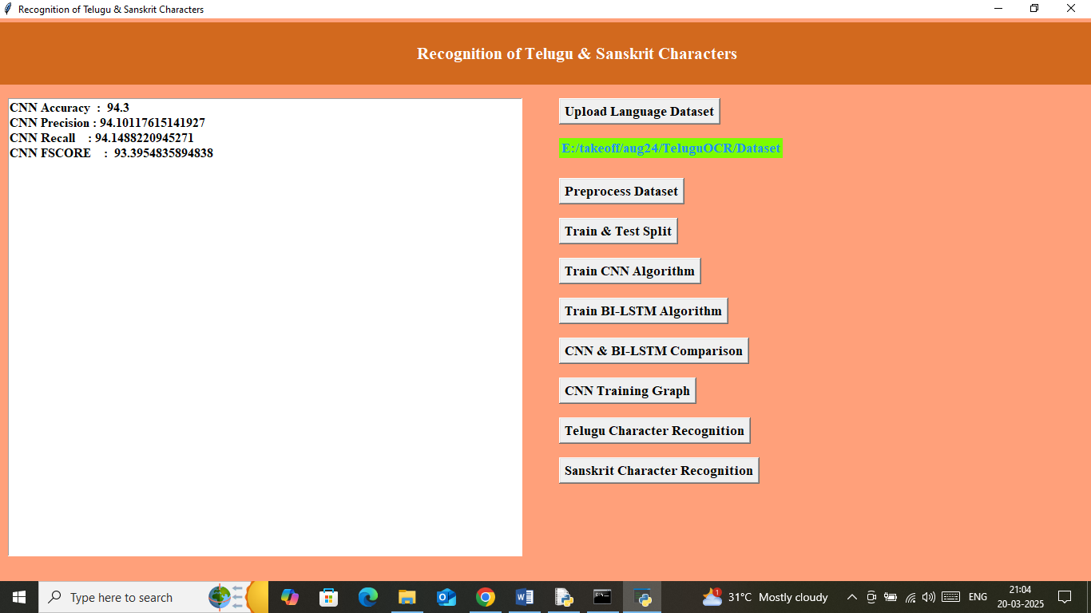
In above screen can see CNN model training completed and it got validation accuracy as 94% on testing data and can see other metrics like precision, recall and FSCORE. Now click on ‘Train BI-LSTM Algorithm’ button to train BILSTM algorithm and then will get below output
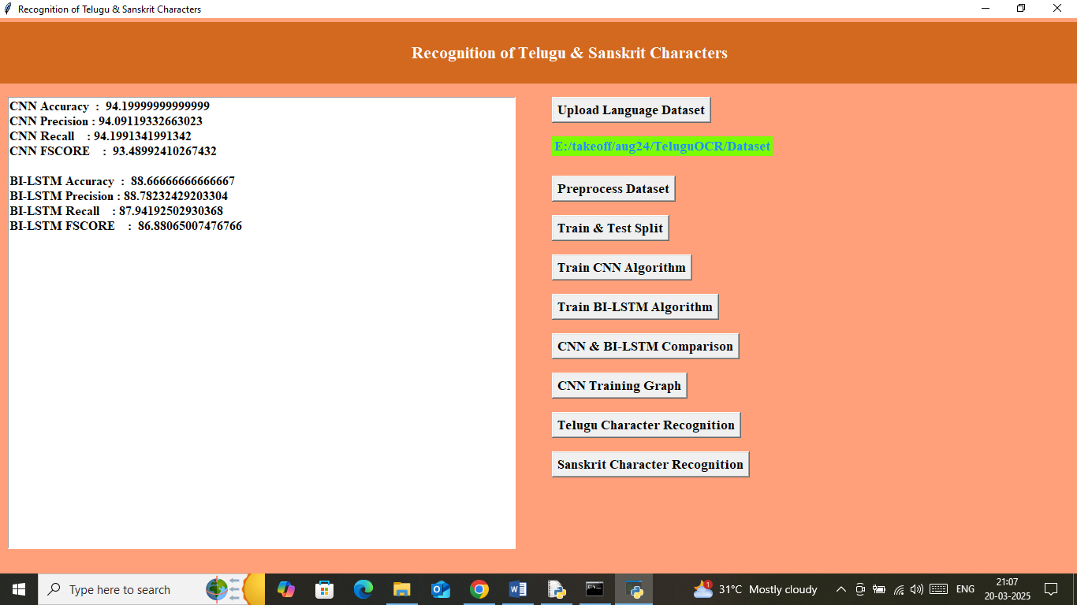
In above screen BILSTM got 88% accuracy and now click on ‘CNN & BI-LSTM Comparison’ button to get below graph
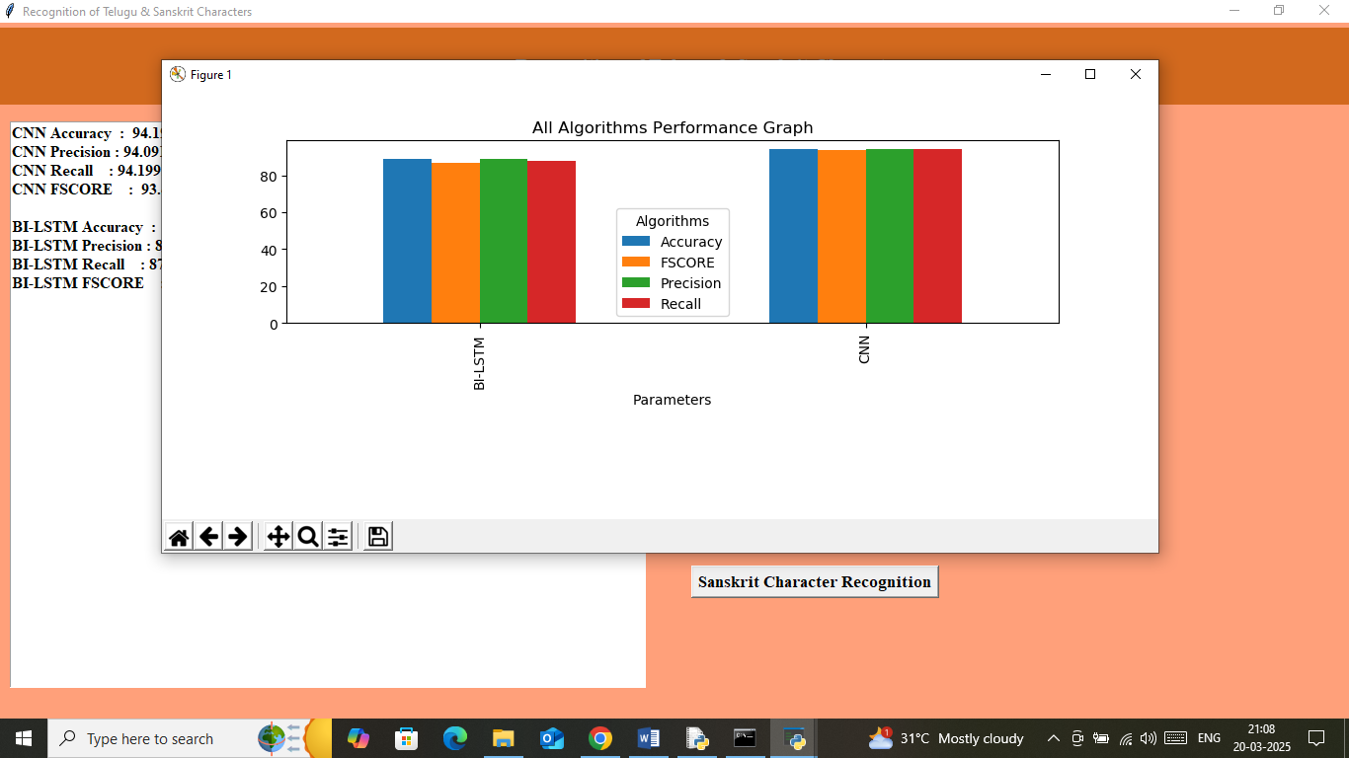
In above graph showing comparison graph between both algorithms where x-axis represents algorithm names and y-axis represents accuracy and other metrics in different color bars. In both algorithms CNN got high accuracy. Now click on ‘CNN Training Graph’ button to get below graph
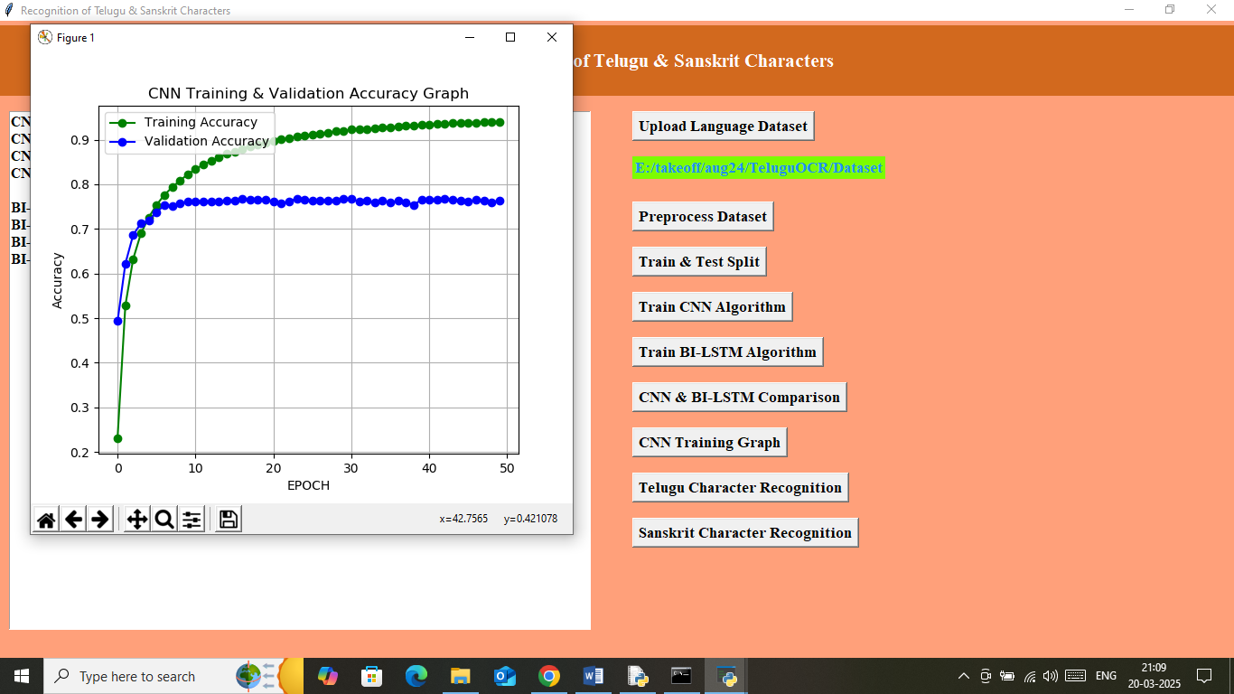
In above graph x-axis represents training epoch and y-axis represents accuracy and then green line represents Training Accuracy and blue line represents Validation accuracy and in above graph can see with each increasing epoch both training and validation accuracy got increased from 0 to 1. Now close above graph and then click on ‘Telugu Character Recognition’ button to get upload test image
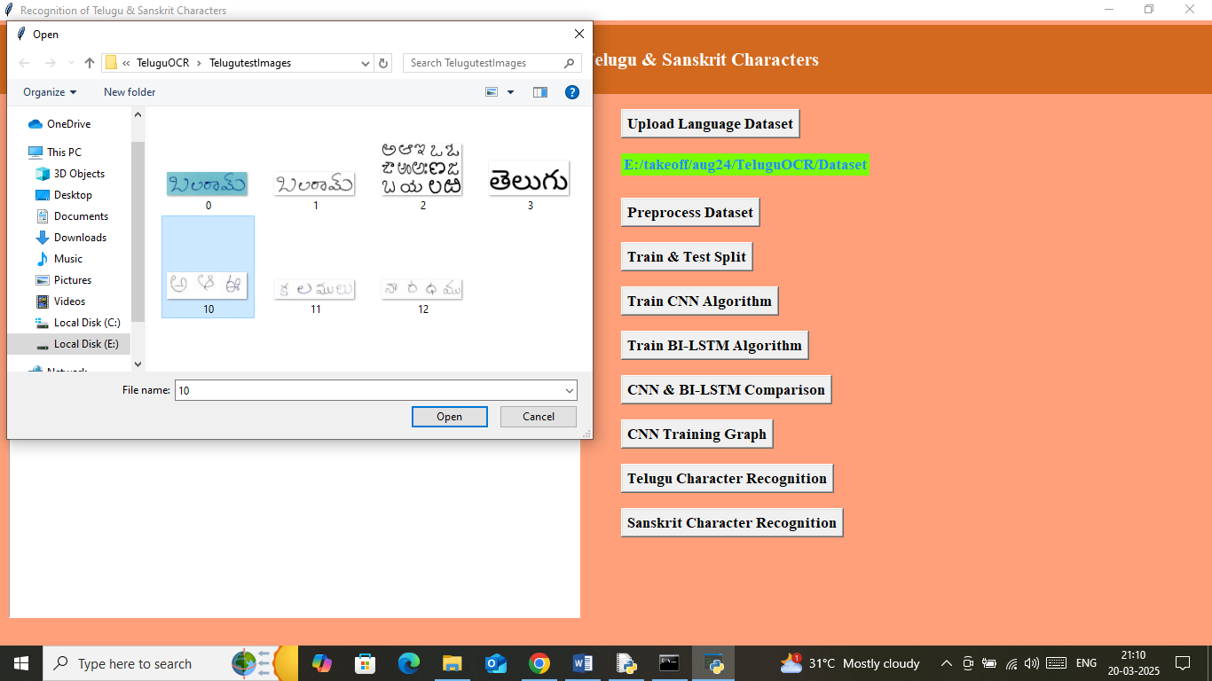
In above screen selecting and uploading 10.jpg image and then click on ‘Open’ button to get below output
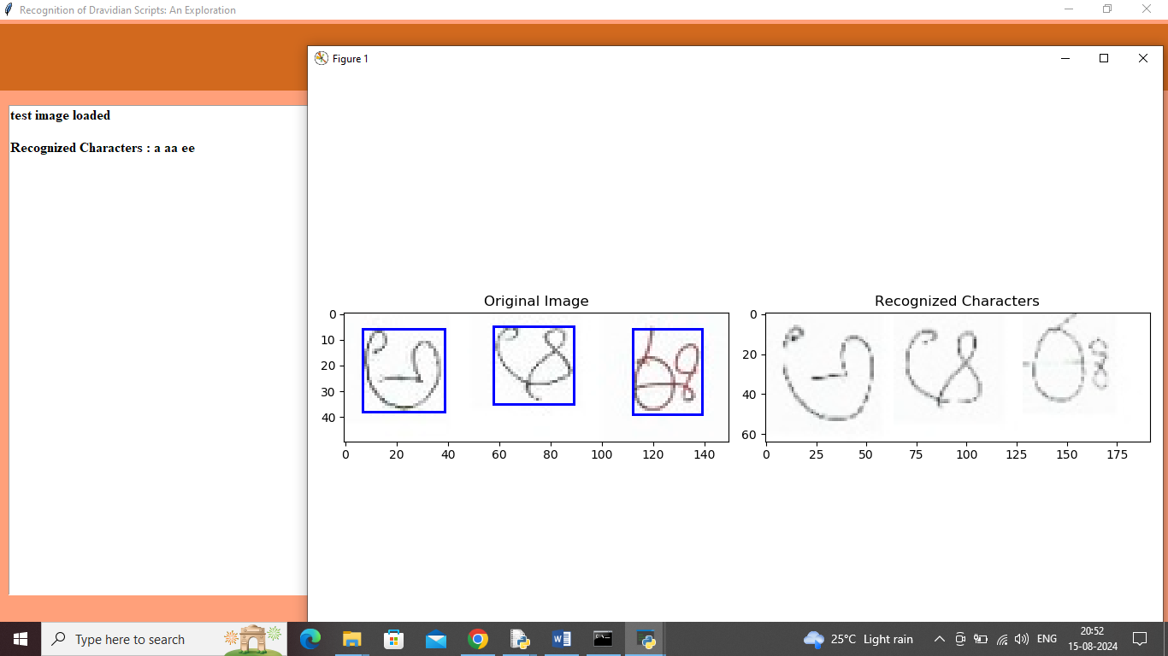
In above screen first panel showing uploaded original image and then using morphological approach segmented each character and showing in blue bounding boxes and then second panel showing predicted characters and same recognition character names we can see in text area separated with spaces. In above screen can see recognized characters as ‘a aa and ee’. Similarly can upload and test other images. Below are some more output
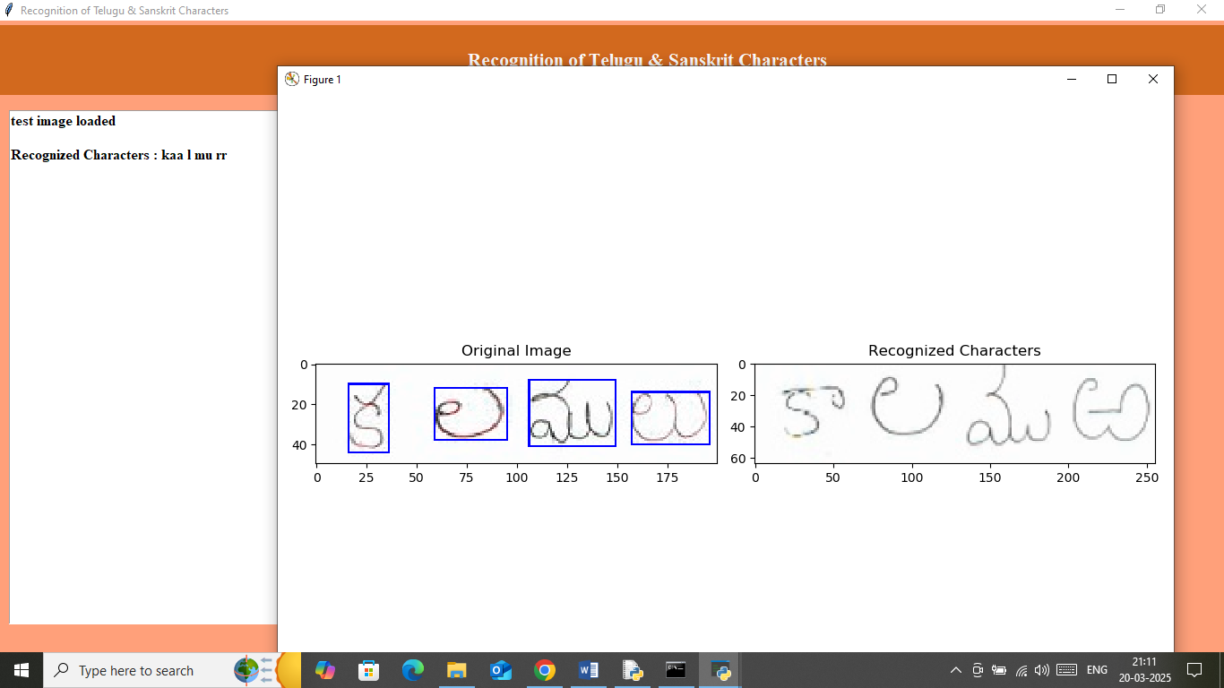
In above screen can see recognized characters as ‘kaa l mu rr’. Similarly you can upload and test other images. Now click on ‘Sanskrit Character Recognition’ button to upload Sanskrit image and then will get below output
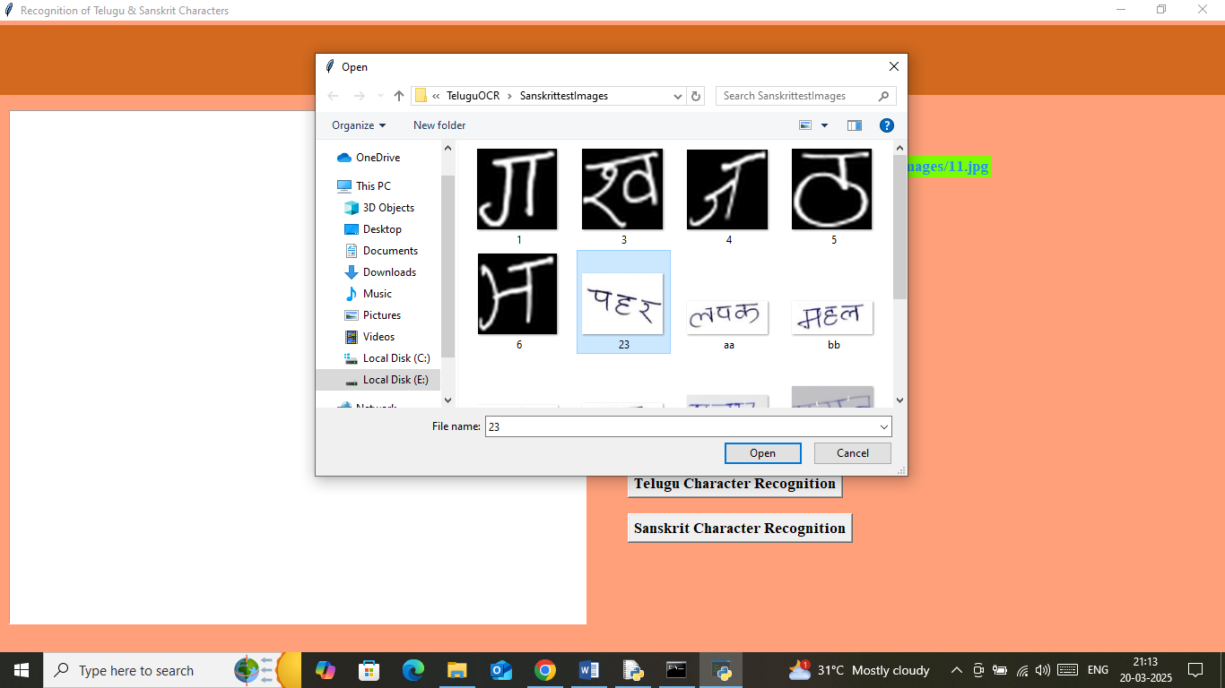
In above screen selecting and uploading test image and below is the recognition output
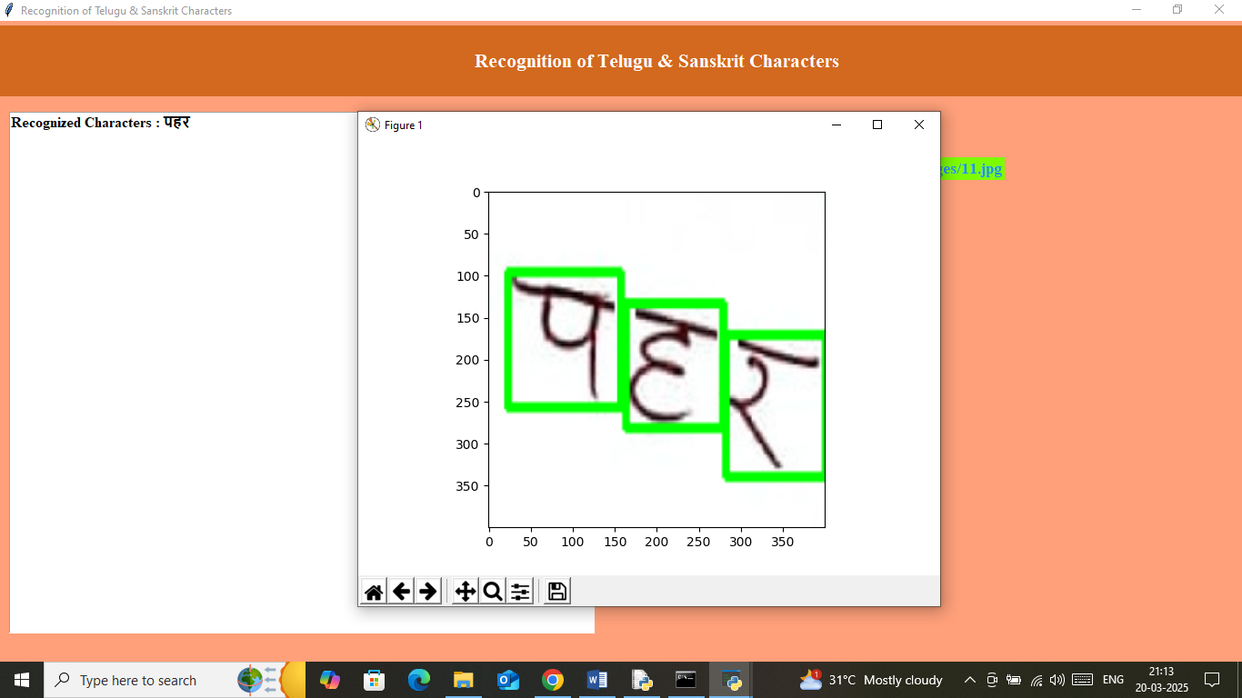
In above screen can see recognition character displaying in text area and can see with green bounding box. Below is another test images output
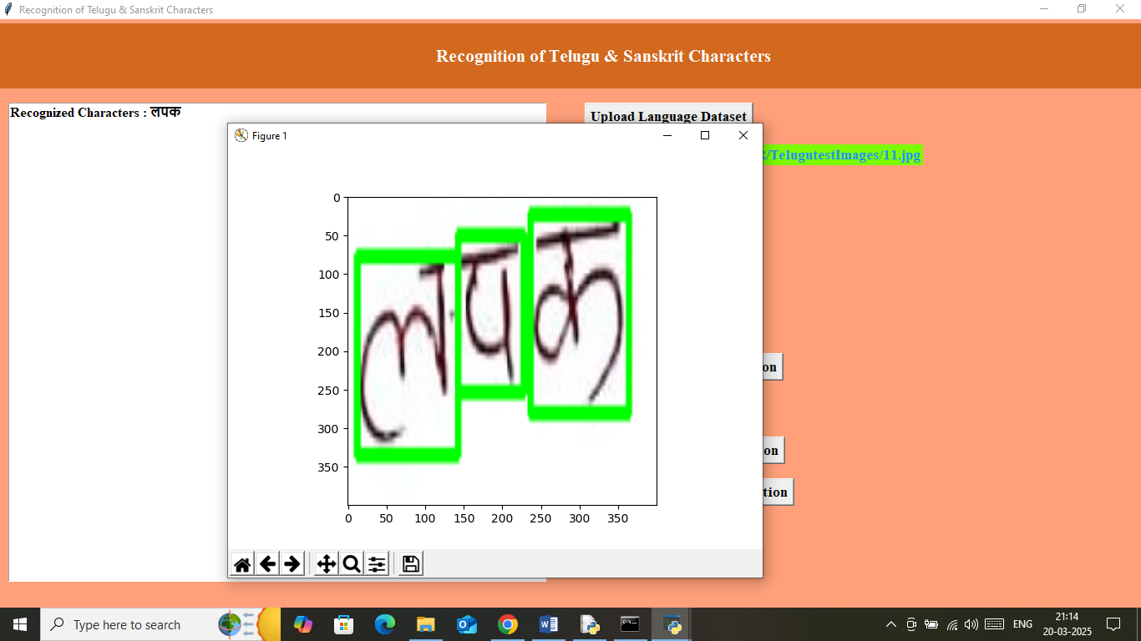
In above screen can recognized characters and similarly you can upload and test other images.
Note: application may not recognized all characters from images as no OCR software is 100% accurate on hand written images.

