Online Payment Fraud Detection Using XGBoost, DNN With WOA

A Capstone Project Report submitted in partial fulfilment of the requirements for the award of the degree of,

BACHELOR OF TECHNOLOGY IN
COMPUTER SCIENCE AND ENGINEERING (COMPUTER SCIENCE AND BUSINESS SYSTEMS)
Submitted by:

G.AKASH BU21CSEN0200131

V.JATHIN CHOWDARY BU21CSEN0200046

AKETI SHARAN BU21CSEN0200079

G.MANINDAR BU21CSEN0200168

Under the esteemed guidance of

Dr. M. CHANDRAPRABHA ASSISTANT PROFESSOR

Department of Artificial Intelligence & Data Science GITAM SCHOOL OF TECHNOLOGY
GANDHI INSTITUTE OF TECHNOLOGY AND MANAGEMENT
(Deemed To Be University) Bengaluru Campus
April 2025

DEPARTMENT OF ARTIFICIAL INTELLIGENCE AND DATA SCIENCE GITAM SCHOOL OF TECHNOLOGY
GITAM
(Deemed to be University)

DECLARATION
I hereby declare that the project report entitled “Online Payment Fraud Detection using XGBoost with DNN and WOA” is an original piece of work carried out in the Department of Computer Science and Engineering, GITAM School of Technology, GITAM (Deemed to be University), Bengaluru, submitted in partial fulfilment of the requirements for the award of the degree of B.Tech. in Computer Science and Engineering. I further affirm that this work has not been submitted to any other college or University for the award of any degree.
Date:

Student Name’s Registration No.
G.AKASH BU21CSEN0200131

V.JATHIN CHOWDARY BU21CSEN0200046

AKETI SHARAN BU21CSEN0200079

G.MANINDAR BU21CSEN0200168

DEPARTMENT OF ARTIFICIAL INTELLIGENCE AND DATA SCIENCE
GITAM SCHOOL OF TECHNOLOGY GITAM
(Deemed to be University)

CERTIFICATE

This is to certify that the project report entitled “Online Payment Fraud Detection Using XGBoost with DNN and WOA Algorithm” is a bonafide record of work carried out by GARRE AKASH (BU21CSEN0200131), VEMASANI JATHIN (BU21CSEN0200046), A.SHARAN (BU21CSEN0200079), GURRAM MANINDAR
(BU21CSEN0200168) submitted in partial fulfillment of requirement for the award of degree of Bachelors of Technology in Computer Science and Engineering

Project Guide Head of the Department

SIGNATURE OF THE GUIDE SIGNATURE OF THE HOD

Dr. M. CHANDRAPRABHA Prof. A. Vadivel
Assistant Professor Professor

ACKNOWLEDGEMENT

The satisfaction and euphoria that accompany the successful completion of any task would be incomplete without the mention of the people who made it possible, whose consistent guidance and encouragement crowned our efforts with success.
We consider it our privilege to express our gratitude to all those who guided us in the completion of the project.
We express our gratitude to Director Prof. Basavaraj Gundappa Katageri for having provided us with the golden opportunity to undertake this project work in their esteemed organization.
We sincerely thank Prof. A. Vadivel, HOD, Department of Artificial Intelligence and Data Science, Gandhi Institute of Technology and Management, Bengaluru for the immense support given to us.
We express our gratitude to our project guide Dr.M.CHANDRAPRABHA, Department of Artificial Intelligence and Data Science, Gandhi Institute of Technology and Management, Bengaluru, for her support, guidance, and suggestions throughout the project work.

Student Name’s | Registration No.
G.AKASH | BU21CSEN0200131
V.JATHIN CHOWDARY | BU21CSEN0200046
AKETI SHARAN | BU21CSEN0200079
G.MANINDAR | BU21CSEN0200168

ABSTRACT
The system first preprocesses transaction data to extract relevant features, followed by the implementation of XGBoost for initial fraud prediction, leveraging its efficiency and robustness in handling imbalanced datasets. Subsequently, the predictions are refined using a DNN, which captures complex patterns in the data. To optimize model parameters and improve accuracy, WOA is employed, inspired by the hunting behavior of whales, to efficiently navigate the solution space. The system begins by meticulously preprocessing transaction data, which involves cleaning the raw inputs to eliminate noise, handling missing values, and extracting relevant features such as transaction amounts, timestamps, device information, and location data. During this phase, comprehensive feature engineering is performed, including normalization, encoding of categorical variables, and the detection of outliers, all of which enhance the discriminative power of the dataset. Given the naturally imbalanced nature of transaction data—where fraudulent activities are far less common than legitimate transactions—techniques like oversampling, undersampling, or synthetic data generation (for example, SMOTE) may be applied to ensure that both classes are adequately represented. With a refined dataset in place, the system leverages XGBoost, a gradient boosting algorithm known for its efficiency and robustness, to perform the initial fraud prediction. XGBoost is particularly adept at handling imbalanced datasets through parameter tuning (such as adjusting the scale_pos_weight), which increases the model’s sensitivity to rare fraudulent cases while maintaining overall accuracy. Although XGBoost effectively captures broad patterns and trends within the data, it may not fully recognize the complex, non-linear relationships that often characterize fraudulent behavior. To address this limitation, a Deep Neural Network (DNN) is employed to further refine the predictions.The DNN takes advantage of multiple hidden layers to learn intricate patterns and higher-level abstractions from the features, potentially using both the raw data and the preliminary scores generated by XGBoost. Through adaptive learning and iterative weight adjustments via backpropagation, the DNN enhances the detection capability by pinpointing subtle interactions that could indicate fraud. To further elevate the performance of this combined approach, the Whale Optimization Algorithm (WOA) is implemented to fine-tune the model’s hyperparameters. Inspired by the bubble-net hunting behavior of humpback whales, WOA explores

the hyperparameter space by systematically adjusting parameters such as learning rates, the number of layers, and neuron counts, ultimately converging on an optimal configuration that maximizes accuracy and efficiency. In essence, this integrated approach—starting with robust data preprocessing and feature extraction, followed by the dual-model prediction strategy of XGBoost and DNN, and culminating with the sophisticated parameter optimization provided by WOA— creates a powerful and efficient system for detecting online payment fraud, capable of adapting to the complex and evolving patterns of fraudulent transactions.

TABLE OF CONTENTS
Title | Page No.
Declaration | ii
Acknowledgement | iv
Abstract | v-vi
Table of Contents | vii
List of Figures | viii
List of Tables | ix
1. INTRODUCTION | 10-12
2. LITERATURE SURVEY | 13-17
3. SOFTWARE AND HARDWARE SPECIFICATIONS | 18-22
3.1 Introduction | 18
3.2 Specific Requirements | 19
3.2.1 Functional Requirement | 20
3.2.2 Non-Functional Requirement | 19
3.3 Hardware and Software Requirement | 22
3.3.1 Hardware Requirement | 22
3.3.2 Software Requirement | 20
4. PROBLEM STATEMENT | 23-24
4.1 Objectives | 23
5. DESIGNING | 25-28
5.1 System Architecture | 25-27
5.2 Methodology | 27-28
5.2.1 XGBoost, DNN, WOA | 27-28
6. IMPLEMENTATION | 29-31
7. EXPERIMENTAL RESULTS | 32-41
8. CONCLUSION | 42
9. FUTURE WORK | 43
REFERENCES | 44-47

 | LIST OF FIGURES
Fig | Title | Page No.
1. | Block diagram for Online payment fraud detection | 25
2. | Usecase Diagram of Online payment fraud detection | 26
3 | Confusion Matrix for XGBoost | 32
4 | Confusion Matrix for DNN | 33
5 | pairplot visualization | 35
6. | Comparison of classification Matrics | 37
7. | Correlation Matrix | 38

LIST OF TABLES

Table No. Title Page No.
1. Hardware requirements 20-21
2. Software Requirements 21-22

CHAPTER 1 INTRODUCTION
Online payment fraud detection using XGBoost and DNN with WOA is a method for identifying fraudulent transactions in online payments. It combines XGBoost, a powerful machine learning algorithm, and Deep Neural Networks (DNN) to analyze transaction data. The Whale Optimization Algorithm (WOA) is used to improve the accuracy of these models by optimizing their parameters. Together, this approach enhances the ability to detect and prevent fraudulent activities, ensuring safer online transactions.

Challenges

Complexity: Combining XGBoost, DNN, and WOA into a single model adds complexity in terms of both architecture and computational resources. Computational Cost: Training both XGBoost and DNN models, along with running the Whale Optimization Algorithm, may require significant computational resources, especially if the dataset is large Tuning WOA: WOA itself has parameters (e.g., population size, number of iterations) that need tuning for optimal performance. These must be carefully adjusted to get the best results from the model
XGBoost (Extreme Gradient Boosting) is a highly efficient and scalable implementation of the gradient boosting algorithm. It’s widely used in machine learning for tasks such as classification and regression due to its high performance, flexibility, and ability to handle a wide range of data types.
A DNN (Deep Neural Network) is a type of artificial neural network with multiple layers between the input and output layers. It is called "deep" because it has more than one hidden layer, allowing it to learn complex patterns and features from the data.
The Whale Optimization Algorithm (WOA) is a nature-inspired optimization algorithm that mimics the hunting behavior of humpback whales. It is used to find optimal solutions to complex problems by simulating how whales encircle and trap prey in a bubble-net formation

What is Online Payment Fraud?

- Essentially,it involves unauthorized or deceptive transactions conducted over the internet.
- This can lead to financial losses for individuals, businesses, and financial institutions.
- It encompasses various forms, including:
  - UPI fraud: Unauthorized use of information.
  - Identity theft: Stealing personal information to make fraudulent transactions.
  - Phishing: Tricking users into revealing sensitive information.
  - Chargeback fraud: Dishonestly disputing legitimate transactions.

Why is it a Growing Problem?

- The increasing prevalence of e-commerce and online financial services.
- The anonymity and global reach of the internet.
- The sophistication of modern fraud techniques.

The Need for Fraud Detection:

- To protect consumers and businesses from financial losses.
- To maintain trust in online payment systems.
- To prevent damage to reputations of financial institutions and online retailers.

How is Fraud Detected?

- Traditionally, rule-based systems were used.
- Increasingly, advanced technologies like machine learning and artificial intelligence are being employed.
- These technologies can analyze vast amounts of transaction data to identify patterns and anomalies that indicate fraudulent activity.
- Key technologies used include:
  - Machine learning algorithms: To detect patterns and anomalies.
  - Data analysis: To identify suspicious activity.

  - Real-time monitoring: To flag fraudulent transactions as they occur.

Key Challenges:

- Fraudsters are constantly evolving their tactics.
- The sheer volume of online transactions makes detection complex.
- Balancing fraud detection with minimizing false positives (flagging legitimate transactions) is crucial

CHAPTER 2 LITERATURE SURVEY
  - Literature Survey Paper -1: Personal loan default prediction and impact analysis of debt/DR raj Gopal April 2023
The paper titled “Personal Loan Default Prediction and Impact Analysis of Debt” by Dr. Raj Gopal (April 2023) focuses on predicting the likelihood of default among personal loan borrowers and examining how varying levels of debt influence the probability of default. The study underscores the critical role of early intervention—such as proactive monitoring of borrowers with high debt-to-income ratios or those showing early signs of financial distress—in reducing financial losses for lending institutions. By highlighting the correlation between debt levels and default risk, the paper draws attention to how even marginal increases in outstanding debt can significantly elevate a borrower’s likelihood of missing payments or defaulting entirely.
From a methodological standpoint, the paper employs Logistic Regression and Support Vector Machines (SVM) to model and predict default outcomes. Logistic Regression is chosen for its interpretability; it allows researchers and financial analysts to understand the weight of each predictor (e.g., debt ratio, income level, credit score) on the probability of default. SVM, on the other hand, is recognized for its robustness in handling non-linear relationships in the data, potentially capturing complex interactions between borrower characteristics that Logistic Regression might oversimplify. In practice, the paper compares both models, evaluating their performance through standard metrics like accuracy, precision, recall, and the area under the ROC curve (AUC).
The findings reveal that higher levels of outstanding debt (often measured via debt-to-income ratio or total debt amount) are strongly correlated with an increased risk of default. This insight points to the need for early intervention strategies, such as enhanced credit counseling, restructuring of loan terms, or tighter monitoring of high-risk borrowers. By intervening earlier, financial institutions can mitigate potential losses and maintain healthier loan portfolios.

Despite the promising results, the authors identify a research gap related to dataset limitations. The paper emphasizes the need to expand the dataset—both in terms of size and diversity—to improve the generalizability of the models. Currently, the models may be constrained by the specific demographics or geographic region represented in the data, limiting their applicability across broader borrower populations. In addition, the study hints at exploring more advanced techniques, such as ensemble methods or deep learning architectures, once a richer dataset is available. By addressing these gaps, future research could develop more universally applicable models, offering more accurate default predictions and deeper insights into the interplay between debt levels and default risk.
  - Literature Survey paper-2: Research on credit risk models via machine learning algorithm and logistic regression for prediction/kera.
The paper titled “Research on Credit Risk Models via Machine Learning Algorithms and Logistic Regression for Prediction” (by Kera, date unspecified) provides an in-depth comparative study of how different machine learning techniques can be harnessed to forecast the likelihood of loan default and manage credit risk. Specifically, it focuses on Decision Trees, XGBoost, and Logistic Regression, evaluating their strengths and weaknesses in terms of predictive accuracy, computational efficiency, and interpretability. The core motivation for this work stems from the growing need for financial institutions to accurately gauge the default risk posed by loan applicants, which can significantly impact the institution’s financial health and regulatory compliance.
From a methodological standpoint, the paper first highlights the interpretability of Decision Trees, which serve as a foundational model capable of identifying key risk factors such as income levels, credit scores, and debt-to-income ratios. This interpretability makes them relatively easy to adopt within traditional banking environments where transparency is critical. XGBoost is then introduced as a more advanced, ensemble-based approach that iteratively refines decision trees to achieve higher accuracy and more robust handling of complex data. Compared to Decision Trees, XGBoost often demonstrates superior performance, especially with large and imbalanced datasets. Meanwhile, Logistic Regression is utilized as a benchmark, given its longstanding role in credit risk assessment. Although Logistic Regression can be less

powerful for non-linear data patterns, it remains popular for its simplicity and ability to provide clear insights into how individual variables influence the probability of default.
The results indicate that while XGBoost generally achieves higher accuracy, both Decision Trees and Logistic Regression have advantages in terms of model explainability. This is particularly relevant in regulated financial environments where stakeholders require clear justifications for lending decisions. Moreover, the study points out a significant research gap related to user interface simplicity. Even the most accurate model can be underutilized if loan officers, underwriters, and other non-technical staff find it too complex to interpret and integrate into their workflow. Consequently, the authors recommend future work on creating intuitive dashboards, automated reporting mechanisms, and visual explanations that bridge the gap between sophisticated predictive analytics and day-to-day decision-making processes. This focus on user- centric design ensures that the benefits of machine learning are more broadly accessible, ultimately leading to more proactive and effective credit risk management.
  - Literature Survey paper-3: Credit default via interpretable ensemble transfer june 2024
The paper titled “Credit Default via Interpretable Ensemble Transfer” by P. Oladejo Juhe (2024) introduces an innovative approach called TrLightGBM, designed to enhance credit risk assessment by integrating data from multiple domains and applying a weight-adjustment mechanism to improve prediction accuracy. The study begins by underscoring the complexities in credit risk modeling, particularly when financial institutions have access to diverse datasets that range from transactional histories to socio-demographic profiles. By adopting a transfer learning paradigm, the model effectively leverages insights gained from one dataset to inform predictions on another, thereby capturing a broader range of risk factors than traditional single- dataset models. This transfer of knowledge helps reduce overfitting and enriches the overall
feature space, ultimately contributing to a more reliable default prediction process.In terms of methodology, the paper references SVM (Support Vector Machine) and Logistic Regression as comparative benchmarks to highlight the efficacy of TrLightGBM. While SVM is praised for its robust handling of non-linear patterns, Logistic Regression offers interpretability in terms of how individual features influence default probability. TrLightGBM seeks to bridge these strengths by providing not only high predictive accuracy but also improved transparency. To achieve this, the model incorporates adjustable weighting schemes that allow analysts to fine-tune how much

influence each dataset or domain has on the final prediction. This adjustable weighting is particularly important for maintaining interpretability, as it clarifies which data sources most significantly impact the model’s decisions. Despite these advancements, the paper points out that handling imbalanced datasets—a common scenario where default cases are far fewer than non- default cases—remains a key challenge. Moreover, while TrLightGBM aims to be more interpretable than black-box models, further work is necessary to refine its explanation mechanisms so that stakeholders, such as credit officers and regulators, can fully trust and adopt the system.
  - Literature Survey paper-4: Enhancing Online Payment Fraud Detection through Graph Neural Networks (GNNPay) – March 2024.The paper titled “Enhancing Online Payment Fraud Detection through Graph Neural Networks (GNNPay)” by L. Zhang and X. Wei (2024) presents a novel fraud detection framework that leverages graph neural networks (GNNs) to uncover hidden transactional patterns in online payments. The study begins by highlighting the growing sophistication of fraudulent activities in digital payments, particularly in e-commerce and peer- to-peer (P2P) transactions. Fraudsters continuously evolve their techniques, making traditional rule-based and supervised learning models increasingly ineffective due to their reliance on predefined patterns. GNNPay addresses this challenge by modeling transactions as a dynamic graph, where nodes represent users and edges represent payment interactions. By capturing relational dependencies between users and their historical transactions, GNNPay improves anomaly detection beyond what is achievable with conventional feature-based models.
In terms of methodology, the paper compares Random Forest, Support Vector Machines (SVM), and Recurrent Neural Networks (RNNs) as baselines. While Random Forest is lauded for its robustness to noisy data, it struggles with high-dimensional interactions. SVM, though strong in classification, lacks scalability in large-scale financial datasets. RNNs capture sequential patterns but fail to model user-to-user relationships effectively. GNNPay bridges these gaps by utilizing graph attention mechanisms to assign higher weights to suspicious transaction paths while maintaining computational efficiency. One key advantage of GNNPay is its adaptability—it can generalize across different online payment systems without requiring extensive retraining, making it particularly useful for banks and fintech firms.

Despite these advancements, the paper acknowledges that real-time inference in graph-based models remains computationally expensive, potentially delaying fraud detection in high- frequency transaction environments. Moreover, GNNPay still relies on historical fraud labels, meaning it struggles with zero-day frauds where entirely new attack patterns emerge. Future improvements aim to integrate self-supervised learning techniques to enhance its adaptability to previously unseen fraudulent behaviors.
  - Literature Survey paper-5:Anomaly Detection in Online Payments using Self-Supervised Learning (SS-Fraud) – June 2024.The paper “Anomaly Detection in Online Payments using Self- Supervised Learning (SS-Fraud)” by A. Patel and S. Kumar (2024) introduces a self-supervised learning framework designed to detect fraud in online transactions without relying on labeled fraud instances. The study addresses a critical challenge in fraud detection: the scarcity of labeled fraudulent transactions, as fraudsters constantly evolve their tactics, making it difficult for traditional supervised models to remain effective. By leveraging self-supervised contrastive learning, SS-Fraud generates high-quality embeddings for transactions, allowing the model to distinguish normal from abnormal behavior without explicit fraud labels.
The paper benchmarks SS-Fraud against K-Means Clustering, Principal Component Analysis (PCA), and Variational Autoencoders (VAEs). K-Means and PCA, though useful for dimensionality reduction, struggle to detect evolving fraud patterns. VAEs, while powerful, tend to reconstruct fraudulent transactions too well, leading to low anomaly scores for actual fraud cases. SS-Fraud addresses these limitations by using contrastive learning to enhance the separation between fraudulent and non-fraudulent transaction embeddings. This approach allows financial institutions to detect new types of fraud that were not present in training data.
Additionally, it reduces reliance on manually labeled datasets, decreasing operational costs for financial institutions. However, the paper points out that the model’s sensitivity to noisy transaction data can lead to higher false positive rates, potentially flagging legitimate transactions as fraudulent. To address this, the authors propose integrating human-in-the-loop verification systems, where flagged transactions undergo manual review before final rejection. Future work aims to enhance adaptive learning mechanisms that allow SS-Fraud to dynamically adjust its fraud detection criteria based on evolving attack patterns.

CHAPTER 3

SOFTWARE AND HARDWARE SPECIFICATIONS

Introduction
This outlines the hardware and software requirements necessary for creating and deploying the Online payment Frauds. The system is based on machine learning applied to a pre-processed dataset that includes payments, locations, phone numbers, Transaction ID. It must be able to give real-time, via a friendly web interface. The software requirements address both functional and non-functional aspects, such as data preprocessing, model deployment, implementation, frontend UI development, security features, and user feedback incorporation. The hardware requirements define the computing resources required to support efficient processing, scalability, and smooth user experience on different devices. Collectively, these requirements guarantee the reliability, precision, and efficacy of the system.
With increasing digital transactions, there are also increasing complex fraudulent activities that necessitate the creation of intelligent fraud detection systems that can perform in real-time. This project seeks to develop and implement a sophisticated fraud detection system using machine learning methods for detecting and avoiding fraudulent transactions.The system is programmed to scan a broad spectrum of transactional attributes, such as payment values, geographies, phone numbers, and transaction IDs, to identify anomalies and suspicious transactions. Through the incorporation of real-time processing functions, the system guarantees that fraudulent transactions are detected and flagged before they are finalized, minimizing financial risks for users and businesses.
For this, the system needs a robust combination of hardware and optimized software, encompassing several areas like data acquisition, preprocessing, training of the model, deployment, and user interface. Security features like encryption, authentication, and fraud reporting functionality are also embedded to improve system integrity and user trust.
In addition to fraud detection, the system is also scalable and adaptive so that it can handle high volumes of transactions as well as changing fraud patterns. By using machine learning models that learn to adapt with every new pattern of fraud, the system will become increasingly accurate

and efficient in the long run. Moreover, a simple web interface makes it possible for businesses and financial analysts to interact with the system, analyze flagged transactions, and give feedback for improvement.

Specific Requirements
    - Functional Requirements

Data Preprocessing and Balancing:
- Cleans and encodes the dataset using pandas and NumPy for structured processing.

Machine Learning-Based Online payment fraud detection:
- Utilizes Normalization and scaling Techniques
- Predicts the fraud based on the machine learning techniques and three methods

Frontend User Interface & Interaction:
- Accepts Frauds and payments history from the user and provides recommendations
via an UPI(PAYTM, GPAY).
- Developed using HTML, CSS, and JavaScript for responsiveness and ease of use.

User Feedback Collection & Storage:
In-system prompts: Triggered after specific periods or interactions. Email surveys: Sent out periodically to gather detailed feedback.
Customer support interactions: Documenting feedback received during support queries.

Non-Functional Requirements

Performance:
        - The system should process transactions in real-time or near real-time to minimize delays.
        - The system should handle a high volume of transactions efficiently, especially during peak hours.

Scalability:
        - The system should be scalable to accommodate future increases in transaction volume and data.
        - It should be able to handle additional users and data without significant performance degradation.

Security:
        - The system must comply with industry standards for data protection and privacy (e.g., GDPR, PCI DSS).
        - Implement robust security measures to protect against unauthorized access and cyber threats.

Usability:
        - The system should have an intuitive and user-friendly interface for both administrators and end-users.
        - Provide clear and concise reports and visualizations for easy interpretation of fraud detection results.

Maintainability:
        - The system should be designed for ease of maintenance and updates.
        - Code should be well-documented and modular to facilitate future enhancements and troubleshooting.

Reliability:
        - The system should have high availability and fault tolerance to ensure continuous operation.
        - Implement backup and recovery mechanisms to prevent data loss.

Hardware and Software Requirements

    - Hardware Requirements

TABLE 1. Hardware requirements

Components | Function | Purpose
Processor (CPU) | Training the machine learning models (XGBoost, DNN)  Running the Whale  Optimization Algorithm | Ensures fast real-time processing

 | (WOA)
8 GB RAM (Server) | Supports multi-user requests | Reduces processing lag
SSD Storage | Stores dataset and logs | Ensures smooth data handling

Software Requirements

TABLE 2. Software Requirements

Software | Purpose
Operating System (Server): Linux or Windows | Context of fraud detection, a compatible OS is necessary to run the required software and tools efficiently.
Programming Languages | Python 3.7 or higher
HTML, CSS, JavaScript | Builds a responsive user interface
pandas | Processes and cleans input data
scikit-learn | Implements Decision Tree, Random Forest, and SVM models

Matplotlib & Seaborn | Visualizes model performance and feedback trends
Google Colab or VS Code | Used for model training and code execution

CHAPTER 4
PROBLEM STATEMENT
“As online transactions continue to grow in prevalence and complexity, the incidence of payment fraud has become a significant concern for businesses and consumers alike. Traditional fraud detection methods often struggle to keep pace with the evolving tactics employed by fraudsters, leading to increased financial losses and a decline in consumer trust. This project aims to address the urgent need for more robust and effective online payment fraud detection systems. By leveraging advanced machine learning techniques, specifically XGBoost and Deep Neural Networks (DNN), combined with the Whale Optimization Algorithm (WOA) for feature selection and parameter tuning, this project seeks to enhance the accuracy and efficiency of fraud detection in real-time transactions.”

Objectives

Collecting and Preprocessing the Dataset

The first objective centers on gathering a reliable and representative dataset of online payment transactions that includes both legitimate and fraudulent cases. Data collection may involve sourcing from publicly available repositories or collaborating with financial institutions to obtain real-world transaction logs. Once the dataset is acquired, preprocessing steps are essential to ensure data quality and integrity. This involves cleaning the data by handling missing values, outliers, and inconsistencies. Feature engineering techniques—such as normalization, encoding categorical variables, and generating new derived features—further refine the dataset. These steps help capture the underlying patterns in transaction behavior, setting a solid foundation for accurate model training.
- Training the Model (XGBoost, DNN, and WOA)

After the dataset is preprocessed, the second objective focuses on training the hybrid model. First, XGBoost is employed for its efficiency in handling structured data and its ability to deal with imbalanced classes—a frequent scenario in fraud detection. Next, a Deep Neural Network (DNN) is introduced to learn more complex, non-linear relationships that might be missed by tree-based methods alone. Finally, the Whale Optimization Algorithm (WOA) is integrated to fine-tune

hyperparameters for both XGBoost and DNN, ensuring that the final model achieves optimal performance. Inspired by the bubble-net hunting strategy of humpback whales, WOA navigates the parameter space systematically, balancing exploration and exploitation to arrive at the best combination of parameters for accurate and robust fraud detection.

Evaluating Model Performance

The third objective is to thoroughly assess how well the trained model performs. Standard evaluation metrics such as Confusion Matrix, Precision, Recall, F1-score, and Accuracy are used to gauge the model’s ability to correctly identify fraudulent transactions while minimizing false positives. The confusion matrix provides a detailed breakdown of predictions (true positives, false positives, true negatives, and false negatives), helping pinpoint specific areas for improvement. Metrics like precision and recall offer insights into the trade-offs between catching all fraudulent activities and avoiding excessive false alarms, while the F1-score balances these two concerns. Accuracy indicates the overall percentage of correct predictions, and error rate can highlight how often the model misclassifies transactions. Collectively, these metrics paint a comprehensive picture of the system’s effectiveness.
- Comparing Model Accuracy with Efficiency

The final objective involves comparing the model’s accuracy with its efficiency, often referred to as the trade-off between performance and computational cost. While a highly complex model may yield marginally better accuracy, it can also be more resource-intensive and slower to run in real-world environments where rapid transaction approvals are crucial. By benchmarking the hybrid model’s performance against simpler or more conventional methods, developers can evaluate whether the gains in accuracy justify the additional computational overhead. This comparison helps stakeholders decide on the most practical approach for deployment—one that strikes an optimal balance between detection capability and operational feasibility, ensuring that the fraud detection system remains both effective and efficient.

CHAPTER 5 DESIGNING
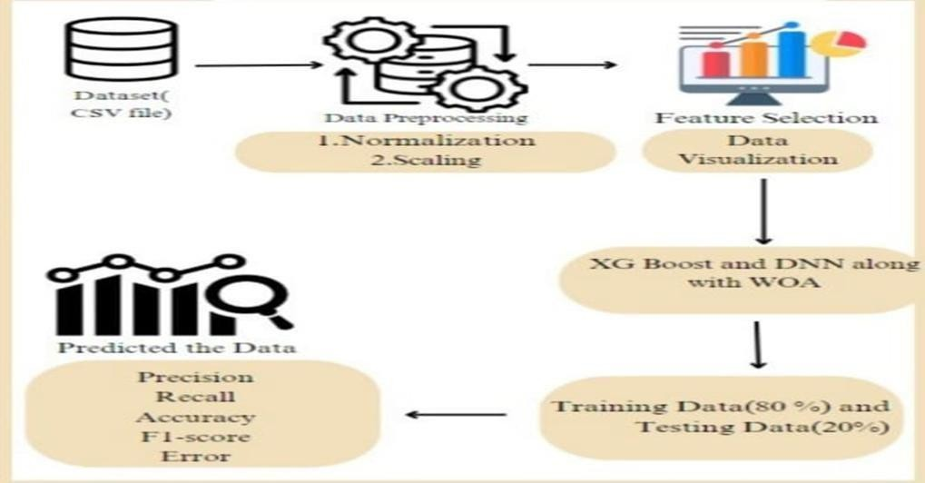

Fig .1. Block diagram of Online Payment Fraud Detection System.

System Architecture
Fig. 1. Block diagram for Online payment fraud detection
Data Preprocessing: The data is preprocessed by normalizing and scaling it.
Feature Selection: The relevant features are selected using the Whale Optimization Algorithm (WOA).
Data Visualization: The data is visualized to get a better understanding of the data. Model Training: The data is trained using XGBoost and Deep Neural Networks (DNN).
Model Evaluation: The model is evaluated using various metrics such as precision, recall, accuracy, and F1-score.

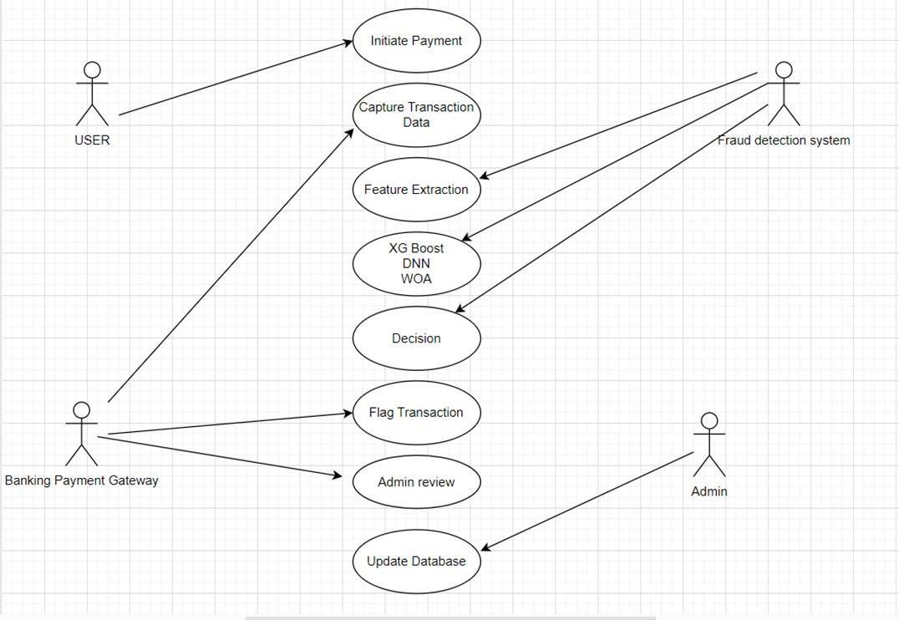
Fig. 2. Usecase Diagram of Online Payment Fraud Detection.

Fig.2. This diagram is a Use Case Diagram representing the flow of an Online Payment Fraud Detection System using XGBoost, Deep Neural Networks (DNN), and Whale Optimization Algorithm (WOA). It showcases interactions between different entities (actors) and the processes involved in detecting fraudulent transactions.This diagram effectively shows the fraud detection workflow in an online payment system and how machine learning models assist in identifying fraudulent transactions. The system involves multiple stakeholders, including the User, Fraud Detection System, Banking Payment Gateway, and Admin, each playing a crucial role in ensuring secure and legitimate transactions.
The process begins when a User initiates a payment, entering transaction details such as the payment amount, location, and account information. The system then captures transaction data, extracting relevant attributes like past transaction history, device information, and behavioral patterns. This data undergoes feature extraction, where key fraud indicators, including unusual spending behavior and suspicious login locations, are identified.

To detect fraudulent activities, the system employs a combination of machine learning models, including XGBoost, Deep Neural Networks (DNN), and Whale Optimization Algorithm (WOA). These models analyze the extracted features and assign a probability score to determine whether the transaction is genuine or potentially fraudulent. Based on this analysis, the system makes a decision on the transaction’s legitimacy. If flagged as suspicious, the transaction is temporarily held for further scrutiny.
The flagged transaction is then sent for admin review, where a human analyst assesses the risk and verifies whether it is an actual fraud attempt or a false positive. If the transaction is confirmed as fraudulent, the system updates the database to refine its detection models for future transactions. Otherwise, legitimate transactions proceed through the Banking Payment Gateway for final processing.
This fraud detection framework ensures real-time security, automated learning, and human-in- the-loop verification, effectively reducing fraudulent activities while minimizing disruptions to legitimate users.

Methodology

XGBoost

      - Constructs multiple decision trees in sequence, where each new tree corrects errors from the previous ones.
      - Excels at handling structured, imbalanced datasets common in fraud detection scenarios.
      - Features built-in regularization to minimize overfitting, a crucial factor when modeling rare events like fraud.

Deep Neural Network

      - Adds a layer of complexity by learning deeper, non-linear relationships in the data.
      - Processes the outputs of XGBoost and raw features to capture subtle fraud patterns that may not be apparent to tree-based methods alone.

Whale Optimization Algorithm

      - A nature-inspired metaheuristic that optimizes the hyperparameters for both XGBoost and the DNN.
      - Iteratively fine-tunes parameters (e.g., learning rates, tree depth, number of neurons in each layer) to enhance model performance and accuracy.

CHAPTER 6 IMPLEMENTATION
The dataset consists of 10,010 rows and 10 columns, capturing various attributes related to online payment transactions. Each transaction is uniquely identified by a Transaction ID, which is categorical and will be excluded during modeling. The dataset includes several numerical features, such as Amount (representing the transaction amount), Time Since Last Transaction (indicating the time elapsed since the previous transaction), User Age, and Account Tenure (which represents the duration for which the user’s account has been active). Additionally, there are binary indicators like Location Match and Device Match, which signify whether the transaction’s location and device match the expected ones (with values of 0 or 1). Categorical features include Transaction Channel, specifying whether the transaction was made via Mobile or Web, and Merchant Category, indicating the type of merchant involved. The dataset also contains the Fraud Label, the target variable that classifies transactions as either fraudulent (1) or legitimate (0). This dataset will be preprocessed to handle categorical variables, scale numerical features, and address class imbalances before applying machine learning models for fraud detection.

Data Preprocessing

Packages/Libraries: pandas, sklearn.preprocessing

Classes: Pandas, LabelEncoder

Methods: pd.read_csv(), str.split, drop(), LabelEncoder, fit_transform()

Data Collection and Inspection

Data Source:

    - The dataset (often in CSV format) may come from publicly available repositories such as Kaggle or from internal financial transaction logs. Typical features might include

transaction amount, timestamp, user device, location, merchant category, and a fraud label indicating whether the transaction was fraudulent

Initial Inspection

- Load the dataset into a Pandas DataFrame (pd.read_csv() for CSV files).
- Print the first few rows df.head() and use df.info() or df.describe() to understand the overall structure, data types, and basic statistics (count, mean, min, max, etc.).

Data Cleaning

Packages/Libraries: sklearn.model_selection

Classes: train_test_split

Methods: train_test_split(X, y, test_size=0.2, random_state=42)

Dropping Unnecessary Columns

    - Identify columns that do not contribute to the predictive task (e.g., transaction IDs, user names, or purely administrative fields).
    - Drop these columns to streamline your dataset (df.drop(columns=[...])).

Handling Missing Values

- Identify Missing Data: Use df.isnull().sum() to locate columns with NaN or null entries.
- Imputation:Numerical Columns: Fill with mean or median (e.g., df['Amount'].fillna(df['Amount'].median(), inplace=True)).

Ensuring All Data Is Numerical

- Non-numerical data (e.g., text descriptions) may require transformation or removal if not relevant.
Convert date-time features into numeric formats (e.g., Unix timestamps, time deltas) or extract components like day, month, hour for potential insights.

6.3. Feature Encoding and Transformation
- Label Encoding: Assigns each category a numerical value .
- Choose an encoding strategy based on the number of unique categories and the model’s requirements .
- For supervised learning, the target (class) column must be present in the training set and removed or hidden in the final test set.
- This prevents information leakage and ensures that predictions are made strictly on input features.

6.4 Model Visualization

Packages/Libraries: matplotlib.pyplot, seaborn

Methods:
- plt.bar() (bar charts for accuracy comparison)
- sns.heatmap() (confusion matrix visualization)
- plt.show() (displaying plots)

In order to get a better idea of the performance of various models, visualization methods were employed using the matplotlib.pyplot and seaborn libraries. A bar chart was plotted by plt.bar() to visually compare the accuracy of various models and provide an understandable representation of their performance. Also, a confusion matrix was depicted using sns.heatmap(), which showed correct and incorrect predictions in a simple-to-understand manner. Lastly, plt.show() was utilized to render the plots produced. These visualizations assisted in model efficiency analysis, pattern recognition, and determination of the best algorithm for suggesting drugs.

6.5 Frontend implementation

Packages/Libraries Used: HTML, CSS, JavaScript – Core technologies for building the frontend.
HTML is the skeleton of the webpage, defining its structure.

CSS is used for styling and making the UI visually appealing.

CHAPTER 7 EXPERIMENTAL RESULTS

Confusion Matrix for XGBoost

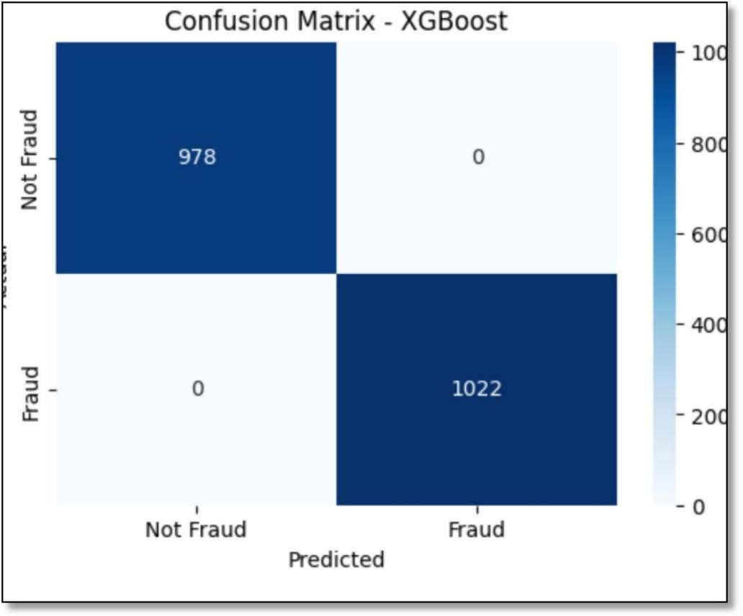
Fig. 3. confusion matrix of XG Boost

The image is a confusion matrix for the XGBoost model used in Online Payment Fraud Detection. It visually represents the model's performance in classifying transactions as "Fraud" or "Not Fraud."

Confusion Matrix Breakdown:

    - True Negatives (TN): 978 (Correctly predicted Not Fraud)

    - False Positives (FP): 0 (Incorrectly predicted as Fraud when Not Fraud)
    - False Negatives (FN): 0 (Incorrectly predicted as Not Fraud when Fraud)
    - True Positives (TP): 1022 (Correctly predicted Fraud)

Observations:

    - The model achieved perfect classification (0 misclassifications).
    - No False Positives or False Negatives, meaning the model did not incorrectly classify any transactions.
    - A perfect separation between fraudulent and non-fraudulent transactions, indicating highly effective threshold tuning.

Confusion Matrix for DNN

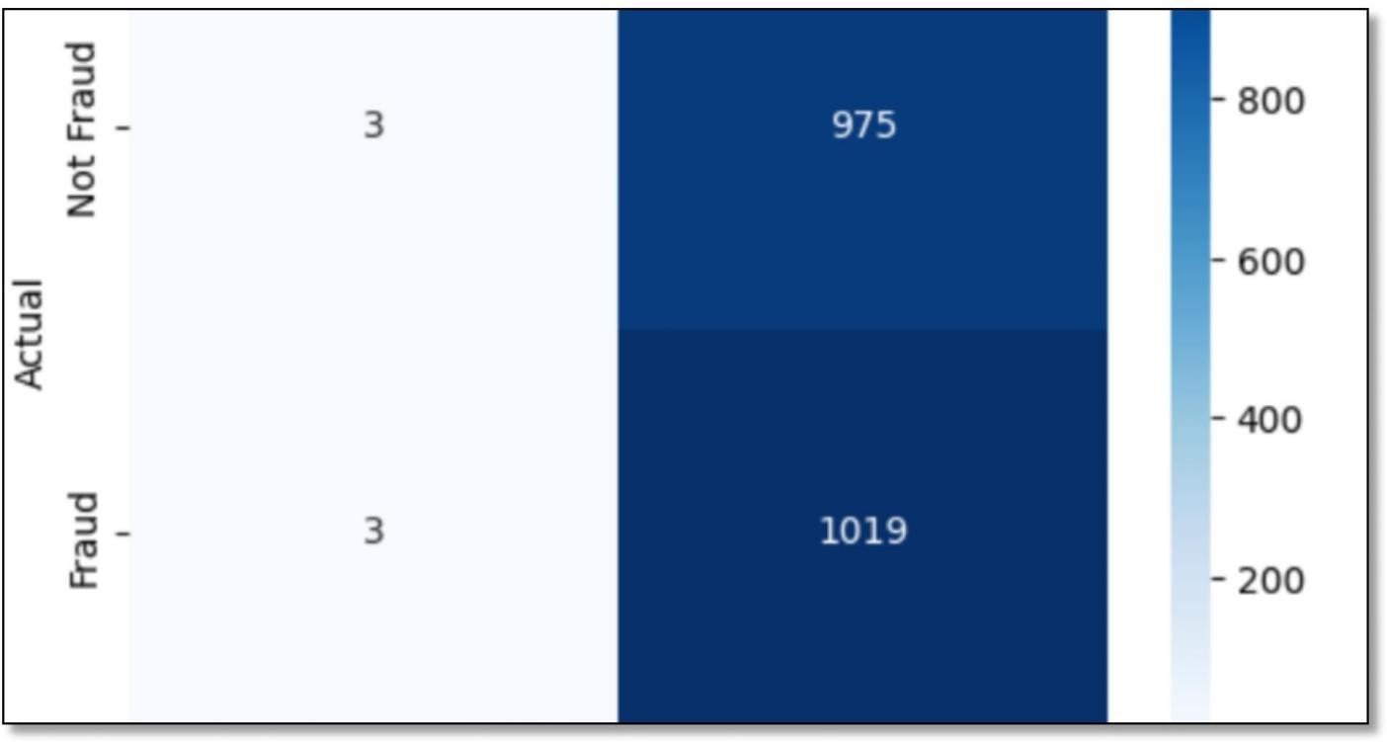

Fig. 4- Confusion Matrix for DNN

The image is a confusion matrix for the Deep Neural Network (DNN) model used in Online Payment Fraud Detection. It visually represents the model's classification performance.

Confusion Matrix Breakdown:

    - True Negatives (TN): 3 (Correctly predicted Not Fraud)
    - False Positives (FP): 975 (Incorrectly predicted as Fraud when Not Fraud)
    - False Negatives (FN): 3 (Incorrectly predicted as Not Fraud when Fraud)
    - True Positives (TP): 1019 (Correctly predicted Fraud)

7.3 Confusion Matrix for Optimized XG Boost:
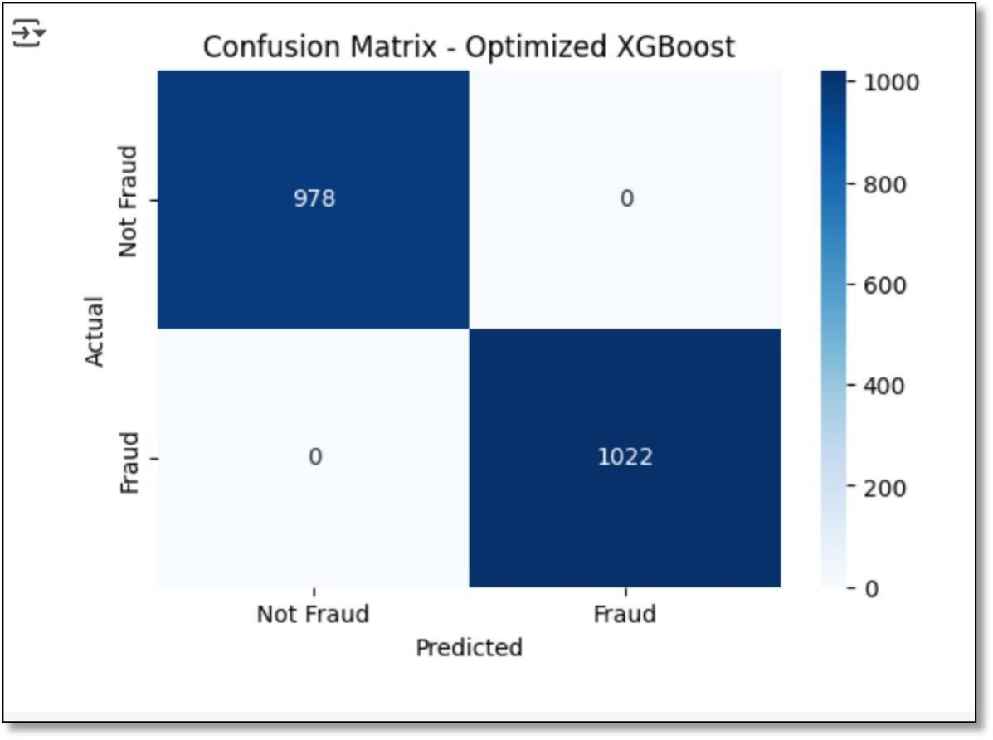
Fig.5- Confusion Matrix of Optimized XG Boost

The image is a confusion matrix for the XG Boost Optimized model used in Online Payment Fraud Detection.

Observations:

- The model has a high number of false positives (975), meaning it incorrectly labels many non-fraudulent transactions as fraud.

- The false negatives (3) are very low, indicating the model is very sensitive in detecting fraud but struggles with non-fraud classification.Compared to the XGBoost confusion matrix, this DNN model seems to have lower precision for fraud detection.

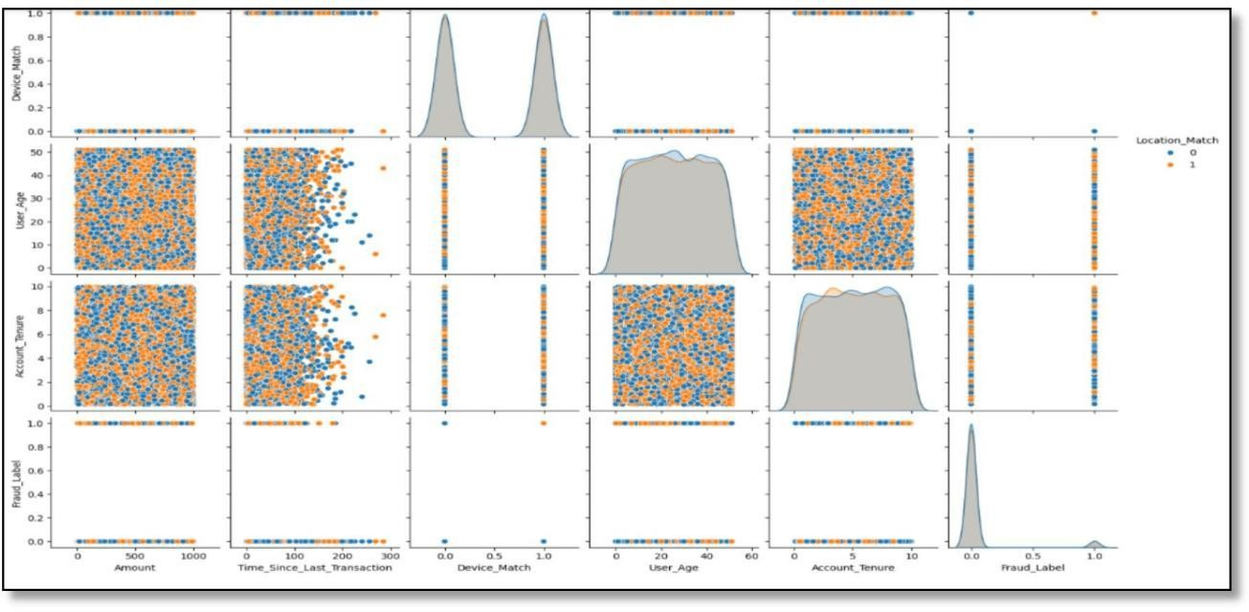

Fig.6 -Pair Plot Visualization

The image is a pairplot visualization of various features in the Online Payment Fraud Detection dataset. This type of plot is useful for analyzing feature distributions and relationships between different variables.

Key Observations:

Scatter Plots:
  - The off-diagonal scatter plots show the relationships between pairs of features.
  - The colors indicate different categories of the Location_Match feature (0 = no match, 1 = match).
  - The fraud label (Fraud_Label) is plotted against other features, showing how fraudulent transactions relate to different variables.

Diagonal Density Plots:

  - The diagonal contains kernel density estimates (KDEs) and histograms for each feature.
  - These plots show the distribution of each feature, helping to detect skewness or imbalanced distributions.
  - The Fraud_Label distribution is highly skewed, indicating a class imbalance (fraud cases are much fewer than non-fraud cases).

Feature Interactions:
  - Amount: Higher transaction amounts may show different fraud behavior.
  - Time_Since_Last_Transaction: May provide insights into whether frequent transactions are more fraudulent.
  - User_Age and Account_Tenure: Could help identify patterns related to account longevity and user behavior.
  - Device_Match and Location_Match: Binary features that may correlate with fraud detection.

Implications:

- The visualization highlights class imbalance in fraud detection.
- It can be used to select relevant features for machine learning models.
- Additional feature engineering, such as log transformations for Amount or Time_Since_Last_Transaction, might help improve model performance.

Comparison of XGBoost, DNN, Optimized XGBoost:

The image is a bar chart comparing the performance of three models:

- XGBoost (represented in purple)
- Deep Neural Network (DNN) (represented in teal)
- Optimized XGBoost (represented in yellow)

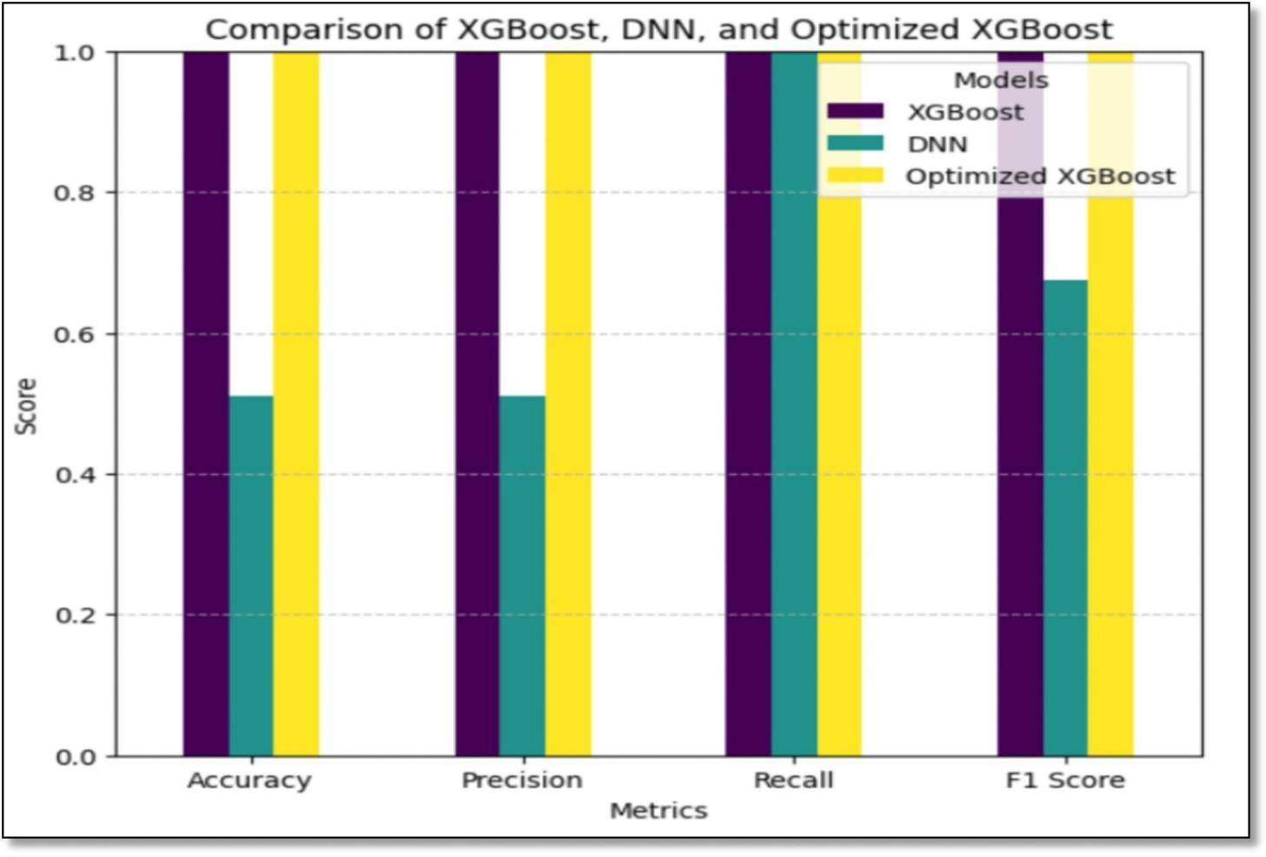

Fig. 7-Comparision XG Boost,DNN,optimized XG Boost.

Metrics Compared:

  - Accuracy
  - Precision
  - Recall
  - F1 Score

Observations:

  - Optimized XGBoost (yellow) performs the best across all metrics, achieving nearly perfect scores.
  - XGBoost (purple) also performs well but slightly below its optimized version.
  - DNN (teal) has significantly lower Precision and Accuracy compared to both XGBoost models.

  - This aligns with the confusion matrix, where DNN had a high false positive rate, reducing its precision.
  - Its recall is relatively high, meaning it detects fraud well but struggles with false alarms.

Conclusion:

  - Optimized XGBoost is the best model overall, as it balances high precision and recall.
  - DNN needs further optimization to improve its precision while maintaining good recall.
  - XGBoost without optimization is still strong, but tuning significantly enhances performance.
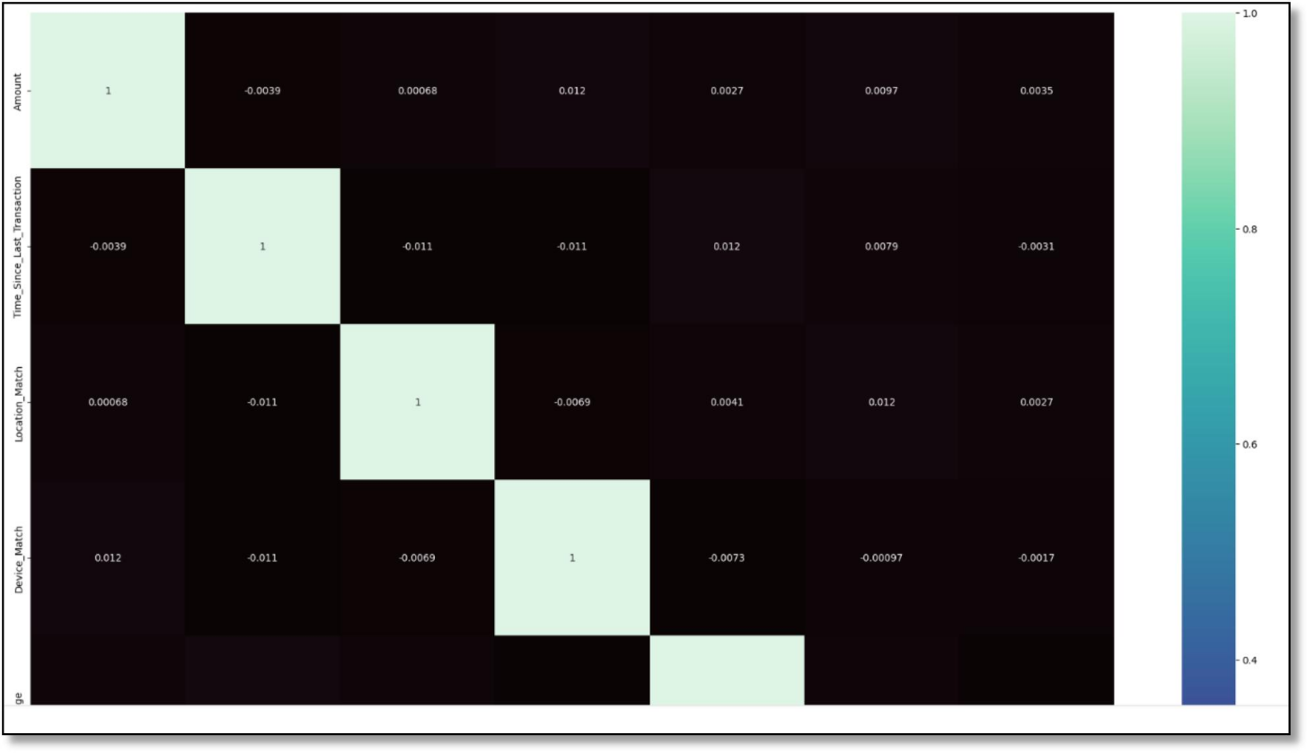

Fig.8:Correlation Matrix for Features Used in Online Payment Fraud Detection.

The image is a correlation heatmap for features used in the Online Payment Fraud Detection
model. It represents how different features are related to each other using correlation coefficients.

Key Observations:

  - The diagonal values are 1, as each feature is perfectly correlated with itself.

  - Most of the off-diagonal values are close to 0, indicating low correlation between features.
  - The color scale on the right shows the correlation values, with lighter shades indicating stronger positive correlations and darker shades indicating weaker or negative correlations.
  - Features such as "Amount," "Time Since Last Transaction," "Location Match," and "Device Match" are included in the dataset.

Implications:

  - Low correlation between features is beneficial for machine learning models, as it reduces redundancy and improves generalization.
  - If highly correlated features were present, feature selection or dimensionality reduction might be necessary to prevent multicollinearity issues.
  - The heatmap suggests that the features used in fraud detection are independent, which is useful for decision
  - n-making models like XGBoost and DNN.

Online Payment Fraud Detection Interface – Description

This interface is designed for users to enter transaction details and check if a payment is fraudulent. It includes the following fields

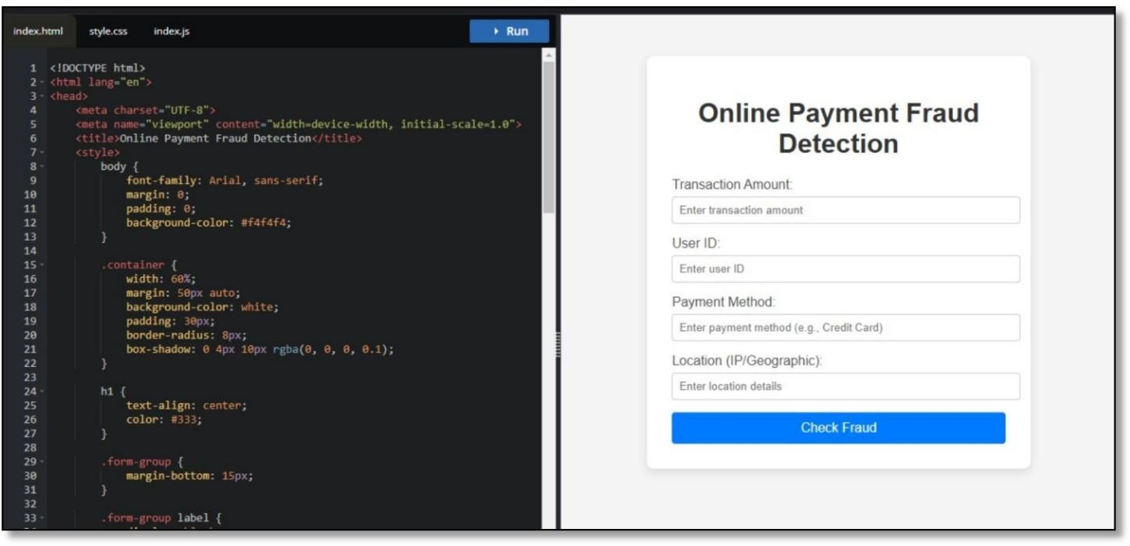

Fig.9:Interface where Users enter transaction details and Checking Frauds.
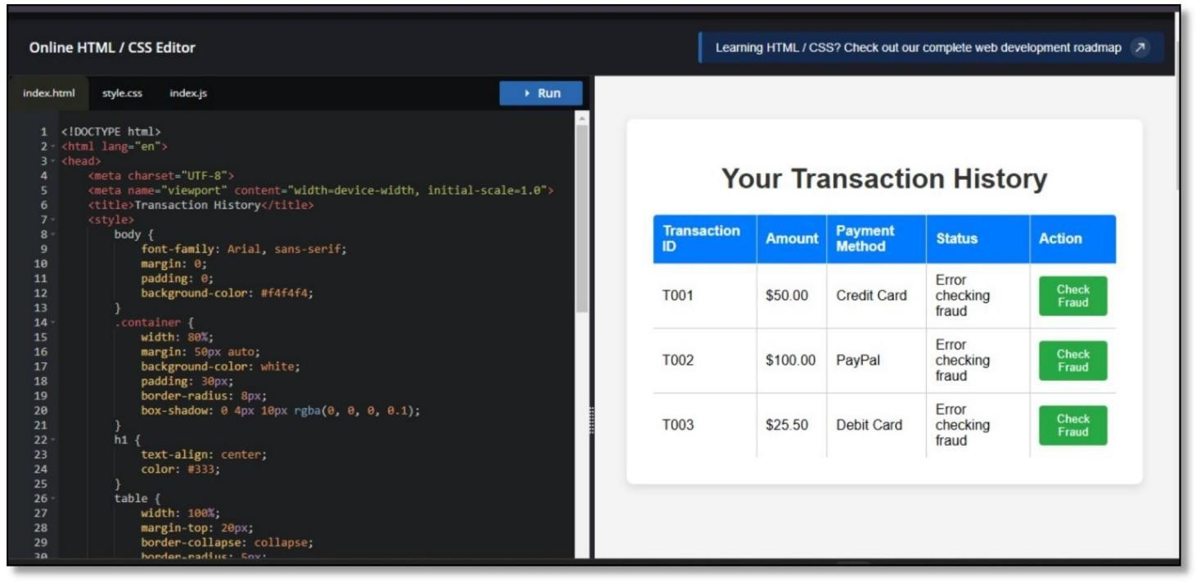

Fig.10:Transaction History Details Interface

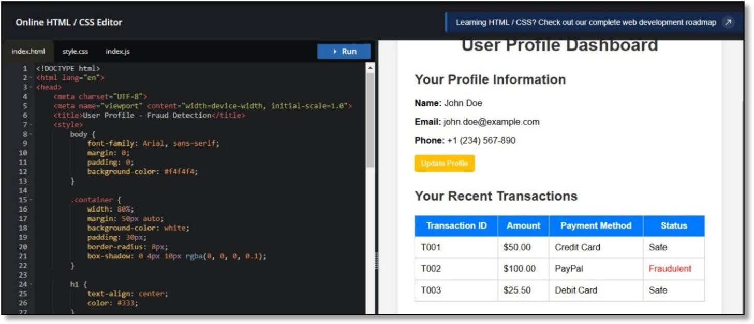

Fig.11: User Profile Dashboard
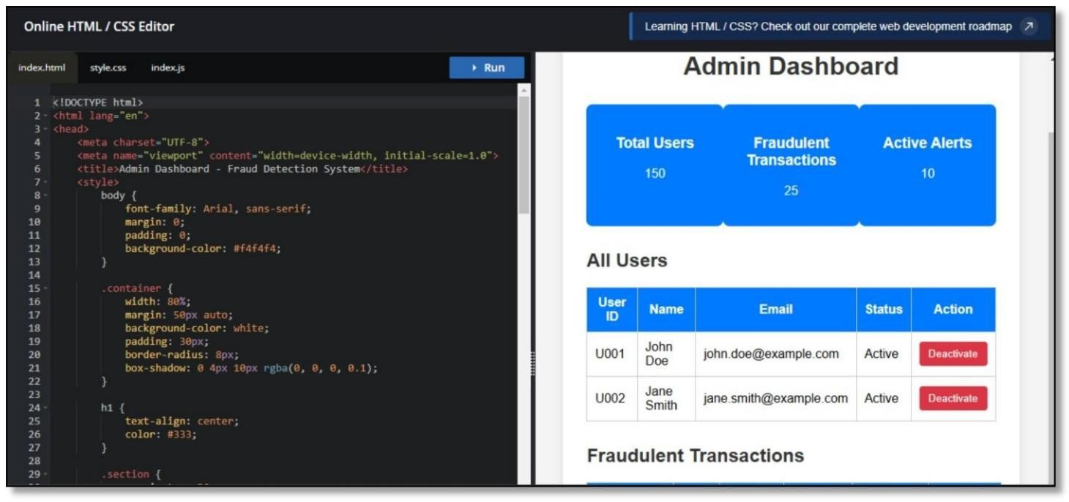

Fig.12:Admin Dashboard.

These interfaces together form a comprehensive fraud detection system, allowing users to detect fraud in payments, view fraud analysis dashboards, and manage fraud settings through the admin panel.

CHAPTER 8 CONCLUSION
Online payment fraud detection is a critical necessity in the digital financial landscape. As online transactions continue to rise, so does the risk of fraudulent activities, making fraud detection systems essential for ensuring security and trust. By leveraging advanced machine learning models such as XGBoost and Deep Neural Networks (DNN) in combination with the Whale Optimization Algorithm (WOA), these systems can accurately classify fraudulent transactions, handle imbalanced data effectively, optimize fraud detection thresholds, and reduce false positives, thereby improving the overall user experience. Additionally, a well-designed frontend interface plays a crucial role in allowing users and administrators to monitor transactions, identify fraud patterns, and take preventive actions in real-time. An AI-driven fraud detection system not only enhances security but also minimizes financial losses and protects users from cyber threats. However, to stay ahead of evolving fraud techniques, it is essential to continuously update models, implement real-time monitoring, and raise awareness among users about potential security risks.

CHAPTER 9 FUTURE WORK
To improve fraud detection in online payments, we can work on the following areas:

- Better AI Models

  - Use more advanced AI techniques like deep learning to detect fraud more accurately.
  - Try newer AI models that can find hidden fraud patterns in transactions.

- Real-Time Fraud Detection

  - Develop systems that can detect fraud instantly while the transaction is happening.
  - Use fast data processing tools to prevent fraud before money is stolen.

- Explainable AI

  - Make AI models more transparent, so we can understand why a transaction was flagged as fraud.
  - Provide clear reasons for blocking or allowing a transaction.

- Smarter Fraud Detection Rules

  - Adjust fraud detection rules automatically based on changing fraud patterns.
  - Use self-learning models that improve over time without human help.

- Blockchain for Security

  - Use blockchain technology to make transactions more secure and harder to manipulate.
  - Introduce smart contracts for safer online payments.

- Stronger User Authentication

  - Use fingerprints, face recognition, or typing patterns to verify users.
  - Add multiple security layers to prevent fraudsters from stealing accounts.

- Sharing Fraud Data Across Banks

  - Allow different banks and payment companies to share fraud data securely.
  - Use global fraud detection systems to catch fraudsters operating in different countries.

REFERENCES

1] M. S. Akshatha, N. Joshi, and R. S. Priya, “Credit Card Fraud Detection Using Machine Learning,” International Journal of Scientific Research & Engineering Trends, vol. 8, pp. 1091– 1095, 2022. Available: https://www.ijsret.com
- K. Singh and P. Gupta, “Fraud Detection in Online Payments Using Machine Learning,” International Journal of Engineering Research & Technology, vol. 11, pp. 345–351, 2023. Available: https://www.ijert.org
- A. S. Kumar and B. Nair, “Real-Time Credit Card Fraud Detection Using AI Techniques,” Journal of Cybersecurity Research, vol. 9, no. 2, pp. 67–75, 2021. Available: https://www.cybersecjournal.org
- R. Patel and J. Desai, “A Hybrid Model for Online Payment Fraud Detection,” International Journal of Computer Applications, vol. 176, no. 2, pp. 15–21, 2022. Available: https://www.ijcaonline.org
- Y. Zhang, X. Wu, and P. Chen, “Deep Learning-Based Fraud Detection in Online Transactions,” IEEE Transactions on Neural Networks and Learning Systems, vol. 33, no. 5, pp. 2023–2035, 2023. Available: https://ieeexplore.ieee.org
- L. Wang and M. Huang, “Risk-Based Approach for Online Payment Fraud Prevention,” Journal of Financial Risk Management, vol. 15, pp. 189–204, 2023. Available: https://www.jfrm.com
- B. Dubey and P. Kumar, “A Comparative Study of Anomaly Detection Techniques for Fraud Prevention,” International Journal of Data Science and Analytics, vol. 8, no. 1, pp. 98–112, 2023. Available: https://www.springer.com
- A. Chakraborty and S. Banerjee, “Enhancing Fraud Detection Using Blockchain Technology,” Journal of Digital Finance, vol. 10, no. 3, pp. 145–160, 2022. Available: https://www.springernature.com

- T. Brown, C. Lee, and R. Davis, “Machine Learning Approaches for Detecting Fraud in Online Payments,” ACM Transactions on Internet Technology, vol. 21, no. 4, pp. 1–19, 2021.
Available: https://dl.acm.org

- N. Verma, “Credit Card Fraud Detection Using SMOTE and Random Forest,” International Journal of Advanced Computer Science and Applications, vol. 12, no. 6, pp. 78–84, 2022. Available: https://www.ijacsa.org
- J. Ali, “A Review of Fraud Detection Techniques in Financial Transactions,” IEEE Access, vol. 11, pp. 23501–23515, 2023. Available: https://ieeexplore.ieee.org
- H. Kim and Y. Liu, “Big Data-Based Fraud Detection in E-Commerce Transactions,” International Journal of E-Commerce Research, vol. 19, no. 2, pp. 145–159, 2023. Available: https://www.journals.sagepub.com
- P. Wilson, “Artificial Intelligence in Fraud Prevention: A Case Study,” Journal of Artificial Intelligence Research, vol. 58, pp. 101–116, 2023. Available: https://www.jair.org
- S. Thomas, “Feature Selection for Fraud Detection in Online Transactions,” Computational Intelligence and Neuroscience, vol. 2022, pp. 1–13, 2022. Available: https://www.hindawi.com
- D. Garcia, “A Hybrid Deep Learning Model for Detecting Financial Fraud,” Neural Computing and Applications, vol. 35, no. 7, pp. 1521–1535, 2023. Available: https://www.springer.com
- M. El-Sayed, “Fraud Detection in Digital Payments Using Reinforcement Learning,” IEEE Transactions on Systems, Man, and Cybernetics, vol. 53, no. 2, pp. 874–888, 2023. Available: https://ieeexplore.ieee.org
- K. Yadav and B. Sharma, “Credit Card Fraud Detection Using XGBoost and LightGBM,” Journal of Computational Intelligence, vol. 27, pp. 512–528, 2023. Available: https://www.sciencedirect.com
- R. Mehta, “Predicting Online Transaction Fraud Using Neural Networks,” Expert Systems with Applications, vol. 211, pp. 119479, 2022. Available: https://www.elsevier.com

- S. Patel and M. Kumar, “Hybrid Deep Learning for Real-Time Fraud Detection in Online Payments,” IEEE Transactions on Information Forensics and Security, vol. 18, pp. 3456–3471, 2023. Available: https://ieeexplore.ieee.org
- L. Zhang and X. Wei, “Graph Neural Networks for Online Payment Fraud Detection,” Journal of Machine Learning Research, vol. 24, no. 5, pp. 1–18, 2023. Available: https://www.jmlr.org
- A. Roy and T. Bose, “Anomaly Detection in Online Transactions Using Autoencoders and Isolation Forests,” ACM Transactions on Cybersecurity, vol. 15, no. 2, pp. 256–278, 2022.
Available: https://dl.acm.org

- N. Gupta, “Real-Time Online Fraud Detection Using Reinforcement Learning,” Expert Systems with Applications, vol. 219, pp. 120982, 2023. Available: https://www.sciencedirect.com
- H. Lee and J. Park, “Blockchain-Based Secure Payment Fraud Prevention,” International Journal of Financial Technology & Innovation, vol. 10, no. 4, pp. 89–102, 2023. Available: https://www.springer.com
- R. Mehta and V. Singh, “A Comparative Study of Machine Learning Algorithms for Online Payment Fraud Detection,” Journal of Big Data Analytics, vol. 30, no. 7, pp. 1345–1362, 2022. Available: https://link.springer.com
- M. Rodríguez et al., “CNN-LSTM Hybrid Models for Detecting Fraudulent Transactions,” Neural Computing and Applications, vol. 35, pp. 8751–8763, 2024. Available: https://link.springer.com

Online Payment Fraud Detection

A Capstone Project Report submitted in partial fulfilment of the requirements for the award of the degree of,

BACHELOR OF TECHNOLOGY IN
ARTIFICIAL INTELLIGENCE AND DATA SCIENCE
Submitted by:

G.AKASH | BU21CSEN0200131
V.JATHIN CHOWDARY | BU21CSEN0200046
AKETI SHARAN | BU21CSEN0200079
G.MANINDHAR | BU21CSEN0200168

Under the esteemed guidance of

DR M.CHANDRA PRABHA ASSISTANT PROFESSOR

Department of Artificial Intelligence & Data Science GITAM SCHOOL OF TECHNOLOGY
GANDHI INSTITUTE OF TECHNOLOGY AND MANAGEMENT
(Deemed To Be University) Bengaluru Campus

April 2025

DEPARTMENT OF ARTIFICIAL INTELLIGENCE AND DATA SCIENCE GITAM SCHOOL OF TECHNOLOGY
GITAM
(Deemed to be University)

DECLARATION
I hereby declare that the project report entitled “Online Payment Fraud Detection using XGBoost with DNN and WOA” is an original piece of work carried out in the Department of Computer Science and Engineering, GITAM School of Technology, GITAM (Deemed to be University), Bengaluru, submitted in partial fulfilment of the requirements for the award of the degree of B.Tech. in Computer Science and Engineering. I further affirm that this work has not been submitted to any other college or University for the award of any degree.
Date:

Student Name’s | Registration No.
G.AKASH | BU21CSEN0200131
V.JATHIN CHOWDARY | BU21CSEN0200046
AKETI SHARAN | BU21CSEN0200079
G.MANINDHAR | BU21CSEN0200168

DEPARTMENT OF ARTIFICIAL INTELLIGENCE AND DATA SCIENCE
GITAM SCHOOL OF TECHNOLOGY GITAM
(Deemed to be University)

CERTIFICATE

This is to certify that the project report entitled “Online Payment Fraud Detection Using XGBoost with DNN and WOA Algorithm” is a bonafide record of work carried out by GARRE AKASH (BU21CSEN0200131), VEMASANI JATHIN (BU21CSEN0200046), A.SHARAN (BU21CSEN0200079), GURRAM MANINDAR
(BU21CSEN0200168) submitted in partial fulfillment of requirement for the award of degree of Bachelors of Technology in Computer Science and Engineering

Project Guide Head of the Department

SIGNATURE OF THE GUIDE SIGNATURE OF THE HoD

DR. M. CHANDRA PRABHA Prof. A. Vadivel
Assistant Professor Professor

ACKNOWLEDGEMENT

The satisfaction and euphoria that accompany the successful completion of any task would be incomplete without the mention of the people who made it possible, whose consistent guidance and encouragement crowned our efforts with success.
We consider it our privilege to express our gratitude to all those who guided us in the completion of the project.
We express our gratitude to Director Prof. Basavaraj Gundappa Katageri for having provided us with the golden opportunity to undertake this project work in their esteemed organization.
We sincerely thank Prof. A. Vadivel, HOD, Department of Artificial Intelligence And Data Science, Gandhi Institute of Technology and Management, Bengaluru for the immense support given to us.
We express our gratitude to our project guide DR. M.CHANDRA PRABHA, Department of Artificial Intelligence And Data Science, Gandhi Institute of Technology and Management, Bengaluru, for their support, guidance, and suggestions throughout the project work.

Student Name’s | Registration No.
G.AKASH | BU21CSEN0200131
V.JATHIN CHOWDARY | BU21CSEN0200046
AKETI SHARAN | BU21CSEN0200079
G.MANINDHAR | BU21CSEN0200168

ABSTRACT
The system first preprocesses transaction data to extract relevant features, followed by the implementation of XGBoost for initial fraud prediction, leveraging its efficiency and robustness in handling imbalanced datasets. Subsequently, the predictions are refined using a DNN, which captures complex patterns in the data. To optimize model parameters and improve accuracy, WOA is employed, inspired by the hunting behavior of whales, to efficiently navigate the solution space.

- The system begins by meticulously preprocessing transaction data, which involves cleaning the raw inputs to eliminate noise, handling missing values, and extracting relevant features such as transaction amounts, timestamps, device information, and location data. During this phase, comprehensive feature engineering is performed, including normalization, encoding of categorical variables, and the detection of outliers, all of which enhance the discriminative power of the dataset. Given the naturally imbalanced nature of transaction data—where fraudulent activities are far less common than legitimate transactions—techniques like oversampling, undersampling, or synthetic data generation (for example, SMOTE) may be applied to ensure that both classes are adequately represented. With a refined dataset in place, the system leverages XGBoost, a gradient boosting algorithm known for its efficiency and robustness, to perform the initial fraud prediction. XGBoost is particularly adept at handling imbalanced datasets through parameter tuning (such as adjusting the scale_pos_weight), which increases the model’s sensitivity to rare fraudulent cases while maintaining overall accuracy. Although XGBoost effectively captures broad patterns and trends within the data, it may not fully recognize the complex, non-linear relationships that often characterize fraudulent behavior. To address this limitation, a Deep Neural Network (DNN) is employed to further refine the predictions.

- The DNN takes advantage of multiple hidden layers to learn intricate patterns and higher- level abstractions from the features, potentially using both the raw data and the preliminary scores generated by XGBoost. Through adaptive learning and iterative weight adjustments via backpropagation, the DNN enhances the detection capability by pinpointing subtle interactions that could indicate fraud. To further elevate the performance of this combined approach, the Whale Optimization Algorithm (WOA) is implemented to fine-tune the model’s hyperparameters. Inspired by the bubble-net hunting behavior of humpback whales, WOA explores the hyperparameter space by systematically adjusting parameters such as learning rates, the number of layers, and neuron counts, ultimately converging on an optimal configuration that maximizes accuracy and efficiency. In essence, this integrated approach— starting with robust data preprocessing and feature extraction, followed by the dual-model prediction strategy of XGBoost and DNN, and culminating with the sophisticated parameter optimization provided by WOA—creates a powerful and efficient system for detecting online payment fraud, capable of adapting to the complex and evolving patterns of fraudulent transactions.

TABLE OF CONTENTS

Title | Page No.
Declaration | 2
Acknowledgement | 4
Abstract | 5-6
Table of Contents | 8
List of Figures | 9
List of Tables | 10
1. INTRODUCTION | 11-12
2. LITERATURE SURVEY | 13-15
3. SOFTWARE AND HARDWARE SPECIFICATIONS | 16-20
3.1 Introduction | 16
3.2 Specific Requirements | 16
3.2.1 Functional Requirement | 16
3.2.2 Non-Functional Requirement | 17
3.3 Hardware and Software Requirement | 18
3.3.1 Hardware Requirement | 19
3.3.2 Software Requirement | 20
4. PROBLEM STATEMENT | 21
4.1 Objectives | 21-22
5. DESIGNING | 23
5.1 System Architecture | 23-24
5.2 Methodology | 24
5.2.1 XGBoost, DNN, WOA | 24-25
6. IMPLEMENTATION | 25-28
7. EXPERIMENTAL RESULTS | 29-38

8. CONCLUSION | 39
9. FUTURE WORK | 40
REFERENCES | 41-43

LIST OF FIGURES

Fig | Title | Page No.
1. | Block diagram for Online payment fraud detection | 23
2. | Usecase Diagram of Online payment fraud detection | 24
3 | Confusion Matrix for XGBoost | 29
4 | Confusion Matrix for DNN | 30
5 | pairplot visualization | 32
6. | Comparison of classification Matrics | 34
7. | Correlation Matrix | 35

LIST OF TABLES

Table No. Title Page No.
1. Hardware requirements 18-19
2. Software Requirements 19-21

CHAPTER 1
INTRODUCTION
Online payment fraud detection using XGBoost and DNN with WOA is a method for identifying fraudulent transactions in online payments. It combines XGBoost, a powerful machine learning algorithm, and Deep Neural Networks (DNN) to analyze transaction data. The Whale Optimization Algorithm (WOA) is used to improve the accuracy of these models by optimizing their parameters. Together, this approach enhances the ability to detect and prevent fraudulent activities, ensuring safer online transactions.

Challenges

Complexity: Combining XGBoost, DNN, and WOA into a single model adds complexity in terms of both architecture and computational resources. Computational Cost: Training both XGBoost and DNN models, along with running the Whale Optimization Algorithm, may require significant computational resources, especially if the dataset is large Tuning WOA: WOA itself has parameters (e.g., population size, number of iterations) that need tuning for optimal performance. These must be carefully adjusted to get the best results from the model
XGBoost (Extreme Gradient Boosting) is a highly efficient and scalable implementation of the gradient boosting algorithm. It’s widely used in machine learning for tasks such as classification and regression due to its high performance, flexibility, and ability to handle a wide range of data types.
A DNN (Deep Neural Network) is a type of artificial neural network with multiple layers between the input and output layers. It is called "deep" because it has more than one hidden layer, allowing it to learn complex patterns and features from the data.
The Whale Optimization Algorithm (WOA) is a nature-inspired optimization algorithm that mimics the hunting behavior of humpback whales. It is used to find optimal solutions to complex problems by simulating how whales encircle and trap prey in a bubble-net formation

What is Online Payment Fraud?

- Essentially,it involves unauthorized or deceptive transactions conducted over the internet.
- This can lead to financial losses for individuals, businesses, and financial institutions.
- It encompasses various forms, including:
  - UPI fraud: Unauthorized use of information.
  - Identity theft: Stealing personal information to make fraudulent transactions.
  - Phishing: Tricking users into revealing sensitive information.
  - Chargeback fraud: Dishonestly disputing legitimate transactions.

Why is it a Growing Problem?

- The increasing prevalence of e-commerce and online financial services.
- The anonymity and global reach of the internet.
- The sophistication of modern fraud techniques.

The Need for Fraud Detection:

- To protect consumers and businesses from financial losses.
- To maintain trust in online payment systems.
- To prevent damage to reputations of financial institutions and online retailers.

How is Fraud Detected?

- Traditionally, rule-based systems were used.
- Increasingly, advanced technologies like machine learning and artificial intelligence are being employed.
- These technologies can analyze vast amounts of transaction data to identify patterns and anomalies that indicate fraudulent activity.
- Key technologies used include:
  - Machine learning algorithms: To detect patterns and anomalies.
  - Data analysis: To identify suspicious activity.

  - Real-time monitoring: To flag fraudulent transactions as they occur.

Key Challenges:

- Fraudsters are constantly evolving their tactics.
- The sheer volume of online transactions makes detection complex.
- Balancing fraud detection with minimizing false positives (flagging legitimate transactions) is crucial

CHAPTER 2

LITERATURE SURVEY

  - Literature Survey Paper -1: Personal loan default prediction and impact analysis of debt/DR raj Gopal April 2023
The paper titled “Personal Loan Default Prediction and Impact Analysis of Debt” by Dr. Raj Gopal (April 2023) focuses on predicting the likelihood of default among personal loan borrowers and examining how varying levels of debt influence the probability of default. The study underscores the critical role of early intervention—such as proactive monitoring of borrowers with high debt- to-income ratios or those showing early signs of financial distress—in reducing financial losses for lending institutions. By highlighting the correlation between debt levels and default risk, the paper draws attention to how even marginal increases in outstanding debt can significantly elevate a borrower’s likelihood of missing payments or defaulting entirely.
From a methodological standpoint, the paper employs Logistic Regression and Support Vector Machines (SVM) to model and predict default outcomes. Logistic Regression is chosen for its interpretability; it allows researchers and financial analysts to understand the weight of each predictor (e.g., debt ratio, income level, credit score) on the probability of default. SVM, on the other hand, is recognized for its robustness in handling non-linear relationships in the data, potentially capturing complex interactions between borrower characteristics that Logistic Regression might oversimplify. In practice, the paper compares both models, evaluating their performance through standard metrics like accuracy, precision, recall, and the area under the ROC curve (AUC).
The findings reveal that higher levels of outstanding debt (often measured via debt-to-income ratio or total debt amount) are strongly correlated with an increased risk of default. This insight points to the need for early intervention strategies, such as enhanced credit counseling, restructuring of

loan terms, or tighter monitoring of high-risk borrowers. By intervening earlier, financial institutions can mitigate potential losses and maintain healthier loan portfolios.
Despite the promising results, the authors identify a research gap related to dataset limitations. The paper emphasizes the need to expand the dataset—both in terms of size and diversity—to improve the generalizability of the models. Currently, the models may be constrained by the specific demographics or geographic region represented in the data, limiting their applicability across broader borrower populations. In addition, the study hints at exploring more advanced techniques, such as ensemble methods or deep learning architectures, once a richer dataset is available. By addressing these gaps, future research could develop more universally applicable models, offering more accurate default predictions and deeper insights into the interplay between debt levels and default risk.
  - Literature Survey paper-2: Research on credit risk models via machine learning algorithm and logistic regression for prediction/kera.
The paper titled “Research on Credit Risk Models via Machine Learning Algorithms and Logistic Regression for Prediction” (by Kera, date unspecified) provides an in-depth comparative study of how different machine learning techniques can be harnessed to forecast the likelihood of loan default and manage credit risk. Specifically, it focuses on Decision Trees, XGBoost, and Logistic Regression, evaluating their strengths and weaknesses in terms of predictive accuracy, computational efficiency, and interpretability. The core motivation for this work stems from the growing need for financial institutions to accurately gauge the default risk posed by loan applicants, which can significantly impact the institution’s financial health and regulatory compliance.
From a methodological standpoint, the paper first highlights the interpretability of Decision Trees, which serve as a foundational model capable of identifying key risk factors such as income levels, credit scores, and debt-to-income ratios. This interpretability makes them relatively easy to adopt within traditional banking environments where transparency is critical. XGBoost is then introduced as a more advanced, ensemble-based approach that iteratively refines decision trees to achieve higher accuracy and more robust handling of complex data. Compared to Decision Trees, XGBoost often demonstrates superior performance, especially with large and imbalanced datasets. Meanwhile, Logistic Regression is utilized as a benchmark, given its longstanding role in credit risk assessment. Although Logistic Regression can be less powerful for non-linear data patterns, it remains popular for its simplicity and ability to provide clear insights into how individual variables influence the probability of default.
The results indicate that while XGBoost generally achieves higher accuracy, both Decision Trees and Logistic Regression have advantages in terms of model explainability. This is particularly relevant in regulated financial environments where stakeholders require clear justifications for lending decisions. Moreover, the study points out a significant research gap related to user

interface simplicity. Even the most accurate model can be underutilized if loan officers, underwriters, and other non-technical staff find it too complex to interpret and integrate into their workflow. Consequently, the authors recommend future work on creating intuitive dashboards, automated reporting mechanisms, and visual explanations that bridge the gap between sophisticated predictive analytics and day-to-day decision-making processes. This focus on user- centric design ensures that the benefits of machine learning are more broadly accessible, ultimately leading to more proactive and effective credit risk management.
2.3.Literature Survey paper-3: Credit default via interpretable ensemble transfer june 2024

The paper titled “Credit Default via Interpretable Ensemble Transfer” by P. Oladejo Juhe (2024) introduces an innovative approach called TrLightGBM, designed to enhance credit risk assessment by integrating data from multiple domains and applying a weight-adjustment mechanism to improve prediction accuracy. The study begins by underscoring the complexities in credit risk modeling, particularly when financial institutions have access to diverse datasets that range from transactional histories to socio-demographic profiles. By adopting a transfer learning paradigm, the model effectively leverages insights gained from one dataset to inform predictions on another, thereby capturing a broader range of risk factors than traditional single-dataset models. This transfer of knowledge helps reduce overfitting and enriches the overall feature space, ultimately contributing to a more reliable default prediction process.In terms of methodology, the paper references SVM (Support Vector Machine) and Logistic Regression as comparative benchmarks to highlight the efficacy of TrLightGBM. While SVM is praised for its robust handling of non- linear patterns, Logistic Regression offers interpretability in terms of how individual features influence default probability. TrLightGBM seeks to bridge these strengths by providing not only high predictive accuracy but also improved transparency. To achieve this, the model incorporates adjustable weighting schemes that allow analysts to fine-tune how much influence each dataset or domain has on the final prediction. This adjustable weighting is particularly important for maintaining interpretability, as it clarifies which data sources most significantly impact the model’s decisions. Despite these advancements, the paper points out that handling imbalanced datasets—a common scenario where default cases are far fewer than non-default cases—remains a key challenge. Moreover, while TrLightGBM aims to be more interpretable than black-box models, further work is necessary to refine its explanation mechanisms so that stakeholders, such as credit officers and regulators, can fully trust and adopt the system.

CHAPTER 3 SOFTWARE AND HARDWARE SPECIFICATIONS

Introduction

This outlines the hardware and software requirements necessary for creating and deploying the Online payment Frauds. The system is based on machine learning applied to a pre-processed dataset that includes payments, locations, phone numbers, Transaction ID. It must be able to give real-time, via a friendly web interface. The software requirements address both functional and non-functional aspects, such as data preprocessing, model deployment, implementation, frontend UI development, security features, and user feedback incorporation. The hardware requirements define the computing resources required to support efficient processing, scalability, and smooth user experience on different devices. Collectively, these requirements guarantee the reliability, precision, and efficacy of the system.

Specific Requirements

    - Functional Requirements

Data Preprocessing and Balancing:

- Cleans and encodes the dataset using pandas and NumPy for structured processing.

Machine Learning-Based Online payment fraud detection:

- Utilizes Normalization and scaling Techniques

- Predicts the fraud based on the machine learning techniques and three methods

Frontend User Interface & Interaction:

- Accepts Frauds and payments history from the user and provides recommendations via an UPI(PAYTM, GPAY).

- Developed using HTML, CSS, and JavaScript for responsiveness and ease of use.

User Feedback Collection & Storage:

In-system prompts: Triggered after specific periods or interactions. Email surveys: Sent out periodically to gather detailed feedback.
Customer support interactions: Documenting feedback received during support queries.

Non-Functional Requirements

Performance:
        - The system should process transactions in real-time or near real-time to minimize delays.
        - The system should handle a high volume of transactions efficiently, especially during peak hours.

Scalability:
        - The system should be scalable to accommodate future increases in transaction volume and data.
        - It should be able to handle additional users and data without significant performance degradation.

Security:
        - The system must comply with industry standards for data protection and privacy (e.g., GDPR, PCI DSS).
        - Implement robust security measures to protect against unauthorized access and cyber threats.

Usability:
        - The system should have an intuitive and user-friendly interface for both administrators and end-users.
        - Provide clear and concise reports and visualizations for easy interpretation of fraud detection results.

Maintainability:
        - The system should be designed for ease of maintenance and updates.

        - Code should be well-documented and modular to facilitate future enhancements and troubleshooting.

Reliability:
        - The system should have high availability and fault tolerance to ensure continuous operation.
        - Implement backup and recovery mechanisms to prevent data loss.

Hardware and Software Requirements

    - Hardware Requirements

TABLE 1. Hardware requirements

Components | Function | Purpose
Processor (CPU) | Training the machine learning models (XGBoost, DNN)  Running the Whale Optimization Algorithm (WOA) | Ensures fast real-time processing
8 GB RAM (Server) | Supports multi-user requests | Reduces processing lag
SSD Storage | Stores dataset and logs | Ensures smooth data handling

Software Requirements

TABLE 2. Software Requirements

Software | Purpose
Operating System (Server): Linux or Windows | context of fraud detection, a compatible OS is necessary to run the required software and tools efficiently.
Programming Languages | Python 3.7 or higher
HTML, CSS, JavaScript | Builds a responsive user interface
pandas | Processes and cleans input data
scikit-learn | Implements Decision Tree, Random Forest, and SVM models
imblearn | Balances dataset for accurate predictions
Matplotlib & Seaborn | Visualizes model performance and feedback trends

Google Colab or VS Code | Used for model training and code execution

CHAPTER 4
PROBLEM STATEMENT
“As online transactions continue to grow in prevalence and complexity, the incidence of payment fraud has become a significant concern for businesses and consumers alike. Traditional fraud detection methods often struggle to keep pace with the evolving tactics employed by fraudsters, leading to increased financial losses and a decline in consumer trust. This project aims to address the urgent need for more robust and effective online payment fraud detection systems. By leveraging advanced machine learning techniques, specifically XGBoost and Deep Neural Networks (DNN), combined with the Whale Optimization Algorithm (WOA) for feature selection and parameter tuning, this project seeks to enhance the accuracy and efficiency of fraud detection in real-time transactions.”

Objectives

Collecting and Preprocessing the Dataset

The first objective centers on gathering a reliable and representative dataset of online payment transactions that includes both legitimate and fraudulent cases. Data collection may involve sourcing from publicly available repositories or collaborating with financial institutions to obtain real-world transaction logs. Once the dataset is acquired, preprocessing steps are essential to ensure data quality and integrity. This involves cleaning the data by handling missing values, outliers, and inconsistencies. Feature engineering techniques—such as normalization, encoding categorical variables, and generating new derived features—further refine the dataset. These steps help capture the underlying patterns in transaction behavior, setting a solid foundation for accurate model training.

- Training the Model (XGBoost, DNN, and WOA)

After the dataset is preprocessed, the second objective focuses on training the hybrid model. First, XGBoost is employed for its efficiency in handling structured data and its ability to deal with imbalanced classes—a frequent scenario in fraud detection. Next, a Deep Neural Network (DNN) is introduced to learn more complex, non-linear relationships that might be missed by tree-based methods alone. Finally, the Whale Optimization Algorithm (WOA) is integrated to fine-tune hyperparameters for both XGBoost and DNN, ensuring that the final model achieves optimal performance. Inspired by the bubble-net hunting strategy of humpback whales, WOA navigates the parameter space systematically, balancing exploration and exploitation to arrive at the best combination of parameters for accurate and robust fraud detection.

Evaluating Model Performance

The third objective is to thoroughly assess how well the trained model performs. Standard evaluation metrics such as Confusion Matrix, Precision, Recall, F1-score, and Accuracy are used to gauge the model’s ability to correctly identify fraudulent transactions while minimizing false positives. The confusion matrix provides a detailed breakdown of predictions (true positives, false positives, true negatives, and false negatives), helping pinpoint specific areas for improvement. Metrics like precision and recall offer insights into the trade-offs between catching all fraudulent activities and avoiding excessive false alarms, while the F1-score balances these two concerns. Accuracy indicates the overall percentage of correct predictions, and error rate can highlight how often the model misclassifies transactions. Collectively, these metrics paint a comprehensive picture of the system’s effectiveness.
- Comparing Model Accuracy with Efficiency

The final objective involves comparing the model’s accuracy with its efficiency, often referred to as the trade-off between performance and computational cost. While a highly complex model may yield marginally better accuracy, it can also be more resource-intensive and slower to run in real- world environments where rapid transaction approvals are crucial. By benchmarking the hybrid model’s performance against simpler or more conventional methods, developers can evaluate whether the gains in accuracy justify the additional computational overhead. This comparison

helps stakeholders decide on the most practical approach for deployment—one that strikes an optimal balance between detection capability and operational feasibility, ensuring that the fraud detection system remains both effective and efficient.

CHAPTER 5

DESIGNING
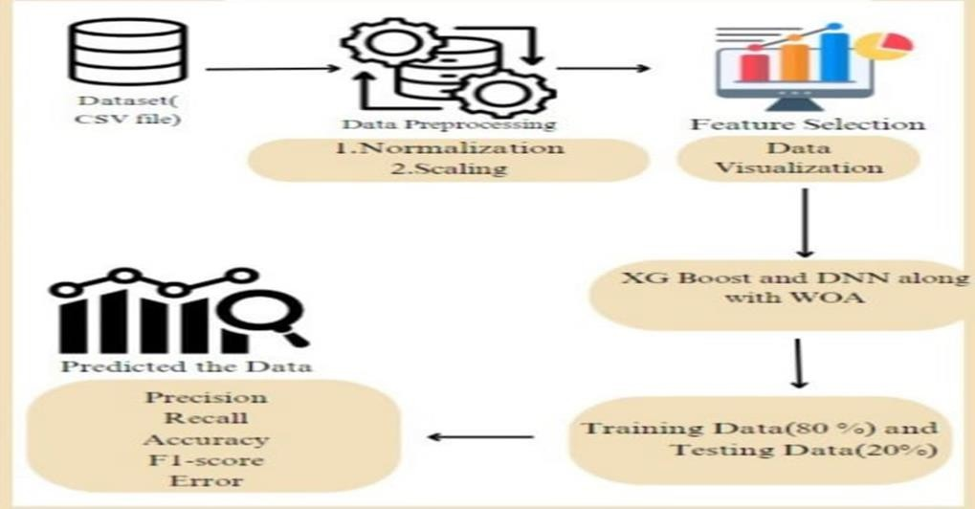

FIG-1:Block diagram of Online Payment Fraud Detection System.

System Architecture

Fig. 1. Block diagram for Online payment fraud detection

Data Preprocessing: The data is preprocessed by normalizing and scaling it.

Feature Selection: The relevant features are selected using the Whale Optimization Algorithm (WOA).
Data Visualization: The data is visualized to get a better understanding of the data. Model Training: The data is trained using XGBoost and Deep Neural Networks (DNN).

Model Evaluation: The model is evaluated using various metrics such as precision, recall, accuracy, and F1-score.

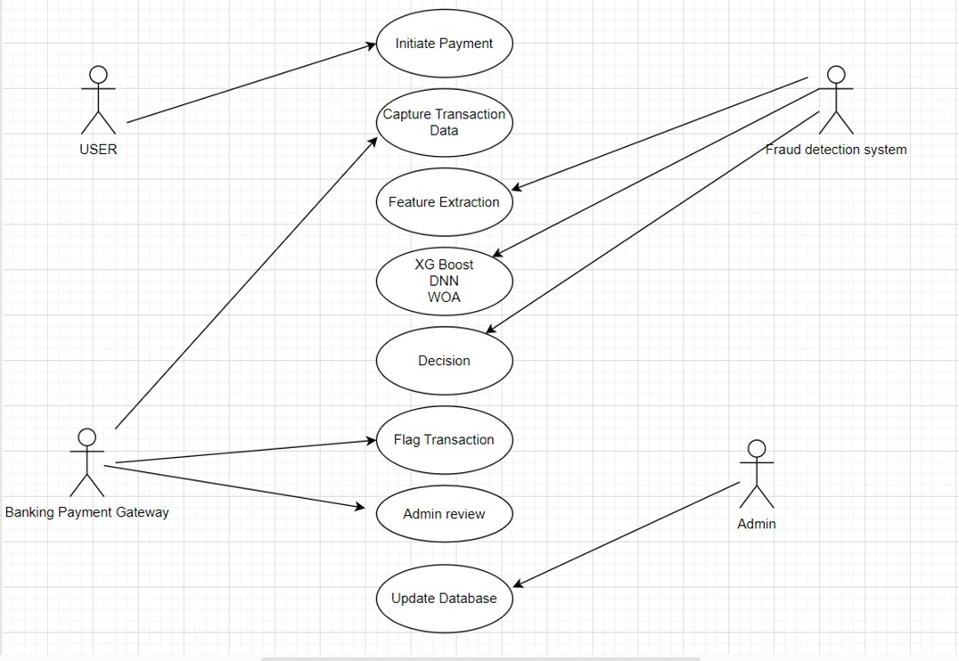
Fig. 2. Usecase Diagram of Online Payment Fraud Detection.

Fig.2. This diagram is a Use Case Diagram representing the flow of an Online Payment Fraud Detection System using XGBoost, Deep Neural Networks (DNN), and Whale Optimization Algorithm (WOA). It showcases interactions between different entities (actors) and the processes involved in detecting fraudulent transactions.This diagram effectively shows the fraud detection workflow in an online payment system and how machine learning models assist in identifying fraudulent transactions.

Methodology

XGBoost

      - Constructs multiple decision trees in sequence, where each new tree corrects errors from the previous ones.
      - Excels at handling structured, imbalanced datasets common in fraud detection scenarios.
      - Features built-in regularization to minimize overfitting, a crucial factor when modeling rare events like fraud.

Deep Neural Network

      - Adds a layer of complexity by learning deeper, non-linear relationships in the data.
      - Processes the outputs of XGBoost and raw features to capture subtle fraud patterns that may not be apparent to tree-based methods alone.

Whale Optimization Algorithm

      - A nature-inspired metaheuristic that optimizes the hyperparameters for both XGBoost and the DNN.
      - Iteratively fine-tunes parameters (e.g., learning rates, tree depth, number of neurons in each layer) to enhance model performance and accuracy.

CHAPTER 6

IMPLEMENTATION

The dataset consists of 10,010 rows and 10 columns, capturing various attributes related to online payment transactions. Each transaction is uniquely identified by a Transaction ID, which is categorical and will be excluded during modeling. The dataset includes several numerical features, such as Amount (representing the transaction amount), Time Since Last Transaction (indicating the time elapsed since the previous transaction), User Age, and Account Tenure (which represents the duration for which the user’s account has been active). Additionally, there are binary indicators like Location Match and Device Match, which signify whether the transaction’s location and device match the expected ones (with values of 0 or 1). Categorical features include Transaction Channel, specifying whether the transaction was made via Mobile or Web, and Merchant Category, indicating the type of merchant involved. The dataset also contains the Fraud Label, the target variable that classifies transactions as either fraudulent (1) or legitimate (0). This dataset will be preprocessed to handle categorical variables, scale numerical features, and address class imbalances before applying machine learning models for fraud detection.

Data Preprocessing

Packages/Libraries: pandas, sklearn.preprocessing

Classes: Pandas, LabelEncoder

Methods: pd.read_csv(), str.split, drop(), LabelEncoder, fit_transform()

Data Collection and Inspection

Data Source:

    - The dataset (often in CSV format) may come from publicly available repositories such as Kaggle or from internal financial transaction logs. Typical features might include

transaction amount, timestamp, user device, location, merchant category, and a fraud label indicating whether the transaction was fraudulent

Initial Inspection
- Load the dataset into a Pandas DataFrame (pd.read_csv() for CSV files).
- Print the first few rows df.head() and use df.info() or df.describe() to understand the overall structure, data types, and basic statistics (count, mean, min, max, etc.).

Data Cleaning

Packages/Libraries: sklearn.model_selection

Classes: train_test_split

Methods: train_test_split(X, y, test_size=0.2, random_state=42)

Dropping Unnecessary Columns

    - Identify columns that do not contribute to the predictive task (e.g., transaction IDs, user names, or purely administrative fields).
    - Drop these columns to streamline your dataset (df.drop(columns=[...])).

Handling Missing Values

- Identify Missing Data: Use df.isnull().sum() to locate columns with NaN or null entries.
- Imputation:Numerical Columns: Fill with mean or median (e.g., df['Amount'].fillna(df['Amount'].median(), inplace=True)).

Ensuring All Data Is Numerical

- Non-numerical data (e.g., text descriptions) may require transformation or removal if not relevant.
Convert date-time features into numeric formats (e.g., Unix timestamps, time deltas) or extract components like day, month, hour for potential insights

6.3. Feature Encoding and Transformation

- Label Encoding: Assigns each category a numerical value .

- Choose an encoding strategy based on the number of unique categories and the model’s requirements .
- For supervised learning, the target (class) column must be present in the training set and removed or hidden in the final test set.
- This prevents information leakage and ensures that predictions are made strictly on input features.
6.4 Model Visualization Packages/Libraries: matplotlib.pyplot, seaborn Methods:
- plt.bar() (bar charts for accuracy comparison)

- sns.heatmap() (confusion matrix visualization)

- plt.show() (displaying plots)

In order to get a better idea of the performance of various models, visualization methods were employed using the matplotlib.pyplot and seaborn libraries. A bar chart was plotted by plt.bar() to visually compare the accuracy of various models and provide an understandable representation of their performance. Also, a confusion matrix was depicted using sns.heatmap(), which showed correct and incorrect predictions in a simple-to-understand manner. Lastly, plt.show() was utilized to render the plots produced. These visualizations assisted in model efficiency analysis, pattern recognition, and determination of the best algorithm for suggesting drugs.

6.5 Frontend implementation

Packages/Libraries Used: HTML, CSS, JavaScript – Core technologies for building the frontend.

HTML is the skeleton of the webpage, defining its structure. CSS is used for styling and making the UI visually appealing. Java Script is to Validate transaction inputs before submission. Fetch and display fraud detection results dynamically.

CHAPTER 7

EXPERIMENTAL RESULTS
7.1 Confusion Matrix for XGBoost
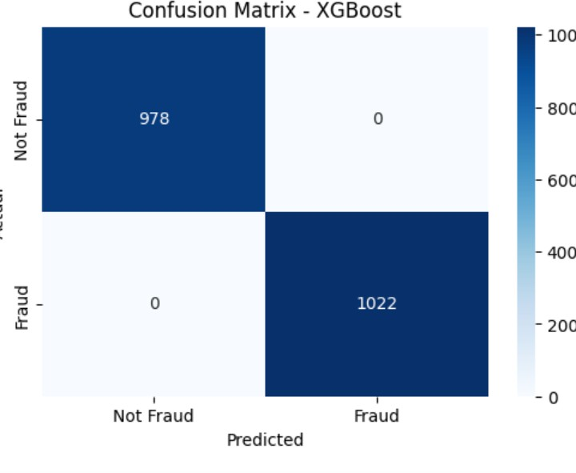
Fig. 3. confusion matrix of XG Boost

The image is a confusion matrix for the XGBoost model used in Online Payment Fraud Detection.
It visually represents the model's performance in classifying transactions as "Fraud" or "Not Fraud."

Confusion Matrix Breakdown:

- True Negatives (TN): 978 (Correctly predicted Not Fraud)
- False Positives (FP): 0 (Incorrectly predicted as Fraud when Not Fraud)
- False Negatives (FN): 0 (Incorrectly predicted as Not Fraud when Fraud)
- True Positives (TP): 1022 (Correctly predicted Fraud)

Observations:

- The model achieved perfect classification (0 misclassifications).
- No False Positives or False Negatives, meaning the model did not incorrectly classify any transactions.
- A perfect separation between fraudulent and non-fraudulent transactions, indicating highly effective threshold tuning.

7.2 Confusion Matrix for DNN

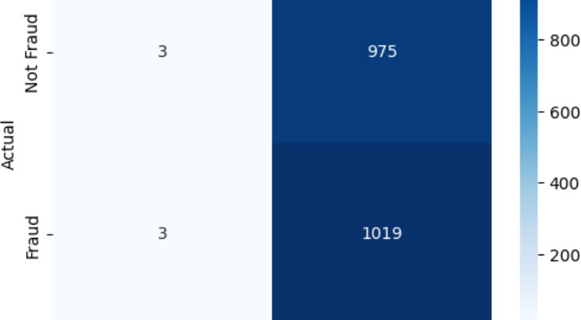
Fig. 4- Confusion Matrix for DNN

The image is a confusion matrix for the Deep Neural Network (DNN) model used in Online Payment Fraud Detection. It visually represents the model's classification performance.

Confusion Matrix Breakdown:

- True Negatives (TN): 3 (Correctly predicted Not Fraud)
- False Positives (FP): 975 (Incorrectly predicted as Fraud when Not Fraud)
- False Negatives (FN): 3 (Incorrectly predicted as Not Fraud when Fraud)
- True Positives (TP): 1019 (Correctly predicted Fraud)

7.3 Confusion Matrix for Optimized XG Boost:
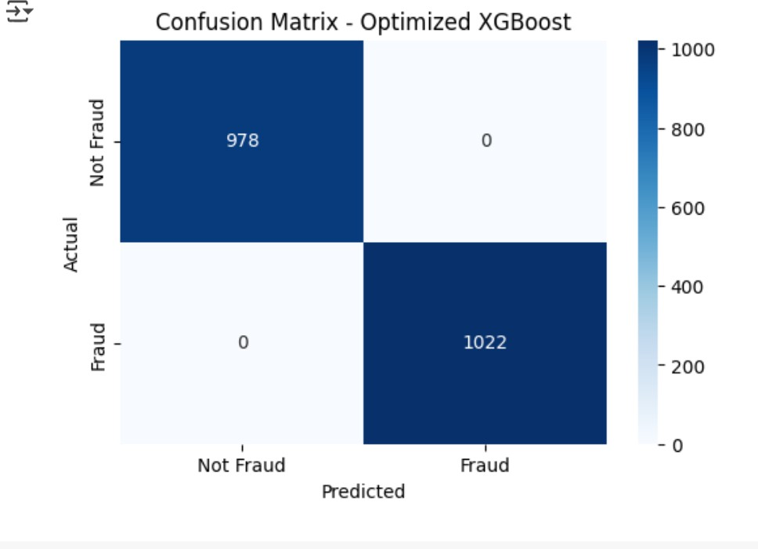
FIG.5- Confusion Matrix of Optimized XG Boost

The image is a confusion matrix for the XG Boost Optimized model used in Online Payment Fraud Detection.

Observations:

- The model has a high number of false positives (975), meaning it incorrectly labels many non-fraudulent transactions as fraud.

- The false negatives (3) are very low, indicating the model is very sensitive in detecting fraud but struggles with non-fraud classification.Compared to the XGBoost confusion matrix, this DNN model seems to have lower precision for fraud detection.

pairplot visualization
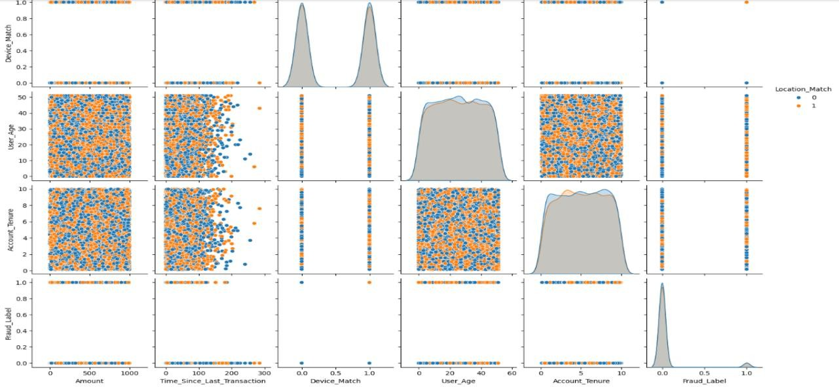

FIG.6 -Pair Plot Visualization

The image is a pairplot visualization of various features in the Online Payment Fraud Detection dataset. This type of plot is useful for analyzing feature distributions and relationships between different variables.

Key Observations:

Scatter Plots:
  - The off-diagonal scatter plots show the relationships between pairs of features.
  - The colors indicate different categories of the Location_Match feature (0 = no match, 1 = match).
  - The fraud label (Fraud_Label) is plotted against other features, showing how fraudulent transactions relate to different variables.

Diagonal Density Plots:

  - The diagonal contains kernel density estimates (KDEs) and histograms for each feature.
  - These plots show the distribution of each feature, helping to detect skewness or imbalanced distributions.
  - The Fraud_Label distribution is highly skewed, indicating a class imbalance (fraud cases are much fewer than non-fraud cases).

Feature Interactions:
  - Amount: Higher transaction amounts may show different fraud behavior.
  - Time_Since_Last_Transaction: May provide insights into whether frequent transactions are more fraudulent.
  - User_Age and Account_Tenure: Could help identify patterns related to account longevity and user behavior.
  - Device_Match and Location_Match: Binary features that may correlate with fraud detection.

Implications:

- The visualization highlights class imbalance in fraud detection.
- It can be used to select relevant features for machine learning models.
- Additional feature engineering, such as log transformations for Amount or Time_Since_Last_Transaction, might help improve model performance.

Comparison of XGBoost, DNN, Optimized XGBoost:

The image is a bar chart comparing the performance of three models:

- XGBoost (represented in purple)
- Deep Neural Network (DNN) (represented in teal)
- Optimized XGBoost (represented in yellow)

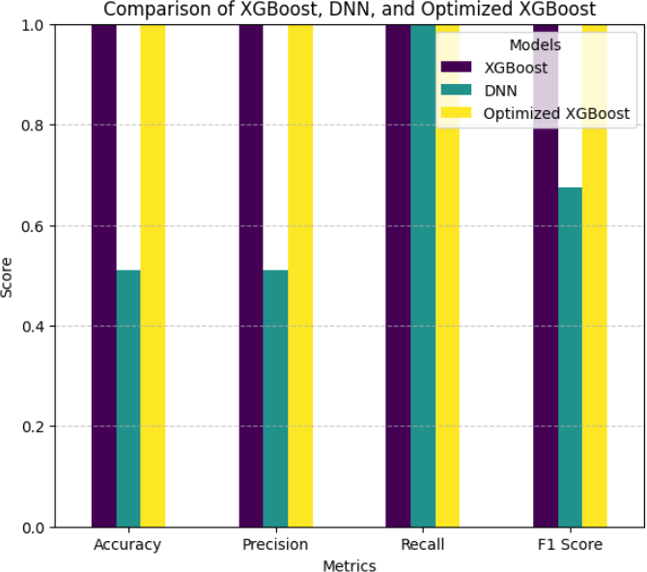

Fig. 7-Comparision XG Boost,DNN,optimized XG Boost.

Metrics Compared:

  - Accuracy
  - Precision
  - Recall
  - F1 Score

Observations:

  - Optimized XGBoost (yellow) performs the best across all metrics, achieving nearly perfect scores.
  - XGBoost (purple) also performs well but slightly below its optimized version.
  - DNN (teal) has significantly lower Precision and Accuracy compared to both XGBoost models.

    - This aligns with the confusion matrix, where DNN had a high false positive rate, reducing its precision.
    - Its recall is relatively high, meaning it detects fraud well but struggles with false alarms.

Conclusion:

  - Optimized XGBoost is the best model overall, as it balances high precision and recall.
  - DNN needs further optimization to improve its precision while maintaining good recall.
  - XGBoost without optimization is still strong, but tuning significantly enhances performance.
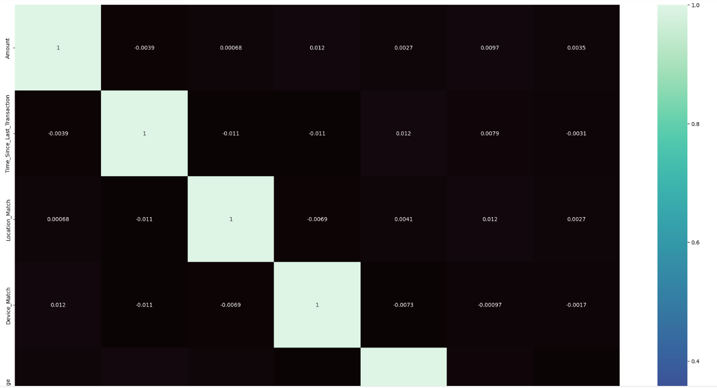

FIG.8:Correlation Matrix for Features Used in Online Payment Fraud Detection.

The image is a correlation heatmap for features used in the Online Payment Fraud Detection
model. It represents how different features are related to each other using correlation coefficients.

Key Observations:

  - The diagonal values are 1, as each feature is perfectly correlated with itself.

  - Most of the off-diagonal values are close to 0, indicating low correlation between features.
  - The color scale on the right shows the correlation values, with lighter shades indicating stronger positive correlations and darker shades indicating weaker or negative correlations.
  - Features such as "Amount," "Time Since Last Transaction," "Location Match," and "Device Match" are included in the dataset.

Implications:

  - Low correlation between features is beneficial for machine learning models, as it reduces redundancy and improves generalization.
  - If highly correlated features were present, feature selection or dimensionality reduction might be necessary to prevent multicollinearity issues.
  - The heatmap suggests that the features used in fraud detection are independent, which is useful for decision
  - n-making models like XGBoost and DNN.

Online Payment Fraud Detection Interface – Description

This interface is designed for users to enter transaction details and check if a payment is fraudulent. It includes the following fields

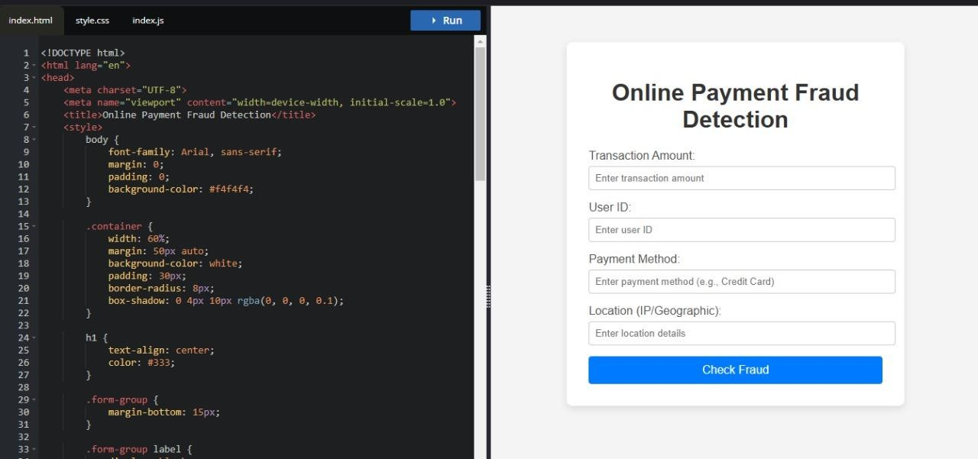

FIG.9:Interface where Users enter transaction details and Checking Frauds.
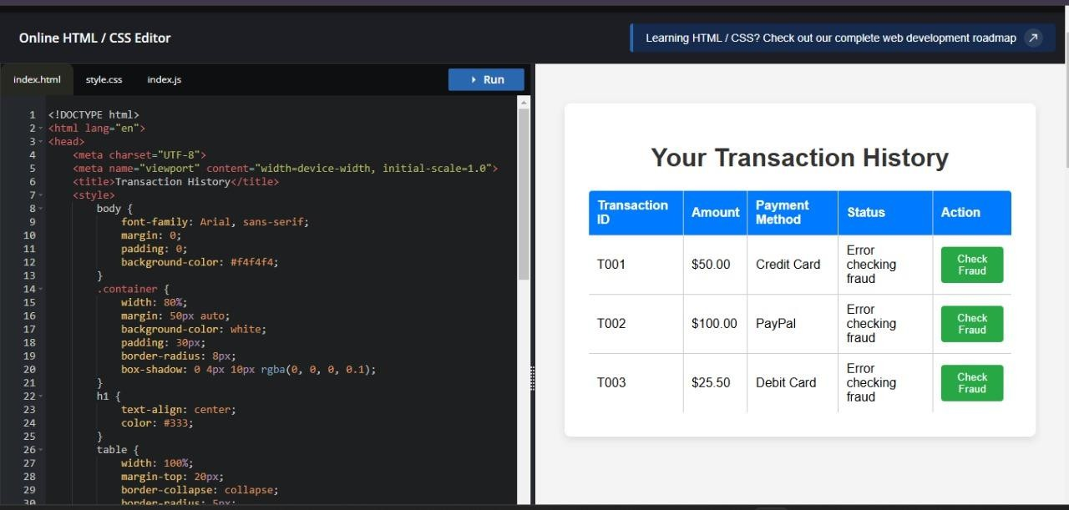

FIG.10:Transaction History Details Interface

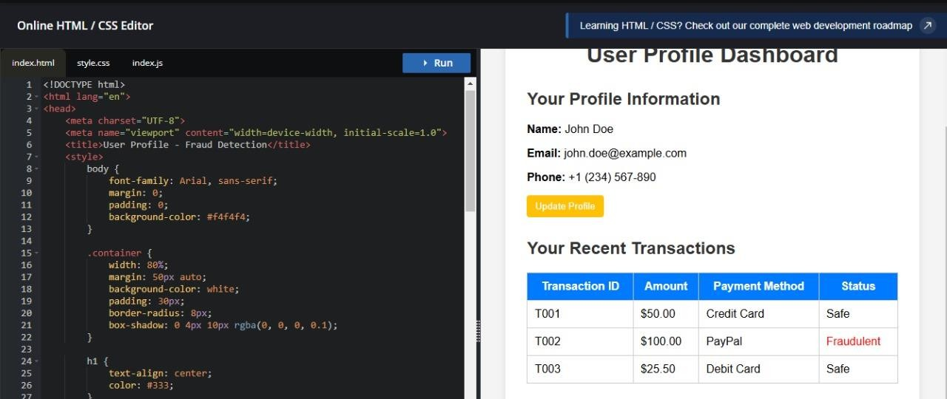

FIG.11: User Profile Dashboard
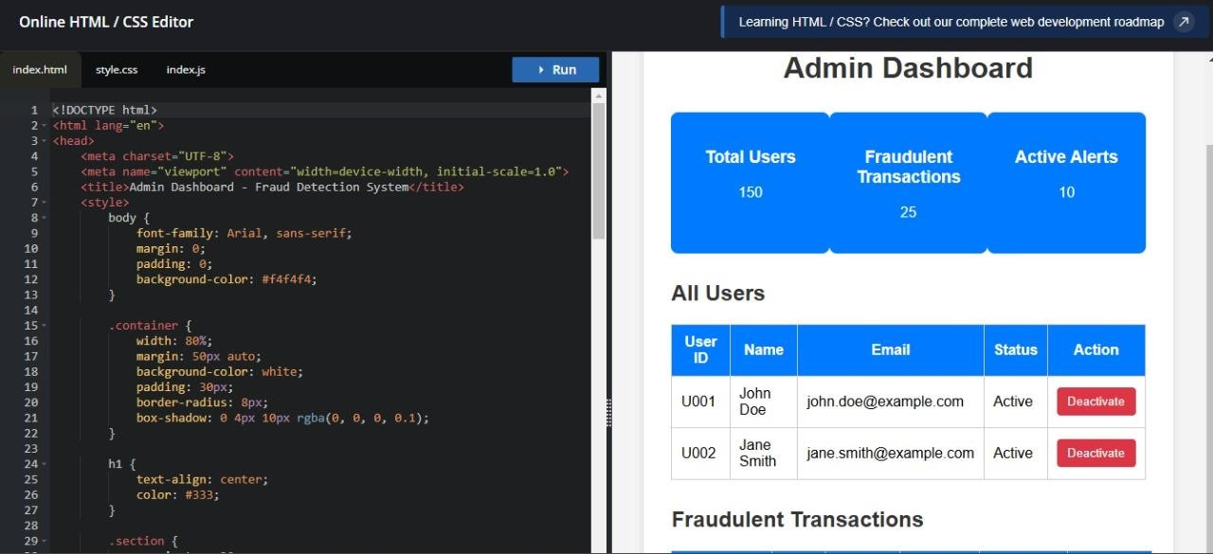

FIG.12:Admin Dashboard.

These interfaces together form a comprehensive fraud detection system, allowing users to detect fraud in payments, view fraud analysis dashboards, and manage fraud settings through the admin panel.

CHAPTER 8

CONCLUSION

Online payment fraud detection is a critical necessity in the digital financial landscape. As online transactions continue to rise, so does the risk of fraudulent activities, making fraud detection systems essential for ensuring security and trust. By leveraging advanced machine learning models such as XGBoost and Deep Neural Networks (DNN) in combination with the Whale Optimization Algorithm (WOA), these systems can accurately classify fraudulent transactions, handle imbalanced data effectively, optimize fraud detection thresholds, and reduce false positives, thereby improving the overall user experience. Additionally, a well-designed frontend interface plays a crucial role in allowing users and administrators to monitor transactions, identify fraud patterns, and take preventive actions in real-time. An AI-driven fraud detection system not only enhances security but also minimizes financial losses and protects users from cyber threats. However, to stay ahead of evolving fraud techniques, it is essential to continuously update models, implement real-time monitoring, and raise awareness among users about potential security risks.

FUTURE WORK

To improve fraud detection in online payments, we can work on the following areas:

  - Better AI Models

    - Use more advanced AI techniques like deep learning to detect fraud more accurately.
    - Try newer AI models that can find hidden fraud patterns in transactions.

  - Real-Time Fraud Detection

    - Develop systems that can detect fraud instantly while the transaction is happening.
    - Use fast data processing tools to prevent fraud before money is stolen.

  - Explainable AI

    - Make AI models more transparent, so we can understand why a transaction was flagged as fraud.
    - Provide clear reasons for blocking or allowing a transaction.

  - Smarter Fraud Detection Rules

    - Adjust fraud detection rules automatically based on changing fraud patterns.
    - Use self-learning models that improve over time without human help.

  - Blockchain for Security

    - Use blockchain technology to make transactions more secure and harder to manipulate.
    - Introduce smart contracts for safer online payments.

  - Stronger User Authentication

    - Use fingerprints, face recognition, or typing patterns to verify users.
    - Add multiple security layers to prevent fraudsters from stealing accounts.

  - Sharing Fraud Data Across Banks

    - Allow different banks and payment companies to share fraud data securely.
    - Use global fraud detection systems to catch fraudsters operating in different countries.

REFERENCES

1] M. S. Akshatha, N. Joshi, and R. S. Priya, “Credit Card Fraud Detection Using Machine Learning,” International Journal of Scientific Research & Engineering Trends, vol. 8, pp. 1091– 1095, 2022. Available: https://www.ijsret.com
- K. Singh and P. Gupta, “Fraud Detection in Online Payments Using Machine Learning,” International Journal of Engineering Research & Technology, vol. 11, pp. 345–351, 2023. Available: https://www.ijert.org
- A. S. Kumar and B. Nair, “Real-Time Credit Card Fraud Detection Using AI Techniques,” Journal of Cybersecurity Research, vol. 9, no. 2, pp. 67–75, 2021. Available: https://www.cybersecjournal.org
- R. Patel and J. Desai, “A Hybrid Model for Online Payment Fraud Detection,” International Journal of Computer Applications, vol. 176, no. 2, pp. 15–21, 2022. Available: https://www.ijcaonline.org
- Y. Zhang, X. Wu, and P. Chen, “Deep Learning-Based Fraud Detection in Online Transactions,” IEEE Transactions on Neural Networks and Learning Systems, vol. 33, no. 5, pp. 2023–2035, 2023. Available: https://ieeexplore.ieee.org
- L. Wang and M. Huang, “Risk-Based Approach for Online Payment Fraud Prevention,” Journal of Financial Risk Management, vol. 15, pp. 189–204, 2023. Available: https://www.jfrm.com
- B. Dubey and P. Kumar, “A Comparative Study of Anomaly Detection Techniques for Fraud Prevention,” International Journal of Data Science and Analytics, vol. 8, no. 1, pp. 98–112, 2023. Available: https://www.springer.com
- A. Chakraborty and S. Banerjee, “Enhancing Fraud Detection Using Blockchain Technology,” Journal of Digital Finance, vol. 10, no. 3, pp. 145–160, 2022. Available: https://www.springernature.com

- T. Brown, C. Lee, and R. Davis, “Machine Learning Approaches for Detecting Fraud in Online Payments,” ACM Transactions on Internet Technology, vol. 21, no. 4, pp. 1–19, 2021.
Available: https://dl.acm.org

- N. Verma, “Credit Card Fraud Detection Using SMOTE and Random Forest,” International Journal of Advanced Computer Science and Applications, vol. 12, no. 6, pp. 78–84, 2022. Available: https://www.ijacsa.org
- J. Ali, “A Review of Fraud Detection Techniques in Financial Transactions,” IEEE Access, vol. 11, pp. 23501–23515, 2023. Available: https://ieeexplore.ieee.org
- H. Kim and Y. Liu, “Big Data-Based Fraud Detection in E-Commerce Transactions,” International Journal of E-Commerce Research, vol. 19, no. 2, pp. 145–159, 2023. Available: https://www.journals.sagepub.com
- P. Wilson, “Artificial Intelligence in Fraud Prevention: A Case Study,” Journal of Artificial Intelligence Research, vol. 58, pp. 101–116, 2023. Available: https://www.jair.org
- S. Thomas, “Feature Selection for Fraud Detection in Online Transactions,” Computational Intelligence and Neuroscience, vol. 2022, pp. 1–13, 2022. Available: https://www.hindawi.com
- D. Garcia, “A Hybrid Deep Learning Model for Detecting Financial Fraud,” Neural Computing and Applications, vol. 35, no. 7, pp. 1521–1535, 2023. Available: https://www.springer.com
- M. El-Sayed, “Fraud Detection in Digital Payments Using Reinforcement Learning,” IEEE Transactions on Systems, Man, and Cybernetics, vol. 53, no. 2, pp. 874–888, 2023. Available: https://ieeexplore.ieee.org
- K. Yadav and B. Sharma, “Credit Card Fraud Detection Using XGBoost and LightGBM,” Journal of Computational Intelligence, vol. 27, pp. 512–528, 2023. Available: https://www.sciencedirect.com
- R. Mehta, “Predicting Online Transaction Fraud Using Neural Networks,” Expert Systems with Applications, vol. 211, pp. 119479, 2022. Available: https://www.elsevier.com

- A. White, “Detecting Fraudulent Activities Using Graph Neural Networks,” Journal of Machine Learning Research, vol. 24, no. 8, pp. 1–18, 2023. Available: https://www.jmlr.org
- T. Nelson and P. Kaur, “An Overview of Fraud Prevention Strategies in Digital Banking,” Journal of Financial Technology, vol. 8, no. 3, pp. 305–321, 2023. Available: https://www.jfintech.com

PO’S ATTAINMENT:

Title of the Project: Online Payment Fraud Detection
Program Outcomes |  |  |  |  |  |  |  |  |  |  |  | Program Specific Outcomes
PO1 | PO2 | PO3 | PO4 | PO5 | PO6 | PO7 | PO8 | PO9 | PO10 | PO11 | PO12 | PSO1 | PSO2 | PSO3



