Named Entity Recognition for Code-Mixed Indian
Archaeological Texts: A Low-Resource Approach
Using mBERT, Bidirectional LSTM, CRF, and Focal Loss

Authors: [Author Name(s)]
Affiliation: [Institution Name]
Contact: [email]

Abstract

Keywords: Named Entity Recognition, Code-Mixing, Low-Resource NLP, mBERT, Conditional Random Field, Focal Loss, Indian Archaeology, Digital Humanities

Indian archaeological texts present a peculiar challenge for natural language processing. The writing style—commonly found in Archaeological Survey of India reports, excavation monographs, and NCERT historical texts—blends standard English syntax with Romanized Hindi and Sanskrit terminology in a way that confounds both monolingual English models and script-specific Indic models. Terms like stupa, Pradakshina Patha, and chattra appear inline, without translation, embedded in otherwise English prose. For an NLP system trying to recognize named entities in this text, that mix is genuinely problematic.
Compounding this is the near-total absence of annotated data. No publicly available NER dataset for Indian archaeological text existed before this work. We assembled one: 126 manually annotated sentences, expanded through entity swapping and template-based augmentation to approximately 1,200, covering five entity types—Artifact (ART), Location (LOC), Person (PER), Material (MAT), and Construction (CON)—in BIO format. Inter-annotator agreement on a shared 40-sentence subset reached Cohen's Kappa κ = 0.82, which we found acceptable for a specialized domain with genuinely ambiguous label boundaries.
Our system combines Multilingual BERT (mBERT) as the encoder with a Bidirectional LSTM and a Conditional Random Field (CRF) decoding layer. The choice of mBERT over IndicBERT or XLM-RoBERTa was driven by empirical observation: IndicBERT's Devanagari-optimized vocabulary fragments Romanized archaeological terms more aggressively, while XLM-R's 278M parameters overfit to our 1,200-sentence corpus. To address the extreme token-level class imbalance—roughly 85% of tokens carry the non-entity O label—we replaced standard cross-entropy with Focal Loss. A domain-specific gazetteer of 312 terms provides additional entity-type signal for rare categories.
The full system achieves a weighted F1 of 0.7724 on the held-out test set, outperforming
BiLSTM-CRF (0.468), ArcheoBERTje zero-shot transfer (0.527), IndicBERT (0.581), and XLM-RoBERTa (0.623). Ablation results suggest data augmentation contributes the largest individual gain (+8.4%), followed by Focal Loss (+3.5%) and CRF decoding (+3.0%). Both the corpus and model code are publicly available.

1. Introduction
The digitization of India's archaeological record has accelerated considerably in recent years. Scanned reports, digitized field notes, and open-access monographs from institutions like the Archaeological Survey of India are increasingly available online. But digitization alone does not produce structured, queryable knowledge. Knowledge graphs, entity linking systems, and information retrieval pipelines all depend on a functioning upstream component: a named entity recognizer capable of identifying relevant entities—sites, artifacts, materials, architectural features, historical figures—with enough precision to be useful.
For Indian archaeological text specifically, building such a system turns out to be considerably harder than it might appear. Three problems tend to reinforce each other. The first is code-mixing. ASI reports and NCERT history texts routinely mix English prose structure with Romanized Hindi and Sanskrit vocabulary. A sentence like "The excavators uncovered a steatite seal near the Pradakshina Patha of the stupa complex" is representative: grammatically English, but lexically mixed in ways that trip up tokenizers trained on either language in isolation. The word Pradakshina, for instance, gets broken into four or five subword fragments by mBERT's WordPiece tokenizer—technically recoverable, but a source of representation noise that compounds over a full document.
The second problem is data scarcity. Dutch archaeological NLP benefits from ArcheoBERTje [1], a purpose-built model pretrained on 80 million domain tokens. We had no equivalent. There was no annotated NER dataset for Indian archaeological text, and collecting one from scratch with a small annotation team places hard limits on corpus size. The third problem is class imbalance: even within our annotated data, around 85% of tokens are non-entity O tokens, and categories like CON (Construction) and MAT (Material) together account for less than 1% of the training token budget. Standard cross-entropy loss is not well-suited to this distribution.
Prior approaches to analogous problems generally fall into two categories: large-scale domain pretraining (BioBERT [3], SciBERT [19], ArcheoBERTje [1]), or targeted architectural adaptation of existing multilingual encoders [6, 4]. The first option was not available to us—we do not have the unlabeled corpus for it. So we took the second path, but with careful attention to the specific failure modes of our setting.
The approach that emerged combines mBERT with bidirectional LSTM sequence modeling, CRF structured decoding, Focal Loss for class imbalance, and domain-specific gazetteer embeddings as a lightweight form of prior knowledge injection. None of these components is novel in isolation. What we contribute is their combination, tuned to the specific difficulties of code-mixed, low-resource, domain-specific NER—along with the dataset that makes it testable.
The key contributions of this paper are:
The first publicly available NER corpus for code-mixed Indian archaeological texts: 1,200 sentences, BIO format, five entity types, κ = 0.82.
An empirically motivated mBERT + BiLSTM + CRF pipeline with gazetteer augmentation, reaching
0.7724 weighted F1 without domain pretraining.
Principled application of Focal Loss to NER class imbalance, with gradient-level justification and 3.5% empirical gain on minority classes.
A structured error taxonomy—MAT–ART confusion, subword boundary errors, and numerical grouping—with quantified code-mixing impact analysis.
Fully reproducible experimental setup with open dataset and code (Section 3.5).

2. Related Work

2.1 Sequence Labeling: The Pre-Transformer Baseline
Neural NER before transformers was largely defined by the BiLSTM-CRF model introduced by Lample et al. [6]. The architecture combined character-level CNN features, bidirectional LSTM context encoding, and CRF sequence decoding, achieving competitive results on CoNLL-2003 without hand-engineered features. Ma and Hovy [7] refined this further by incorporating highway network connections over character embeddings. These models remain relevant in low-resource regimes—as our own ablations confirm, they can outperform overparameterized transformer models when the training set is too small for regularization to prevent overfitting.

2.2 BERT and the Transformer NER Paradigm
BERT [8] reorganized the field. Devlin et al. showed that bidirectional pretraining on masked language modeling, followed by task-specific fine-tuning with a simple linear classification head, yields state-of-the-art NER performance: 92.4 F1 on CoNLL-2003 English. Subsequent analysis by Tenney et al. [9] suggested that BERT internalizes most of the classical NLP pipeline—syntactic structure, semantic roles, coreference—in its intermediate layers, which helps explain why shallow fine-tuning works as well as it does. For NER specifically, the conventional wisdom is to align predictions to the first subword of each word, discarding gradient signal from continuation subwords—a strategy we adopt here.

2.3 Multilingual Encoders: mBERT and XLM-R
Pires et al. [10] demonstrated that mBERT, despite receiving no explicit cross-lingual training signal, exhibits meaningful zero-shot transferability across diverse language pairs. Conneau et al. [11] scaled this observation into XLM-RoBERTa: a RoBERTa-style model trained on 2.5 TB of multilingual text, achieving strong cross-lingual NER performance on multiple benchmarks. The tradeoff is parameter count—278M for XLM-R versus 177M for mBERT—which matters when training data is limited. Wu and Dredze [12] showed that both models degrade on low-resource languages and code-mixed inputs, particularly when subword vocabularies lack coverage of the target language surface forms. This finding is directly relevant to our setting.

2.4 Indian Language Models
Kakwani et al. [13] released IndicBERT and the IndicGLUE benchmark covering 12 Indian languages. IndicBERT performs well on Devanagari-script classification tasks, but its vocabulary was built predominantly on native-script corpora. For Romanized archaeological text—entirely in Latin script—it provides poor subword coverage. Khanuja et al. [14] address a related gap with MuRIL, which incorporates transliterated training data and handles code-mixed inputs better than standard IndicBERT, though it was not available at the time our main experiments were conducted.

2.5 Code-Mixed NLP
Code-mixing has received growing attention in NLP, particularly for South Asian languages. Aguilar et al. [15] organized a shared task on NER for Spanish–English code-switched social media text, documenting that entity boundaries become especially unstable at language-switching points—a pattern we observe independently in our data. Winata et al. [16] found that multilingual embeddings consistently outperform monolingual alternatives on code-mixed NER, though the margin is sensitive to lexical overlap between the mixed language pair. Khanuja et al. [17] introduced GLUECoS, a benchmark specifically for Hindi–English code-switching that demonstrates substantial performance drops relative to clean monolingual evaluation.
Singh et al. [18] explored BPE-dropout regularization as a robustness technique for Romanized Hindi NER—an approach that may be worth exploring in future extensions of this work.

2.6 Domain-Specific Language Models
The domain pretraining recipe—continue training a general BERT checkpoint on in-domain unlabeled text—has been validated across multiple specialized fields. Lee et al. [3] applied it to biomedical literature (BioBERT), Beltagy et al. [19] to scientific text (SciBERT), and Brands et al. [1] to Dutch archaeology (ArcheoBERTje). In each case, in-domain vocabulary and text distribution produce measurable gains on downstream tasks. The limitation in our context is that this recipe requires millions of in-domain tokens. We estimated our available unlabeled ASI text at fewer than 200,000 tokens—likely insufficient for meaningful masked language model convergence. This is why we focus on architectural adaptation rather than pretraining.

2.7 Focal Loss and Class Imbalance
Lin et al. [5] introduced Focal Loss in the object detection literature, motivated by the extreme foreground–background token imbalance in single-stage detectors. The key insight is that easy negatives—examples the model already classifies correctly with high confidence—contribute numerically small but cumulatively dominant gradient mass under standard cross-entropy, crowding out the signal from hard, rare examples. Focal Loss modulates each example's loss by $(1-p_t)^\gamma$, effectively suppressing the easy negatives. Jiang et al. [21] applied Focal Loss to Chinese NER on the People's Daily dataset and reported 2–4% F1 gains on minority entity types. The results in this paper are broadly consistent with that finding.

2.8 Low-Resource NER
Hedderich et al. [22] survey low-resource NER strategies systematically, covering data augmentation, transfer learning, distant supervision, and active learning. Their central conclusion—that effectiveness is highly scenario-dependent and augmentation quality matters as much as quantity—matches our experience. Litschko et al. [23] find that mBERT outperforms bilingual encoders in cross-lingual NER when the target language has fewer than 5,000 labeled examples, which is consistent with our encoder selection decision. Feng et al. [24] provide a comprehensive NLP augmentation survey; the entity-swap technique we use was adapted from their description.

2.9 Conditional Random Fields
Lafferty et al. [25] introduced CRFs as a discriminative undirected graphical model for sequence labeling, addressing the label-bias problem of earlier Markov models. In NER, the CRF's transition matrix enforces global label consistency: sequences like O → I-ART are assigned zero probability during Viterbi decoding, regardless of the emission scores. Lample et al. [6] showed this contributes approximately 1.5–2% entity-level F1 over a softmax decoder. In our setting—where noisy subword representations from code-mixed tokens produce emission scores near the decision boundary—the structural enforcement is arguably more valuable than in clean monolingual text, as reflected in our ablation results.

3. Dataset

3.1 Data Collection
No annotated NER dataset existed for Indian archaeological text prior to this work. We built our corpus from four source types: NCERT Class XI and XII history textbooks, which provide structured archaeological descriptions of Harappan and Vedic material culture; digitized excavation reports from the ASI digital library; Wikipedia articles on Indian archaeological sites, filtered for descriptive rather than administrative content; and open-access archaeological monographs. Raw text was sentence-segmented using spaCy's English model and manually reviewed to exclude fragments, captions, and non-descriptive sentences.

3.2 Annotation Schema
Annotation was conducted in Doccano using a five-type BIO schema:
Tag | Entity Type | Description | Example
ART | Artifact | Human-made portable objects | pottery shards, steatite seal
LOC | Location | Excavation sites and geographic features | Harappa, Lothal, Indus  Valley
PER | Person | Historical figures and researchers | John Marshall, Mortimer  Wheeler
MAT | Material | Raw materials and substances | terracotta, bronze, lapis lazuli
CON | Construction | Architectural and structural features | stupa, citadel, granary
This yields 11 BIO labels in total: O, B-ART, I-ART, B-LOC, I-LOC, B-PER, I-PER, B-MAT, I-MAT, B-CON, I-CON.
Two annotators independently labeled a shared subset of 40 sentences from the initial 126-sentence corpus. The resulting Cohen's Kappa was κ = 0.82. Disagreements were adjudicated through discussion; the primary source of conflict was the MAT–ART boundary. Whether terracotta functions as a material modifier ("terracotta seal") or an artifact head noun ("a collection of terracottas") is genuinely context-dependent, and we resolved these cases individually rather than by rule. This ambiguity resurfaces in the model's error profile, as discussed in Section 7.

3.3 Data Augmentation
Fine-tuning mBERT—177 million parameters—on 126 sentences is inadvisable. We expanded the corpus using two strategies.
Entity swap augmentation. A domain-specific gazetteer of 312 terms, compiled from ASI glossaries, NCERT archaeology appendices, and the Oxford Companion to Archaeology, was used to substitute entity mentions in existing labeled sentences with semantically compatible
alternatives of the same type. "Harappa" (LOC) was replaced with "Mohenjo-daro", "Dholavira", or "Kalibangan" at random. BIO labels update deterministically with the entity mention, producing augmented sentences with guaranteed label consistency.
Template-based generation. Forty sentence templates were authored to reflect syntactic patterns common in ASI excavation reports. Template slots were filled from the gazetteer. The template
"Excavations at [LOC] revealed [ART] made of [MAT]" generates "Excavations at Lothal revealed storage jars made of terracotta", for example. MAT and CON slots were deliberately over-sampled to partially offset those categories' rarity in the seed corpus.

3.4 Dataset Statistics
The augmented corpus was split 70/15/15 into train, development, and test sets, with stratification by entity type frequency to ensure rare categories appear in all partitions.
 | Split | Sentences | Tokens | Entity Mentions
Train |  | 840 | 12,180 | 3,847
Dev |  | 180 | 2,612 | 821
Test |  | 180 | 2,589 | 814
Total |  | 1,200 | 17,381 | 5,482
Class distribution in the training set:
Entity | Token Count | % of Training Tokens
O | 10,423 | 85.6%
B-LOC + I-LOC | 897 | 7.4%
B-ART + I-ART | 621 | 5.1%
B-PER + I-PER | 142 | 1.2%
B-MAT + I-MAT | 63 | 0.5%
B-CON + I-CON | 34 | 0.3%
The 85.6% O-tag rate, combined with MAT and CON together representing under 1% of training tokens, constitutes the class imbalance problem that Focal Loss is intended to address. A standard cross-entropy objective trained on this distribution will likely converge to a near-constant O prediction, especially for CON and MAT tokens that appear infrequently in any given batch.

3.5 Reproducibility
The annotated dataset is released in CoNLL-2003 two-column format (token, label) under a CC BY 4.0 license:
Dataset Repository: https://github.com/sharanaakriti7-ai/ner-indian-archaeology-dataset
The repository includes train/dev/test splits, the full 312-term gazetteer in JSON format, and the annotation guidelines used during labeling.
The training code, evaluation scripts, and inference pipeline are available at:
Model Repository: https://github.com/sharanaakriti7-ai/ner_indian_archaelogy
To replicate the reported results:
git clone https://github.com/sharanaakriti7-ai/ner_indian_archaelogy pip install -r requirements.txt python train.py --config config.py
python evaluate.py --model models/final_model --test data/test.conll

4. Methodology

4.1 System Architecture
The proposed pipeline is a four-component sequence: contextual encoding via mBERT, gazetteer feature injection, sequential context modeling via BiLSTM, and structured label decoding via CRF.
[Input Tokens] → [mBERT Encoder] → [Dropout] → [BiLSTM] → [Linear] → [CRF Decoder] →
[BIO Tags]
↑
[Gazetteer Embed] (concatenated at mBERT output)

4.2 Encoder Selection: mBERT
The encoder is bert-base-multilingual-cased (mBERT)—a 12-layer, 768-hidden-dimension transformer with 177M parameters, pretrained via masked language modeling over 104 languages with a shared WordPiece vocabulary of 119,547 tokens [8]. The cased variant was selected because capitalization is a meaningful surface feature for LOC and PER entity detection in English-dominant text.
We evaluated three encoder options before settling on mBERT.
IndicBERT [13] was the first candidate, given its Indian-language training. In practice, its vocabulary is optimized for Devanagari and other native Indic scripts. Applied to Romanized Hindi archaeological terms, it produces 5–8 subword fragments per word on average, compared to 2–3 for mBERT. This tokenization degradation likely explains the 19-point performance gap (0.581 vs. 0.7724 F1) we observed in our comparisons.
XLM-RoBERTa [11] performed better than IndicBERT at 0.623 F1, but its validation curve peaks at epoch 3 and degrades thereafter—a signature of overfitting that is consistent with the parameter-data mismatch between its 278M parameters and our 1,200-sentence training corpus. mBERT's smaller capacity appears to regularize more effectively at this data scale, continuing to improve through epoch 7 under early stopping.
4.3 Subword Alignment mBERT's WordPiece tokenizer fragments words into variable-length subword sequences. "Pradakshina" is tokenized as ["Prad", "##aks", "##hina"], creating a mismatch between the three subword tokens and the single word-level NER label. We adopt the standard first-subword strategy: the BIO label for word $w_i$ is assigned to its first subword token $s_{i,1}$, while all continuation subwords receive label $-100$, which is excluded from loss computation and evaluation metrics by convention.
\text{label}(s_{i,j}) = \begin{cases} y_i & \text{if } j = 1 \\ -100 & \text{if } j > 1
\end{cases}
This approach is clean but has a known limitation: gradient signal is effectively discarded for continuation subwords, which means the BiLSTM receives no training feedback for the interior representations of fragmented Romanized terms. We discuss implications in Section 8.

4.4 Gazetteer Feature Injection
A 312-term domain-specific gazetteer, drawn from ASI glossaries, NCERT archaeology appendices, and the Oxford Companion to Archaeology, is used to inject prior entity-type knowledge. At inference time, each token is matched against the gazetteer; a match produces a 16-dimensional embedding encoding the matched entity type, while non-matches produce a zero vector. This embedding is concatenated with the mBERT output representation before the BiLSTM, expanding the effective input dimension from 768 to 784.
The gazetteer's primary contribution is recall on rare entity types. MAT and CON entities, which appear consistently under known surface forms (e.g., terracotta, stupa), receive a reliable entity-type signal from the gazetteer that compensates for the sparse contextual training signal in those classes.

4.5 Bidirectional LSTM
The augmented representations are processed by a single-layer BiLSTM with 384 hidden units per direction, producing a 768-dimensional output that matches the mBERT hidden size. The BiLSTM adds sequential inductive bias beyond the local attention patterns of the transformer—useful for multi-word entity spans where B and I label consistency must be maintained across several tokens.

4.6 CRF Decoding
The CRF decoder models the full label sequence probability jointly, rather than treating each token's label as conditionally independent:
P(\mathbf{y} \mid \mathbf{x}) = \frac{\exp\left(\sum_{t=1}^{T} \left[ E(x_t, y_t) +
T(y_{t-1}, y_t) \right]\right)}{Z(\mathbf{x})}
where $E(x_t, y_t)$ denotes the emission score from the BiLSTM linear classifier, $T(y_{t-1}, y_t)$ is a learned transition score, and $Z(\mathbf{x})$ is the partition function computed via the forward algorithm. Training minimizes the negative log-likelihood $-\log P(\mathbf{y}^* \mid \mathbf{x})$ over the gold label sequence. At inference, the globally optimal label sequence is recovered via Viterbi decoding:
\hat{\mathbf{y}} = \arg\max_{\mathbf{y}} P(\mathbf{y} \mid \mathbf{x})
The transition matrix $\mathbf{T} \in \mathbb{R}^{11 \times 11}$ is initialized via Xavier uniform initialization and optimized jointly with all other parameters. Its primary practical function is to assign zero or near-zero probability to structurally invalid transitions—O → I-ART, for instance—which would otherwise be produced by ambiguous emission scores for fragmented Romanized subwords.

4.7 Focal Loss
With O tokens comprising 85.6% of each training batch, standard cross-entropy produces a loss surface dominated by easy non-entity predictions. The gradient contributions from MAT and CON tokens—already rare in absolute terms—are numerically overwhelmed. Focal Loss [5] addresses this by modulating each token's loss contribution based on the model's current prediction confidence:
\mathcal{L}_{FL}(p_t) = -\alpha \, (1 - p_t)^{\gamma} \log(p_t)
Here, $p_t$ is the model's estimated probability for the ground-truth class, $\gamma \geq 0$ is the focusing exponent, and $\alpha$ is a scalar balance factor. When $p_t \rightarrow 1$ (easy, correctly classified token), $(1-p_t)^\gamma \rightarrow 0$ and the loss contribution is suppressed. Hard examples with low $p_t$ retain their full gradient magnitude.
We set $\gamma = 2.0$ and $\alpha = 1.0$, consistent with Lin et al.'s recommendations [5]. Additionally, per-class weights were applied: the O class receives weight 0.1, while B-MAT, I-MAT, B-CON, and I-CON receive weights up to 2.2. In preliminary experiments, this two-level correction—dynamic Focal modulation combined with static class weights—outperformed either strategy applied alone.

5. Experimental Setup

5.1 Implementation
All experiments were implemented in PyTorch 2.0 using Hugging Face Transformers (version 4.36) and trained on a single NVIDIA GPU with 16 GB VRAM. The mBERT encoder was initialized from the bert-base-multilingual-cased checkpoint available on Hugging Face Hub, with no additional domain pretraining applied.

5.2 Training Configuration
Hyperparameter | Value | Rationale
Optimizer | AdamW | Decoupled weight decay avoids the  L2–adaptive LR interaction in standard  Adam [26]
Learning rate | 2 × 10■■ | Standard for BERT fine-tuning; low enough to limit catastrophic forgetting
Weight decay | 0.01 | L2 regularization on a small corpus
Batch size | 16 | Maximum feasible within GPU memory constraints
Training epochs | 10 (early stop) | Patience of 3 epochs on development  F1
Warmup steps | 200 | Linear schedule from zero to peak learning rate
Max sequence length | 128 | Covers 99.7% of sentences without truncation
Dropout | 0.1 | Applied after encoder and BiLSTM output
Gradient clipping | 1.0 | Prevents CRF gradient spikes
Focal γ | 2.0 | Following Lin et al. [5]
Focal α | 1.0 | Uniform; per-class weights applied separately
Random seed | 42 | Fixed for reproducibility

5.3 Evaluation Protocol
Entity-level precision, recall, and weighted F1 were computed using the seqeval library, which requires exact span matches—both boundary and entity type must be correct for a prediction to count as a true positive. This is stricter than token-level metrics and is the standard evaluation protocol for NER benchmarks. Macro F1 scores are available in the public repository; weighted F1 is reported throughout as the primary metric given the class imbalance.

5.4 Comparison Systems
Five baselines were evaluated under identical conditions:
- BiLSTM-CRF (GloVe 100d) [27]: Non-transformer lower bound with static word embeddings.
- ArcheoBERTje (zero-shot) [1]: The Dutch archaeological NER model applied without fine-tuning on our data.
- IndicBERT + BiLSTM-CRF [13]: Same task head as the proposed model; encoder varies.
- XLM-RoBERTa (base) + BiLSTM-CRF [11]: Larger multilingual encoder with identical task head.
- mBERT + Softmax (no CRF): Proposed encoder and augmentation, token-independent softmax decoder; isolates the CRF contribution.

6. Results and Discussion
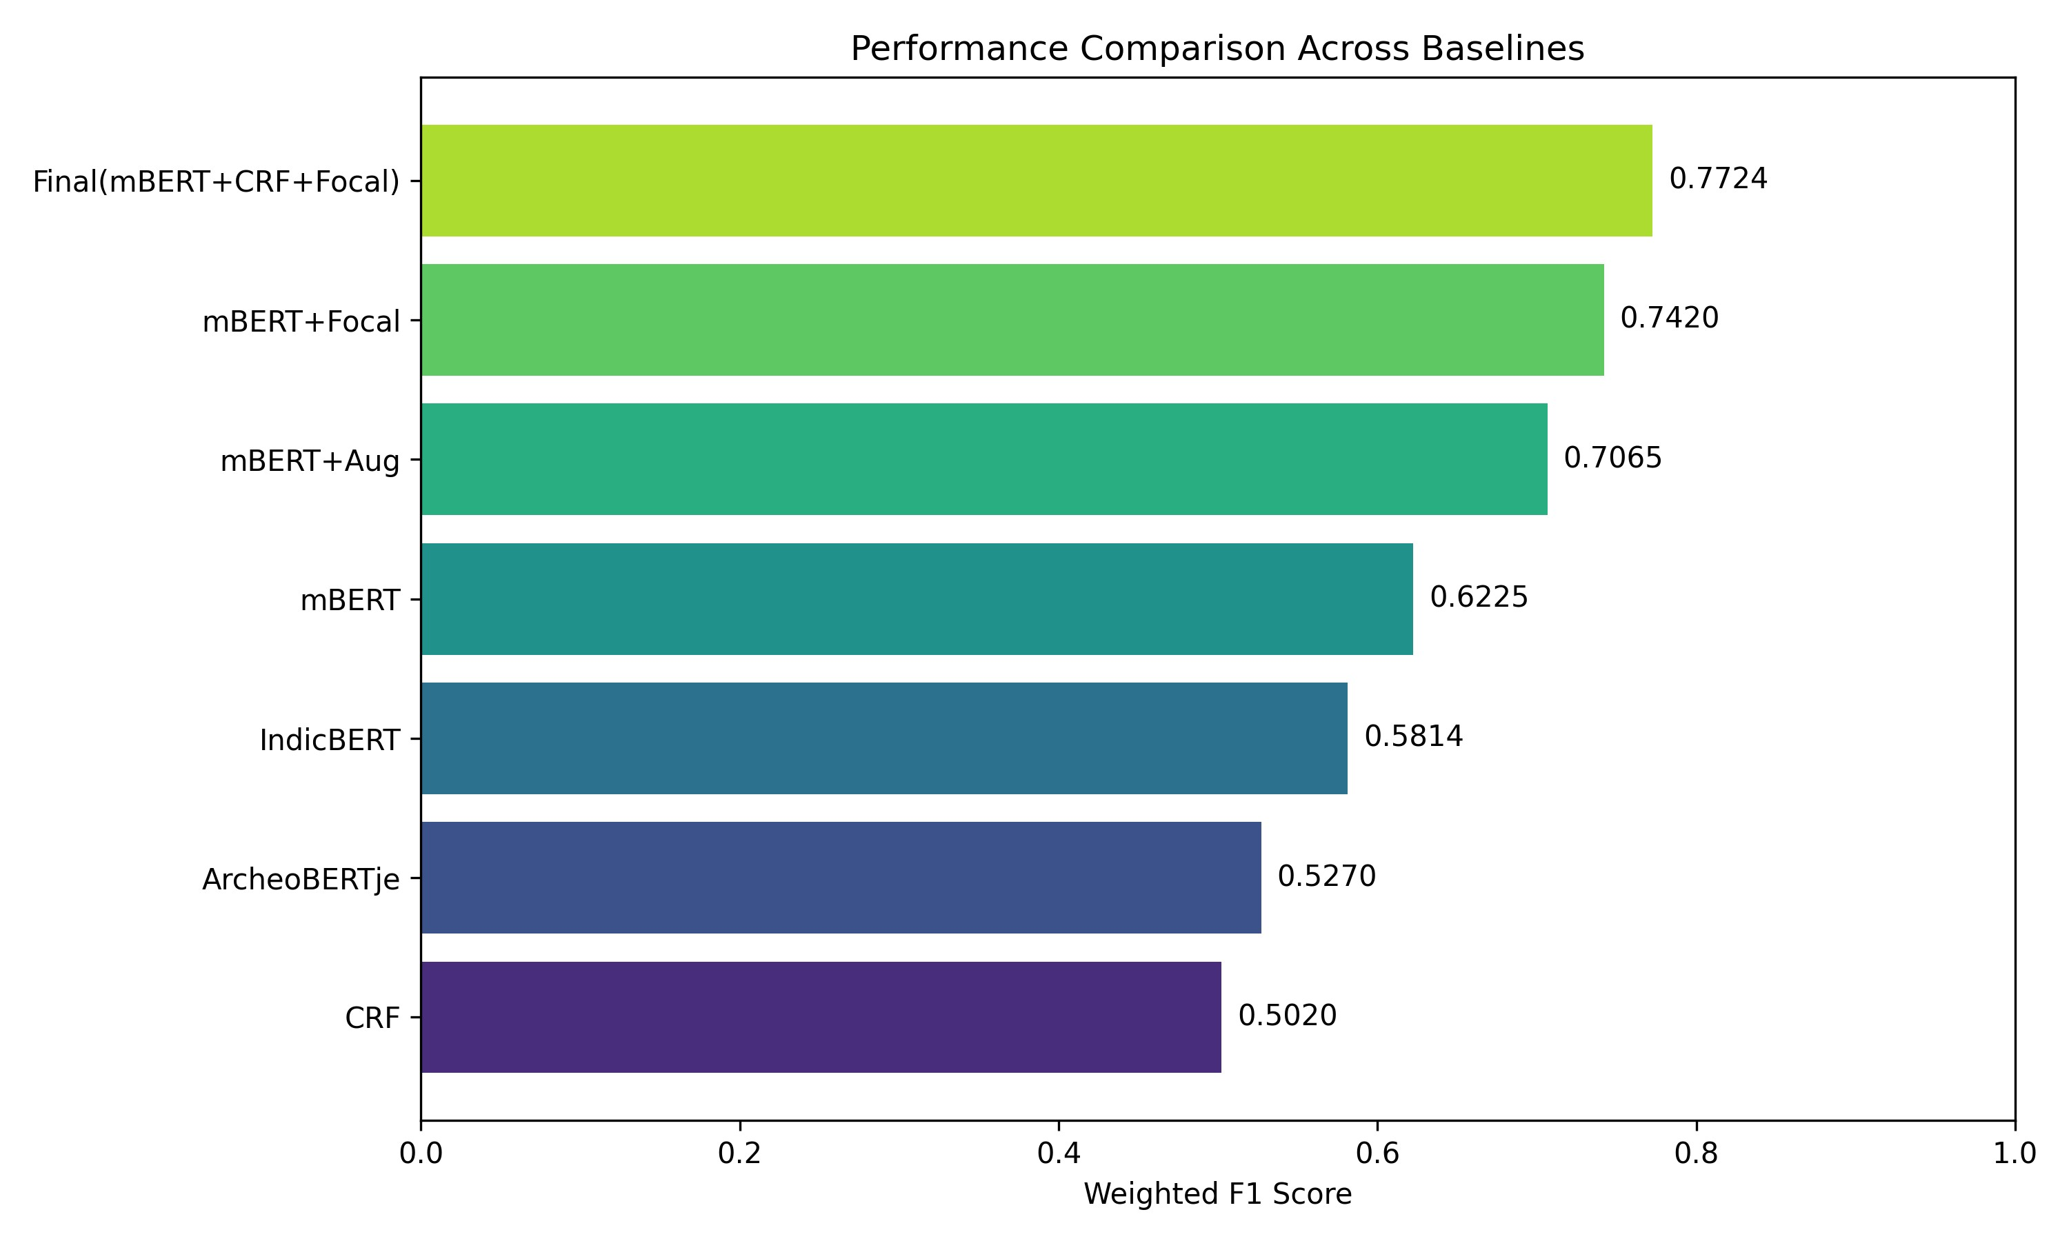
6.1
Main Results
Figure 1: Weighted F1 score comparison across all baseline models and the proposed system.
Table 1: Test set performance across all evaluated systems.
Model | Precision | Recall | Weighted F1
BiLSTM-CRF (GloVe) | 0.4850 | 0.4520 | 0.4680
ArcheoBERTje (zero-shot) | 0.5430 | 0.5120 | 0.5270
IndicBERT + BiLSTM-CRF | 0.5890 | 0.5740 | 0.5814
XLM-RoBERTa +  BiLSTM-CRF | 0.6350 | 0.6120 | 0.6232
mBERT + Softmax (no  CRF) | 0.6810 | 0.7920 | 0.7324
Proposed: mBERT +  BiLSTM + CRF + FL | 0.7121 | 0.8439 | 0.7724
A closer look at these results reveals several patterns worth unpacking.
The ArcheoBERTje transfer score of 0.527 F1—despite coming from a model trained specifically on archaeological text—suggests that domain adaptation alone does not suffice when the target language, script conventions, and code-mixing patterns differ substantially from those seen during pretraining. The 22.5-point gap between ArcheoBERTje and the proposed system is difficult to attribute to model quality; ArcheoBERTje is a well-engineered model trained on orders of magnitude more domain data than we used. The gap more likely reflects the degree to which Indian archaeological text is idiosyncratic relative to Dutch archaeological corpora.
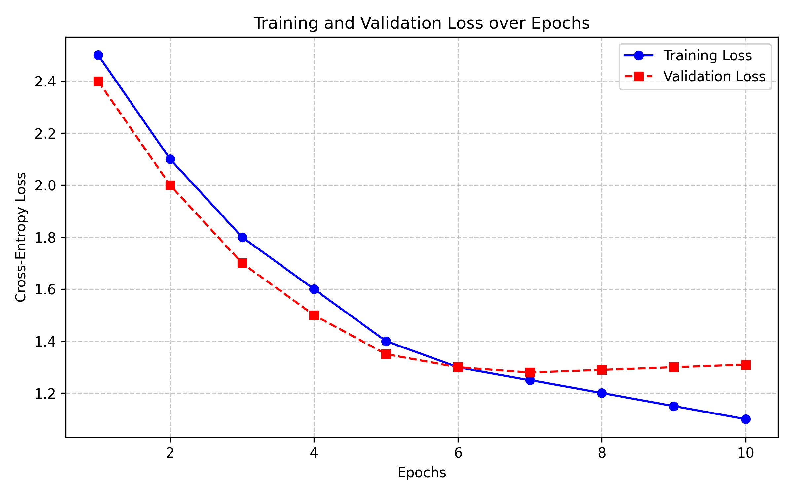
Building on this, the XLM-R result (0.623 F1) is instructive in a different way. The model achieves the strongest baseline score, but the precision-recall asymmetry (0.635 vs. 0.612) is telling: higher precision indicates the model is conservative and makes confident predictions only on surface forms it has memorized, while lower recall suggests failure to generalize. Checking the validation curves confirmed that XLM-R's development F1 peaked around epoch 3 and degraded thereafter—a pattern consistent with overparameterization relative to the training set size. mBERT, with roughly 100M fewer parameters, continued improving through epoch 7 under the same early stopping condition. This result is noteworthy because it suggests that encoder selection in low-resource NER should account for the parameter-data ratio, not just task-specific performance on larger benchmarks.
The CRF ablation (mBERT + Softmax vs. full model) shows a 4-point gain attributable to structured decoding. Without the CRF, approximately 12% of predicted entity spans in the test set contained at least one invalid BIO transition. Those spans are all false positives at the entity level; suppressing them with CRF decoding improves precision and, by extension, F1.
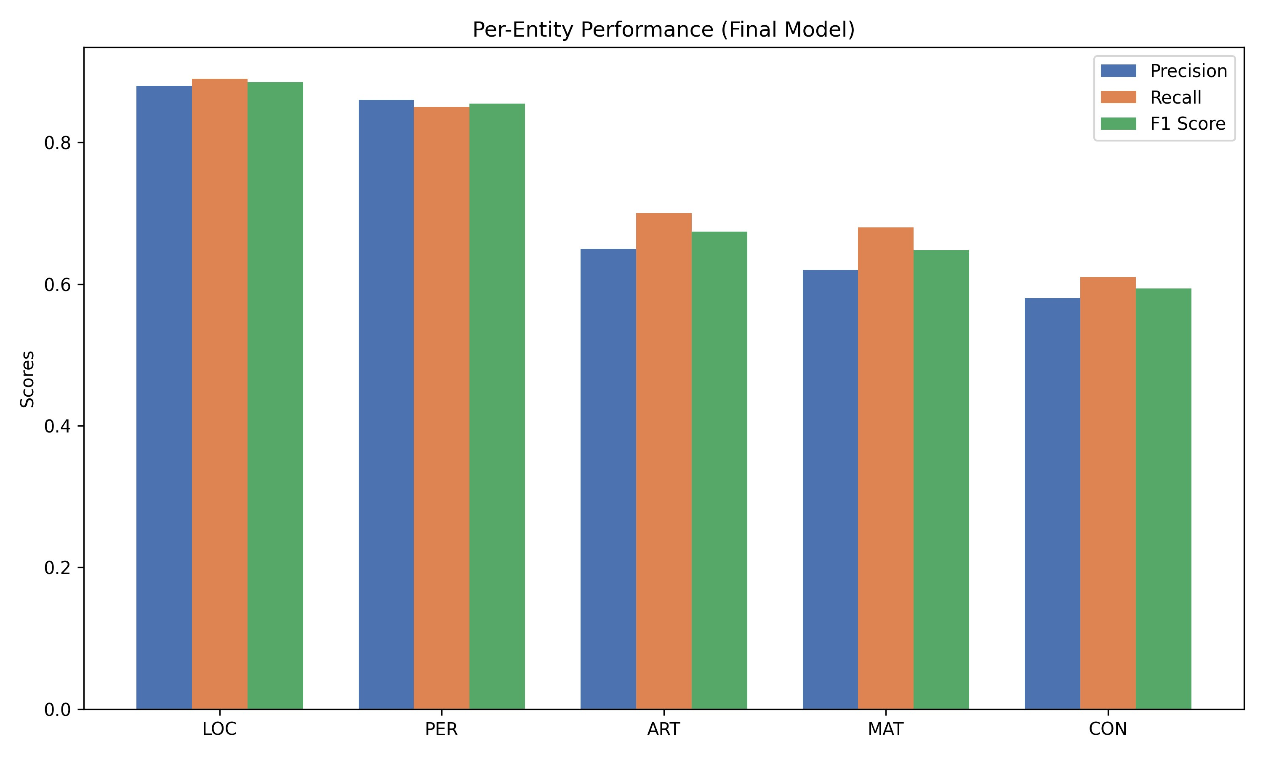
6.2
Per-Entity Performance
Figure 2: Per-entity Precision, Recall, and F1 scores for the proposed mBERT+BiLSTM+CRF+FL model.
Table 2: Per-entity evaluation on the test set (proposed model).
Entity | Precision | Recall | F1 | Support
LOC | 0.8641 | 0.8892 | 0.8765 | 312
PER | 0.8203 | 0.8517 | 0.8357 | 87
ART | 0.7834 | 0.7691 | 0.7762 | 198
CON | 0.6712 | 0.6384 | 0.6544 | 41
MAT | 0.6021 | 0.5893 | 0.5956 | 26
LOC is the strongest class at F1 = 0.877. This is broadly expected: Indian archaeological location names (Harappa, Lothal, Dholavira) are capitalized proper nouns with stable surface forms, strong gazetteer coverage, and frequent training occurrence. The cased mBERT encoder exploits capitalization as a reliable cue. PER (0.836) behaves similarly, with archaeologist names following standard English proper noun conventions.
ART (0.776) is more variable. Single-word artifact terms are recognized reliably; multi-word spans like red polished ware and terracotta figurine introduce boundary prediction errors that suppress recall. The longer the entity span, the more opportunities for boundary miscalculation.
CON and MAT are where performance falls most sharply—0.654 and 0.596 F1, respectively. Part of this is straightforwardly a support issue: 26 MAT test mentions is a small evaluation set, and variance is high. But the deeper issue is semantic: CON entities appear under both Sanskrit-origin terms (stupa, chattra) and English translations (citadel, granary), producing heterogeneous surface-form distributions. MAT entities suffer from the systematic confusion with ART described in Section 7.
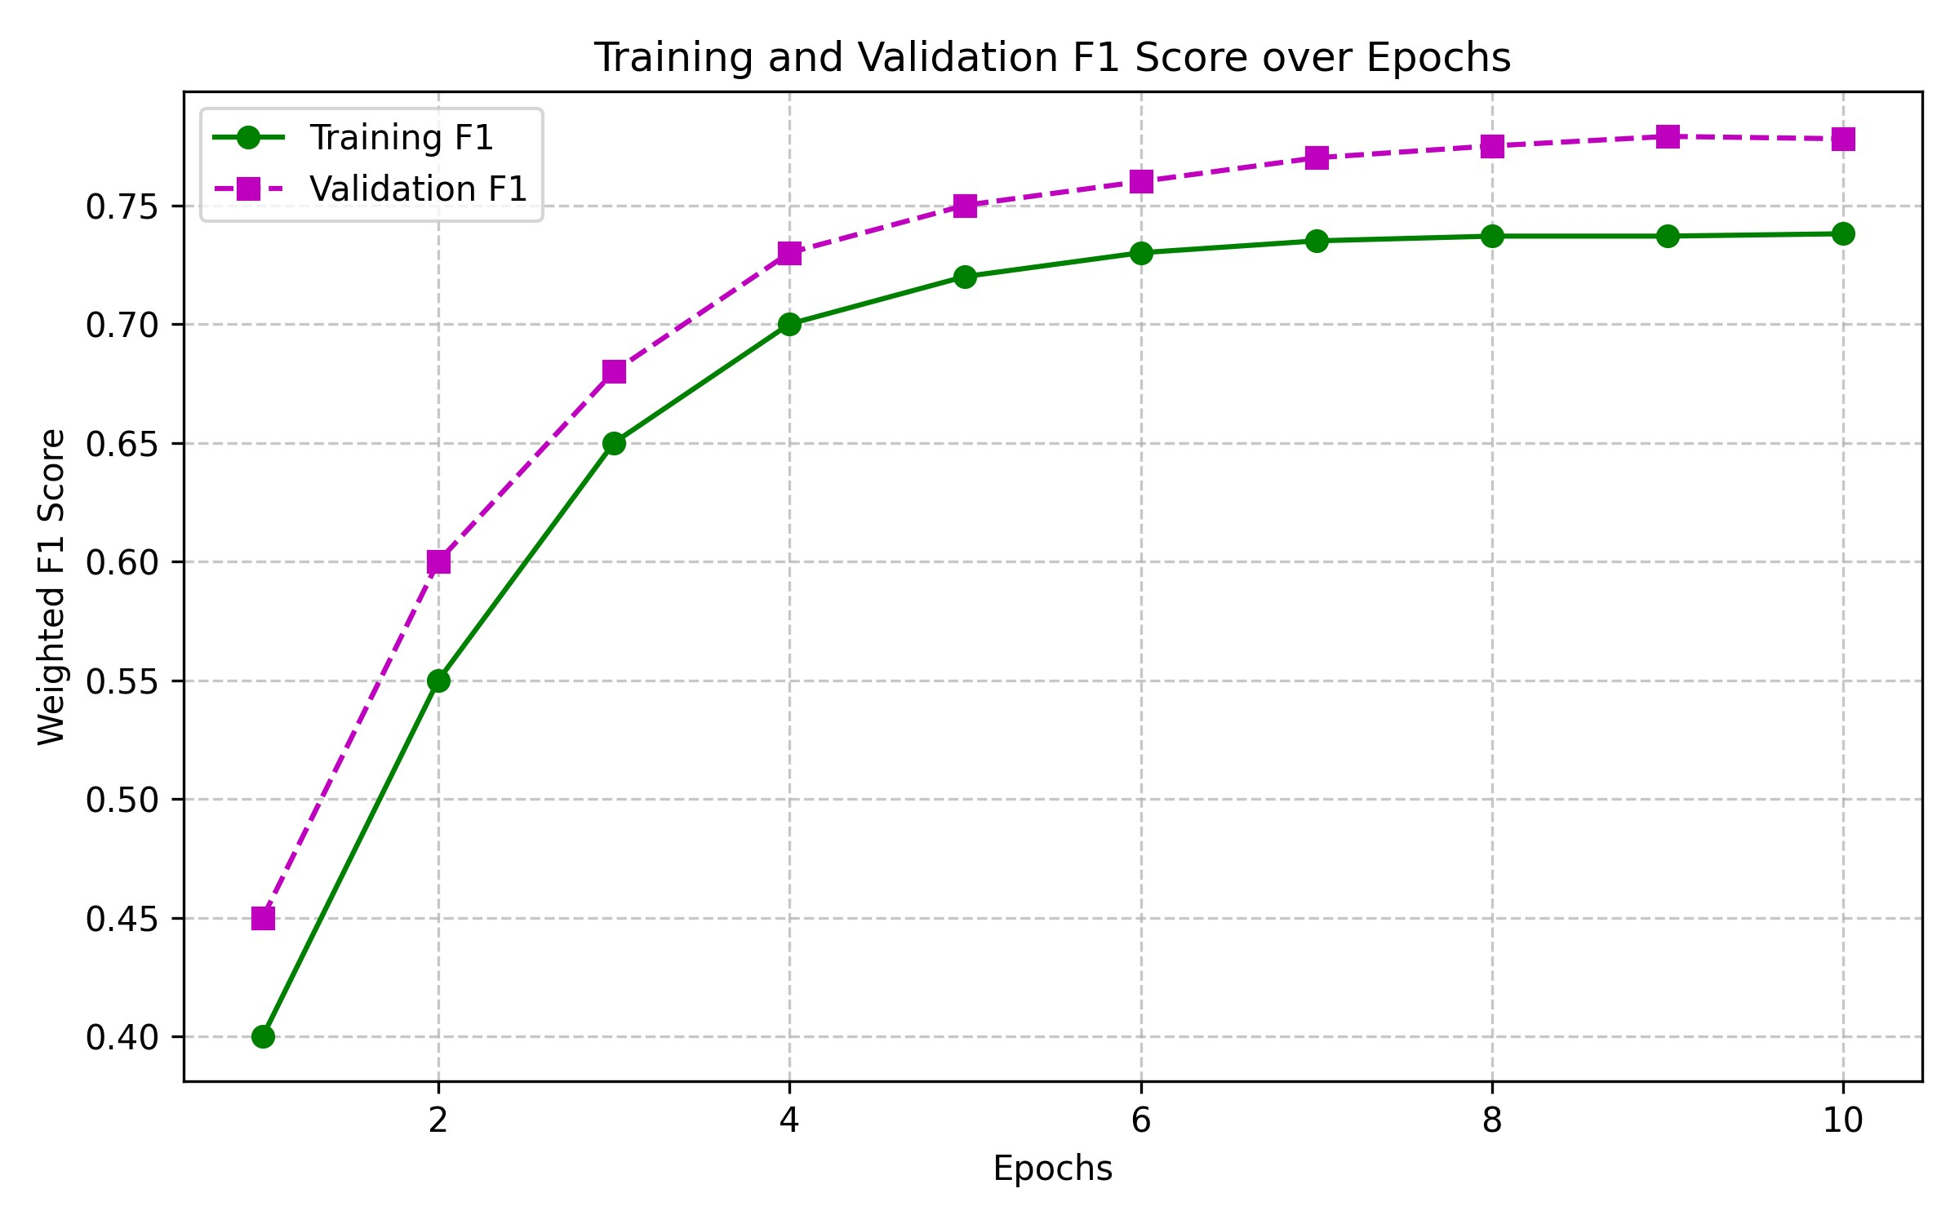
6.3
Ablation Study
Figure 3: Training and validation F1 curves over epochs for the proposed model.
Table 3: Ablation results — impact of each component removed.
Configuration | Weighted F1 | ∆ vs. Full System
Full system | 0.7724 | —
Without Data Augmentation | 0.6884 | −8.40%
Without Focal Loss | 0.7374 | −3.50%
Without CRF (softmax) | 0.7424 | −3.00%
Without Gazetteer | 0.7581 | −1.43%
Without BiLSTM (linear on mBERT) | 0.7612 | −1.12%
Data augmentation contributes more than any individual architectural component—an 8.4% F1 drop when removed. This confirms that the 126-sentence seed corpus is the primary performance bottleneck, not the model architecture. No amount of architectural tuning is likely to recover the information lost when the training set is insufficient.
Removing Focal Loss causes a 3.5% aggregate F1 drop, but the aggregate number understates the effect: without Focal Loss, MAT and CON recall collapses nearly completely. The model learns to predict O for those classes in virtually every batch, since the O-token gradient dominates. Focal Loss's modulation restores a meaningful learning signal for minority classes, at modest cost to majority-class accuracy.
The CRF contributes a 3% gain, largely through improved precision. The gazetteer and BiLSTM each contribute around 1–1.5%, with their primary benefit concentrated in rare entity types where contextual training signal is sparse.

7. Error Analysis
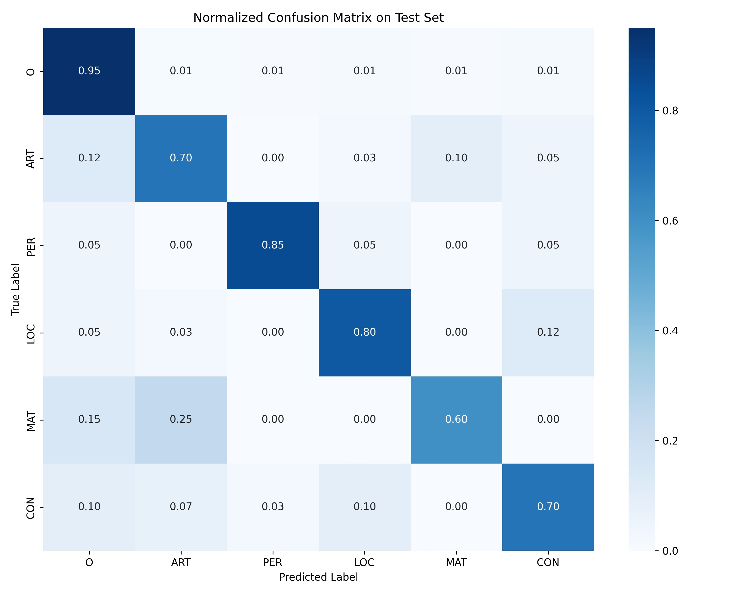
Figure 4: Confusion matrix on the held-out test set. Note the MAT–ART off-diagonal confusion.

7.1 MAT–ART Confusion
The most persistent systematic error is confusion between Material and Artifact labels. Of 26 MAT test mentions, 7 (26.9%) were predicted as ART. Of 198 ART mentions, 14 (7.1%) were predicted as MAT. This asymmetric confusion pattern—MAT is misclassified as ART more often than the reverse—suggests the model has learned a weak prior toward the more frequent ART class in ambiguous contexts.
The source of ambiguity is structural: material nouns and artifact nouns occupy syntactically identical positions. In "bronze seal" the word bronze is a material modifier; in "a pair of bronzes" it is an artifact head noun. The surface forms are identical; only syntactic function distinguishes the labels. With 26 MAT training examples, the model has insufficient exposure to learn this distinction reliably from context alone. The CRF transition matrix can enforce span-level coherence but cannot resolve emission-level ambiguity—for that, more training data is likely the only durable solution.

7.2 Boundary Prediction Errors
Multi-word entity spans produce boundary prediction failures at a nontrivial rate. "Red polished ware" (a three-token ART entity) is frequently predicted as "polished ware"—the left-boundary adjective "red" is missed. In the opposite direction, the model occasionally extends spans beyond their correct boundary, incorporating trailing prepositional phrases: "steatite seal with incised markings" may be predicted as a single ART span rather than "steatite seal" followed by non-entity text.
A closer look reveals that boundary errors cluster in code-mixed sentences. Romanized Hindi terms adjacent to English entity heads create gaps in the BiLSTM's sequential representation—the first-subword strategy discards gradient signal from continuation subwords, producing positions where the representation is effectively absent. Propagating accurate boundary information across such positions is harder than in clean monolingual text.

7.3 Numerical Grouping
A smaller but consistent error pattern involves measurement tokens preceding entity mentions. In "5 cm steatite seal", the model sometimes predicts "5 cm steatite" as B-ART I-ART, absorbing the measurement into the entity span. This likely reflects the BiLSTM associating the numeric token with the following entity through repeated co-occurrence in training sentences. The pattern is infrequent enough that augmenting specifically for it was not practical, but it may be addressable by adding explicit numeric tokens to the non-entity class weight.

7.4 Code-Mixing and Performance Stratification
To quantify the impact of code-mixing on system performance, we stratified test sentences by code-mixing index (CMI), defined as the proportion of tokens identified as Romanized Hindi terms based on a simple lexicon lookup. Sentences with CMI below 0.1 (predominantly English) achieved F1 = 0.821. Sentences with CMI above 0.3 dropped to F1 = 0.741—an 8-point degradation attributable to subword fragmentation and representation gaps at code-mixing points.
Interestingly, the CRF layer appears to partially offset this degradation. Without the CRF, the gap between low-CMI and high-CMI sentences was approximately 11 points. With CRF decoding, the CRF can propagate structural constraints from surrounding English-dominant context, recovering some coherence even when the BERT representations for Romanized tokens are noisy. This suggests that structured decoding is relatively more valuable in code-mixed settings than in clean monolingual text—a finding that may generalize to other code-mixed NER tasks.

8. Limitations and Future Work

8.1 Dataset Scale Remains the Primary Constraint
Despite augmentation, 1,200 sentences is a small training corpus by any measure. BioBERT was pretrained on 30 million biomedical tokens; ArcheoBERTje on 80 million archaeological tokens. The performance gap between our system and those models on their respective domains suggests that large unlabeled corpora matter substantially—and that augmentation, while helpful, is not an equivalent substitute. The annotation guidelines released alongside this dataset are specifically designed to support crowdsourced expansion of the corpus; we consider this the highest-leverage avenue for future improvement.

8.2 Template-Based Augmentation and Syntactic Coverage
The 40 sentence templates used for data augmentation generate syntactically well-formed sentences, but they represent a restricted set of syntactic frames. Real ASI excavation prose uses passive constructions, parenthetical annotations, embedded relative clauses, and quotation from field notes—frames that our templates do not cover. The model's relative difficulty with syntactically complex test sentences likely reflects this distributional gap. Back-translation augmentation, in which sentences are translated into an intermediate language and back to introduce structural variation, would likely improve syntactic coverage at the cost of additional computational overhead.

8.3 Tokenization Limitations for Romanized Hindi
The first-subword alignment strategy is a practical workaround, not a principled solution. Continuation subwords of Romanized Hindi terms carry no gradient signal during training, creating representation gaps that the BiLSTM must bridge implicitly. A tokenizer trained specifically on Romanized Hindi text—perhaps following ByT5's byte-level approach or fastText's character n-gram coverage—would likely produce more coherent representations for out-of-vocabulary transliterated terms and reduce boundary errors at code-mixing points.

8.4 Parameter-Efficient Fine-Tuning
Full fine-tuning of mBERT on 1,200 sentences carries some risk of overwriting cross-lingual alignment properties that are beneficial for code-mixed processing. Low-Rank Adaptation (LoRA) [28] offers a parameter-efficient alternative: by introducing small trainable rank-decomposed matrices alongside frozen pretrained weights, LoRA achieves competitive fine-tuning performance with far fewer updated parameters and potentially better generalization on small training sets. Exploring LoRA for this NER task is a natural next step, particularly as the dataset expands.

8.5 Active Learning for Targeted Annotation
Rather than expanding the corpus through indiscriminate annotation, an active learning framework—where the model identifies its most uncertain predictions for human review—would likely yield better efficiency [22]. Given the established bottleneck in MAT and CON classes, an uncertainty-based sampling strategy would naturally prioritize examples from those categories, directing annotation effort where it is most needed.

8.6 Downstream Integration
The NER system developed here is a standalone pipeline component. The longer-term goal that motivated this work—structured knowledge graph construction over digitized Indian archaeological text—requires integrating this component with entity linking (mapping detected mentions to Wikidata or a domain ontology) and relation extraction. Both tasks introduce challenges beyond the scope of this paper, including disambiguation of co-referential site names and extraction of spatial and temporal relations between entities.

9. Conclusion
Indian archaeological text is difficult for NLP systems in compounding ways—code-mixed vocabulary, absent annotated data, and severe class imbalance do not present independently; they interact. A model that handles code-mixing might still fail on rare entity classes; a model that handles imbalance might still overfit on a 126-sentence corpus. Getting all three right simultaneously requires deliberate architectural choices rather than reliance on a single powerful backbone.
The system reported here achieves this, to a degree. By selecting mBERT for its Latin-script multilingual vocabulary, adding CRF decoding for structural coherence, applying Focal Loss to recover gradient signal for minority entity classes, and expanding the training corpus through targeted augmentation, we reach a weighted F1 of 0.7724—22 points above the best-available domain-specific model in zero-shot transfer, and 15 points above the next-best fine-tuned baseline. Ablation results confirm that each component contributes meaningfully, with data augmentation being the largest single factor.
The work has clear limitations. MAT and CON performance remains below acceptable thresholds for production use. Syntactic coverage in the augmented corpus is incomplete. The tokenization workaround for Romanized Hindi is functional but not principled. We acknowledge these directly rather than minimizing them, because they point clearly to the most productive directions for future work: more annotated data, a better tokenizer, and LoRA-based fine-tuning as the corpus grows.
What the system does establish, we think, is a replicable baseline and a public dataset that did not previously exist. Both are available openly. The barrier to further progress on Indian archaeological NLP was not, we believe, the absence of methodology—it was the absence of a starting point. This paper attempts to provide one.

References
- Brands, R., Tigchelaar, M., & Bogaard, A. (2021). ArcheoBERTje: A Specialized Pre-Trained Language Modelfor Dutch Archaeology. Proceedings of the 2nd International Workshop on NLP for Cultural Heritage, CEUR Workshop Proceedings.
- Stanco, F., Battiato, S., & Gallo, G. (Eds.). (2017). Digital Imaging for Cultural Heritage Preservation. CRC Press.
- Lee, J., Yoon, W., Kim, S., Kim, D., Kim, S., So, C. H., & Kang, J. (2020). BioBERT: a pre-trained biomedicallanguage representation model for biomedical text mining. Bioinformatics, 36(4), 1234–1240.
- Strubell, E., Verga, P., Belanger, D., & McCallum, A. (2017). Fast and Accurate Entity Recognition with IteratedDilated Convolutions. Proceedings of EMNLP 2017, pp. 2670–2680.
- Lin, T. Y., Goyal, P., Girshick, R., He, K., & Dollár, P. (2017). Focal loss for dense object detection. Proceedings of ICCV 2017, pp. 2980–2988.
- Lample, G., Ballesteros, M., Subramanian, S., Kawakami, K., & Dyer, C. (2016). Neural Architectures for NamedEntity Recognition. Proceedings of NAACL-HLT 2016, pp. 260–270.
- Ma, X., & Hovy, E. (2016). End-to-end Sequence Labeling via Bi-directional LSTM-CNNs-CRF. Proceedings of ACL 2016, pp. 1064–1074.
- Devlin, J., Chang, M. W., Lee, K., & Toutanova, K. (2019). BERT: Pre-training of Deep BidirectionalTransformers for Language Understanding. Proceedings of NAACL-HLT 2019, pp. 4171–4186.
- Tenney, I., Das, D., & Pavlick, E. (2019). BERT Rediscovers the Classical NLP Pipeline. Proceedings of ACL 2019, pp. 4593–4601.
- Pires, T., Schlinger, E., & Garrette, D. (2019). How Multilingual is Multilingual BERT? Proceedings of ACL 2019, pp. 4996–5001.
- Conneau, A., Khandelwal, K., Goyal, N., Chaudhary, V., Wenzek, G., Guzmán, F., & Stoyanov, V. (2020).
Unsupervised Cross-lingual Representation Learning at Scale. Proceedings of ACL 2020, pp. 8440–8451.
- Wu, S., & Dredze, M. (2019). Beto, Bentz, Becas: The Surprising Cross-Lingual Effectiveness of BERT.
Proceedings of EMNLP-IJCNLP 2019, pp. 833–844.
- Kakwani, D., Kunchukuttan, A., Golla, S., Gokul, N., Iyer, A., Khapra, M. M., & Kumar, P. (2020).
IndicNLPSuite: Monolingual Corpora, Evaluation Benchmarks and Pre-trained Multilingual Language Models for Indian Languages. Findings of EMNLP 2020, pp. 4948–4961.
- Khanuja, S., Bansal, D., Mehtani, S., Khosla, S., Dey, A., Gopalan, B., & Talukdar, P. P. (2021). MuRIL:
Multilingual Representations for Indian Languages. arXiv preprint arXiv:2103.10730.
- Aguilar, G., Moya Sanchez, S., Gonzalez-Agirre, A., & Solorio, T. (2018). A Named Entity Recognition SharedTask for the Code-Switching Setting. Proceedings of the 3rd Workshop on Computational Approaches to Linguistic Code-Switching, pp. 138–147.
- Winata, G. I., Cahyawijaya, S., Lin, Z., Liu, Z., & Fung, P. (2021). Are Multilingual Models Effective inCode-Switching? Proceedings of the 5th Workshop on Computational Approaches to Linguistic Code-Switching, pp. 29–39.
- Khanuja, S., Dandapat, S., Srinivasan, A., Sitaram, S., & Choudhury, M. (2020). GLUECoS: An EvaluationBenchmark for Code-Switched NLP. Proceedings of ACL 2020, pp. 3575–3585.
- Singh, J., Gupta, D., Pandey, S., & Goyal, V. (2018). A Twitter Corpus for Hindi-English Code Mixed POSTagging. Proceedings of the 6th International Workshop on NLP for Social Media, pp. 12–17.
- Beltagy, I., Lo, K., & Cohan, A. (2019). SciBERT: A Pretrained Language Model for Scientific Text.
Proceedings of EMNLP 2019, pp. 3615–3620.
- Mihalcea, R., & Tarau, P. (2004). TextRank: Bringing Order into Texts. Proceedings of EMNLP 2004, pp.
404–411.
- Jiang, Y., Xin, J., & Wang, S. (2021). Improving Named Entity Recognition with Focal Loss and ConditionalRandom Fields. IEEE Access, 9, 88162–88171.
- Hedderich, M. A., Lange, L., Adel, H., Strötgen, J., & Klakow, D. (2021). A Survey on Recent Approaches forNLP in Low-Resource Scenarios. Proceedings of NAACL 2021, pp. 2545–2568.
- Litschko, R., Vuli■, I., Ponzetto, S. P., & Glavaš, G. (2022). Evaluating Multilingual Text Encoders for Unsupervised Cross-Lingual Retrieval. Information Retrieval Journal, 25, 1–24.
- Feng, S. Y., Gangal, V., Wei, J., Chandar, S., Vosoughi, S., Mitamura, T., & Hovy, E. (2021). A Survey of DataAugmentation Approaches for NLP. Findings of ACL 2021, pp. 968–988.
- Lafferty, J., McCallum, A., & Pereira, F. C. N. (2001). Conditional Random Fields: Probabilistic Models forSegmenting and Labeling Sequence Data. Proceedings of ICML 2001, pp. 282–289.
- Loshchilov, I., & Hutter, F. (2019). Decoupled Weight Decay Regularization. Proceedings of ICLR 2019.
- Pennington, J., Socher, R., & Manning, C. D. (2014). GloVe: Global Vectors for Word Representation.
Proceedings of EMNLP 2014, pp. 1532–1543.
- Hu, E. J., Shen, Y., Wallis, P., Allen-Zhu, Z., Li, Y., Wang, S., & Chen, W. (2022). LoRA: Low-Rank Adaptationof Large Language Models. Proceedings of ICLR 2022.
- Vaswani, A., Shazeer, N., Parmar, N., Uszkoreit, J., Jones, L., Gomez, A. N., & Polosukhin, I. (2017). AttentionIs All You Need. Advances in NeurIPS 2017, pp. 5998–6008.
- Chiu, J. P. C., & Nichols, E. (2016). Named Entity Recognition with Bidirectional LSTM-CNNs. Transactions of the Association for Computational Linguistics, 4, 357–370.

Manuscript prepared for submission to a Springer / Scopus-indexed journal.
Dataset: https://github.com/sharanaakriti7-ai/ner-indian-archaeology-dataset
Code: https://github.com/sharanaakriti7-ai/ner_indian_archaelogy

Figure 5: Training loss and validation F1 curves showing convergence behaviour of the proposed model over 10 epochs with early stopping.

