


A
Major Project Phase – II Report on

“CONFLICT AVOIDANCE AND LANDSLIDE
UPDATE OF VEHICLE IN DEEP CURVIES”

Submitted in the partial fulfillment for the award of
Bachelor of Engineering
In
Electronics and Communication Engineering
Submitted by

KOUSHIK N D 2GB22EC019

Under the Guidance of
Mr.RAVINAIK R
Assistant Professor

DEPARTMENT
OF
ELECTRONICS & COMMUNICATION ENGINEERING GOVERNMENT ENGINEERING COLLEGE HUVINAHADAGALI - 583219, VIJAYANAGARA (DIST) 2025-26


Government of Karnataka
Department of Collegiate and Technical Education
GOVERNMENT ENGINEERING COLLEGE
HUVINAHADAGALI – 583219,
VIJAYANAGARA (DIST)

CERTIFICATE
This is to certify that the Major project report entitled “CONFLICT AVOIDANCE AND LANDSLIDE UPDATE OF VEHICLE IN DEEP CURVIES” carried out by KOUSHIK N D(2GB22EC019) a bonafide students of Government Engineering College, Huvinahadagali in partial fulfillment for the award of Bachelor of Engineering in Electronics and Communication Engineering of the Visvesvaraya Technological University, Belagavi during the academic year 2025-2026.The Project report has been approved as it satisfies the academic requirements in respect of Major Project prescribed for the said Degree

Signature of Coordinator Signature of Guide

Signature of HOD Signature of Principal

EXAMINER’S NAME SIGNATURE
- ……………………………………………… ………………….

- ……………………………………………… ………………….
Date : Place :

ACKNOWLEDGEMENT

The sense of contentment and elation that accomplishes the successful completion of our task would be incomplete without mentioning the names of the people who helped in accomplishment of this major project, whose constant guidance, support and encouragement resulted in its realization.

We would specially thank our project coordinator Mr.Ravinaik R Department of Electronics and Communication Engineering for their expert guidance, encouragement and valuable suggestions at every step.

We would specially thank our project guide Mr.Ravinaik R Department of Electronics and Communication Engineering for their expert guidance, encouragement and valuable suggestions at every step.

We would also like to express our gratitude to Dr. Rajashekhar U Head of the department of Electronics and Communication for encouraging and inspiring us to carry out major project work.

We would like to thank Dr. Arun K V Principal Government Engineering College, Huvinahadagali, for continuous support and constant encouragement to carry out major project report.

I am extremely happy to acknowledge and express us sincere gratitude to our friends who gave us constant support and encouragement and well wishes for their help and co- operation and solution to problems during the project work.

KOUSHIK N D (2GB22EC019)

ABSTRACT

The project aims to decrease the number of accidents that occur on curved roadways. To do this, a warning LCD Display that displays as a vehicle approach from the other side of the bend serves as a message to the driver. The IR transmitter and receiver sensor, which is connected to the Arduino Uno microcontroller, is used to detect the vehicle. And Motor operated gates are fixed upon each sides for free passage of vehicles from one side to other side. On the winding roads in the ghat portion, this might save thousands of lives. By implementing a new technique, they come up with a plan to prevent accidents after determining their causes and effects. Two IR sensors make up the new method, which alerts the vehicle on the opposite road. Landslide is one of the hazardous and critical geographical process, which damages to civil infrastructure and property as well as causes loss of life. This paper is an attempt with regard to the expansion of a landslide susceptible approach by using Accelerometer Sensor. And Rain Sensor is used for detecting heavy rainfall. Upon detecting the landslide condition or Heavy Rains it warns on display as a message and closes gates on either side of ghat till road condition gets normal.

“Vehicle Detection and Collision Avoidance System in Deep Curves” is a system which is used to detect the vehicles on one side of the Deep curve and assist the vehicles on the other side of Deep curve using Vehicle. Traffic Congestion and Accidents are very much common in Deep curves due to lack of communication between the vehicles and zero visibility over the Deep bends. Existing prototypes do offer solution for collision avoidance, but fails ineffective traffic management which is most essential in hilly areas. The purpose of this project is to intellectually detect and classify the vehicles, avoid collision using Vehicles, LCDs and effective traffic management using vehicle class information. In this project, we provide systematic approach to the above problem statement and explain the need of effective traffic management in Deep curves.

Acknowledgement Abstract
Contents
List of figures

CONTENTS

i ii iii iv

CHAPTER 01 INTRODUCTION

  - Introduction 1
  - Objective 1
  - Problem Statements 2
CHAPTER 02 LITERATURE SURVEY
  - Literature survey 3
CHAPTER 03
SYSTEM REQUIREMENTS AND SPECIFICATION
  - Hard Requirements 4
  - Software Requirements 4
CHAPTER 04 SYSTEM DESIGN
  - Hub Model 5
  - Vehicle Model 6

CHAPTER 05
SYSTEM IMPLIMENTATION
5.1 Introduction To Embedded C 17
5.2 Introduction To Arduino IDE 18
CHAPTER 06
PROGRAME CODE
6.1 Program code 21
CHAPTER 07
RESULT
7.1 Landslide Detection 37
7.2 Rainfall Detection 38
CHAPTER 08
ADVANTAGES, DISADVANTAGES AND APPLICATION
8.1 Advantages 39
  - Disadvantages 39
8.3 Application 39
CHAPTER 09
CONCLUSION AND FUTURE SCOPE 40

BIDLIOGRAPHY 41

LIST OF FIGURES

FIGURE NO | NAME OF FIGURE | PAGE NO
4.1 | HUB MODEL | 5
4.2 | VEHICLE MODEL | 6
4.3 | ARDUNIO UNO | 8
4.4 | IR SENSOR | 9
4.5 | ADXL SENSOR | 10
4.6 | RAIN SENSOR | 11
4.7 | ZIGBEE COMMUNICATION | 12
4.8 | LCD DISPLAY | 12
4.9 | MOTOR GATES | 14
4.10 | BUZZER | 15
4.11 | ESP-32 | 16
4.12 | LANDSLIDE DETECTION | 37
4.13 | RAINFALL DETECTION | 38

CHAPTER - 1

Introduction

INTRODUCTION

Normally the “Conflict Avoidance and Landslide Update System for Vehicles in Deep Curves” project leverages a combination of advanced technologies, including Arduino Uno, IR sensors, ADXL sensors ,Rain Sensors, LCD displays, and Zigbee communication, to enhance road safety in areas with deep curves and potential landslide risks. This system offers real-time assistance to drivers by detecting obstacles, monitoring vehicles dynamics, and providing critical updates on road conditions. Deep curves on mountainous roads and the threat of landslides pose significant hazards to drivers and passengers. These challenges include reduced visibility, limited reaction time, and the potential. For sudden obstruction due to landslides. This project aims to address these issues by creating a comprehensive solution that assists drivers in navigating challenging road conditions while keeping them informed about potential landslide risks.
Road transportation in hilly and mountainous regions often faces significant safety challenges due to deep curves, steep gradients, and unstable terrain. Two major risks that frequently lead to accidents in such environments are vehicle conflicts especially at blind turns and landslides, which may suddenly obstruct the roadway. Traditional safety measures such as signboards and speed limits are often insufficient because drivers have limited visibility and very little reaction time in these hazardous zones.
To address these issues, modern intelligent transportation systems focus on real-time conflict avoidance and dynamic landslide monitoring. Conflict avoidance involves detecting the presence, speed, and direction of vehicles approaching from opposite sides of a curve and alerting them before a potential collision occurs. This can be achieved using sensors, IoT modules, wireless communication, and onboard vehicle systems. Landslide updates rely on slope sensors, geotechnical monitoring, rainfall data, and early-warning communication to inform vehicles of blockages or terrain movement ahead.
Integrating these two safety mechanisms ensures that vehicles travelling through deep curves receive instant alerts, allowing drivers or autonomous systems to make safe decisions such as slowing down, stopping, or choosing alternate routes. As a result, the combined system enhances road safety, reduces accident risks, and improves the reliability of transportation networks in hill regions.

Objectives

- Develop a real-time conflict avoidance system using Arduino Uno and IR sensors to identify obstacles and potential conflicts on the road, especially in deep curves.

- Implement an ADXL sensor to monitor Landslides and provide drivers with information on vehicle tilt and lateral acceleration in real-time.
- Utilize an LCD display to present visual warnings and updates to the driver regarding road conditions and potential conflicts.
- Establish a Zigbee communication network between vehicles to exchange critical information about road conditions, obstacles, and potential landslide risks.
- Ensure compatibility with existing vehicle systems and navigation devices, making it easy to retrofit vehicles with this system.

Problem Statement

    - Landslides pose a significant threat to human lives and infrastructure in hilly and mountainous regions. Rapid detection and early warning systems are crucial for mitigating the impact of landslides. The aim of this project is to develop a landslide detection system using Arduino and MEMS (Micro-Electro-Mechanical Systems) sensors to provide real-time monitoring and alerting in landslide-prone areas.
    - This sophisticated system detects the presence of vehicle on one side of the curve (vehicles ascending) using camera, classifies the following vehicle into ‘light’ or ‘heavy’ vehicle category.
    - It alerts the driver of vehicles on other side of the curve (vehicle descending) using LED display board. The specially designed LCD display board consists of information such as vehicle class and traffic signals.
    - The principle behind reducing traffic congestion is, a vehicle can easily pass through the hair pin curve.
    - From this system the driver is aware about the upcoming opposite vehicle’s category i.e., either Light vehicle or Heavy vehicle and can judge the distance with which the opposite vehicle can cross the curve and stop well behind wait for the approaching vehicle to cross the curve.

LITERATURE SURVEY
The most crucial stage of the software development process is a literature review. It's important to assess the company's strength, the economics, and the time element before building the tool. The next steps are to decide which operating systems and programming languages are required for the project's development once these requirements have been met. The folks require outside assistance before they can build the initiative. You can find this outside assistance in books or online. The aforementioned factors are taken into account before building the proposal for the proposed system.
K.P. Sreevishakh, Prof.S.P. Dhanure presented “Automotive Crash Insight using AMR Sensor System,” The Unit was created to avoid a collision based accident. The Arduino microcontroller, which handles all of the system's essential functions, is the "heart" of the unit. Additionally, it will be covered in the sections that follow. This system will gather data from the Ultrasonic transceiver and send it to the controller via the Wi-Fi router as a result.
S. Rakul,S. Ravia and K.N. Thirukkuralkani presented "Implementation of Vehicle Mishap Averting System Using Arduino Microcontroller." By avoiding collisions, the device is intended to prevent accidents. An Arduino microcontroller, which handles all of the crucial functions of the system, serves as its "heart." Additionally, it will be covered in the parts that follow. This system will gather data from the ultrasonic transceiver and send it to the controller over the Wi-Fi router in response. The vehicle information will be displayed to users via the buzzer signal, light-emitting display, and liquid crystal display. The system's main objective is to avoid collisions when two or more vehicles turn at the same time on a U-bend.
A landslide is defined as the movement of a mass of rock, debris or earth down a slope. Landslide are a type of “mass wasting”, which denotes any down-slope movement of soil and rock under the direct influence of gravity. The term “landslide” encompasses five modes of slope movement: falls, topples, slides, spreads, and flows. These are further subdivided by the type of geologic material (bedrock, debris, or earth).
Debris flows (commonly referred to as mudflows or mudslides) and rock falls are examples of common landslide types.
Almost every landslide has multiple causes. Slope movement occurs when forces acting down-slope (mainly due to gravity) exceed the strength of the earth materials that compose the slope.
Causes include factors that increase the effects of down-slope forces and factors that increase the effects of down-slope forces and factors that contribute to low or reduced strength.

CHAPTER -3

SYSTEM REQUIREMENTS AND SPECIFICATION

Hardware Requirements
    - Arduino UNO
    - IR Sensor
    - ADXL Sensor
    - Rain Sensor
    - LCD Display
    - Zigbee Communicator
    - Buzzer
    - Motor Gates
    - ESP-32

Software Requirements
    - Embedded C
    - Arduino IDE

CHAPTER-4
SYSTEM DESIGN

Hub Model For Landslide Detection

ACCELEROMETER

ARDUNIO UNO
RAIN SENSOR
ZIGBEE
LCD DISPLAY
MOTOR GATES
IR SENSOR
POWER SUPPLY

Fig 4.1: Hub Model For Landslide Detection

Vehicle Model FOR CONFLICT AVOIDANCE IN DEEP CURVES

LCD DISPLAY

ZIGBEE

ESP-32

BUZZER

Fig 4.1:Vehicle Model For Conflict Avoidance In Deep Curves
POWER SUPPLY

Arduino Uno
Arduino Uno is an open-source hardware and software company, project and user community that designs and manufactures single-board microcontrollers and microcontroller kits for building digital devices and interactive objects that can sense and control both physically and digitally. Its products are licensed under the GNU Lesser General Public License (LGPL) or the GNU General Public License (GPL), permitting the manufacture of Arduino boards and software distribution by anyone. Arduino boards are available commercially in preassembled form or as do- it-yourself (DIY) kits. Arduino board designs use a variety of microprocessors and controllers. The boards are equipped with sets of digital and analog input/output (I/O) pins that may be interfaced to various expansion boards or breadboards (shields) and other circuits. The boards feature serial communications interfaces, including Universal Serial Bus (USB) on some models, which are also used for loading programs from personal computers. The microcontrollers are typically programmed using a dialect of features from the programming languages C and C++. In addition to using traditional compiler toolchains, the Arduino project provides an integrated development environment (IDE) based on the Processing language project.
The Arduino Uno project started in 2003 as a program for students at the Interaction Design Institute Ivrea in Ivrea, Italy, aiming to provide a low-cost and easy way for novices and professionals to create devices that interact with their environment using sensors and actuators. Common examples of such devices intended for beginner hobbyists include simple robots, thermostats and motion detectors.
The name Arduino Uno comes from a bar in Ivrea, Italy, where some of the founders of the project used to meet. The bar was named after Arduino of Ivrea, who was the margrave of the March of Ivrea and King of Italy from 1002 to 1014.Arduino is a microcontroller board based on the ATmega328P. It has 14 digital input/output pins (of which 6 can be used as PWM outputs), 6 analog inputs, a 16 MHz quartz crystal, a USB connection, a power jack, an ICSP header and a reset button. It contains everything needed to support the microcontroller; simply connect it to a computer with a USB cable or power it with an AC-to-DC adapter or battery to get started. You can tinker with your UNO without worrying too much about doing something wrong, worst case scenario you can replace the chip for a few dollars and start over again. "Uno" means one in Italian and was chosen to mark the release of Arduino Software (IDE) 1.0. The Uno board and version 1.0 of Arduino Software (IDE) were the reference versions of Arduino Uno, now evolved to newer releases. The Uno board is the first in a series of USB Arduino boards, and the reference model for the Arduino platform; for an extensive list of current, past or outdated boards see the Arduino index of boards.

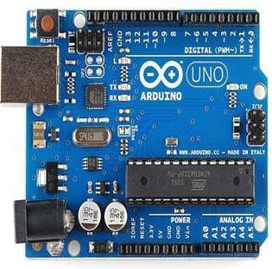

Fig 4.1.1: ARDUNIO UNO VERSION 1.0
Arduino Specification Table:

Microcontroller | ATmega328P
Operating Voltage | 5v
Input voltage | 7-12v
Input voltage limit | 6-20v
Digital I/O Pins | 6
Analogue input Pins | 6
DC current per I/O pins | 20 mA
DC current for 3.3v Pin | 50 mA
Flash Memory | Of which o.5KB is used
SRAM | 2 KB
EEPROM | 1KB
Clock Speed | 16MHz
Length | 68.6mm
Width | 53.4nm
Weight | 25g

IR SENSOR
An infrared sensor is an electronic device that emits in order to sense some aspects of the surroundings. An IR sensor can measure the heat of an object as well as detects the motion. These types of sensors measure only infrared radiation, rather than emitting it that is called a passive IR sensor. Usually, in the infrared spectrum, all the objects radiate some form of thermal radiation. These types of radiations are invisible to our eyes, that can be detected by an infrared sensor. The emitter is simply an IR LED (Light Emitting Diode) and the detector is simply an IR photodiode that is sensitive to IR light of the same wavelength as that emitted by the IR LED. When IR light falls on the photodiode, the resistances and the output voltages will change in proportion to the magnitude of the IR light received.

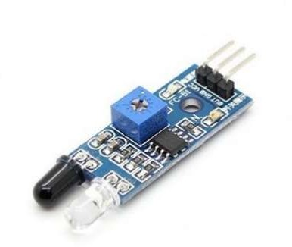

Fig 4.1.2: IR SENSOR
An infrared sensor circuit is one of the basic and popular sensor module in an electronic device. This sensor is analogous to human’s visionary senses, which can be used to detect obstacles and it is one of the common applications in real-time. This circuit comprises of the following components
- LM358 IC 2 IR transmitter and receiver pair
- Resistors of the range of kilo-ohms.
- Variable resistors.
- LED (Light Emitting Diode).

ADXL SENSOR

The ADXL335 is a small, thin, low power, complete 3-axis accelerometer with signal conditioned voltage outputs. The product measures acceleration with a minimum full-scale range of
±3 g. It can measure the static acceleration of gravity in tilt sensing applications, as well as dynamic acceleration resulting from motion, shock, or vibration.

The user selects the bandwidth of the Accelerometer using the CX, CY, and CZ capacitors at the XOUT, YOUT, and ZOUT pins. Bandwidths can be selected to suit the application, with a range of 0.5 Hz to 1600 Hz for X and Y axes, and a range of 0.5 Hz to 550 Hz for the Z axis.

The ADXL335 is available in a small, low profile, 4 mm × 4 mm × 1.45 mm, 16-lead, plastic lead frame chip scale package (LFCSP_LQ).

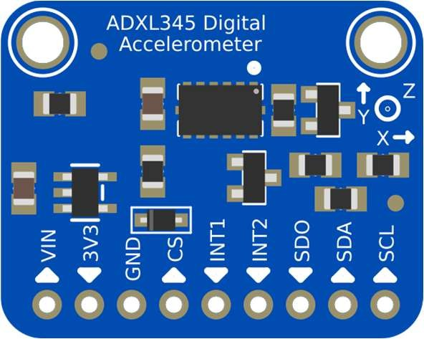

Fig 4.1.3.ADXL SENSOR

Features:

- 3-axis sensing
- Small4 mm × 4 mm × 1.45 mm LFCSP
- Low power - 350 μA (typical)
- Single-supply operation1.8 V to 3.6 V
- 10,000 g shock survival
- Excellent temperature stability
- BW adjustment with a single capacitor per axis
- ROHS/WEEE lead-free compliant

RAIN SENSOR

A rain sensor in vehicle safety projects plays a crucial role in conflict avoidance, especially on deep curves where visibility and traction are compromised. By detecting rainfall intensity, the system can automatically adjust vehicle speed, braking sensitivity, and traction control to prevent skidding or collisions. When integrated with curve geometry data, the sensor helps calculate safe cornering speeds, ensuring that drivers receive timely alerts or automatic interventions to maintain stability and avoid accidents in hazardous weather conditions.

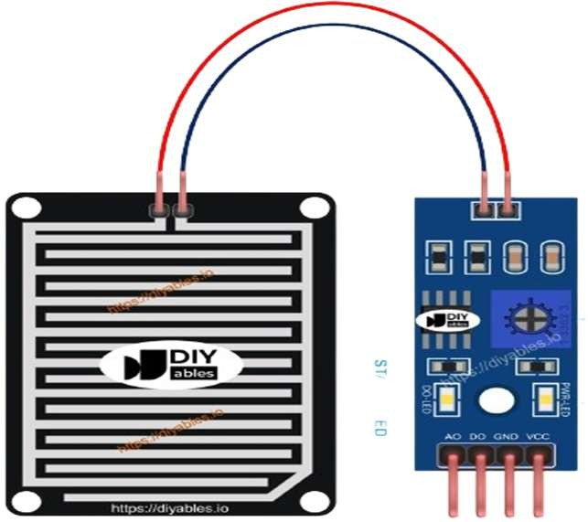

Fig 4.1.4.RAIN SENSOR

To enhance safety further, landslide monitoring systems can be connected to vehicles through IoT-based roadside sensors and V2X communication. These systems detect soil movement or rainfall thresholds that indicate landslide risks and send real-time updates to vehicles approaching vulnerable areas. Combined with rain sensor data, the vehicle’s conflict avoidance module can warn drivers, reroute them, or even initiate automatic safety measures. This integration creates a smart transportation framework that reduces risks in mountainous regions and deep curves, ultimately protecting both drivers and infrastructure.

ZIGBEE COMMUNICATION
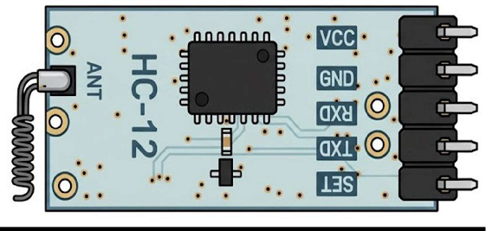
Fig 4.1.5: ZIGBEE COMMUNICATION

A Zigbee transceiver is a device used to enable communication in Zigbee wireless networks. Zigbee is a wireless communication protocol commonly used in IoT (Internet of Things) applications due to its low power consumption, low data rate, and short-range communication capabilities. A Zigbee transceiver facilitates the transmission and reception of data packets between devices in a Zigbee network. Here's an overview of a Zigbee transceiver.
Zigbee transceiver is a key component in Zigbee wireless networks, enabling reliable, low- power communication between devices in IoT and embedded systems applications. It provides the essential functions for transmitting and receiving data packets according to the Zigbee protocol, facilitating the creation of efficient and scalable wireless networks.

LCD DISPLAY

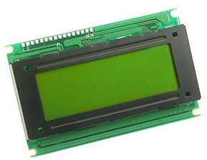

Fig 4.1.6 : LCD DISPLAY
A 16*2 LCD demonstrates contains two lines likewise; there are 16 characters for each line. Each character is appeared by 5x7 pixel lattice. This LCD includes two registers, specifically, Order and Data. The charges select extras the charge bearings that are given to the LCD. A charge is a

rule given to LCD to do a predefined errand like presenting it, clears its screen, sets the cursor position, controls show et cetera. The data enrol saves the data to be appeared on the LCD .
A liquid-crystal display (LCD) is a flat-panel display or other modulated optical that uses the light- modulating properties of liquid crystals. Liquid crystals do not emit light directly, instead using a backlight or reflector to produce images in color or monochrome. LCDs are available to display arbitrary images (as in a general-purpose computer display) or fixed images with low information content, which can be displayed or hidden, such as preset words, digits, and 7-segment displays, as in a digital clock. They use the same basic technology, except that arbitrary image are made up of a large number of small pixels, while other displays have larger elements.
LCD is used in wide range application including computer monitors, televisions, instrument panels aircraft and indoor and outdoor signage. Small LCD screens are common in portable consumer devices such as digital cameras, watches, calculators, and mobile telephones, including smartphones. LCD screens are also used on consumer electronics products such as DVD players, video game devices and clocks. LCD screens have replaced heavy, bulky cathode ray tube (CRT) displays in nearly all applications. LCD screens are available in a wider range of screen sizes than CRT and plasma displays, with LCD screens available in sizes ranging from tiny digital watches to huge, big- screen television sets.
Since LCD screens do not use phosphors, they do not suffer image burn-in when a static image is displayed on a screen for a long time (e.g., the table frame for an aircraft schedule on an indoor sign). LCDs are, however, susceptible to imagepe resistance.

MOTOR GATES

Motorized gates in a vehicle safety project serve as physical control mechanisms that complement sensor-based conflict avoidance and landslide update systems. In deep curve scenarios, where visibility and road conditions are unpredictable, these gates can be installed at strategic points along mountain roads or landslide-prone areas. When rain sensors or landslide monitoring systems detect hazardous conditions, the gates automatically close to restrict vehicle entry, thereby preventing accidents caused by poor traction, blocked roads, or unstable terrain. This ensures that vehicles do not proceed into unsafe zones, acting as a proactive barrier for conflict avoidance.

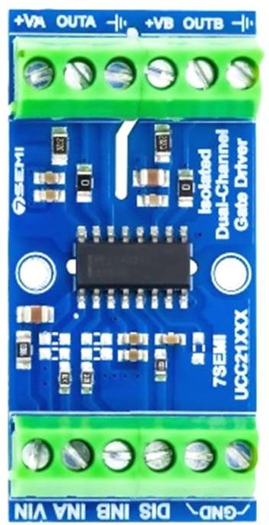

Fig 4.1.7:.MOTOR GATES

Additionally, motorized gates can be integrated with IoT communication systems to provide real-time updates to approaching vehicles. For example, if roadside sensors detect soil movement or heavy rainfall that increases landslide risk, the gates can be triggered to shut down access while simultaneously sending alerts to vehicles via V2X communication. This dual function — physical restriction and digital notification — creates a layered safety framework. By combining rain sensors, buzzers for driver alerts, and motorized gates for physical control, the project ensures comprehensive protection in deep curves and mountainous regions, reducing both collision risks and exposure to landslide hazards.

BUZZER

A buzzer in a vehicle safety project acts as a critical alert mechanism for conflict avoidance and landslide updates, especially in deep curve driving scenarios. When the system detects rainfall through sensors or identifies risky road conditions, the buzzer provides immediate audio feedback to the driver. This ensures that the driver’s attention is captured quickly, even if visual warnings are missed, helping prevent skidding, collisions, or unsafe maneuvers in sharp curves. The buzzer essentially serves as the “voice” of the conflict avoidance module, translating sensor data into urgent, actionable alerts.
In addition, when roadside IoT sensors or V2X communication systems detect potential landslides ahead, the buzzer can be triggered to warn the driver before entering hazardous zones. This audio alert complements visual dashboard warnings, ensuring redundancy and reliability in high-risk environments. By combining rain detection, landslide updates, and buzzer alerts, the system creates a

multi-layered safety framework that enhances driver awareness and reaction time, ultimately reducing accidents in mountainous regions and deep curves.

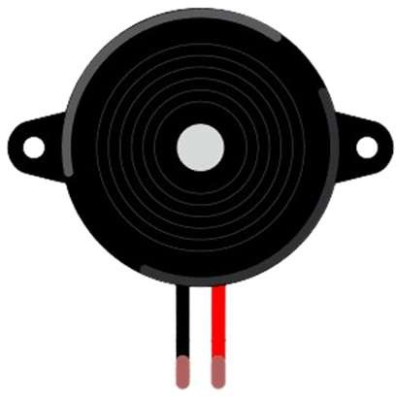

Fig 4.1.8: BUZZER

In addition, when roadside IoT sensors or V2X communication systems detect potential landslides ahead, the buzzer can be triggered to warn the driver before entering hazardous zones. This audio alert complements visual dashboard warnings, ensuring redundancy and reliability in high-risk environments. By combining rain detection, landslide updates, and buzzer alerts, the system creates a multi-layered safety framework that enhances driver awareness and reaction time, ultimately reducing accidents in mountainous regions and deep curves.

ESP-32
The ESP-32 is a low-cost, low-power, and highly integrated microcontroller developed by Espressif Systems. It combines a powerful dual-core processor with built-in Wi-Fi and Bluetooth capabilities, making it one of the most versatile platforms for Internet of Things (IoT) applications. The ESP-32 supports both Bluetooth Classic and Bluetooth Low Energy (BLE), enabling wireless communication with smartphones, sensors, and other devices.
Designed for high performance and efficiency, the ESP-32 comes with a 32-bit dual-core CPU, up to 240 MHz clock speed, 520 KB RAM, and built-in flash memory. It also includes advanced peripherals such as touch sensors, ADC, DAC, PWM, SPI, I2C, and UART interfaces. These features allow the ESP-32 to interface with a wide range of sensors, actuators, and external modules.

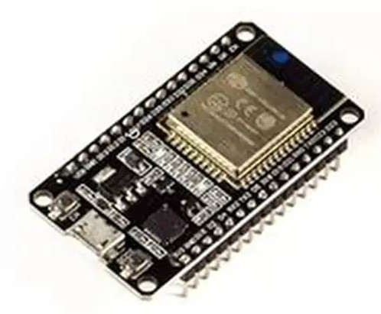

Fig 4.1.9.ESP-32
Designed for high performance and efficiency, the ESP-32 comes with a 32-bit dual-core CPU, up to 240 MHz clock speed, 520 KB RAM, and built-in flash memory. It also includes advanced peripherals such as touch sensors, ADC, DAC, PWM, SPI, I2C, and UART interfaces. These features allow the ESP-32 to interface with a wide range of sensors, actuators, and external modules.
Due to its powerful processing capability and wireless connectivity, the ESP-32 is widely used in applications such as home automation, smart devices, remote monitoring, robotics, wearables, and industrial automation. Its ease of programming using platforms like Arduino IDE, MicroPython, and ESP-IDF has made it extremely popular among students, hobbyists, and professional developers.Overall, the ESP-32 is a high-performance, flexible, and cost-effective microcontroller that enables rapid development of modern IoT-based solutions.

CHAPTER-5

SYSTEM IMPLIMENTATION

Introduction To Embedded C

Embedded C is an extension of the C programming language, designed specifically for programming embedded systems (microcontrollers, microprocessors, and other hardware devices).
It combines the efficiency of C with hardware-specific features, making it ideal for resource- constrained devices like IoT gadgets, automotive controllers, and consumer electronics.

Key Features of Embedded C

Low-level hardware access: Directly interacts with registers, ports, and memory.

Efficiency: Produces fast, compact code suitable for devices with limited RAM and processing power.
Portability: Programs can often be reused across different microcontrollers with minor changes.
Extensions: Includes special keywords and data types (e.g., sbit, sfr) for hardware control.
Structure of an Embedded C Program

Header files – e.g., #include <reg51.h> for 8051 microcontrollers. Global declarations – Define ports, pins, or variables.
Main function – Contains initialization and an infinite loop (while(1)) for continuous operation. Functions – Modular blocks for tasks like sensor reading or motor control.

Application of Embedded C

- Consumer Electronics

Mobile phones, digital cameras, MP3 players, and smartwatches rely on Embedded C for firmware.

Washing machines, microwave ovens, and refrigerators use it to control sensors, timers, and user interfaces.
- Automotive Systems

Engine control units (ECUs) for fuel injection and ignition timing. Anti-lock braking systems (ABS), airbags, and infotainment systems.

Advanced driver-assistance systems (ADAS) like lane detection and collision avoidance 3.Communication Systems
Routers, modems, and mobile base stations. Satellite communication and GPS devices.
Embedded C manages protocols, data transfer, and real-time signal processing.

- Industrial Automation & Robotics

Programmable logic controllers (PLCs) for factory automation. Robotics systems for precise motor control and sensor integration. Smart meters and IoT devices for monitoring and control.
- Aerospace & Défense

Flight control systems, navigation, and radar.

Missile guidance and unmanned aerial vehicles (UAVs).

Embedded C provides deterministic performance under strict safety standards

Introduction To Arduino IDE Introduction to Arduino IDE
The Arduino IDE (Integrated Development Environment) is the official software used to write, compile, and upload programs (called sketches) to Arduino boards. It provides an easy-to-use interface for beginners and powerful tools for advanced users working on embedded electronics projects.

Key Features of Arduino IDE

- Code Editor

You write your program in a simple editor window.

Supports syntax highlighting, auto-formatting, and basic error checking.

- Compiler

Converts your written Arduino code (C/C++) into machine code that the microcontroller can understand.

- Upload Tool

Sends your compiled program to the Arduino board via USB. Shows progress and errors in the console area.
- Built-in Libraries

Provides libraries for sensors, displays, motors, communication (I2C, SPI, UART), etc. Makes coding faster and easier.
- Serial Monitor & Serial Plotter Helps observe real-time sensor data.
Used for debugging and communication between Arduino and PC.

Applications of Arduino IDE

The Arduino IDE is widely used in electronics, embedded systems, and automation projects. It enables users to write, compile, and upload code to Arduino boards, making it useful in many fields.
- Educational Projects

Used in schools, colleges, and training institutes. Helps students learn embedded C programming.
Ideal for basic projects like LED blinking, sensors, motors. Example: Line-following robot, weather station.
- Embedded Systems Development

Allows engineers to quickly prototype embedded systems.

Supports sensors (IR, ultrasonic, temperature), actuators, and communication modules. Example: Home automation system, smart door lock.
- Robotics

Used to develop and control robots.

Supports robot navigation, obstacle detection, motor control, and sensor integration. Example: Arduino-based robotic arm, obstacle-avoiding robot.

- IoT (Internet of Things) Applications

Useful for IoT devices when combined with Wi-Fi modules like ESP8266 or ESP32. Can send data to cloud platforms.
Example: IoT weather monitoring, smart agriculture system.

- Industrial Automation

Used in small-scale industrial automation and prototyping. Controls machines, monitors temperature, pressure, or motor speed. Example: Conveyor belt control, motor speed monitoring.
- Home Automation

Controls lights, fans, appliances, and security systems. Works with PIR sensors, relays, and Wi-Fi modules. Example: Smart home lighting system.

CHAPTER-6

PROGRAME CODE

Code For Main Model

#include<SoftwareSerial.h> SoftwareSerial Serial1(6,7); #include <Wire.h>
#include <LiquidCrystal_I2C.h> LiquidCrystal_I2C lcd(0x27,16,2); int m1=2;
int m2=3; int m3=5; int m4=4; int ir1=8; int ir2=9; int a=0; int k=1;
int red1=10; int red2=15; int green1=11; int green2=16; int buzzer=17; int rain=A0;

#include <Wire.h>
#include <Adafruit_Sensor.h> #include <Adafruit_ADXL345_U.h>
Adafruit_ADXL345_Unified accel = Adafruit_ADXL345_Unified(); void setup()
{
// put your setup code here, to run once:

Serial.begin(9600); Serial1.begin(9600); lcd.init(); lcd.backlight(); lcd.clear(); pinMode(ir1,INPUT); pinMode(ir2,INPUT); pinMode(m1,OUTPUT); pinMode(m2,OUTPUT); pinMode(m3,OUTPUT); pinMode(m4,OUTPUT);
pinMode(red1,OUTPUT); pinMode(red2,OUTPUT); pinMode(green1,OUTPUT); pinMode(green2,OUTPUT);

pinMode(rain,INPUT); Serial.println("LANDSLIDE MONITORING"); lcd.clear();
lcd.setCursor(0,0); lcd.print(" LANDSLIDE "); lcd.setCursor(0,1);
lcd.print(" MONITORING "); delay(1500);
if(!accel.begin())
{

Serial.println("No valid sensor found"); lcd.clear();
lcd.setCursor(0,0); lcd.print("ADXL not Found");

delay(100);

while(1);

}
digitalWrite(m1,LOW); digitalWrite(m2,LOW); digitalWrite(m3,LOW); digitalWrite(m4,LOW); GREEN();
}

void loop()
{
// put your main code here, to run repeatedly: ADXL();
RAIN_CHECK(); IR_CHECK();

}

void ADXL()
{
sensors_event_t event; accel.getEvent(&event);
float X_val=event.acceleration.x; float Y_val=event.acceleration.y; float Z_val=event.acceleration.z;
Serial.print("X: "); Serial.print(event.acceleration.x); Serial.print(" ");
////
Serial.print("Y: "); Serial.print(event.acceleration.y); Serial.print(" ");

////
Serial.print("Z: "); Serial.print(event.acceleration.z); Serial.print(" ");
//((X_val>0.5 && X_val<2.0)) delay(1000);
if(k==1 && (X_val>-1.5&&X_val<2))
{
a=1;
digitalWrite(m1,LOW); digitalWrite(m2,LOW); digitalWrite(m3,LOW); digitalWrite(m4,LOW);

}
else if(a==1 && ((X_val<-7.50)||(X_val>7.5)||(Y_val<-7.50)||(Y_val>7.5)))
{
k=0; a=0;
Serial.println("$LANDSLIDE DETECTED#"); Serial.println("$Alert!! Landslide Detected#"); Serial1.println('L');
lcd.clear(); lcd.setCursor(0,0); lcd.print(" LANDSLIDE "); lcd.setCursor(0,1); lcd.print(" DETECTED ");

delay(1000); lcd.clear(); lcd.setCursor(0,0);
lcd.print("GATES CLOSING"); Serial.println("$GATES CLOSING#");

Serial.println("$Attention!! Gates Closing due to Landslide#"); digitalWrite(m1,HIGH);
digitalWrite(m2,LOW); digitalWrite(m3,HIGH); digitalWrite(m4,LOW); delay(500); digitalWrite(m1,LOW); digitalWrite(m2,LOW); digitalWrite(m3,LOW); digitalWrite(m4,LOW);

delay(1000); RED();
// lcd.clear();
// lcd.setCursor(0,0);
// lcd.print("GATES OPENING");
// digitalWrite(m1,LOW);
// digitalWrite(m2,HIGH);
// digitalWrite(m3,LOW);
// digitalWrite(m4,HIGH);
// delay(500);
// digitalWrite(m1,LOW);
// digitalWrite(m2,LOW);
// digitalWrite(m3,LOW);
// digitalWrite(m4,LOW);
// delay(1000);
}
else if(k==0&&(X_val>-1.5&&X_val<2))
{
k=1; a=1;

lcd.clear(); lcd.setCursor(0,0);
lcd.print("GATES OPENING"); Serial.println("$GATES OPENING#"); Serial.println("$Attention!! Gates Opening#"); digitalWrite(m1,LOW); digitalWrite(m2,HIGH); digitalWrite(m3,LOW); digitalWrite(m4,HIGH);
delay(500); digitalWrite(m1,LOW); digitalWrite(m2,LOW); digitalWrite(m3,LOW); digitalWrite(m4,LOW); delay(1000); GREEN();
}
}

void RAIN_CHECK()
{
int rainval=analogRead(A0); rainval=1023-rainval; Serial.print("Rain:"); Serial.println(rainval); lcd.clear(); lcd.setCursor(0,0); lcd.print("Rain:"); lcd.setCursor(6,0); lcd.print(rainval);

delay(500); if(rainval>550)
{
lcd.clear(); lcd.setCursor(0,0);
lcd.print("RAINFALL IS MORE");
Serial1.println('R'); Serial.println("RAINFALL IS MORE"); Serial.println("$Rainfall is More#");

delay(1000); lcd.clear(); lcd.setCursor(0,0);
lcd.print("GATES CLOSING"); digitalWrite(buzzer,LOW); digitalWrite(m1,HIGH); digitalWrite(m2,LOW); digitalWrite(m3,HIGH); digitalWrite(m4,LOW); delay(500); digitalWrite(m1,LOW); digitalWrite(m2,LOW); digitalWrite(m3,LOW); digitalWrite(m4,LOW); RED();
delay(5000); lcd.clear(); lcd.setCursor(0,0);
lcd.print("GATES OPENING"); digitalWrite(m1,LOW); digitalWrite(m2,HIGH);

digitalWrite(m3,LOW); digitalWrite(m4,HIGH); delay(500); digitalWrite(m1,LOW); digitalWrite(m2,LOW); digitalWrite(m3,LOW); digitalWrite(m4,LOW); delay(1000);
GREEN();

}
else
{
digitalWrite(m1,LOW); digitalWrite(m2,LOW); digitalWrite(m1,LOW); digitalWrite(m4,LOW); delay(1000);
}
}

void IR_CHECK()
{
int irval=digitalRead(ir1); int ir2val=digitalRead(ir2); if((irval==LOW))
{
Serial.println("ROAD1 CLEAR"); lcd.clear();
lcd.setCursor(0,0); lcd.print("ROAD1 CLEAR");

ROAD1();
delay(1000); GREEN();
delay(1000);
}
else if((ir2val==LOW))
{
Serial.println("ROAD2 CLEAR"); lcd.clear();
lcd.setCursor(0,0); lcd.print("ROAD2 CLEAR"); ROAD2();
delay(1000); GREEN();
delay(1000);
}

}

void ROAD1()
{
digitalWrite(red1,LOW); digitalWrite(red2,HIGH); digitalWrite(green1,HIGH); digitalWrite(green2,LOW); delay(2500);
}
void ROAD2()
{
digitalWrite(red1,HIGH);

digitalWrite(red2,LOW); digitalWrite(green1,LOW); digitalWrite(green2,HIGH); delay(2500);
}
void RED()
{
digitalWrite(red1,HIGH); digitalWrite(red2,HIGH); digitalWrite(green1,LOW); digitalWrite(green2,LOW);

}

void GREEN()
{
digitalWrite(red1,LOW); digitalWrite(red2,LOW); digitalWrite(green1,HIGH); digitalWrite(green2,HIGH);
}

Code For Vehicle Model

#include<LiquidCrystal.h>
int rs=13,en=12,d4=14,d5=27,d6=26,d7=25;
LiquidCrystal lcd(rs,en,d4,d5,d6,d7); int buzzer=5;
void setup() {
// put your setup code here, to run once: Serial.begin(9600);

Serial2.begin(9600);
// Serial1.begin(9600); lcd.begin(16,2); pinMode(buzzer,OUTPUT);

lcd.setCursor(0,0); lcd.print("VEHICLE MODEL");

Serial.println("LANDSLIDE VEHICLE MODEL"); delay(1000);
digitalWrite(buzzer,LOW);
}

void loop() {
// put your main code here, to run repeatedly: lcd.clear();
lcd.setCursor(0,0); lcd.print("Vehicle Model"); delay(1000);

if(Serial2.available()>0)
{
char ch=Serial2.read(); Serial.println(ch); delay(500);
if(ch=='L')
{
Serial.println("Landslide Detected");

lcd.clear(); lcd.setCursor(0,0);

lcd.print(" LANDSLIDE "); lcd.setCursor(0,1); lcd.print(" DETECTED "); digitalWrite(buzzer,HIGH); delay(3000); digitalWrite(buzzer,LOW); delay(500);
}
if(ch=='R')
{
Serial.println("MORE RAINFALL");

lcd.clear(); lcd.setCursor(0,0);
lcd.print("MORE RAINFALL"); digitalWrite(buzzer,HIGH); delay(3000); digitalWrite(buzzer,LOW); delay(500);
}
}

}

6.3 Code For Telegram Model

#include<ESP8266WiFi.h> #include<WiFiClientSecure.h> #include<UniversalTelegramBot.h> #include<ArduinoJson.h>
const char* ssid = "Bharath";
const char* password ="123456789";
// with your network credentials

// Initialize Telegram BOT
#define BOTtoken "8571476276:AAGU50R7cjTe1d92w-N8JcKOSGKIzcSYHR8" // your Bot Token (Get from

Botfather)

// Use @myidbot to find out the c''hat ID of an individual or a group
// Also note that you need to click "start" on a bot before it can
// message you
#define CHAT_ID "5533502575"

X509List cert(TELEGRAM_CERTIFICATE_ROOT);
WiFiClientSecure client; UniversalTelegramBot bot(BOTtoken, client);

char Start_buff[70]; int i,z;
char ch; int str_len;
char textmessage[20]; String text;
void MESSAGE_SEND(); void WAITING();
void setup()
{
// initialize the Serial Serial.begin(9600);
Serial.println("Starting TelegramBot...");

configTime(0, 0, "pool.ntp.org"); // get UTC time via NTP client.setTrustAnchors(&cert); // Add root certificate for api.telegram.org

// Attempt to connect to Wifi network: Serial.print("Connecting Wifi: "); Serial.println(ssid);

WiFi.mode(WIFI_STA); WiFi.begin(ssid, password);

while (WiFi.status() != WL_CONNECTED) { Serial.print(".");
delay(500);
}

Serial.println(""); Serial.println("WiFi connected"); Serial.print("IP address: "); Serial.println(WiFi.localIP());

// bot.sendMessage(CHAT_ID, "Bot started up", ""); bot.sendMessage(CHAT_ID, "Landslide Monitoring");

}
void loop()
{

WAITING();

}
void MESSAGE_SEND()
{
bot.sendMessage(CHAT_ID, "SEND START TO CONTINUE");
// myBot.sendMessage(msg_sender_id1, "WELCOME TO ATM");

}

char Serial_read(void)
{
char ch; while(Serial.available() == 0); ch = Serial.read();
return ch;
}
void WAITING()
{
Serial.println("WAITE");

buffer_clear();
// msg.text[0]='\0';
// msg.text[1]='\0';
// msg.text[2]='\0' ;
// msg.text[3]='\0';
// msg.text[4]='\0';
// msg.text[5]='\0';

while(1)
{
if (Serial.available() > 0)
{
//Serial.println("halo");

while(Serial_read()!='$'); i=0;
while((ch=Serial_read())!='#')
{
Start_buff[i] = ch; i++;
}
Start_buff[i]='\0';
}
Serial.println(Start_buff);

bot.sendMessage(CHAT_ID, Start_buff); delay(100);

// if((Start_buff[0]=='F'))
// {
// //Serial.println(Start_buff);
// bot.sendMessage(CHAT_ID, Start_buff);
// delay(100);
// Waiting_for_Response();
// }
// if((Start_buff[0]=='A'))
// {
// String one = "Accident Occured AT:https://www.google.com/maps/?q=";
// String two = "," ;
// String message = one +"12.9219513" +two + "77.564949";

// // Convert String to char array
// int str_len = message.length() + 1;
// char textmessage[str_len];
// message.toCharArray(textmessage,str_len);
// Serial.println(textmessage);
// bot.sendMessage(CHAT_ID,textmessage);
// delay(100);
// }
}
}
void buffer_clear()
{
for(z=0;z<60;z++)
{
Start_buff[z]='\0';
// textmessage[z]='\0';

}
}
void buffer1_clear()
{
for(z=0;z<5;z++)
{

text[z]='\0';

}

}

void Waiting_for_Response()
{
buffer1_clear(); while(1)

{
int numNewMessages = bot.getUpdates(bot.last_message_received + 1);

while (numNewMessages)
{
Serial.println("got response"); handleNewMessages(numNewMessages);
numNewMessages = bot.getUpdates(bot.last_message_received + 1);
}
}

}

void handleNewMessages(int numNewMessages)
{
Serial.print("handleNewMessages "); Serial.println(numNewMessages);

for (int i = 0; i < numNewMessages; i++)
{
String chat_id = bot.messages[i].chat_id; String text = bot.messages[i].text;
Serial.print(text);
// if (text == "1234")
// {
//
//// Serial.println("*1234#");
//// delay(1000);
//// WAITING();
// }

}
// numNewMessages=0;
// buffer1_clear();
}

CHAPTER-7

Landslide detection

PROJECT RESULT

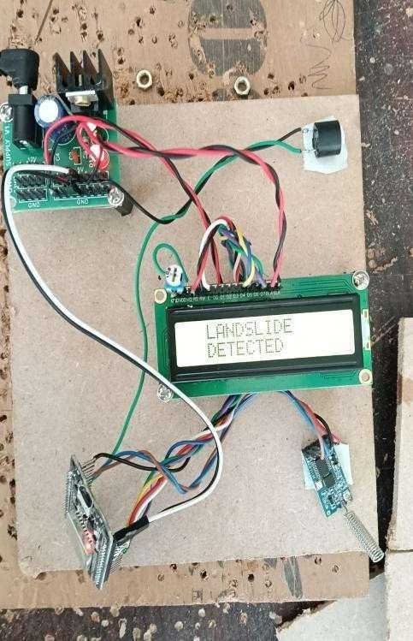

Fig :7.1. Landslide Detection

Landslide detection is the process of identifying early signs that a landslide may occur . It uses different technologies, sensors, and observation methods to monitor the stability of slopes.

The main purpose of landslide detection is to predict landslides in advance, so people, vehicles, and authorities can take safety measures to reduce damage and save lives.

Rainfall Detection
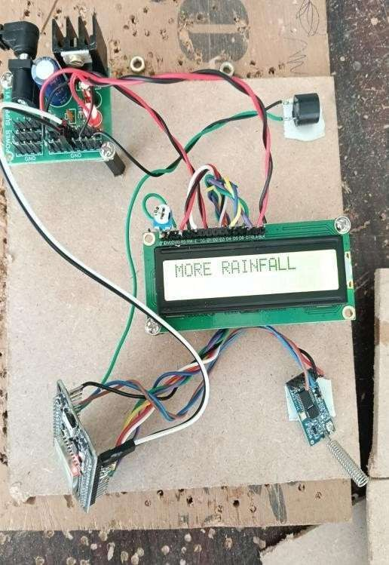

Fig :7.2. Rainfall Detection

Rainfall detection is the process of identifying, measuring, and monitoring rainfall in real time. It uses various sensors and instruments to detect the presence and intensity of rain. Rainfall detection is important for weather forecasting, agriculture, disaster management, and environmental monitoring.

The main purpose of rainfall detection is to provide accurate and timely information about rainfall so we can take precautions against floods, landslides, and other weather-related hazards.

CHAPTER-8

ADVANTAGES, DISADVANTAGES AND APPLICATIONS

Advantages

- Saves time
- Early warning
- Reduces human error
- Improves road safety

Disadvantages

- Limited range
- Weather effect

Applications

- Hilly and curved roads
- Bridges and ghat section
- Construction and mining areas
- Highways and tunnels
- Traffic control

CHAPTER-9

CONCLUSION & FUTURE SCOPE

Conclusion

- The "Conflict Avoidance and Landslide Update System for Vehicles in Deep Curves" project utilizes Arduino Uno, IR sensors, ADXL sensors, LCD displays, and Zigbee communication to provide real-time assistance and updates to drivers navigating challenging terrains. This system aims to prevent accidents, improve road safety, and save lives while optimizing traffic flow in areas prone to deep curves and landslides.
- For the driver to easily observe a vehicle approaching from the opposite direction, convex mirrors are utilised in the existing system at curves.
- This system functions fine during the day but fails miserably at night. The suggested method makes advantage of sensors at hairpin turns, which function incredibly well at night.
- We will be able to remedy the issue by placing the sensors on either side of the curves. The sensor sends a signal that looks like this if the vehicle is 10 metres from the bend. The various hazardous impact of landslides on environment where studied.An efficient environment for analyzing and displaying results with powerful set of tools.

Future Scope
- Solar power integration enables the system to operate continuously in remote deep-curve and landslide-prone areas without dependence on grid electricity.
- Government-supported vehicle system helps authorities install and maintain safety devices in vehicles to reduce accidents on deep curves and landslide-prone roads.
- Automatic emergency message to nearby hospital and rescue teams
- Automatic speed limit enforcement when vehicle enter deep curves

BIBLIOGRAPHY

- REFERENCE[1]Harshada Targe, Anushka Mahajan, Mohit Patil, Yogesh Lilake and Vijay Sonawane, “Advance Road Safety For Ghat Road’s At Hairpin Bend”, International Research Journal of Engineering and Technology, Volume: 05, Issue: 01, January 2018.

- REFERENCE[2] Aravinda B, Chaithralakshmi C and Deeksha, “Sensor Based Accident Prevention System”, International Journal of Innovative Research in Electrical, Electronics, Instrumentation and Control Engineering, Volume: 04, Issue: 06, June 2016.

- REFERENCE[3] R. Anusha, K. Sonia, V.M.K. Vamsi Prasad and J.Raj Kumar, “ Collision Avoidance At Hairpin Curves Using Sensors”, Journal of Emerging Technologies and Innovative Research, Volume: 06, Issue: 04, April 2019.

- REFERENCE[4] Anand M G, A Dhanyakumar, Bhaskar N and Mahaling S B, “Sensor Based Accident Prevention System in Curving”, International Journal of Advance Research and Innovative Ideas in Education, Volume: 05, Issue: 02, December 2019.

- REFERENCE[5] Anuradha A, Trupti Tagare, Vibha T. G and Priyanka N, “Implementation of Critical Intimation System for Avoiding Accidents in Hairpin Curves & Foggy Areas”, International Journal of Science Technology & Engineering, Volume: 05, Issue: 05, November 2018.

- REFERENCE[6] Avinash Shetty, Bhavish Bhat, RameshaKarantha and Srinivasa Hebbar, “Smart Transport System Signalling Sensor System Near Hairpin Bends”, International Journal of Scientific & Engineering Research, Volume: 09, Issue: 04, April 2018.

