- Prepare Source RDS
Create/identify the Account A RDS MySQL 8.4.9 instance. Confirm the source database is companydb.
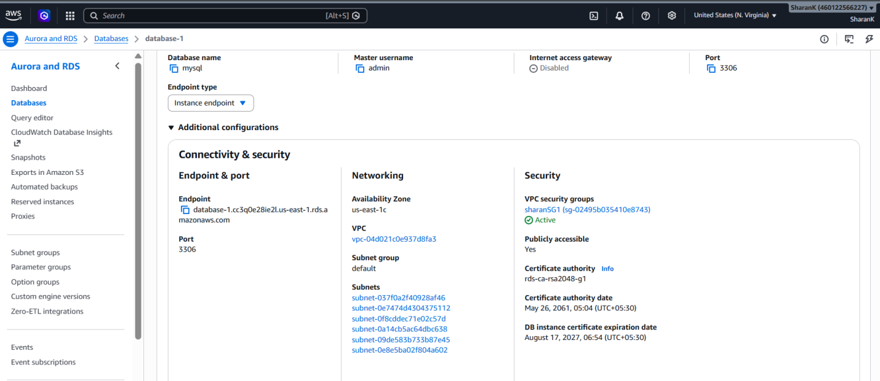

Configure MySQL binary logging and CDC prerequisites. Verify binlog_format is ROW. Create the DMS source user with the required privileges.
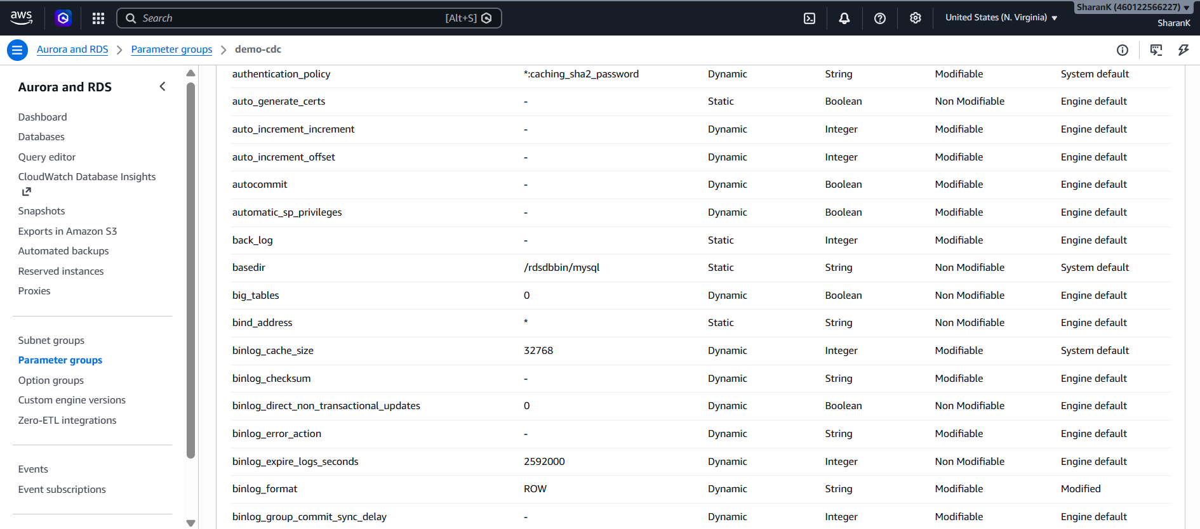

- Prepare Target RDS (Different AWS account)
Create/identify the Account B RDS MySQL 8.4.9 instance.Create the target database companydb if required.
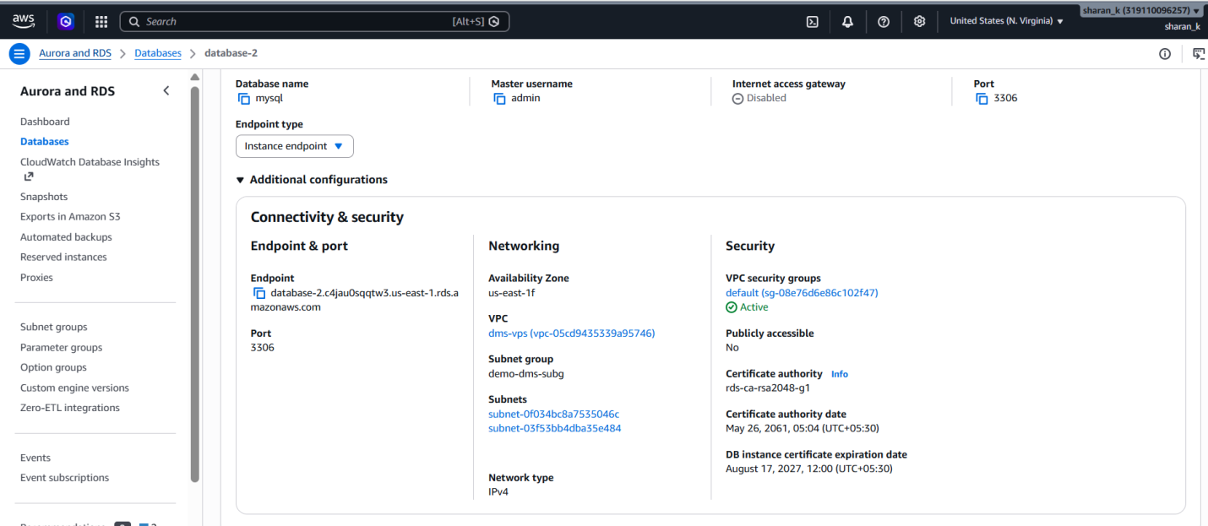

Create the DMS target user.Grant the required read/write privileges for the target.
Make sure the target can accept connections from the DMS migration network.
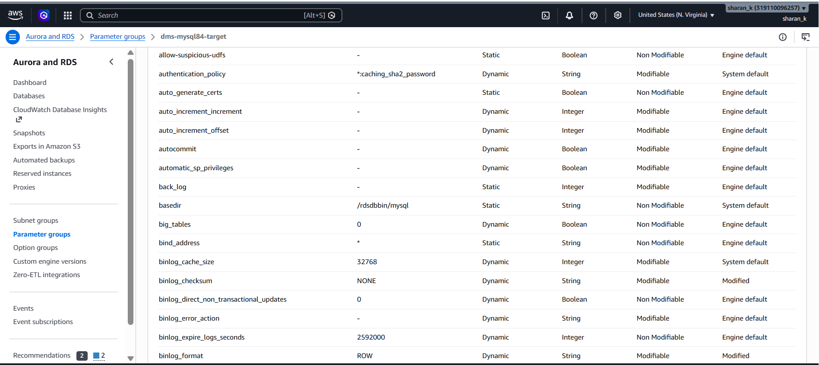

- MySQL Timeout Settings
For both source and target RDS, verify MySQL timeout parameters.
net_read_timeout should be at least 300 seconds.
net_write_timeout should be at least 300 seconds.
wait_timeout should be at least 300 seconds.
Example working values: net_read_timeout=600, net_write_timeout=600, wait_timeout=28800.
Use the RDS MySQL 8.4 parameter group for persistent changes.
- Create Secrets for both the RDS in target account
Create a source database secret containing Account A endpoint, username and password.
Create a target database secret containing Account B endpoint, username and password.

Soure Secret
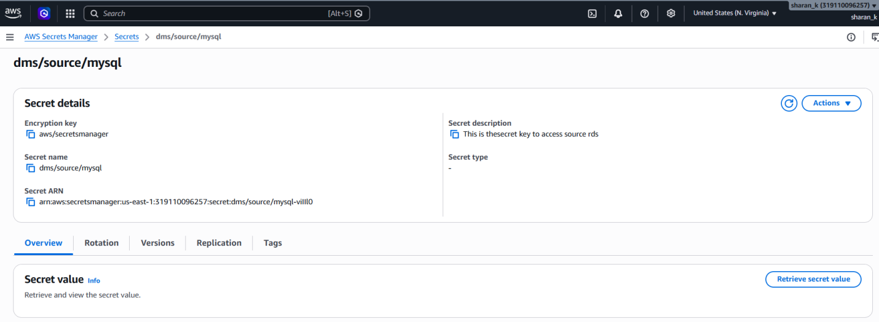

Target Secret
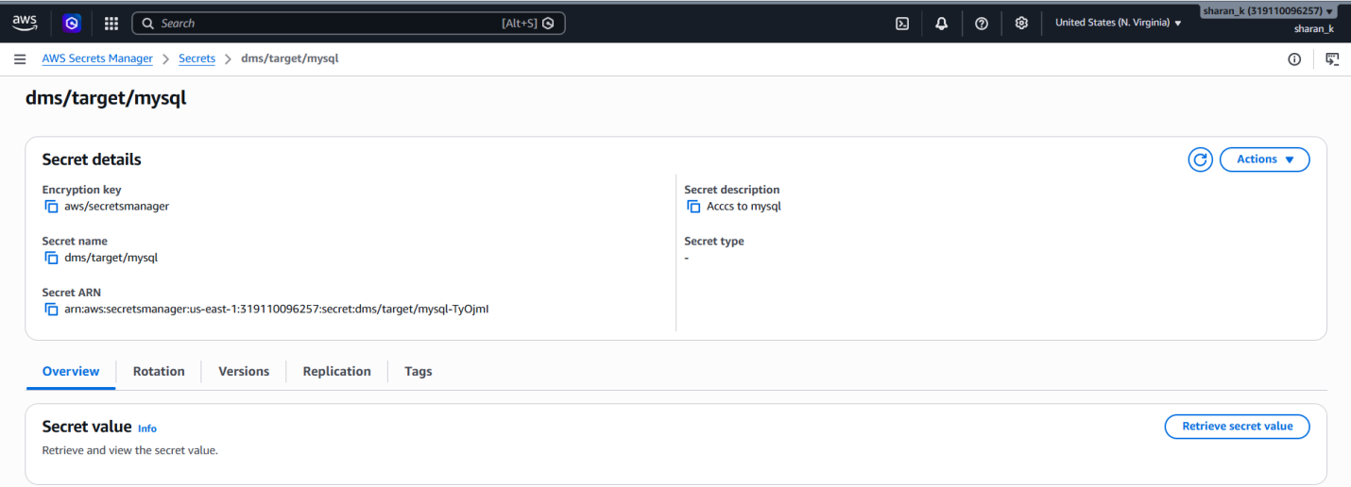

- IAM Configuration Update
Create the IAM roles/policies required by the managed DMS migration.
Allow access to the required Secrets Manager secrets.
Allow the required DMS and networking operations.
Allow S3 access if premigration assessment reports are stored in S3.
Use least privilege rather than unrestricted permissions where practical.

- Create Instance Profile (For Homogenous migration)
DMS → Convert or move to managed → Instance profiles.
Create an Instance Profile. Select the required VPC. Select suitable subnets/subnet group.
Select the security group that allows connectivity to both RDS databases.
Associate the required IAM role.
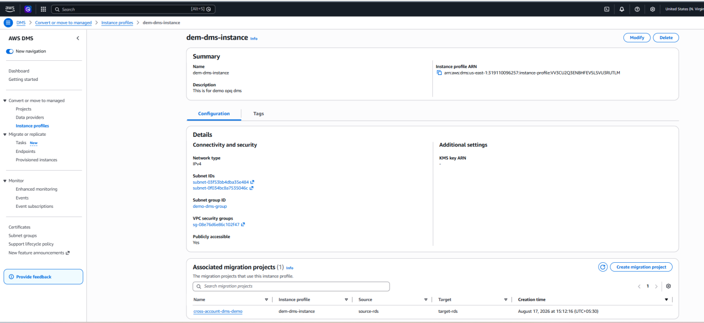

- Create Instance Profile (For Tradition migration)
DMS → Migrate or replicate → Replication instances.
Create a replication instance and select the VPC/subnet group/security group.
Choose an instance class appropriate for the workload.
Wait until the replication instance is Available.
This compute resource is explicitly managed in the traditional workflow.

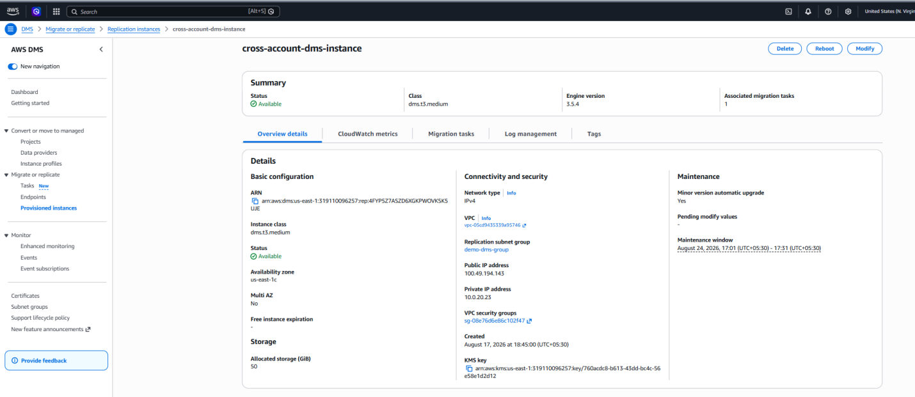
- Create Data Providers (For Homogenous migration)
DMS → Convert or move to managed → Data providers.
Create a Source& Target Data Provider.
Engine: MySQL. Point it to respective RDS. Select the source & target Secrets Manager secrets.
Test the connection and confirm Success.

Source Data Provider
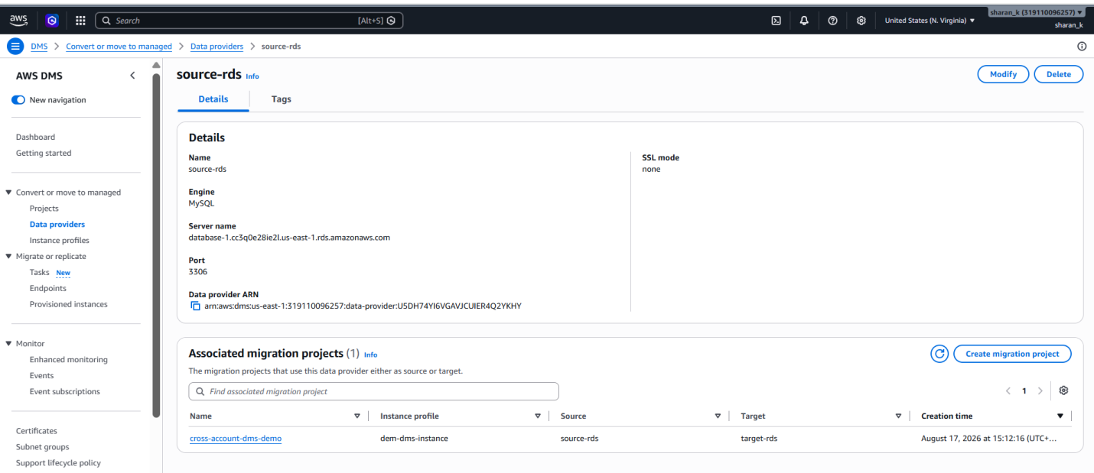

Target Data Provider
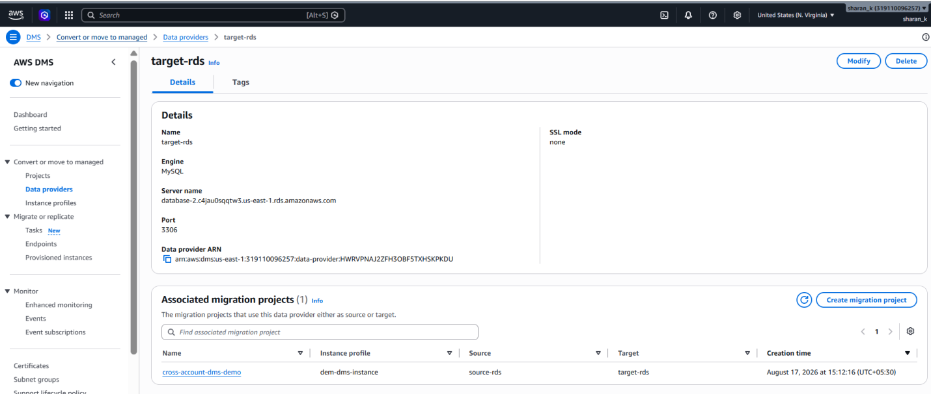

- Create Source & Target Endpoints (For Traditional Migration)
DMS → Migrate or replicate → Endpoints.
Create Source Endpoint → MySQL → Account A RDS.
Create Target Endpoint → MySQL → Account B RDS.
Configure hostname, port 3306, database, credentials/secret.
Test both endpoint connections successfully.

Source Endpoint
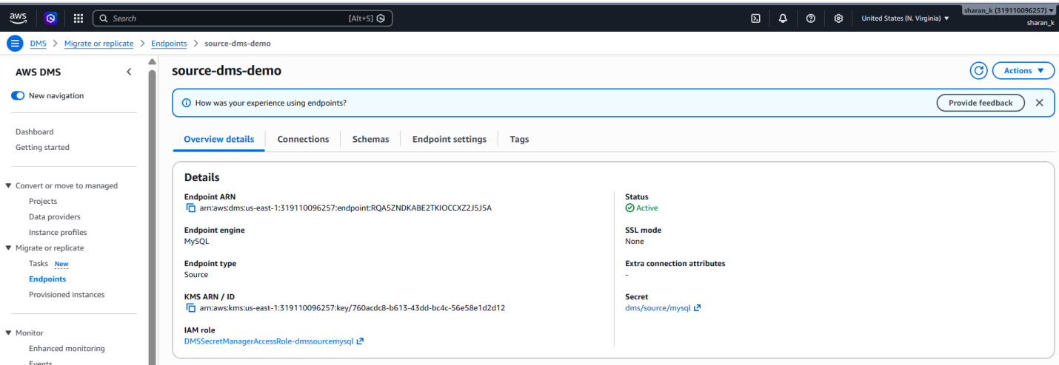

Target Endpoint
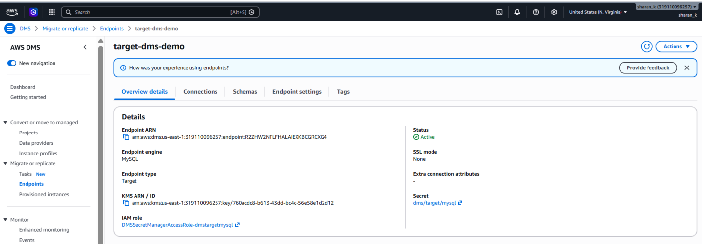

Make sure that the database URL and pointing to the respective account RDS only.

- Create Migration Project (For Homogeneous Migration)
DMS → Convert or move to managed → Migration projects.
Click Create migration project. Give the project a meaningful name, for example cross-account-dms-demo. Select the Source Data Provider. Select the Target Data Provider. Select the Instance Profile.
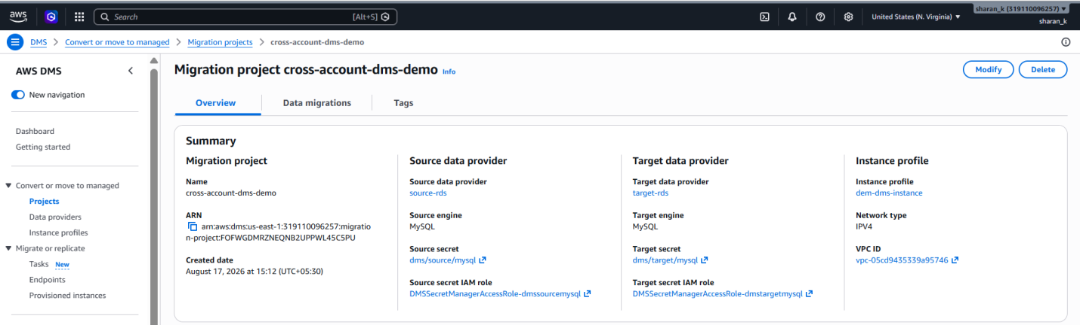

- Create the Replication task.
DMS → Migrate or replicate → Tasks → Create task.
Select Replication Instance. Select Source Endpoint. Select Target Endpoint.
Migration type: Migrate existing data and replicate ongoing changes (Full Load + CDC).
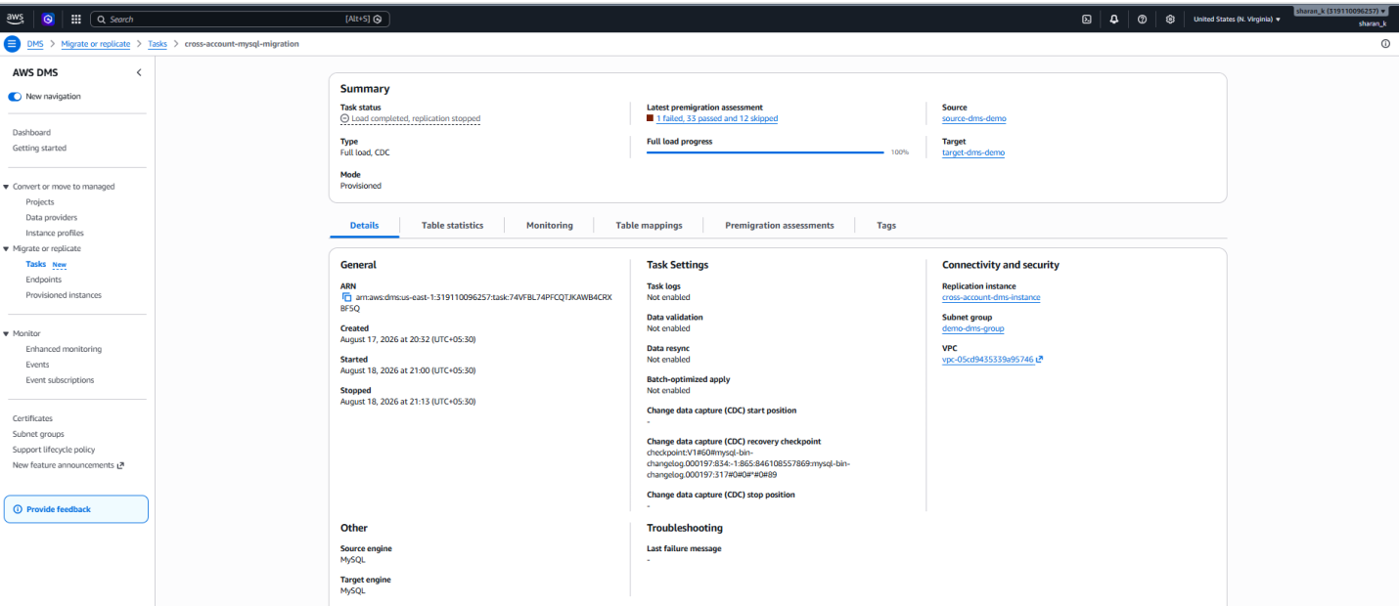

- Task Settings
Configure target table preparation mode.
Configure LOB handling if required.
Enable CloudWatch logging.
Configure error handling and validation as required.
Configure CDC/task settings as needed.
- Create Data Migration
Open the migration project → Data migrations → Create data migration.
Give the migration a meaningful name. Select Full load and change data capture (CDC).
Enable CloudWatch logs. Configure other migration options as required.
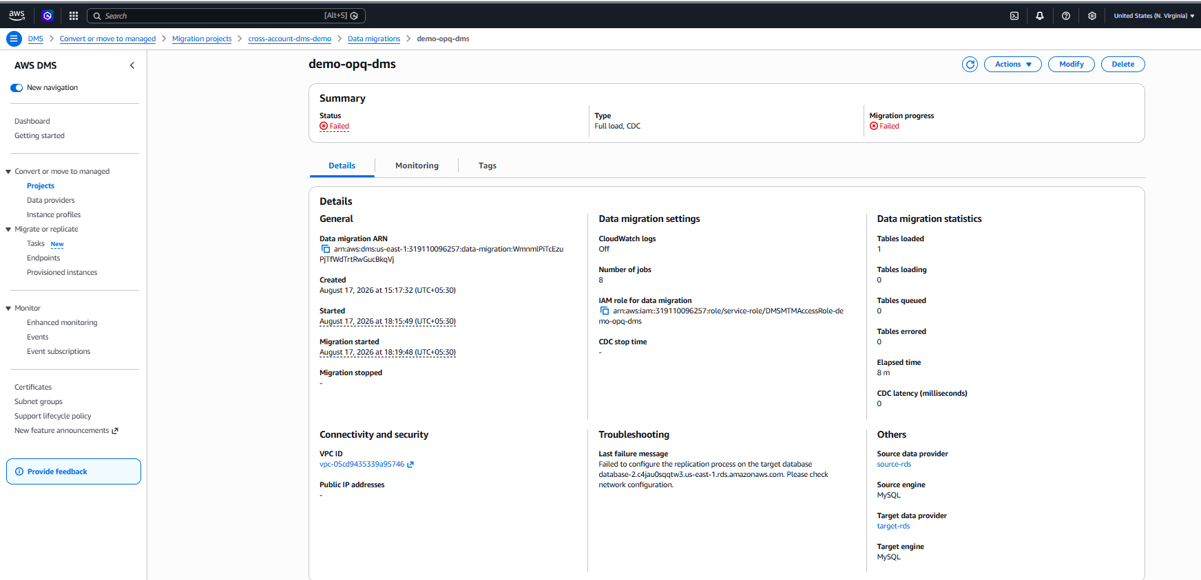

- Premigration Assessment
Create a premigration assessment run. Enter a valid assessment run name. Select or create an S3 bucket for assessment reports. Select the applicable assessments.
Run the assessment. Resolve all Failed prerequisite checks before starting the migration.
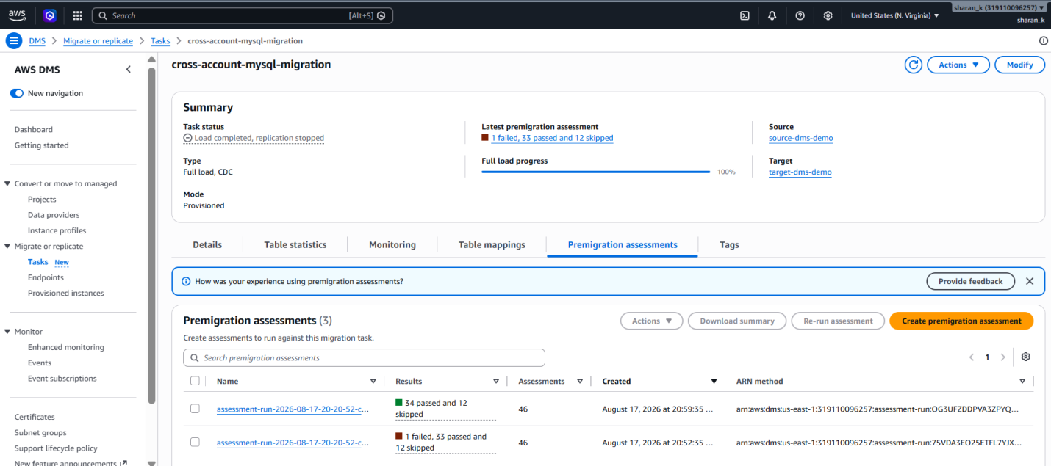

- Common Assessment Failures
MySQL net_read_timeout / net_write_timeout / wait_timeout too low.
DMS user missing target read/write privileges.
Source CDC/binlog prerequisites not configured.
Incorrect credentials or wrong endpoint in a secret.
Network/security-group access problems.
Always use the assessment message to identify the exact missing prerequisite.

- Start Migration (For Homogenous Migration)
Open the Data Migration. Initial status may be Start required. Actions → Start/Resume.
The managed service starts the migration environment. The migration progresses through startup, Full Load and CDC.
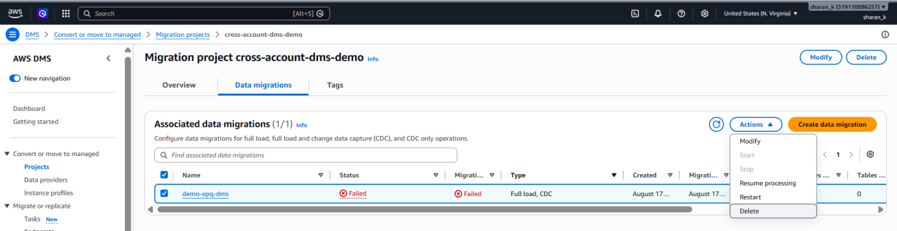

- Start & Verify Migration (For Traditional Migration)
Select task → Actions → Start/Resume.
Monitor Full Load progress and CloudWatch/task logs. After Full Load, verify CDC status and latency. Compare Account A and Account B row counts.
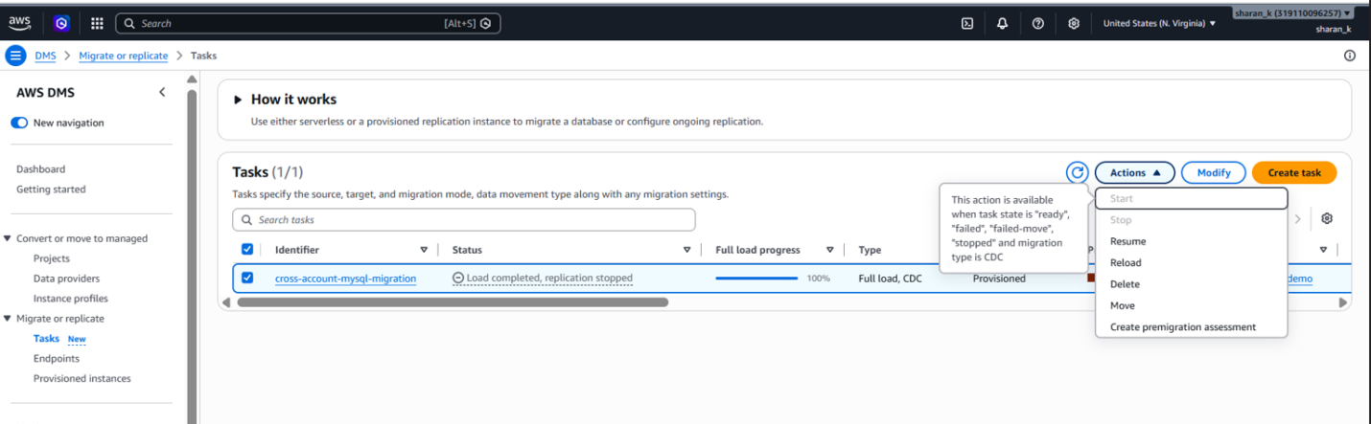

- Useful Mysql Commands
To create table in Source Database connected using Myworkbench
CREATE DATABASE companydb;
USE companydb;
CREATE TABLE aspirants (
id INT PRIMARY KEY,
name VARCHAR(100),
stream VARCHAR(100),
salary INT
); -
INSERT INTO companydb.aspirants VALUES
(1,'Sharan','SRE',125000),
(2,'Kabil','OPS',128000),
(3,'Siddu','DEVOPS',123000),
(4,'Arun''SRE',130000);

To check the CDC working you need to add new entry to table after the Full load is completed and use the insert command for that.
Ex: INSERT INTO companydb.aspirants VALUES
(7,'Shruti','SRE',105000);

- AWS CLI commands
sudo dnf install mariadb105 –y - Install Mysql on ec2
mysql -h <databse endpoint> -u admin –p – connect to the databse
SHOW DATABASES;
USE companydb;
SHOW TABLES;

