Explore AWS organizations and AWS IAM Identity Centre
- Create an AWS account in for the organization
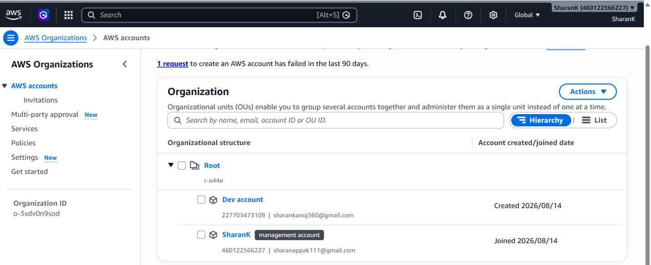

- Enable the IAM Identity Center
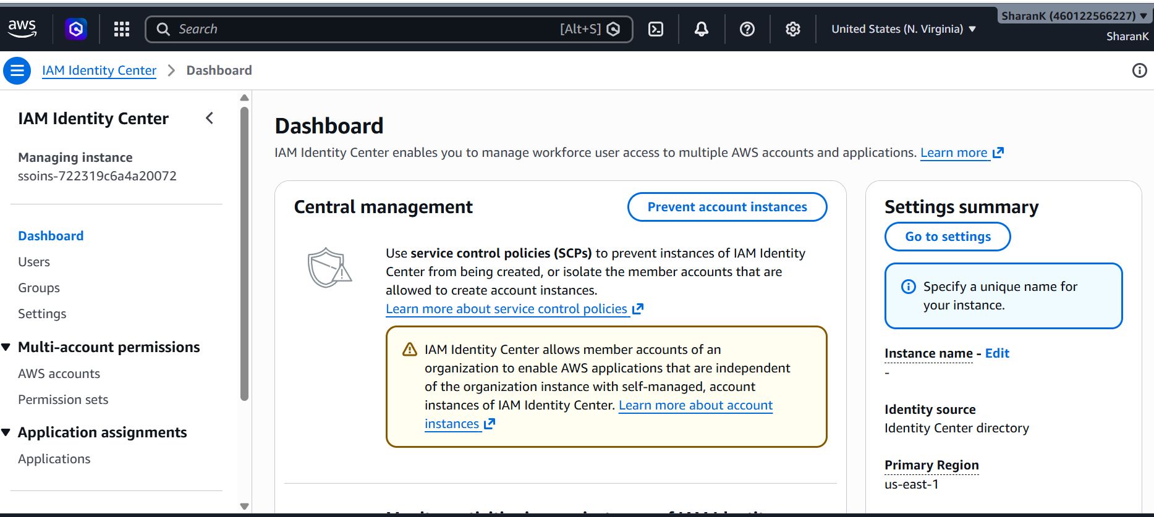

- Create a User and group and add user to group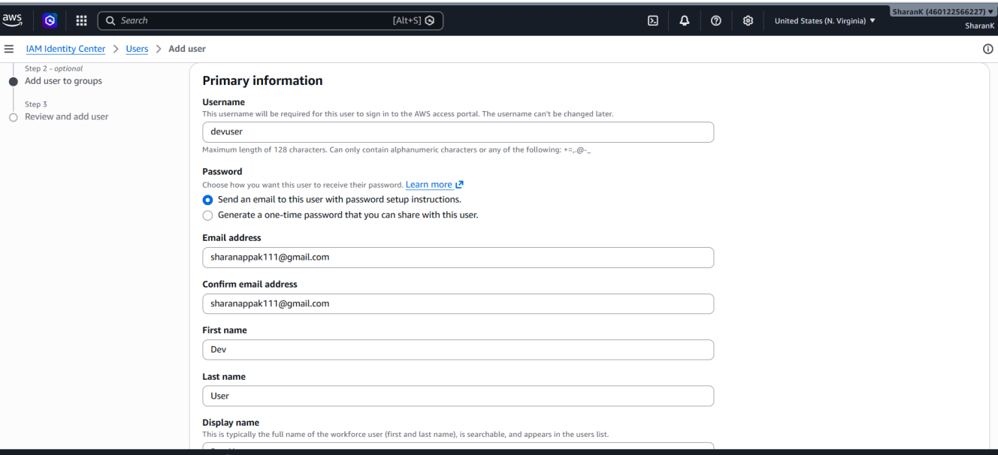
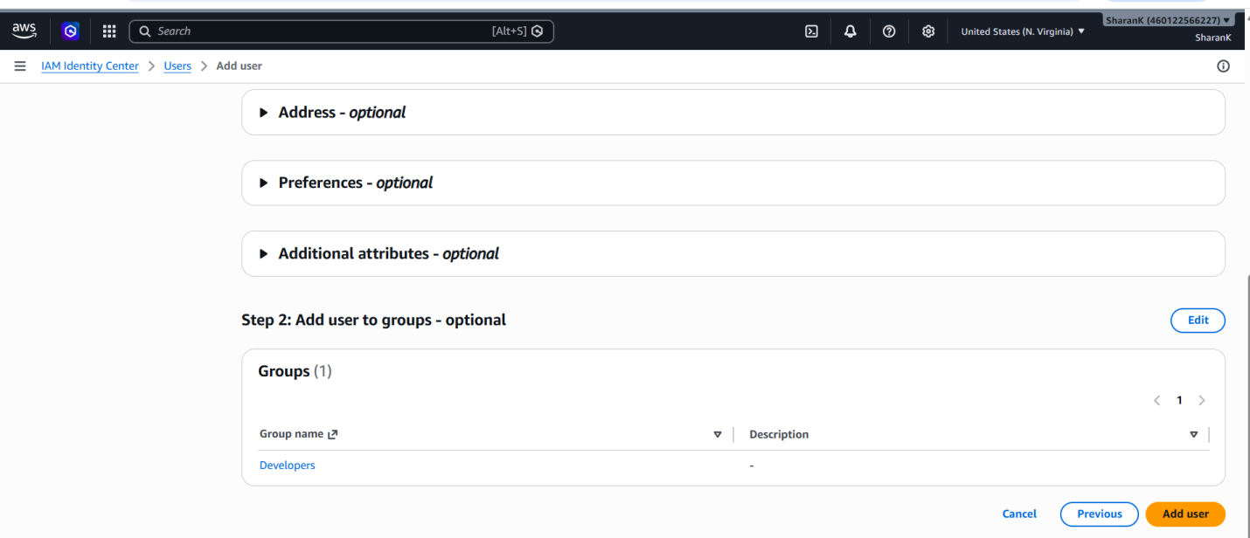
- Set permission for readonly access
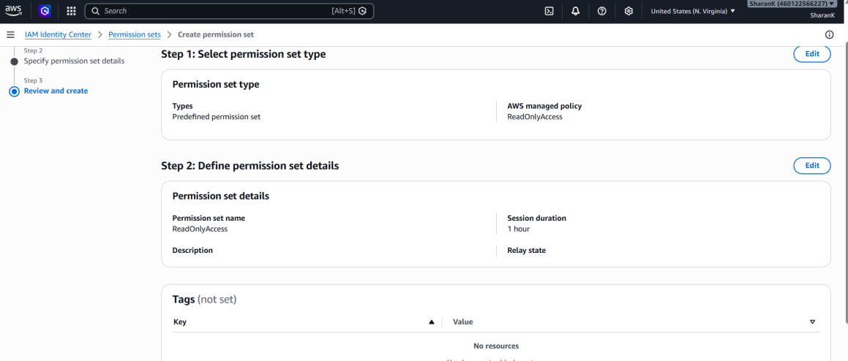

- Add the groups and the permission set to the account created
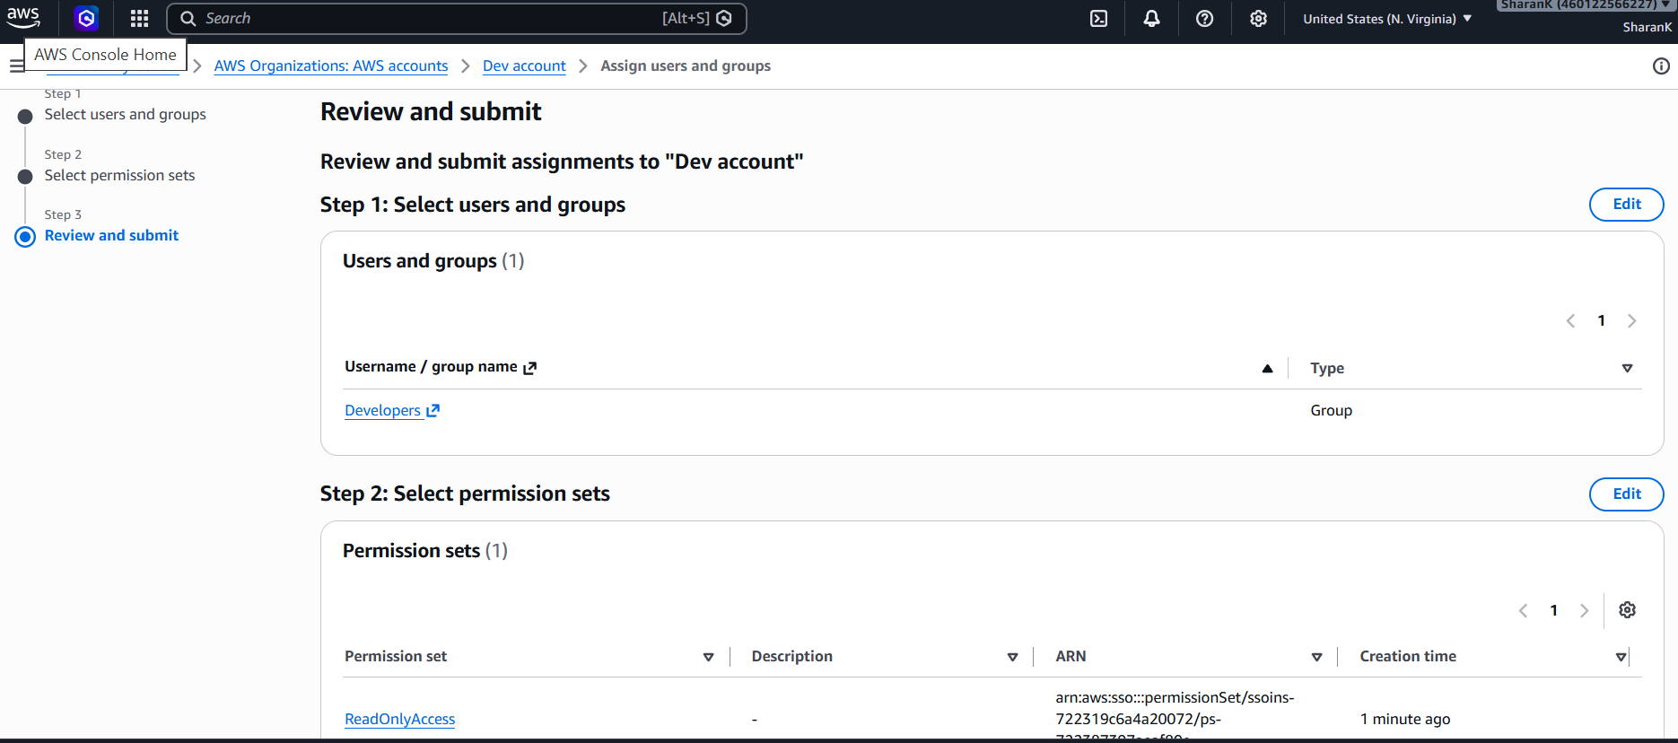

- Once the set up is done, you need to go to the mail and set the password for the user. We could have setup password initially but we choose the option of confirmation over mail.
- Now with the URl user will be able to access the portal
