Cloud Front Caching and Invalidation
- Create an S3 Bucket
Open AWS Console → S3 → Create bucket. Enter an unique bucket name and create the bucket.
- Enable Static Website Hosting
Open the bucket → Properties → Static website hosting → Enable. Set Index document to index.html.
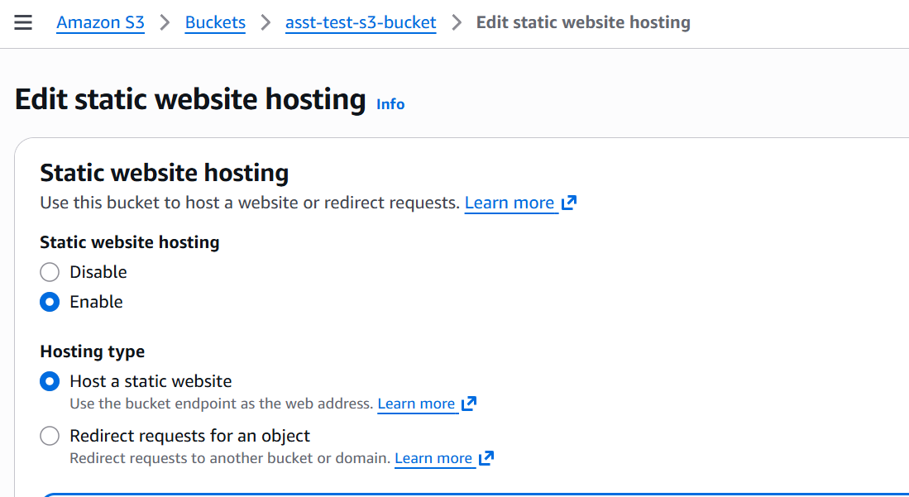
- Upload Website File -- Create index.html containing <h1>Version 1</h1> and upload it to the bucket.
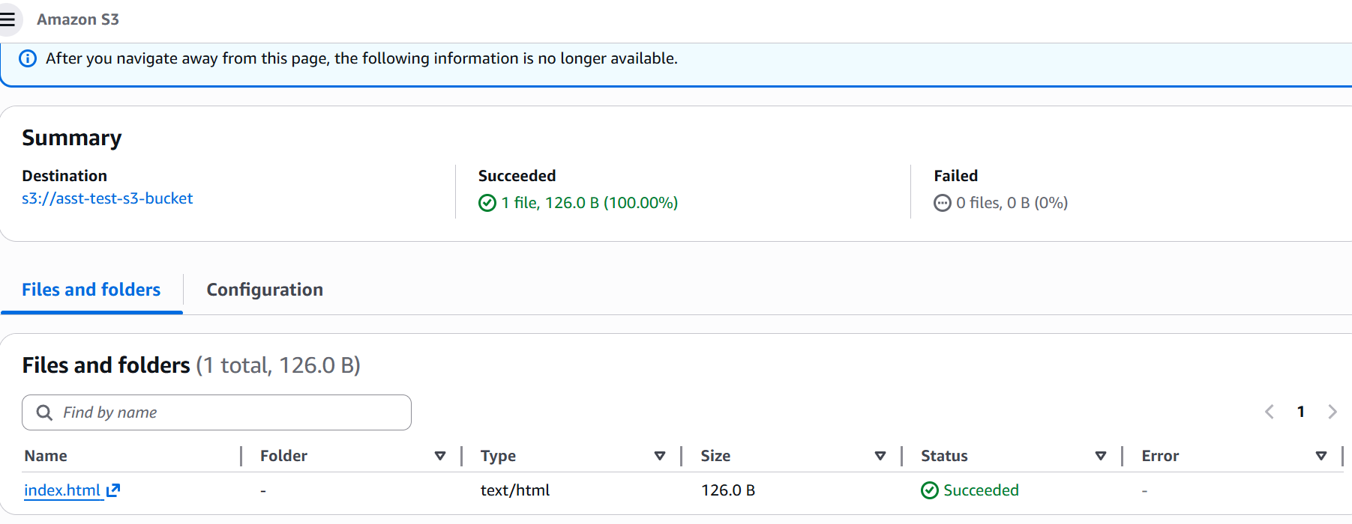
- Allow Public Access
Disable Block Public Access if required and configure a bucket policy to allow public read access.
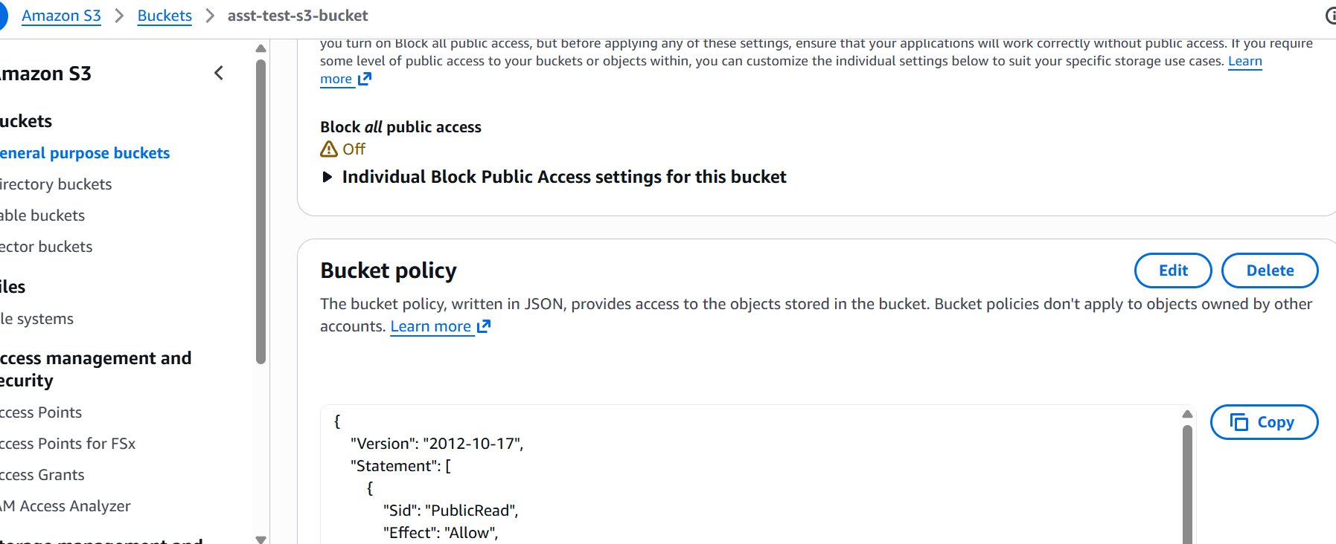
- Verify Website
Open the S3 Website Endpoint and verify that Version 1 is displayed.
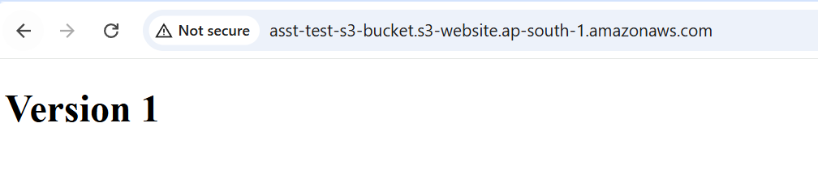
- Create CloudFront Distribution
Go to CloudFront → Create Distribution. Select the S3 website endpoint as the origin and create the distribution.
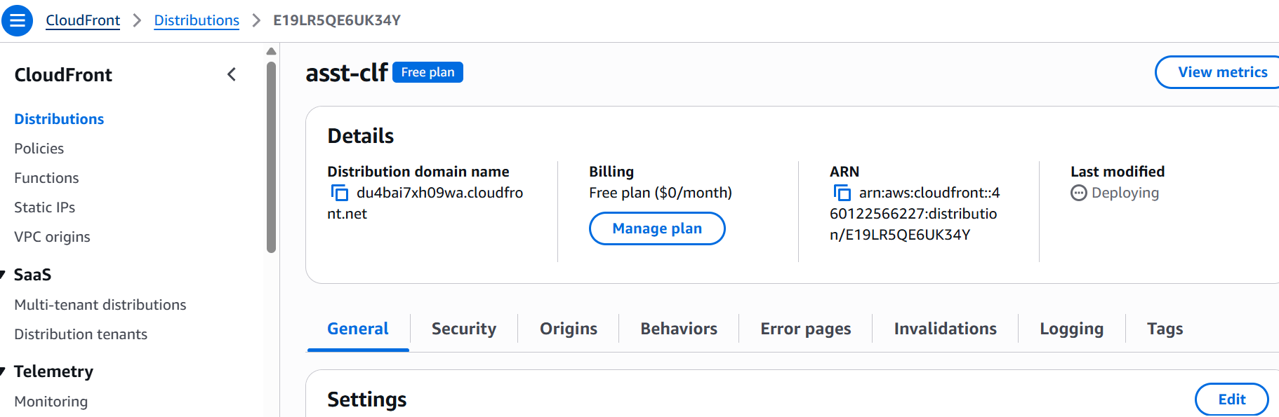
- Wait for Deployment
Wait until the distribution status becomes Deployed.
- Test CloudFront
Open the CloudFront domain and verify it displays Version 1.
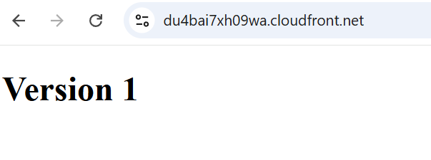
- Update Website
Modify index.html to display Version 2 and upload it.
- Verify Cached Content
Refresh the CloudFront URL. It may still display Version 1 because of caching.

- Create Invalidation
Go to Invalidations, create one with path /*.

- Wait for Completion
Wait until the invalidation status is Completed.

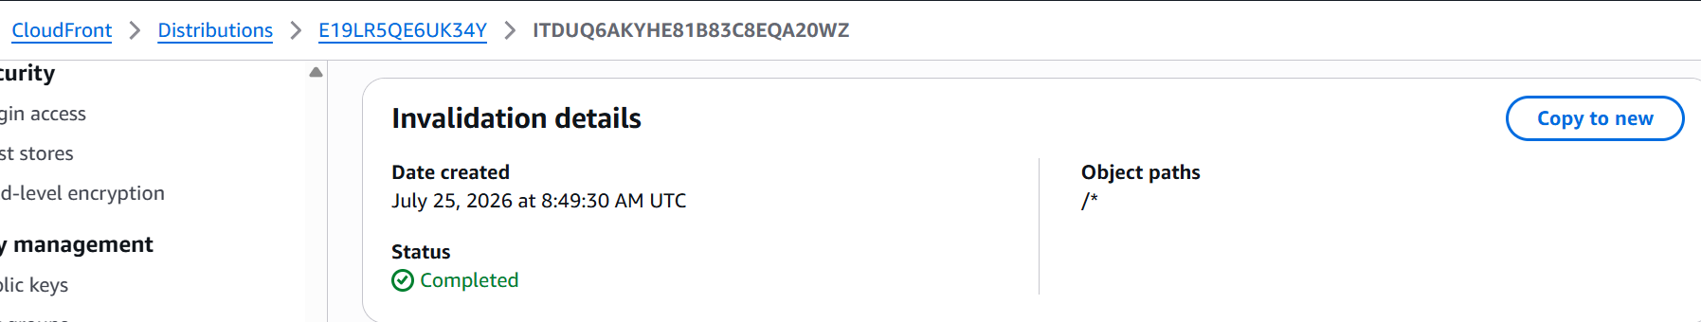
- Verify Updated Content
Refresh the CloudFront URL and verify Version 2 is displayed.
