Load Balance Two Nginx Servers

- I launched two Amazon Linux 2023 EC2 instances (t2.nano & t3.micro) in different Availability Zones. And enabled public IP.
- Created WebServer-SG with inbound: SSH(22) from My IP only.
- Created ALB-SG with inbound: HTTP(80) from Anywhere (0.0.0.0/0).
- Edit WebServer-SG and add HTTP(80) with source = ALB-SG.
- SSH to Server A:Perform there stesps to enable ngnix in them.
sudo dnf update -y; sudo dnf install nginx -y; sudo systemctl enable --now nginx; echo 'This message is from Server A' | sudo tee /usr/share/nginx/html/index.html; curl localhost.
- Repeated same steps above on Server B, replacing the message with 'This message is from Server B'.
- Create a Target Group: Target type=Instances, Protocol=HTTP, Port=80, Health check path=/. Register both instances(serverA & serverB).
- Create an Internet-facing Application Load Balancer across at least two AZs. Listener: HTTP:80. Forward to the target group. Attach ALB-SG.
- Wait until both targets become Healthy.
- Copy the ALB DNS name and test using: for i in {1..10}; do curl http://<ALB-DNS>; echo; done. Responses should alternate.
- Stop nginx on Server A: sudo systemctl stop nginx. Confirm Server A becomes Unhealthy and traffic goes only to Server B.
- Restart nginx: sudo systemctl start nginx.
- Enable Target Group stickiness (Attributes -> Edit -> Stickiness) and test again.
- Cleanup: Delete ALB, Target Group, EC2 instances, then Security Groups.

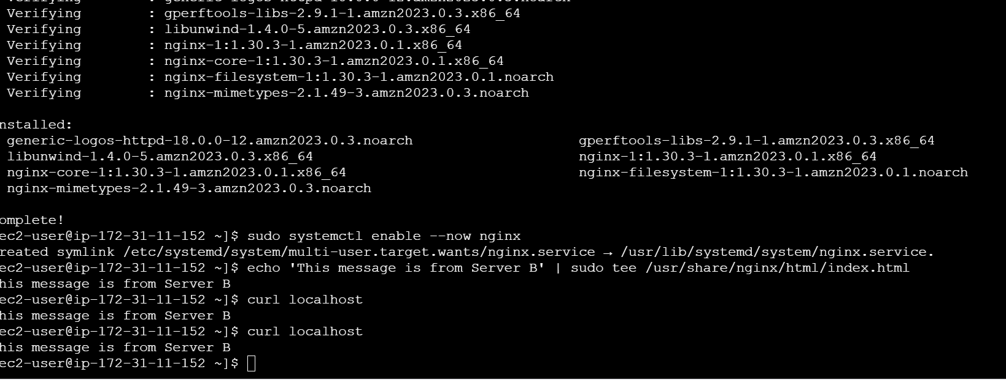
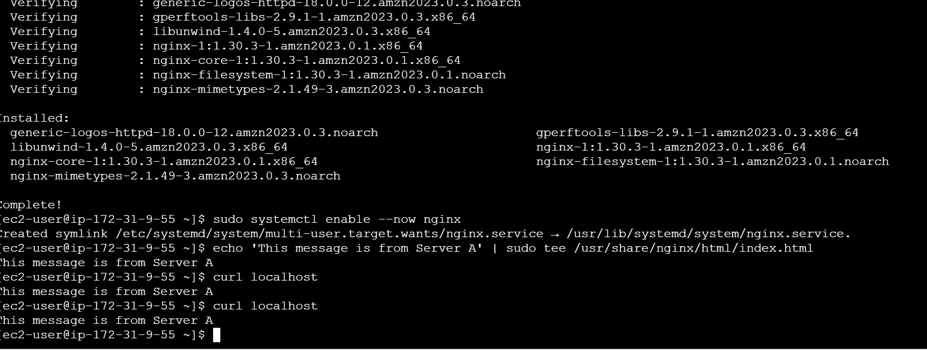
Launch of load balancer and attaching the targets to it
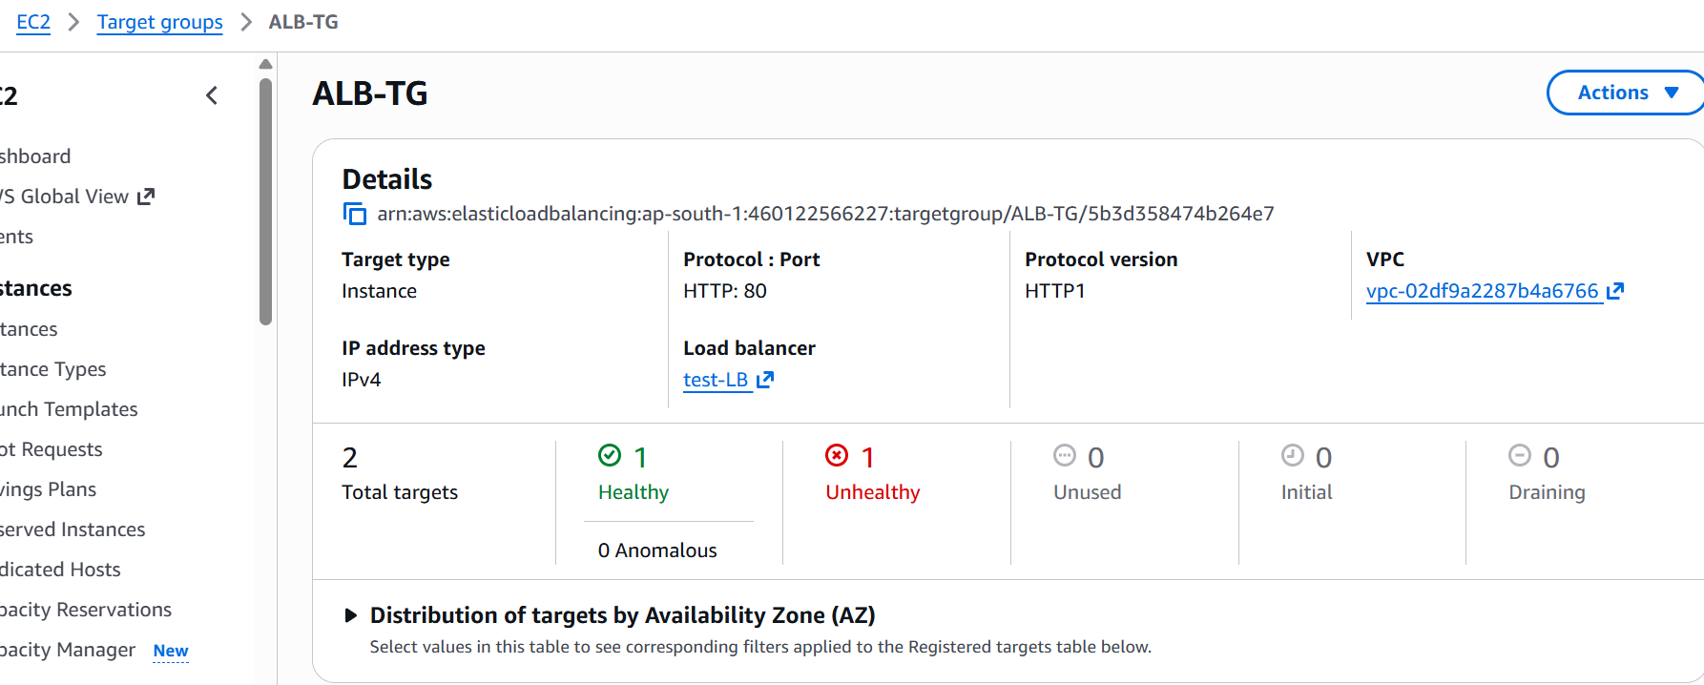
This is snippet for setting up security groups
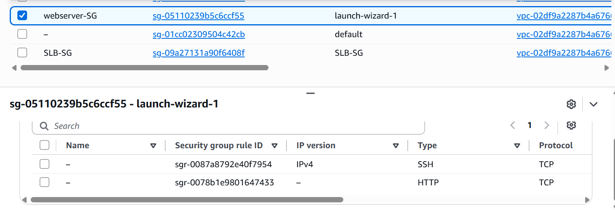
Then we will create a shell script for load balancer so we will have response from the one which is active

