- Create the Lambda Function
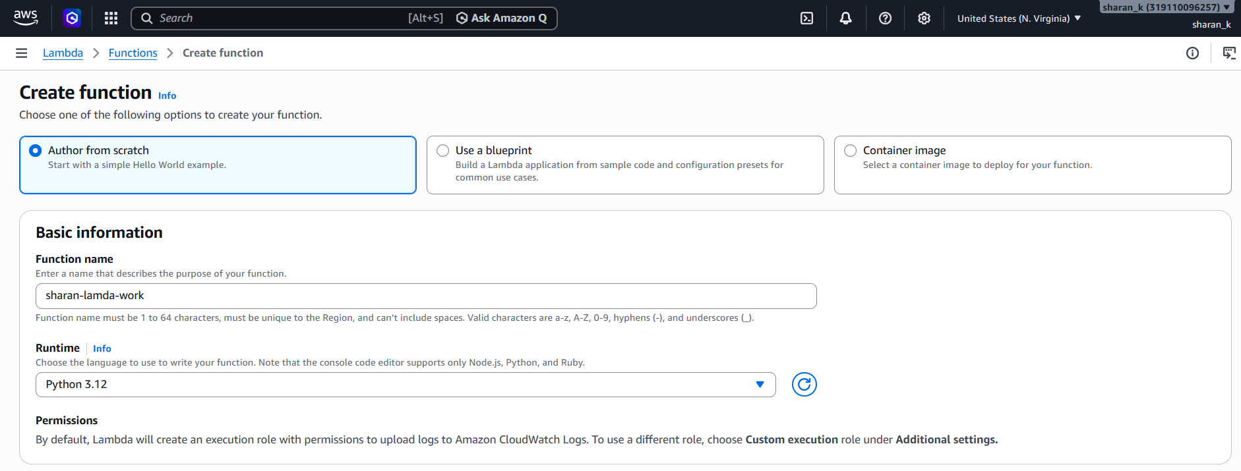

- Enable function URL. -
We set auth type as NONE so it makes the web app publicly accessible.
We check the box for Configure cross-origin resource sharing (CORS) to prevent browser blocks.
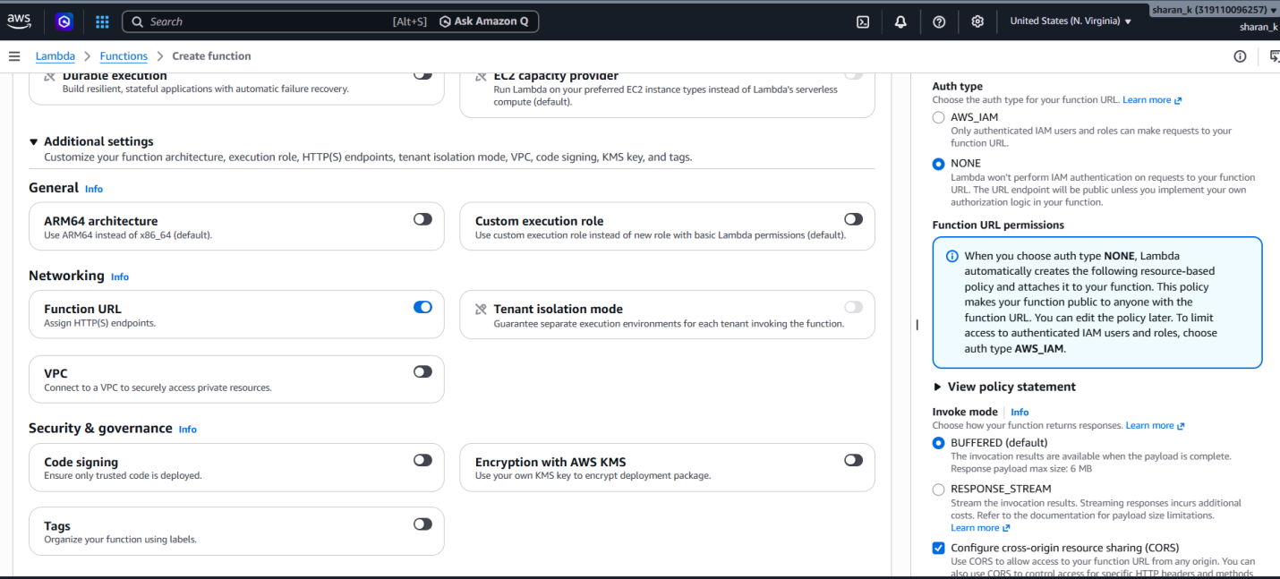

- Add the Web Code
AWS Lambda will load our configurations and present a built-in code editor, we will add our simple python code in the .py file.
Once code is written we will deploy it.
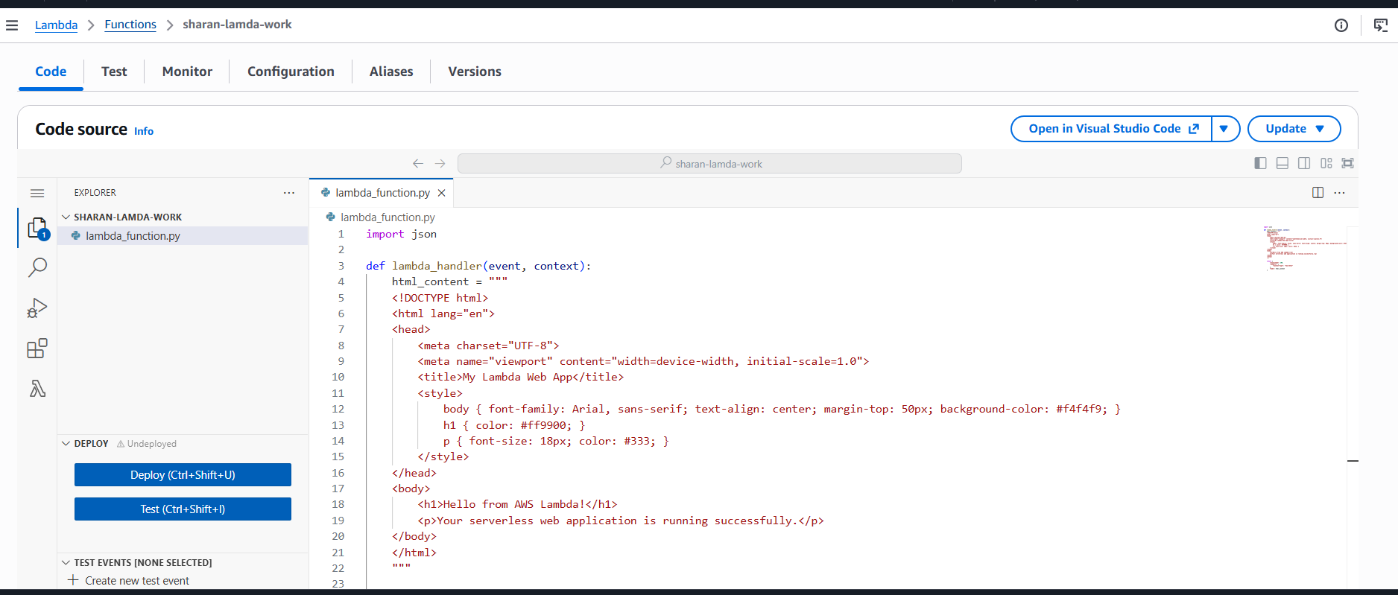

- Launch the Web App
At the Function overview section at the top of the page locate the Function URL property. And run it on browser and the live web app will be displayed.

