Machine Learning

1 Boosting
a Gradient Calculation
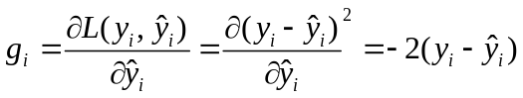

b Weak Learner Selection
To compute the optimal value of the step size , we first compute the gradient of 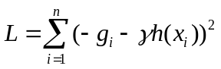 :
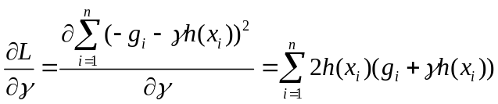
Let the gradient equals to zero, we get the optimal:
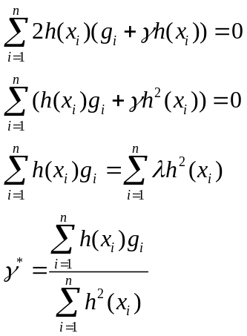
Once we have the optimaland replace it in the original formula, the selection of 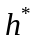 will be derived independent of .

c Step Size Selection
To compute the optimal value of the step size , we first compute the gradient of 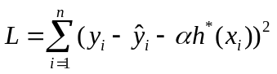 :
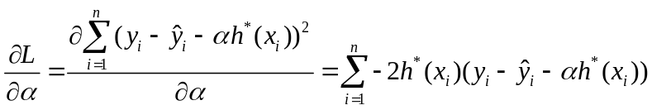
Let the gradient equals to zero, we get the optimal:

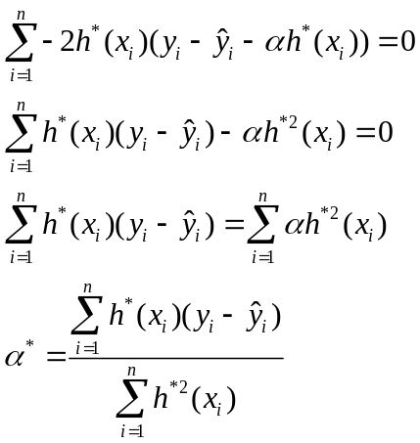

2 Neural Network
- Suppose there are D inputs, M hidden layers, K outputs.
The first hidden layer output is: 