Acknowledgement

I would love to express my gratitude for everyone supporting me through the project completion of my project titled “Class Mentor”. First and foremost, I extend my deepest appreciation to my project guide Assistant Professor Ms. Aditi Chikhalikar for her continuous guidance and support throughout the year which were valuable insights in shaping this project. I feel truly fortunate to have had the opportunity to work under her mentorship.

I also extend my sincere and grateful thanks to our Co-ordinator Dr. Tushar Sambhare for motivating us throughout the project. His vision and dedication were crucial in keeping the me motivated and focused. I am grateful to Dr. Sridhara Shetty, Principal of Bunts Sangha’s S. M. Shetty College of Science, Commerce and Management Studies along with the faculty and staff members for providing a conducive learning environment and resources that were essential for this project's execution.

I would also like to acknowledge the support and encouragement received from my fellow friends who contributed their time and effort to help me with certain things throughout the project. Lastly, I would like to express a heartful gratitude to my family for their support and understanding during the course of this project.

- Sharan Dayanand Puthran

**Index**

|  |  |  |
| --- | --- | --- |
| Sr. No | **Table of Content** | **Page No.** |
| **1** | **Introduction** | **3** |
|  | 1.1 Background | 3 |
|  | 1.2 Objective | 5 |
|  | 1.3 Purpose, Scope | 6 |
|  | 1.3.1 Purpose | 6 |
|  | 1.3.2 Scope | 7 |
|  | 1.3.3 Applicability | 7 |
|  | 1.4 Achievement | 8 |
|  | 1.5 Organization of Report | 9 |
| **2** | **Survey Of Technology** | **10** |
|  | 2.1 Available Technology | 10 |
|  | 2.1.1 Front-End | 10 |
|  | 2.1.2 Back-End | 13 |
|  | 2.1.3 Database | 14 |
|  | 2.2 Feasibility Study | 14 |
|  | 2.3 Study of SDLC Model | 17 |
| **3** | **Requirements and Analysis** | **19** |
|  | 3.1 Existing System | 19 |
|  | 3.2 Requirement Specification | 19 |
|  | 3.2.1 Functional Requirements | 20 |
|  | 3.2.2 Non-Functional Requirements | 20 |
|  | 3.2.3 User Requirements | 21 |
|  | 3.3 Software and Hardware Requirements | 21 |
|  | 3.3.1 Software Requirements | 21 |
|  | 3.3.2 Hardware Requirements | 21 |
|  | 3.4 Planning and Scheduling | 22 |
|  | 3.4.1 Planning | 22 |
|  | 3.4.2 Scheduling | 22 |
|  | 3.4.3 Gantt Chart | 23 |
|  | 3.5 Preliminary Product Description | 24 |
| **4** | **System Design** | **25** |
|  | 4.1 Basic Module | 25 |
|  | 4.1.1 Administrative Module | 25 |
|  | 4.1.2 User Module | 26 |
|  | 4.2 Schema Design | 27 |
|  | 4.2.1 Data Dictionary | 27 |
|  | 4.3 System Design | 32 |
|  | 4.3.1 Use-Case Diagram | 32 |
|  | 4.3.2 Activity Diagram | 36 |
|  | 4.3.3 Class Diagram | 40 |
|  | 4.3.4 Sequence Diagram | 42 |
|  | 4.3.5 Data-Flow Diagram | 45 |
|  | 4.3.6 ER Diagram | 48 |
|  | 4.4 User-Interface Design | 50 |
|  | 4.5 Test Case Design | 53 |
| **5** | **Implementation and Testing** |  |
|  | 5.1 Implementation Approaches |  |
|  | 5.2 Coding Details |  |
|  | 5.3 Coding Efficiency |  |
|  | 5.4 Testing Approaches |  |
|  | 5.4.1 Unit Testing |  |
|  | 5.4.2 Integration Testing |  |
|  | 5.5 Modifications and Improvements |  |
| **6** | **Results and Discussion** |  |
|  | 6.1 Test Reports |  |
|  | 6.2 Test Cases |  |
|  | 6.3 User Documentation |  |
| **7** | **Conclusion** |  |
|  | 7.1 Conclusion |  |
|  | 7.2 Limitations of the Project |  |
|  | 7.3 Future Scope of the Project |  |
|  | 7.4 References |  |

**Chapter 1**

**Introduction**

# 1.1 Background:

In this developing environment people are giving more and more importance to education. Education has become an important necessity for today’s generation to secure them a great future ahead and become successful in their life ahead. Now students are not only getting involved in schools for their education but also they are joining private tuitions to get better result in their school grades. Classes are those group of tutors who brush up student’s skills and help them learn more terms about a particular subject and syllabus. Students usually join classes because of less facility or resources in schools or they need some extra attention in their studies from other peoples or tutors so that’s why private tuitions and classes are used to brush up skills of those students who need extra attention their studies.

Some students also don’t feel comfortable to ask doubts to teacher, these students can seek help from their private tutors and they can help them to clear their doubts and other stuffs students is unsure about. In classes there are fewer students or students are divided into smaller batches so it gets easier for the tutors give personal attention to the students and help them with their studies and different stuffs which they need to clear and help them with the resources they need to gain the skill which schools can’t properly provide to students such as one on one attention to each students. Every school contains over 70-80 students per class in such a huge proportion of students the teachers or school doesn’t keep the ability to give one-on-one attention to each and every student present in the classroom, so that’s why classes or private tutors helps to fill this void that schools can fill up.

Classes can help to enable students to grasp concepts more quickly, understand more complex instruction much better and retain them better overtime so that amount of struggling with the program is reduced, and they can get their work done. It also helps to remove distraction in the classroom environment and engage the attention of students in resulting in a measurable and significant improvement in student achievement and reduction in failure rate. Track each student real time to ensure that they are staying in task. Collaborative tools to send messages to students and support learning.

Class management is very much important part of an education system in classes or private tuitions the better u are able to manage a class and manage those students and help them with better resources, more students will be able to get a better attention and education in that class. However, in this rapidly changing, evolving world it’s not quite easy to manage the Class data manually. There is a huge amount of data involved in managing class, Data regarding student teachers and activities going on the classes need to be processed precisely so that it doesn’t disturb the flow of the management happening in the Class. Developers are continuously looking for different ways to effectively and efficiently manage the schedule and data of a particular class which performs better activity and provide an amazing experience to both student and class owner.

Class Mentor which is a Class Management System which is an extensive web application that is design to manage and keep the record of a particular class, it acts like and information system management which is storing the large amount of data and record of student, course and employee in database. It has a structured format of different modules that will be managing by the main admin or the main class branch manager or system administrator. Users can get information about the class, course and various other stuffs. It can basically carry out many function or task such as attendance system, scheduling time, keeping and deleting the record. It mostly demanding software.

# 1.2 Objectives:

The main objective of this software is to optimize the admin and educational processes in the classes. By the introduction of such system, the particular class is aimed to achieve efficient admin workflows which can help them in task such as student registration, staff management, tutor or management. Accessibility and inclusivity are vital aspects of class management objectives, the education and all the system must be accessible to all the users and teachers is one of the main objectives of this system regardless of the physical location. Ultimately, Class Mentor objectives revolve around achieving cost efficient, sustainable and adaptable systems that not only should meet the expectations of a user or an administrator but also evolve to meet the changing needs of the environments and stakeholders.

The primary objectives of this system are as follows:-

1. To provide the registration page and login Id for students, teachers in the website and also allow admin to keep track about records of all the students and teachers present in the class.
2. To maintain all the student vital information in a secure database which can be only access and altered admin.
3. To track and manage the attendance of students and also maintain the number of lectures taken by the teacher and store it in a database which can be accessed by the admin.
4. Provide fees structure for a particular course or subject in the website.
5. It will keep records of the Course, Employee and Teacher, batch by the Class Id in the admin.
6. Help to generate timetables and provide to students.
7. Provide resources to students with the help of resource library .
8. To track and maintain the progress of student’s basis on the assignments submitted and number of quiz solved.
9. Provide a personalized dashboard which provides information about the assignment due dates, courses enrolled and progress of the student in that particular course.at

# 1.3 Purpose and Scope of the Project:

The primary purpose of the project is to design, develop and implement a robust class management system to fulfil the evolving needs of classes and private tuitions and also it helps to enhance the overall educational experience. It also provides the tutors with essentials tools to develop interactive and engaging content which enhance the learning experience making it more professional and easier to handle and manage various aspects in a class or private tuitions. Purpose also involves managing physical and digital resources such as classrooms digital learning materials into one resource library which can be accessed by students.

## 1.3.1 Purpose:

* Creates an efficient environment for managing various task related to class or private tuitions.
* Can also be proven as hub for various educational features to be implemented.
* Can also provide and effective communication between different roles present such as teacher and student or teacher and parent.
* It also makes sure to ensure accessibility and inclusivity in education in these private class or tuitions.
* It also helps to simplifies student registration, authentication and management.
* It also helps to reduce manual record-keeping efforts by the class admin.
* Teachers can also provide resources to everyone in the class using resource library.
* Students can access quiz created by their tutors in which they can track their progress in studies.
* It can also provide the performance of the child of their tutors or parents.
* It also helps to reduce manual workloads for the class managers or admin.
* It also optimizes resource utilization.
* It also helps to cut costs for private tuitions and classes.
* Ensures plan for maintenance, upgrades and scalability.

## 1.3.2 Scope:

* It will manage User authorization and User authentication.
* Different profiles will be managed for the respective roles such as Admin, Teachers and Students.
* Dashboard will show particular relevant information to the particular role assigned.
* Record and track attendance of the students and relevant information is passed to the teachers and also the parents of the students.
* Allow teachers to create assignment and quiz and allow them to grade them as per the performance of the student.
* Discussion forms for class discussion and announcements.
* Generate reports on student performance, attendance and class statistics.
* It ensures users have access only to features and data relevant to their roles.

## 1.3.3 Applicability:

The Class Mentor is designed and developed to serve and help a diverse range of users within private educational institutions such as classes, private tuitions. The system’s flexibility and functionality helps to fulfil the needs of various stakeholders for modern educational management.

The key users who will benefit from and interact with the Class Mentor:

1. Class Managers and Administrators: Class managers and Administrators are the primary users of the system. They use these systems to manage their day work regarding the overall class management and also day-to-day operations of the institution. Task including student enrolment, timetable generation or lecture scheduling, resource allocations and all the necessary financial management.
2. Teachers and Tutors: Teachers play a vital role in the implementation of Class Mentor. They can use this system to manage the courses, assignments and also quizzes and also access student performance in assignments and quiz. They can also organize and upload lecture materials, course details and also reference books and textbooks for students to access.
3. Students: Students are the most important and essential users of this system because of their dependence on the system for course materials and other essential stuffs such as assignment submission, checking progress giving various quiz arranged by the tutors etc. The Class Mentor enhances the learning experience by providing students with a platform for accessing resources, tracking progress and staying informed about course-related updates.
4. Parents and Guardians: In most of the classes, these institutions conduct physical parents meeting so that they can discuss about student’s progress and also view student’s grade on particular exams so this can do with the help of Class Mentor where parents are granted access to the system to monitor their children’ progress, view their grades and also communicate with the teachers regarding particular doubts about some management or their student.
5. IT Administrators: IT service Administrators are responsible for maintaining the stability of website to keep it error free and keep it secure. They manage the whole technical infrastructure of the system. The ensure that system runs smoothly and performs updates and provide assistance to class manager or admin regarding any technical issues and implement measures to protect sensitive data of users or stakeholders.

# 1.4 Achievement:

While developing this system there has been a lot of changes and development. Logical thinking has been enhanced, also got better overview and understanding about how a particular system works in a web. Also, with enhancement in logical thinking error solving capabilities are increased with the help of the proper understanding of the system. It also made me realise how actually things work behind the system which means how the data is stored and how the system interacts with the database for storing and retrieving data from the data store.

It also gave me a better understanding how the user interface should be designed and how it should be appealing for the users to interact, lastly they are the ones who are going to invest their most of the time in the system so being comfortable with the system is important to get the better understanding of the system while operating it. Lastly it was most important experience to learn from and to create new thing or new system in the future.

# 1.5 Organisation of Report:

Chapter 1: Introduction

This chapter contents would contain the background of the project with certain objectives defined for Class Mentor, also purpose of the project with scope and its applicability are mentioned with achievements which would be gained from the project I am undertaking.

Chapter 2: Survey of Technologies

This chapter would provide an full overview of the technologies which are implemented in the project, all the technology for frontend S and backend development are also mentioned with the detailed information of the technologies being used and explanation of the choice of technologies and languages used.

Chapter 3 :Requirement and Analysis

It defines about the Requirements provided and the definition of the system that is going to be proposed .Various activities and diagrams showcase the functionality of the system.

Chapter 4: System Design

This chapter would contain a detail system design including architecture details of the system with the help of detailed flowcharts and diagram representing the overall system functionality.

**Chapter 5: Implementation and Testing**

This chapter covers all the implementation approaches used during the development of the project and also all the factors which are essential during the development of the project.

**Chapter 6: Results and Discussion**

This chapter covers all the details related to testing process and all the results obtained after the testing process it also provides the overall user documentation which can be used by the user to know how to operate the system.

**Chapter 7: Conclusion**

This chapter covers the limitation and future scope for the project gives the detailed overview of what is the future of the project which is been developed.

**Chapter 2**

**Survey of Technologies**

## 2.1 Available Technologies:

There are variety of technologies available in the market to develop a particular system. Each Technology present has some of its own pros and cons. Some technologies can be considered for rapid development of system while some can be considered to be easy to use while developing a system. Based on the available technologies there are variety of technologies available in the market such as:

* C#
* Python
* Java
* ReactJS
* AngularJS
* Flutter
* NodeJS
* ExpressJS
* Kotlin
* Firebase
* MongoDB

Class mentor is a web-based application which is created using following technologies:

## 2.1.1 Front-End:

**HTML5**

HTML5 is the latest version of HTML present in the market. It is de-facto standard used for structuring a web page. It can allow more interactive content and can enhance the capabilities of web page with various responsive controls present in the language. This control can be used for taking user inputs from the user, navigate the user through different pages, access the contents of different pages or create forms for taking the input from the user

The characteristics of HTML are as follows:

1. It provides a semantic structure.
2. It is platform-independent.
3. It contains Backward Compatibility.
4. It contains Cross-browser Compatibility.
5. It simplifies the validation process in forms which can be used for taking inputs from the user.

**Justification:** HTML is implemented and used in the project for structuring different web pages, taking inputs from the user through forms and also help in displaying contents to the user. It can be also used for taking data from the user allowing user interaction with the system.

**CSS**

CSS (Cascading Style Sheet) is a stylesheet which can be used in a web development process which can alter how the website is shown to the user. It can alter with the website look and visual feel of the website to the user. It has various aspects to change in a web page such as colour, font, spacing, padding etc. It can also be used to smoothen the responsiveness of the website with appealing and innovative designs.

The Characteristics of CSS are as follows:

1. Define style for the website.
2. Contains animations and transitions which can be used for innovative designs.
3. One particular style created for a content can be reused for other contents of the page.
4. It can also help to render the contents in terms of width, height, padding, borders.
5. CSS is compatible with various languages such as HTML or XML and various browsers.

**Justification:** CSS is used to provide a good-looking GUI for the system. A good Graphical User Interface can give a better understanding of the system to the user and users can be more comfortable with the system when they have a good GUI. CSS is mainly used to provide styling to the HTML pages.

**JavaScript:**

JavaScript is a programming language which can use to set the dynamic behaviour of an web page. It can add another layer of interactivity with the users and allow developers to create client-side scripts that run directly in a user’s browsers. JavaScript provides features such as validations, interactive user interfaces. JavaScript has its own set of public libraries such as react, angular etc which can be used to provide dynamic features to a web page.

The characteristics of JavaScript are as follows:

1. It is a interpreted language.
2. It allows variables to change their Datatypes during runtime environment.
3. It is Object-Oriented Language so its supports objects, classes and various types of inheritance.
4. It can run on various platforms because it has cross-platform support.
5. JavaScript contains concepts like DOM which can be defined ad Document Object Model which can be modified.

**Justification:** JavaScript is mainly used to provide dynamic behaviour to the web pages. It can be used to provide form validation controls and also allows to make changes in the web pages for specific input provided by the user.

**Bootstrap:**

Bootstrap is an open-source framework for designing and developing front end in web application. It has a huge community which maintains the whole framework. Various templates and different styles are present in Bootstrap which can be easily implemented in an web-based application. It can enhance the front-end design and provide various template for creating a good GUI which can be appealing to look at. It can be also be useful to create responsive web pages. Bootstrap has a huge library of templates which can be used to create visually appealing website.

Characteristics of Bootstrap:

1. Bootstrap contains its own responsive grid system.
2. Bootstrap contains predefined CSS styles.
3. Bootstrap has a huge library of various templates.
4. Templates can be customizable and easy to code.
5. It contains Cross-Browser Compatibility.

## 2.1.2 Backend:

**PHP**

PHP which can be also known as “Hypertext preprocessor” is a server-side scripting language made for creating websites. It is mainly used for building dynamic web applications and websites. It can be also used to validate the user details and also interact with the backend technologies and generate or run queries.

Characteristics of PHP:

1. It provides Database Connectivity.
2. It is embedded in HTML.
3. It provide Session Management.
4. It has a huge library and framework Support.
5. It is open-source.

**Justification:** PHP cane be used to provide backend to the system. It is mainly used to interact with the database. And also retrieve information from the backend and provide the response to the user. It is also used for processing the data from the database. It can be also used to store session state of a particular user or create or identify session from the user.

## 2.1.3 Database:

**MySQL**

MySQL is free open-source software which is used to handle and maintain relational database. It can alter with the characteristics of the table and also can be used to maintain and create the records present in the tables of the database. It is very powerful and efficient tool used to manage various tables in the database. It can be highly customizable and integrated with various programming languages. It provides security and transaction management features to ensure data security and privacy.

The characteristics of MySQL are as follows:

1. It is open source.
2. It can be used to manage and handle relational database.
3. It uses SQL querying languages to alter and manage the tables.
4. It is known for its speed and efficiency.
5. Ensures ACID (Atomicity, Consistency, Isolation, Durability) properties.

**Justification:** It is mainly used to handle the relational database for the system. It can be used to provide CRUD operation to the database tables. It can help to store information in the database table and handle the data from the table using its own query language to perform operations in the database.

## 2.2 Feasibility Study:

Feasibility means whether something is possible or practical to achieve. With considering certain factors such as financial, technical and operational. The primary goal of the feasibility study is to determine whether the project is technically, economically and operationally feasible to develop providing the decision makers with insights of potential risk which can ruin the project and also benefits which can be provided by the projects. The study helps in making various informed decisions regarding the project modification or abandonment which can help to ensure that resources invested on the project can be allocated efficiently and effectively.

* Technical feasibility

Technical feasibility study revolves around assessing whether the project can be successfully developed and implemented from a technological point. This study determines is there an availability of necessary technical resources or infrastructure to develop the project. it takes into consideration of hardware and software or development tools available to develop the project in the first place. It also examines potential challenges such as compatibility issues which also includes scalability and integration capabilities with the existing system. It also aims to ensure that project can be technically feasible withing the constraints of current available technology and resources to meeting the performances and functionality requirements. The types of Feasibility Study can be categorized into:-

* Operational feasibility

Operational Feasibility is an important aspect to consider when implementing a class management system. The operational feasibility of a management system involves assessing the class’s ability to support and maintain the system. The class should have necessary staffing and resources to operate the system. Proper training will be provided to the staff and the management of class for effectively operating the system. A thorough analysis will be conducted to determine if the class has the capacity to handle the increased workload associated with the implementation of the system. Additionally, the compatibility of the system with the class’s existing processes should be evaluated to ensure a smooth transition.

* Resource feasibility

The resource feasibility of this system will involve assessing the availability of personnel, financial resources, and materials required to implement and maintain the system. Analysis will be conducted to determine if the class has the necessary staffing, budget and equipment to support the project. The allocation of resources, such as personnel and budget will be evaluated to ensure that the implementation and ongoing operation of the system are not impacted by a lack of resources. The availability of vendor support and maintenance services will also be considered. Additionally, the training and development required for staff to effectively use the system is considered. This includes the cost of training programs, time required for training, and any potential productivity losses during the transition period. A well-planned resource feasibility analysis will ensure that the class has the necessary resources in place to support the successful implementation and ongoing operation of the system.

* Economic Feasibility

The cost of implementing this system includes the purchase of software, hardware and the labour involved in installation and training. A financial analysis has been conducted for the system and has determined ROI which is knows as return on investment on this system. After comparing the costs and benefits of system economically the ROI through this system is high and can be used for further benefits and also to improve the user experience with the class with the help of this system. And also, long-term system sustainability has been considering through this study and the system will receive multiple useful updates introducing new features for the benefit of the class and will also provide regular maintenance for system sustainability.

* How this project is feasible

The practicability of the Class Mentor project is emphasized by its talent to address detracting needs within instructional organizations. It streamlines managerial processes, reducing occasion and exertion necessary for tasks like attendance tracking and grade administration. The system embellishes communication with coaches, scholars, parents, and administrators, supporting a cooperative learning atmosphere. With concentrated dossier management, it guarantees dossier veracity and accessibility. Furthermore, the project joins accompanying current technological proficiencies, guaranteeing mechanics feasibility. It offers a ascendable and flexible solution, friendly organizations of differing sizes. In conclusion, the project's feasibility is coming from allure capacity to capably meet the versatile necessities of educational organizations while leveraging up-to-date electronics.

## 2.3 Study of SDLC Model:

SDLC in Software development Terms can be described as Software Development Life Cycle. SDLC means it defines the whole software development process in a visual representation form which can be called as an SDLC model. It can be describing as a sequence of stages occurs during the development of an software product. SDLC contains a list of models which can be chosen based on the type of software product developing.

Different types of SDLC models can be:

* Waterfall model
* Incremental Model
* Iterative Model
* Spiral Model
* Modified Waterfall Model

**Incremental Model:**

Incremental model is type of SDLC model which combines various features of waterfall model and evolutionary development. In this model initial requirements are collected and evaluated and then the system functionality is divided into increments. Each Increment delivers a system functionality. Based on the functionality developed feedback can be received to improve the further increments which will be provided until the whole system is completed. Requirements and the functionality to be delivered are predefined after the development of the functionality is finished the system evaluation is conducted to see if the particular increment has fulfilled the requirements.

**Advantages:**

* Users using the system wouldn’t have to wait till the whole system gets developed. They can get an idea of how system would work early on during the development period.
* It reduces the risk of project failure.
* Increments can be used as prototypes which can give a clear representation of further requirements from the system.

**Disadvantages:**

* Each increment to provide some functionality to the user to it becomes hard to map the user requirements with the system functionality while keep the increment small.
* Change of requirements occurs. Change management is important while developing an increment.

**Diagram:**

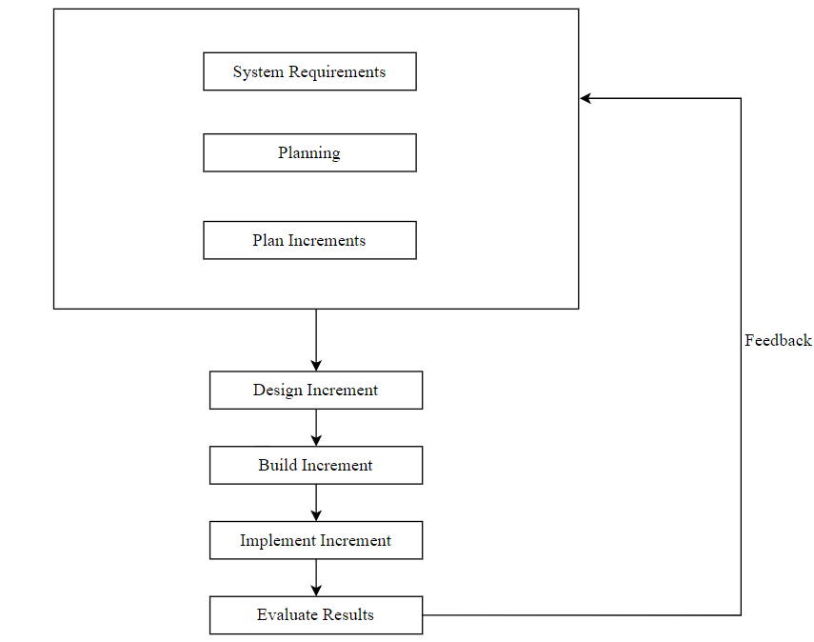

Figure 2.1 Incremental Model

**Justification:**

Class mentor is divided into different modules and it contains different types of roles such as admin, teacher and student these roles have its own set of functionalities across the system. Each increment can provide a functionality to one of the roles and it can be easy and useful while developing the system. Different modules contains own set of functionalities which can be divided and developed in increments.

**Chapter 3**

**Requirement and Analysis**

# 3.1 Existing System:

The existing system class management system in many private tuitions and classes depends on the outdated manual processes. These system involve a huge amount of paperwork for minimal tasks such as student record-keeping such as their attendance and all the grades they have scored in their exam resulting in time consuming admin work and risk of huge data errors. Additionally, communication within this systems is often inefficient and also rely on physical notes or email updates that can be easily overlooked. Scheduling class and generating time table and managing assignments is not simple and also prone to human errors. Moreover, accessibility of student information and their academic records is limited to specific physical location making it challenging for teachers, students, parents to access essential data when needed.

**Problems with Existing System:**

The existing system included a lot of manual work which we cause a need of an extra personal at work which can increase the cost of the classes and private tutors monthly for doing the extra manual work. Sometimes the manual work can generate some error which can cause the data to lose its integrity and this can cause some loss to the manager handling the class. Manual task requires lot of hard work and can take up a huge amount of time to handle some processes such as storing the marks of the student gained by a student or sometimes calculating the performance based on the grades of the student can be challenging and requires huge amount of work to be done.

# 3.2 Requirement Specification

The Requirement analysis for the Class Mentor is key thing for its successful implementation. Key features contains user authentication and access control to safeguard the data based on the user roles. Efficient student and teacher information including their personal details, attendance record, salary and academic performance is very important to safeguard. Class and timetable scheduling and also resource allocation should be optimized to prevent conflicts and resource wastage. Effective communication tools and resource management features enhances operational efficiency. Reporting analytics capabilities while scalability and integration ensure long-term viability and compatibility.

## 3.2.1 Functional Requirements:

Functional Requirements of a system defines the actual behaviour and the functionality of the system.

1. The system should provide admin the ability to add modify different user roles assigned in the system.
2. All the details regarding the user role which can be teacher or student should be recorded and maintained in the database.
3. Quiz generated and the results of the quiz must be stored in the database of the system which can be further used for performance tracking
4. System should be able to record the attendance of the student in the class and generate report on monthly basis.
5. Students must be able to provide the feedback of the course or the subject teachers and the class owner should have a right to access the feedback of the students which can be further used for future development of classes.

## 3.2.2 Non-Functional Requirements

Non-Functional Requirements mainly focuses on the quality of the system produced rather than the functionality that system provides.

1. The graphics and the GUI of the system must be visually appealing and user-friendly to all the user roles.
2. System should ensure responsive design for various devices and browsers.
3. Class Mentor should adapt various security measures to ensure that the user data is safely stored and there is no privacy invasion occurring.
4. User authentication and access control must be specified for different user roles.
5. System should ensure high performance and must ensure responsiveness, even dealing with high number of users at a time.

**3.2.3 User Requirements:**

An User Requirement can be defined as an expectation of an user for the system functionality or how the system should be operated and used.

1. User may need and interactive easy which can be easy to use and graphical use interface must be attractive to look and interact with.
2. For some user’s graphics may be important but for some processing speed and the performance should be taken in consideration while developing the system. Minimal loading time and processing time can help to achieve good performance for the system.
3. Error-Free system is another requirement of the system user may want the system to be error free and also easy to maintain and also repair in a system failure.
4. System must be developed keeping in mind of user interactions with the system user inputs must be validated and errors generated by the users must be handled properly.

# 3.3 Software and Hardware Requirements

## 3.3.1 Software Requirements:

* + Operating System: Windows 10.
  + DPI: Normal Size.
  + Colour Quality: Highest 64 bits.
  + Browsers: Internet Explorer, Google Chrome, or any other compatible browser.
  + Front-end: HTML, CSS, JavaScript, Bootstrap.
  + Backend: PHP, MySQL.

## 3.3.2 Hardware Requirements:

* + Intel® CoreTMi3-7020U CPU @2.30GHZ 2.30 GHz.
  + 8.00GB Ram Storage.
  + 64-bit Operating System.
  + X64-based processor.
  + Windows 10
  + Network connectivity: Ethernet Wire, Router.
  + Connection: USB
  + Screen resolution: 1360x786px.
  + Input device: Mouse, Touchpad.

# 3.4 Planning and Scheduling

## 3.4.1 Planning

Planning is one of the most important aspect while developing these systems. A proper plan will ensure the project development to go as smooth as possible and also ensure fast development of the system. Planning refers as activities conducted while developing the system. All the activities to develop the project are mentioned and defined properly while planning the project. It is made sure that these activities goes as smoothly as possible by avoiding risks. It can be a primary part of project management. It can be complete task list of to be conducted while developing the project. Planning also ensures monitoring and reporting the progress of the project at different phases. This helps us to get a better understanding of how the project will be managed and developed.

## 3.4.2 Scheduling

Scheduling is a most important aspect taken into consideration while planning a project management. Scheduling is used to accomplish the goals of an activity in a particular amount of time. Scheduling can be helpful to determine how much time a particular task can take or how much time we should invest in a particular task or developing a particular module. Each and every task has its own time schedule and development concerns with completing the particular task in that time schedule.

## 3.4.3 Gantt Chart

A Gantt Chart is type of bar chart which can describe the timetable for the project. It also shows the beginning and end dates of the project and list of all the activities mapped with a start date and an end date. It breaks down the work structure for the project into different set of activities and give each activity a start date and an end date depending upon the amount of time to be invested on that particular task. It is one of the most important analytical tool for planning and scheduling.

It can be used to track the progress of the projects while the development phases starts which clearly emphasize on the beginning of a particular task and ending of a particular task

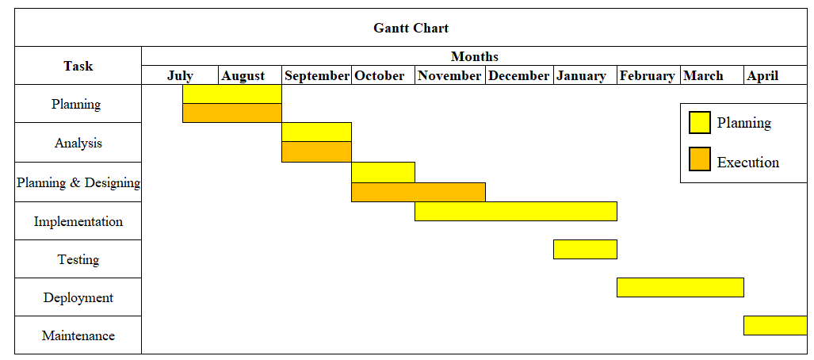

Figure 3.1 Gantt Chart

# 3.5 Preliminary Product Description

## 3.5.1 Proposed System

The proposed Class Mentor represents a valuable solution designed to address the shortcomings of traditional manual system in private tuition or classes. This type of modern system offers a centralized data management approach, providing all the student information their attendance their grades and performance etc which can be securely accessed from the data base. By automating processes like this can reduce paper work and can also reduce admin work of managing different stuffs. It can also provide improved communication enhancing collaboration between teachers and students and parents. The implementation of this digital class management system promises to revolutionize the way private tutors and classes manage their classes leading to increasing efficiency, accuracy and transparency in admin task throughout the academic year.

**Advantages of Proposed system:**

1. All the student data can be stored and accessed from one place.
2. Chances of errors are slim.
3. Reduces paper work less usage of paper.
4. Reduce time taken to handle admin tasks.
5. Enhances transparency between teachers, students and parents.

**Disadvantages of Proposed System:**

1. System Errors can cause System failure.
2. It can have its own maintenance and repair cost during system failure.
3. Relying the system may cause some inconvenience during power outages which can cause disruptions during the learning process or handling the class.
4. Some Students or some parents of students may resist adopting digital methods over traditional methods.
5. Students living in remote areas accessing this online system may face some trouble while connecting or interacting through the system.

**Chapter 4**

**System Design**

# 4.1 Basic Modules:

A Class Management System can be structured into different modules, it consist modules for each role present in the system so each role can be separated and they can work independently in their particular module. Each module has different features to perform task and achieve certain goals.

## 4.1.1 Administrative Module:

* Student management:

It can allow the administrator to add a student to the system, modify some particular student details or remove some student details

* Teacher Management:

It can allow administrator to add, modify and remove the teacher details from the system.

* Performance Tracking:

It allows the administrator to track the performance of various students and access their performance to look into the development of a particular student in a class.

* Batch Management:

It allows the administrator to do some modifications in the batch, administrator can create different batches of student and add or remove a particular student from the batch.

* Course Management:

Allows admin to manage and modify the course in present in the system and also assign teachers to the course.

* Access feedback :

Allows admin to access feedback details which are collected from the system.

## 4.1.2 User module:

1. Teacher:

* Timetable generation:

Allows the user to generate a timetable which can be scheduling lectures for the students and assigning the lecture.

* Quiz generation:

Allows the user the to generate MCQ type quiz for the students to attempt to track their progress in studies.

* Assignment Generation:

Allows user to generate o an assignment based on the assignment of student the teacher can grade the assignment

* Student List:

Allows user to access the student list present in that particular course or batch created by the admin.

* Resource Library:

Allows user to access the resource library and allow to add or remove resources from the library.

* Modification of announcements:

Allows user to modify the announcements by adding announcements and sending it to user present in the course.

1. Student:

* Access to Resource Library:

Access to resource library is allowed to the user, user can view content present in resource library.

* Assignment Access:

User is allowed to get an access of assignments posted by the respective teacher allocated to the course and also submit assignment for grading.

* Quiz Access:

User is allowed to get an access of assignments posted by the respective teacher allocated to the course and also submit assignment for grading.

* Announcements:

Allows user to access announcements posted by the teacher of the respective course.

## 4.2 Schema Design:

A Schema Design shows the relationship between database tables. Mainly the Schema Design can be used to separate different types of entities and it shows the relation between those different entities. Schema Design can be a blueprint of database it can also describe how the data is organized inside the database.

It can give a better understanding of a database to the programmers and also the operators and it can give a whole overview of how the data is stored inside the database. It can give better understanding to solve errors regarding the database when the developer has the whole structure of database.

# 4.2.1 Data Dictionary:

Data dictionary defines the structure of database present in the system, specifying relationships between them. It also defines what data would be present in which table of the relational database. MySQL uses relational database management system for managing relational databases. There are different tables present for each data store available and managing of these table is the table of MySQL.

Data Dictionary in MySQL is process that requires careful consideration of system’s data access and pattern of the contents stored in the database table. It is very important to balance the flexibility of the data store to increase the performance that meets the needs of the application.

|  |  |  |  |  |  |
| --- | --- | --- | --- | --- | --- |
| **Sr No** | **Column Name** | **Column Type** | **Size** | **Constraint** | **Description** |
| 1 | CourseID | Int | 11 | Primary Key | Unique Identifier for Course table. |
| 2 | Course Name | Varchar | 30 | Unique | Course Name. |

1. CourseDetails: This table contains Course Details for the system.

Table 4.1 – Database Table – CourseDetails

|  |  |  |  |  |  |
| --- | --- | --- | --- | --- | --- |
| **Sr No** | **Column Name** | **Column Type** | **Size** | **Constraint** | **Description** |
| 1 | TeacherID | Int | 11 | Primary Key | Unique Identifier for Teacher. PK |
| 2 | FirstName | Varchar | 30 | Not Null | First name of the Teacher. |
| 3 | LastName | Varchar | 30 | Not Null | Last name of the Teacher. |
| 4 | Email | Varchar | 70 | Unique | Email address of the Teacher. |
| 5 | Phone | Varchar | 10 | Unique | Phone no of a teacher. |
| 6 | SubjectsTaken | Varchar | 50 | Not Null | Subjects taken by the Teacher. |
| 7 | Education | Varchar | 70 | Not Null | Education details of the Teacher. |
| 8 | Username | Varchar | 30 | Unique | Username of the Teacher inside the system. |
| 9 | Password | Varchar | 10 | Not Null | Password for the Teacher. |

1. TeacherDetails: Information of all the teachers are stored in this table.

Table 4.2 – Database Table – TeacherDetails

|  |  |  |  |  |  |
| --- | --- | --- | --- | --- | --- |
| **Sr No** | **Column Name** | **Column Type** | **Size** | **Constraint** | **Description** |
| 1 | StudentID | Int | 11 | Primary Key | Unique Identifier for student. PK |
| 2 | CourseID | Int | 11 | Foreign Key | Foreign key Reference to Course table. |
| 3 | FirstName | Varchar | 30 | Not Null | First name of the student. |
| 4 | LastName | Varchar | 30 | Not Null | Last name of the student. |
| 5 | Email | Varchar | 70 | Unique | Email address of the student |
| 6 | Phone | Varchar | 10 | Unique | Phone no of a student |
| 7 | Age | Int | 3 | Not Null | Age of the student |
| 8 | UserName | Varchar | 30 | Unique | Username of the student inside the system. |
| 9 | Password | Varchar | 10 | Not Null | Password for the student. |

1. StudentDetails: student information are stored in the table below.

Table 4.3 – Database Table – StudentDetails

1. AttendanceDetails: Stores the attendance details of a student.

|  |  |  |  |  |  |
| --- | --- | --- | --- | --- | --- |
| **Sr No** | **Column Name** | **Column Type** | **Size** | **Constraint** | **Description** |
| 1 | AttendanceID | Int | 11 | Primary Key | Unique Identifier for attendance table |
| 2 | CourseID | Int | 11 | Foreign Key | Foreign key reference to course table |
| 3 | StudentID | Int | 11 | Foreign Key | Foreign key reference to Student table |
| 4 | Date | date |  |  | Stores the date when the attendance is marked. |
| 5 | Status | Varchar | 10 |  | Determines either student is absent or present in class |

Table 4.4 – Database Table - AttendanceDetails

1. FeedbackDetails: Information about the feedback form submitted by the student.

|  |  |  |  |  |  |
| --- | --- | --- | --- | --- | --- |
| **Sr no** | **Column Name** | **Column**  **Type** | **Size** | **Constraint** | **Description** |
| 1 | FeedbackId | Int | 11 | Primary Key | Unique Identifier for feedbackDetails table |
| 2 | TeacherID | Int | 11 | Foreign Key | Foreign Key reference from teacher’s table |
| 3 | CourseID | Int | 11 | Foreign Key | Foreign Key reference from Course’s table |
| 4 | StudentID | Int | 11 | Foreign Key | Foreign Key reference from Student’s table |
| 5 | Feedback | Varchar | 200 | Not Null | Question about the Feedback |
| 6 | Suggestion | Varchar | 200 |  | Answer in terms of excellent, good, bad, worse. |

Table 4.5 – Database Table – FeedbackDetails

|  |  |  |  |  |  |
| --- | --- | --- | --- | --- | --- |
| **Sr No** | **Column Name** | **Column Type** | **Size** | **Constraint** | **Description** |
| 1 | QuizID | Int | 11 | Primary Key | Unique Identifier for QuizTopic table. |
| 2 | CourseID | Int | 11 | Foreign key | Foreign key reference to Course table. |
| 3 | SubjectID | Int | 11 | Foreign key | Foreign key reference to Subject table. |
| 4 | Quiztopic | Varchar | 50 |  | Topic for the Quiz. |
| 5 | Difficulty | Varchar | 20 |  | Difficulty level assigned by the teacher to the quiz |

1. QuizTopic: This table contains topic of the quiz based on and the difficulty level

Table 4.6 – Database Table – QuizTopic

1. QuizDetails: It contains all the information regarding the quiz.

|  |  |  |  |  |  |
| --- | --- | --- | --- | --- | --- |
| **Sr No** | **Column Name** | **Column Type** | **Size** | **Constraint** | **Description** |
| 1 | QuizID | Int | 11 | Foreign key | Unique Identifier for Quiz table. |
| 2 | QuestionID | Int | 11 | Primary Key | Foreign key reference to Subject table. |
| 3 | Question | Varchar | 200 |  | Contains the Questions of the Quiz. |
| 4 | Opt1 | Varchar | 70 |  | Contains the Option 1 for the Question. |
| 5 | Opt2 | Varchar | 70 |  | Contains the Option 2 for the Question. |
| 6 | Opt3 | Varchar | 70 |  | Contains the Option 3 for the Question. |
| 7 | Opt4 | Varchar | 70 |  | Contains the Option 4 for the Question. |
| 8 | Answer | Varchar | 70 |  | Contains the Answer for the Question. |

Table 4.7– Database Table - QuizDetails

1. QuizMarks: This table contains all the records of the marks obtained by the student in quiz.

|  |  |  |  |  |  |
| --- | --- | --- | --- | --- | --- |
| **Sr No** | **Column Name** | **Column Type** | **Size** | **Constraint** | **Description** |
| 1 | QuizID | Int | 11 | Foreign key | Reference from Quiz table. |
| 2 | StudentID | Int | 11 | Foreign key | Reference from Student table. |
| 3 | Attempted | Int | 11 |  | Contains Number of questions attempted by the student. |
| 4 | NotAttempted | Int | 11 |  | Contains Number of questions not attempted by the student. |
| 5 | Wrongans | Int | 11 |  | Contains Number of wrong answers to the questions attempted by the student. |
| 6 | Totalmarks | Int | 11 |  | Total marks obtained by the student. |

Table 4.8 – Database Table - QuizMarks

1. SubjectDetails: Contains all the details regarding the subjects coming under a particular course.

|  |  |  |  |  |  |
| --- | --- | --- | --- | --- | --- |
| **Sr No** | **Column Name** | **Column Type** | **Size** | **Constraint** | **Description** |
| 1 | SubjectID | Int | 11 | Primary Key | Unique Identifier for Subject Table. |
| 2 | CourseID | Int | 11 | Foreign Key | Foreign Key reference to course table. |
| 3 | TeacherID | Int | 11 | Foreign Key | Foreign Key reference to  Teacher table. |
| 4 | SubjectName | Varchar | 30 |  | Contains the subject Name. |

Table 4.9 – Database Table – SubjectDetails

1. AssignmentDetails: It contains all the information regarding the assignment for the students.

|  |  |  |  |  |  |
| --- | --- | --- | --- | --- | --- |
| **Sr No** | **Column Name** | **Column Type** | **Size** | **Constraint** | **Description** |
| 1 | AssignmentID | Int | 11 | Primary key | Unique identifier for Assignment table. |
| 2 | Assignmentquestion | Varchar | 200 |  | Contains the question of the assignment. |
| 3 | AssignmentWeightage | Varchar | 5 |  | Contains the marks of assignment assigned |
| 4 | AssignmentSubDate | date |  |  | Submission date of the Assignment |
| 5 | TeacherID | Int | 11 | Foreign key | Foreign key reference to Teacher table. |
| 6 | SubjectID | Int | 11 | Foreign key | Foreign key reference to Subject table. |
| 7 | AssignmentSublink | Varchar | 100 |  | It contains the submission link of the assignments |

Table 4.10 – Database Table - AssignmentDetails

1. AssignmentMarks: Contains the record of student marks given on the based on the quality of assignment

|  |  |  |  |  |  |
| --- | --- | --- | --- | --- | --- |
| **Sr No** | **Column Name** | **Column Type** | **Size** | **Constraint** | **Description** |
| 1 | AssignID | Int | 11 | Foreign Key | Reference to Assignment table. |
| 2 | StudentID | Int | 11 | Foreign Key | Reference to Student table. |
| 3 | SubjectID | Int | 11 | Foreign Key | Reference to Subject table. |
| 4 | Marks | Int | 11 |  | Contains the mark of the student based on the quality of assignment submitted. |

Table 4.11 – Database Table – AssignmentMarks

1. AdminLogin: Contains the details of the admin of the system.

|  |  |  |  |  |  |
| --- | --- | --- | --- | --- | --- |
| **Sr No** | **Column Name** | **Column Type** | **Size** | **Constraint** | **Description** |
| 1 | Sno | Int | 11 | Primary key | Primary key for Admin Table. |
| 2 | email | Varchar | 70 |  | Contains the email of the admin. |
| 3 | Username | Varchar | 30 |  | Contains the username of the admin. |
| 4 | Password | varchar | 10 |  | Contains the password assigned for the admin login |

Table 4.12 – Database Table – AdminLogin

1. Announcementdetails: Contains all the information regarding the announcement posted by the teacher.

|  |  |  |  |  |  |
| --- | --- | --- | --- | --- | --- |
| **Sr No** | **Column Name** | **Column Type** | **Size** | **Constraint** | **Description** |
| 1 | AnnouncementID | Int | 11 | Primary key | Primary key for the announcement details table. |
| 2 | CourseID | Int | 11 | Foreign Key | Reference to Course table. |
| 3 | SubjectID | Int | 11 | Foreign Key | Reference to Subject table. |
| 4 | Announcementtitle | Int | 50 |  | Contains the announcement title which will be displayed on student’s end. |
| 5 | AnnouncementDesc | Varchar | 150 |  | Contains the announcement Description which will be displayed on student’s end. |

Table 4.13 – Database Table – Announcementdetails

1. Resourcesdetails: Contains all the information regarding the resources posted by the teacher for students.

|  |  |  |  |  |  |
| --- | --- | --- | --- | --- | --- |
| **Sr No** | **Column Name** | **Column Type** | **Size** | **Constraint** | **Description** |
| 1 | ResourceID | Int | 11 | Primary key | Primary key for the Resource details table. |
| 2 | CourseID | Int | 11 | Foreign Key | Reference to Course table. |
| 3 | Resourcename | Varchar | 50 |  | Contains the name of the resource. |
| 4 | Resourcedesc | Varchar | 150 |  | Contains the description to the resource to provide some context about the resource to students. |
| 5 | Filename | Varchar | 70 |  | Contains the filename of the resource. |
| 6 | Filepath | Varchar | 100 |  | Contains the filepath of the resource. |
| 7 | Studentfilepath | Varchar | 100 |  | Contains the filepath for student’s end. |

Table 4.14 – Database Table – Resourcedetails

1. Timetabledetails: Contains the lectures scheduled by the teacher for the students.

|  |  |  |  |  |  |
| --- | --- | --- | --- | --- | --- |
| **Sr No** | **Column Name** | **Column Type** | **Size** | **Constraint** | **Description** |
| 1 | TimetableID | Int | 11 | Primary key | Primary key for the Resource details table. |
| 2 | CourseID | Int | 11 | Foreign Key | Reference to Course table. |
| 3 | SubjectID | Int | 11 | Foreign Key | Reference to Subject table. |
| 4 | TeacherID | Int | 11 | Foreign Key | Reference to Teacher table. |
| 5 | Date | date |  |  | Contains Date when lecture is scheduled. |
| 6 | Filepath | Time |  |  | Contains Startime when lecture is scheduled. |
| 7 | Studentfilepath | time |  |  | Contains endtime when lecture is scheduled. |

Table 4.15 – Database Table – Timetabledetails

4.3 System Design:

4.3.1 Use-Case Diagram:

Use case diagram represents how a particular user interacts with the system. Use Case diagram can be defined as a graphical representation of the user interaction with the system. Use case can also be used to define the Functionality of the system. It can be user tasks or goals carried out by the system and interaction of user with the system to achieve those tasks and goals. The main purpose of the use case diagram is to capture the dynamic aspect of a system. It tells about the user’s point of view of the software and what user is supposed to do in the system:

* System Boundary:

It is used to enclose all the functionality present in the system and define the actors using the system. Anything inside a system boundary can be considered as a part of a system. Actors are present outside the boundary interacting with the system which can be shown using associations

* Actor:

An Actor represents a user in the system it can tell why kind of role user is playing and all the functions and activities he performs.

* Use case:

It indicates a function of system provided it can be a unit of work to achieve a particular goal by one or more users.

* Association:

It represents which actor is associated with which use case or which actor participates in a particular use case is clearly defined using association.

**Use-case for Admin:**

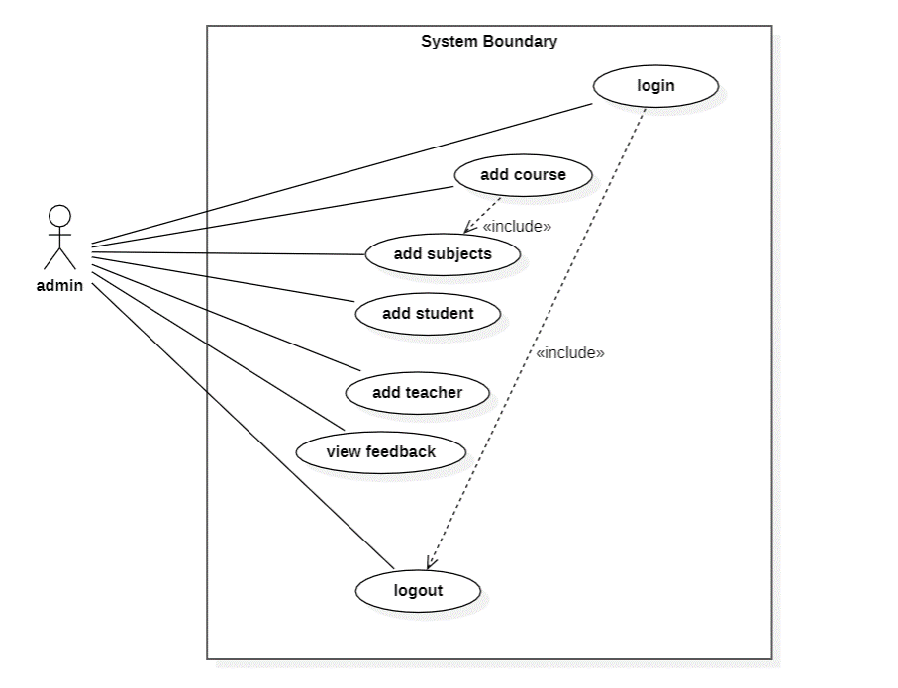

Figure 4.1 Use Case Diagram for Admin

**Use-case for User-1: Teacher**

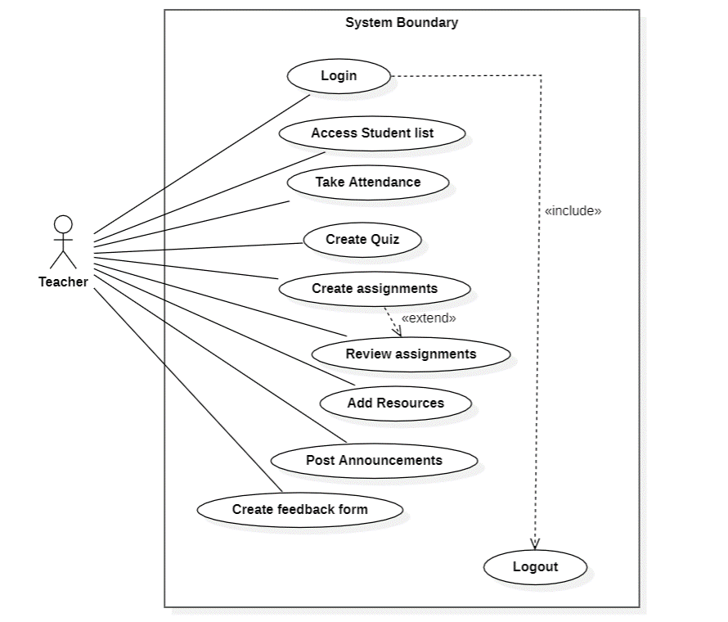

Figure 4.2 Use Case Diagram for Teacher

**Use-case for User-2: Student**

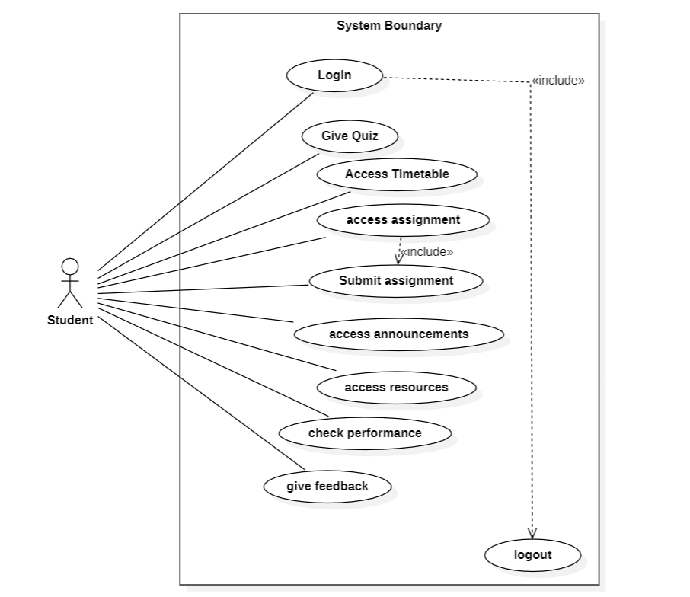

Figure 4.3 Use Case Diagram for Student

# 4.3.2 Activity Diagram:

Activity Diagram is the type of flowchart diagram which can represent transition between the activities the user perform. It can describe the flow of the system for each role of user defined for the system. It takes different use cases and put it in a proper flow to ensure the flow of the system. It can help to visualize the flow of the system. It can be useful for putting an order and flow of activities in the system and when it occurs

* Initial Activity:

Initial node is a type of control node which indicates the start of the system describes when and what activity has been invoked. There can be one activity or many other activities present in the initial node. Initial nodes are denoted using small solid circle

* Activity:

It is used to represent an activity of the user with the system. Or a functionality user will use while performing some task or achieving some goal.

* Transition:

it can be useful for representing the flow of data from one activity to another activity. It can be useful to denote what can a user do in after a particular activity or the data that is flowing from one activity to another activity. It is denoted using an arrow symbol.

* Decision:

Decision node is also a type of control where it can take one incoming transition and send that incoming transition into multiple another activity based on the condition specified for the transition. Decision node is denoted using a diamond-shaped symbol.

**Activity Diagram for Admin:**

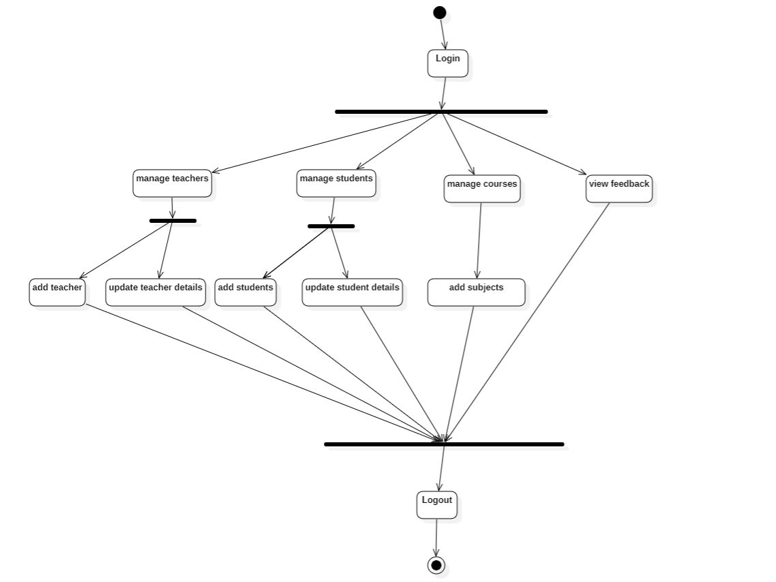

Figure 4.4 Activity Diagram for Admin

**Activity Diagram for User-1: Teacher**

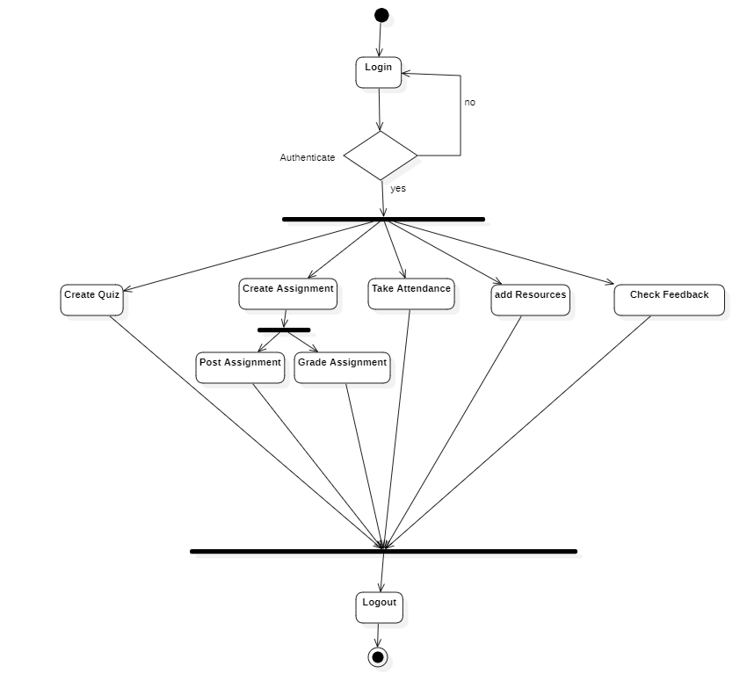

Figure 4.5 Activity Diagram for Teacher

**Activity Diagram for User-2: Student:**

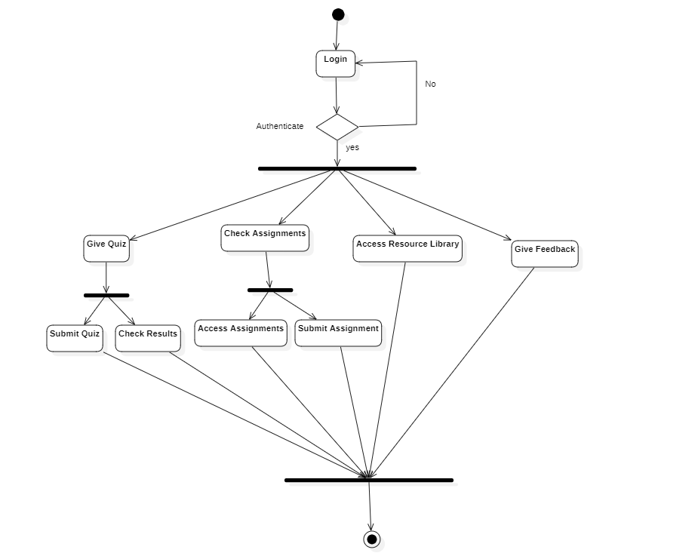

Figure 4.6 Activity Diagram for Student

## 4.3.3 Class Diagram:

A Class Diagram is merely used to define the structure and relation between different classes and object present in the system. It can describe the visual representation of the system structures and classes present in the system with the proper methods present in the classes of perform some functionality or action inside the system.

* Class:

Class can be defined as an entity in the class diagram. A class can have attributes and methods which can define what functionality a particular class can perform.

* Attributes:

Attributes mention the properties of a class inside a system.

* Methods:

Methods defines the behaviour of a class and also describes about the functionality provided by the class in the system.

* Association:

Association defines the relationship between two classes which can be meant by objects of one class can be connected to the objects of another class. It can describe the links between two or more classes.

**Diagram:**

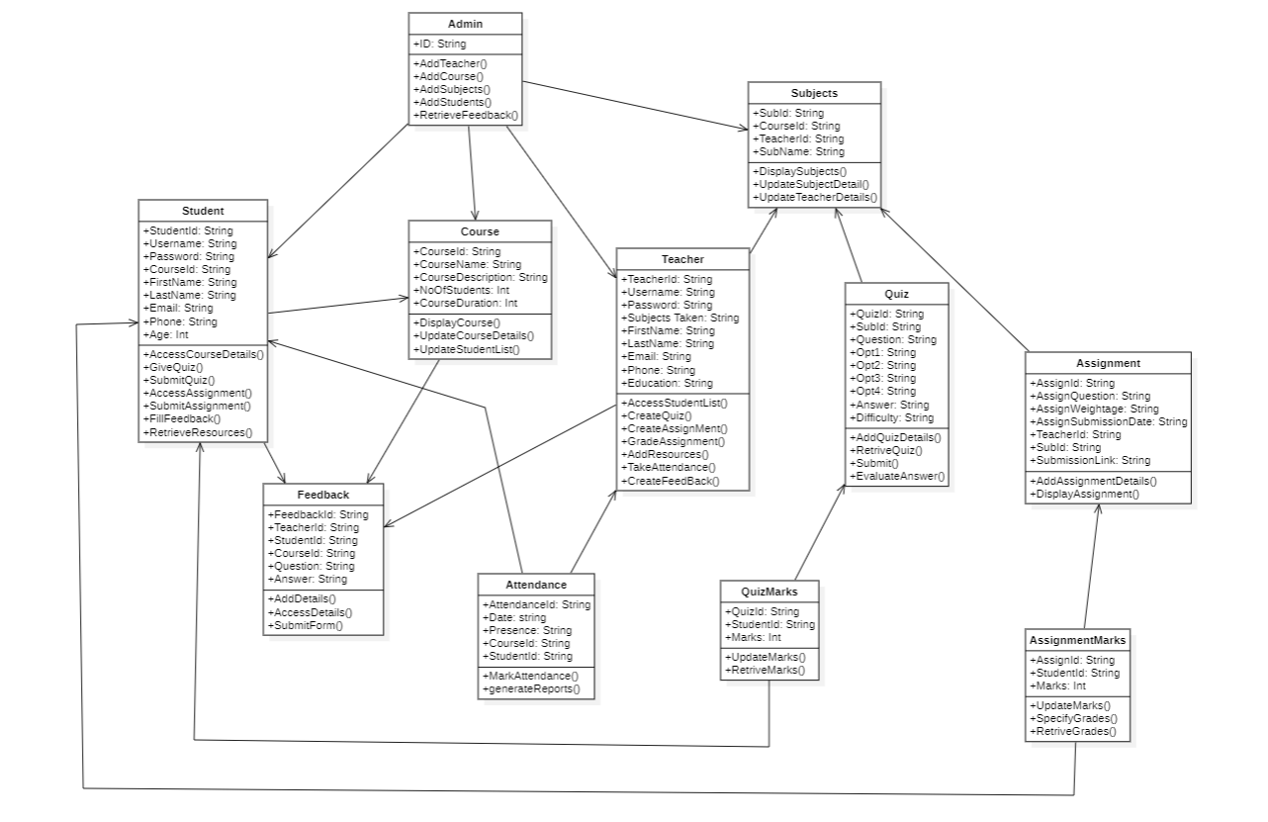

Figure 4.7 Class Diagram

# 4.3.4 Sequence Diagram:

The Sequence Diagram emphasis mainly upon the sequence of messages passed from one module to another one rather than the relationship between the objects in the system. Sequence diagram is used to provide detailed visual representation of how the messages are getting exchanged and how the system is responding to particular messages exchanging. The main purpose of the diagram is to represent how different objects interact with each other. Its interaction are arranged in a time sequence.

* Lifelines:

Lifeline is representing a duration of an object which can be alive or interacting with other objects in the system. Lifelines can be represented in dashed lines.

* Messages:

It can be used to send messages from one object to another. It can be represented using arrow symbol.

* Activation Bar:

It can represent a period of time in which another object is actively processing a message which is generated from a different object

* Acknowledgement:

It represents a communication between an object which is conveying acknowledgement to another object through message defined as acknowledgement.

**Sequence Diagram for Admin:**

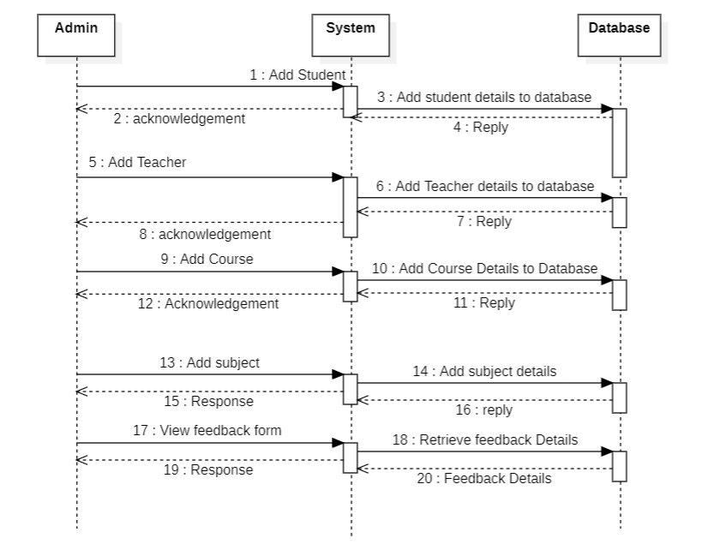

Figure 4.8 Sequence Diagram for Admin

**Sequence Diagram for User-1: Teacher**

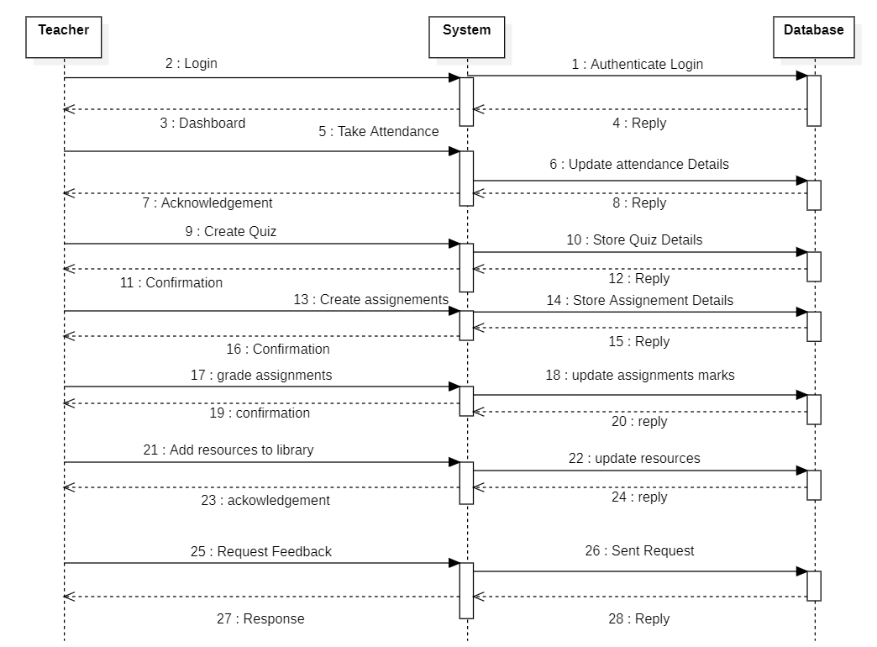Figure 4.9 Sequence Diagram for Teacher

**Sequence Diagram for User-2: Student:**

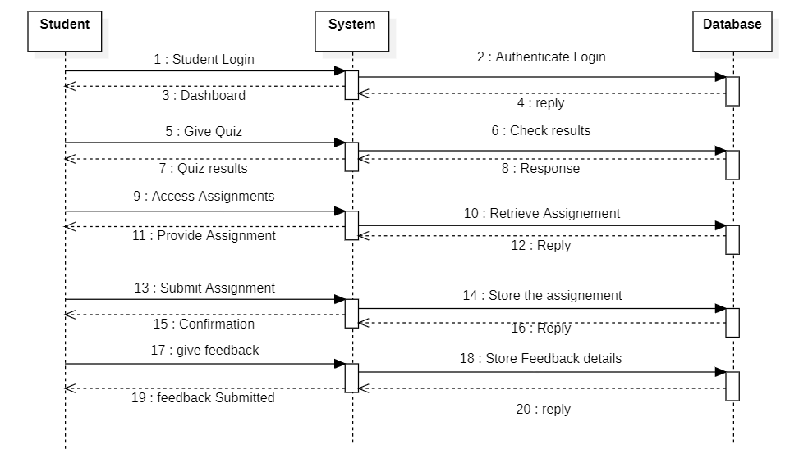

Figure 4.10 Sequence Diagram for Student

# 4.3.5 Data- Flow Diagram:

Data flow diagram defines how data is processed by a system when a user inputs a data or an output is generated. It also represents the flow of information in the system, such as where it comes from and where it gets stored and processed. In a Data Flow Diagram, it has different levels to it which represents how the data is processed at each level. Each level adds an additional detail to how the data is being processed, managed and stored in the system.

* Processes:

A process can be used to represent an activity or a function, it can be a simple input taken from the user or an output generated as a response to user’s activity in the system.

* Data Flows:

Data flows helps to represent the movement of a data inside the system from a Point A to Point B. It can be use to describe the transfer of data and type of data being transferred between these points.

* Data Stores:

It represents where the data is stored in the system. It can be defined as physical system such as database or a server where a data can be stored and process it can also represent temporary storage in a process.

Level – 0 (Context-Level) Data Flow Diagram:

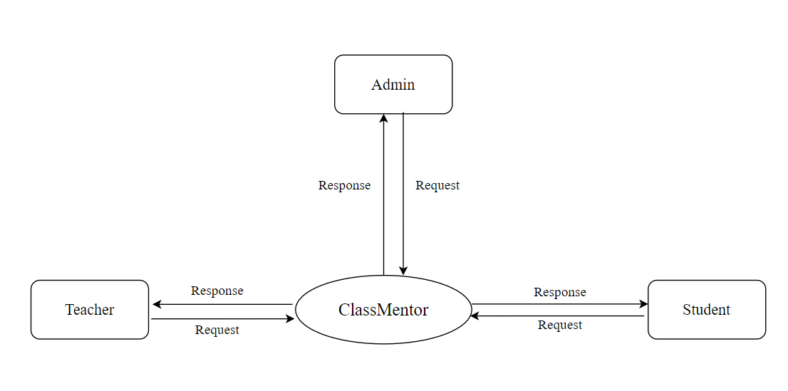

Figure 4.11 Level 0 Data-Flow Diagram

**Level 1 Data-Flow Diagram for Admin:**

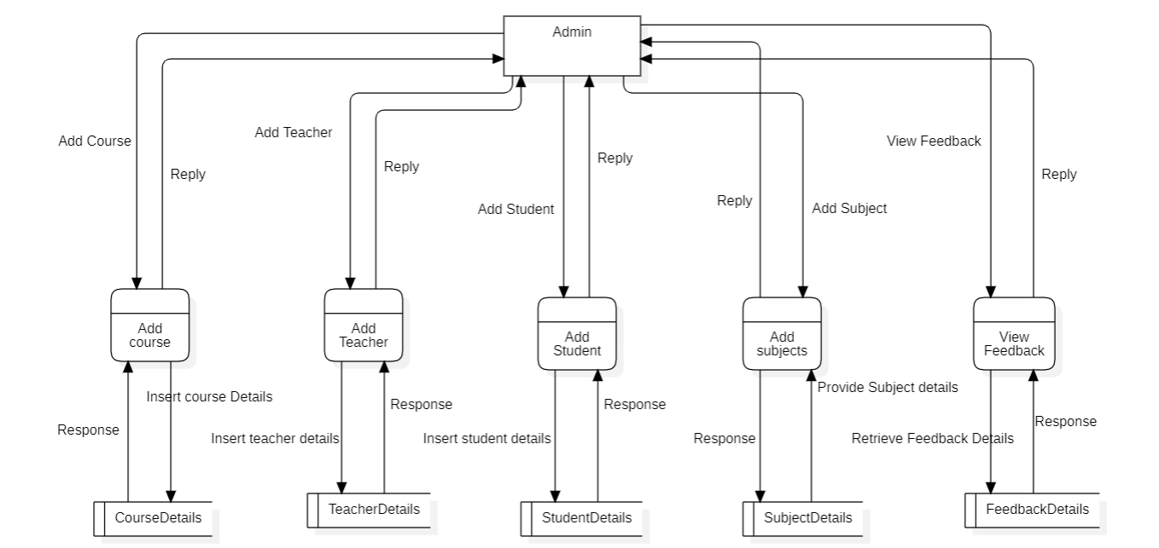

Figure 4.12 Level 1 Data-Flow Diagram for Admin

**Level 1 Data-Flow Diagram for User-1: Teacher**

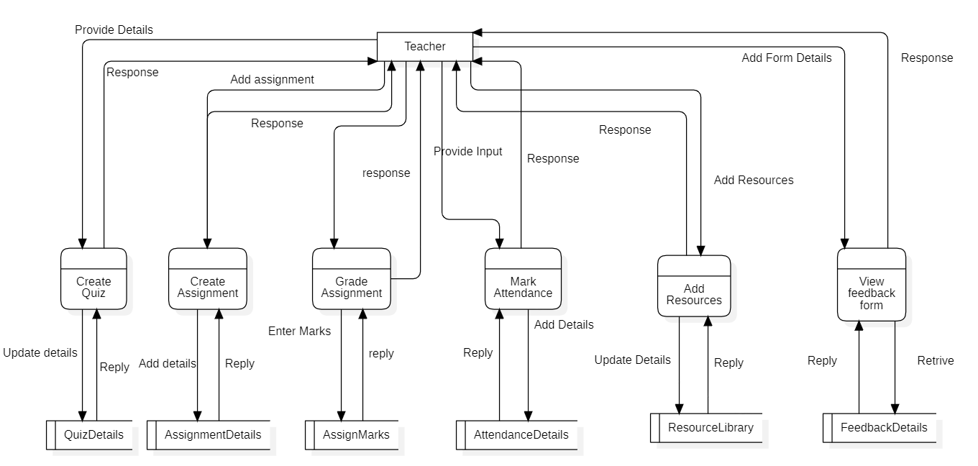

Figure 4.13 Level 1 Data-Flow Diagram for Teacher

**Level 1 Data-Flow Diagram for User-2: Student**

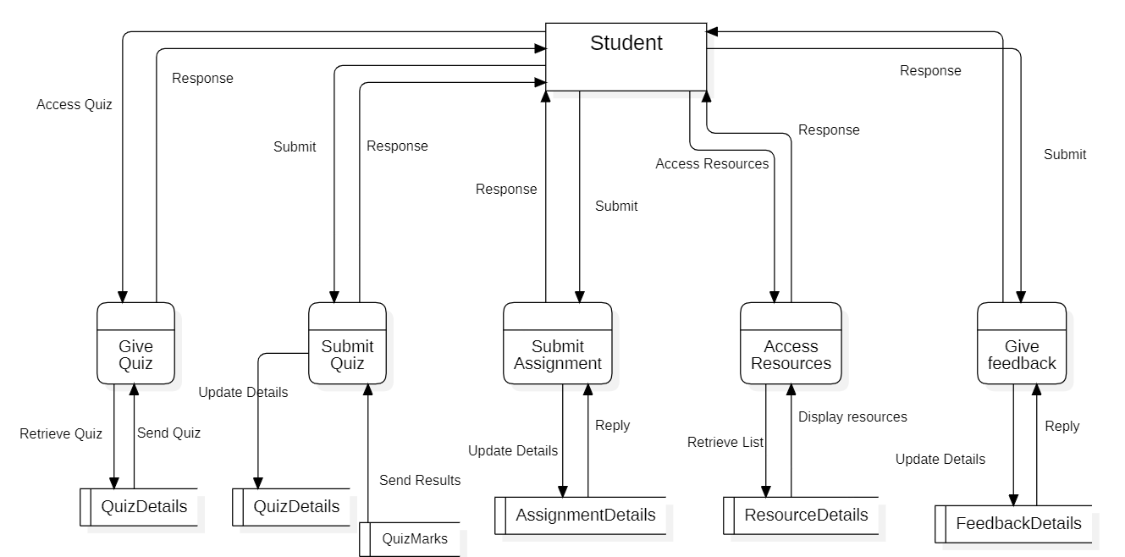

# Figure 4.14 Level 1 Data-Flow Diagram for Student

# 4.3.6 ER Diagram:

An ER Diagram which can be commonly known as Entity-relationship Diagram is a flowchart which tells how different entities are related with each other in a particular system. ER diagram are mostly the visual representation of a relational database which can have different types of fields. It can be also known as ER models which have different types of symbols to define various entities and also relation between those entities in the table by connecting lines.

ER Diagram can give an exact representation of a database all the different relations present in the database between the tables of the database table. It can be used to create a logical database schema. All the different entities present in the database table are represented in the diagram of the table.

* **Entity:**

An entity can be a physical object in the real world, an entity can be anything which refers to a physical object such as a person, event or a place. It can be also a subject teachers, courses in case of a Class Mentor. Entities are represented in ER Diagram by a rectangle and are named using singular nouns.

* **Attributes:**

Attribute can be defined as a characteristic of an entity. It can be also defined as a property of an entity for example teacher name can be an attribute of an entity teacher. It can the name, age and qualifications of the students which are the properties of admission entity set. An Attribute also reflects the level of detail of information present in a table.

* **Relationships:**

Relations in an ER diagram defined how different entities are connected to each other. It can be clear representation of relationship between the entities and different types of association or interaction between the entities of the table.

* **Cardinality:**

It further decide the relations between the two entities by placing a number between the relationships .for example in an email one user can have multiple accounts. This relationship follows multiple models such as one to many, many to one and many too many to define the number in the relationship between these entities.

**Diagram:**

# 

# Figure 4.15 ER Diagram

# 4.4 User Interface Design:

User interface is the most important aspect in a system because in this the user is handling and interacting with the system. A good graphical user interface allows the user to understand more about the system and give a better understanding of the system. It can define the interaction between the system and the user. User interface should be easy to learn and easy to use so that everyone should be comfortable with the system operation. It should be functional and error-free and should ensure fast performance so that user doesn’t have to wait longer to perform actions.

Characteristics and considerations in a User Interface Design:

* UI should be appealing to the user.
* It should be simple enough to learn by every user.
* It should contain responsive design.
* It should be error-free.
* It should be scalable so that new components can be added to the UI.

**User Interface Design:**

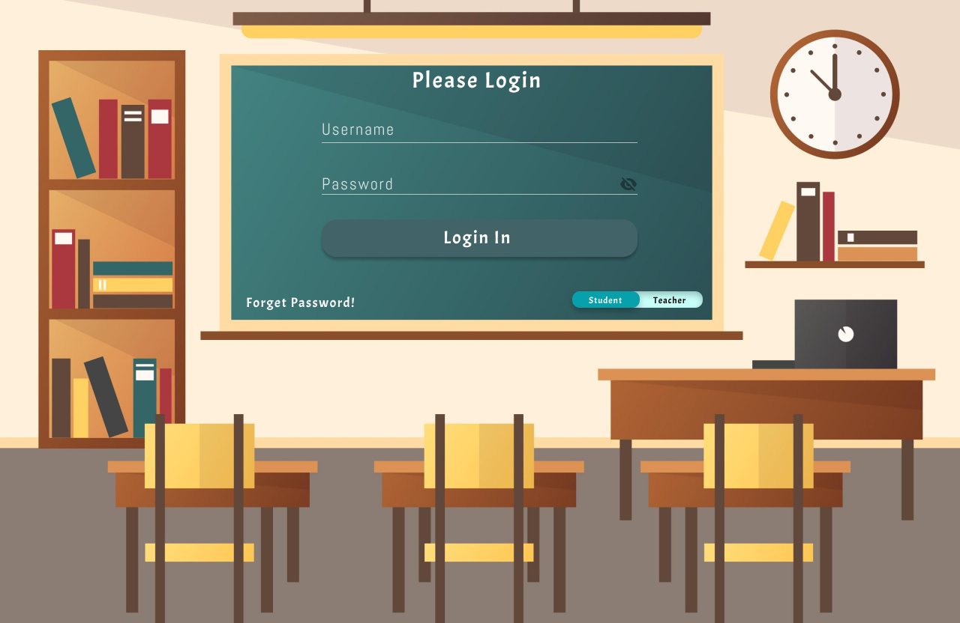

Figure 4.16 Use Interface Design-1

Explanation: This page here gives the full overview of how the Login and User Authentication would take place. Here User gives his username which is provided by the class admin priorly, and also the password. When the username and password is valid then the system allows the user to enter and perform the task.

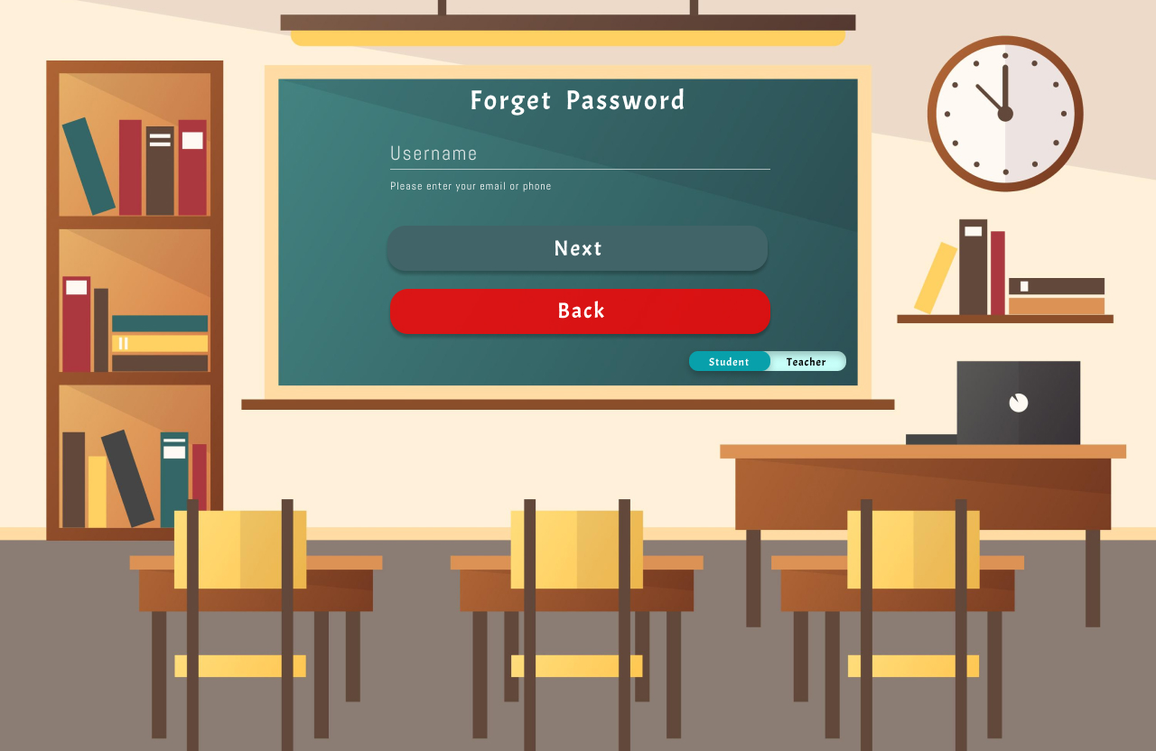  
Figure 4.17 User Interface Design-2

Explanation: This particular GUI here can be used for resetting the password for a particular, sometimes usually user forgets his password and then he can enter the system so this functionality is provided so that the user can reset/change his password and carry on his work. Here the user had to enter his username so that the system can determine which user wants to change his password.

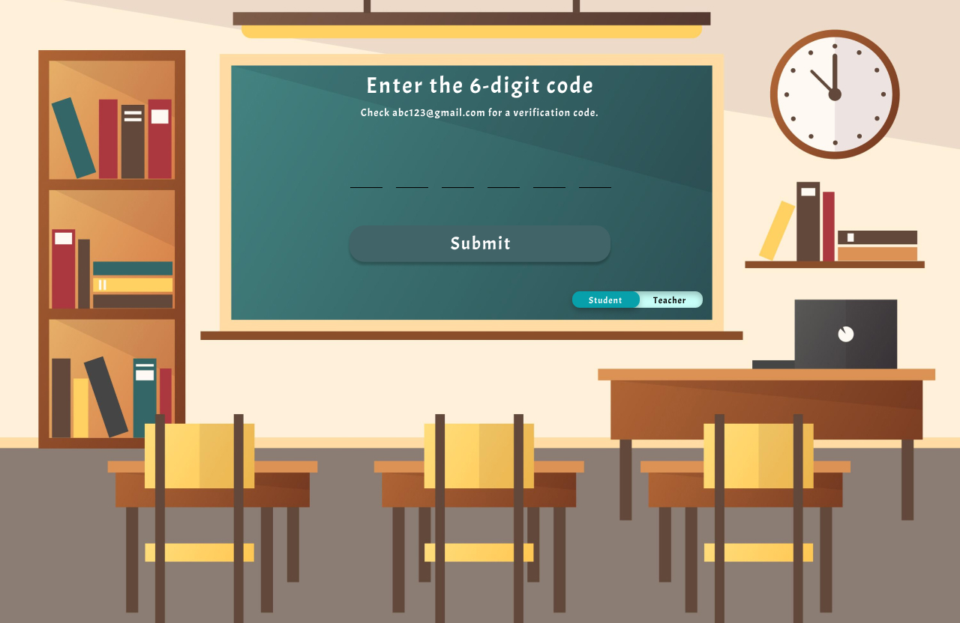

Figure 4.18 User Interface Design - 3

Explanation: In this interface user has to enter the code which he is going to get to this email or phone number. This is a security measure so that another user shouldn’t be able the change the password for user.

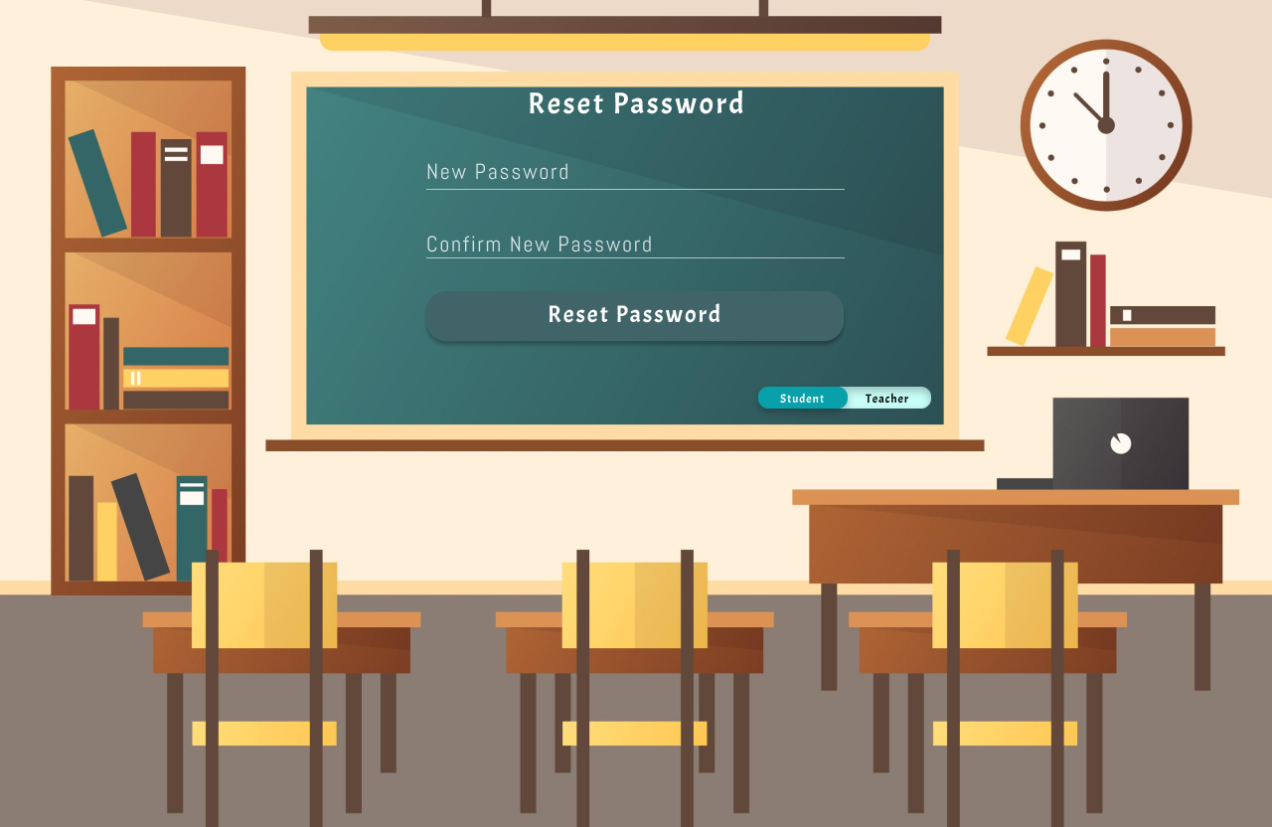

Figure 4.19 User Interface Design-4

Explanation: Here the user can change his password and when both the passwords are matched then the new password is set as the current password and password has been changes successfully.

# 4.5 Test Case Design:

Test case design is a phase of the software testing which can be used to test the software to ensure the system meeting the requirements and error free and also ensure the functionality of the system is in a proper manner. Test case can be used to find errors in the outputs of the system when a user is giving the inputs to the system. It also ensures all the system functionality mentioned is working in a proper manner and in an error-free manner.

Test case is majorly use to determine the quality of the system and also ensure that system meets the specification of the user and also ensure if the software being developed is a high-quality software.

|  |  |  |  |  |  |
| --- | --- | --- | --- | --- | --- |
| Testcase ID | Testcase Procedure | Testcase Data | Expected Output | Actual Output | Pass/Fail |
| TC001 | Valid Username  Valid Password | Username:  Admin110  Password:  admin123 | Dashboard of the admin |  |  |
| TC002 | Invalid  Username  Valid  Password | Username:  Admin110  Password:  admin123 | Please enter valid Username |  |  |
| TC003 | Valid  Username  Invalid  Password | Username:  Admin110  Password:  Admin112 | Password is incorrect |  |  |
| TC004 | Blank Username  Blank password | Username:  Password: | Please fill the credentials to procced login |  |  |
| TC005 | Blank  Username  Valid  Password | Username:  Password:  admin123 | Please enter the username to procced login |  |  |
| TC006 | Valid Username and Blank password | Username:  Admin110  Password: | Please enter password to procced login |  |  |
| TC007 | User Details:  Valid FirstName, LastName, Email, Phone  Invalid Age | FirstName: Test  LastName:123  Email:Test123@gmail.com  Phone: 9029412824  Age:213 | Invalid age, please ensure age entered comes between 0-100 |  |  |
| TC008 | User Details:  Valid FirstName, LastName, Age, Phone  Invalid Email | FirstName: Test  LastName:123  Email:Test123@gmal.con  Phone: 9029412824  Age:15 | Please enter valid email or check the email format. |  |  |
| TC009 | User Details:  Valid FirstName, LastName, Email, Age  Invalid Phone | FirstName: Test  LastName:123  Email:Test123@gmail.com  Phone: 902941282401  Age:15 | Invalid Number. Please enter 10-digit phone number. |  |  |
| TC010 | User Details:  Blank FirstName, Valid Lastname, Email, Age, Phone | FirstName:  LastName: 123  Email:Test123@gmail.com  Phone: 902941282401  Age:15 | Please enter FirstName to ensure registration. |  |  |
| TC011 | User Details:  Blank LastName, Valid FirstName, Email, Age, Phone | FirstName: Test  LastName:  Email:[Test123@gmail.com](mailto:Test123@gmail.com)  Phone: 9029412824  Age: 15 | Please enter LastName to ensure registration. |  |  |
| TC012 | User Details:  Blank Email Valid FirstName, LastName, Age, Phone | FirstName: Test  LastName: 123  Email:  Phone: 9029412824  Age: 15 | Please enter Email to ensure registration, |  |  |
| TC013 | User Details:  Blank Phone Valid  FirstName, LastName,  Age, Email | FirstName: Test  LastName: 123  Email:[Test123@gmail.com](mailto:Test123@gmail.com)  Phone:  Age: 15 | Please enter Phone number to ensure registration |  |  |
| TC014 | User Details:  Blank Age Valid FirstName, LastName, Email, Phone | FirstName: Test  LastName: 123  Email:Test123@gmail.com  Phone: 9029412824  Age: | Please enter Age to ensure registration |  |  |
| TC015 | Forgot Password:  Valid Email | Email:Test123@gmail.com | Proceeds Further to the next page |  |  |
| TC016 | Forgot Password:  Invalid Email | Email:Test124gmail.com | Email doesn’t exist in the system |  |  |
| TC017 | Forgot Password:  Blank Email | Email: | Please enter Email to proceed further |  |  |
| TC018 | Forgot Password:  Valid Code | Code:659314 | Proceeds further to next page |  |  |
| TC019 | Forgot Password:  Invalid Code | Code:659313 | Please enter valid code which is provided in your email |  |  |
| TC020 | Forgot Password:  Blank Code | Code: | Please enter the code to carry on further |  |  |
| TC021 | Forgot Password:  Valid New password matching to Confirm Password | New Password: student123  Confirm Password:  student123 | Password has been changed successfully |  |  |
| TC022 | Forgot Password:  Valid New password but it is not matching to the Confirm Password | New Password: student123  Confirm Password: student124 | Passwords doesn’t match. Please check and try again |  |  |
| TC023 | Forgot Password: Blank New Password | New Password: | Please enter the new password |  |  |
| TC024 | Forgot Password:  Valid New Password, Blank Confirm Password | New Password: student123  Confirm Password: | Please enter the password once again to ensure the reset |  |  |
| TC025 | Submitting a Feedback Form:  Feedback Exceeding the Character limit | (Just for Example scenario)  Character limit: 65  Feedback: The teacher’s teaching sense is really good and the notes she provides is very well presented and easy to understand  Number of Characters:68 | Please Enter the Feedback under 65 Character Limit. |  |  |
| TC026 | Creating a Feedback Form:  Blank Question | Question: | Please enter the question to proceed further creating the form |  |  |
| TC027 | Submitting a Feedback Form:  Valid Feedback and Suggestion | Feedback: good teaching sense and well-prepared notes  Suggestion: Need to be punctual and improve handwriting | Thank you for your response. |  |  |
| TC028 | Submitting a Feedback Form:  Valid Feedback Suggestion exceeding the character limit | Character limit: 65  Feedback: good teaching sense and well-prepared notes  Suggestion: Need to be punctual and improve handwriting and provide assignments often in the classroom  Number of characters: 80 | Please answer all the question and submit the Form. |  |  |
| TC029 | Submitting a Feedback Form:  Valid Feedback Blank Suggestion | Feedback: good teaching sense and well-prepared notes  Suggestion: | Please enter the suggestion to provide to the teacher |  |  |
| TC030 | Course Details:  Valid Course Name | Course Name: Python | Course has been enrolled. |  |  |
| TC031 | Course Details:  Blank Course Name | Course Name: | Please enter the course name to be enrolled |  |  |
| TC032 | Subject Details: Course Selected, Teacher Selected and Valid Subject Name | Course Selected: Python  Teacher Selected: Test123  Subject name: Variables | Subjects enrolled successfully |  |  |
| TC033 | Subject Details:  Blank Course, Valid Teacher Selected, Valid Subject Name | Course Selected:  Teacher Selected: Test123  Subject name: Variables | Please Select a Course to add its Subject |  |  |
| TC034 | Subject Details:  Valid Course Selected, Blank Teacher , Valid Subject Name | Course Selected: Python  Teacher Selected:  Subject name: Variables | Please Select a teacher to assign to its Subject |  |  |
| TC035 | Subject Details:  Valid Course Selected, Valid Teacher Selected , Blank Subject Name | Course Selected: Python  Teacher Selected: Test123  Subject name: | Please enter the subject name |  |  |
| TC036 | Subject Details:  Valid Course Selected, Valid Teacher Selected , Invalid Subject Name | Course Selected: Python  Teacher Selected: Test123  Subject name: @16523fsdv | Please enter a valid subject name |  |  |
| TC037 | Assignment Details:  Valid Question, Blank weightage,  Valid Submission Date | Question: Write about python and its history  Weightage:  Submission Date: 22/06/2023 | Please enter the weight for the assignment |  |  |
| TC038 | Assignment Details:  Valid Question, Valid weightage,  Invalid Submission Date | Question: Write about python and its history  Weightage: 5  Submission Date: 22/06/20234 | Please enter the correct submission date for the assignment |  |  |
| TC039 | Assignment Details:  Blank Question, Valid weightage,  Valid Submission Date | Question:  Weightage:  Submission Date: 22/06/2023 | Please enter the Question for the assignment |  |  |
| TC040 | Assignment Details:  Valid Question, Blank weightage,  Blank Submission Date | Question: Write about python and its history  Weightage:  Submission Date: | Please enter the Submission Date for the assignment |  |  |

Table 4.11 – Test Cast Table

Chapter 5

Implementation and Testing

5.1 Implementation Approaches:

After designing the key aspects of the software and defining the goals and objectives which are needed to be achieved from the software the next step is to implement the software. The designing phase only gives the overview of the system that has to be developed but during implementation, a structured approach is considered which contains several activities carried out that ensure the software is being developed based on the user’s requirements from the software. Standards and different implementation approaches are used to ensure the software quality and also the end-user satisfaction with the software. During this implementation stage, a plan of activities that needs to be carried out for the development of the software is created also standards to ensure the software’s quality is adopted.

ClassMentor is a class management system with a diverse number of user roles interacting with the system giving inputs and getting the results from the system to handle the different user roles inside a system, a structure needs to be developed and functionalities developed under that user role is defined during the implementation plan. Individual structures containing various functionalities are further divided into singular modules each module is then designed and developed one by one. These singular modules are fitted into increments where the increments are assigned a period to be developed after completing the development of a module it is then tested and taken feedback based on its performance, quality, working, and then finally it is integrated into the system. Validations were implemented based on the functionality of that particular module. Each module is developed thinking about the potential problems it could face and proper solutions are implemented so that the system doesn’t get affected by those.

Proper standards are implemented during the development of ClassMentor to ensure software quality. The standards ensure clear and proper naming conventions throughout the variables, and functions created during the development of the system, which can easily provide readability across the code. Also, systematic error handling methods are implemented so that the user knows what is wrong with the input provided by him to the system this helps to maintain the overall stability of the system. Security concerns regarding the system were properly kept in mind and also best practices and functions were implemented in the code to avoid various harmful attacks such as SQL injection or cross-site scripting. These security practices also help to ensure the confidentiality, integrity, and availability of the data traveling from the user to the system.

ClassMentor is developed by adopting the methods of the Incremental Model where each functionality is divided into increments and each increment is delivered in a particular period. The developed increments should provide some functionality to the user and the user will provide feedback based on the quality and correctness of the functionality also keeping in mind whether the requirements from the functionality have been satisfied or not. The below gnatt chart represents the amount of time taken for the project to be developed it represents how much time each activity was intended to take and also the actual time taken to complete that activity completely.

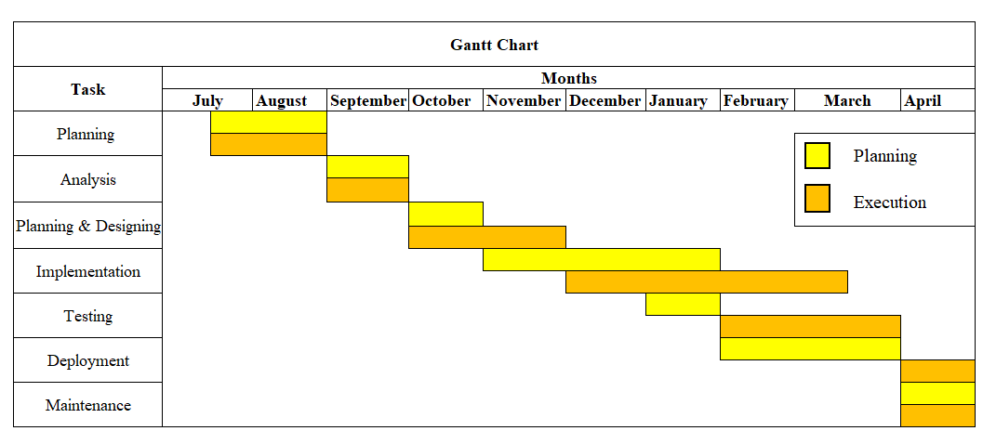

Figure 5.1 Gnatt Chart

## 5.2 Coding Details:

ClassMentor is developed using PHP which is a server-side scripting language. PHP implemented in the system was used to write the core logic and algorithms to achieve the functionalities that will meet the user requirements of the system. The selection of PHP for developing ClassMentor was mainly based on ease-to-learn, Cross-platform Compatibility, Fast execution, and Integration Capabilities. PHP was also to manage and handle the database operations such as fetching, inserting, and updating the data in the database. It can be used to perform numerous backend functions and also frontend functions where we can embed HTML scripts inside the PHP code which can be used to develop the frontend of the system.

With PHP which handles various database actions, MySQL is used to store the data coming as input from the user. It can perform various functions such as fetching the data to the user to show some output to the user regarding functionality and it has its query language which can perform various database operations on the tables present in the database. It can also be used to define the relationship between different tables which can be helpful to process the data properly and provide detailed data about a particular subject or individual when the outputs are displayed to the user.

• Code Snippets:

• GUI Screenshots:

## 5.3 Coding Efficiency:

Coding efficiency can be defined as the optimization of the code where minimal resources are used to run the code and effective measures are applied to ensure the performance of the developed system is being increased based on the code written for the system. Code Efficiency is directly related to the algorithm efficiency and speed of runtime execution of the system. The main objective is to ensure the high performance of the system. Less resource consumption and fast processing times can also help to ensure a high software quality of the overall system developed. Effective measures are implemented to make the system as lightweight as possible so that it doesn’t affect the performance of the overall system. Coding efficiency can also help to decrease the processing time for a web page and can help to provide fast outputs based on the inputs provided by the user.

Some practices during the coding of the system to ensure the optimization of code are as follows:

* Reusable components are written in a file and imported to particular parts where it is necessary, for example sidebar developed for the users is imported into each page rather than rewriting the whole code again.
* Usage of SVG is prioritized to obtain fast processing of images present in the system.
* Remove unnecessary code and duplicate code while using reusable components during the development.
* Only the required amount of size is allotted to the elements of MySQL while creating tables to store the data.
* Function reusability has been implemented to ensure unnecessary duplication of the same function is avoided.

## 5.4 Testing Approaches:

Software testing is a process to find bugs and defects in the system and to check whether the developed system meets the customer’s requirements. Software testing is carried out to see whether the software developed meets the quality standards and the requirements of the customer and the user who will use the system. Software testing also checks whether the functionality of the system works as per the requirements of the user and also checks whether the flow of the system working properly or not. In software testing individual functionalities are tested also those individual functionalities are then integrated with other components to test the overall functionality of the system.

Software testing is also done to check the quality of the system and whether the system meets the quality standards that are needed on the customer end. It checks the integrity of the system and also the data which flows through the system. Also, software testing checks whether it provides valid output based on the input and also it checks what the system and how the system reacts when the user inputs incorrect data in the system which means it tests the overall validation of the system. Testing also ensures the completeness of the system whether the system developed is complete and all the modules mentioned during the requirements are completed and satisfied by the user. The software testing process includes two integral processes which are as follows:

* **Verification**

Verification is one of the integral processes of software testing which is carried out throughout the software development life cycle. Verification is done to find out whether the system that is developed meets the requirements of the customer which are defined during the requirements definition phase. To ensure ClassMentor meets the requirements various processes are carried out such as code reviews, inspections, etc to ensure it is developed keeping in mind it meets the requirements specified.

* **Validation**

Validation is another side of the integral process of software testing which is carried out usually after the development of the software. Validation is carried out to find out whether the software meets the end-user needs of the system and delivers desired outcomes to the customer or the user of the system. It helps to ensure the reliability and quality of the system produced whether it meets the quality requirements of the user.

## 5.4.1 Unit testing:

Software units are the smallest part of software which holds a single functionality of the system. In a software unit single transaction is carried out in the system or a single process is carried out by the system. Unit testing focuses on the individual components of the system and tests the singular units for correctness and completeness and to find defects and errors in the individual components of the system. It is also tested to find out whether these individual units work as intended or as mentioned in the requirements of the software. Unit testing mainly focuses on the smallest units of the software design or software module that’s why it is also called Module testing. The Different modules are separated and tested individually to check whether they work as intended. Unit testing is usually carried out during the programming stage by the developers.

Because Unit testing is carried out during the programming stage it ensures early detection of errors and defects from the system that can be fixed and gives a good amount of time to find a solution for the defect. In this way, most errors and defects are solved during the development phase of the software. Which can help to improve the overall quality of the code written to develop the software.

How unit testing is implemented during the development of ClassMentor

* Firstly, system was broken down to individual units in which contained some forms, unit testing helped to determine the data inserted inside the form is properly stored.
* Also, whether if all the hyperlinks stored in the system lead to the right page.
* Buttons clicked by the user should perform the right actions or insert the data where it is assigned to be inserted.
* All the data requested by the user should be displayed and provided by the system in a proper assigned format.

## 5.4.2 Integration testing:

While Unit testing focuses on individual modules or software units Integration testing involves the integration of these individual modules and carries out testing. Integration testing usually starts at the module level where the individual units are integrated and tested to find out the defects and ensure the correctness of the system. After that the modules are integrated to form the developed system and the entire system is tested to ensure the software quality or to find defects and errors in the entire system which can be fixed. It mainly focuses on testing the interfaces and interactions between the integrated units in the system and how the data between the units is passed on to provide the functionality of the system. It usually identifies the defects related to interaction between the components flow of the system and also the interoperability between the components of the system.

It helps to ensure the overall software quality of the system and also helps to find interface defects and validates interoperability between the software components. It also ensures whether the software behaves as per it is defined in the software requirement.

How integration testing is implemented during the development of ClassMentor

* It is checked whether if a teacher inserts some data related to an assignment that assignment should be present at the student’s end with a proper button leading to the submission link provided by the teacher when the button is clicked.
* It is also used to check if a resource file uploaded by the teacher is able to get access from the student’s end able to download.
* It is also ensured the lectures scheduled for the students by the respective teacher is proper displayed in the timetable in a proper format.
* It is also checked to see whether the system directs to the proper user role based on their authentication details and based on the user role they have selected.
* It is also ensured that all the session variables are properly destroyed and the system redirects to the login page when the logout button is clicked by the user.

## 5.5 Modifications and Improvements:

One of the major advantages of an incremental model is the modules can be modified after the user has provided feedback to make some changes or to make work some functionalities and improvements in the system which is causing the functionalities not to work as intended. During the development stage, there were many bugs and errors encountered in the system which was disturbing the whole structure and flow of the system and was affecting the performance and functionality of the modules present in the system. All these bugs and errors were found during the testing phase and effective measures were implemented to fix the bugs present in the system which was causing issues in the system’s flow. The bugs that caused the problems and the solution to fix those bugs in the system are as follows:

* When the user inputs the data and then submits it to the system it gets properly submitted but when the user refreshes the page the same data is stored again in the database which causes data duplication and unnecessary insertion of data in the database. To fix this bug, before submitting the data and inserting it into the database it was checked whether the data is already present in the table if not, the data is inserted or else the data is not inserted.
* When the teacher tried to upload some files to be displayed at student’s end it wasn’t displaying at the students end, so to solve this another directory was created inside the code files of student role directory and during the submission of the resource on the teacher end that particular file was also stored in the directory present in the student role’s code file.
* There was the problem regarding the password encryption inside the database table where password was storing in plaintext. So, encryption functions were used to store the password in and encrypted format.
* One of the major problem was accidental deletion of files which was faced during the development of ClassMentor and to overcome this major problem git was used to store the versions of the developed system. Git is a version control software which can be used to push projects into the GitHub where there can’t be any accidental deletion and modification of files.

**Chapter 6**

**Results and Discussion**

# 6.1 Test Reports:

The test reports for ClassMentor gives a completed overview of the testing process carried out to check the integrity of the functionality, the bugs present in the system and all the outcomes ClassMentor produces under a particular environment which it works on. ClassMentor is a class management system which is used for handling various operations undergoing in a private tution. Because of diverse number of users are going to interact from the system based on their role as a admin or as teacher or as a student of that private tution testing number of possibilities becomes essential for the system to know the proper flow of the system between different user roles.

The main objective of the testing process was to ensure the completeness of the system and also the working of the functionality on a particular work environment while also ensuring the end user satisfaction from the software. And also, to find out the advantage of software over the existing system. Testing strategy was useful to meet the objectives of the testing process and ensure the tests conducted on the system in a proper manner. Testing process can be also used to ensure whether if the user requirements from the ClassMentor is met on the user-end and also the business requirements from the ClassMentor is satisfied from the end of customer who is purchasing the product for their business use.

During testing process, it also ensured the quality of the system is developed upto a standard defined earlier during the planning stage and also it is ensured that all the modules present in the system are working as intended and also proper error handling has been developed to handle the diversity of inputs given to the system from different user and their roles. Testing process not only ensures the correctness of the system but also the tolerance of the system based on its error-handling capabilities and also number of users using the system for their use at the same time. How capable ClassMentor is to handle number of users at the same times is also measured during the testing process.

# 6.2 Test Cases:

Test cases are the systematic approach to test the system or its modules to ensure the proper working of the functionality present in the system and also to ensure the completeness of a system. It can be also used to ensure whether the system meets the requirements of the user and also to look into the error-handling capabilities and validations of the system.

The test cases developed for ClassMentor are as follows:-

|  |  |  |  |  |  |
| --- | --- | --- | --- | --- | --- |
| Testcase ID | Testcase Procedure | Testcase Data | Expected Output | Actual Output | Pass/Fail |
| TC001 | Valid Username  Valid Password | Username:  Admin110  Password:  admin123 | Dashboard of the admin | Directs to dashboard of admin | Pass |
| TC002 | Invalid  Username  Valid  Password | Username:  Admin110  Password:  admin123 | Please enter valid Username | Display’s Invalid username | Pass |
| TC003 | Valid  Username  Invalid  Password | Username:  Admin110  Password:  Admin112 | Password is incorrect | Display’s Invalid Password | Pass |
| TC004 | Blank Username  Blank password | Username:  Password: | Please fill the credentials to procced login | Please enter the required field | Pass |
| TC005 | Blank  Username  Valid  Password | Username:  Password:  admin123 | Please enter the username to procced login | Please enter the required field | Pass |
| TC006 | Valid Username and Blank password | Username:  Admin110  Password: | Please enter password to procced login | Please enter the required field | Pass |
| TC007 | User Details:  Valid FirstName, LastName, Email, Phone  Invalid Age | FirstName: Test  LastName:123  Email:Test123@gmail.com  Phone: 9029412824  Age:213 | Invalid age, please ensure age entered comes between 0-100 | Displays Data inserted sucessfully | Pass |
| TC008 | User Details:  Valid FirstName, LastName, Age, Phone  Invalid Email | FirstName: Test  LastName:123  Email:Test123@gmal.con  Phone: 9029412824  Age:15 | Please enter valid email or check the email format. | Displays  Enter a valid email | Pass |
| TC009 | User Details:  Valid FirstName, LastName, Email, Age  Invalid Phone | FirstName: Test  LastName:123  Email:Test123@gmail.com  Phone: 902941282401  Age:15 | Invalid Number. Please enter 10-digit phone number. | Doesn’t take more than 10 numbers | Pass |
| TC010 | User Details:  Blank FirstName, Valid Lastname, Email, Age, Phone | FirstName:  LastName: 123  Email:Test123@gmail.com  Phone: 902941282401  Age:15 | Please enter FirstName to ensure registration. | Please enter the required field | Pass |
| TC011 | User Details:  Blank LastName, Valid FirstName, Email, Age, Phone | FirstName: Test  LastName:  Email:[Test123@gmail.com](mailto:Test123@gmail.com)  Phone: 9029412824  Age: 15 | Please enter LastName to ensure registration. | Please enter the required field | Pass |
| TC012 | User Details:  Blank Email Valid FirstName, LastName, Age, Phone | FirstName: Test  LastName: 123  Email:  Phone: 9029412824  Age: 15 | Please enter Email to ensure registration, | Please enter the required field | Pass |
| TC013 | User Details:  Blank Phone Valid  FirstName, LastName,  Age, Email | FirstName: Test  LastName: 123  Email:[Test123@gmail.com](mailto:Test123@gmail.com)  Phone:  Age: 15 | Please enter Phone number to ensure registration | Please enter the required field | Pass |
| TC014 | User Details:  Blank Age Valid FirstName, LastName, Email, Phone | FirstName: Test  LastName: 123  Email:Test123@gmail.com  Phone: 9029412824  Age: | Please enter Age to ensure registration | Please enter the required field | Pass |
| TC015 | Forgot Password:  Valid Email | Email:Test123@gmail.com | Proceeds Further to the next page | Proceeds to Further page | Pass |
| TC016 | Forgot Password:  Invalid Email | Email:Test124gmail.com | Email doesn’t exist in the system | Email doesn’t exist in the system | Pass |
| TC017 | Forgot Password:  Blank Email | Email: | Please enter Email to proceed further | Please enter the required field | Pass |
| TC018 | Forgot Password:  Valid Code | Code:659314 | Proceeds further to next page | Proceeds further to next page | Pass |
| TC019 | Forgot Password:  Invalid Code | Code:659313 | Please enter valid code which is provided in your email | Please Enter the valid code provided on email | Pass |
| TC020 | Forgot Password:  Blank Code | Code: | Please enter the code to carry on further | Please enter the required field | Pass |
| TC021 | Forgot Password:  Valid New password matching to Confirm Password | New Password: student123  Confirm Password:  student123 | Password has been changed successfully | Password changed successfully | Pass |
| TC022 | Forgot Password:  Valid New password but it is not matching to the Confirm Password | New Password: student123  Confirm Password: student124 | Passwords doesn’t match. Please check and try again | Displays Passwords doesn’t match. Please check and try again | Pass |
| TC023 | Forgot Password: Blank New Password | New Password: | Please enter the new password | Please enter the required field | Pass |
| TC024 | Forgot Password:  Valid New Password, Blank Confirm Password | New Password: student123  Confirm Password: | Please enter the password once again to ensure the reset | Please enter the required field | Pass |
| TC025 | Submitting a Feedback Form:  Feedback Exceeding the Character limit | (Just for Example scenario)  Character limit: 65  Feedback: The teacher’s teaching sense is really good and the notes she provides is very well presented and easy to understand  Number of Characters:68 | Please Enter the Feedback under 65 Character Limit. | Please Enter the feedback under 65 Character limit | Pass |
| TC026 | Submitting a Feedback Form:  Blank Feedback | Feedback: | Please enter the Feedback to proceed further creating the form | Please enter the required field | Pass |
| TC027 | Submitting a Feedback Form:  Valid Feedback and Suggestion | Feedback: good teaching sense and well-prepared notes  Suggestion: Need to be punctual and improve handwriting | Thank you for your response. | Feedback Submitted Successfully | Pass |
| TC028 | Submitting a Feedback Form:  Valid Feedback Suggestion exceeding the character limit | Character limit: 65  Feedback: good teaching sense and well-prepared notes  Suggestion: Need to be punctual and improve handwriting and provide assignments often in the classroom  Number of characters: 80 | Please answer all the question and submit the Form. | Please Enter the Suggestion under 65 Character limit | Pass |
| TC029 | Submitting a Feedback Form:  Valid Feedback Blank Suggestion | Feedback: good teaching sense and well-prepared notes  Suggestion: | Please enter the suggestion to provide to the teacher | Please enter the required field | Pass |
| TC030 | Course Details:  Valid Course Name | Course Name: Python | Course has been enrolled. | Displays course enrolled successfully | Pass |
| TC031 | Course Details:  Blank Course Name | Course Name: | Please enter the course name to be enrolled | Please enter the required field | Pass |
| TC032 | Subject Details: Course Selected, Teacher Selected and Valid Subject Name | Course Selected: Python  Teacher Selected: Test123  Subject name: Variables | Subjects enrolled successfully | Subject added Successfully | Pass |
| TC033 | Subject Details:  Blank Course, Valid Teacher Selected, Valid Subject Name | Course Selected:  Teacher Selected: Test123  Subject name: Variables | Please Select a Course to add its Subject | Please enter the required field | Pass |
| TC034 | Subject Details:  Valid Course Selected, Blank Teacher , Valid Subject Name | Course Selected: Python  Teacher Selected:  Subject name: Variables | Please Select a teacher to assign to its Subject | Please enter the required field | Pass |
| TC035 | Subject Details:  Valid Course Selected, Valid Teacher Selected , Blank Subject Name | Course Selected: Python  Teacher Selected: Test123  Subject name: | Please enter the subject name | Please enter the required field | Pass |
| TC036 | Subject Details:  Valid Course Selected, Valid Teacher Selected , Invalid Subject Name | Course Selected: Python  Teacher Selected: Test123  Subject name: @16523fsdv | Please enter a valid subject name | Please enter a valid subject name | Pass |
| TC037 | Assignment Details:  Valid Question, Blank weightage,  Valid Submission Date | Question: Write about python and its history  Weightage:  Submission Date: 22/06/2023 | Please enter the weight for the assignment | Please enter the required field | Pass |
| TC038 | Assignment Details:  Valid Question, Valid weightage,  Invalid Submission Date | Question: Write about python and its history  Weightage: 5  Submission Date: 22/06/20234 | Please enter the correct submission date for the assignment | Please enter the required field | Pass |
| TC039 | Assignment Details:  Blank Question, Valid weightage,  Valid Submission Date | Question:  Weightage:  Submission Date: 22/06/2023 | Please enter the Question for the assignment | Please enter the required field | Pass |
| TC040 | Assignment Details:  Valid Question, Blank weightage,  Blank Submission Date | Question: Write about python and its history  Weightage:  Submission Date: | Please enter the Submission Date for the assignment | Please enter the required field | Pass |

Table 6.11 – Test Cast Table

|  |  |  |  |  |
| --- | --- | --- | --- | --- |
|  |  | **TEST REPORT** | |  |
| Total Executed: | 40 |  | | |
| Passed | 40 |  | Failed: | 0 |
| Pending | 0 |  | |  |
| In-Process | 0 |  | |  |
| Blocked | 0 |  | |  |
| Test Planned | 40 |  | |  |

Table 6.11 – Test Reports Table

# 6.3 User Documentation:

This user documentation is a complete guide for the usage of ClassMentor which explains different modules and functionality and how things works while operating ClassMentor. It gives a detailed information on how to proper use ClassMentor and its functionalities to ease the work and help to achieve the business objcetives and goals from the developed system. Following is the complete walkthrough of ClassMentor:

* Login page: This the ClassMentor’s login page where two user roles can be logged in through the system. Firstly, the user has to enter the valid username and password assigned by the admin to the system and based on the user role which can be either teacher or student he should toggle the switch.
* Teacher’s Dashboard: This is the dashboard of the teacher where relevant information is dynamically updated and present in the dashboard where a particular subject teacher can see his subject name, total number of students, next lecture scheduled and details of student under his/her subject.
* Add test: In this page the teacher can add test where he/she can input the test name and also the difficulty level for the test.
* Display test information: In this page the teacher can add questions to the test and also view the questions added and also view the results of the students who attempted the delete and has complete authority to delete a test.
* Attendance: In this page it provides the complete list of students present in the subject dynamically and teacher can mark student’s attendance based on whether the student is present or absent.
* View Attendance: In this the teacher can view the attendance of the students for her subject based on the date provided by the teacher as an input.
* Schedule lecture: In this page the teacher can schedule her lecture based on the date, and timings provided by the teacher as an input.
* View Schedule: This page provides the complete schedule of the teacher based on the lectures he/she assigned and also can delete it if the lecture is cancelled.
* Add Resource: In this page the teacher can add a resource which can be anything from a pdf to a word file or a text file and can input the name of the resource with proper description of the resource.
* View Resources: Here the teacher can delete the unwanted resources or view or download if he/she needs it.
* Post Notice: In this page the teacher can post the notice, the notice title and description of the notice is stored
* Manage Notices: In this page the teacher can manage the details of notice and also delete unwanted notices from the system.
* Feedback: In this page the teacher can view the feedback provided by the students with also suggestion of improvements provided by the students.
* Give test: This is based on the student’s user role where the student can give the test given by their subject teacher after giving the test the result of the test are displayed but also separately stored where the student can access the test result for later.
* Submit assignment: In this page the student can submit his assignment given by the teacher through the submission link provided by the teacher.
* View Marks: This page displays the marks given by the teacher to the student based on the assignment’s quality the marks are displayed also the weightage for the assignment is displayed.
* Timetable: This page displays the overall schedule for the week which means the lectures scheduled by the teacher is displayed here and all the timings and relevant information is provided in the timetable.
* Resources: Here the student can access the resources where he/she can view the files and download it for later use.
* Notices: This page displays the notices provided by the teacher the teacher and also name of the teacher is displayed to know the identity of the teacher.
* Share Feedback: Here user can share his thoughts on the teacher where there is dropdown where he can select the name of the teacher he wants to provide feedback for and he can provide the feedback and suggestion for improvement for the teacher.

**Chapter 7**

**Conclusion**

# 7.1 Conclusion:

ClassMentor is a comprehensive class management system mainly used for handling various functional aspects of a private tution which can increase the performance of private tution who implemented the developed system. Huge chunks of Data involving records related to Students and respective Teachers of Courses and Subjects are collected from the private tutions are handled, managed and processed precisely which doesn’t disturb the flow of the management of the class is one of the major objectives of the ClassMentor which has being developed. This conclusion sums up major things related to the development and implementation of the project such as technologies used, features implemented, uses of system for a user, limitation and scope for improvement and mainly what personal learnings gained while developing the system.

The development of ClassMentor held some challenges which was difficult to overcome but one of those where the selection of technology stack to be implemented in ClassMentor. The stack of technologies implemented in ClassMentor are PHP which is a server-side scripting language mainly used for writing backend logic and also core logic and algorithms for ClassMentor which helped me to achieved functionalities required to implement in ClassMentor’s development phase, while use of MySQL helped in data storage in a systematic manner which were coming from the different parts of the user inputs given to the system. All the data collected from the system from the user are stored in their allotted tables and used when required for processing of the data and displaying the output to the user. While HTML and CSS played a major role for the development of graphical user interface from where the user interacts with the system, with the help of that set of technologies it was able to accomplish user-friendly web pages. Whereas JavaScript was mainly used for validation of user inputs which helped to filter out the data before storing in the system.

One of the most core objective of the ClassMentor was to handle the operations of a private tutions and handling the data generated by the user and process it for further use or display the output to the user. To achieve this objective of ClassMentor the features implemented such as User-authentication, role-based accesss control which is one of the most important feature implemented in ClassMentor it ensure abstraction of the data and assigns the functions to the user according to their level of authorization in the system. Also, different roles containing different functionalities such as teacher’s role can assign and grade the assignment of a particular student who has submitted the assignment, also can organize weekly test and post notices regarding various topics. Admin can add, update and delete various users and courses and subjects of a respective course. Students have access to resources posted by their respective subject teachers and can also access the timetable and submit assignment and view their grades regarding the particular assignment.

There are three roles currently present in ClassMentor each role has its own benefit because they have their own functions, benefits gained by each user using the system can be calculated as how useful the system can be for that particular user. ClassMentor is a web application designed to manage and keep records of the data generated which has a structured format for the main admin of the private tution which makes his job easy on the data management side. Whereas teachers can manage and handle their respective subject students and their data regarding their academics, grades etc. While ClassMentor has a significant advantages when implemented but there is always scope for improvement in everything, ClassMentor can be enhanced to be more scalable where it can handle huge amount of data when the volume of user and data increased. Also, integration with other Learning Management Systems can be useful for students to gain more knowledge from different sources while being on a centralised platforms lastly use feedback can be a proven as a major role for increasing the scope of improvements from ClassMentor.

ClassMentor provided me a great opportunity to explore my skills towards the technology stack implemented in the system. It helped me to enhance my problem-solving capabilities while increasing my logical thinking towards various aspects while developing the system. It increased my productivity towards by bringing up the motivation for developing things on schedule. It gave me a logical perspective on how things work behind a web page inside a system also gave knowledge about different aspects required to make a functional system. Also gave the understanding of the needs of the user while developing the system and learned the perspective of the user while developing the system. Also it gave me a idea of the how flow of the system should be defined and implemented to understand and develop the intended system.

Lastly, on personal level ClassMentor has helped me to flourish and enhance not only the technical skills but also soft skills required for the development of the project.

# 7.2 Limitations of the Project:

* Admin has to manually enter the details user roles(Student and Teacher) and assign them their username and password.
* Doesn’t contain parent role which means parents cannot have their functionalities in the system such as view their child’s marks, grades and attendance.

# 7.3 Future Scope of Project:

* To add a new user role namely Parent where they can view and access their particular child’s marks, attendance and grades allotted to their child.
* To implement tough security measures to avoid cyber-attacks and security breaches.
* To give users more flexibilities on their personal details stored in the system.
* To add a messaging system where students or parents can message to their subject teacher regarding some doubts and queries related to studies.
* To add a payment gateway for the students to pay their fees
* A mobile app for Teachers and Students to increase the flexibility of the system.

# 7.4 References: