**IOT based Intelligent Gas Leakage Detector Using Arduino**

**Introduction:**

The Internet of Things is an emerging topic of technical, social and economic significance. Consumer products, durable goods, cars and trucks, industrials and utility components, sensors, and other everyday objects are being combined with Internet connectivity and powerful data analytic capabilities that promise to transform the way we work, live, and play. In an increasingly interconnected world, the Internet of Things has emerged as a transformative technology, revolutionary how we interact with and monitor our surroundings. This project introduces the “IOT- based Intelligent Gas Leakage Detector Using Arduino”, a cutting-edge solution that leverages the power of IoT to enhance gas leak detection and response.

Gas leaks, whether in homes, industries, or commercial spaces, pose significant threats of life, property and environment. Traditional gas detectors offer limited functionalities and often lack the ability to provide real-time alerts or remote monitoring. Safety is the most important thing in any minor household or in big industries where gas are used to perform many tasks so it become necessary that good safety systems are installed in such industries to avoid dangerous accidents in industries or regular households containing LPG gas cylinders. The main objective of the work is designing a microcontroller based on toxic gas detecting and alerting system which detects and alerts hazardous gases like LPG and propane and also it displays and notifies the personal each and every second in the LCD display.

**System Overview:**

This IoT-based gas leakage detector represents a pivotal advancement in safety technology. By seamlessly connecting to a Wi-Fi network, the device empowers users to establish custom minimum and maximum gas concentration thresholds. This flexibility allows the system to adapt to various environments and the specific requirements of homes, hotels and LPG gas storage areas, where the stakes for gas leak detection are particularly high.

At the heart of this cutting-edge system lies the MQ5 gas sensor, a high-performance device engineered to sense LPG gas levels with remarkable precision. This sensor continuously samples the air, monitoring the concentration of LPG gas. It acts as vigilant sentinel, ensuring that gas levels are maintained within safe bounds. The system’s user-friendly interface incorporates an RGB LED indicator on the circuit. When the sensor detects that the concentration of LPG gas in the air falls within the predefined safety limits, the RBG LED emits a reassuring green glow. This vivid visual cue signifies that the environment is secure, offering peace of mind to those withing proximity.

However, the true innovation of this system shines when gas levels surge beyond the preset thresholds. In such a critical scenario, the RBG LED undergoes a dramatic transformation, casting a stark red light that serves as an unmistakable warning signal. Simultaneously, the system takes decisive action to safeguard lives and property. The solenoid valve, responsible for controlling the flow of gas is promptly turned off cutting the source of the leak. This immediate response significantly reduced the risk of potential explosion or fire.

Furthermore, the system doesn't stop at local alerts. Its integration with IoT technology means that it can communicate vital information in real-time to users and relevant authorities. This remote monitoring and reporting capability add an extra layer of safety, as it enables swift emergency response and damage control measures to be implemented. The system becomes an interconnected safety net, ensuring that the information flows seamlessly, even when individuals are not physically present at the site.

**Block Diagram:**

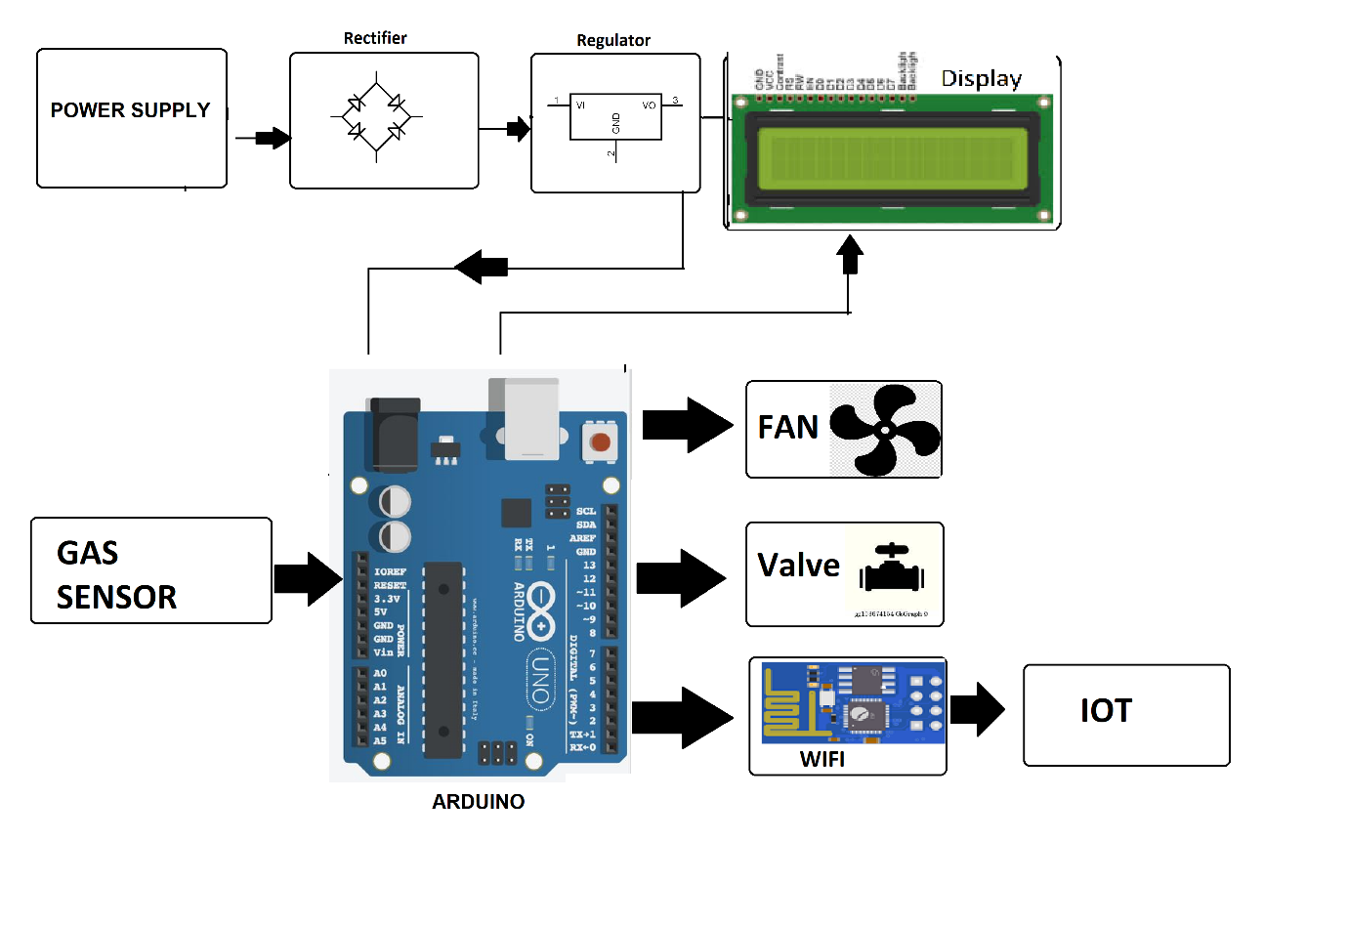

**Advantages:**

* **Early-detection** : IoT-based gas leakage systems can detect gas leaks in real- time, enabling early detecting of potential hazards.

This early detection helps prevent accidents and allows for prompt action to mitigate the gas leak.

* **Remote Monitoring**: Users can monitor the gas leakage system remotely through smartphone or computer

This provides convenience and allows users to check the status of their system from anywhere, enhancing safety and peace of mind.

* **Automated Alerts:** The System can send alerts and notifications to users when a gas leak is detected

This feature ensures that users are immediately informed of any danger allowing them to take appropriate action without delay.

* **Data Logging and Analysis:** IoT systems can log and analyse historical data related to gas leakage.

This data can be useful for identifying trends, optimizing gas usage, and ensuring system reliability.

* **Integration with Other Systems:** IoT- based gas leakage systems can be integrated with other home or industrial automation systems.

**Disadvantages:**

* **Cost:** Setting up an IoT-based gas leakage system can be expensive due to the cost of sensors, microcontrollers and networking equipment.
* **Complexity :** Designing and configuring an IoT system can be complex, requiring technical expertise.
* **Reliability:** IoT systems are reliant on internet connectivity, which may not always be stable.
* **Privacy and Security:** IoT devices can be vulnerable to hacking and data breaches.
* **Maintenance:** IoT-based systems require Regular maintenance to ensure they function correctly.

Components such as sensors and microcontrollers may degrade over time and need replacement, which adds to the ongoing cost and effort of system maintenance.

**Hardware Design:**

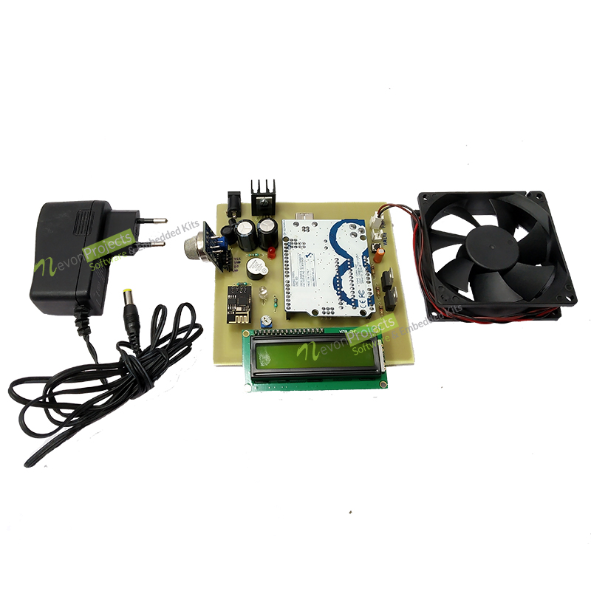

**Components Used:**

1. **Arduino:** It is a type of microcontroller which is used for processing the inputs coming from the sensors and display output as per the inputs processed.
2. **LCD:** It is Liquid Crystal Display which can be used to display outputs or some messages alerting about the leakage.
3. **Wi**-­**Fi module:** It is used to enable wireless-communication for remote monitoring.
4. **DC Fan**: It provides ventilation in case of a gas leak.
5. **Gas Sensor**: It is a input device which is used to detect MQ5 gas leakage and trigger the alerts.
6. **Buzzer**: It is an audible alarm for notifying gas leaks.
7. **Regulator**: It is used to regulate voltage to power the components.
8. **Crystal Oscillator**: It provide precise timing for microcontroller operation.
9. **Resistors**: It controls the flow of electric current in the circuit.
10. **Capacitors**: It used to store and release electrical energy.
11. **Transistors**: It amplifies and switches electronic signals.
12. **Cables and Connectors**: It is used to link components and ensure electrical connections.
13. **Diodes**: It controls the direction of current flow.
14. **PCB and Breadboards**: It provided platforms for circuit assembly.
15. **LED**: It is a visual indicator for system status.
16. **Transformer/Adapter**: It is used to convert AC to DC power for the system.
17. **Push Buttons**: It is a manual input for system control.
18. **Switch**: It is used to control the power supply to the system.
19. **Integrated Circuit**: It performs specific functions in the circuit.
20. **IC Sockets**: It holds and protects integrated circuits.

**Conclusion:**

In conclusion, the IoT-based gas leakage system represents a significant stride in enhancing safety and automation in both residential and industrial settings. This innovative system harnesses power of interconnected devices to detect gas leaks in real-time, offering a multitude of benefits. By utilizing components like gas sensors, microcontrollers this system can swifty identify gas leaks ensuring the safety of occupants and preventing potential disasters. Moreover, its ability to provide remote monitoring and automated alerts via smartphones or computers allows users to stay informed and take immediate action when necessary, even when they are far from the site.

In essence, this system is a testament to the potential of IoT technology to revolutionize safety measures, making our environments more secure and efficient. As technology continues to advance the IoT-based intelligent gas leakage system using Arduino serves as a beacon of progress in the realm of smart and secure living. Its adoption promises a safer and more connected future for us all.