Dear Doctor

Congratulations! Your Registration is approved. Please check this step by step instruction on how to setup up your profile and calendar.

**IN THIS VIDEO WE WILL SHOW YOU HOW TO SCHEDULE THE CALENDAR AND SETUP YOUR PROFILE AFTER SUCCESSFUL REGISTRATION ON DOCTOR FROM HOME WEBSITE**

**How to schedule your calendar on doctorfromhome.in video:** <https://www.youtube.com/watch?v=GTGxFMl2nRw>

Please log on using the registered email address or Mobile no and update your profile

**Profile Checklist:**

1.

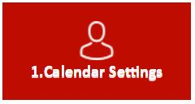

Calendar settings :( Please note this is a recurring calendar to make changes to the calendar once setup you will need to log on and update the changes accordingly)

1.1

As shown below

1. Select day- Monday, Tuesday….
2. Select Start time for the day
3. Select End time for the day
4. Slot minutes allows you to choose the time for each consult in 15/30/45/60 minutes

Example 1. If you choose to be available between 9 am- 15:00(3 pm) on Tuesday- you can select

15/30/45/60 minutes slots for the consults and put the price of each consult of your choice.

Click on the Add Button to schedule another slot for the same day

Or

Just click on PUBLISH (Publish will make your calendar available to patient’s for booking)

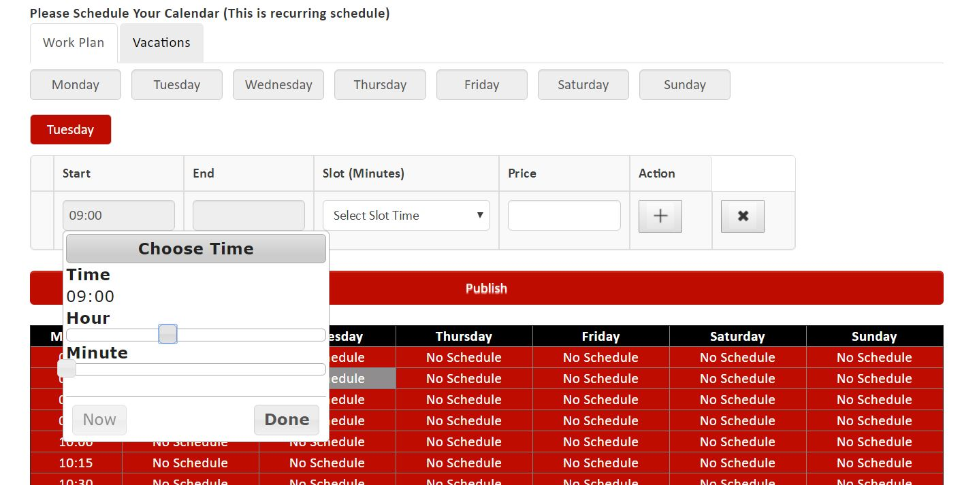

Publish

4

3

2

1

2.

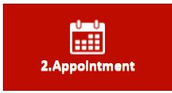

Appointment shows the list of appointment booked by the patient

3.



All appointments shows the list of all appointments till date

4.

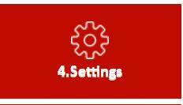

Edit **Profile**:

* Name, email, phone no
* **My Details**: Specialty, Education, Hospital Affiliations, Languages, Certifications, Awards, professional Membership,
* **Change Password**
* **Upload Image**(Please upload a professional image of yourself)
* **Upload Document :** allows you to upload your professional documents like certificate and qualification’s

Logout: Allows you to logout from your profile

Thank You

Admin

[admin@doctorfromhome.in](mailto:admin@doctorfromhome.in)